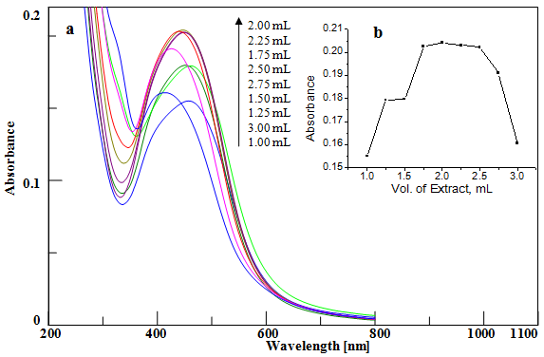
Figure S1 (a) UV- Vis spectra of AgNPs synthesized using H. asiatica at different extract volume, (b) Variation of absorbance with volume of extract.
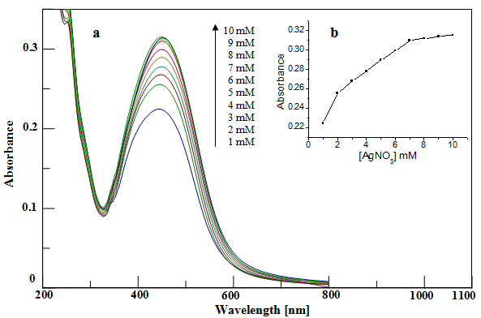
Figure S2 (a) UV-Vis spectra of AgNPs synthesized using H. asiatica at different AgNO₃ concentration, (b) Variation of absorbance with [AgNO₃].
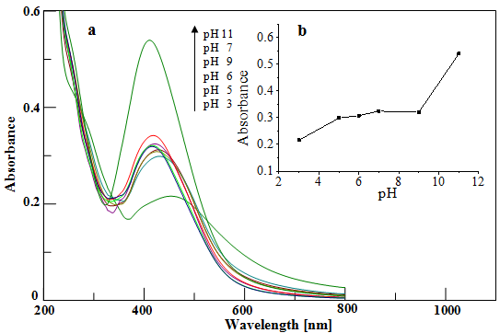Figure S3 (a) UV-Vis spectra of AgNPs synthesized using H. asiatica at different pH, (b) Variation of absorbance with pH.
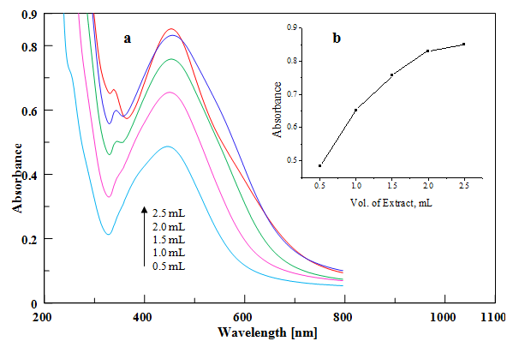
Figure S4 (a) UV- Vis spectra of AgNPs synthesized using H. asiatica at different extract volume, (b) Variation of absorbance with volume of extract (Absence of sunlight).
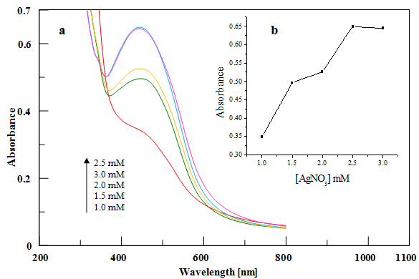
Figure S5 (a) UV-Vis spectra of AgNPs synthesized using H. asiatica at different AgNO₃ concentration, (b) Variation of absorbance with [AgNO₃] (Absence of sunlight).
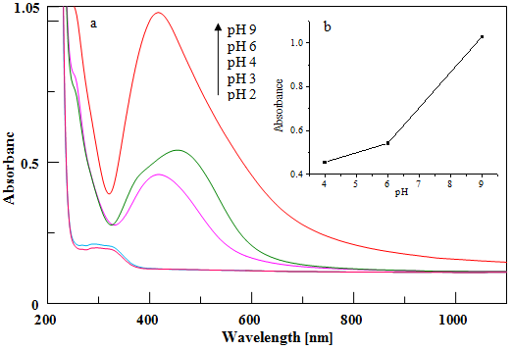
Figure S6 (a) UV-Vis spectra of AgNPs synthesized using H. asiatica at different pH, (b) Variation of absorbance with pH (Absence of sunlight).
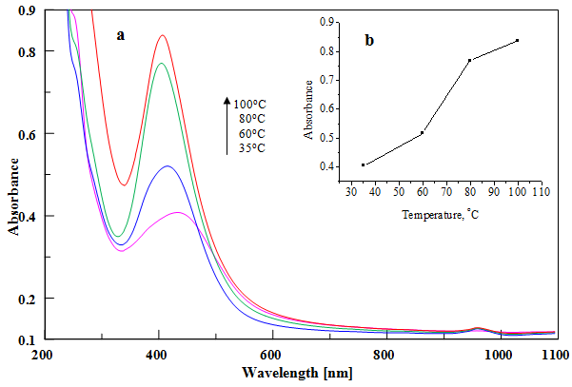Figure S7 (a) UV-Vis spectra of AgNPs synthesized using H. asiatica at different temperature, (b) Variation of absorbance with temperature (Absence of sunlight).
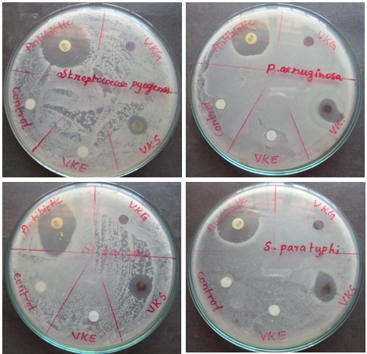
Figure S8 Antimicrobial activity of nanoparticles against various microbes (VKE-Extract, VKS-AgNPs and VKG-AuNPs (Antibiotic: Tetracycline)).
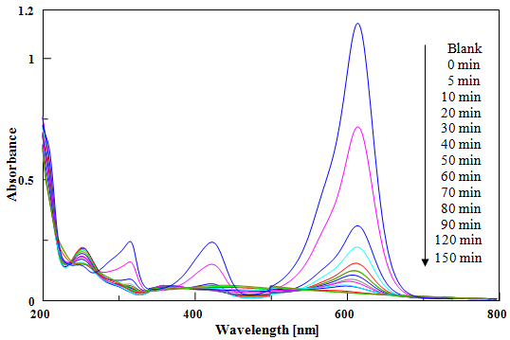
Figure S9 UV–Vis spectra of MG in the presence of AgNPs (MG - 1×10⁻⁵ M, AgNPs - 10 mg) as a function of time at pH 9.
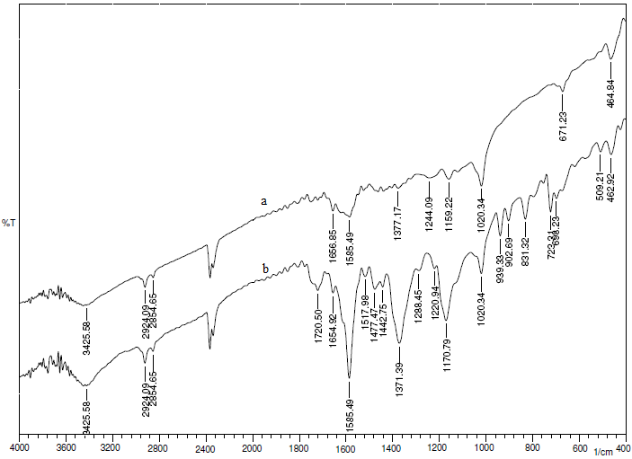
Figure S10 FT-IR spectra of (a) AgNPs after reaction in sunlight (b) MG.
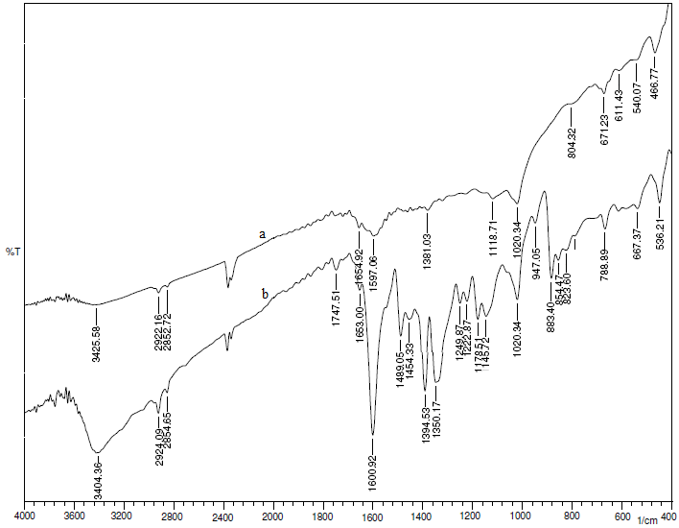
Figure S11 FT-IR spectra of (a) AgNPs after reaction in sunlight (b) MB.
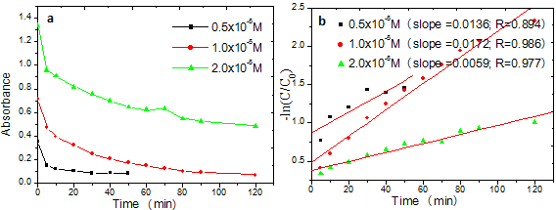
Figure S12 Plot of (a) Absorbance vs time and (b) –ln (C/C₀) vs time at different MB concentrations.
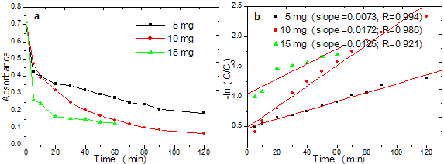
Figure S13 Plot of (a) Absorbance vs time (b) –ln (C/C₀) vs time at different catalyst dosage.
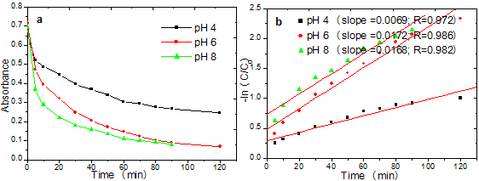
Figure S14 Plot of (a) Absorbance vs time (b) –ln (C/C₀) vs time at different pH.
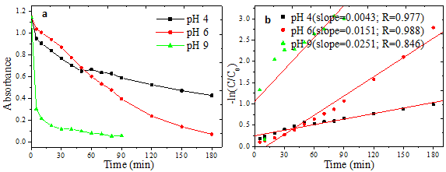
Figure S15 Plot of (a) Absorbance vs time (b) –ln (C/C₀) vs time at different pH.

