Supporting information
Novel UV-activated biofunctionalization of up-converting nanocrystals for detection of proteins
Małgorzata Misiak*^{1,2} , Maciej Gawłowski¹, Agnieszka Kowalczyk¹, Michał Skowicki¹, Katarzyna Prorok², Tomasz Lipiński*¹
*Corresponding authors
m.misiak@intibs.pl
Tomasz.lipinski@port.org.pl ,
¹ŁUKASIEWICZ-PORT, Stabłowicka 147, 54-066 Wrocław, Poland;
²Institute of Low Temperature and Structure Research, Polish Academy of Sciences, Okólna 2, 50-422 Wrocław, Poland

- Synthesis of UCNPs
  - Synthesis of α-NaYF₄: 20 % Yb³⁺ 2 % Er³⁺ nanocrystals
The thermal decomposition of trifluoroacetate salts with some modifications has been used to synthesize the nanoparticles (1)(2).
Prior to synthesis the trifluoroacetate precursors were prepared by dissolution of the proper amount of oxides i.e. Y₂O₃, Yb₂O₃ and Er₂O₃ (total amount 2.5 mmol) in trifluoroacetic acid (TFA) and water 1:1 v/v solution. After obtaining the clear solution the solvent has been evaporated with the use of rotary evaporator, then placed on a hotplate, and left for one night to dry in the temperature of 130 ºC.
The dry precursor was further used for the synthesis. The 5 mmol of sodium trifluoroacetate CF₃COONa was added to the three-neck round bottom flask containing previously prepared dry precursor. Subsequently 40 cm³ of oleic acid as an complexing solvent and 40 cm³ of 1-octadecene as a high boiling solvent were added to the flask. Afterwards the flask was placed in the heating mantle with the magnetic stirrer, heated to 115 ºC , put under vacuum and nitrogen flow alternately for about 1 hour to remove excess water, trifluoroacetic acid and oxygen from the reaction. Next the flask was placed under nitrogen flow and the solution was heated up to 305 ºC and kept for one hour. Afterwards solution was cooled down to the room temperature and the mixture of n-hexane and acetone was added to precipitate nanocrystals. The nanocrystals were collected via centrifugation at 10 000 rpm for 10 minutes and washed with ethanol. The nanocrystals were dispersed in 10 cm³ of chloroform and left for the synthesis of core-shell nanoparticles.
  - Synthesis of core-shell α-NaYF₄: 20 % Yb³⁺ 2 % Er³⁺@ NaYF₄ nanocrystals
The method of synthesis was analogous to the synthesis of core particles with some modifications. The shell precursor containing 5 mmol yttrium trifluoroacetate was prepared and dried in the three-necked round bottom flask. The 40 cm³ oleic acid and 40 cm³ 1-octadecene were added and the flask was placed in the heating mantle with the magnetic stirrer, heated to 115 ºC under vacuum and nitrogen flow alternately for about 1 hour. Subsequently the solution was cooled down to the room temperature and the core particles in chloroform were added. The chloroform was then slowly removed from the solution by evaporation at 70-100 ºC under nitrogen flow and vacuum. Afterwards the solution was heated up to 305 ºC and kept for 1 hour. After the reaction was finished the solution was cooled down to the room temperature and nanocrystals were precipitated with the mixture of n-hexane and acetone. The nanocrystals were centrifuged for 10 minutes at 10000 rpm and washed with ethanol. The core-shell nanocrystals were dispersed in 10 cm³ of chloroform and kept for further experiments.

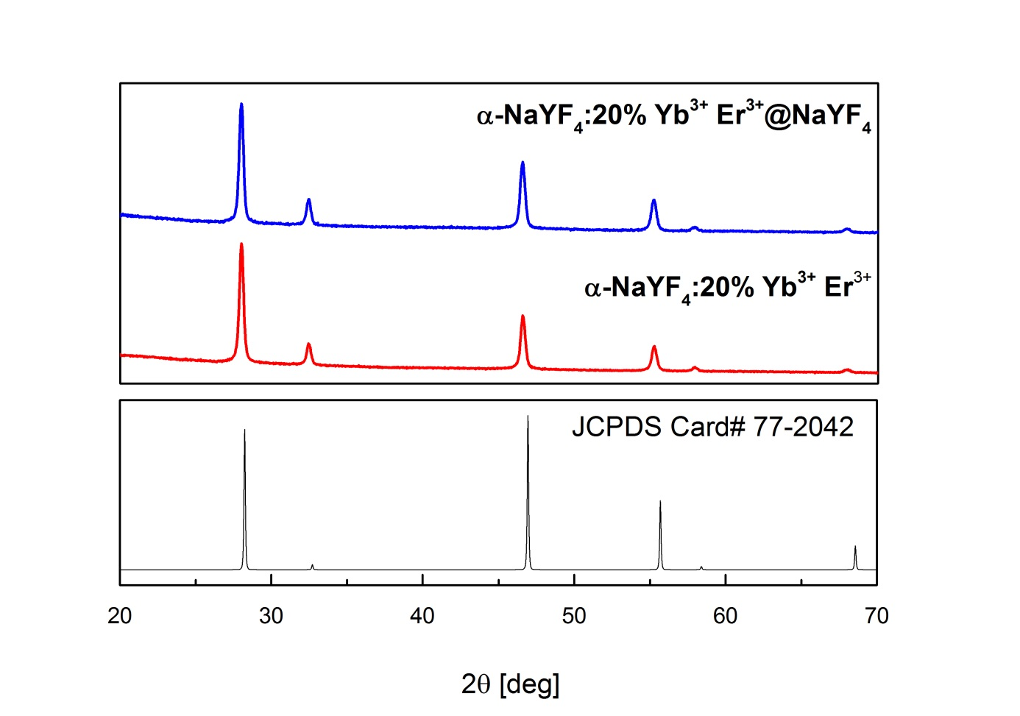
Fig.S1. XRD pattern of the obtained UCNPs

  - Synthesis of core nanoparticles β-NaYF₄: 20 % Yb³⁺ 2 % Er³⁺
Prior to synthesis the acetate precursors were prepared by dissolution of the proper amount of oxides i.e. Y₂O₃, Yb₂O₃ and Er₂O₃ (total amount 2.5 mmol) in acetic acid and water 1:1 v/v. After obtaining the clear solution the solvent has been evaporated with the use of rotary evaporator, and left for one night to dry on a hotplate heated to the temperature of 130 ᵒC.
The synthesis was provided following the procedure described in ref. (2) with some modifications. The 30 cm³ of oleic acid and 75 cm³ of 1-octadecene were added to the round-bottom flask containing 5 mmol of yttrium and lanthanides (Yb³⁺, Er³⁺) acetate salts. The solution was heated to 145ᵒC and stirred under vacuum for 30 min to remove water and oxygen, and to form oleate salts from acetates. Subsequently the temperature was decreased to ~80ᵒC and the flask was placed under nitrogen flow. Then the solution of 0.5 g NaOH and 0.7410 g NH₄F in 20 cm³ methanol was added. The solution was stirred under nitrogen at 70ᵒC for 15 min, then the flask was opened and methanol was evaporated from the reaction mixture. The solution then was kept under vacuum for 15 min at 120ᵒC. Afterwards, the temperature was increased to 305ᵒC and the reaction was kept under nitrogen for one hour. The mixture was cooled to the temperature around 70ᵒC and 16 cm³ of ethanol was added to precipitate the synthesized nanocrystals. Next, the nanocrystals were collected by centrifugation at 10 000 rpm for 10 minutes, washed with n-hexane and ethanol, centrifuged and dispersed in 10 cm³ of chloroform.
  - Synthesis of core-shell nanoparticles β-NaYF₄: : 20 % Yb³⁺ 2 % Er³⁺ @ NaYF₄
The 15 cm³ of oleic acid and 38 cm³ of 1-octadecene were added to the round-bottom flask containing 2.5 mmol of yttrium acetate salt. The solution was heated to 145ᵒC and stirred under vacuum for 30 min to remove water and oxygen, and to form oleates from acetates. The temperature was decreased to 80ᵒC and 5 cm³ of previously synthesized core nanoparticles solution was added. After the evaporation of the chloroform from the solution, 0.25 g of NaOH and 0.3705 g NH₄F in 10 cm³ methanol was added. The mixture was stirred under nitrogen at 70ᵒC for 15 min, then the flask was opened and methanol was evaporated from the reaction mixture. In the next step the solution was kept under vacuum for 15 min at 120ᵒC. Afterwards, the temperature was increased to 305ᵒC and the reaction was stirred under nitrogen for one hour. The mixture was cooled to the temperature around 70ᵒC and 8 cm³ of ethanol was added to precipitate nanocrystals. The nanocrystals were then collected by centrifugation at 10000 rpm for 10 minutes, washed with n-hexane and ethanol, centrifuged and dispersed in 5 cm³ of chloroform.
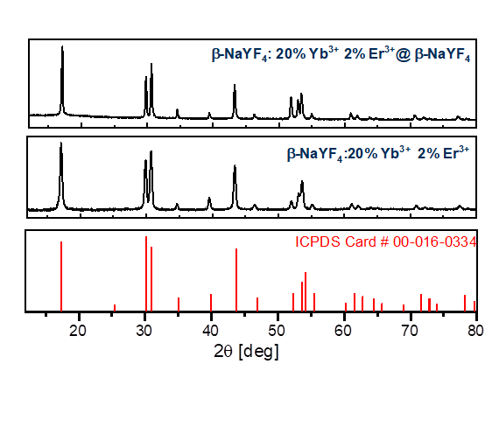Fig.S2. XRD pattern of the obtained hexagonal UCNPs

- Separation of Dex-NH₂ coated UCNPs
Fig. S3 Chromatogram from size exclusion chromatography after coating with Dex-NH₂. Column filled with Sepharose CL-6B, 0.9% NaCl (appropriate ionic strength was necessary for separation to occur), flow: 1 ml/min. RU - refraction units

- DLS, Zeta potential and FTIR
All measurements were carried out on Malvern Zetasizer Nano ZS instrument, in mQ water or solutions of NaCl.
UCNPs were monitored for changes in size distribution and polydispersity index during biofunctionalization (Table S1; Fig. S3). It can be seen that size of NPs is consistently increasing with each successive added layer while polydispersity is maintained at low level.
Table S1. Changes in average size of UCNPs at different stages of functionalization. H_{d} – hydrodynamic diameter, PDI – polydispersity index.
 | H_{d} [nm] | PDI
Ligand-free NP | 60.32±30.53 | 0.256
NP-PVP | 67.19±22.72 | 0.114
NP-PVP-Dex | 91.83±33.74 | 0.135
NP-PVP-Dex-Protein G | 99.62±42.86 | 0.185

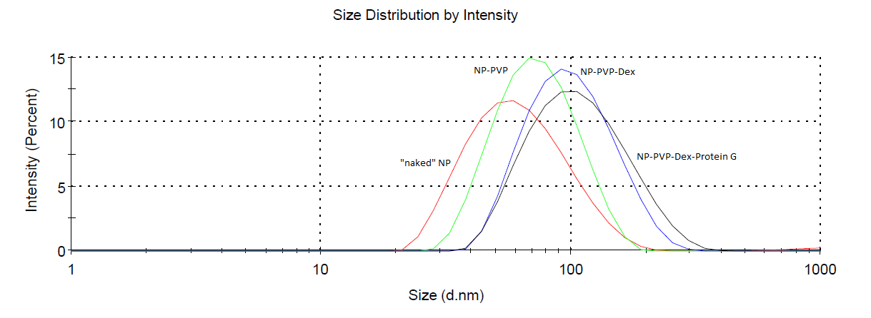
Fig. S4 The particle size distribution at different stages of biofunctionalization. The data corresponds to Table 1.
DLS instrument calculates particle diameter with solvation shell, so-called hydrodynamic diameter. It is highly dependent on interaction between particle surface and surrounding ions or solvent molecules. Therefore obtained results should be treated as evidence for reaction to take place rather than information about real size. Transmission electron microscopy is a technique more relevant to determine size of UCNPs close to the actual value.
Another meaningful parameter is the Zeta Potential which is associated with surface charge. It can be useful to predict how particles would act with each other or surrounding molecules. Removing oleic acid by acid treatment results in high positive charge of bare UCNPs. Addition of each layer is reflected by shifts in measured potential (Fig. S5). The measurements after coating with modified PVP zeta potential could not be measured due to precipitation of nanoparticles in NaCl solution. Slightly negative value after conjugation with Protein G is consistent with a negative net charge of protein.
Fig. S5 Effect of coating on Zeta Potential of UCNPs. Nanoparticles dispersed in 1.54 mM NaCl.

Fig.S6 FT-IR data for NaYF₄:YbEr@NaYF₄ nanocrystals after each step of biofunctionalization obtained on Thermo Scientific Nicolet 6700 ​with Smart Orbit Diamond ATR. (a) The as synthesized oleate-capped nanoparticles. (b) PVP-ANB-NOS functionalized NPs. (c) NPs functionalized with PVP-ANB-NOS and dextran. (d) NPs functionalized with PVP-ANB-NOS, dextran and IgG. (e) NPs functionalized with PVP-ANB-NOS, dextran and protein G. The right panel shows FT-IR spectra of PVP-ANB-NOS, Dextran, immunoglobulin G and protein G. The bands of as synthesized nanocrystals at 2,925 and 2,850 cm⁻¹ can be assigned to the antisymmetric and symmetric –CH₂ stretching present in the oleate moieties. The bands for the NPs@PVP-ANB-NOS and PVP-ANB-NOS alone for −CH₂ −CH groups of PVP can be seen at ~2,970 and ~2,940, respectively. The peak at 1,270–1,285 cm⁻¹ typical for —C–N bond in PVP is also visible. In both cases, strong absorption peak, which is characteristic for carbonyl group of PVP at ~1,650–1,660 cm⁻¹ can be observed. The band in PVP-ANB-NOS at 2120 cm⁻¹ can be assigned to azide group that is not visible on NPs due to strong distortion area and low abundance of material. In case of PVP-dextran functionalized nanoparticles the broad band at ~3,300 cm^{–1} and band at ~1,080 cm⁻¹ can be assigned to the hydroxyl stretching vibrations of the polysaccharide and C–O bonds of dextran, respectively. (d, e) The bands at ~1,600-1,640 cm^{–1} is the characteristic amide I bands from proteins (α-helices), which is also attributed to the carbonyl stretching frequency characteristic to protein secondary structures. The band at 1,520 cm^{–1} is the characteristic amide II band. The bands around 2,900cm⁻¹ of protein G originate from glycerol used for protein stabilization. (3–6)

- Dot-blot reading

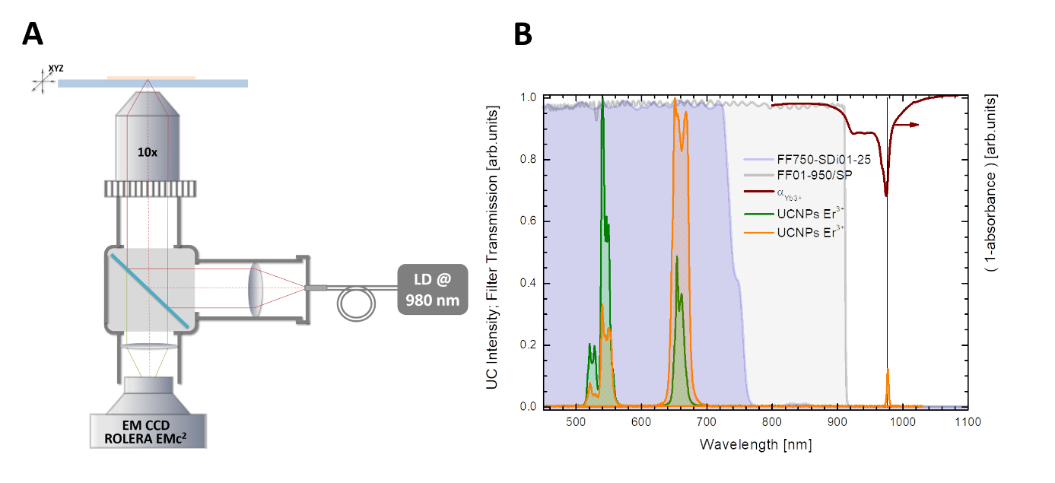
Fig. S7 The experimental setup design and properties. (A) Schematic view of the up-conversion imaging microscope. The beam of 975 nm laser diode (3W) is reflected by a dichroic filter towards the sample. Then the up-conversion emission passes through a short-pass filter FF01-950/SP and the image is taken with use of EMCCD Rolera EM-C². (B) Emission spectra of as-synthesized hexagonal (green) and cubic (orange) nanoparticles; transmission spectra of dichroic (FF750-SDi01-25) and emission filters (FF01-950/SP) used for the imaging. Absorption spectrum of Yb³⁺ in NaYF₄ is provided for comparison (upside down).
To quantify the dot’s intensity a program in lab view was developed in-house, in which loaded pictures of UC dot-blots are converted to 8bit pictures (grayscale images) and used for analysis. First, the region of interest is defined (ROI) manually and pixels in one line (along b axis) are summed up (Fig.S7 B) to let define the position of cursors C1 and C2 which demarcate the background borders. Then total intensity minus background is calculated. Linear equation for a line going through these points:
$$\left(x-x_{C1}\right)\left(y_{C2}-y_{C1}\right)-(y-y_{C1})(x_{C2}-x_{C1})= 0$$
x_{C1}, y_{C1} and x_{C2},y_{C2} are coordinates shown on Fig S7 (B). Based on this equation a line to evaluate background from signal is created and area under it (restricted by C1 and C2 lines) is integrated, and subtracted from total ROI intensity value. The final value used for further analysis comes from the signal originating from the dot.
$$S= \sum_{a}{\sum_{b}{I_{ROI}\left(a,b\right)-B}}$$
Since the UC process is relatively weak, long acquisition times for single image were required. While there was no autofluorescence of the subject of interest under 980 nm excitation, non-specific binding or light scattering were major factors responsible for background signal.

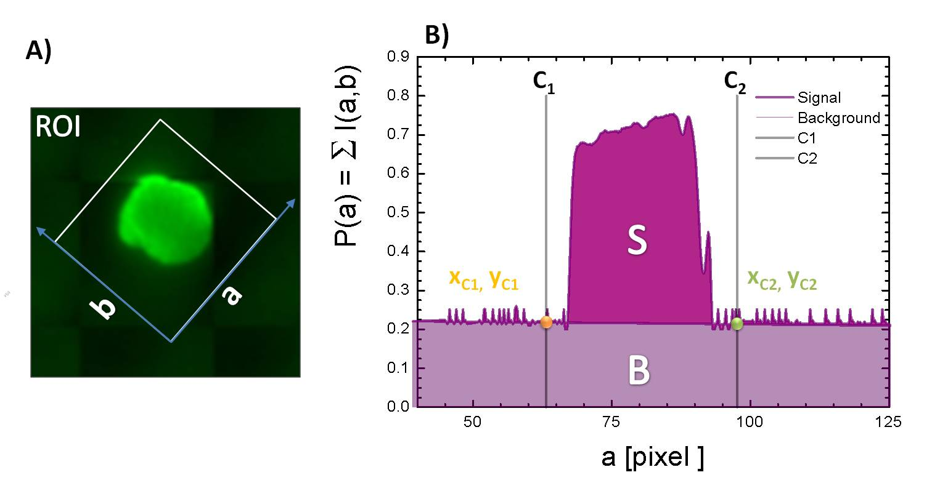
Fig. S8 Schematically shown algorithm for signal quantification. (A) Graph showing intensity of the pixels I(a,b) for the chosen region of interest (ROI). The intensity along a-axis being a sum over b-axis P(a)=Ʃ I(a,b). The C₁ and C₂ are cursors used to subtract the background from signal (B).

- References

1. John-Christopher Boyer, and Louis A. Cuccia, J. A. Capobianco*, Synthesis of Colloidal Upconverting NaYF4: Er3+/Yb3+ and Tm3+/Yb3+ Monodisperse Nanocrystals (2007), doi:10.1021/NL070235+.
2. K. A. Abel, J. C. Boyer, F. C. J. M. Van Veggel, Hard proof of the NaYF4/NaGdF4 nanocrystal core/shell structure. J. Am. Chem. Soc. 131, 14644–14645 (2009).
3. V. Ayala, A. P. Herrera, M. Latorre-Esteves, M. Torres-Lugo, C. Rinaldi, Effect of surface charge on the colloidal stability and in vitro uptake of carboxymethyl dextran-coated iron oxide nanoparticles. J. Nanoparticle Res. 15, 1–14 (2013).
4. P. Tao, Y. Li, A. Rungta, A. Viswanath, J. Gao, B. C. Benicewicz, R. W. Siegel, L. S. Schadler, TiO2 nanocomposites with high refractive index and transparency. J. Mater. Chem. 21, 18623–18629 (2011).
5. W. Kong, T. Sun, B. Chen, X. Chen, F. Ai, X. Zhu, M. Li, W. Zhang, G. Zhu, F. Wang, A general strategy for ligand exchange on upconversion nanoparticles. Inorg. Chem. 56, 872–877 (2017).
6. L. M. Miller, M. W. Bourassa, R. J. Smith, FTIR spectroscopic imaging of protein aggregation in living cells. Biochim. Biophys. Acta - Biomembr. 1828 (2013), pp. 2339–2346.

