Supplementary Materials
Prevalence, Patient Characteristics, and Treatment of Patients with Hypertrophic Cardiomyopathy: A Nationwide Payer Database Study

Yuika Ikeda¹ • Tsunehisa Yamamoto¹ • Makio Torigoe¹ • Bruno Casaes Teixeira² • Thomas Laurent¹
¹Bristol Myers Squibb K.K., Tokyo, Japan
²Bristol Myers Squibb, Uxbridge, UK

Corresponding author: Yuika Ikeda, 2-1, Otemachi 1-chome, Chiyoda-ku, Tokyo 100-0004, Japan (Yuika.Ikeda@bms.com)

Supplementary Methods

Prevalence of hypertrophic cardiomyopathy
The prevalence of hypertrophic cardiomyopathy (HCM) was calculated for each calendar year, insurance type, HCM subtype, and 5-year age group using the following formula.
$$Prevalence =\frac{Patients diagnosed with HCM during the calendar year }{The number of people insured from Jan 1 toDec 31 of the calendar year}$$
The standardized prevalence of each 5-year age group for ages 74 years and below was calculated using the following formula.
$$Prevalence per 5 year age group (P)=\left(\left(p-b-c\right)×A+b×B+c×C\right)÷p$$
$A$ is the prevalence of HCM in the Kempo data. $B$ is the prevalence of HCM in the Kokuho data $C$ is the prevalence of HCM in the Advanced Elderly Medical Service System (AEMSS) data. $b$ is the number of insured people in the Kokuho data. $c$ is the number of insured people in the AEMSS data. $p$ is the number of people in the insured population in Japan in the 5-year age group. Values for $b$ and $c$ are sourced from data on medical insurance [1].
The standardized prevalence of each 5-year age group for ages 75 years and above was calculated using the following formula.
$Prevalence per 5 year age group (P)=C$
$C$ is the prevalence of HCM in the AEMSS data.
The overall estimated number of people with HCM in Japan was calculated using the following formula.
$$Overall estimated number of people with HCM in Japan in each 5‐year age group=P×p$$
For 2021, basic data for medical insurance was not available; therefore, the proportion of AEMSS, Kokuho, and other insurances in 2020 was used to estimate the standardized prevalence (P). $p$, the number of people in the insured population in Japan in each 5-year group, was calculated as follows.
$$p =overall population in each 5 year age group×\left(100-{1.61}^{}\right)\%$$
Data source: population estimates [2]
1.61% is the proportion of welfare recipients in 2020.
Table S1 Inclusion and exclusion criteria
Disease description | Definition (ICD-10 code and disease code)
Inclusion criteriaª
HCM | I421, I422, and I420 (Disease code: 8846101)
D-HCM | I420 (Disease code: 8846101)
Obstructive HCM | I421 (Disease code: 4251008)
MVO-HCM | I421 (Disease code: 8846149)
Apical HCM | I422 (Disease code: 8846150)
HCM, unknown | I422 (Disease code: 4254015)
Nonobstructive HCM | I422 (Disease code: 4254018)
Exclusion criteria
Dilated cardiomyopathy | I420 (Disease code: 4254028)
Secondary cardiomyopathy | I429 (Disease code: 8836830)
Transthyretin amyloid cardiomyopathy | E854 (Disease code: 8850066)
Amyloidosis | E858 (Disease codes: 2773035,845843, 8845844, 8846070)
Cardiac amyloidosis | E854 (Disease code: 8834886）
Fabry disease | E752 (Disease code: 8839589)
Pompe disease | E740 (Disease code: 8846170, 8846202, 8846143)
Danon disease | E740 (Disease code: 8846187)
Rheumatic aortic valve stenosis | I060 (Disease code: 8849007)
Rheumatic aortic stenosis with insufficiency | I062 (Disease code: 8840948)
Takotsubo cardiomyopathy | I518 (Disease code: 8842962)
D-HCM dilated phase of hypertrophic cardiomyopathy, HCM hypertrophic cardiomyopathy, ICD‑10 International Statistical Classification of Diseases and Related Health Problems 10th Revision, MVO-HCM midventricular obstructive hypertrophic cardiomyopathy
ªLatest diagnosis during the observational period was used for the classification of HCM
Both inpatient and outpatient diagnoses were considered. Only confirmed diagnoses are included

Table S2. Comorbidity and mental health disorder ICD-10 codes
Comorbidity | Definition (ICD-10 code)
Diabetes mellitus | E10, E11, E12, E13, E14
Hypertension | I10, I11, I12, I13, I15
Heart failure | I500, I501, I509
Dyslipidemia | E78
Chronic kidney disease | N18, N19
Atrial fibrillation | I48
Arrhythmia; except Atrial fibrillation | I47, I49
Myocardial infarction | I21, I22, I252
Peripheral arterial disease | I700, I701, I702, I708, I709
Valvular heart disease | I05, I06, I07
Ischemic Stroke | G459, I630, I631, I632, I633, I634, I635, I636, I638, I639
Deep vein thrombosis / Pulmonary embolism | I269, I802
Malignant tumor | C00-C97
Chronic obstructive pulmonary disease | J42, J431, J432, J438, J439, J44
Mental disorders
Mood disorders | F30-F39
Neurotic, stress-related and somatoform disorders | F40-F48
Nonorganic sleep disorders | F51
ICD‑10 International Statistical Classification of Diseases and Related Health Problems 10th Revision

Table S3 Characteristics of patients with HCM in 2021 by sex
 | AEMSS  (n = 10,342) |  | Kokuho  (n = 3621) |  | Kempo  (n = 4146)
 | Female  (n = 5237) | Male  (n = 5105) | Female  (n = 1314) | Male  (n = 2307) | Female  (n = 890) | Male  (n = 3256)
Age, years, mean (SD) | 83.4 (5.7) | 81.5 (5.2) | 67.0 (9.3) | 66.6 (9.1) | 52.3 (17) | 53.7 (13.0)
Healthcare setting at which HCM was diagnosedª, n (%)
Clinic | 2427 (46.3) | 2300 (45.1) | 601 (45.7) | 1054 (45.7) | 385 (43.3) | 1584 (48.6)
Hospital | 2809 (53.6) | 2805 (54.9) | 713 (54.3) | 1253 (54.3) | 505 (56.7) | 1672 (51.4)
Comorbidity, n (%)
Hypertension | 4758 (90.9) | 4618 (90.5) | 1090 (83.0) | 2012 (87.2) | 604 (67.9) | 2356 (72.4)
Heart failure | 4141 (79.1) | 3851 (75.4) | 869 (66.1) | 1463 (63.4) | 564 (63.4) | 1795 (55.1)
Dyslipidemia | 3729 (71.2) | 3277 (64.2) | 907 (69.0) | 1506 (65.3) | 442 (49.7) | 1726 (53.0)
Diabetes mellitus | 2465 (47.1) | 2915 (57.1) | 589 (44.8) | 1224 (53.1) | 304 (34.2) | 1253 (38.5)
Atrial fibrillation | 1924 (36.7) | 2295 (45.0) | 324 (24.7) | 673 (29.2) | 143 (16.1) | 618 (19.0)
Arrhythmia | 1933 (36.9) | 2011 (39.4) | 446 (33.9) | 768 (33.3) | 314 (35.3) | 1054 (32.4)
Malignant tumor | 806 (15.4) | 1436 (28.1) | 156 (11.9) | 311 (13.5) | 67 (7.5) | 176 (5.4)
Ischemic stroke | 1015 (19.4) | 1116 (21.9) | 119 (9.1) | 263 (11.4) | 43 (4.8) | 151 (4.6)
Peripheral arterial disease | 983 (18.8) | 1028 (20.1) | 140 (10.7) | 295 (12.8) | 64 (7.2) | 227 (7.0)
Chronic kidney disease | 819 (15.6) | 1041 (20.4) | 118 (9.0) | 252 (10.9) | 50 (5.6) | 206 (6.3)
Chronic obstructive pulmonary disease | 783 (15.0) | 1040 (20.4) | 117 (8.9) | 239 (10.4) | 55 (6.2) | 153 (4.7)
Myocardial infarction | 250 (4.8) | 402 (7.9) | 40 (3.0) | 142 (6.2) | 21 (2.4) | 112 (3.4)
Deep vein thrombosis/pulmonary embolism | 362 (6.9) | 276 (5.4) | 60 (4.6) | 78 (3.4) | 41 (4.6) | 76 (2.3)
Valvular heart disease | 324 (6.2) | 268 (5.2) | 53 (4.0) | 85 (3.7) | 33 (3.7) | 121 (3.7)
Aortic valve stenosis | 397 (7.6) | 177 (3.5) | 23 (1.8) | 29 (1.3) | 12 (1.3) | 29 (0.9)
Hypertensive heart disease | 168 (3.2) | 140 (2.7) | 39 (3.0) | 67 (2.9) | 18 (2.0) | 97 (3.0)
Aortic valve stenosis and insufficiency | 37 (0.7) | 43 (0.8) | 5 (0.4) | 12 (0.5) | 1 (0.1) | 8 (0.2)
AEMSS Advanced Elderly Medical Service System, HCM hypertrophic cardiomyopathy, SD standard deviation
ªHealthcare setting at which HCM was diagnosed for the first time during the calendar year

Table S4 Characteristics of patients with obstructive HCM in 2021
 | AEMSS  (n = 1262) | Kokuho  (n = 383) | Kempo  (n = 394)
Sex, n (%)
Female | 934 (74.0) | 201 (52.5) | 128 (32.5)
Male | 328 (26.0) | 182 (47.5) | 266 (67.5)
Age, years, mean (SD) | 82.5 (5.7) | 67.7 (7.8) | 54.1 (14.4)
Healthcare setting at which HCM was diagnosedª, n (%)
Clinic | 374 (29.6) | 112 (29.2) | 133 (33.8)
Hospital | 888 (70.4) | 271 (70.8) | 261 (66.2)
Comorbidity, n (%)
Hypertension | 1175 (93.1) | 342 (89.3) | 306 (77.7)
Heart failure | 1112 (88.1) | 308 (80.4) | 284 (72.1)
Dyslipidemia | 914 (72.4) | 262 (68.4) | 217 (55.1)
Diabetes mellitus | 623 (49.4) | 188 (49.1) | 164 (41.6)
Atrial fibrillation | 544 (43.1) | 154 (40.2) | 119 (30.2)
Arrhythmia | 550 (43.6) | 155 (40.5) | 187 (47.5)
Malignant tumor | 265 (21.0) | 64 (16.7) | 29 (7.4)
Ischemic stroke | 244 (19.3) | 40 (10.4) | 28 (7.1)
Peripheral arterial disease | 263 (20.8) | 44 (11.5) | 27 (6.9)
Chronic kidney disease | 230 (18.2) | 56 (14.6) | 30 (7.6)
Chronic obstructive pulmonary disease | 205 (16.2) | 35 (9.1) | 19 (4.8)
Myocardial infarction | 87 (6.9) | 24 (6.3) | 12 (3.0)
Deep vein thrombosis/pulmonary embolism | 91 (7.2) | 25 (6.5) | 12 (3.0)
Valvular heart disease | 80 (6.3) | 11 (2.9) | 15 (3.8)
Aortic valve stenosis | 29 (2.3) | 11 (2.9) | 7 (1.8)
Hypertensive heart disease | 34 (2.7) | 14 (3.7) | 7 (1.8)
Aortic valve stenosis and insufficiency | 161 (12.8) | 13 (3.4) | 15 (3.8)
AEMSS Advanced Elderly Medical Service System, HCM hypertrophic cardiomyopathy, SD standard deviation
ªHealthcare setting at which HCM was diagnosed for the first time during the calendar year
Table S5 Characteristics of patients with obstructive HCM in 2021 by sex
 | AEMSS  (n = 1262) |  | Kokuho  (n = 383) |  | Kempo  (n = 394)
 | Female  (n = 934) | Male  (n = 328) | Female  (n = 201) | Male  (n = 182) | Female  (n = 128) | Male  (n = 266)
Age, years, mean (SD) | 83.0 (5.7) | 81.0 (5.4) | 68.4 (5.9) | 66.9 (9.5) | 55.9 (15.3) | 53.1 (13.9)
Healthcare setting at which HCM was diagnosedª, n (%)
Clinic | 276 (29.6) | 98 (29.9) | 54 (26.9) | 58 (31.9) | 34 (26.6) | 99 (37.2)
Hospital | 658 (70.4) | 230 (70.1) | 147 (73.1) | 124 (68.1) | 94 (73.4) | 167 (62.8)
Comorbidity, n (%)
Hypertension | 856 (91.6) | 306 (93.3) | 178 (88.6) | 159 (87.4) | 101 (78.9) | 204 (76.7)
Heart failure | 822 (88.0) | 277 (84.5) | 159 (79.1) | 143 (78.6) | 101 (78.9) | 180 (67.7)
Dyslipidemia | 672 (71.9) | 231 (70.4) | 136 (67.7) | 122 (67.0) | 74 (57.8) | 143 (53.8)
Diabetes mellitus | 425 (45.5) | 191 (58.2) | 88 (43.8) | 97 (53.3) | 52 (40.6) | 110 (41.4)
Atrial fibrillation | 382 (40.9) | 156 (47.6) | 73 (36.3) | 77 (42.3) | 36 (28.1) | 82 (30.8)
Arrhythmia | 393 (42.1) | 150 (45.7) | 76 (37.8) | 75 (41.2) | 58 (45.3) | 128 (48.1)
Malignant tumor | 164 (17.6) | 97 (29.6) | 23 (11.4) | 40 (22.0) | 8 (6.3) | 21 (7.9)
Ischemic stroke | 170 (18.2) | 72 (22.0) | 16 (8.0) | 24 (13.2) | 9 (7.0) | 18 (6.8)
Peripheral arterial disease | 191 (20.4) | 67 (20.4) | 17 (8.5) | 25 (13.7) | 11 (8.6) | 15 (5.6)
Chronic kidney disease | 155 (16.6) | 71 (21.6) | 22 (10.9) | 34 (18.7) | 5 (3.9) | 25 (9.4)
Chronic obstructive pulmonary disease | 138 (14.8) | 65 (19.8) | 14 (7.0) | 21 (11.5) | 8 (6.3) | 11 (4.1)
Myocardial infarction | 53 (5.7) | 32 (9.8) | 7 (3.5) | 17 (9.3) | 3 (2.3) | 9 (3.4)
Deep vein thrombosis/pulmonary embolism | 72 (7.7) | 17 (5.2) | 13 (6.5) | 11 (6.0) | 4 (3.1) | 8 (3.0)
Valvular heart disease | 62 (6.6) | 17 (5.2) | 6 (3.0) | 5 (2.7) | 5 (3.9) | 9 (3.4)
Aortic valve stenosis | 135 (14.5) | 23 (7.0) | 6 (3.0) | 7 (3.8) | 7 (5.5) | 8 (3.0)
Hypertensive heart disease | 23 (2.5) | 10 (3.0) | 8 (4.0) | 6 (3.3) | 2 (1.6) | 4 (1.5)
Aortic valve stenosis and insufficiency | 14 (1.5) | 14 (4.3) | 2 (1.0) | 9 (4.9) | 1 (0.8) | 6 (2.3)
AEMSS Advanced Elderly Medical Service System, HCM hypertrophic cardiomyopathy, SD standard deviation
ªHealthcare setting at which HCM was diagnosed for the first time during the calendar year

Table S6 Treatment patterns of patients with obstructive HCM in 2021
 | AEMSS  (n = 1262) | Kokuho  (n = 383) | Kempo  (n = 394)
Medication, n (%)
Beta-blocker | 1158 (91.8) | 339 (88.5) | 353 (89.6)
Bisoprolol | 759 (60.1) | 225 (58.7) | 245 (62.2)
Carvedilol | 262 (20.8) | 68 (17.8) | 53 (13.5)
Non-DHP calcium channel blockers | 237 (18.8) | 55 (14.4) | 69 (17.5)
Sodium channel blockers | 397 (31.5) | 158 (41.3) | 156 (39.6)
Cibenzoline | 349 (27.7) | 144 (37.6) | 136 (34.5)
Disopyramide | 48 (3.8) | 14 (3.7) | 20 (5.1)
DHP calcium channel blockers | 732 (58.0) | 184 (48.0) | 124 (31.5)
Loop diuretics | 574 (45.5) | 61 (15.9) | 35 (8.9)
MCRAs | 251 (19.9) | 46 (12.0) | 37 (9.4)
ACE inhibitors | 106 (8.4) | 42 (11.0) | 26 (6.6)
ARBs | 633 (50.2) | 149 (38.9) | 123 (31.2)
Thiazide | 105 (8.3) | 27 (7.0) | 18 (4.6)
Vasopressin V2 receptor antagonists | 80 (6.3) | 6 (1.6) | 4 (1.0)
Digitalis | 13 (1.0) | 3 (0.8) | 2 (0.5)
ARNis | 33 (2.6) | 5 (1.3) | 4 (1.0)
Nonpharmacological treatment, n (%)
PTSMA | 37 (2.9) | 19 (4.9) | 13 (3.3)
Pacemaker implantation | 21 (1.7) | 3 (0.8) | 2 (0.5)
Mitral valve replacement | 18 (1.4) | 1 (0.3) | 2 (0.5)
Implantable cardioverter-defibrillator | 12 (0.9) | 4 (1.0) | 7 (1.8)
CRTD | 0 | 0 | 0
Cardiac resynchronization therapy | 0 | 0 | 0
ACE angiotensin-converting enzyme, AEMSS Advanced Elderly Medical Service System, ARB angiotensin II receptor blocker, ARNi angiotensin receptor-neprilysin inhibitor, CRTD cardiac resynchronization therapy with a defibrillator, DHP dihydropyridine, HCM hypertrophic cardiomyopathy, MCRA mineralocorticoid receptor antagonist, PTSMA percutaneous transluminal septal myocardial ablation
Table S7 Characteristics of patients with HCM in 2021 by mental health disorder status
 | AEMSS |  | Kokuho |  | Kempo
 | Mental health disorder |  | Mental health disorder |  | Mental health disorder
 | No | Yes | No | Yes | No | Yes
Sex, n (%)
Female | 3775 (72.1) | 1462 (27.9) | 1040 (79.1) | 274 (20.9) | 744 (83.6) | 146 (16.4)
Male | 4249 (83.2) | 856 (16.8) | 1991 (86.3) | 316 (13.7) | 2935 (90.1) | 321 (9.9)
HCM subtype, n (%)
Obstructive HCM | 979 (77.6) | 283 (22.4) | 320 (83.6) | 63 (16.4) | 349 (88.6) | 45 (11.4)
Other HCM | 7045 (77.6) | 2035 (22.4) | 2711 (83.7) | 527 (16.3) | 3330 (88.8) | 422 (11.2)
Age category, years, n (%)
0–49 | – | – | 162 (77.5) | 47 (22.5) | 1037 (89.9) | 117 (10.1)
50–64 | – | – | 498 (79.9) | 125 (20.1) | 1966 (88.4) | 258 (11.6)
65–74 | 348 (81.7) | 78 (18.3) | 2371 (85.0) | 418 (15.0) | 676 (88.0) | 92 (12.0)
75–84 | 5072 (79.1) | 1344 (20.9) | – | – | – | –
≥ 85 | 2604 (74.4) | 896 (25.6) | – | – | – | –
AEMSS Advanced Elderly Medical Service System, HCM hypertrophic cardiomyopathy

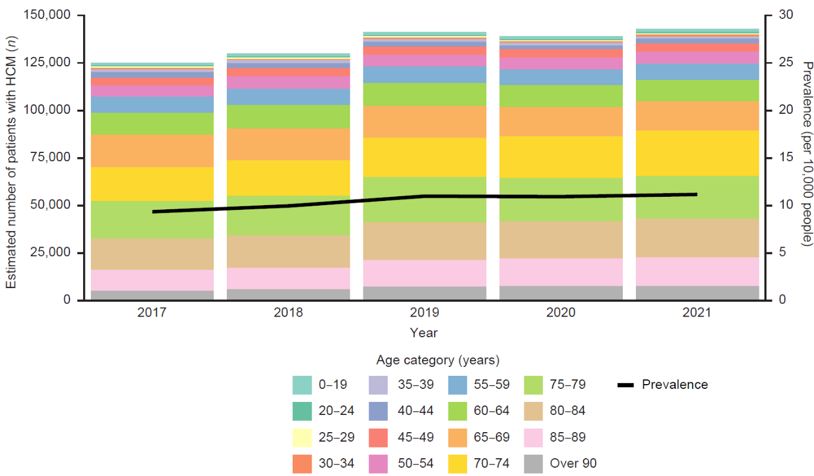
Fig. S1 Estimated prevalence of HCM from 2017 to 2021. HCM hypertrophic cardiomyopathy
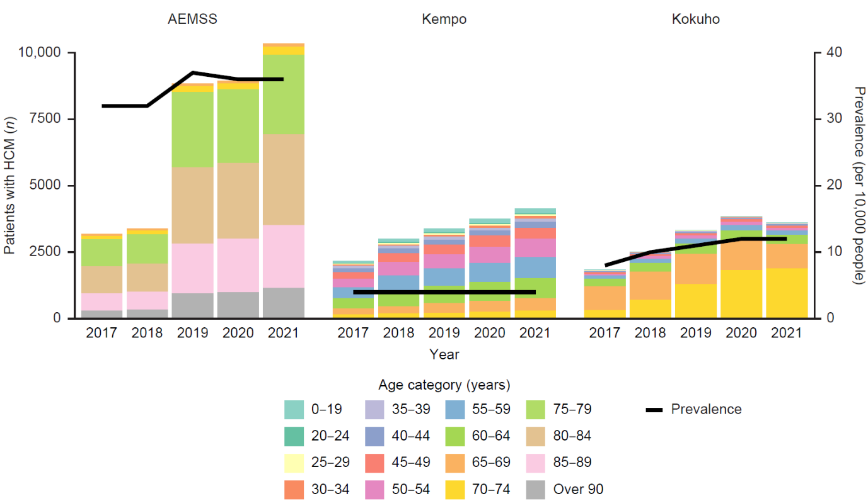
Fig. S2 Prevalence of HCM by insurer from 2017 to 2021. AEMSS Advanced Elderly Medical Service System, HCM hypertrophic cardiomyopathy

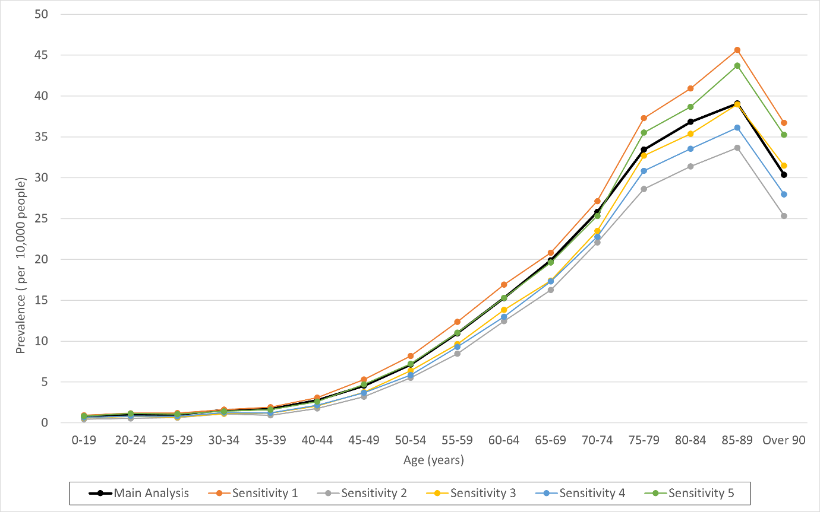
Fig. S3 Sensitivity analysis of the estimated standardized prevalence of HCM in 2021. HCM hypertrophic cardiomyopathy
Main analysis: denominator, persons insured from January 1 to December 31 of the calendar year; observational period, January 1 to December 31, 2021; HCM diagnosis codes: at least one
Sensitivity 1: denominator, persons insured from January 1 to December 31 of the calendar year; observational period, January 1 to December 31, 2021, with a 1-year look-back period; HCM diagnosis codes: at least one
Sensitivity analysis 2: denominator, persons insured from January 1 to December 31 of the calendar year; observational period, January 1 to December 31, 2021; HCM diagnosis codes: at least two
Sensitivity 3: denominator, persons insured from January 1 to December 31 of the calendar year; observational period, January 1 to December 31, 2021, with a 1-year look-back period; HCM diagnosis codes: at least two
Sensitivity 4: denominator, persons insured in June of the calendar year; observational period, January 1 to June 30, 2021; HCM diagnosis codes: at least one
Sensitivity 5: denominator, persons insured in June of the calendar year; observational period, January 1 to June 30, 2021, with a 1-year look-back period; HCM diagnosis codes: at least one

REFERENCES
1. Health Insurance Bureau, Ministry of Health, Labour and Welfare. Basic information on medical insurance. https://www.mhlw.go.jp/stf/seisakunitsuite/bunya/iryouhoken/database/zenpan/kiso.html 2023 (accessed August 2024).
2. Statistics bureau of Japan. Population estimates. https://www.stat.go.jp/data/jinsui/index.htm (accessed August 2024).

