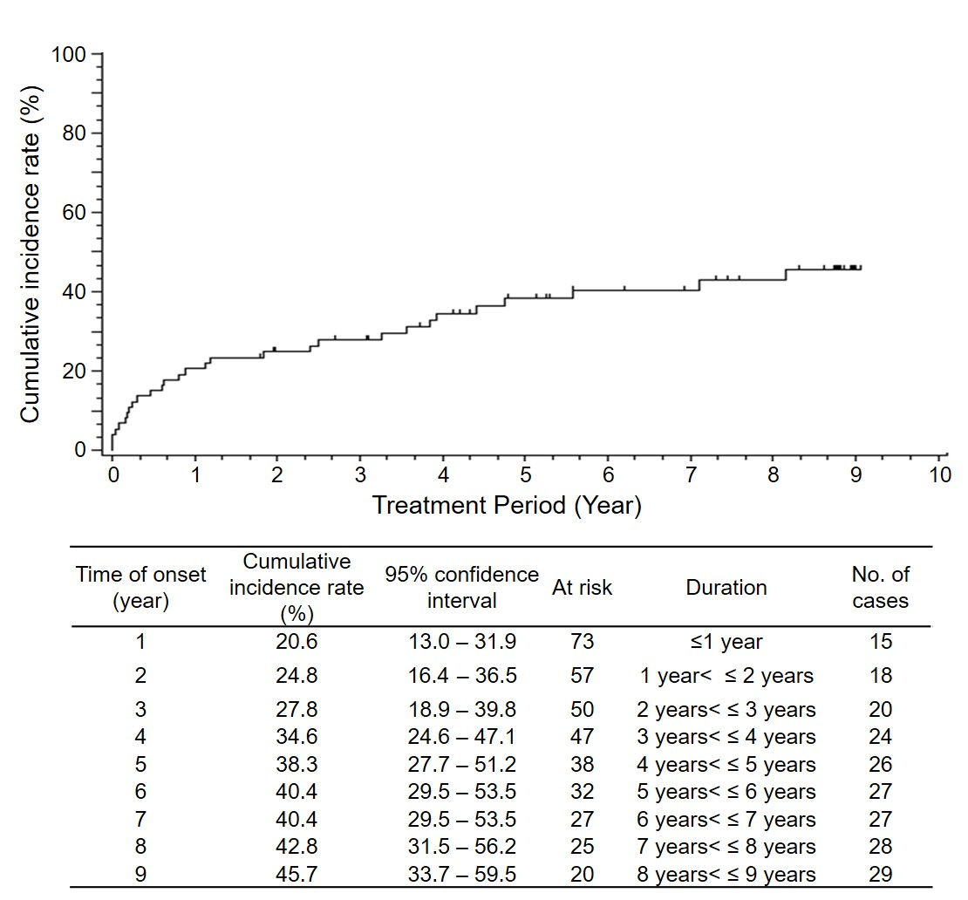

Supplemental Fig. 1. Cumulative curve of the expression rate of drug-related adverse events (related-AEs).
There was a tendency of rapid increment after initiation of ERT (24.8% increase in 0-2 years), followed by slow growing (20.9% increase in 2-9 years).
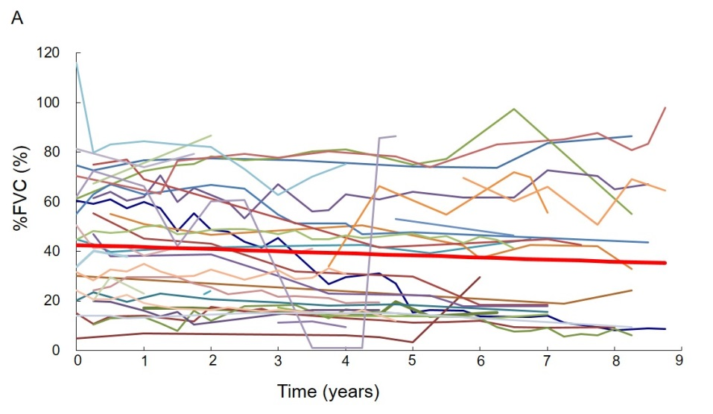
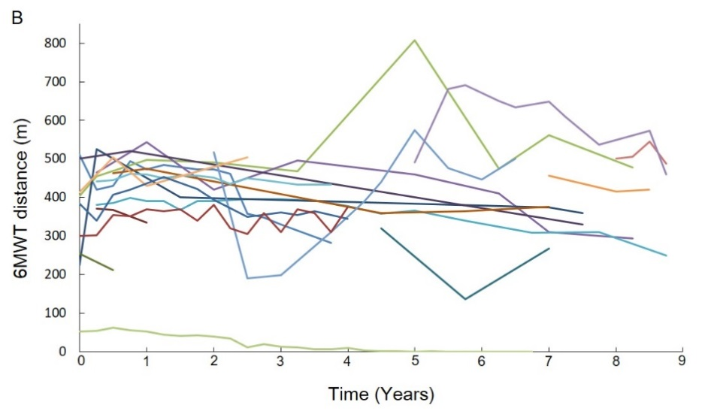
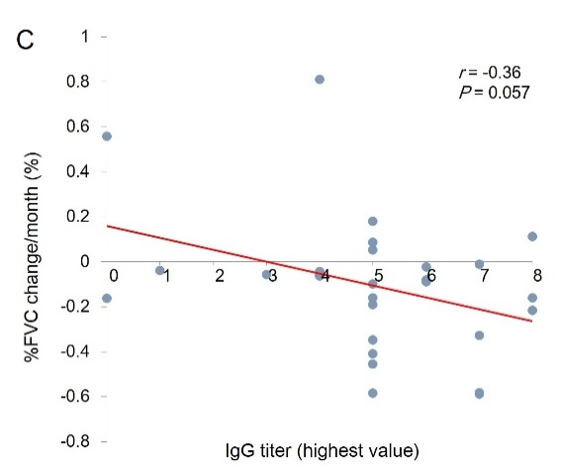

Supplemental Fig. 2. Respiratory and motor function measurements.
A: Individual %FVC transitions of patients whose data was collected for longer than 2 years. Red line represents the regression line from all the data points. In average, % FVC declined with 0.07%/months in this population. B: Individual 6MWT distance transitions of patients whose data was collected for longer than 2 years. Lines in each figures are colored independently. C: Correlation between %FVC change and IgG titer for each patients. The highest value of IgG titers are plotted along horizontal axis as below; 0:negative, 1:100, 2:200, 3:400, 4:800, 5:1600, 6:3200, 7:6400, 8:≥12800. The overall correlation had a negative slope, but did not reach statistical significance.

