Discrete Choice Experiment to Understand Japanese Patients’ and Physicians’ Preferences for Preventive Treatments for Migraine

Jaein Seo^{1,}*, Tommi Tervonen², Kaname Ueda³, Dian Zhang¹, Daisuke Danno⁴, Antje Tockhorn-Heidenreich⁵
¹ Patient-Centered Research, Evidera, Bethesda, MD, USA, jaein.seo@evidera.com
² Patient-Centered Research, Evidera, London, UK (at time of study); Kielo Research, Zug, Switzerland, tommi.tervonen@kieloresearch.com
³ Eli Lilly Japan, Kobe, Hyogo, Japan, ueda_kaname@lilly.com
⁴ Headache Center, Department of Neurology, Tominaga Hospital, daisukedanno@yahoo.co.jp
⁵ Eli Lilly, Indianapolis, IN, USA, tockhorn_antje@lilly.com
*Corresponding author: Jaein Seo, 7101 Wisconsin Ave #1400, Bethesda, MD 20814
Email: Jaein.Seo@evidera.com
Research funding: Eli Lilly and Company

Supplementary materials
Supplementary methods

Supplementary material 1: Random constant logit model
The random constant logit (RCL) model extended the classical multinomial logit model for choice data and took into consideration the heterogeneity of preferences for using self-injectable CGRP mAbs vs. non-CGRP oral medications. It assumed that the patient and physician populations were made up of different groups of people who attached different values (i.e., marginal utilities) to non-CGRP oral medications compared to self-injectable CGRP mAbs. The smaller the utility associated with the non-CGRP oral medication, the more desirable a self-injectable CGRP mAb is. This behavior was represented by a finite mixture of utility values associated with the oral medication [58]. The final model specification was selected by estimating the RCL with varying assumptions about the number of groups in the population and choosing the model with the highest adjusted McFadden R².
The specification of the RCL model was based on a linear and additive indirect utility function:
$$v_{ntj}=β_{1}\left[freq.q3m3inj\right]+$$
$$β_{2}\left[store.7days\right]+β_{3}\left[store.14days\right]+$$
$$β_{4}\left[base.narrow_no_pinch\right]+β_{5}\left[base.wide_no_pinch\right]+$$
$$β_{6}\left[step.twist.button\right]+β_{7}\left[step.press.button\right]+$$
$$β_{8}\left[time.20sec\right]+β_{9}\left[time.10sec\right]+β_{10}\left[time.5sec\right]+$$
$$β_{11}\left[needle.auto\right]+ β_{12}\left[confirm.360view\right]$$
The RCL model allowed for heterogeneity in preferences for the type of treatment (i.e., oral vs autoinjectable). This assumed that respondents could be divided into distinct groups based on their tendency to select oral medication as their preferred treatment option:
- Group 1: Respondents with a strong preference for oral medication (i.e., this option was chosen in most tasks):
$$v_{ntj}^{group1}=α_{1}Oral+v_{ntj}$$
- Group 2: Respondents with a strong preference for an autoinjectable treatment (i.e., the oral medication option was rarely chosen):
$$v_{ntj}^{group2}=α_{2}Oral+v_{ntj}$$
- Group 3: Respondents with a more balanced preference for type of treatment (i.e., the oral medication option was sometimes preferred):
$$v_{ntj}^{group3}=α_{3}Oral+v_{ntj}$$
In the above formulae, α and β are model parameters to be estimated. Each parameter measures the value respondents perceived for changes between levels of one attribute. For example,$β_{1}$ measures the value of changing from the reference level of ‘once a month, one injection’ to ‘once every 3 months, three injections’ for the dosing schedule attribute.
Relative attribute importance
RAI was calculated using the following formula:
$${RAI}_{k}=100×\frac{{\hat{β}}_{k}^{max}-{\hat{β}}_{k}^{min}}{\sum_{k∈[1;K]}{\left({\hat{β}}_{k}^{max}-{\hat{β}}_{k}^{min}\right)}}$$
where (${\hat{β}}_{k}^{max}-{\hat{β}}_{k}^{min}$) is the largest change in utility when moving from the worst (least desirable) to best (most desirable) level of the $k$^{th} attribute. If the worst level was the reference category for the dummy coding of the effects, then ${\hat{β}}_{k}^{min}=0$. The Krinsky-Robb procedure in 10,000 iterations was implemented to compute the 95% confidence intervals (CIs) around the scores [59].
Predicted choice probabilities
Predicted choice probabilities (PCPs) were used to compare the relative desirability of different CGRP mAb autoinjector profiles (galcanezumab, erenumab, fremanezumab). The probability of respondents choosing a CGRP mAb autoinjector was calculated for each of the profiles using the following formula:
$${PCP}_{j}=\frac{exp[v(x_{jnt})]}{\sum_{j∈[1;J]}{exp[v(x_{jnt})]}}$$
where $v(x_{jnt})$ corresponds to the indirect utility of the CGRP mAb autoinjector profiles. The Krinsky-Robb procedure in 10,000 iterations was implemented to compute 95% CIs around the PCPs [59].

Attributes | Levels | Parameters
Alternative-specific constant | Oral medication | Reference
Alternative-specific constant | Autoinjector A | $$α_{1}$$
Alternative-specific constant | Autoinjector B | $$α_{2}$$
Dosing schedule | Once a month, one injection | Reference
Dosing schedule | Once every 3 months, three injections | $$β_{1}$$
Storage requirements | Outside of fridge up to 1 day | Reference
Storage requirements | Outside of fridge up to 7 days | $$β_{2}$$
Storage requirements | Outside of fridge up to 14 days | $$β_{3}$$
Base and pinching | Narrow base, pinching | Reference
Base and pinching | Narrow base, no pinching | $$β_{4}$$
Base and pinching | Wide base, no pinching | $$β_{5}$$
Injection steps | Press down firmly into the skin to inject | Reference
Injection steps | Twist to unlock and press the button to inject | $$β_{6}$$
Injection steps | Press down firmly into the skin to unlock and press the button to inject | $$β_{7}$$
Injection duration | 30 seconds | Reference
Injection duration | 20 seconds | $$β_{8}$$
Injection duration | 10 seconds | $$β_{9}$$
Injection duration | 5 seconds | $$β_{10}$$
Needle removal | Pull-out | Reference
Needle removal | Auto-retract | $$β_{11}$$

The β parameters measured the utility effects of deviating from a reference level within an attribute. The α parameters were alternative-specific constants that captured respondents’ overall tendency to choose an autoinjector over an oral medication (i.e., status quo). To account for heterogeneity in opt-in behaviour, the model allowed for a finite mixture of constants. This mixture assumed that there were groups of respondents with distinct constants reflecting different tendencies to choose the oral medication option. The number of groups was selected based on the lowest Bayesian information criterion.

Supplementary material 2: Video script in English
Section 1: Treatment type
Shot/Image | Text/GFX | Audio - VOICEOVER | Japanese
 | “TREATMENT TYPE” TEXT GRAPHICS animate on screen. | Injectable treatments used for migraine prevention can be delivered using different device types. | 片頭痛の予防治療で使用される注射薬は、異なるタイプの注射器を使って投与します。
- Display the autoinjector device A.  - Zoom in for detail. Show the autoinjector and hand holding the autoinjector (be sure 90 degrees) | Onscreen text: Autoinjector [appears in sync with narration].  GFX: Show a needle automatically inserted to a skin as a button is pressed (animated).  GFX: Illustrate/superimpose 90-degree angle to the body [fade out].  Onscreen text: The needle is not visible before, during, or after the injection. | This is one type of Autoinjector  Once activated, this device automatically injects the needle. | Onscreen text: オートインジェクター
 |  |  | これはオートインジェクターの１種です。この注射器は、準備ができると自動的に針が刺さります。
 |  |  | Onscreen text: 注射の前・最中・後に針を目にすることはありません。
- Display the pre-filled syringe B.  - Zoom in for detail. Show the syringe with 45 to 90-degree angle hold.  - Actress uses thumb to press the plunger down. | Onscreen text: Prefilled syringe [appears in sync with narration].  GFX: Show a needle inserted to a skin (animate close-up to the needle) .  GFX: Illustrate/superimpose 45- to 90-degree angle to the body [fade out].  Onscreen text: The needle is visible. | This is a pre-filled syringe.  You need to manually insert the needle. | Onscreen text: プレフィルドシリンジ（既に薬剤が充填されているている注射器）
 |  |  | これはプレフィルドシリンジです。ご自身で針を刺す必要があります。
 |  |  | Onscreen text: 針が見えます
- Show mouth and hand taking pills with water [fade out]. | Onscreen text: Oral pills [appears in sync with narration]. | These are oral pills.  You take pills into your mouth. | Onscreen text: 内服薬
- Show mouth and hand taking pills with water [fade out]. | Onscreen text: Oral pills [appears in sync with narration]. | These are oral pills.  You take pills into your mouth. | これらは内服薬です。ご自身で錠剤をのみます

Section 2: Dosing schedule
Shot/Image | Text/GFX | Audio - VOICEOVER | Japanese
 | “DOSING SCHEDULE” TEXT GRAPHICS animate on screen. | Preventive migraine treatment requires you to take medicine regularly, as prescribed. | 片頭痛予防治療では、処方された通り定期的に薬を飲む必要があります。
 | GFX/animation:  - Show a calendar marked once daily in the morning (note that this is to show they have to take pills at the same time) with oral pill [focus on the calendar not the pill].  - Show a calendar marked once a month with autoinjector C [focus on the calendar not the device].  - Show a calendar marked 3 injections, once every 3 months with autoinjector D [focus on the (animated) calendar not the device]    Onscreen text: A dosing schedule refers to how often your doctor prescribes you to use a preventive treatment for migraine. | Oral medications should be taken every day. Injectable treatments can involve one injection, once a month or three injections in one sitting, once every three months. | 内服薬は毎日服用しないといけないですが、注射薬は1カ月ごとに1回注射、もしくは一度に3回注射することで3か月に1回の投与のものがあります。
Onscreen text:
投薬スケジュールは、片頭痛予防薬をどのくらいの頻度で投与するか、かかりつけの医師が処方することを指します。

Section 3: Storage requirements
Shot/Image | Text/GFX | Audio - VOICEOVER | Japanese
 | STORAGE REQUIREMENT” TEXT GRAPHICS animate on screen
- Display pills in a cupboard and injection in the fridge.  - Show actor removing device from fridge and placing on countertop (outside of sunlight).  - Long shot of the fridge for GFX described.  - Show use of sharps container. | GFX: Show a device is discarded if it’s left 1 day/7 days/14 days (all of them each) outside of fridge.    Onscreen text: If injectable medications are kept outside of the fridge at room temperature longer than the permitted amounts of time, they need to be discarded. | Injectable medications must be kept in the fridge. Once removed from the fridge, these medications can be kept outside of the fridge, at room temperature, for specific amounts of time:  - Up to 1 day (or 24 hours)  - Up to 7 days, or  - Up to 14 days | 注射薬は冷蔵庫で保存しなければいけません。冷蔵庫から出したら、特定時間内室温で保管できるものもあります。  - 1日 （または２４時間）  - 7日
 |  |  | Onscreen text: 冷蔵庫から出したら一定時間以上室温で保管することはできないので、それ以上時間がたったら捨てないといけないものもあります。

Section 4: Base and pinching
Shot/Image | Text/GFX | Audio - VOICEOVER | Japanese
 | “BASE AND PINCHING” TEXT GRAPHICS animate on screen.
- Shot of wide and narrow bases being compared. | GFX/fixed image: Illustrate both wide base and narrow base.  Onscreen text: The size and shape of the base varies by injectable treatment types. The needle size is identical across all these autoinjectors, regardless of base shape. | The base refers to the bottom compartment of an autoinjector, which you place against your skin. | 接触面というのはオートインジェクターの先端にあたる部分で、ここを注射する部位に当てます。
  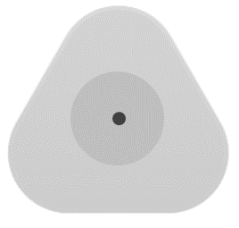  大きな接触面 |   小さな接触面
- Shot of wide and narrow bases being compared. |  |  | Onscreen text: 注射器の種類によって接触面の大きさと形は異なります。針のサイズは、接触面の形状に関係なく、３つすべてのオートインジェクターで同じです。
- Display autoinjector C base from a bottom-up view (triangular).  - Display the device lying on side on a table, not rolling.  - Actress puts it on her skin to indicate that it’s stably placed on her skin even when moving around (no pinching is required). |  | A wide base auto-injector prevents it from rolling off the table, provides stability, and eliminates pinching while injecting. | 接触面が大きいオートインジェクターはテーブルの上に置いても転がり落ちることはなく、安定感があり、注射するときに皮膚をつまむ必要がありません。
- Place autoinjector A and D on the table and show rolling a little bit.  - Display their base from bottom up  (Note: From this angle the “Narrow Base” will look like a hollow circle or ‘ring’, not the filled-in grey circle graphic shown above). |  | A narrow base contacts your skin less and is more compact. | 接触面が狭いと肌への接触が少なく、コンパクトになります。
 | GFX: Illustrate a needle inserted at a 90 degree angle into the fatty layer through the skin (animated needle).  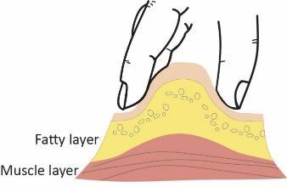 | Self-injectable treatments should be injected under the skin, but above the muscle, into the fatty layer. | 注射薬は皮膚と筋肉の間の脂肪層に注射しないといけません。
- Show actress placing device on her stomach and thigh area, separately. | Onscreen text: You can choose to inject into your stomach or thigh. |  | Onscreen text: お腹や太ももへの注入を選択することができます。
- Display actor pinching skin and placing autoinjector onto pinched chunk of skin. |  | Some injectable treatments require pinching of the skin, | 注射しやすくするために皮膚をつまむ必要のある注射器もありますが、
- Display actor placing autoinjector on skin, without any pinching using autoinjector C. |  | while others do not require pinching. | 皮膚をつまむ必要のないものもあります。

Section 5: Injection steps
Shot/Image | Text/GFX | Audio - VOICEOVER | Japanese
 | “INJECTION STEPS” TEXT GRAPHICS animate on screen. | Autoinjectors require different steps to administer the injection. | 注射薬は注射器によって投与の手順が異なります。
- On a three-way split screen, a close-up of the actor’s hand shows her holding the auto-injectors vertically so we see the caps visible. She then removes the caps from each one. |  | All autoinjectors have a cap that you remove first. | まずキャップを外します。
- Simulate autoinjector D [grab the device the way it is shown].  - Press down firmly into the skin to inject (“Click” sound) - ensure skin is shown to be depressed as some pressure is needed to unlock the device. | 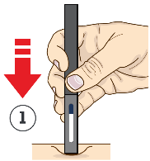  Onscreen text: Press down firmly into the skin to inject. | Autoinjectors that do not need unlocking can be pressed down firmly into your skin to start the injection, without having to press a button. | ロックを解除する必要のないオートインジェクターは、ボタンを押さなくても注射する部分に強く押し当てるだけで注射できます。
 |  |  | Onscreen text: 注射する部位に強く押し当てる
- Simulate autoinjector C [only show top end of device: lock/unlock. Do not show the bottom base]. [Hold the device the way it is shown]. | GFX: Animate the button being pressed (“Click” sound), only touch lightly the skin no need to press the device firmly onto the skin.  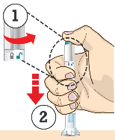  Onscreen text: Twist to unlock and press the button to inject | Some autoinjectors need unlocking by twisting before injecting. Once unlocked, you press a button to start the injection. | このオートインジェクターは針を刺す前にひねってロックを解除しないといけません。ロックを解除しボタンを押すと注射できます。
 |  |  | Onscreen text: ひねってロックを解除してからボタンを押す
- Simulate autoinjector A [note the device needs to be pushed into the skin to stabilize it]. [Grab the device the way it is shown].  - Actress presses the device down  - “firmly” into the skin to unlock and press the button to inject (“Click” sound). | GFX: Show some skin depression, but less than autoinjector D. Note the needle shield needs to push back into the device (animated) to unlock the device.  Onscreen text: Press down firmly into the skin to unlock, then press the button to inject  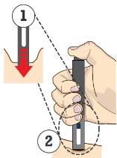 | Some autoinjectors need unlocking by pressing down firmly into the skin before injecting. Once unlocked, you press a button to start the injection. | このオートインジェクターは針を刺す前に、注射する部分に強く押し当ててロックを解除しないといけません。ロックを解除しボタンを押すと注射できます。
 |  |  | Onscreen text: 注射する部位に強く押し当ててロックを解除してからボタンを押す

Section 6: Injection duration
Shot/Image | Text/GFX | Audio - VOICEOVER | Japanese
- Show actress seeing the auto-injector as she is looking at her wristwatch.  - Show actress injecting. | “INJECTION DURATION” TEXT GRAPHICS animate on screen. | The injection duration is the time it takes to inject the medicine -- from the time the needle is inserted under the skin to the time the full dose is completely administered. | 注入時間とは、皮膚に針を挿入してから、薬を全て注入し終えるまでの時間のことです。
- Over the shoulder shot tight on the actor’s wrist as we see her watch’s second hand moving. | GFX: show the range of 5 to 30 seconds.  Onscreen text: Injection duration is the time it takes to inject the medicine -- from the time the needle is inserted under the skin to the time the full dose is completely administered. | The injection duration varies by injectable treatments, from 5 to 30 seconds. | 注入時間は注射薬によって異なります。5秒から30秒の幅があります。
 |  |  | Onscreen text: 注入時間とは、皮膚に針を挿入してから、薬を全て注入し終えるまでの時間のことです。

Section 7: Needle removal
Shot/Image | Text/GFX | Audio - VOICEOVER | Japanese
 | “NEEDLE REMOVAL” TEXT GRAPHICS animate on screen.
- Show that actress’ thumb is away from the button, to show that she does not need to press a button to activate needle retraction and then (use GFX to remove the side of the device from the image, so that we can see inside the device. Show the needle going into the skin and then auto retracting with the device still against the persons skin- then zoom back out to the exterior of the device so it is clear you cannot actually see this process in real life and the needle is covered [close-up the bottom of autoinjector C without showing the triangular base].  - Show actress removing/sliding device from skin at any angle (not at a 90-degree angle) | GFX: Initially show the animated device from the exterior.  GFX to remove the side of the device from the image, so that we can see inside the device. Show the needle going into the skin and then auto retracting with the device still against the persons skin- then zoom back out to the exterior of the device so it is clear you cannot actually see this process in real life and the needle is covered. | Some autoinjectors have needles that auto-retract, which means the device pulls the needle out by itself, once the dose is complete. | オートインジェクターの中には、注入が終わると針が自動的に注射筒内に収まるものがあります。
- Again initially show the animated device from the exterior, but remove the side and zoom in so we can see inside the device. Show the needle going into the skin. But then animate pulling the needle out of their skin - it does not auto retract, the device will need to be pulled away from the skin with the needle remaining in the same position as during the injection. The needle guard should be pushed back as they initiate the injection and should return to cover the needle as the needle is being pulled out (animate to show a 90-degree angle) and away from their skin. Only move back to an exterior view once the needle has been pulled out of the skin, to show that the needle would be covered in reality, but that there is no auto retraction.  - Show actress removing  - The needle at the same angle it was injected (straight up at a 90-degree angle). | GFX: Again initially show the animated device from the exterior, but remove the side and zoom in so we can see inside the device. Show the needle going into the skin. But then animate pulling the needle out of their skin - it does not auto retract, the device will need to be pulled away from the skin with the needle remaining in the same position as during the injection. The needle guard should be pushed back as they initiate the injection and should return to cover the needle as the needle is being pulled out (animate to show a 90-degree angle) and away from their skin. Only move back to an exterior view once the needle has been pulled out of the skin, to show that the needle would be covered in reality, but that there is no auto retraction.  Onscreen text: The needle does not auto-retract. | Some autoinjectors have a needle guard that covers the needle, and you need to pull the needle straight out from your skin yourself, once the dose is complete. | それとは反対に、自動的に針が注射筒内に収まらないのでご自身で引き抜かなければならないものもあります。
 |  |  | Onscreen text: 針が自動的に注射筒内に収まる機能はありません。

Section 8: Dose confirmation
Shot/Image | Text /GFX | Audio - VOICEOVER | Japanese
 | “DOSE CONFIRMATION” TEXT GRAPHICS animate on screen.
 | GFX: Display the animated autoinjector A's dose confirmation window changing color to grey. 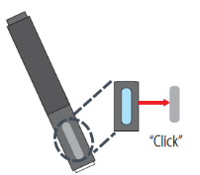 | Some auto-injectors have a thin window, which changes color when the dose is complete. | オートインジェクターの中には、注入が終わると色が変わる表示窓が付いているものがあります。
- Have the window face the patient, but have the camera angle come from above (patient’s perspectives) so that the camera also sees it.  - Record “Click” sound for dose confirmation.  - Display actor continuing to hold device in place for 10 seconds (animate the time) after the confirmation click (show time lapse without specifying time by showing animated time lapse upper right corner).  - Actress looks at her wrist watch. | GFX: animate the time; show time lapse without specifying time by showing animated time lapse upper right corner.  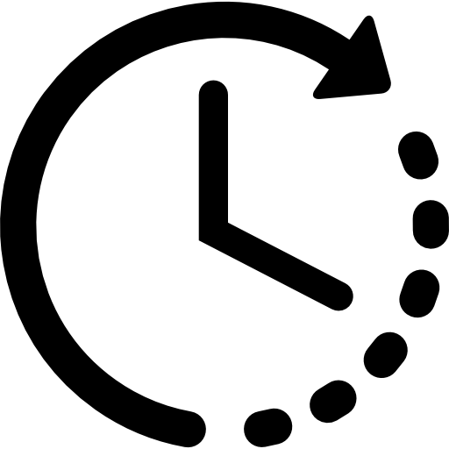 | You must ensure the window is at an angle you can see while injecting.  Some autoinjectors “click” before dose completion, so you have to continue to hold the needle in skin after this “click”. | 色の変化を確認するために、注入する間は窓が見える角度にしてオートインジェクターを持つ必要があります。  注入が終わると「カチッ」と音がするものもあります。このタイプのオートインジェクターの中には注射が終わる前に「カチッ」と音がするので、その音がしてもしばらくボタンを押したままにしないといけないものもあります。
- Film from above (patient perspective) to show the patient holding the device against their skin, with the dose confirmation window (360 degree) visible to the patient and camera during the injection.  - Record “Click” sound for dose confirmation.  - Still from above, display actor removing the device immediately after the confirmation click (focus should be on the 360-degree window of the device). | GFX: Display the animated autoinjector C’s clear 360-degree view of dose completion- show the device turning to show that you can see from all angles with an arrow around it (do not show the triangular base per the image)  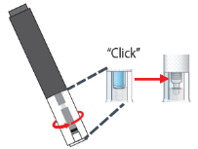 | Other auto injectors are clear, with a 360-degree view from any angle.  They “click” after dose completion, so you can be certain the dose is complete when it “clicks.” | 一方、本体の一部を透明にして360度どの角度から見ても注入が終了したことがわかるものもあります。  注射が終わると「カチッ」と音がして、これが投与完了の合図になるものもあります。

Section 9: Side effects
Shot/Image | Text/GFX | Audio – VOICEOVER | Japanese
 | “Side Effects” TEXT GRAPHICS animate on screen.
- Actress with an autoinjector in hand looks confused, rubs her forehead, put her autoinjector down on the counter and scratch the injection site which looks swollen and red. | Onscreen text: Injectable treatment and oral medication both come with risks but have different side effects. | You may experience injection site reactions such as pain, rash and swelling that occurs at the site of an injection with injectable treatments.  Highlight “may”, “injectable” | 注射した部分に痛みや発疹がでたりその部分が腫れたりする可能性があります。
 |  |  | Onscreen text: 注射薬にも内服薬にも副作用が生じるおそれはありますが、起きる副作用は異なります。
- Actress with an oral medication bottle in hand looks confused, rubs her forehead, puts the bottle down on the counter and gingerly touches her stomach. She walks to another part of the kitchen and steps on a scale. We see her face worried about her weight change. | Onscreen text: Injectable treatment and oral medication both come with risks but have different side effects. | You may experience side effects including thinking and memory problems, stomach discomfort, and weight change with oral medications.  Highlight “may”, “oral” | 内服薬の場合は、気持ちの変化や記憶力の低下、胃の不快感、体重の変化といった副作用が起きる可能性があります。
 |  |  | Onscreen text: 注射薬にも内服薬にも副作用が生じるおそれはありますが、起きる副作用は異なります。

Section 10: Choice questions – all animated
Shot/Image | Text/GFX | Audio - VOICEOVER | Japanese
 | 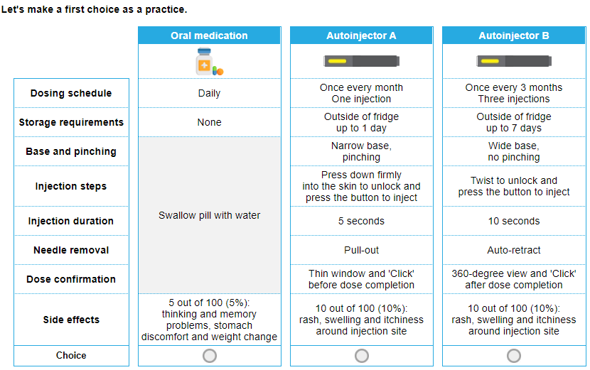  Highlight “three treatment options”  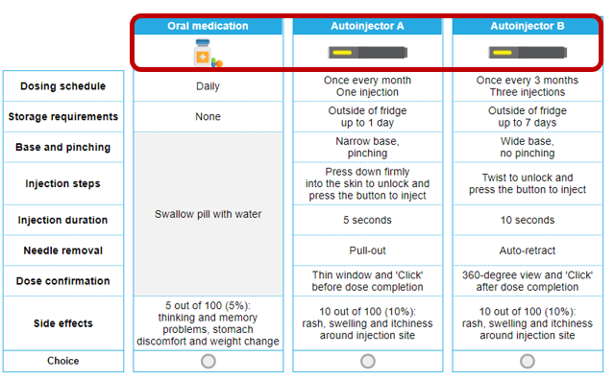 | In section 2, you will be shown three preventive treatment options and asked to select the one you prefer. | セクション2では3種類の片頭痛予防薬をご覧いただいて、より好ましいものを1つだけ選んでいただきます。
 | 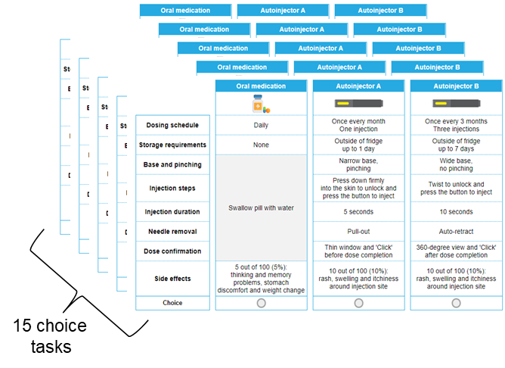  Animate to show repeated choice tasks behind each other like above. | You will make 15 choices repeatedly. While the 15 choice questions may look similar, they are in fact different. | 質問を繰り返して15回回答していただきます。15の設問もよく似ていますが、それぞれ異なる点があります。
 | Highlight the attributes to encourage people to consider all these aspects  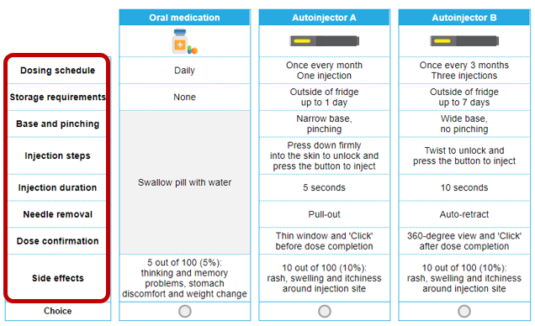 | When you choose your preferred treatment option, it is important to consider all of these aspects and weigh the pros and cons. | 予防薬を選ぶときには、必ずあらゆる側面を考慮して、利点と欠点のどちらに重きを置くのかも考えてくださいますようお願いします。
 |  | You will now start the online survey. | これから、オンラインアンケートを開始します。

Supplemental figures
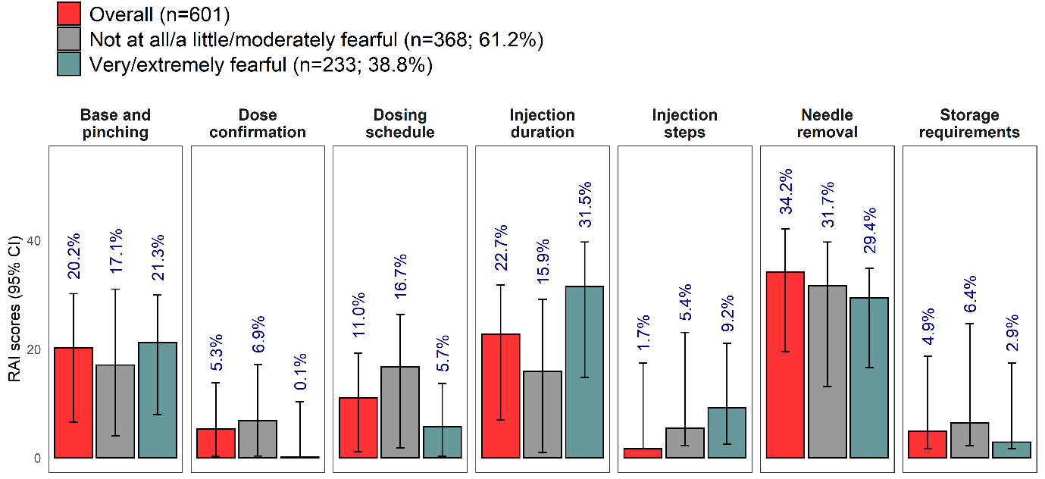
Figure S1. Relative attribute importance (95% CI) in patients according to fear of needles. CI, confidence interval; RAI, relative attribute importance.

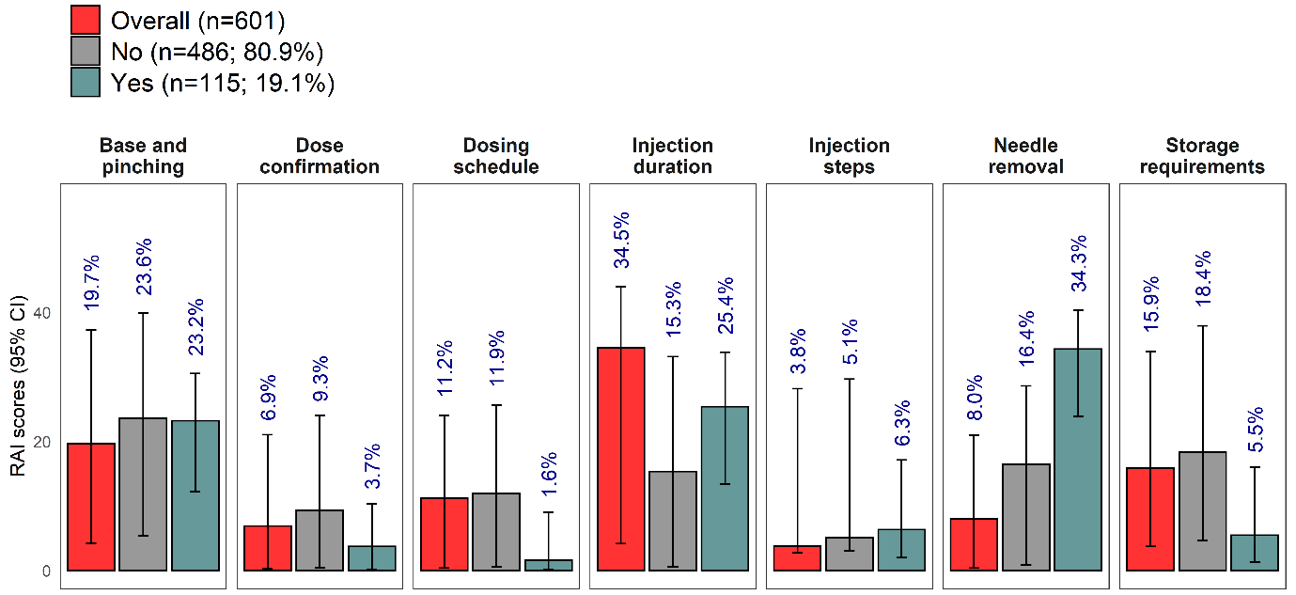 Figure S2. Relative attribute importance (95% CI) in patients according to prior experience with self-injectables. CI, confidence interval; RAI, relative attribute importance.

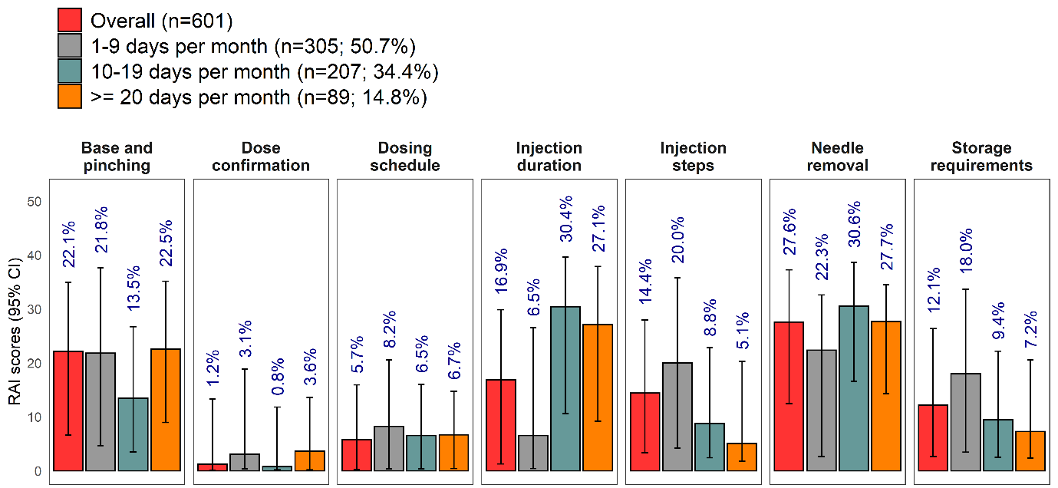 Figure S3. Relative attribute importance (95% CI) in patients according to number of migraine headache days per month. CI, confidence interval; RAI, relative attribute importance.
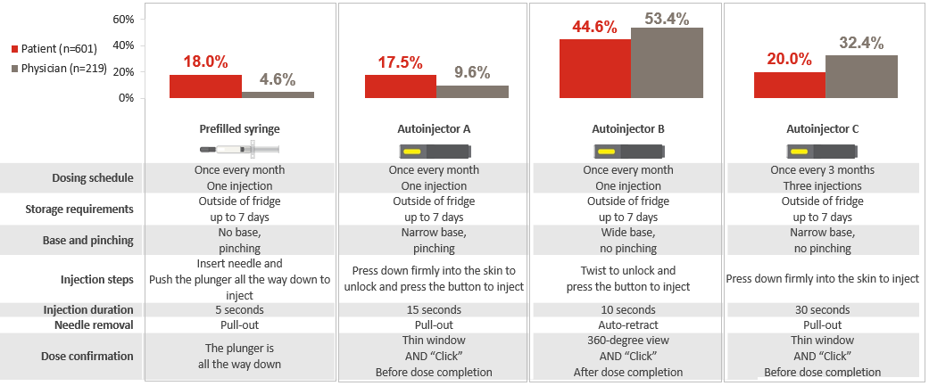
Figure S4. Direct elicitation question. Percentages shown are for patient and physician preferences for each option. Autoinjector A has a profile comparable to that of the erenumab autoinjector. Autoinjector B has a profile comparable to that of the galcanezumab autoinjector. Autoinjector C has a profile comparable to that of the fremanezumab autoinjector. The prefilled syringe has a profile comparable to the erenumab prefilled syringe.

Supplemental tables
Table S1. Survey structure
Survey Structure
Screening | A screening questionnaire was used to determine the eligibility of potential participants by collecting information about their country of residence, literacy in Japanese, age, self-reported diagnosis of migraine, average number of headache days experienced per month over the past 3 months, number of months experiencing headache days, and treatment history for migraine prevention in the past 5 years. The Migraine Symptom Severity Score (MSSS) was also administered as part of the screening questionnaire [40].
Consent | Following confirmation of study eligibility, eligible participants were asked to review study information before starting the survey. After reading a brief statement regarding the objectives and voluntary nature of the survey, confidentiality, and whom to contact in case of questions, participants were asked to provide online consent to participate by selecting “I consent” on the screen. Participants were able to save a copy of the consent page as a pdf for their records.
Introduction | An introductory page informed participants of the study objectives and survey structure and provided a definition of preventive treatments.
Section 1:  Attribute description | A 4-minute video was used to familiarize participants with the attributes and levels that were included in the DCE (see video script in Supplementary Materials). It described the attributes and levels using four different autoinjectors (Table 1) and instructed participants on how to complete the choice tasks. The video consisted of animated and filmed sequences with a professional actress and voiceover artists simulating storage and administration of migraine treatment options in Japanese. It was not possible to skip the video.
Section 2:  Choice tasks | A total of 15 choice tasks were presented (Figure 1): a practice choice task, 12 experimental choice tasks, a repeat of the practice choice task, and a direct elicitation question. Each choice task asked participants to select a preferred treatment among three hypothetical preventive treatment options for migraine: two hypothetical self-injectable CGRP mAbs autoinjectors and a non-CGRP oral medication as an opt-out alternative. For all choices where participants selected the non-CGRP oral medication, a follow-up question forced a choice between the two autoinjector options. The direct elicitation question asked participants to choose between four treatment options: a prefilled syringe and three different autoinjectors.
Section 3:  Participant information | For patients, clinical questions collected information about time since first migraine experience, time since diagnosis, overall health, experience with self-injectable for any health condition, fear of injection, and headache-related disability (MIDAS) [38]. Sociodemographic questions collected information about sex at birth, education level, employment status, and health insurance. Lastly, a series of questions were asked about numeracy and health literacy and numeracy [34-37].  Physicians were asked about their type of work facility, their medical specialty, years in practice, number of migraine patients treated in the previous 3 months, types of treatments prescribed for migraine in the previous 3 months, and satisfaction with currently available preventive treatments for migraine.
CGRP, calcitonin gene-related peptide; DCE, discrete choice experiment; mAb, monoclonal antibody; MIDAS, Migraine Disability Assessment
Table S2. Choice data validity assessments
 | Total (N=820) | Patients (N=601) | Physicians (N=219) | p-valueª
Stability test, n (%) |  |  |  | 0.66
Inconsistent answers | 217 (26.5) | 162 (27.0) | 55 (25.1)
Consistent answers | 603 (73.5) | 439 (73.0) | 164 (74.9)
Dominant attribute preferences, n (%) |  |  |  | <0.001
Storage requirements | 59 (7.2) | 34 (5.7) | 25 (11.4)
Base and pinching | 75 (9.1) | 58 (9.7) | 17 (7.8)
Injection duration | 85 (10.4) | 57 (9.5) | 28 (12.8)
Needle removal | 142 (17.3) | 106 (17.6) | 36 (16.4)
Dose confirmation | 39 (4.8) | 21 (3.5) | 18 (8.2)
None | 420 (51.2) | 325 (54.1) | 95 (43.4)
Serial non-participation, n (%) |  |  |  | <0.001
Always choosing oral medication | 150 (18.3) | 139 (23.1) | 11 (5.0)
None | 234 (28.5) | 198 (32.9) | 36 (16.4)
Never choosing oral medication | 436 (53.2) | 264 (43.9) | 172 (78.5)
Time to complete the DCE survey (min), n (%) |  |  |  | 0.041
<5.00 | 639 (77.9) | 474 (78.9) | 165 (75.3)
5.00– 9.59 | 134 (16.3) | 100 (16.6) | 34 (15.5)
≥10.00 | 47 (5.7) | 27 (4.5) | 20 (9.1)
ª Chi-square test
Table S3. RCL model estimates of patient preferences
 | Patients (N=601)
 | Marginal utility (SE) |  | 95% CI
1. Preferences
Oral medications
Average | -0.193 (0.190) | -0.565; 0.179
Group 1 (autoinjector supporters) (50.5%) | -3.327 (0.233)*** | -3.784; -2.871
Group 2 (autoinjector skeptics) (20.2%) | 0.462 (0.096)*** |  | 0.274; 0.649
Group 3 (autoinjector opponents) (29.3%) | 4.765 (0.181)*** |  | 4.411; 5.119
Dosing schedule
Once a month, one injection | Reference
Once every 3 months, three injections | 0.005 (0.030) |  | -0.055; 0.064
Storage requirements
Outside the fridge for up to 1 day | Reference
Outside the fridge for up to 7 days | 0.013 (0.042) |  | -0.069; 0.095
Outside the fridge for up to 14 days | 0.019 (0.042) |  | -0.062; 0.101
Base and pinching
Narrow base, pinching | Reference
Narrow base, no pinching | 0.112 (0.042)** |  | 0.029; 0.195
Wide base, no pinching | 0.154 (0.042)*** |  | 0.071; 0.237
Injection steps
Press down firmly into the skin to inject | Reference
Twist to unlock and press the button to inject | 0.034 (0.042) |  | -0.049; 0.117
Press down firmly into the skin to unlock and press the button to inject | 0.026 (0.042) |  | -0.056; 0.109
Injection duration
30 seconds | Reference
20 seconds | 0.040 (0.051) |  | -0.060; 0.140
10 seconds | 0.115 (0.051)* |  | 0.015; 0.216
5 seconds | 0.213 (0.051)*** |  | 0.114; 0.312
Needle removal
Pull-out | Reference
Auto-retract | 0.225 (0.030)*** |  | 0.166; 0.283
Dose confirmation
Thin window and “Click” before dose completion | Reference
360-degree view and “Click” after dose completion | -0.014 (0.030) |  | -0.073; 0.045
2. Membership (constant)
Group 1 (autoinjector supporters) | Reference
Group 2 (autoinjector skeptics) | -0.916 (0.122)*** |  | -1.155; -0.677
Group 3 (autoinjector opponents) | -0.546 (0.097)*** |  | -0.736; -0.355
Analysis information: respondents = 601; observations = 7212; parameters = 17; LL = -5142.4; BIC = 10435.8; APR = 34.9%
Significance: *** p-value < 0.1%, ** p-value < 1%, * p-value < 5%
APR, adjusted McFadden pseudo-R²; BIC, Bayesian information criterion; CI, confidence interval; LL, log-likelihood; RCL, random constant logit; SE, standard error

Table S4. RCL model estimates of physician preferences
 | Physicians (N=219)
 | Marginal utility (SE) |  | 95% CI
1. Preferences
Oral medications
Average | -2.308 (0.238)*** | -2.776; -1.841
Group 1 (autoinjector supporters) (87.8%) | -3.020 (0.226)*** | -3.463; -2.576
Group 2 (autoinjector opponents) (12.2%) | 2.816 (0.183)*** |  | 2.457; 3.174
Dosing schedule
Once a month, one injection | Reference
Once every 3 months, three injections | 0.409 (0.043)*** |  | 0.324; 0.494
Storage requirements
Outside the fridge for up to 1 day | Reference
Outside the fridge for up to 7 days | 0.224 (0.060)*** |  | 0.106; 0.341
Outside the fridge for up to 14 days | 0.254 (0.060)*** |  | 0.136; 0.372
Base and pinching
Narrow base, pinching | Reference
Narrow base, no pinching | 0.008 (0.061) |  | -0.112; 0.127
Wide base, no pinching | -0.026 (0.061) |  | -0.146; 0.095
Injection steps
Press down firmly into the skin to inject | Reference
Twist to unlock and press the button to inject | 0.062 (0.061) |  | -0.058; 0.181
Press down firmly into the skin to unlock and press the button to inject | 0.048 (0.061) |  | -0.071; 0.167
Injection duration
30 seconds | Reference
20 seconds | 0.210 (0.075)** |  | 0.063; 0.356
10 seconds | 0.302 (0.075)*** |  | 0.156; 0.449
5 seconds | 0.381 (0.074)*** |  | 0.235; 0.527
Needle removal
Pull-out | Reference
Auto-retract | 0.090 (0.043)* |  | 0.006; 0.174
Dose confirmation
Thin window and “Click” before dose completion | Reference
360-degree view and “Click” after dose completion | -0.023 (0.043) |  | -0.107; 0.061
2. Membership (constant)
Group 1 (autoinjector supporters) | Reference
Group 2 (autoinjector opponents) | -1.974 (0.208)*** |  | -2.383; -1.566
Analysis information: respondents = 219; observations = 2628; parameters = 15; LL = -1937.7; BIC = 3993.6; APR = 32.4%
Significance: *** p-value < 0.1%, ** p-value < 1%, * p-value < 5%
APR, adjusted McFadden pseudo-R²; BIC, Bayesian information criterion; CI, confidence interval; LL, log-likelihood; RCL, random constant logit; SE, standard error

