Epidemiology, Patient Characteristics and Treatment Patterns of Myasthenia Gravis in Taiwan: a Population-based Study

Supplementary materials
Figure S1 Treatment of prevalent MG patients with at least one MG-related prescription from 2013-2019
Figure S2 The distribution of age of onset and gender among incident patients with MG
TABLE S1 ICD codes for comorbidities
TABLE S2 Baseline characteristics of prevalent MG patients from 2013-2019
TABLE S3 Patterns of plasma exchange treatment among prevalent MG patients from 2013-2019

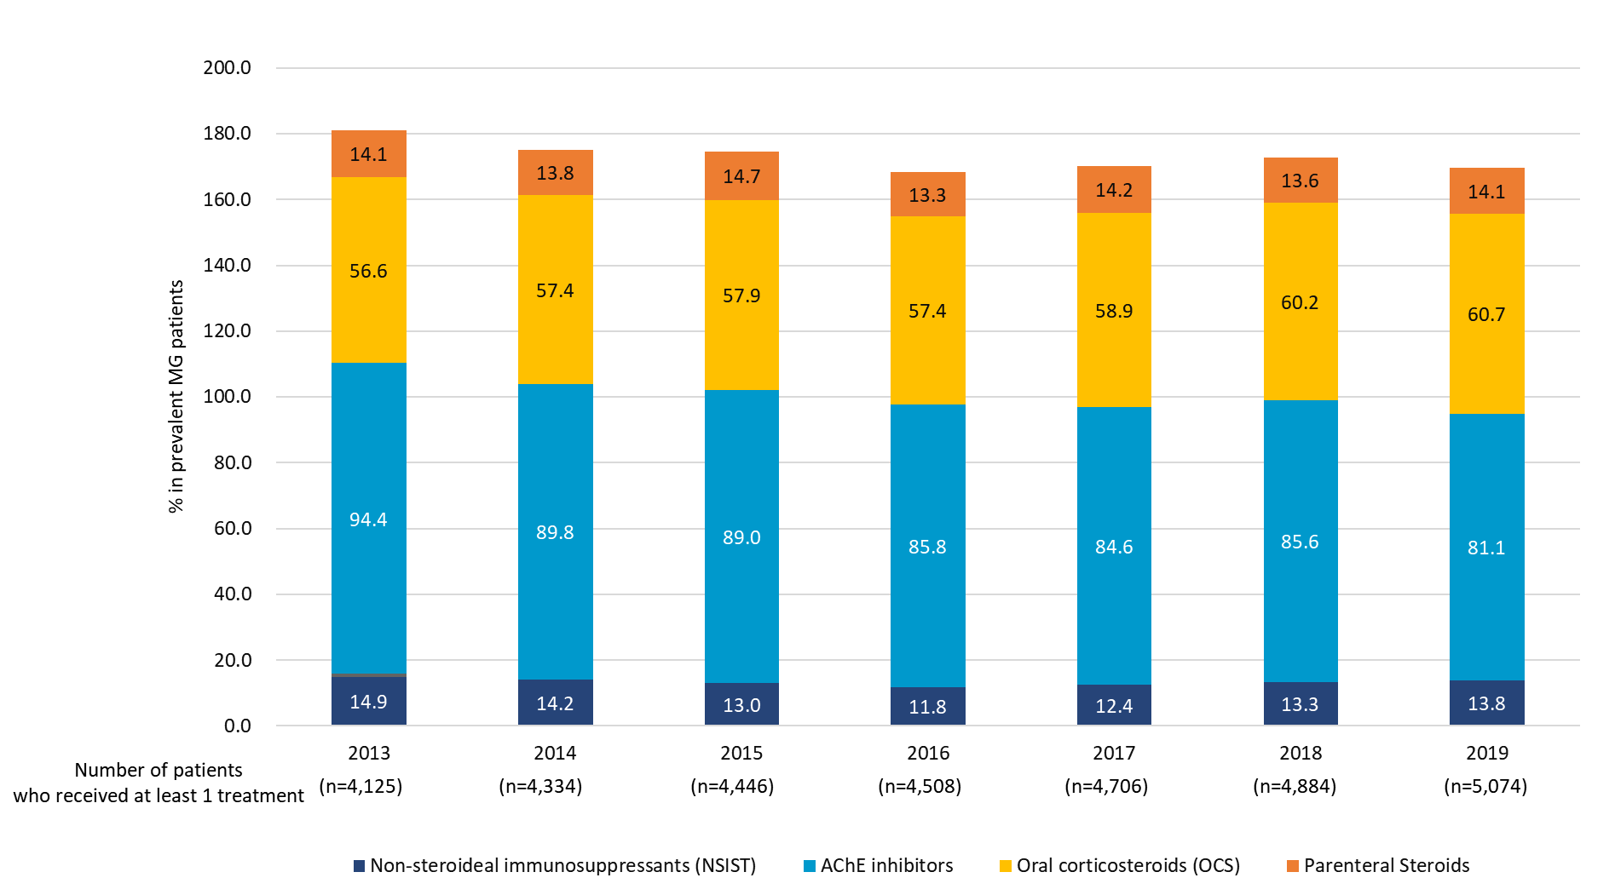

Note: Patients who received neostigmine and pyridostigmine were included in AChE inhibitors group. The total proportion exceeds 100 since patients might receive at least one treatment during the year.
Figure S1 Treatment of prevalent MG patients with at least one MG-related prescription during 2013-2019

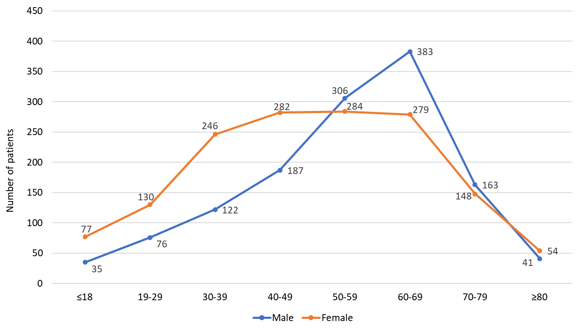

Figure S2 The distribution of age of onset and gender among incident patients with MG

TABLE S1 ICD codes of comorbidities
Category | Diseases | ICD-9-CM | ICD-10-CM
Thyroid disorders | Autoimmune thyroiditis | 245.2 | E06.3, E06.5
Thyroid disorders | Other thyroid disorders | 240.x, 241.x, 242.0x, 242.1x, 242.2x, 242.3x, 242.9x, 244.x | E03.2, E03.8, E03.9, E04.0, E04.1, E04.2, E04.9, E05.0x, E05.1x, E05.2x, E05.9x, E89.0
Autoimmune disorders | Rheumatoid arthritis | 714 | M08.0, M05, M06
Autoimmune disorders | Systemic lupus erythematosus | 710.0 | M32
Autoimmune disorders | Type 1 diabetes | 250.x1 | E10
Autoimmune disorders | Ankylosis spondylitis | 720 | M08.1, M45
Autoimmune disorders | Psoriasis ± psoriatic arthritis | 696.0, 696.1, 696.8 | L40
Autoimmune disorders | Crohn’s disease | 555 | K50
Autoimmune disorders | Ulcerative colitis | 556 | K51
Mental health | Anxiety | 300.0 | F41
Mental health | Depression | 296.2-296.3, 300.4, 311 | F31-F33
Metabolic diseases | Dyslipidemia | 272, 414.0, 414.3, 440 | E78
Metabolic diseases | Obesity | 278 | E66
Metabolic diseases | Osteoporosis | 733.0 | M80, M81
Metabolic diseases | Type 2 diabetes | 250.x0 | E11
Cardiovascular diseases | Hypertension | 401-405 | I10-I15
Cardiovascular diseases | Cardiac arrhythmia | 427 | I47-I49
Thymus disorders | Thymoma | 164.0 | C37
Thymus disorders | Hyperplasia of thymus | 254.0 | E32.0

TABLE S2 Baseline characteristics of prevalent MG patients from 2013-2019
Year | 2013 |  | 2014 |  | 2015 |  | 2016 |  | 2017 |  | 2018 |  | 2019
Total population in Taiwan | 23,373,517 |  | 23,433,753 |  | 23,492,074 |  | 23,539,816 |  | 23,571,227 |  | 23,588,932 |  | 23,603,121
Prevalent MG patients | 4,476 |  | 4,785 |  | 4,983 |  | 5,174 |  | 5,361 |  | 5,499 |  | 5,752
Prevalence rate (per 100,000) | 19 |  | 20 |  | 21 |  | 22 |  | 23 |  | 23 |  | 24
Patient demographics
 | n | % | n | % | n | % | n | % | n | % | n | % | n | %
Sex, male | 1,738 | 38.8 | 1,883 | 39.4 | 1,977 | 39.7 | 2,060 | 39.8 | 2,143 | 40.0 | 2,213 | 40.2 | 2,367 | 41.2
Age group (years)
≤18 | 163 | 3.6 | 177 | 3.7 | 189 | 3.8 | 189 | 3.7 | 182 | 3.4 | 176 | 3.2 | 161 | 2.8
19-29 | 287 | 6.4 | 301 | 6.3 | 311 | 6.2 | 313 | 6.1 | 307 | 5.7 | 294 | 5.4 | 306 | 5.3
30-39 | 693 | 15.5 | 751 | 15.7 | 752 | 15.1 | 743 | 14.4 | 731 | 13.6 | 713 | 13.0 | 711 | 12.4
40-49 | 850 | 19.0 | 893 | 18.7 | 936 | 18.8 | 948 | 18.3 | 975 | 18.2 | 983 | 17.9 | 1,010 | 17.6
50-59 | 970 | 21.7 | 1,036 | 21.7 | 1,057 | 21.2 | 1,112 | 21.5 | 1,149 | 21.4 | 1,179 | 21.4 | 1,244 | 21.6
60-69 | 776 | 17.3 | 855 | 17.9 | 932 | 18.7 | 1,026 | 19.8 | 1,118 | 20.9 | 1,231 | 22.4 | 1,336 | 23.2
70-79 | 526 | 11.8 | 554 | 11.6 | 585 | 11.7 | 610 | 11.8 | 653 | 12.2 | 652 | 11.9 | 706 | 12.3
≥ 80 | 211 | 4.7 | 218 | 4.6 | 211 | 4.4 | 233 | 4.5 | 246 | 4.6 | 271 | 4.9 | 278 | 4.8
MG Myasthenia Gravis

TABLE S3 Patterns of plasma exchange treatment among prevalent MG patients from 2013-2019
Year | 2013 |  | 2014 |  | 2015 |  | 2016 |  | 2017 |  | 2018 |  | 2019
Number of prevalent MG cases | 4,476 |  | 4,785 |  | 4,983 |  | 5,174 |  | 5,361 |  | 5,499 |  | 5,752
Number of MG patients with at least 1 plasma exchange | 172  (3.8%) |  | 167  (3.5%) |  | 176  (3.5%) |  | 179  (3.5%) |  | 180  (3.4%) |  | 181  (3.3%) |  | 184  (3.2%)
Distribution of plasma exchange episodesª annually (per patient)
 | n | % | n | % | n | % | n | % | n | % | n | % | n | %
1 | 144 | 83.7 | 137 | 82.0 | 139 | 79.0 | 142 | 79.3 | 153 | 85.0 | 148 | 81.8 | 159 | 86.4
2 | 22 | 12.8 | 22 | 13.2 | 23 | 13.1 | 27 | 15.1 | 21 | 11.7 | 24 | 13.3 | 19 | 10.3
≥3 | 6 | 3.5 | 8 | 4.8 | 14 | 8.0 | 10 | 5.6 | 6 | 3.4 | 9 | 5.0 | 6 | 3.2
Mean (SD) | 1.20 (0.48) |  | 1.23 (0.55) |  | 1.31 (0.67) |  | 1.27 (0.60) |  | 1.20 (0.54) |  | 1.25 (0.60) |  | 1.17 (0.48)
Median | 1 |  | 1 |  | 1 |  | 1 |  | 1 |  | 1 |  | 1
ªPlasma exchange received within the same hospitalization event was defined as “one episode”
MG Myasthenia Gravis, SD Standard Deviation

