Supplementary Material
Retrospective multicenter chart review study of adjunctive cannabidiol for seizures associated with Lennox-Gastaut syndrome, Dravet syndrome and tuberous sclerosis complex

Adam Strzelczyk¹, Kerstin Alexandra Klotz^{2,3}, Thomas Mayer⁴, Felix von Podewils⁵,
Susanne Knake⁶, Gerhard Kurlemann⁷, Luise Herold⁵, Ilka Immisch⁶, Elisa Buhleier¹,
Felix Rosenow¹, Susanne Schubert-Bast^{1,8}

¹Goethe-University Frankfurt, Epilepsy Center Frankfurt Rhine-Main, Department of Neurology, University Medicine Frankfurt, Frankfurt am Main, Germany
²Department of Pediatric Neurology, University Hospital Bonn, Bonn, Germany
³Department of Neuropediatrics and Muscle Disorders, Center for Pediatrics, Medical Center, University of Freiburg, Faculty of Medicine, University of Freiburg, Freiburg i.Br., Germany ⁴Epilepsy Center Kleinwachau, Radeberg, Germany
⁵Department of Neurology, Epilepsy Center, University Hospital Greifswald, Greifswald, Germany
⁶Epilepsy Center Hessen, Department of Neurology, Philipps-University Marburg, Marburg, Germany
⁷St. Bonifatius Hospital, Lingen, Germany
⁸Goethe-University Frankfurt, University Hospital for Children and Adolescents, Department of Pediatric Epileptology, University Medicine Frankfurt, Frankfurt am Main, Germany

Correspondence to: Prof. Dr. med. Adam Strzelczyk
Epilepsy Center Frankfurt Rhine-Main
Department of Neurology
Goethe-University Frankfurt
Theodor-Stern-Kai 7
60596 Frankfurt am Main
Germany
Phone: +49-69-6301-7466
Fax: +49-69-6301-84466
Email: strzelczyk@med.uni-frankfurt.de

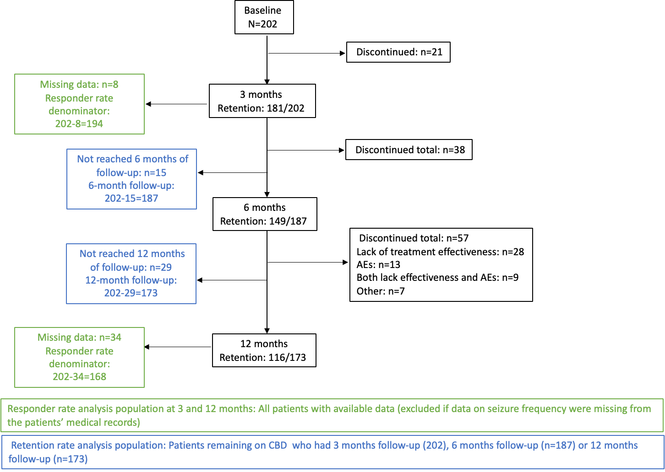

Fig S1: Patient disposition and analysis populations
Abbreviation: AEs, adverse events CBD, cannabidiol.
Table S1. Responder rates over time for total seizures and generalized tonic-clonic seizure at 3 and 12 months.

 | 3 months |  |  |  |  |  |  |  | 12 months
 | Overall  N=202 |  | <6 years  N=29 |  | 6–17 years  N=71 |  | ≥18 years  N=102 |  | Overall  N=202 |  | <6 years  N=29 |  | 6–17 years  N=71 |  | ≥18 years  N=102
Seizures | N | Cumulative  (≥ reduction)  N (%) | N | Cumulative  (≥ reduction)  N (%) | N | Cumulative  (≥ reduction)  N (%) | N | Cumulative  (≥ reduction)  N (%) | N | Cumulative  (≥ reduction)  N (%) | N | Cumulative  (≥ reduction)  N (%) | N | Cumulative  (≥ reduction)  N (%) | N | Cumulative  (≥ reduction)  N (%)
Total seizures
Seizure free | 7 | Seizure free:  7 (3.6) | 1 | Seizure free:  1 (3.7) | 1 | Seizure free:  1 (1.5) | 5 | Seizure free:  5 (5.1) | 7 | Seizure free:  7 (4.2) | 1 | Seizure free: 1 (3.8) | 3 | Seizure free:  3 (4.9) | 3 | Seizure free:  3 (3.7)
75–99% reduction | 19 | ≥75%:  26 (13.4) | 1 | ≥75%:  2 (7.4) | 10 | ≥75%:  11 (16.2) | 8 | ≥75%:  13 (13.1) | 26 | ≥75%:  33 (19.6) | 5 | ≥75%:  6 (23.1) | 12 | ≥75%:  15 (24.6) | 9 | ≥75%:  12 (14.8)
50–<75% reduction | 58 | ≥50%:  84 (43.3) | 8 | ≥50%:  10 (37.0) | 23 | ≥50%:  34 (50.0) | 27 | ≥50%:  40 (40.4) | 41 | ≥50%:  74 (44.0) | 6 | ≥50%:  12 (46.2) | 17 | ≥50%:  32 (52.5) | 18 | ≥50%:  30 (37.0)
25–49% reduction | 47 | ≥25%:  131 (67.5) | 8 | ≥25%:  18 (66.7) | 18 | ≥25%:  52 (76.5) | 21 | ≥25%:  61 (61.6) | 17 | ≥25%:  91 (54.2) | 3 | ≥25%:  15 (57.7) | 8 | ≥25%:  40 (65.6) | 6 | ≥25%:  36 (44.4)
No effect | 51 | 51 (26.3) | 7 | 7 (25.9) | 12 | 12 (17.6) | 32 | 32 (32.3) | 19 | 19 (11.3) | 2 | 2 (7.7) | 3 | 3 (4.9) | 14 | 14 (17.3)
Seizure increase | 12 | 12 (6.2) | 2 | 2 (7.4) | 4 | 4 (5.9) | 6 | 6 (6.1) | 1 | 1 (0.6) | 0 | 0 | 0 | 0 | 1 | 1 (1.2)
Discontinued | 0 | 0 | 0 | 0 | 0 | 0 | 0 | 0 | 57 | 57 (33.9) | 9 | 9 (34.6) | 18 | 18 (29.5) | 30 | 30 (37.0)
Total /denominator | 194 | 194 | 27 | 27 | 68 | 68 | 99 | 99 | 168 | 168 | 26 | 26 | 61 | 61 | 81 | 81
Not availableª | 8 | 8 | 2 | 2 | 3 | 3 | 3 | 3 | 34 | 34 | 3 | 3 | 10 | 10 | 21 | 21
GTCS
Seizure free | 11 | Seizure free: 11 (11.7) | 0 | Seizure free: 0 | 1 | Seizure free:  1 (2.8) | 10 | Seizure free:  10 (21.7) | 11 | Seizure free:  11 (12.5) | 1 | Seizure free:  1 (8.3) | 3 | Seizure free:  3 (9.7) | 7 | Seizure free:  7 (15.6)
75–99% reduction | 9 | ≥75%:  20 (21.3) | 3 | ≥75%:  3 (25.0) | 4 | ≥75%:  5 (13.9) | 2 | ≥75%:  12 (26.1) | 9 | ≥75%:  20 (22.7) | 2 | ≥75%:  3 (25.0) | 6 | ≥75%:  9 (29.0) | 1 | ≥75%:  8 (17.8)
50–<75% reduction | 31 | ≥50%:  51 (54.3) | 5 | ≥50%:  8 (66.7) | 15 | ≥50%:  20 (55.6) | 11 | ≥50%:  23 (50.0) | 22 | ≥50%:  42 (47.7) | 5 | ≥50%:  8 (66.7) | 8 | ≥50%:  17 (54.8) | 9 | ≥50%:  17 (37.8)
25–49% reduction | 18 | ≥25%:  69 (73.4) | 2 | ≥25%:  10 (83.3) | 9 | ≥25%:  29 (80.6) | 7 | ≥25%:  30 (65.2) | 7 | ≥25%:  49 (55.7) | 0 | ≥25%:  8 (66.7) | 3 | ≥25%:  20 (64.5) | 4 | ≥25%:  21 (46.7)
No effect | 20 | 20 (21.3) | 1 | 1 (8.3) | 5 | 5 (13.9) | 14 | 14 (30.4) | 8 | 8 (9.1) | 0 | 0 | 1 | 1 (3.2) | 7 | 7 (15.6)
Seizure increase | 5 | 5 (5.3) | 1 | 1 (8.3) | 2 | 2 (5.6) | 2 | 2 (4.3) | 1 | 1 (1.1) | 0 | 0 | 0 | 0 | 1 | 1 (2.2)
Discontinued | 0 | 0 | 0 | 0 | 0 | 0 | 0 | 0 | 30 | 30 (34.1) | 4 | 4 (33.3) | 10 | 10 (32.3) | 16 | 16 (35.6)
Total/denominator | 94 | 94 | 12 | 12 | 36 | 36 | 46 | 46 | 88 | 88 | 12 | 12 | 31 | 31 | 45 | 45
Not available | 30 |  | 1 |  | 9 |  | 20 | - | 44 |  | 2 |  | 15 |  | 27
No GTCS at baseline | 78 |  | 16 |  | 26 |  | 36 |  | 70 |  | 15 |  | 25 |  | 30
ª Not available: at 3 months= data on seizure frequency was missing (i.e. was not documented in the patients’ medical records); at 12 months= patients who did not have
12 months of follow-up from the time of starting CBD treatment to the data cut-off and with missing data.
Abbreviations: CBD, cannabidiol; GTCS, generalized tonic-clonic seizure.

Table S2. EMA Summary of Product Characteristics and pivotal clinical trials evidence.

Indication | Recommended dose | Clinical trial | Efficacy evidence | Safety | OLE
LGS | Starting:  5 mg/kg/day  Maintenance:  10 mg/kg/day  Maximum:  20 mg/kg/day | GWPCARE3¹  Mean age ± SD (range):  Placebo: 15.3±9.3 (2.6–43.4)  CBD 10: 15.4±9.5 (2.6–42.6)  CBD 20: 16.0±10.8 (2.6–48.0) | ≥50% reduction in drop seizures:  Placebo ± CLB (n=76/37): 14.5%/21.6%  10 mg/kg/day ± CLB (n=73/37): 35.6%/40.5%  20 mg/kg/day ± CLB (n=76/36): 39.5%/55.6% | AEs:  10 mg/kg/day (n=67): 84%  Somnolence: 21%  Decreased appetite: 16%  Diarrhea: 10%  URTI: 16%  Pyrexia: 9%  Vomiting: 6%  20 mg/kg/day (n=82): 94%  Somnolence: 30%  Decreased appetite: 26%  Diarrhea: 15%  URTI: 13%  Pyrexia: 12%  Vomiting: 12% | GWPCARE5 in LGS patients who completed GWPCARE3 or GWPCARE4 (N=366)²  ≥50% reduction in drop seizures: 49–58% across timepoints to Week 156  Retention: 62% completed the maximum of 1 year treatment  AEs: 96.4%  Convulsion: 38.5%  Diarrhea: 38.3%  Pyrexia: 34.4%  Somnolence: 29.2%  Vomiting: 29.2%
LGS |  | GWPCARE4³  Median age (range): CBD 20: 14.2  (2.7–39.0)  Placebo: 13.3  (2.8–45.1) | Placebo ± CLB (n=85/42): 23.5%/28.6%  20 mg/kg/day ± CLB (n=86/42): 44.2%/54.8% | AEs in 20 mg/kg/day CBD group (n=86): 86%  Diarrhea: 19%  Somnolence: 15%  Pyrexia: 13%  Decreased appetite: 13%  Vomiting: 10%
DS |  | GWPCARE2⁴  Mean age ± SD (range):  Placebo: 9.6±4.6  (2.2–18.1)  CBD 10: 9.2±4.3 (2.3–17.7)  CBD 20: 9.3±4.3 (2.2–18.9) | ≥50% reduction in convulsive seizures:  Placebo ± CLB (n=65/41): 26.2%/36.6%  10 mg/kg/day ± CLB (n=66/45): 43.9%/55.6%  20 mg/kg/day ± CLB (n=67/40): 49.3%/62.5% | AEs  10 mg/kg/day (n=64): 87.5%  Decreased appetite: 17%  Diarrhea: 17%  Somnolence: 25%  Pyrexia: 23%  Fatigue: 8%  Vomiting: 6%  20 mg/kg/day (n=69): 89.9%  Decreased appetite: 29%  Diarrhea: 26%  Somnolence: 23%  Pyrexia: 22%  Fatigue: 22%  Vomiting: 16% | GWPCARE5 in DS patients who completed GWPCARE1 Part A or  Part B, or GWPCARE2: N=315⁵  ≥50% reduction in convulsive seizures: 45–74% across timepoints to Week 156  One-year retention rate: 73%^{7a}  AEs: 97%  Diarrhea: 43%  Pyrexia: 39%  Decreased appetite: 31%  Somnolence: 28%
DS |  | GWPCARE1⁶  Median age (range):  Placebo: 9.2  (2.8–18.4)  CBD 20: 9.1  (2.5–18.0) | Placebo ± CLB (n=59/38): 27.1%/23.7%  20 mg/kg/day ± CLB (n=61/40): 42.6%/47.5% | AEs: 93%  Diarrhea: 31%  Decreased appetite: 28%  Fatigue: 20%  Vomiting: 15%  Pyrexia: 15%  URTI: 11%
TSC | Starting:  5 mg/kg/day  Maintenance:  10 mg/kg/day  Maximum:  25 mg/kg/day | GWPCARE6⁸  Median age (range):  Placebo: 10.9  (1.2–55.8)  CBD 25: 11.6  (1.1–56.8) | ≥50% reduction in  TSC-associated seizures  Placebo (n=76): 22.4%  CBD 25 mg/kg/day (n=75): 36% | CBD 25 mg/kg/day:  AEs: 93%  Diarrhea: 31%  Somnolence: 13%  Decreased appetite: 20%  Pyrexia: 19%  Vomiting: 17%  γ-Glutamyltransferase level increased: 16%  Nasopharyngitis: 15%  Alanine aminotransferase level increased:12%  Aspartate aminotransferase level increased: 11% | OLE of GWPCARE6: N=199⁹  ≥50% reduction in TSC-associated seizures: 53–61% across timepoints to Week 48  One-year retention rate: 79%  AEs: 92%  Diarrhea: 42%  Seizure: 22%  Decreased appetite: 20%  Somnolence: 16%  Pyrexia: 16%  Vomiting: 16%
ª Data from earlier data-cut.
Abbreviations: AE, adverse event; CBD, cannabidiol; CLB, clobazam; DS, Dravet syndrome; OLE, open-label extension; LGS, Lennox-Gastaut syndrome,
SD, standard deviation; TSC, tuberous sclerosis complex; URTI, upper respiratory tract infection.

References

- Devinsky O, Patel AD, Cross JH, et al. Effect of Cannabidiol on Drop Seizures in the Lennox-Gastaut Syndrome. N Engl J Med. 2018;378(20):1888-97.
- Patel AD, Mazurkiewicz-Bełdzińska M, Chin RF, et al. Long-term safety and efficacy of add-on cannabidiol in patients with Lennox-Gastaut syndrome: Results of a long-term open-label extension trial. Epilepsia. 2021;62(9):2228-39.
- Thiele EA, Marsh ED, French JA, et al. Cannabidiol in patients with seizures associated with Lennox-Gastaut syndrome (GWPCARE4): a randomised, double-blind, placebo-controlled phase 3 trial. Lancet. 2018;391(10125):1085-96.
- Miller I, Scheffer IE, Gunning B, et al. Dose-Ranging Effect of Adjunctive Oral Cannabidiol vs Placebo on Convulsive Seizure Frequency in Dravet Syndrome: A Randomized Clinical Trial. JAMA Neurol. 2020;77(5):613-21.
- Scheffer IE, Halford JJ, Miller I, et al. Add-on cannabidiol in patients with Dravet syndrome: Results of a long-term open-label extension trial. Epilepsia. 2021;62(10):2505-17.
- Devinsky O, Cross JH, Laux L, et al. Trial of Cannabidiol for Drug-Resistant Seizures in the Dravet Syndrome. N Engl J Med. 2017;376(21):2011-20.
- Devinsky O, Nabbout R, Miller I, et al. Long-term cannabidiol treatment in patients with Dravet syndrome: An open-label extension trial. Epilepsia. 2019;60:294-302.
- Thiele EA, Bebin EM, Bhathal H, et al. Add-on Cannabidiol Treatment for Drug-Resistant Seizures in Tuberous Sclerosis Complex: A Placebo-Controlled Randomized Clinical Trial. JAMA Neurol. 2021;78(3):285-92.
- Thiele EA, Bebin EM, Filloux F, et al. Long-term cannabidiol treatment for seizures in patients with tuberous sclerosis complex: An open-label extension trial. Epilepsia. 2022;63(2):426-39.

