Table S1. Key Model Assumptions
Assumption
All costs are presented in 2018 Canadian dollars.
Age groups considered in the model were as follows: < 2 years, 2 to 4 years; 5-17 years; 18-34 years; 35-49 years; 50-64 years; 65+ years.
Vaccination costs include the cost of the vaccine and administration. We assume that individuals vaccinated received the full dosing schedule.
Other medical costs include direct medical costs and indirect costs of lost productivity associated with each event experienced.
Events considered included invasive pneumococcal disease (IPD), hospitalized pneumonia, nonhospitalized pneumonia, and acute otitis media (AOM).
Events were estimated based on observed overall incidence rates multiplied by the estimated population size for each age group each year. In the base case, we assume that the IPD data from TIBDN were representative of the Canadian population. We tested this assumption in scenario analysis including data from Quebec.
Given that additional factors might have contributed to the observed decline in all-cause pneumonia, we assumed that only 50% of the observed reductions in incidence were attributable to PCVs.
For AOM, because we do not have data on the proportion of cases that were pneumococcal over time historically, and because there were no other AOM interventions introduced during this period, we assumed that all reductions in incidence of AOM were due to the pneumococcal vaccine program.
For the scenario in which no vaccine was introduced, we assume the maximum observed historical incidence from 2001-2004 for all subsequent years (2005-2015), with no increase or decrease in incidence. We tested this assumption including three scenario analyses: using 2001 observed incidence; using 2004 observed incidence; and using the average incidence from 2001-2004.
Due to limited data, we assumed IPD incidence for 2015 to be equal that of 2014.
For indirect costs, we considered only work days lost for the individual (if working age adult), parent (if a child), or caregiver (if over 65). Travel costs and other indirect costs were conservative not considered.
No costs related to disease sequelae were considered.
AOM = acute otitis media; IPD = invasive pneumococcal disease; TIBDN = Toronto Invasive Bacterial Disease Network.

Figure S1. Incidence of invasive pneumococcal disease in Quebec, 2001-2014
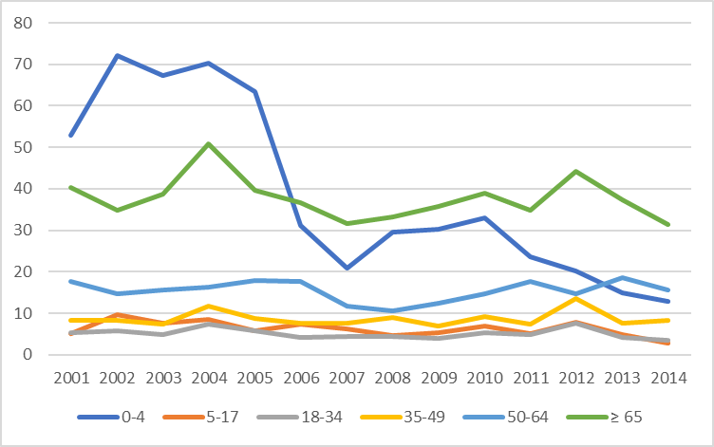
Source: Canadian incidence per 100,000 obtained from Institut National de Sante Publique Quebec (INSPQ). Laboratoire de santé publique du Québec. Rapport annuel 2000 Programme de surveillance du pneumocoque. PCV7 original market in Canada was 20Jun2001. Available at: http://webprod5.hc-sc.gc.ca/dpd-bdpp/info.do?code=68040&lang=eng. Accessed 31Aug16. PCV10 original market date was 22May2009. Available at: http://webprod5.hc-sc.gc.ca/dpd-bdpp/dispatch-repartition.do?lang=eng. Accessed 31Aug16. PCV13 original market in Canada was 01Mar2010. Available at: http://webprod5.hc-sc.gc.ca/dpd-bdpp/info.do?code=82074&lang=eng. Accessed 31Aug16.

Table S2. Percentage of the Ontario and Quebec population contributed by Quebec
 | Age Group (years)
Year | 0-4 | 5-17 | 18-34 | 35-49 | 50-64 | ≥ 65
2001 | 36.17% | 36.19% | 37.49% | 38.90% | 40.64% | 39.30%
2002 | 36.02% | 35.92% | 37.21% | 38.48% | 40.50% | 39.16%
2003 | 36.00% | 35.81% | 37.05% | 38.13% | 40.38% | 39.09%
2004 | 35.96% | 35.74% | 36.97% | 37.77% | 40.23% | 39.02%
2005 | 35.84% | 35.75% | 36.84% | 37.41% | 40.06% | 39.04%
2006 | 35.72% | 35.82% | 36.78% | 37.07% | 39.80% | 39.13%
2007 | 35.63% | 35.89% | 36.92% | 36.81% | 39.58% | 39.30%
2008 | 35.58% | 35.87% | 37.08% | 36.57% | 39.32% | 39.46%
2009 | 35.65% | 35.83% | 37.31% | 36.47% | 39.06% | 39.62%
2010 | 35.73% | 35.74% | 37.40% | 36.47% | 38.80% | 39.82%
2011 | 35.86% | 35.70% | 37.36% | 36.55% | 38.58% | 39.94%
2012 | 36.01% | 35.76% | 37.06% | 47.69% | 38.49% | 39.79%
2013 | 36.21% | 35.86% | 36.76% | 36.71% | 38.34% | 39.62%
2014 | 36.38% | 35.94% | 36.41% | 36.83% | 38.15% | 39.57%
2015 | 36.52% | 35.95% | 36.02% | 36.95% | 37.98% | 39.51%
Statistics Canada. Table 17-10-0060-01 Estimates of population as of July 1st, by marital status or legal marital status, age and sex. DOI: https://doi.org/10.25318/1710006001-eng.

