Supplemental Figure 1. Definition of High-Risk Patients
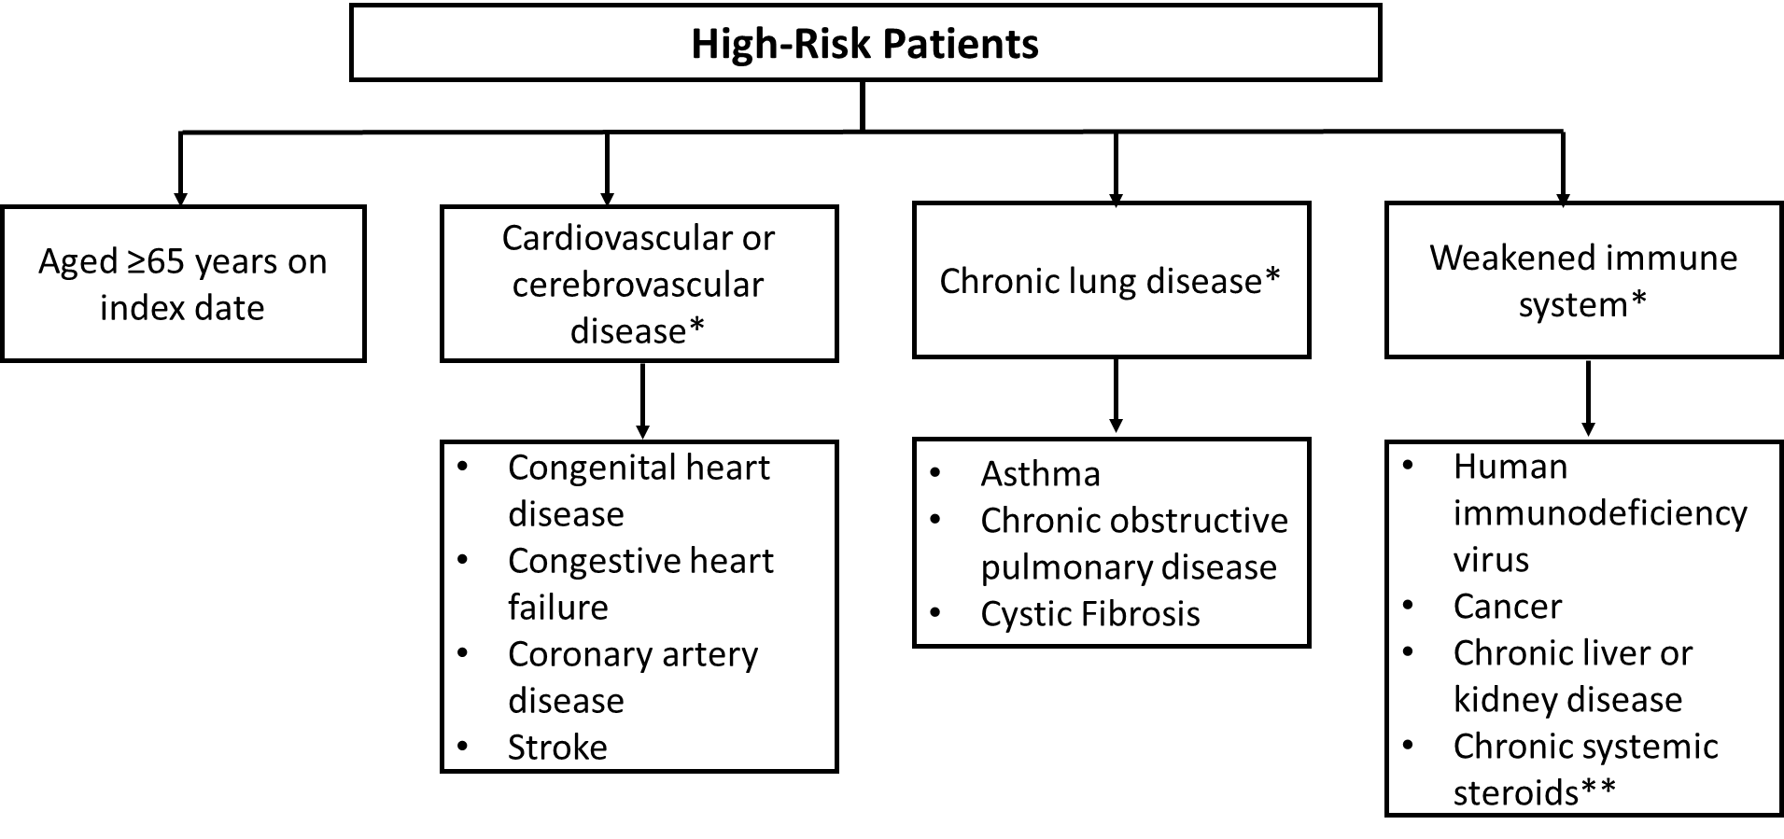

* Patients that had diagnosis of cardiovascular/cerebrovascular, chronic lung disease, or weakened immune system during 6-month baseline period
**continuous systemic steroid use at a dose of 20mg/day prednisone-equivalent for a period >14 days

