Supplementary material
Supplementary Figure SI. Architectural Lay-out of the New Single-room Unit
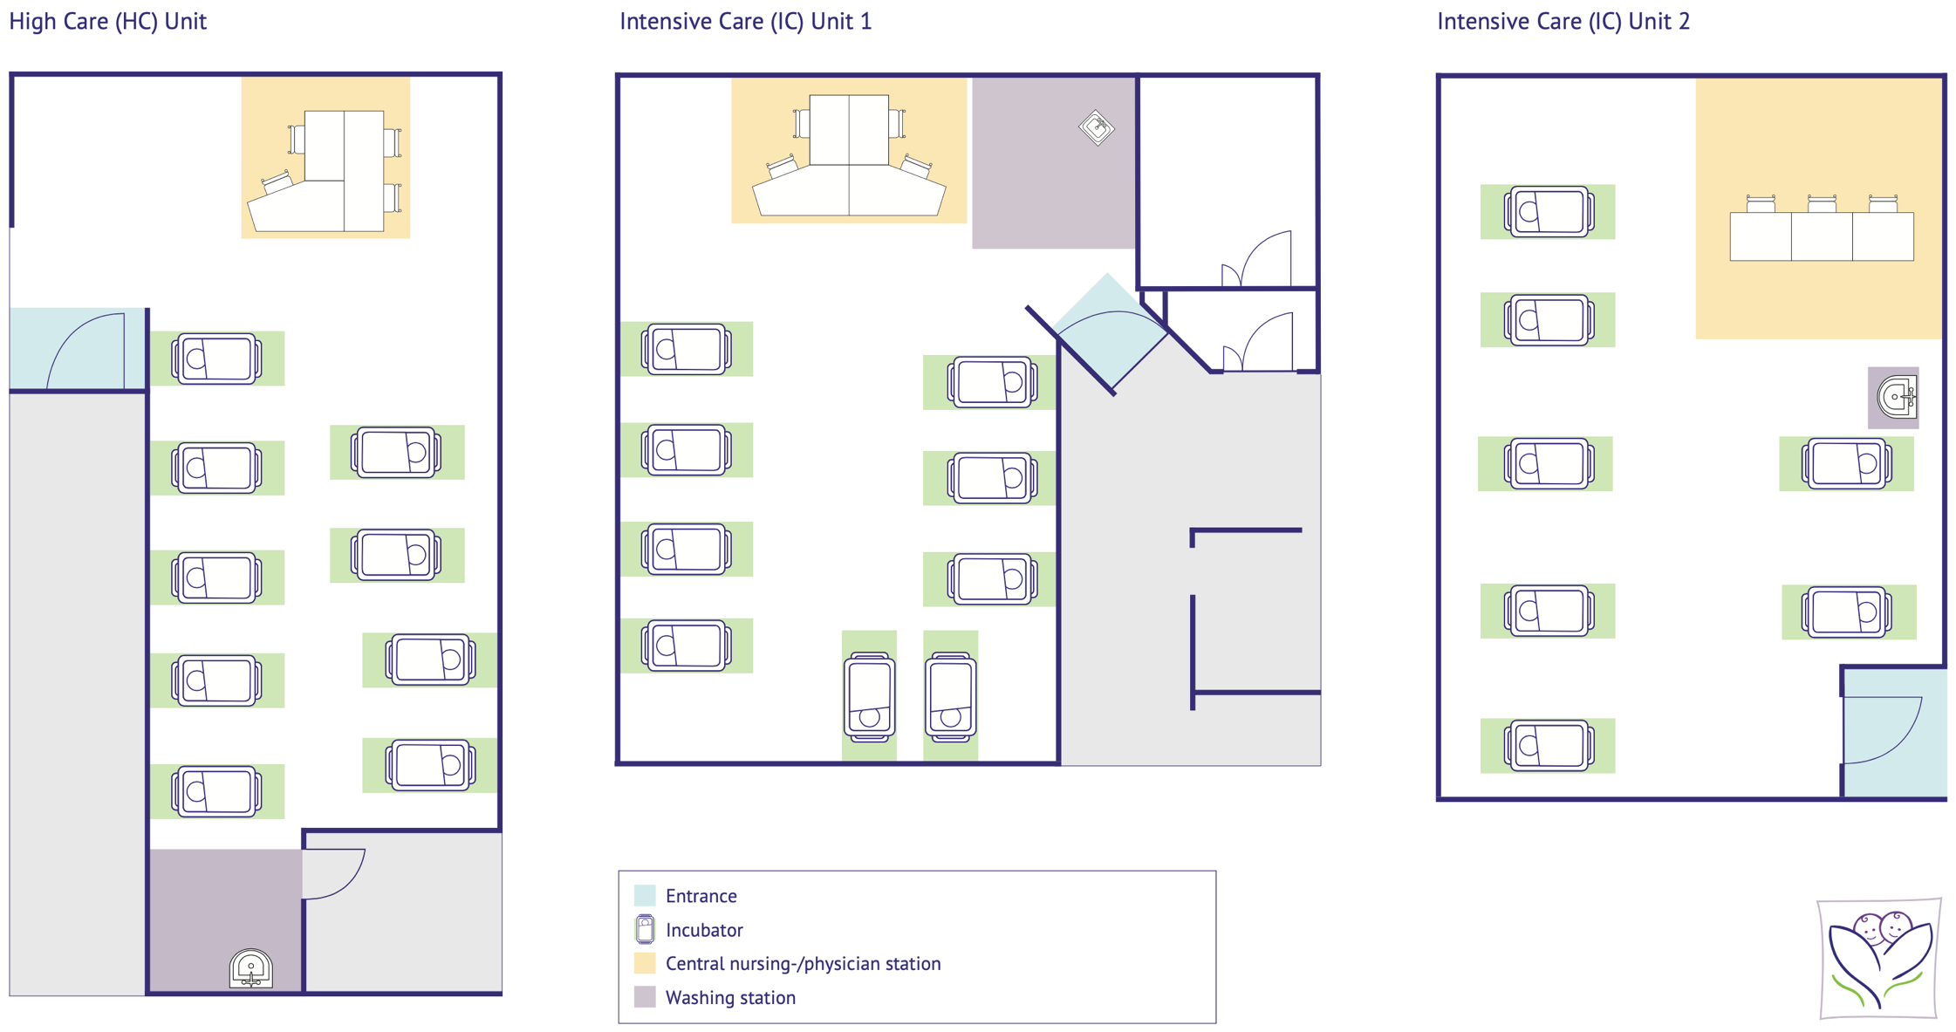
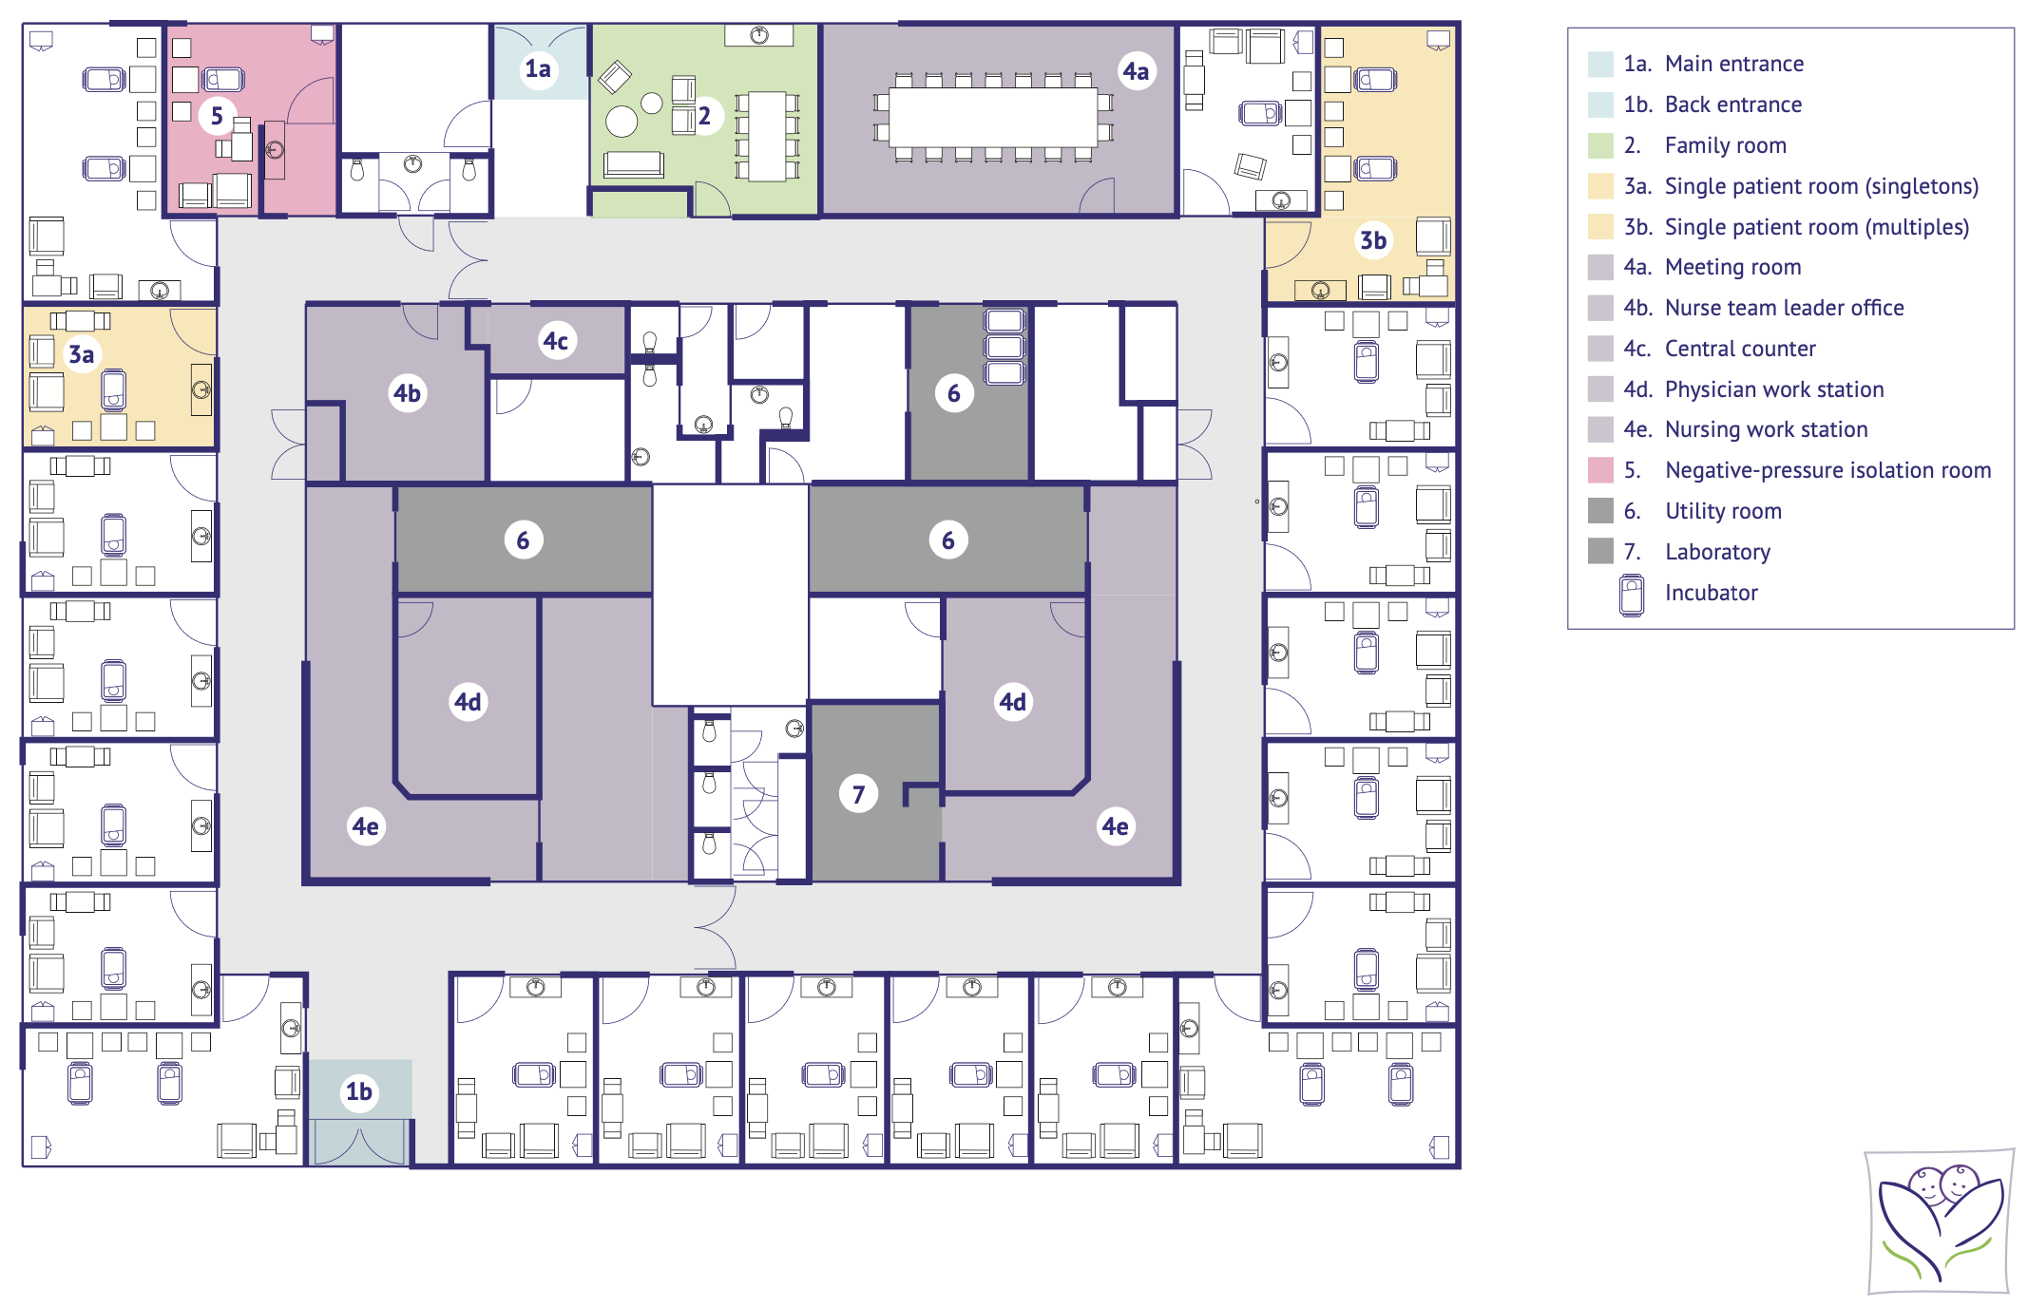 Supplementary Figure S2. Architectural Lay-out of the Historical Open-bay Unit

Supplementary Table S1. Definition of CLABSI
Start infection:
- 72h ≥ after birth by one or more blood cultures * AND
- Central-line was in place for > 2 consecutive calendar days OR
- Infection starts on the day of central-line removal or the following day.
Criterium 1 (positive blood culture, no commensal):
- There are ≥ 1 positive blood culture(s) AND
- The cultured microorganism is not part of common commensal AND
- Blood culture finding cannot be attributed to an infection elsewhere in the body.
Criterium 2 (positive blood culture, commensal ¥):
- Clinical symptoms of infection are present according to the treating physician.
2A AND
- There are ≥ 2 positive blood cultures from which common commensal was cultured ∇ AND
- Clinical symptoms of infection, as well as the cultured microorganism cannot be attributed to an infection elsewhere in the body.∂

2B AND
- There are ≥ 1 positive blood culture(s) from which common commensal was cultured AND
- Clinical symptoms of infection, as well as the cultured microorganism cannot be attributed to an infection elsewhere in the body AND
- CRP is ≥ 10 mg/L within the first 36 hours following blood culture collection.
* Blood specimens can be collected through peripheral venepuncture or can be sampled via central-lines.
¥ Common commensals according to the NHSN common commensal organisms list include, but are not limited to, Coagulase negative Staphylococci (CoNS) [21].
∇ Two or more blood specimens sampled on different occasions – i.e. on the same or consecutive calendar day.
∂ Clinical symptoms of infection must occur within an infection window of 3 days before and/or 3 days after blood sampling.

Supplementary Table S2. Case Definitions for (Non-CLABSI) Neonatal Nosocomial Infections
Infection Type | Definition | Source
Primary bloodstream infection (PBSI) | At least one of the following: hypothermia or hyperthermia (< 36.5 °C or ≥ 38 °C) or temperature instability, hypotension, tachycardia, apnea, feeding problems, irritability, apathy AND isolation of a known pathogen from a blood culture* AND the organism is not related to an infection at another site AND provision of appropriate antibiotic therapy.  * Isolation of a common skin pathogen (i.e. CoNS) must be accompanied by a rise in CRP ≥ 10 mg/L within the first 36 hours after start infection. | Leistner et al. (2013) [22], van der Zwet et al. (2005) [23]
Secondary bloodstream infection (SBSI) | A BSI that is thought to have been seeded from a site-specific infection at another body site AND isolation of at least one known pathogen from a blood culture that matches the pathogen identified from the site-specific specimen AND provision of appropriate antibiotic therapy. | CDC 2020 [24]
Persistent bacteremia after CLABSI | Persisting presence of a known pathogen in the bloodstream as determined by a blood culture after removal of a central-line (occurring ≥ 72 hours after central-line removal and start adequate antibiotic therapy).*  * Must involve the same offending organism responsible for CLABSI. | This study
Ventilator-associated pneumonia (VAP) | Neonate is mechanically ventilated AND two or more of the following: purulent sputum, changes in sputum characteristics, worsening of ventilation conditions or gas exchange AND radiological changes compatible with pneumonia^{A} AND isolation of a pathogenic microorganism from tracheal aspirate, bronchial secretion or sputum. | CDC 2020 [25], van der Zwet et al. (2005) [23]
Hospital-acquired pneumonia (HAP) | Neonate is not mechanically ventilated AND at least one of the following: tachypnea, cyanosis, wheezing, rales, crepitation, purulent sputum or changes in sputum characteristics AND radiological changes compatible with pneumonia^{A} AND isolation of a pathogenic microorganism from tracheal aspirate, bronchial secretion or sputum. | CDC 2020 [25], van der Zwet et al. (2005) [23]
Upper respiratory tract infection (URTI) | At least one of the following: hypothermia or hyperthermia (< 36.5 °C or ≥ 38 °C) or temperature instability, hypotension, tachycardia, apnea, dyspnea, feeding problems, irritability, apathy, increased respiratory secretion, changes in sputum characteristics AND absence of radiological changes compatible with pneumonia^{A} AND isolation of a pathogenic microorganism from tracheal aspirate, bronchial secretion or sputum. | This study
Urinary tract infection (UTI) | Mono-cultural bacterial growth of ≥ 10,000 – 100,000 CFU/mL of a uropathogen collected by SUC or freshly collected CAD sample OR mono-cultural bacterial growth ≥ 100,000 CFU/mL of a uropathogen collected by BC OR any bacterial growth of a uropathogen collected by SA AND abnormal urinalysis findings (pyuria and/or bacteriuria) AND provision of appropriate antibiotic treatment. | AAP 2011 [26], NvK Richtlijn UWI [27]
Meningitis | Presence of clinical symptoms suggestive for a meningitis ^{B} AND isolation of a known pathogen from a CSF culture obtained via lumbar puncture, shunt, reservoir or drain* AND cellular and biochemical abnormalities in CSF material (WBC count ≥ 20 mm³, protein content > 1.5 g/L in premature infants, > 1.0 g/L in full-term infants, glucose < 1.1 mmol/L in premature infants and < 1.7 mmol/L in full-term infants) AND provision of appropriate antibiotic therapy.  * Isolation of a common skin pathogen (i.e. CoNS) not considered a positive CSF result. | Vergnano et al. (2016) [28], Ku 2015 [29]
Necrotizing enterocolitis (NEC) | At least two of the following: hypothermia or hyperthermia (< 36.5 °C or ≥ 38 °C) or temperature instability, bradycardia, apnea, respiratory and/or metabolic acidosis, apathy, vomiting, abdominal distension, pre-feeding residuals, persistent microscopic or gross blood in stools AND at least one characteristic radiographic abnormality.^{C} | Bell 1978 [12], Leistner et al. (2013) [22], Vermont Manual of Operations 2019 [30]
Conjunctivitis | Conjunctivital inflammation with the isolation of a known pathogen from conjunctivital swab AND provision of appropriate antibiotic therapy. | This study
Skin and/or soft tissue infections | Presence of localized (i.e. redness, swelling, pustulosis etc.) and/or systemic symptoms (i.e. temperature instability, irritability, feeding intolerance etc.) AND isolation of a known pathogen from purulent material and/or regular skin swab AND provision of appropriate antibiotic therapy. | This study
CoNS: coagulase-negative staphylococci, CRP: C-reactive protein; CLABSI, central-line associated bloodstream infection; CFU, colony-forming units; SUC, sterile urethral catherization; CAD, catheter a demeure; BC, bag collection; SA, suprapubic aspiration; CSF: cerebral spinal fluid, WBC: white blood cell.
^{A} Radiological changes compatible with pneumonia include infiltration, consolidation, pleural adhesion and/or pleural effusion.
^{B} Temperature ≥ 38 °C or < 36.5 °C, focal neurological symptoms, seizures, bulging fontanel, irritability, lethargy etc.) and/or cerebral ultrasonic evidence (i.e. debris in the ventricles).
^{C} Pneumoperitoneum, pneumatosis intestinalis, unchanging ‘rigid’ loops of small bowel.

Supplementary Table S3. Pathogen Distribution of CLABSI and PBSI Episodes According to Unit Type
Isolated organism(s) | OBU | SRU
CLABSI, n | 23 | 14
Gram-positive, n (%)  CoNS  Enterococcus spp  S.aureus (MSSA) | 22 (97)  20 (87)  1 (4)  1 (4) | 12 (86)  10 (71)  2 (14)  0 (0)
Gram-negative, n (%)  Acinetobacter spp  Enterobacter spp | 1 (4)  1 (4)  0 (0) | 1 (7)  0 (0)  1 (7)
Fungi, n (%)  Candida | 0 (0)  0 (0) | 1 (7)  1 (7)
PBSI, n | 40 | 44
Gram-positive, n (%)  CoNS  Enterococcus spp  S.aureus (MSSA)  Streptococcus spp | 36 (90)  28 (70)  2 (5)  4 (10)  2 (5) | 38 (86)  30 (68)  0 (0)  8 (18)  0 (0)
Gram-negative, n (%)  Pseudomonas spp  E.coli  Enterobacter spp  Klebsiella spp  Citrobacter koseri | 2 (5)  1 (2.5)  0 (0)  0 (0)  0 (0)  1 (2.5) | 4 (9)  0 (0)  2 (5)  1 (2)  1 (2)  0 (0)
Fungi, n (%)  Candida | 1 (2.5)  1 (2.5) | 1 (2)  1 (2)
Polymicrobial, n (%)  Klebsiella, Citrobacter koseri  E.coli, Acinetobacter spp | 1 (2.5)  1 (2.5)  0 (0) | 1 (2)  0 (0)  1 (2)

Supplementary Table S4. Antibiotic Exposure
Variable | OBU | SRU | P value
Antibiotic exposure ≤ 24 hours postpartum, n (%) | 229 (62) | 198 (57) | 0.19
Antibiotic exposure ≥ 72 hours after admission, n (%) | 235 (64) | 196 (57) | 0.06
Total LOT, d | 2832 | 2413 | 0.51
Total DOT, d | 5042 | 4234 | 0.99
LOT per 1,000 patient-days | 345 | 346 | 0.51
DOT per 1,000 patient-days | 616 | 607 | 0.99
OBU, open-bay unit; SRU, single-room unit; LOT, length of treatment; DOT, days of treatment per antibiotic agent; d, days.

Supplementary Table S5. Univariate and Multivariate Fine-Gray Competing Risk Regression Model for Nosocomial Infections
Covariate | Univariate model |  |  | Multivariate model
 | sDH | 95% CI | P value | sDH | 95% CI | P value
Unit type (SRU) | 0.95 | 0.68-1.34 | 0.78 | 0.93 | 0.66-1.31 | 0.68
Gestational age (wk) |  |  |  | 0.87 | 0.74-1.04 | 0.12
Sex (female) |  |  |  | 1.04 | 0.73-1.46 | 0.84
5 min Apgar score |  |  |  | 0.97 | 0.87-1.08 | 0.55
Birth weight (gr) |  |  |  | 1.00 | 1.00-1.00 | 0.12
Birth modus (caesarian section) |  |  |  | 1.16 | 0.79-1.70 | 0.44
Antenatal steroids |  |  |  | 0.99 | 0.51-1.96 | 0.99
Duration invasive mechanical ventilation (d) |  |  |  | 1.03 | 1.01-1.05 | 0.01
Exposure to central-line |  |  |  | 1.24 | 0.71-2.18 | 0.45
Duration central-line use (d) |  |  |  | 1.00 | 0.96-1.04 | 0.90
Antibiotics ≤ 24 hours postpartum |  |  |  | 0.87 | 0.60-1.27 | 0.47
Length of hospital stay (d) |  |  |  | 1.00 | 0.99-1.01 | 0.97
SRU, single-room unit; sDH, subdistribution hazard ratio; CI, confidence interval; wk, weeks; gr, grams; d, days.
P-values < 0.05 were considered significant and are depicted in bold.
Univariate model based on 712 infants.
Multivariate model based on 697 cases due to missing values for the variables Apgar score at 5 min and Antenatal steroids.
When multiple infection episodes occurred in the same infant, only the first episode was included in the analysis.

