Supplementary Figures
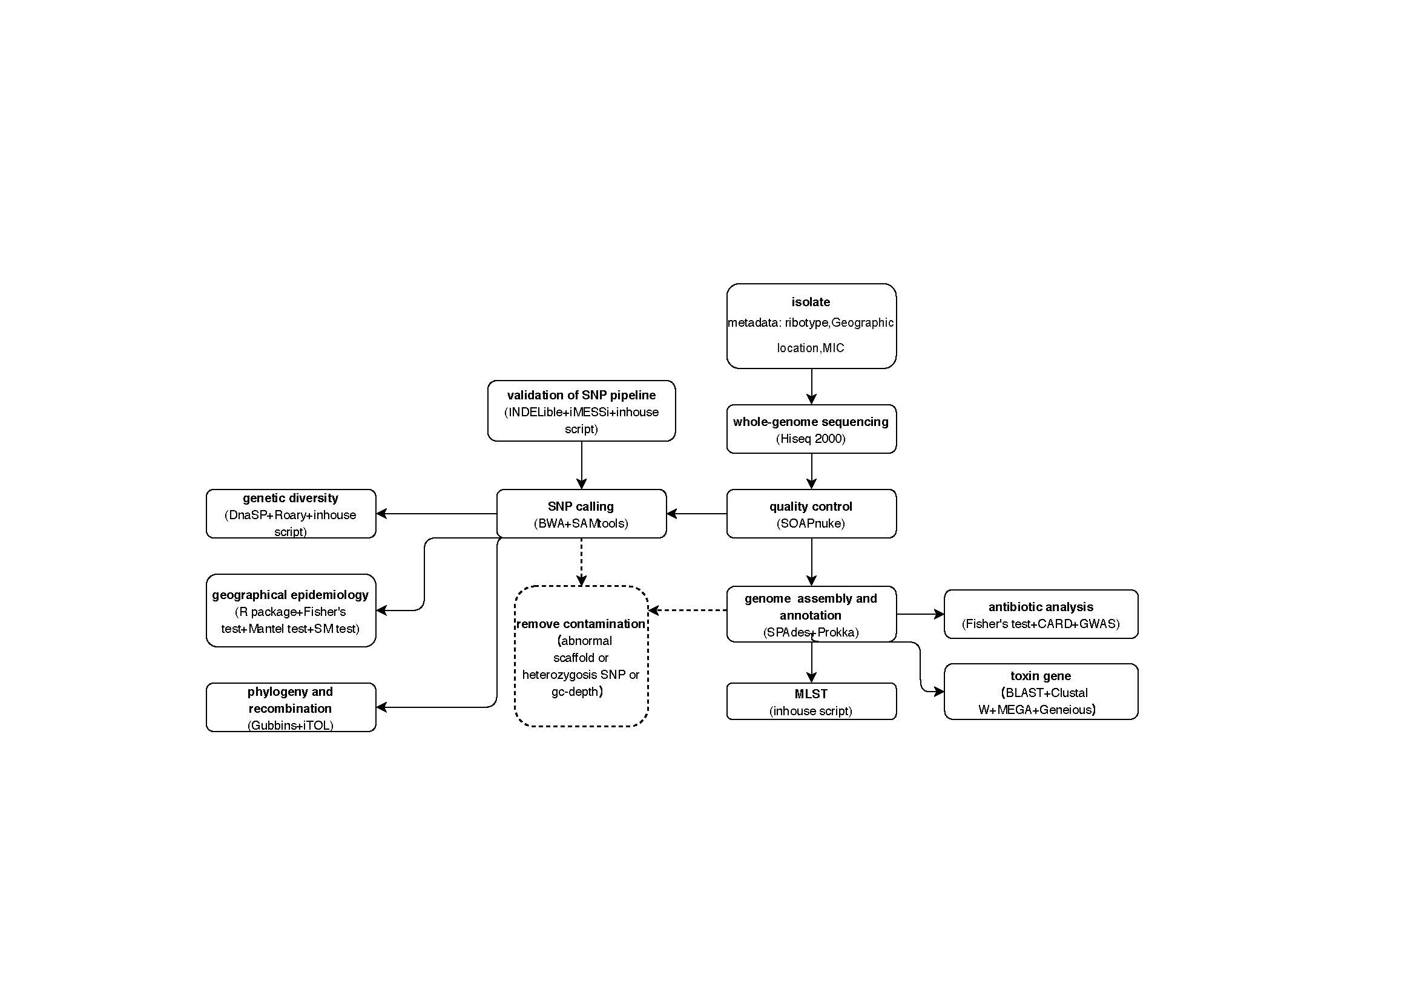
Fig. S1. Study data flow chart

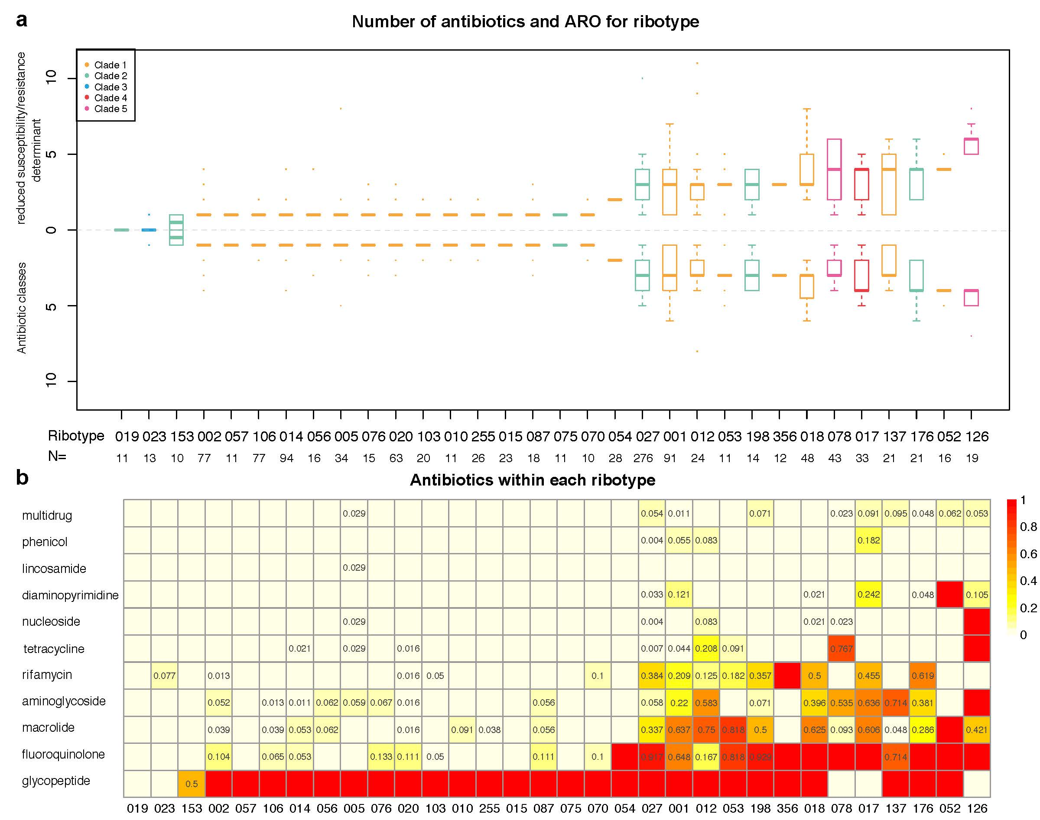
Fig. S2. Reduced susceptibility/resistance determinants identified amongst the major ribotypes by in silico annotation.
(a) Boxplots above the dashed line represent the number of reduced susceptibility/resistance determinants identified within each major ribotype, using the Comprehensive Antibiotic Resistance Database and literature reports. Boxplots below the dashed line represent the number of corresponding antibiotic classes affected by these determinants. Boxplots are color-coded according to clade.
(b) The values correspond to the reduced susceptibility/resistance ratio (except 0 or 1) for each ribotype.
The ribotypes were ranked by the median of number of reduced susceptibility/resistance determinants.
ARO, Antibiotic Resistance Ontology.

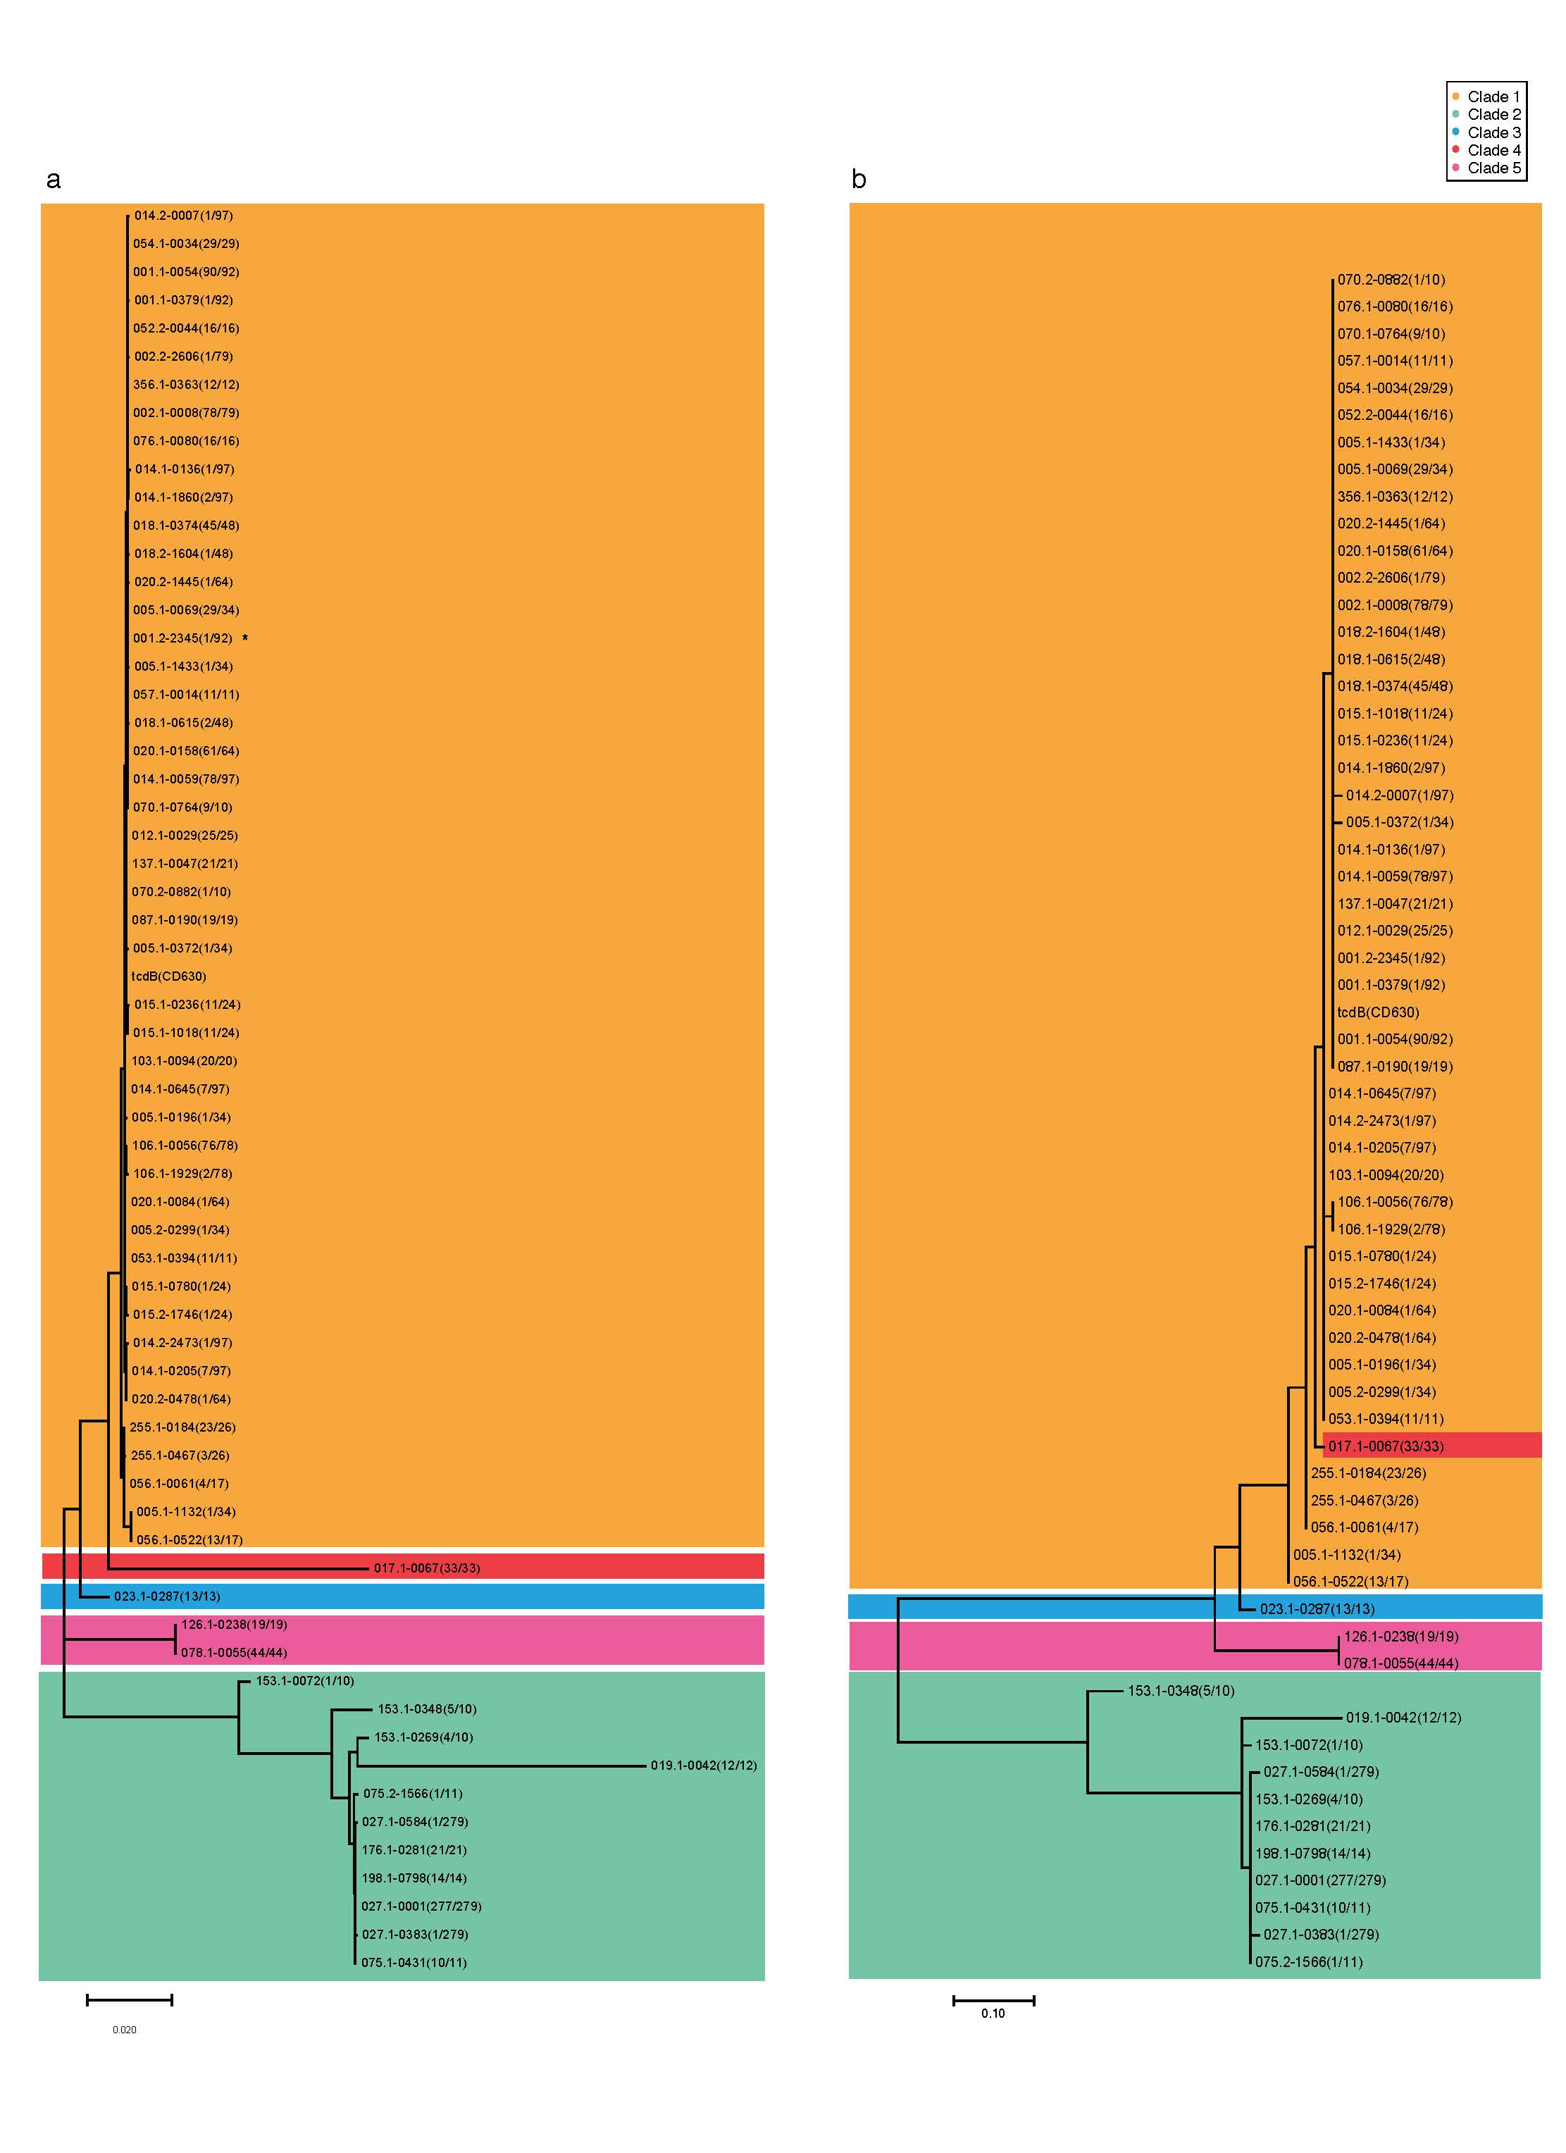
Fig. S3. VT tree of the (A) complete gene and (B) CROP domain of tcdB.
Representative amino acid sequences of 62 tcdB VTs were used to construct the maximum-likelihood gene tree by MEGA7. “*” indicates the VT with a stop-gain mutation.
VT, variant type.
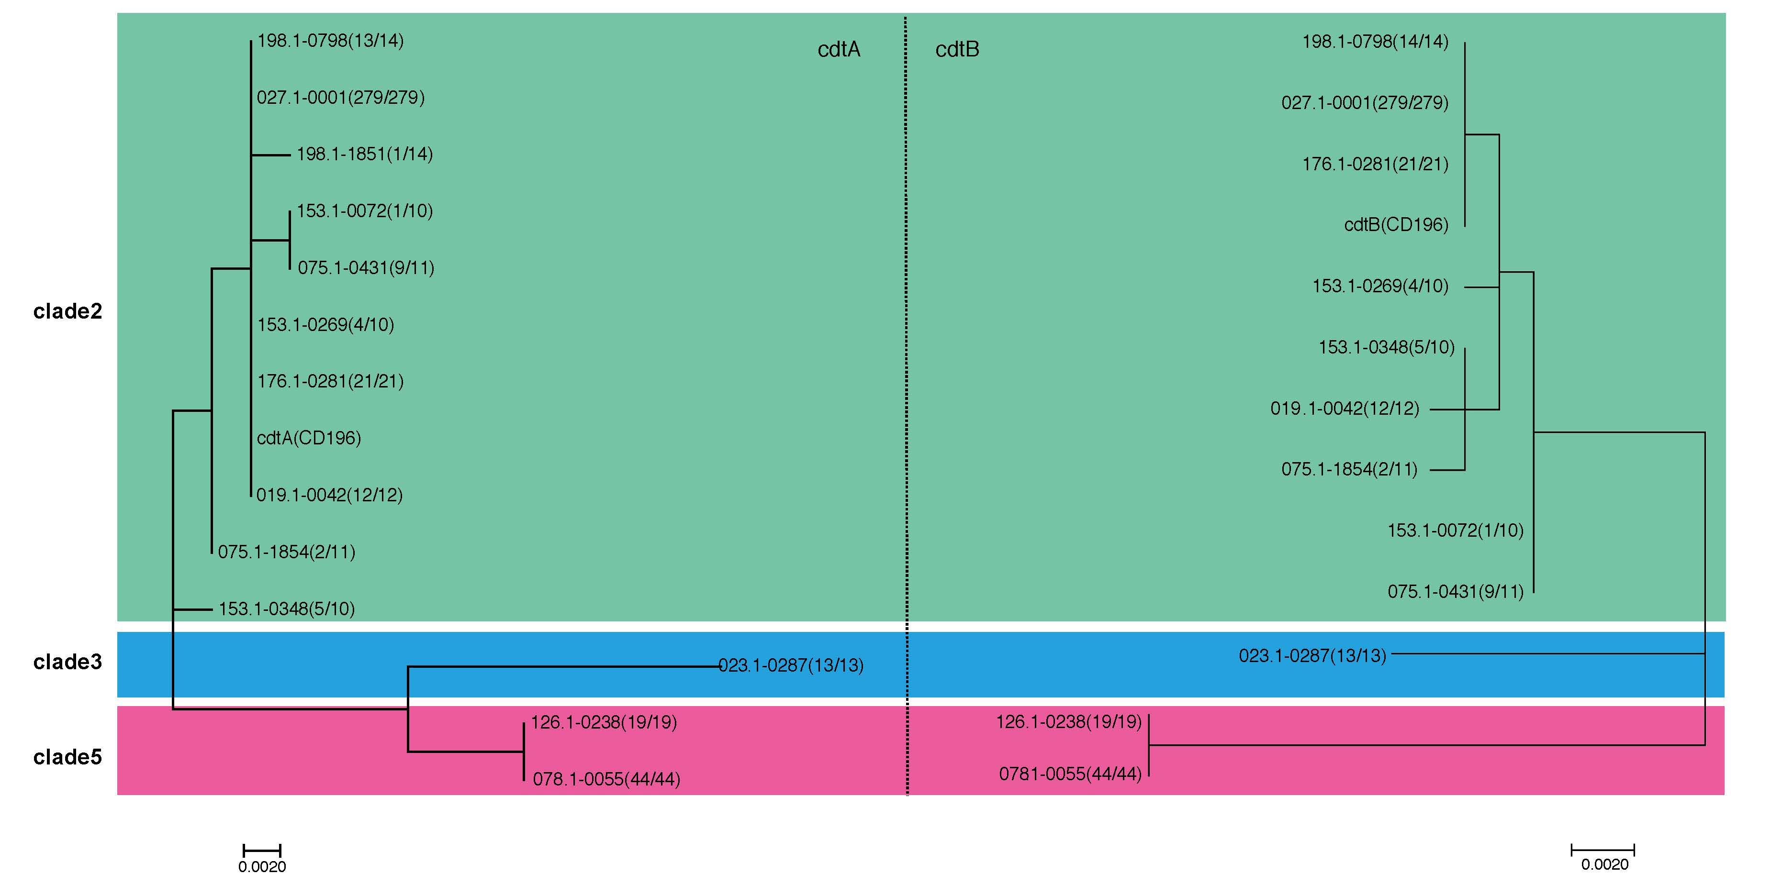
Fig. S4. Maximum-likelihood tree of cdtA and cdtB.
The VT for each ribotype is displayed. Background shading is color-coded according to clade.
VT, variant type.

