Appendix
Supplementary Methods – adjusted Saint George Respiratory Questionnaire (aSGRQ)

Symptom component
Questions about how much chest trouble you have
Question 1. You cough: | - Most days a week  - Several days a week  - Occasionally/only with chest infections  - Not at all
Question 2. You bring up phlegm (sputum): | - Most days a week  - Several days a week  - Occasionally/only with chest infections  - Not at all
Question 3. You feel breathless | - Most days a week  - Several days a week  - Not at all
Activity component
Disturbances to daily activities
How would you describe your chest condition? | - Causes me a lot of problems  - Is the most important problem I have  - Causes me a few problems  - Causes no problem
Activity and breathlessness | - Getting washed or dressed  - Walking around the home  - Walking outside on the level  - Walking up a flight of stairs  - Talking  - My cough or breathing disturbs my sleep  - I get exhausted easily

Supplementary Table 1. WHO-CPS scores at diagnosis and follow up.

Patient State | Descriptor | At diagnosis  (T_{D}) | At follow-up  (T₁)
Mild disease | 1 Asymptomatic* |  | 259 (58.20)
Mild disease | 2 Symptomatic, independent | 174 (39.10) | 128 (28.76)
Mild disease | 3 Symptomatic, assistance needed | 39 (8.76) | 58 (13.03)
Moderate disease | 4 Hospitalised, no oxygen therapy | 38 (8.54) | -
Moderate disease | 5 Hospitalised; oxygen by mask or nasal prongs | 147 (33.03) | -
Severe disease | 6 Hospitalised; oxygen by NIV or high flow | 7 (1.57) | -
Severe disease | 7 Intubation and mechanical ventilation, pO2/FiO2 _150 or SpO2/FiO2 _200 | 21 (4.72) | -
Severe disease | 8 Mechanical ventilation pO2/FIO2 <150 (SpO2/FiO2 <200) or vasopressors | 18 (4.04) | -
Severe disease | 9 Mechanical ventilation pO2/FiO2 <150 and vasopressors, dialysis, or ECMO | 1 (0.22) | -
Data available from 445 patients.
*Only COVID-19 symptomatic patients were included in the study
The WHO-CPS is a 10-point scale. Score 10 (corresponding to patients who died, 10=dead) was not included in the study

Supplementary Figure 1. Study design diagram.

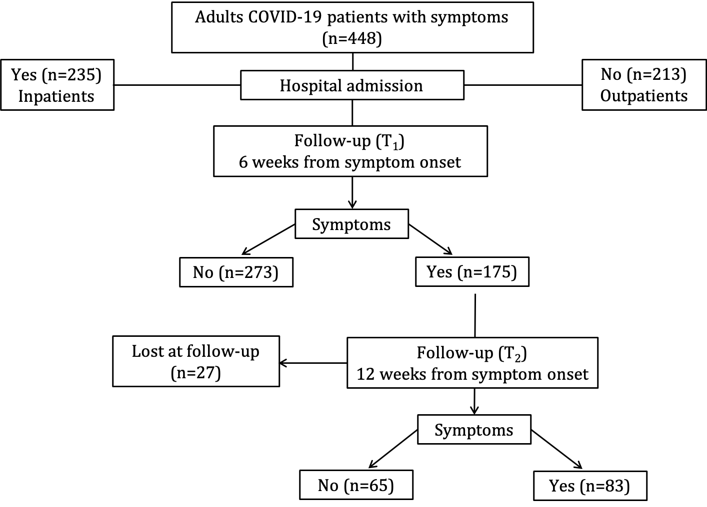

Figure 2 (A - F). Kaplan Maier curves reporting duration of most common symptoms among inpatients and outpatients with COVID-19
