Supplementary Material for
Integrase inhibitors partially restore bacterial translocation, inflammation and gut permeability induced by HIV infection: impact on gut microbiota
Pablo Villoslada-Blanco¹, Patricia Pérez-Matute^{1§}, María Íñiguez¹, Emma Recio-Fernández¹, Pilar Blanco-Navarrete², Luis Metola³, Valvanera Ibarra ³, Jorge Alba³, María de Toro⁴, José A. Oteo^{1,3}.
¹Infectous Diseases, Microbiota and Metabolism Unit. Infectious Diseases Department. Center for Biomedical Research of La Rioja (CIBIR), Logroño, La Rioja, Spain.
²Centro de Salud Siete Infantes de Lara, Logroño, La Rioja, Spain.
³Infectious Diseases Department. Hospital Universitario San Pedro, Logroño, La Rioja, Spain.
⁴Genomics and Bioinformatics Platform. Center for Biomedical Research of La Rioja (CIBIR), Logroño, La Rioja, Spain.

§Corresponding author: Patricia Pérez-Matute
Infectious Diseases, Microbiota and Metabolism Unit. Infectious Diseases Department, Center for Biomedical Research of La Rioja (CIBIR), Logroño, La Rioja, Spain.
C/Piqueras 98
CIBIR building, third floor
26006 Logroño (La Rioja)
cpperez@riojasalud.es

Supplementary table 1
Supplementary figure 1
Supplementary table 1. Different INSTIs-based treatments combinations used in HIV-infected patients.
INSTI | Backbone | Number of patients
Dolutegravir | Abacavir and lamivudine | 10/15 (66.67%)
Dolutegravir | Lamivudine | 2/15 (13.33%)
Bictegravir | Emtricitabine and tenofovir alafenamide | 3/15 (20.00%)
HIV (human immunodeficiency virus infection), INSTI (integrase strand transfer inhibitor).
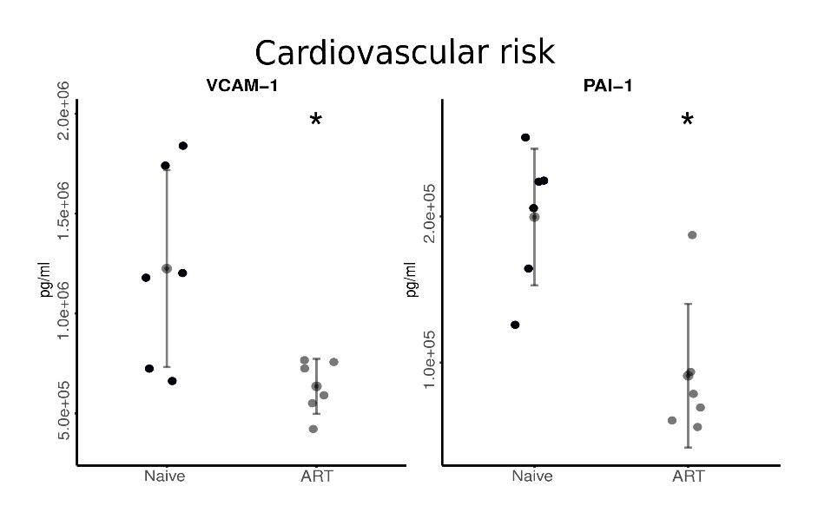
Supplementary figure 1. Levels of cardiovascular risk markers comparing ART-treated patients before and after one year of treatment. *p<0.05 vs. control. ART (antiretroviral treatment), ICAM-1 (intracellular adhesion molecule 1), PAI-1 (plasminogen activator protein 1), TMAO (trimethylamine N-oxide), VCAM-1 (vascular cell adhesion molecule 1).

