SUPPLEMENTARY MATERIALS

Initial experiences with invasive meningococcal disease: Insights from survivors and their caregivers
Oscar Herrera-Restrepo (ORCID: 0000-0001-8193-999X)¹, Nuzhat Afroz (ORCID: 0000-0002-3048-2704)², Eliazar Sabater Cabrera (ORCID: 0000-0002-3184-2855)³, Matthew Reaney (ORCID: 0000-0003-2918-722X)⁴, France Ginchereau Sowell (ORCID: 0000-0002-7728-2435)⁵, Ramiya Kumar (ORCID: 0000-0002-0651-8316)⁶, Alicia Stillman (ORCID: 0009-0000-0295-7752)⁷, Patti Wukovits (ORCID: 0009-0005-6091-6314)⁷, Mariana Rodrigues (ORCID: 0009-0009-4867-8615)⁷, Sofia B. Pinto (ORCID: 0000-0001-7758-6706)⁸, Zeki Kocaata (ORCID: 0000-0002-5231-3389)⁹, Obinna Onwude (ORCID: 0009-0008-1811-7684)⁴
¹GSK, Philadelphia, PA, USA
²IQVIA, Amsterdam, the Netherlands
³GSK, Madrid, Spain
⁴IQVIA, London, UK
⁵IQVIA, New York, NY, USA
⁶IQVIA, Bangalore, India
⁷American Society for Meningitis Prevention, Farmington Hills, MI, USA
⁸GSK, Rio de Janeiro, Brazil
⁹GSK, Wavre, Belgium

Correspondence to: Oscar Herrera-Restrepo
Email: oscar.x.herrera-restrepo@gsk.com
FMC Tower Suite 1700
2929 Walnut St, Philadelphia, PA 19104, United States

Supplementary Figure 1. Study procedures and data collection at each step
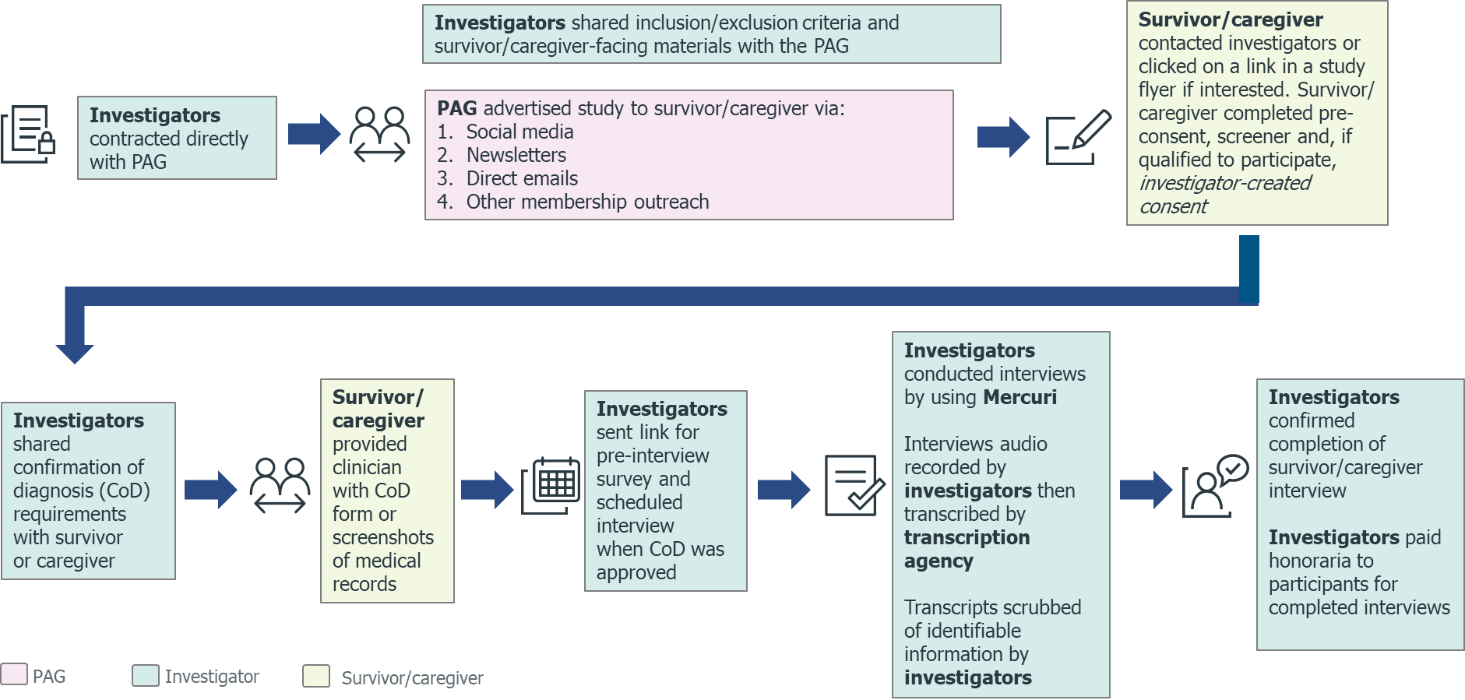
Abbreviations: CoD, confirmation of diagnosis; PAG, patient advocacy group.

Supplementary Figure 2. Life conditions before IMD (by age group at IMD diagnosis)
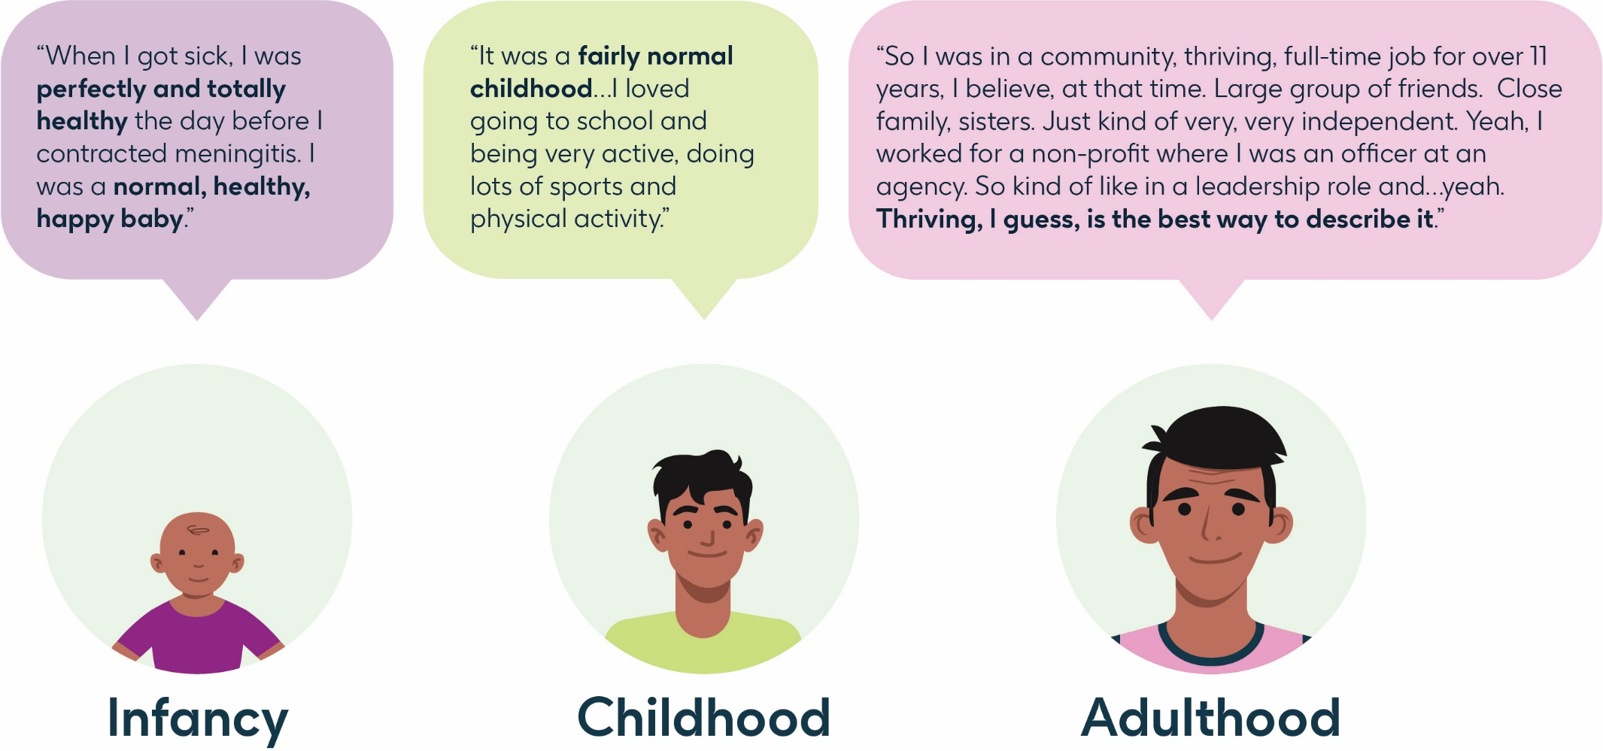
Abbreviations: IMD, invasive meningococcal disease.
Supplementary Table 1. Study eligibility criteria
Inclusion Criteria |  | Exclusion Criteria
IMD Survivors | Caregivers | IMD Survivors and Their Caregivers
were eligible if they:  - Provided a CoD of IMDª at any time in their lives and had survived IMD,  - Had access to a telephone/cell phone and internet,  - Were able to participate in a brief pre-interview survey^{b} and 75–90-minute interview,  - Were willing and able to provide informed consent^{c} or assent,  - Were able to read, understand, and speak in English,  and  - Resided in the US | were eligible if they:  - Were the parent/legal guardian^{d} (or other individual) currently (at the time of screening) caring for a survivor with a confirmed IMD diagnosisª,  - Were aged ≥18 years,  - Had access to a telephone/cell phone and internet,  - Were able to participate in a brief pre-interview survey and 75–90-minute interview,  - Were willing and able to provide informed consent  - Were able to read, understand, and speak in English,  and  - Resided in the US | were not eligible if they:  - Lacked the ability or were unwilling to provide informed consent or assent  - Lacked the ability or were unwilling to complete a brief pre-interview survey and/or 75–90-minute interview,  - Did not have access to a telephone/cell phone or internet,  or  - Were not willing to be audio recorded during interviews
ªEither via a clinician-completed CoD form or medical record screenshots as proof of diagnosis/treatment.
^{b}Survivors aged >14 years were eligible to complete the pre-interview survey alone.
^{c}For survivors aged <18 years, their caregivers were required to consent that the child was able and willing to take part in the study, and the child was required to sign an assent form.
^{d}Legal guardian, or legally authorized representative (LAR), refers to an individual who, under law, has the ability to act on behalf of another person (such as a minor study participant); the LAR may be a parent, grandparent, or caregiver who has the legal authority to grant consent on behalf of another who has been invited to participate in research.
Note: Where an IMD survivor had ≥2 caregivers, the caregiver that provided the greater proportion of care was preferred for study participation.
Abbreviations: CoD, confirmation of diagnosis; IMD, invasive meningococcal disease; US, United States.

Supplementary Table 2. Survivors’ demographic and clinical characteristics
Demographic characteristics | Value
Demographic characteristics | n | %
Age, years
Mean | 36
Median | 37
Range | 14–51
Subgroups (based on age)
Adolescents (14–17 years)ª | 1 | 9
Adults (≥18 years) | 10 | 91
Gender
Female | 6 | 55
Maleª | 5 | 45
Highest level of education completed
Completed elementary school^{b} | 1 | 9
Completed middle school | 0 | 0
Completed high school | 0 | 0
Attended some college (but did not complete the course) | 1 | 9
Completed a college degree | 5 | 45
Completed a graduate college degree or equivalent/higher | 4 | 36
Occupation/work
Studyingª | 2 | 18
Full-time employed | 4 | 36
Part-time employed | 2 | 18
Self-employed | 2 | 18
Housewife or househusband | 2 | 18
Unemployed | 0 | 0
Other^{c} | 2 | 18
Disability benefits
Yes | 2 | 18
Noª | 9 | 72
Ethnicity
Asian | 1 | 9
African American or Black | 0 | 0
Hispanic or Latino | 0 | 0
White or Caucasian (non-Hispanic)ª | 10 | 91
Native American or Alaskan Native | 0 | 0
Native Hawaiian and Other Pacific Islander | 0 | 0
Multiracial or Biracial | 1 | 9
Current living status
Urban (i.e., city or metropolitan area) | 1 | 9
Suburban (i.e., large residential areas that surround main cities) | 8 | 73
Ruralª | 2 | 18
Residing states
Massachusetts | 2 | 18
Ohio | 1 | 9
Colorado | 1 | 9
California | 2 | 18
Minnesota | 1 | 9
Arkansas | 1 | 9
Texas | 1 | 9
New Jersey | 1 | 9
South Dakotaª | 1 | 9
Marital/relationship status
Singleª | 6 | 55
Married | 4 | 36
Partnership/long-term relationship | 1 | 9
Current living situation
Living alone | 2 | 18
Living with spouse/partner | 4 | 36
Living with family/children | 2 | 18
Living with parentsª | 3 | 27
Living with roommates/friends | 2 | 18
Health insurance status
Commercial health insurance | 7 | 64
Medicare | 2 | 18
Medicaidª | 1 | 9
Medishare | 1 | 9
Current household income (USD)
$25,000–$74,999ª | 4 | 36
$75,000–$149,999 | 5 | 45
$150,000 or more | 2 | 18
Diagnosis
Age at diagnosis, years
Mean | 14
Median | 19
Range | <1–37
Age subgroups of survivors (at the time of infection)
<1 year | 2 | 18
1–4 years | 1 | 9
5–10 years | 2 | 9
11–15 years | 0 | 0
16–22 years | 4 | 36
≥23 years | 2 | 18
Time since diagnosis
>12 monthsª | 11 | 100
<12 months | 0 | 0
Hospitalizations and ED visits in past one year
Hospitalizations in past one year
Noneª | 11 | 100
≥1 | 0 | 0
ED visits in past one year
Noneª | 11 | 100
≥1 | 0 | 0
ªIncludes demographic details of adolescent.
^{b}Reported from interview as no response option selected in the screener.
^{c}Selected ‘others’ in the screener, included categories such as online selling of artwork as reported in the interviews.
Abbreviations: ED, emergency department; USD, United States dollar.

Supplementary Table 3. Caregivers’ demographic and clinical characteristics
Demographic characteristics | Value
Demographic characteristics | n | %
Age, years
Mean | 58
Median | 63
Range | 30–60
Gender
Female | 3 |  | 100
Male | 0 |  | 0
Age of survivors for whom they provide care
Adolescents (11–17 years) | 1 |  | 33
Adults (≤18 years) | 2 |  | 67
Highest level of education completed
Completed high school | 1 |  | 33
Attended some college (but did not complete the course) | 1 |  | 33
Completed a college degree | 1 |  | 33
Occupation/work
Self-employed | 1 |  | 33
Housewife | 1 |  | 33
Retired | 1 |  | 33
Ethnicity
Asian | 0 |  | 0
African American or Black | 0 |  | 0
Hispanic or Latino | 0 |  | 0
White (non-Hispanic) | 3 |  | 100
Native American or Alaskan Native | 0 |  | 0
Native Hawaiian and Other Pacific Islander | 0 |  | 0
Multiracial or Biracial | 0 |  | 0
Current living status
Urban (i.e., city or metropolitan area) | 1 |  | 33
Suburban (i.e., large residential areas that surround main cities) | 1 |  | 33
Rural | 1 |  | 33
Residing state
South Dakota | 1 |  | 33
Colorado | 1 |  | 33
Minnesota | 1 |  | 33
Marital/relationship status
Single | 0 |  | 0
Married | 3 |  | 100
Partnership/long-term relationship | 0 |  | 0
Health insurance status
Commercial health insurance | 2 |  | 67
Medicare | 0 |  | 0
Medicaid | 1 |  | 33
Uninsured | 0 |  | 0
Details about caregiving
Relationship with survivor
Father | 0 |  | 0
Mother | 3 |  | 100
Guardian | 0 |  | 0
Living with survivor
Currently living with IMD survivor | 2 |  | 67
Currently not living with IMD survivor | 1 |  | 33
Gender of survivor for whom they provide care
Female | 0 |  | 0
Male | 3 |  | 100
Type of caregiving (current, past)
All care including nursing, post-surgery needs^{a,b} | 3 |  | 100
Full-time support for all activities including assistance with mobilityª | 3 |  | 100
Years of caregiving
<3 | 0 |  | 0
≥3 | 3 |  | 100
Number of days of caregiving in a week
7 | 1 |  | 33
<7 | 2 |  | 66
Number of hours of caregiving in a day (current)
0^{b} | 2 |  | 66
14 | 1 |  | 33
ªMutually inclusive categories.
^{b}Two caregivers reported having provided caregiving full time in the past, but were no longer providing caregiving at the time of the study.

Supplementary Table 4. IMD symptoms reported by survivors and caregivers
Symptoms | Total  (N=14) | Total survivor mentions (N=11) | Spontaneous | Probed | Caregiver mentions (N=3)
Skin rash (bruise) | 9 | 7 | 7 | 0 | 2
Fever | 8 | 6 | 6 | 0 | 2
Unconsciousness | 7 | 6 | 5 | 1 | 1
Fatigue | 7 | 6 | 4 | 2 | 2
Flu-like symptoms | 7 | 5 | 5 | 0 | 2
Vomiting | 6 | 5 | 5 | 0 | 1
Coma | 5 | 4 | 4 | 0 | 1
Nausea | 4 | 3 | 3 | 0 | 1
Headaches/ migraines | 4 | 4 | 4 | 0 | 0
Runny/stuffy nose | 3 | 3 | 3 | 0 | 0
Neck stiffness | 2 | 2 | 2 | 0 | 0
Swelling/ inflammation | 2 | 1 | 1 | 0 | 1ª
Muscle aches | 2 | 2 | 2 | 0 | 0
Numbness | 2 | 0 | 0 | 0 | 2
Floppy neck | 1 | 1 | 1 | 0 | 0
Stiffness | 1 | 1 | 1 | 0 | 0
Pins and needles | 1 | 1 | 1 | 0 | 0
Itchy throat | 1 | 1 | 1 | 0 | 0
Facial muscle paralysis | 1 | 1 | 1 | 0 | 0
Inability to focus | 1 | 1 | 1 | 0 | 0
ªSwelling caused by cellulitis.
Abbreviations: IMD, invasive meningococcal disease.
Supplementary Table 5. Concept saturation of IMD symptoms reported by survivors
 | Wave 1 | Wave 2 | Wave 3
Number of survivors | 4 | 4 | 3
Count of new symptoms | 10 | 5 | 3
% Symptoms first appearing in wave | 56% | 28% | 17%
Symptoms
Fever | X
Unconsciousness | X
Fatigue | X
Vomiting | X
Inability to focus | X
Floppy neck | X
Nausea | X
Coma | X
Headaches/migraines | X
Flu-like symptoms | X
Neck stiffness |  | X
Swelling/inflammation |  | X
Runny/stuffy nose |  | X
Muscle aches |  | X
Pins and needles |  | X
Stiffness |  |  | X
Itchy throat |  |  | X
Facial muscle paralysis |  |  | X
Abbreviations: IMD, invasive meningococcal disease.
Supplementary Table 6. Healthcare resource utilization during the acute phase of IMD
 |  | Total number of survivors using serviceª (n=11) | Total number of times service used across service users in the acute phase
Care and medical services
Hospitalizations |  | 11 | 8
Physicians/specialists |  | 11 | 6
Therapies^{b} |  | 11 | 23
Use of medicines as a part of treatments^{b} |  | 10 | 10
Emergency visits |  | 10 | 10
Medical insurance, reimbursement, copay |  | 8 | 4
ICU |  | 7 | 8
Homecare |  | 4 | 4
Specialized therapies^{b}
Physical therapy | 11 |  |  | 7
Psychological/psychiatric therapy | 9 |  |  | 4
Occupational therapy | 7 |  |  | 5
Speech therapy | 3 |  |  | 2
Medical rehabilitation | 1 |  |  | 1
ªAcross both acute phase and long-term phase. Long-term phase healthcare service use results are presented in the accompanying Part 2 manuscript [Ms2].
^{b}Service was used more than once.
Abbreviations: ICU, Intensive Care Unit; IMD, invasive meningococcal disease.

Supplementary Table 7. Short-term impacts of IMD on survivors
Immediate/short-term impacts | Total survivor mentions (n=9)ª | Spontaneous | Probed
Impacts on functional activities | 9 | 5 | 4
Needing assistance/relying on others | 7 | 3 | 4
Emotional impacts | 6 | 2 | 4
Fear | 4 | 4 | 0
Trauma/shock | 2 | 2 | 0
Confusion | 1 | 1 | 0
School impacts | 6 | 1 | 5
Self-perception/ psychological impacts | 5 | 5 | 0
Financial impacts | 5 | 0 | 5
Difficulty with self-care impacts | 4 | 1 | 3
Work impacts | 4 | 2 | 2
Difficulty planning/time constraints | 3 | 3 | 0
Limitations of social activities | 3 | 1 | 2
Body image impacts | 2 | 2 | 0
Diet/eating impacts | 2 | 1 | 1
Communication problems | 2 | 2 | 0
Falling | 2 | 1 | 1
Sleep problems | 1 | 1 | 0
Speech problems | 1 | 1 | 0
Difficulty swallowing | 1 | 1 | 0
Memory problems | 1 | 1 | 0
Abbreviations: IMD, invasive meningococcal disease.
ªTwo survivors contracted IMD in infancy and were unable to self-report on short-term impacts of IMD.

Supplementary Table 8. Short-term impacts of IMD on caregivers
Short-term/immediate impacts | Total caregiver mentions (n=3)
Physical impacts
Sleep problems | 2
Fatigue/exhaustion | 1
Illness | 0
Emotional impacts
Sadness | 3
Worry | 3
Feeling misinformed | 3
Fear | 3
Hopelessness | 2
Nightmares | 1
Trauma/PTSD | 1
Anger | 1
Panic | 1
Feeling responsible for child’s survival | 1
Impact on personal identify/function | 1
Grief | 0
Social impacts
Impacts on relationships | 2
Impacts on social interactions | 2
Impacts on family life | 2
Work impacts
Taking leave of absence from work | 2
Needing to find temporary work near hospital | 1
Management of care
Home adjustments | 1
Planning for home care services | 1
Financial impacts
Travel/short stays | 3
Survivor financial needs/expenses | 3
Housing arrangements/accommodations | 2
Financial planning | 1
Note: Response of “0” = “not experienced” or “not asked”.
Abbreviations: IMD, invasive meningococcal disease; PTSD, post-traumatic stress disorder.

