Pregabalin and Gabapentin in Patients with Spinal Cord Injury-Related Neuropathic Pain: A Network Meta-Analysis
Chen Tong¹, Zuo Zhengyao¹, Li Mei¹, Su Dongpo¹, Han Qian¹, Mu Fengqun²
- Department of Neurosurgery, North China University of Science and Technology Affiliated Hospital, Tangshan 063000, Hebei Province, China
- Department of Neurology, Gongren Hospital, Tangshan 063000, Hebei Province, China

First Author: Chen Tong and Zuo Zhengyao
Corresponding Author: Chen Tong
E-mail address: ct.1973@163.com

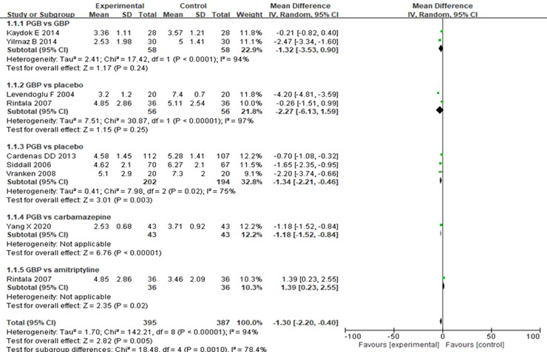
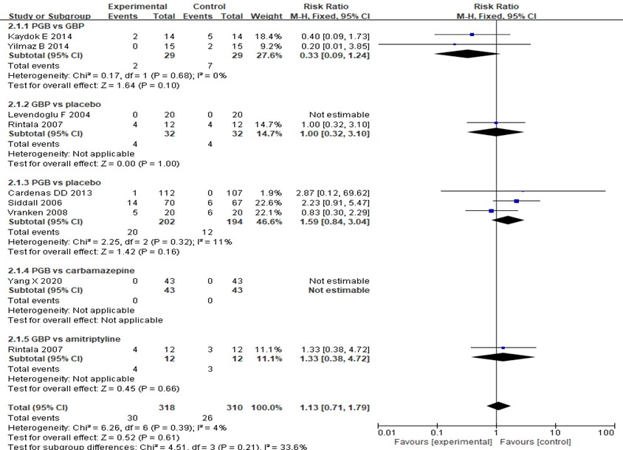
Supplemental Figure 1. a) Subgroup analysis of average pain intensity after treatment. b) Subgroup analysis of the proportion of patients who discontinued treatment due to adverse treatment effects.

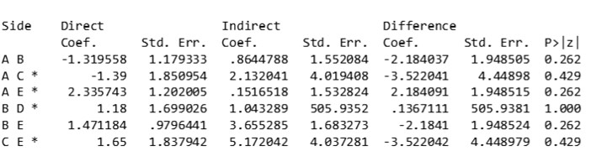
Supplemental Figure 2. Node analysis for consistency
* all evidence regarding these contrasts were derived from trials in which these treatments were directly compared.
(A) Gabapentin (GBP); (B) pregabalin (PGB); (C) amitriptyline; (D) carbamazepine; and (E) placebo.
Supplemental Figure 3. Treatment rankings based on the overall incidence of treatment-related adverse effects.
zero: gabapentin (GBP); _y _B: pregabalin (PGB); _y _C: placebo

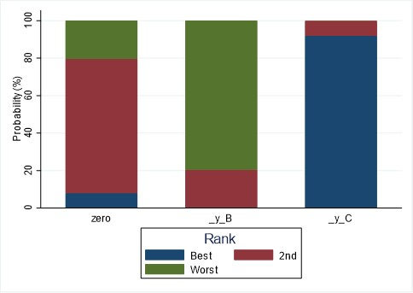
Supplemental Figure 3. Treatment rankings based on the overall incidence of treatment-related adverse effects.
zero: gabapentin (GBP); _y _B: pregabalin (PGB); _y _C: placebo

