Supplemental Materials
Efficacy and safety of mirogabalin in patients with neuropathic pain due to cervical spondylotic radiculopathy: Miro-Cens, a randomized, controlled, interventional study

Takashi Hirai¹, Atsushi Okawa², Hiroshi Takahashi³, Kazuhito Shiosakai⁴, Toshitaka Yoshii¹ on behalf of the Miro-Cens investigators

¹ Department of Orthopedic Surgery, Institute of Science Tokyo, Tokyo, Japan
² Department of Orthopedic Surgery, Yokohama City Minato Red Cross Hospital, Yokohama, Japan
³ Primary Medical Science Department, Medical Affairs Division, Daiichi Sankyo Co., Ltd., Tokyo, Japan
⁴ Data Intelligence Department, Global DX, Daiichi Sankyo Co., Ltd., Tokyo, Japan

*Corresponding author
Takashi Hirai, MD, PhD.
Department of Orthopedic Surgery, Institute of Science Tokyo, 1-5-45 Yushima, Bunkyo-ku, Tokyo 113-8519, Japan
Tel: +81 3 5803 5279
Fax: +81 3 5803 5281
E-mail: hirai.orth@tmd.ac.jp

Supplemental Tables
Table S1. Patients’ characteristics (PPS population)
Characteristic | Mirogabalin add-on group  (N = 60) | NSAIDs alone  group  (N = 66)
Age, years | 57.3 ± 13.6 | 57.7 ± 12.3
≥65 | 21 (35.0) | 20 (30.3)
Male | 36 (60.0) | 41 (62.1)
BMI, kg/m² | 25.2 ± 4.4 | 23.9 ± 2.7
≥25 | 32 (53.3) | 20 (30.3)
CrCL, mL/min | 93.8 ± 29.3 | 86.9 ± 24.5
30 to <60 | 10 (16.7) | 9 (13.6)
≥60 | 50 (83.3) | 57 (86.4)
VAS score for upper limb pain, mm | 63.2 ± 14.6 | 60.9 ± 15.1
Weekly average NRS score for upper limb pain | 5.95 ± 1.45 | 5.93 ± 1.36
<6 | 31 (51.7) | 33 (50.0)
≥6 | 29 (48.3) | 33 (50.0)
Weekly average NRS score for sleep disturbance | 2.80 ± 2.57 | 2.69 ± 2.22
Duration of cervical spondylotic radiculopathy, months | 21.3 ± 34.9 | 23.8 ± 38.5
Median (Q1, Q3) | 8.5 (4.0, 18.5) | 7.0 (4.0, 27.0)
<6 | 22 (36.7) | 26 (39.4)
≥6 | 38 (63.3) | 40 (60.6)
Duration of upper limb pain after cervical spondylotic radiculopathy onset, months | 24.6 ± 42.9 | 22.2 ± 36.7
Complication | 23 (38.3) | 29 (43.9)
Diabetes mellitus | 7 (11.7) | 7 (10.6)
Peripheral arterial disease | 0 | 0
Stroke | 1 (1.7) | 1 (1.5)
Hypertension | 16 (26.7) | 20 (30.3)
Hyperlipidemia | 11 (18.3) | 12 (18.2)
Surgical history other than on the cervical spine | 5 (8.3) | 7 (10.6)
Thoracic spine | 0 | 1 (1.5)
Lumbar spine | 5 (8.3) | 7 (10.6)
Sacral vertebrae | 0 | 0
Coccygeal vertebrae | 0 | 0
NSAID type
Celecoxib (p.o.) | 24 (40.0) | 24 (36.4)
Loxoprofen sodium hydrate (p.o.) | 22 (36.7) | 21 (31.8)
Loxoprofen sodium hydrate (us.ext.) | 8 (13.3) | 11 (16.7)
Etodolac (p.o.) | 2 (3.3) | 7 (10.6)
Lornoxicam (p.o.) | 4 (6.7) | 2 (3.0)
Ketoprofen (us.ext.) | 4 (6.7) | 2 (3.0)
Diclofenac sodium (us.ext.) | 3 (5.0) | 2 (3.0)
Felbinac (us.ext.) | 2 (3.3) | 1 (1.5)
Diclofenac sodium (p.o.) | 1 (1.7) | 2 (3.0)
Zaltoprofen (p.o.) | 0 | 1 (1.5)
Meloxicam (p.o.) | 1 (1.7) | 0
Data are mean ± SD or n (%) values unless otherwise indicated.
BMI, body mass index; CrCL, creatinine clearance; NRS, numerical rating scale; NSAIDs, non-steroidal anti-inflammatory drugs; p.o., oral administration; PPS, per-protocol set; SD, standard deviation; us.ext., topical medicine; VAS, visual analog scale

Table S2. Daily dose of mirogabalin for 12 weeks by renal function at enrollment
Mirogabalin dose | CrCL ≥60 mL/min |  |  |  |  | CrCL 30 to <60 mL/min
Mirogabalin dose | Baseline | Week 2 | Week 4 | Week 8 | Week 12 | Baseline | Week 2 | Week 4 | Week 8 | Week 12
mITT population (N =72) | n = 59 | n = 59 | n = 59 | n = 56 | n = 51 | n = 13 | n = 13 | n = 13 | n = 12 | n = 8
2.5 mg BID | 0 | 0 | 0 | 0 | 0 | 13 (100.0) | 1 (7.7) | 1 (7.7) | 2 (16.7) | 0
5 mg BID | 59 (100.0) | 1 (1.7) | 2 (3.4) | 3 (5.4) | 3 (5.9) | 0 | 12 (92.3) | 3 (23.1) | 4 (33.3) | 4 (50.0)
7.5 mg BID | 0 | 0 | 0 | 0 | 0 | 0 | 0 | 9 (69.2) | 6 (50.0) | 4 (50.0)
10 mg BID | 0 | 57 (96.6) | 16 (27.1) | 16 (28.6) | 15 (29.4) | 0 | 0 | 0 | 0 | 0
15 mg BID | 0 | 1 (1.7) | 41 (69.5) | 36 (64.3) | 32 (62.7) | 0 | 0 | 0 | 0 | 0
Other | 0 | 0 | 0 | 1 (1.8) | 1 (2.0) | 0 | 0 | 0 | 0 | 0
PPS population (N = 60) | n = 50 | n = 50 | n = 50 | n = 48 | n = 46 | n = 10 | n = 10 | n = 10 | n = 9 | n = 8
2.5 mg BID | 0 | 0 | 0 | 0 | 0 | 10 (100.0) | 0 | 0 | 0 | 0
5 mg BID | 50 (100.0) | 0 | 0 | 0 | 0 | 0 | 10 (100.0) | 3 (30.0) | 4 (44.4) | 4 (50.0)
7.5 mg BID | 0 | 0 | 0 | 0 | 0 | 0 | 0 | 7 (70.0) | 5 (55.6) | 4 (50.0)
10 mg BID | 0 | 50 (100.0) | 14 (28.0) | 15 (31.3) | 15 (32.6) | 0 | 0 | 0 | 0 | 0
15 mg BID | 0 | 0 | 36 (72.0) | 32 (66.7) | 30 (65.2) | 0 | 0 | 0 | 0 | 0
Other | 0 | 0 | 0 | 1 (2.1) | 1 (2.2) | 0 | 0 | 0 | 0 | 0
Data are n (%) values.
BID, twice daily; CrCL, creatinine clearance; mITT, modified intention-to-treat; PPS, per-protocol set.
Table S3 NRS scores for upper limb pain from baseline to Week 12
 | Mirogabalin add-on group | NSAIDs alone group
mITT population
Baseline | 5.99 ± 1.45 (n = 72) | 5.93 ± 1.36 (n = 70)
Week 4 | 4.41 ± 1.97 (n = 71) | 5.45 ± 1.99 (n = 65)
Change from baseline | −1.61 ± 1.70 (n = 71) | −0.46 ± 1.70 (n = 65)
Primary analysis (MMRM) | n = 71 | n = 65
Estimated change (95% CI) from baseline | −1.58  (−1.97, −1.19)  P <0.001¹ | −0.47  (−0.88, −0.06)  P = 0.025¹
Difference in estimated mean change (95% CI) | −1.11  (−1.68, −0.55)  P <0.001² | -
Week 8 | 3.75 ± 2.17 (n = 67) | 4.65 ± 2.30 (n = 58)
Change from baseline | −2.27 ± 1.74 (n = 67) | −1.15 ± 2.17 (n = 58)
Primary analysis (MMRM) | n = 67 | n = 58
Estimated change (95% CI) from baseline | −2.24  (−2.70, −1.78)  P <0.001¹ | −1.05  (−1.54, −0.56)  P <0.001¹
Difference in estimated mean change (95% CI) | −1.19  (−1.86, −0.52)  P <0.001² | -
Week 12 | 3.20 ± 2.24 (n = 60) | 4.31 ± 2.11 (n = 53)
Change from baseline | −2.73 ± 2.02 (n = 60) | −1.35 ± 2.24 (n = 53)
Primary analysis (MMRM) | n = 60 | n = 53
Estimated change (95% CI) from baseline | −2.63  (−3.14, −2.11)  P <0.001¹ | −1.07  (−1.62, −0.53)  P <0.001¹
Difference in estimated mean change (95% CI) | −1.55  (−2.31, −0.80)  P <0.001² | -
Week 12 (LOCF) | 3.48 ± 2.28 (n = 72) | 5.06 ± 2.42 (n = 70)
Change from baseline | −2.52 ± 2.01 (n = 72) | −0.87 ± 2.18 (n = 70)
Sensitivity analysis (ANCOVA) | n = 72 | n = 70
Estimated change (95% CI) from baseline at Week 12 (LOCF) | −2.51  (−2.99, −2.02)  P <0.001¹ | −0.87  (−1.36, −0.38)  P <0.001¹
Difference in estimated mean change (95% CI) | −1.64  (−2.33, −0.94)  P <0.001² | -
Week 12 (BOCF) | 3.72 ± 2.42 (n = 72) | 4.91 ± 2.26 (n = 70)
Change from baseline | −2.28 ± 2.11 (n = 72) | −1.02 ± 2.03 (n = 70)
Sensitivity analysis (ANCOVA) | n = 72 | n = 70
Estimated change (95% CI) from baseline at Week 12 (BOCF) | −2.27  (−2.75, −1.79)  P <0.001¹ | −1.03  (−1.51, −0.54)  P <0.001¹
Difference in estimated mean change (95% CI) | −1.24  (−1.93, −0.56)  P <0.001² | -
PPS population
Baseline | 5.95 ± 1.45 (n = 60) | 5.93 ± 1.36 (n = 66)
Week 4 | 4.31 ± 1.95 (n = 60) | 5.44 ± 2.00 (n = 63)
Change from baseline | −1.63 ± 1.70 (n = 60) | −0.47 ± 1.71 (n = 63)
Primary analysis (MMRM) | n = 60 | n = 63
Estimated change (95% CI) from baseline | −1.61  (−2.03, −1.18)  P <0.001¹ | −0.47  (−0.89, −0.05)  P = 0.027¹
Difference in estimated mean change (95% CI) | −1.14  (−1.73, −0.54)  P <0.001² | -
Week 8 | 3.56 ± 2.03 (n = 57) | 4.65 ± 2.30 (n = 58)
Change from baseline | −2.36 ± 1.69 (n = 57) | −1.15 ± 2.17 (n = 58)
Primary analysis (MMRM) | n = 57 | n = 58
Estimated change (95% CI) from baseline | −2.36  (−2.85, −1.86)  P <0.001¹ | −1.05  (−1.54, −0.57)  P <0.001¹
Difference in estimated mean change ± SE (95% CI) | −1.30  (−2.00, −0.61)  P <0.001² | -
Week 12 | 3.11 ± 2.19 (n = 55) | 4.31 ± 2.11 (n = 53)
Change from baseline | −2.74 ± 1.99 (n = 55) | −1.35 ± 2.24 (n = 53)
Primary analysis (MMRM) | n = 55 | n = 53
Estimated change (95% CI) from baseline | −2.70  (−3.25, −2.16)  P <0.001¹ | −1.08  (−1.63, −0.53)  P <0.001¹
Difference in estimated mean change (95% CI) | −1.63  (−2.40, −0.85)  P <0.001² | -
Week 12 (LOCF) | 3.28 ± 2.19 (n = 60) | 5.01 ± 2.45 (n = 66)
Change from baseline | −2.66 ± 1.96 (n = 60) | −0.92 ± 2.23 (n = 66)
Sensitivity analysis (ANCOVA) | n = 60 | n = 66
Estimated change (95% CI) from baseline at Week 12 (LOCF) | −2.66  (−3.19, −2.13)  P <0.001¹ | −0.92  (−1.43, −0.41)  P <0.001¹
Difference in estimated mean change (95% CI) | −1.74  (−2.48, −1.01)  P <0.001² | -
Week 12 (BOCF) | 3.43 ± 2.37 (n = 60) | 4.85 ± 2.29 (n = 66)
Change from baseline | −2.51 ± 2.05 (n = 60) | −1.08 ± 2.08 (n = 66)
Sensitivity analysis (ANCOVA) | n = 60 | n = 66
Estimated change (95% CI) from baseline at Week 12 (BOCF) | −2.51  (−3.04, −1.99)  P <0.001¹ | −1.08  (−1.58, −0.58)  P <0.001¹
Difference in estimated mean change (95% CI) | −1.43  (−2.16, −0.71)  P <0.001² | -
¹ vs. baseline
² vs. the NSAIDs alone group
Data are shown as mean ± SD unless specified.
ANCOVA, analysis of covariance; BOCF, baseline observation carried forward; CI, confidence interval; LOCF, last observation carried forward; mITT, modified intention-to-treat; MMRM, mixed model for repeated measures; NRS, numerical rating scale; NSAIDs, nonsteroidal anti-inflammatory drugs; PPS, per-protocol set; SD, standard deviation.
Table S4. VAS score for upper limb pain from baseline to Week 12
 | Mirogabalin add-on group |  |  |  | NSAIDs alone group
 | Baseline | Week 4 | Week 8 | Week 12 | Baseline | Week 4 | Week 8 | Week 12
mITT population
N | 72 | 72 | 67 | 60 | 70 | 65 | 58 | 54
Mean ± SD, mm | 64.4 ± 14.8 | 45.5 ± 24.6 | 36.8 ± 26.3 | 30.6 ± 26.6 | 61.2 ± 15.3 | 54.8 ± 21.9 | 47.2 ± 25.2 | 43.1 ± 25.4
Change from baseline, mm | - | −18.9 ± 23.3 | −27.2 ± 21.5 | −32.3 ± 27.4 | - | −6.0 ± 19.6 | −12.3 ± 24.7 | −14.8 ± 26.1
Estimated change (95% CI) from baseline¹ | - | −18.1  (−23.0, −13.1)  P <0.001² | −26.1  (−31.5, −20.6)  P <0.001² | −30.6  (−37.0, −24.2)  P <0.001² | - | −6.2  (−11.4, −1.0)  P = 0.019² | −11.6  (−17.4, −5.9)  P <0.001² | −13.3  (−20.0, −6.6)  P <0.001²
Difference in estimated mean change (95% CI)¹ | - | −11.9  (−19.1, −4.7)  P = 0.001³ | −14.4  (−22.4, −6.5)  P <0.001³ | −17.3  (−26.5, −8.0)  P <0.001³ | - | - | - | -
PPS population
N | 60 | 60 | 57 | 55 | 66 | 63 | 58 | 53
Mean ± SD, mm | 63.2 ± 14.6 | 44.6 ± 24.2 | 35.1 ± 26.5 | 30.1 ± 26.0 | 60.9 ± 15.1 | 54.7 ± 22.0 | 47.2 ± 25.2 | 42.5 ± 25.2
Change from baseline, mm | - | −18.6 ± 23.1 | −27.7 ± 22.0 | −32.3 ± 27.4 | - | −6.0 ± 19.9 | −12.3 ± 24.7 | −15.6 ± 25.6
Estimated change (95% CI) from baseline¹ | - | −17.9  (−23.3, −12.6)  P <0.001² | −27.1  (−33.1, −21.1)  P <0.001² | −30.9  (−37.6, −24.2)  P <0.001² | - | −6.4  (−11.6, −1.1)  P = 0.017² | −11.9  (−17.8, −6.0)  P <0.001² | −13.9  (−20.6, −7.2)  P <0.001²
Difference in estimated mean change (95% CI)¹ | - | −11.6  (−19.1, −4.1)  P = 0.003³ | −15.2  (−23.7, −6.8)  P <0.001³ | −17.0  (−26.5, −7.4)  P <0.001³ | - | - | - | -
¹A linear MMRM including treatment group, treatment duration (week), and treatment group-week interactions as fixed effects, the VAS score for upper limb pain at baseline as a covariate, and patients as a random effect.
² vs. baseline
³ vs. the NSAIDs alone group
mITT, modified intention-to-treat; MMRM, mixed model for repeated measures; NSAIDs, non-steroidal anti-inflammatory drugs; PPS, per-protocol set; SD, standard deviation; VAS, visual analog scale.

Table S5. EQ-5D-5L and EQ-VAS¹ from baseline to Week 12
 | Mirogabalin add-on group |  |  |  | NSAIDs alone group
 | Baseline | Week 4 | Week 8 | Week 12 | Baseline | Week 4 | Week 8 | Week 12
mITT population
EQ-5D-5L
N | 60 | 60 | 60 | 60 | 52 | 52 | 52 | 52
Mean ± SD | 0.7733 ±  0.1227 | 0.8089 ±  0.1160 | 0.8161 ±  0.1235 | 0.8334 ±  0.1204 | 0.7471 ±  0.1117 | 0.7864 ±  0.1220 | 0.8047 ±  0.1184 | 0.7927 ± 0.1469
Change from baseline | - | 0.0356 ±  0.1077 | 0.0428 ±  0.0983 | 0.0602 ±  0.1182 |  | 0.0393 ±  0.0884 | 0.0576 ±  0.0899 | 0.0456 ±  0.1178
Estimated change (95% CI) from baseline² | - | 0.0395  (0.0162,  0.0628)  P = 0.001³ | 0.0467  (0.0240,  0.0694)  P <0.001³ | 0.0640  (0.0357,  0.0923)  P <0.001³ | - | 0.0348  (0.0098,  0.0599)  P = 0.007³ | 0.0531  (0.0287,  0.0775)  P <0.001³ | 0.0411  (0.0107,  0.0716)  P = 0.009³
Difference in estimated mean change (95% CI)² | - | 0.0046  (−0.0296,  0.0389)  P = 0.789⁴ | −0.0064  (−0.0398,  0.0270)  P = 0.704⁴ | 0.0229  (−0.0187,  0.0645)  P = 0.278⁴ | - | - | - | -
EQ-5D-5L VAS
Mean ± SD | 66.9 ± 16.1 | 69.6 ± 17.5 | 72.3 ± 15.9 | 72.9 ± 20.5 | 68.9 ± 17.3 | 67.6 ± 18.6 | 70.5 ± 17.4 | 67.4 ± 21.2
Change from baseline | - | 2.7 ± 21.2 | 5.4 ±19.6 | 6.0 ± 21.9 |  | −1.3 ± 20.5 | 1.5 ± 20.1 | −1.5 ± 20.4
Estimated change (95% CI) from baseline² | - | 2.1  (−2.4, 6.5)  P = 0.359³ | 4.7  (0.7, 8.8)  P = 0.023³ | 5.3  (0.4, 10.3)  P = 0.036³ | - | −0.6  (−5.3, 4.2)  P = 0.812³ | 2.3  (−2.1, 6.7)  P = 0.303³ | −0.8  (−6.1, 4.6)  P = 0.778³
Difference in estimated mean change (95% CI)² | - | 2.6  (−3.9, 9.2)  P = 0.425⁴ | 2.5  (−3.5, 8.5)  P = 0.419⁴ | 6.1  (−1.2, 13.4)  P = 0.101⁴ | - | - | - | -
PPS population
EQ-5D-5L
N | 55 | 55 | 55 | 55 | 52 | 52 | 52 | 52
Mean ± SD | 0.7750 ±  0.1224 | 0.8118 ±  0.1161 | 0.8214 ±  0.1211 | 0.8351 ±  0.1254 | 0.7471 ±  0.1117 | 0.7864 ±  0.1220 | 0.8047 ±  0.1184 | 0.7927 ± 0.1469
Change from baseline | - | 0.0368 ±  0.1109 | 0.0464 ±  0.1013 | 0.0602 ±  0.1160 | - | 0.0393 ±  0.0884 | 0.0576 ±  0.0899 | 0.0456 ±  0.1178
Estimated change (95% CI) from baseline² | - | 0.0413  (0.0166,  0.0660)  P = 0.001³ | 0.0509  (0.0271,  0.0748)  P <0.001³ | 0.0646  (0.0349,  0.0944)  P <0.001³ | - | 0.0346  (0.0092,  0.0599)  P = 0.008 | 0.0528  (0.0283,  0.0774)  P <0.001³ | 0.0408  (0.0103,  0.0714)  P = 0.009³
Difference in estimated mean change (95% CI)² | - | 0.0067  (−0.0288,  0.0423)  P = 0.707⁴ | −0.0019  (−0.0362,  0.0324)  P = 0.913⁴ | 0.0238  (−0.0189,  0.0665)  P = 0.272⁴ | - | - | - | -
EQ-5D-5L VAS
Mean ± SD | 66.6 ± 15.8 | 69.7 ± 18.2 | 72.5 ± 16.6 | 72.2 ± 20.6 | 68.9 ± 17.3 | 67.6 ± 18.6 | 70.5 ± 17.4 | 67.4 ± 21.2
Change from baseline | - | 3.1 ± 21.1 | 5.9 ± 19.7 | 5.6 ± 21.6 | - | −1.3 ± 20.5 | 1.5 ± 20.1 | −1.5 ± 20.4
Estimated change (95% CI) from baseline² | - | 2.4  (−2.3, 7.1)  P = 0.318³ | 5.1  (0.8, 9.5)  P = 0.021³ | 4.9  (−0.3, 10.1)  P = 0.066³ | - | −0.5  (−5.4, 4.3)  P = 0.830³ | 2.3  (−2.1, 6.8)  P = 0.303³ | −0.7  (−6.1, 4.6)  P = 0.791³
Difference in estimated mean change (95% CI)² | - | 2.9  (−3.9, 9.7)  P = 0.395⁴ | 2.8  (−3.5, 9.0)  P = 0.377⁴ | 5.6  (−1.9, 13.1)  P = 0.141⁴ | - | - | - | -
¹Complete Case Analyses.
²A linear MMRM including treatment group, treatment duration (week), and treatment group-week interactions as fixed effects, the EQ-5D-5L or EQ-VAS score at baseline as a covariate, and patients as a random effect.
³ vs. baseline
⁴ vs. the NSAIDs alone group
mITT, modified intention-to-treat; MMRM, mixed model for repeated measures; NSAIDs, non-steroidal anti-inflammatory drugs; PPS, per-protocol set; SD, standard deviation; VAS, visual analog scale.

Table S6 PGIC score at week 12
 | Mirogabalin add-on group | NSAIDs alone group
mITT population | N = 60 | N = 54
1 (‘very much improved’) | 9 (15.0) | 5 (9.3)
2 (‘much improved’) | 30 (50.0) | 13 (24.1)
3 (‘minimally improved’) | 15 (25.0) | 12 (22.2)
4 (‘no change’) | 4 (6.7) | 14 (25.9)
5 (‘minimally worse’) | 0 | 8 (14.8)
6 (‘much worse’) | 0 | 2 (3.7)
7 (‘very much worse’) | 2 (3.3) | 0
PGIC (score ≤ 2) | 39 (65.0)  P = 0.001¹ | 18 (33.3)
PGIC (score ≤ 3) | 54 (90.0)  P <0.001¹ | 30 (55.6)
PPS population | N = 55 | N = 53
1 (‘very much improved’) | 8 (14.5) | 5 (9.4)
2 (‘much improved’) | 28 (50.9) | 13 (24.5)
3 (‘minimally improved’) | 15 (27.3) | 11 (20.8)
4 (‘no change’) | 3 (5.5) | 14 (26.4)
5 (‘minimally worse’) | 0 | 8 (15.1)
6 (‘much worse’) | 0 | 2 (3.8)
7 (‘very much worse’) | 1 (1.8) | 0
PGIC (score ≤ 2) | 36 (65.5)  P = 0.002¹ | 18 (34.0)
PGIC (score ≤ 3) | 51 (92.7)  P <0.001¹ | 29 (54.7)
Data are n (%) values.
¹ vs the NSAIDs alone group calculated by Fisher’s exact test
mITT, modified intention-to-treat; NSAIDs, non-steroidal anti-inflammatory drugs; PGIC, Patient Global Impression of Change; PPS, per-protocol set.

Table S7 NRS scores for sleep disturbance from baseline to Week 12
 | Mirogabalin add-on group |  |  |  | NSAIDs alone group
 | Baseline | Week 4 | Week 8 | Week 12 | Baseline | Week 4 | Week 8 | Week 12
mITT population
N | 72 | 71 | 67 | 60 | 70 | 65 | 58 | 53
Mean ± SD | 2.95 ± 2.59 | 2.09 ± 2.27 | 1.97 ± 2.36 | 1.62 ± 2.26 | 2.73 ± 2.28 | 2.22 ± 2.27 | 2.08 ± 2.32 | 1.80 ± 1.89
Change from baseline | - | −0.90 ± 1.93 | −1.08 ± 1.81 | −1.23 ± 1.90 | - | −0.37 ± 1.43 | −0.41 ± 1.77 | −0.63 ± 1.86
Estimated change (95% CI) from baseline¹ | - | −0.83  (−1.19, −0.46)  P <0.001² | −0.97  (−1.37, −0.57)  P <0.001² | −1.12  (−1.54, −0.69)  P <0.001² | - | −0.42  (−0.80, −0.04)  P = 0.029² | −0.42  (−0.85, 0.01)  P = 0.053² | −0.49  (−0.94, −0.04)  P = 0.034²
Difference in estimated mean change (95% CI)¹ | - | −0.40  (−0.93, 0.12)  P = 0.131³ | −0.55  (−1.14, 0.03)  P = 0.064³ | −0.63  (−1.25, −0.01)  P = 0.046³ | - | - | - | -
PPS population
N | 60 | 60 | 57 | 55 | 66 | 63 | 58 | 53
Mean ± SD | 2.80 ± 2.57 | 1.78 ± 2.17 | 1.65 ± 2.26 | 1.53 ± 2.27 | 2.69 ± 2.22 | 2.18 ± 2.22 | 2.08 ± 2.32 | 1.80 ± 1.89
Change from baseline | - | −1.01 ± 1.80 | −1.19 ± 1.77 | −1.27 ± 1.83 | - | −0.40 ± 1.43 | −0.41 ± 1.77 | −0.63 ± 1.86
Estimated change (95% CI) from baseline¹ | - | −0.97  (−1.34, −0.60)  P <0.001² | −1.14  (−1.56, −0.71)  P <0.001² | −1.21  (−1.66, −0.77)  P <0.001² | - | −0.43  (−0.79, −0.07)  P = 0.020² | −0.42  (−0.84, 0.00)  P = 0.051² | −0.49  (−0.93, −0.05)  P = 0.031²
Difference in estimated mean change (95% CI)¹ | - | −0.54  (−1.06, −0.03)  P = 0.040³ | −0.72  (−1.31, −0.12)  P = 0.019³ | −0.73  (−1.35, −0.10)  P = 0.023³ | - | - | - | -
¹A linear MMRM including treatment group, treatment duration (week), and treatment group-week interactions as fixed effects, the NRS score for sleep disturbance at baseline as a covariate, and patients as a random effect.
² vs. baseline
³ vs. the NSAIDs alone group
mITT, modified intention-to-treat; MMRM, mixed model for repeated measures; NRS, numerical rating scale; NSAIDs, nonsteroidal anti-inflammatory drugs; PPS, per-protocol set; ; SD, standard deviation.
Supplemental Figures
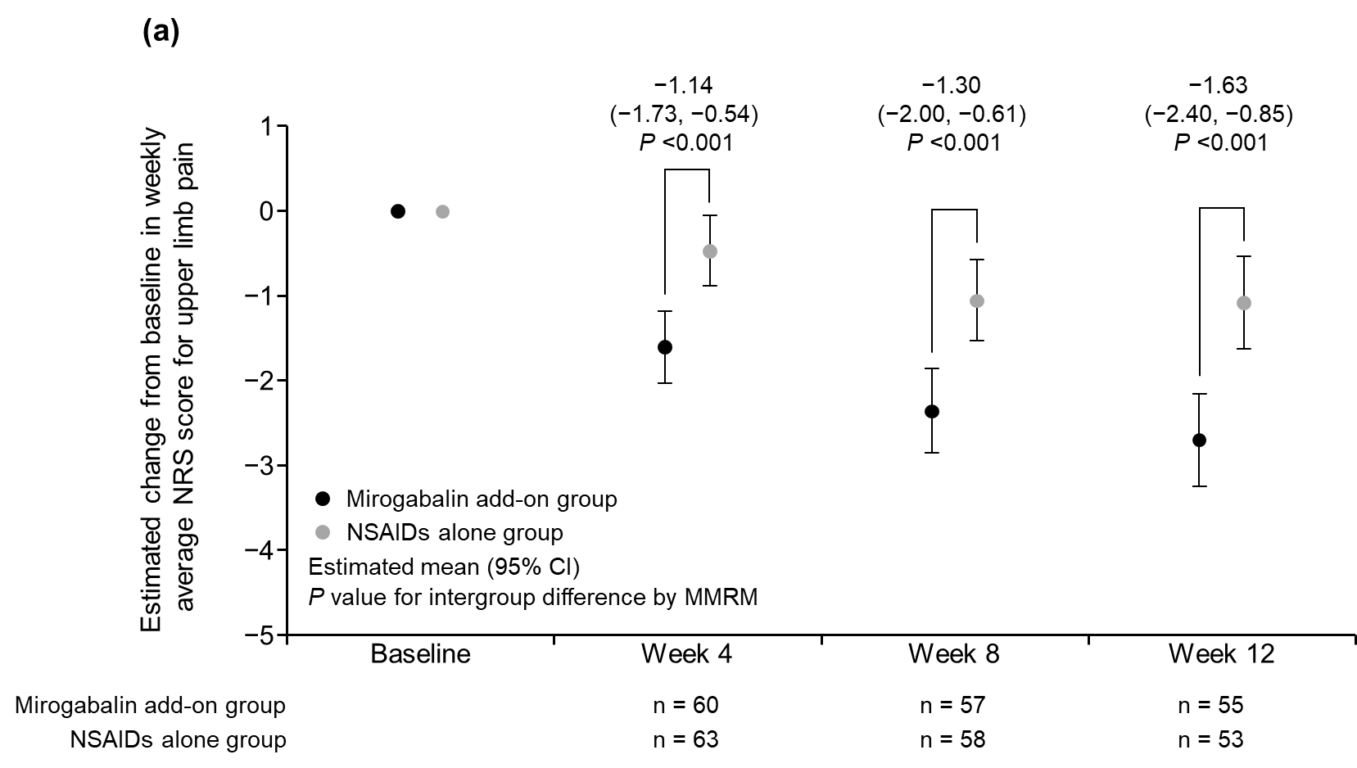
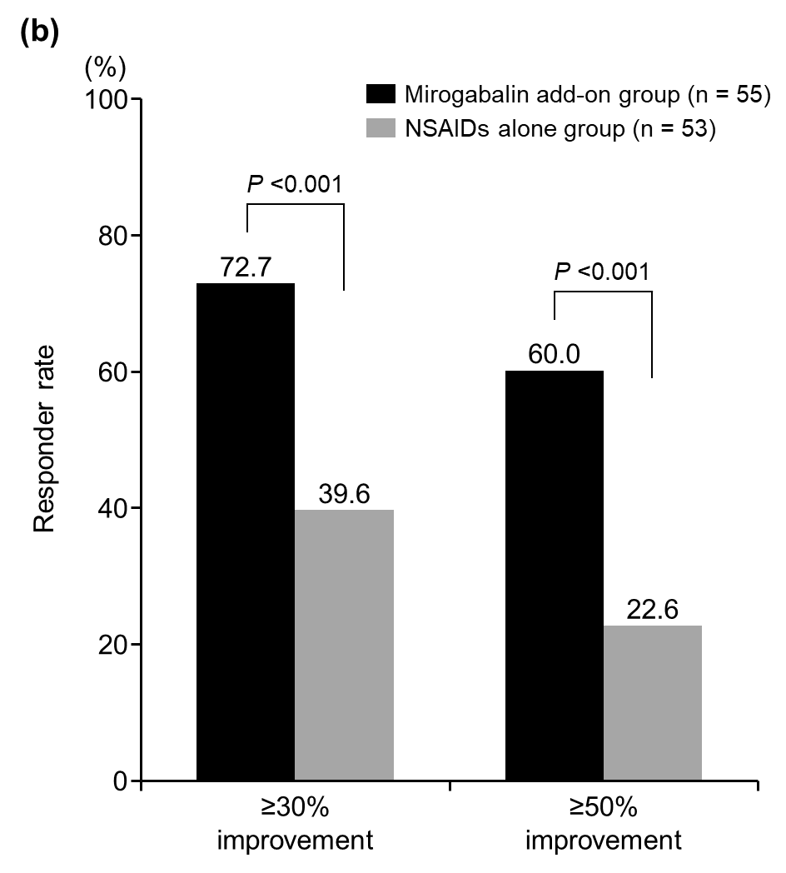
Figure S1 (a) Estimated change from baseline in the weekly average NRS score for upper limb pain over 12 weeks and (b) responder rate on the NRS score for upper limb pain at Week 12 (PPS population)
For panel a, data are estimated mean (95% CI) values. P value for intergroup difference by MMRM analysis. Error bars indicate 95% CIs.
For panel b, p value was calculated by Fisher’s exact test.
CI, confidence interval; MMRM, mixed model for repeated measures; NRS, numerical rating scale; NSAIDs, nonsteroidal anti-inflammatory drugs; PPS, per-protocol set.

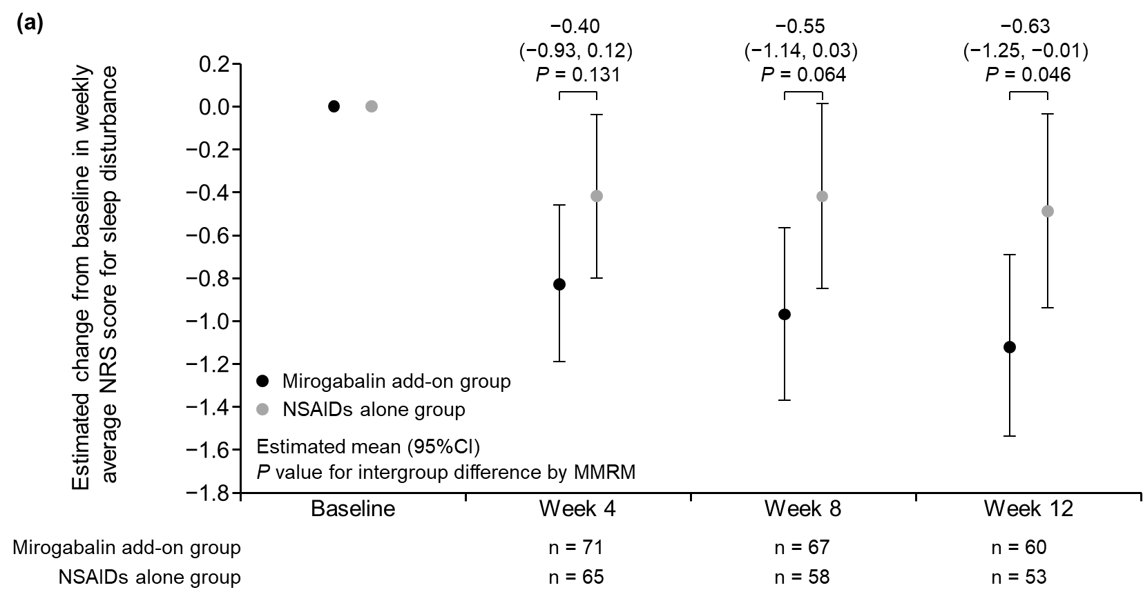
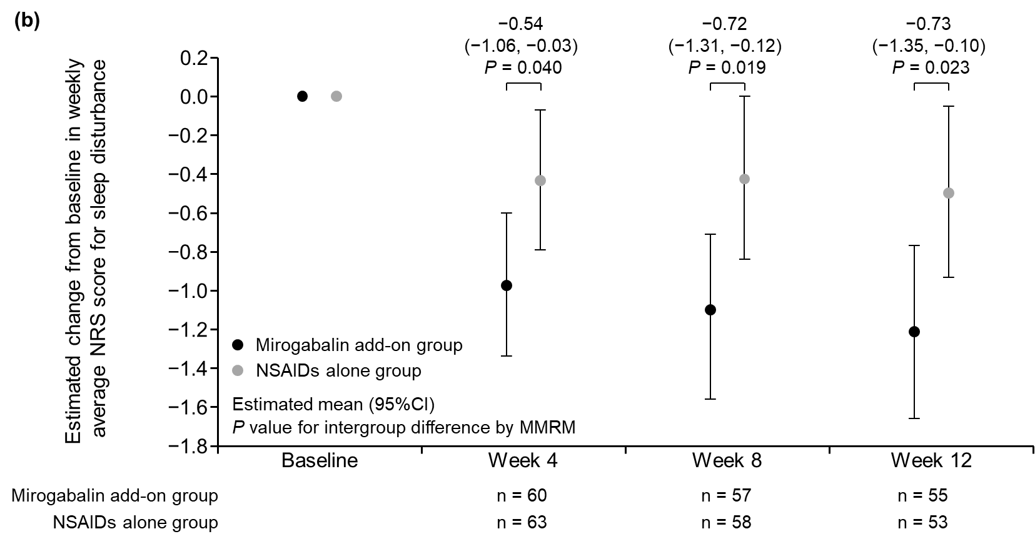
Figure S2 Change from baseline in weekly average NRS score for sleep disturbance in (a) mITT population and (b) PPS population
Data are estimated mean (95% CI) values. P value for intergroup difference by MMRM analysis. Error bars indicate 95% CIs.
A linear MMRM including treatment group, treatment duration (week), and treatment group-week interactions as fixed effects, the NRS score for sleep disturbance at baseline as a covariate, and patients as a random effect.
mITT, modified intention-to-treat; MMRM, mixed model for repeated measures; NRS, numerical rating scale; NSAIDs, non-steroidal anti-inflammatory drugs; PPS, per-protocol set.

