SUPPLEMENT
Supplemental Table 1. Survey item asking participants if the TED was active or inactive TED. The shown descriptions for each TED phase were provided here and throughout the survey.
Item S8. Is your Thyroid Eye Disease (TED) currently active or inactive?
When Thyroid Eye Disease (TED) is active, eye symptoms get worse and can include:

- Inflamed, red, or swollen eyes
- Eye pain with or without eye movement
- Eyes feel dry or gritty (like sand in your eyes)
- Eyes can tear up a lot (even if you are not crying)
- Difficulty opening or closing your eyelids
- Bulging eyes
- Double vision

When Thyroid Eye Disease (TED) is inactive, eyes are much less inflamed (not a lot of redness), but you may still have the following symptoms:

- Eyes feel dry
- Bulging eyes
- Double vision
- Difficulty moving the eyes
- Your doctor may have told you your eye disease has ‘burnt out’, ‘quieted’, or ‘is not active anymore.’

Supplemental Table 2. Survey items pertaining to patient and thyroid eye disease (TED) characteristics, TED signs and symptoms, and TED treatments.
Item # | Question | Response options
Patient characteristics
S1a | What is your age? | _____ # years old (open numerical response)
S2 | Please indicate your gender. | Male, Female
Q55 | To the best of your knowledge, are your thyroid levels normal? | Yes, No
Q56 | Which of the following best describes your thyroid levels? If you are taking medication for control your thyroid levels, please answer for your levels with medication (presented if Q55 response was ‘No’) | Too high, Too low
Q97 | Which of the following conditions have you been diagnosed with by a medical professional? | Gout, Chronic kidney disease/kidney problems, Being overweight or obese, Cardiovascular disease (e.g., heart disease, heart attack, stroke), High blood pressure (hypertension), Respiratory problems (e.g., asthma, emphysema, chronic obstructive pulmonary disease), Rheumatoid arthritis (RA), Anxiety, Cancer, Chronic fatigue syndrome, Depression, Fibromyalgia, Lupus, Osteoarthritis, Psoriatic arthritis (PsA), Psoriasis, Overactive thyroid, Ulcerative colitis, Chron’s disease, or inflammatory bowel disease, Other: please specify, None of the above
Thyroid eye disease characteristics
S5 | At what age were you diagnosed with TED? | _____ # years old (open numerical response)
S8 | Is your TED currently active or inactive? | Active, Inactive (see Supplemental Table 1)
S10 | At what ages was your TED diagnosed as inactive? When TED is inactive, eye are much less inflamed (not a lot of redness), but you may still have the following symptoms: eyes feel dry, bulging eyes, double vision, difficulty moving your eyes. | _____ # years old (open numerical response)
Q41 | What phrase did the healthcare professional use when they told you that your TED was inactive? When TED is inactive, eyes are much less inflamed (not a lot redness), but you may still have the following symptoms: eyes feel dry, bulging eyes, double vision, difficulty moving your eyes. | (Open text response)
TED signs and symptoms
Q24 | What symptoms related to TED were you experiencing at the time of TED diagnosis? | Inflammation and swelling on the eye, Inflammation and welling on the eyelid and/or surrounding area, Pain behind the eyes, Watery eyes (eyes that tear up too much), Dryness/grittiness, Bloodshot eyes, Sensitivity to light, Itchy eyes, Difficulty wearing contacts, Bulging eyes or wide-eyed appearance, Eyes do not look in the same direction, Double vision, Difficulty moving eyes, Blurry vision, Things didn’t look as colorful as they used to, Headaches, Other: please specify, None of the above
Q26 | Please rank the symptoms related to TED, you experienced at the time of diagnosis, according to their impact on your quality of life. A ranking of 1 would have the most impact on your quality of life. | Option to enter 1−5 on symptoms listed in Q24 (each number could only be used once)
Q44 | Symptoms related to inactive TED generally do not include a lot of the same one you had when your disease was active (or more inflamed) However you may still have some symptoms lingering or others you didn’t have before. Which of those symptoms listed below are bothering you (or bothered) you most when your disease became inactive? | Inflammation and swelling on the eye, Inflammation and welling on the eyelid and/or surrounding area, Pain behind the eyes, Watery eyes (eyes that tear up too much), Dryness/grittiness, Bloodshot eyes, Sensitivity to light, Itchy eyes, Difficulty wearing contacts, Bulging eyes or wide-eyed appearance, Eyes do not look in the same direction, Double vision, Difficulty moving eyes, Blurry vision, Things didn’t look as colorful as they used to, Headaches, Other: please specify, None of the above
Q45 | Please rank the symptoms related to inactive TED that you are experiencing according to its impact on your quality of life. A ranking of 1 would have the most impact. | Option to enter 1−5 on symptoms listed in Q44 (each number could only be used once)
TED treatments used/administered
Q27 | What medicines did you use in the active phase of your TED and how long did you take/use them? When TED is active eye symptoms get worse and can include: | Acetaminophen (Tylenol), Ibuprofen or naproxen (Advil, Aleve, Motrin), Aspirin, Over the counter eye lubricants/tear replacements, Prescription medication for dry (Restasis, Xiidra), Topical steroids (eye drops, ointments), Oral steroid, IV steroids, Rituxan (rituximab), Actemra (tocilizumab), Other: please specify
Q43 | What medicines have you been prescribed or recommended in the inactive phase of your TED and how long did you take/use them? When TED is inactive, eye are much less inflamed (not a lot of redness), but you may still have the following symptoms: eyes feel dry, bulging eyes, double vision, difficulty moving your eyes. | Acetaminophen (Tylenol), Ibuprofen or naproxen (Advil, Aleve, Motrin), Aspirin, Over the counter eye lubricants/tear replacements, Prescription medication for dry (Restasis, Xiidra), Topical steroids (eye drops, ointments), Oral steroid, IV steroids, Rituxan (rituximab), Actemra (tocilizumab), Other: please specify
Q28 | How many eye/orbital surgeries or procedures, if any, have you had as a result of your TED? If you have not had any surgeries or procedures, please enter “0”. | _____ Number of eye/orbital surgeries (open numerical response)
Q29 | Please indicate which surgery or procedure was performed, your age at the time of the surgery/procedure and which type of doctor or specialist performed the surgery/procedure. | Behind the eye surgery to relieve pain and maybe improve your eyesight (orbital decompression), Eye muscle surgery (to correct strabismus), Eyelid surgery, Cosmetic surgery to reshape soft tissue around the eye, Orbital radiation, Other: please specify

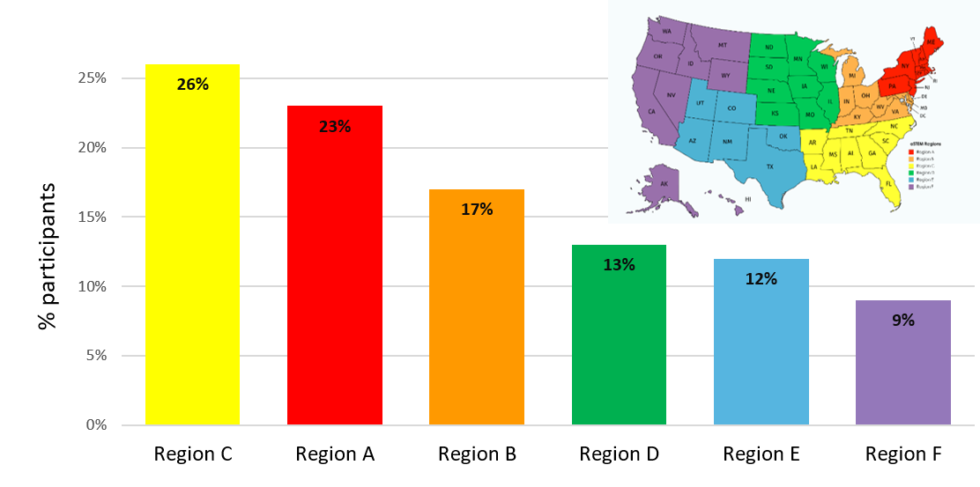
Supplemental Figure. Geographic distribution of survey participants. Participants were well-distributed across the United States, with 35 states represented (no participants were from HI, WV, KS, ND, SD, CT, RI, VT, ID, MT, WY, AS, CO, NM, OK). The shown map of the United States by Unknown Author is licensed under CC BY-SA.

