Supplementary Table 1. Search strategy.
Ovid MEDLINE(R) ALL <1946 to July 10, 2024>
1 | (intrathecal* or intra thecal*).mp.
2 | morphine.mp.
3 | 76I7G6D29C.rn.
4 | 2 or 3
5 | ((spine or spinal) adj3 (administ* or deliver* or analges* or anaesthes* or anesthes* or injection* or block*)).mp.
6 | 1 or 5
7 | 4 and 6
8 | exp abdomen/su
9 | exp abdomen/ and exp surgery/
10 | exp abdominal surgery/
11 | exp digestive system surgical procedures/
12 | ((abdom* or digestive or gastrointestinal or stomach or gastric or liver or hepatic or appendix or pancrea* or intestin* or spleen or splenec*) adj3 (surgery or surgical)).mp.
13 | exp bariatric surgery/ or exp laparotomy/ or abdominoplasty/ or splenectomy/ or liver transplantation/ or pancreas transplantation/
14 | (roux-en-y anastomosis or appendectomy* or biliary tract surg* or biliopancreatic diversion or cholecystectomy* or cholecystostomy* or choledochostom* or hepatic portoenterostomy* or endoscopic sphincterotom* or transduodenal sphincterotom* or biliopancreatic diversion or colectomy* or restorative proctocolectomy* or endoscop* or endoscopic retrograde cholangiopancreatography* or enteroscop* or colonoscop* or sigmoidoscop* or duodenoscop* or endoscopic mucosal resection or esophagoscop* or gastroscop* or proctoscopy* or transanal endoscopic surgery or transanal endoscopic microsurgery or pyloromyotomy* or enterostom* or cecostomy* or colostomy* or duodenostomy* or ileostomy* or jejunostomy* or esophagectomy* or esophagoplast* or esophagostom* or fundoplication or gastrectomy* or pyloromyotomy* or gastroenterostomy* or gastric bypass or gastropexy* or gastroplasty* or gastrostomy* or heller myotom* or hemorrhoidectomy* or hepatectomy* or jejunoileal bypass or lateral internal sphincterotom* or (liver adj2 transplant*) or (pancrea* adj2 transplant*) or pancreatectomy* or pancreaticoduodenectomy* or pancreaticojejunostom* or peritoneovenous shunt or bariatric surg* or laparotomy* or abdominoplast* or splenectom* or prostatectom* or hysterectom*).mp.
15 | 8 or 11 or 12 or 13 or 14
16 | 7 and 15

Embase Classic+Embase <1947 to 2024 July 10>
1 | (intrathecal* or intra thecal*).mp.
2 | morphine.mp.
3 | ((spine or spinal) adj3 (administ* or deliver* or analges* or anaesthes* or anesthes* or injection* or block*)).mp.
4 | 1 or 3
5 | 2 and 4
6 | exp abdomen/su
7 | exp abdomen/ and exp surgery/
8 | exp abdominal surgery/
9 | ((abdom* or digestive or gastrointestinal or stomach or gastric or liver or hepatic or appendix or pancrea* or intestin* or spleen or splenec*) adj3 (surgery or surgical)).mp.
10 | exp bariatric surgery/ or exp laparotomy/ or abdominoplasty/ or splenectomy/ or liver transplantation/ or pancreas transplantation/
11 | (roux-en-y anastomosis or appendectomy* or biliary tract surg* or biliopancreatic diversion or cholecystectomy* or cholecystostomy* or choledochostom* or hepatic portoenterostomy* or endoscopic sphincterotom* or transduodenal sphincterotom* or biliopancreatic diversion or colectomy* or restorative proctocolectomy* or endoscop* or endoscopic retrograde cholangiopancreatography* or enteroscop* or colonoscop* or sigmoidoscop* or duodenoscop* or endoscopic mucosal resection or esophagoscop* or gastroscop* or proctoscopy* or transanal endoscopic surgery or transanal endoscopic microsurgery or pyloromyotomy* or enterostom* or cecostomy* or colostomy* or duodenostomy* or ileostomy* or jejunostomy* or esophagectomy* or esophagoplast* or esophagostom* or fundoplication or gastrectomy* or pyloromyotomy* or gastroenterostomy* or gastric bypass or gastropexy* or gastroplasty* or gastrostomy* or heller myotom* or hemorrhoidectomy* or hepatectomy* or jejunoileal bypass or lateral internal sphincterotom* or (liver adj2 transplant*) or (pancrea* adj2 transplant*) or pancreatectomy* or pancreaticoduodenectomy* or pancreaticojejunostom* or peritoneovenous shunt or bariatric surg* or laparotomy* or abdominoplast* or splenectom* or prostatectom* or hysterectom*).mp.
12 | 6 or 7 or 8 or 9 or 10 or 11
13 | 5 and 12
14 | limit 13 to (article-in-press status or embase status or in-process status)
15 | limit 14 to english language
16 | (random* or rct or blind* or trial).mp.
17 | 15 and 16
18 | limit 17 to (editorial or letter or "review")
19 | 17 not 18

EBM Reviews - Cochrane Central Register of Controlled Trials <June 2024>
1 | (intrathecal* or intra thecal*).mp.
2 | morphine.mp.
3 | 76I7G6D29C.rn.
4 | 2 or 3
5 | ((spine or spinal) adj3 (administ* or deliver* or analges* or anaesthes* or anesthes* or injection* or block*)).mp.
6 | 1 or 5
7 | 4 and 6
8 | exp abdomen/su
9 | exp abdomen/ and exp surgery/
10 | exp abdominal surgery/
11 | exp digestive system surgical procedures/
12 | ((abdom* or digestive or gastrointestinal or stomach or gastric or liver or hepatic or appendix or pancrea* or intestin* or spleen or splenec*) adj3 (surgery or surgical)).mp.
13 | exp bariatric surgery/ or exp laparotomy/ or abdominoplasty/ or splenectomy/ or liver transplantation/ or pancreas transplantation/
14 | (roux-en-y anastomosis or appendectomy* or biliary tract surg* or biliopancreatic diversion or cholecystectomy* or cholecystostomy* or choledochostom* or hepatic portoenterostomy* or endoscopic sphincterotom* or transduodenal sphincterotom* or biliopancreatic diversion or colectomy* or restorative proctocolectomy* or endoscop* or endoscopic retrograde cholangiopancreatography* or enteroscop* or colonoscop* or sigmoidoscop* or duodenoscop* or endoscopic mucosal resection or esophagoscop* or gastroscop* or proctoscopy* or transanal endoscopic surgery or transanal endoscopic microsurgery or pyloromyotomy* or enterostom* or cecostomy* or colostomy* or duodenostomy* or ileostomy* or jejunostomy* or esophagectomy* or esophagoplast* or esophagostom* or fundoplication or gastrectomy* or pyloromyotomy* or gastroenterostomy* or gastric bypass or gastropexy* or gastroplasty* or gastrostomy* or heller myotom* or hemorrhoidectomy* or hepatectomy* or jejunoileal bypass or lateral internal sphincterotom* or (liver adj2 transplant*) or (pancrea* adj2 transplant*) or pancreatectomy* or pancreaticoduodenectomy* or pancreaticojejunostom* or peritoneovenous shunt or bariatric surg* or laparotomy* or abdominoplast* or splenectom* or prostatectom* or hysterectom*).mp.
15 | 8 or 9 or 10 or 11 or 12 or 13 or 14
16 | 7 and 15

Supplementary Figure 1. Risk of bias (RoB). The RoB assessment is displayed in this plot for each trial included in the meta-analysis where pain score was available to be assessed. Level of bias is represented by each colour, low (green), some concerns (yellow), or high (red).

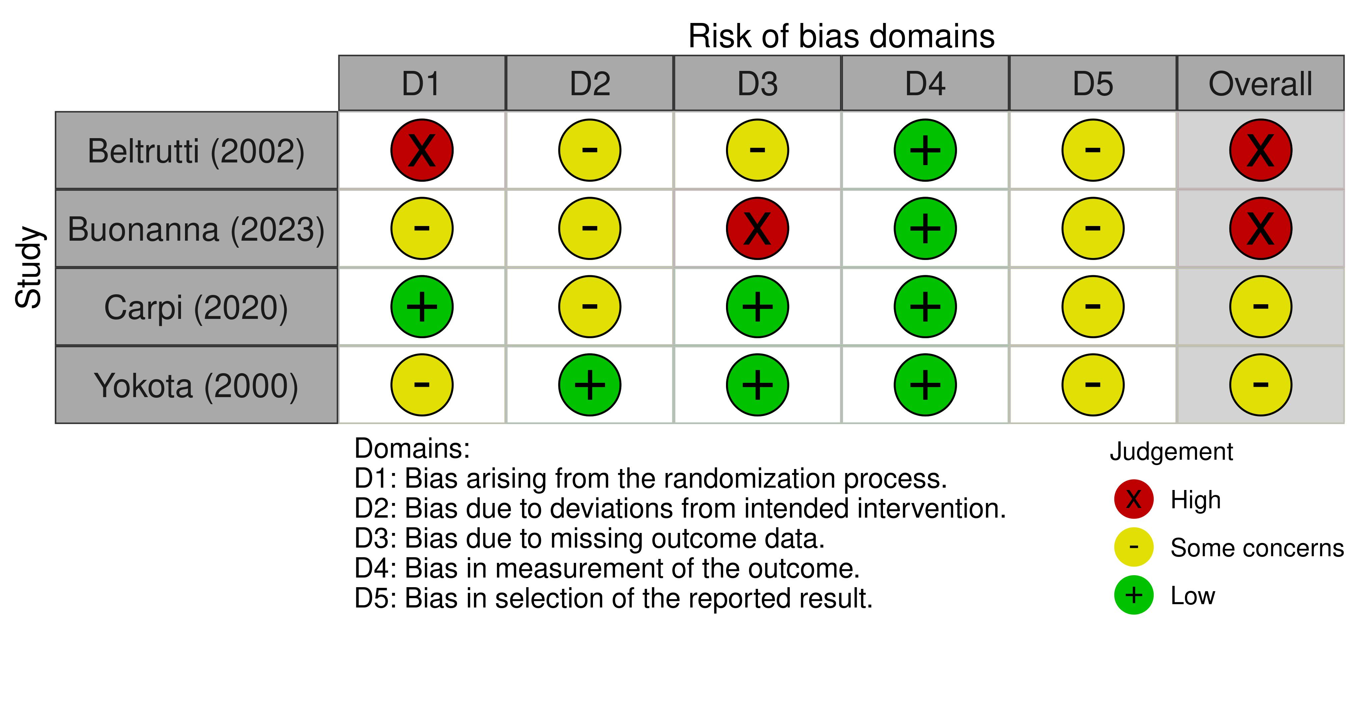

Supplementary Figure 2. Galbraith plot assessing heterogeneity of the main outcome meta-analysis [opioid dose used up to 72 hours post-operatively].
The y-axis shows the standardised effect size, calculated as the mean difference divided by the SE. This standardisation allowed us to compare the effect sizes of studies on the same scale, regardless of their original units. The red line represents the fitted regression line. If there is no heterogeneity, studies should scatter around this line. The horizontal black line at zero represents the "no effect" line, where the standardised effect size equals zero. Points above this line suggest higher opioid use, while points below indicate lower opioid use. The shaded grey area represents the 95% limits. Studies falling outside this area were considered potential outliers or contributors to heterogeneity.

Abbreviations: SE, standardised effect

Supplementary Table 3. Subgroup analyses for pain scores (rest and dynamic) by type of surgery and dose of ITM.

Outcome | Subgroup | No. of studies | No. of patients | Mean Difference (Random, 95% CI)
Pain scores at rest 24 hours after surgery (by type of surgery)
ITM vs Epidural/regional | Laparoscopic | 4 | 292 | -0.15 (-2.07, 1.77)
 | Open | 3 | 136 | -0.48 (-1.26, 0.30)
 | Open and lap | 1 | 200 | 0.30 (-0.23, 0.83)
 | Robotic | 1 | 30 | -0.22 (-0.75, 0.31)
 | Pooled | 9 | 658 | -0.23 (-0.99, 0.53)
ITM vs Sham/IV opioids | NR | 1 | 56 | 1.00 (-1.89, 3.89)
 | Laparoscopic | 6 | 257 | -0.99 (-2.44, 0.46)
 | Open | 8 | 554 | -0.82 (-1.40, -0.24)
 | Open and lap | 1 | 88 | -1.20 (-1.85, -0.55)
 | Percutaneous | 3 | 20 | -0.80 (-3.33, 1.73)
 | Robotic | 3 | 98 | -1.06 (-2.02, -0.11)
 | Pooled | 20 | 1,073 | -0.96 (-1.48, -0.43)
Pain scores at rest 24 hours after surgery (by dose)
ITM vs Epidural/regional* | 0.10 mg | 1 | 200 | 0.30 (-0.23, 0.83)
 | 0.14 mg | 1 | 30 | -0.22 (-0.75, 0.31)
 | 0.20 mg | 2 | 82 | 0.00 (-0.64, 0.64)
 | 0.25 mg | 1 | 120 | -1.00 (-1.25, -0.75)
 | 0.30 mg | 1 | 59 | -1.12 (-1.90, -0.34)
 | 0.40 mg | 3 | 167 | -0.20 (-2.41, 2.81)
 | Pooled | 9 | 658 | -0.23 (-0.99, 0.53)
ITM vs Sham/IV opioids* | 0.10 mg | 1 | 32 | 1.70 (0.57, 2.83)
 | 0.14 mg | 1 | 30 | -0.62 (-1.21, -0.03)
 | 0.17 mg | 1 | 45 | -3.60 (-5.33, -1.87)
 | 0.20 mg | 6 | 349 | -1.12 (-2.09, -0.15)
 | 0.30 mg | 5 | 323 | -1.14 (-2.20, -0.09)
 | 0.40 mg | 2 | 124 | -0.70 (-1.58, 0.18)
 | 0.50 mg | 3 | 78 | -0.80 (-1.68, 0.09)
 | 0.75 mg | 1 | 92 | -1.00 (-1.65, -0.35)
 | Pooled | 20 | 1,073 | -0.96 (-1.48, -0.43)
Pain scores (dynamic) 24 hours after surgery (by type of surgery)
ITM vs Epidural/regional | Laparoscopic | 1 | 45 | -2.00 (-3.30, -0.70)
 | Open | 2 | 186 | 0.52 (-2.52, 3.55)
 | Pooled | 3 | 231 | -0.28 (-2.67, 2.11)
ITM vs Sham/IV opioids | Laparoscopic | 6 | 247 | -0.99 (-1.95, -0.03)
 | Open | 4 | 266 | -0.35 (-1.45, 0.76)
 | Robotic | 3 | 198 | -2.13 (-3.00, -1.26)
 | Pooled | 13 | 711 | -1.11 (-1.80, -0.41)
Pain scores (dynamic) 24 hours after surgery (by dose)
ITM vs Epidural/regional | 0.16 mg | 1 | 132 | 2.10 (1.18, 3.02)
 | 0.25 mg | 1 | 45 | -2.00 (-3.30, -0.70)
 | 0.40 mg | 1 | 54 | -1.00 (-1.27, 0.73)
 | Pooled | 3 | 231 | -0.28 (-2.67, 2.11)
ITM vs Sham/IV opioids | 0.10 mg | 1 | 32 | -2.00 (-3.13, -0.87)
 | 0.175 mg | 1 | 45 | -1.10 (-2.77, 0.57)
 | 0.20 mg | 1 | 124 | -0.85 (-2.59, 0.88)
 | 0.25 mg | 2 | 46 | 0.00 (-1.42, 1.42)
 | 0.30 mg | 1 | 390 | -1.72 (-3.04, -0.39)
 | 0.40 mg | 1 | 36 | 0.50 (0.24, 0.76)
 | 0.50 mg | 1 | 38 | -1.90 (3.17, -0.63)
 | Pooled | 13 | 711 | -1.11 (-1.80, -0.41)

Supplementary Figure 3. Respiratory Depression*.
*Repeated postoperative doses of ITM given in Beltrutti 2002; no changes in the result from adding this study
Supplementary Figure 4. Sedation.
Supplementary Figure 5. Relative risk of pruritus, nausea, and vomiting*.
* Repeated postoperative doses of ITM given in Beltrutti 2002, with exclusion of this this study the overall estimate for pruritus remains similar: (RR 3.40, 95% CI 2.40, 4.81, I²=49.48%, p<0.09)

** Multi-arm studies contributing to multiple comparisons were included by splitting the shared ITM arm equally (participants and events halved); therefore, the number of comparisons shown in the plots is greater than the number of unique studies reported in the text. (Pruritus: 42 vs 40; nausea: 36 vs 34; vomiting: 22 vs 21.)

Supplementary Figure 6. Mean difference of length of stay.

Supplementary Figure 7. Funnel plot of opioid use up to 72 hours post operatively (intrathecal morphine versus control group). Surgery types separated.

For studies in the white region, the null hypothesis of no effect can be rejected at the 1% significance level. That is, the significance tests for these studies would have p-values less than 0.01 or 1%. For studies in the light-grey region, the p-values would be between 1% and 5%. For studies in the darker-grey region, the p-values would be between 5% and 10%. And for studies in the darkest-grey region, the p-values would be larger than 10%. The plot shows that there are studies in all 4 areas

