SUPPLEMENTARY FIGURES

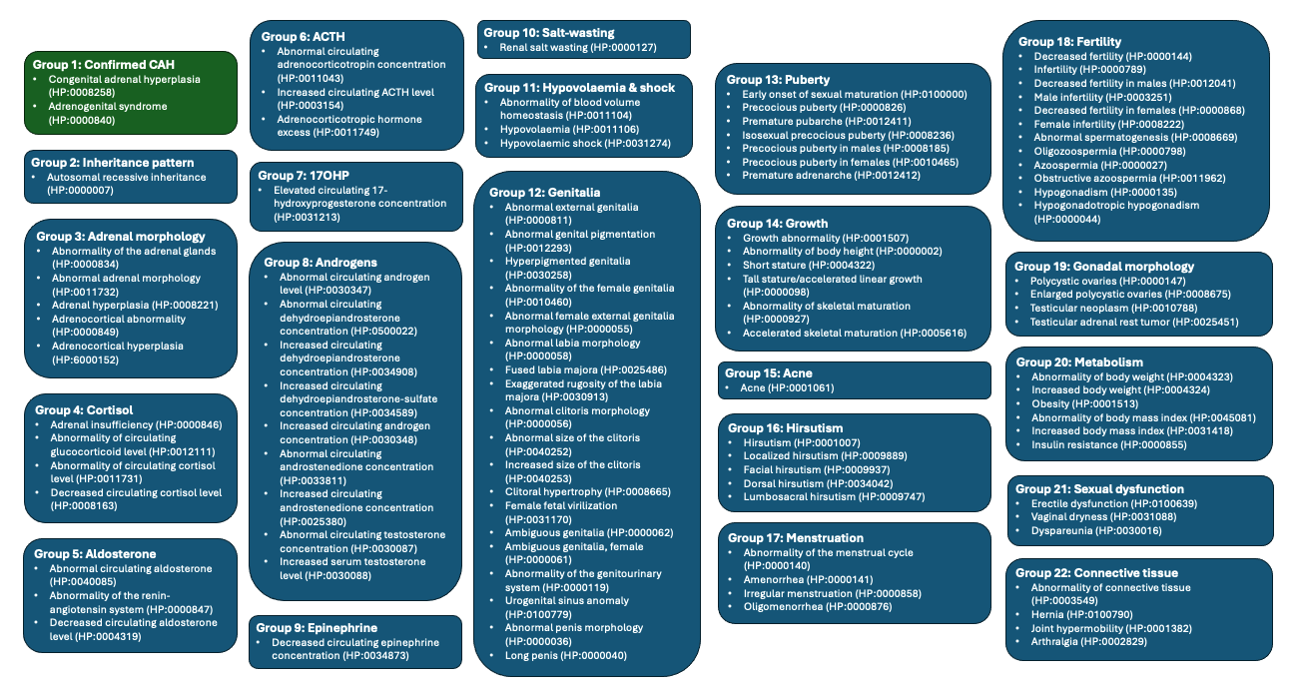
Supplementary Figure 1 – CAH phenotype groups and HPO terms generated from existing literature (1, 17, 31-40) that were used to produce this study’s case and control cohorts. The green box contains terms used to generate the case cohort; the blue boxes are CAH-related phenotypes, which were all used to exclude individuals from the control cohort.

Possible transcription factor | Human gene(s) (Ensembl gene ID) | GTex-reported human adrenal expression (median TPM) | Zebrafish orthologue(s)  (Ensembl gene ID)
ETV2::FIGLA | ETV2  (ENSG00000105672) | 1.17 | None found
ETV2::FIGLA | FIGLA  (ENSG00000183733) | 0.00 | figla (ENSDARG00000087166)
ZNF768 | ZNF768  (ENSG00000169957) | 30.08 | None found
PATZ1 | PATZ1  (ENSG00000100105) | 11.96 | patz1 (ENSDARG00000076584)
ZNF148 | ZNF148  (ENSG00000163848) | 7.37 | znf148 (ENSDARG00000055106)

Supplementary table 1 – Table of transcription factors with potential binding affected by rs150223621; their expression; and zebrafish orthologues. TPM = transcripts per million (for reference, CYP21A2 has predominantly adrenal expression with 1,722 median adrenal transcripts per million).

