- Data collection and analysis tools
  - Translated sample of photovoice diary
Photovoice Diary:
Community-based fisheries management in Timor-Leste from a gender perspective project
Name: Suco:
Photo | Date | What is in this photo? | Photography location | Which questions does this relate to? | Did I ask the subject for consent? |  | Can I include their face?
1 |  |  |  |  | □ Yes | □ No | □ Yes | □ No
2… |  |  |  |  | □ Yes | □ No | □ Yes | □ No
…20 |  |  |  |  | □ Yes | □ No | □ Yes | □ No
  - Translated interview guide
- Name
- Transfer the photos to the laptop
- Using the images and the photovoice diary, gather the stories and ideas from each person individually
- We have four photography prompts, so choose your favourite photos for each question (up to three images). Why are these your favourite photos?
For each photograph
- Tell the story or share your experience related to each photograph
- Why does this condition exist? Why did you choose to take this photo?
- What can you see in this photo? Why?
- How does this photo relate to your own life?
- How does change this make you feel?
- What can we change/develop to make this better or to keep this going?
- How is this photo related to the fisheries monitoring programme? Why?
- During the Photovoice activities, what challenges did you encounter? And what should we improve?
Notes from the interviewer
- What did they say?
- How do you feel about what they said or how they said it?
  - Example of inductive photo story analysis approach
Fig. 9. Example of the inductive photo-story grouping approach used to develop themes within each of the research question topics – in this case, the conditions which enable the fisheries monitoring programme.

- Photo stories with photographers’ full captions plus selected supplementary photo stories
  - Fig. 3
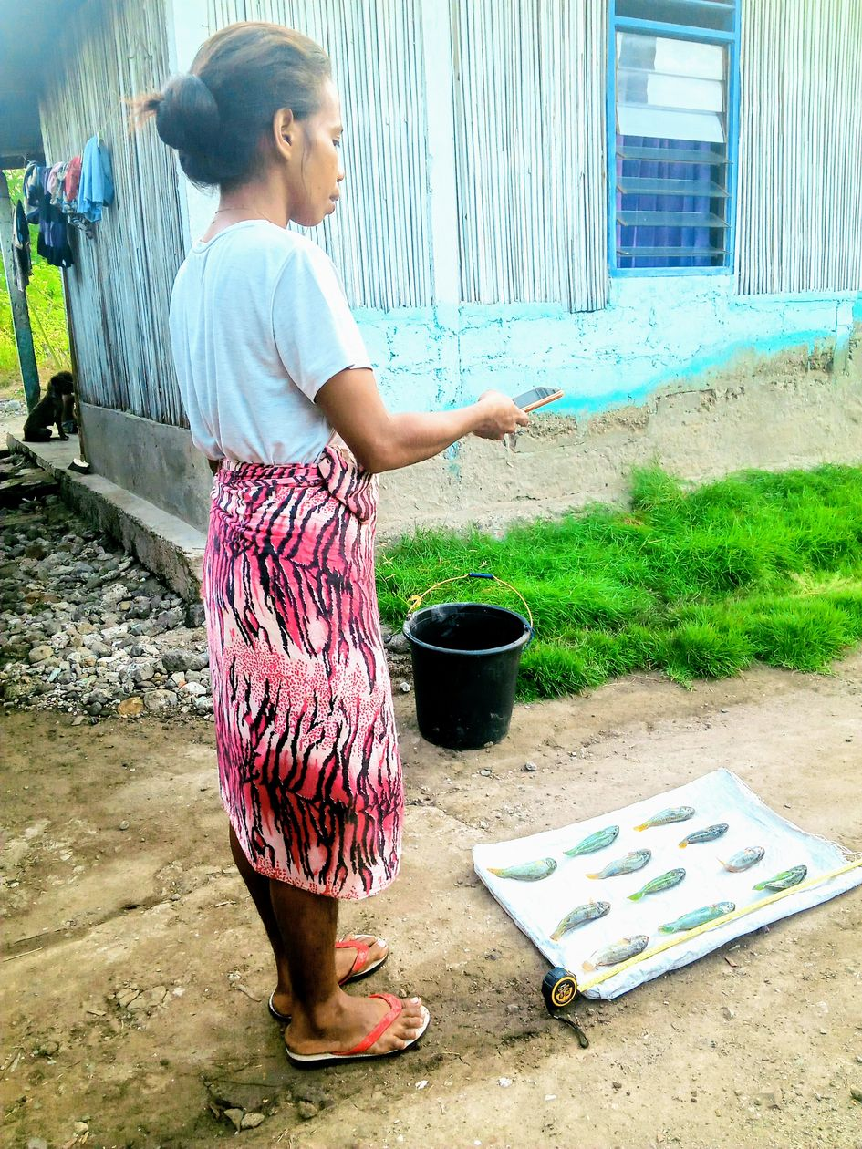 | Fig. 3A) “[This data collector] is collecting data using a tape measure to measure the fish” by Alfansina  This picture shows that I have learned to collect data. [We] are collecting data. She is collecting data by laying the sack on the ground and putting the fish on top of it for the photo. I feel good because doing this programme made me learn new things. This photo shows the fisheries monitoring activities, which involves collecting data by taking photos, filling out the ODK [Open Data Kit] survey and sending it off. It’s easy because the fishers give us access to their fish for data.

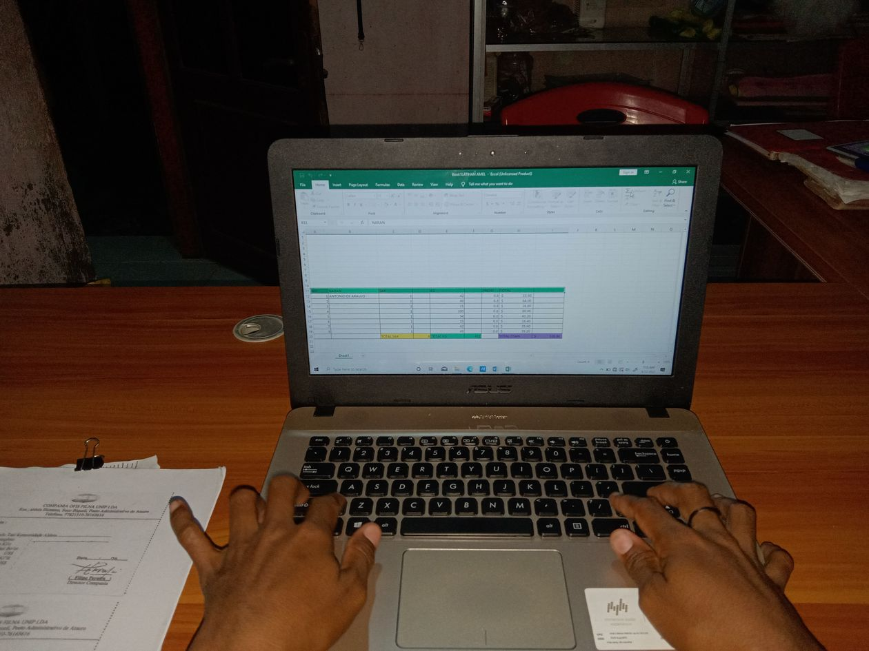 | Fig. 3B) “I want to learn how to use the computer” by Meret  I want to learn how to use computer because we need to prepare graphs and work with data as part of the fisheries monitoring. I also want to learn to use a computer because it relates to my job as a secretary in the seaweed group, to support the group’s work. I would be able to prepare graphs with the data we collect to share with the community.

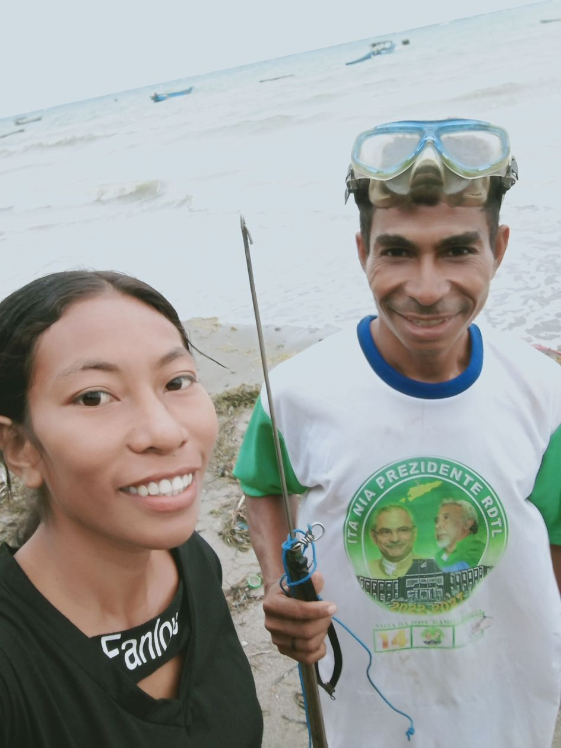 | Fig. 3C) “A selfie with a fisher at the beach” by Hiana  I wanted to take this photo because this fisherman, who is my uncle, always gives me access to his fish to collect data. In the mornings, my uncle prepares his speargun and goggles for diving. He helps me with knowing the fishers’ names and weighing the fish. I live nearby the fishers in our community, which makes it easy for me to collect data. Through the fisheries monitoring programme, I learnt how to collect data, measure and weigh the fish and complete/fill out the ODK form. In the future, I want to learn more about the names of the fish.

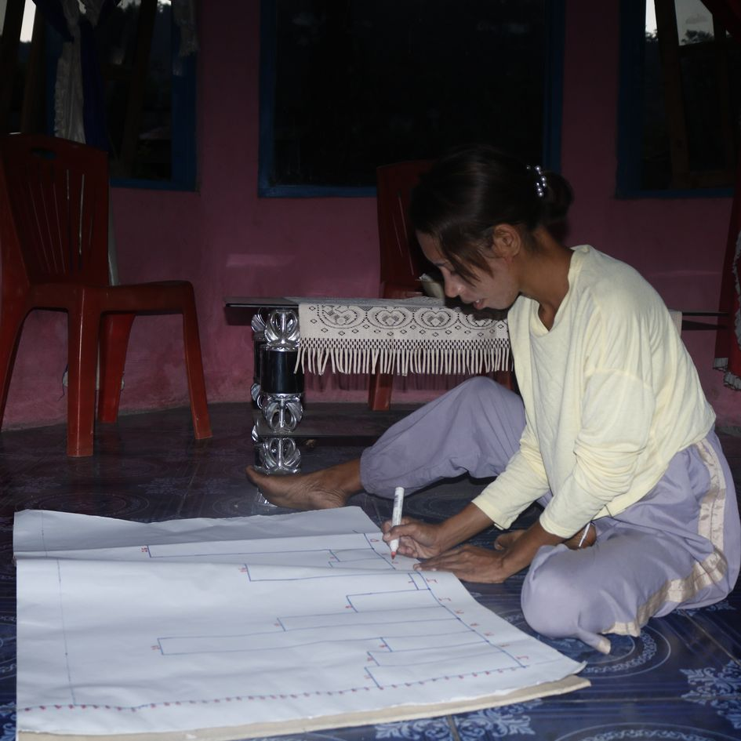 | Fig. 3D) “I know how to make graphs” by Ermelita  I am showing that I now know how to make graphs. Here I am making a graph with the fisheries monitoring data so that we if the amount of fish is decreasing or increasing. I want to show our graphs to the fishers, so that they know which kinds of fish in the ocean are declining or plentiful.
  - Fig. 4
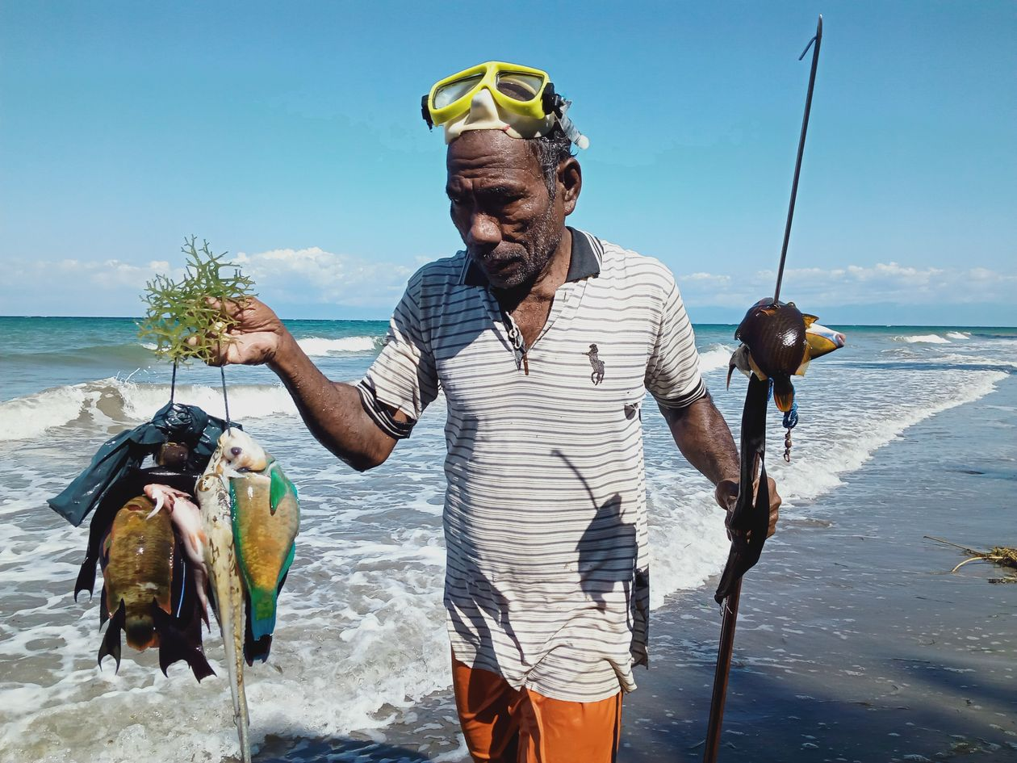 | Fig. 4A) “Being close with a fisherman” by Elmanda  This fisherman just returned from the sea carrying his speargun and the colourful fish he caught are hanging on a string. I took this picture because I collect data from him every day and send it with ODK, so he has become my favourite! I want for the fishers to rest at home when the sea is rough and go diving or fishing when the conditions are good.

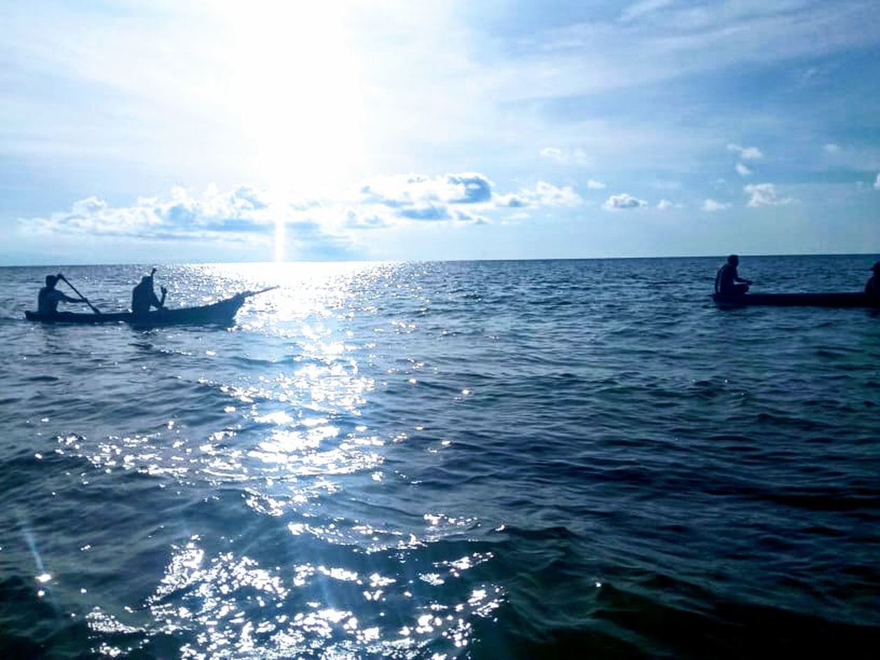
Fig. 4B) “The time in the morning when the fishers go fishing” by Samsi
I wanted to take this picture because the fishers usually go fishing early in the morning, so it’s hard for us to meet them around this time. Four fishers are paddling the canoes and they bring spearguns ready for fishing together as a group. From this photo, I wanted to call for support to provide motorboats to the fishers, so that they can go fishing further away. This would be a good because the fishers already know to use the canoe for fishing nearby, as it does not require too much fuel, but they would use the motorboat for fishing far away. I want the fishers to use life-saving equipment when they go fishing, whether it is with the canoe or motorboat. This relates to the fisheries monitoring because the fishers easily allow us to collect data from their fish.

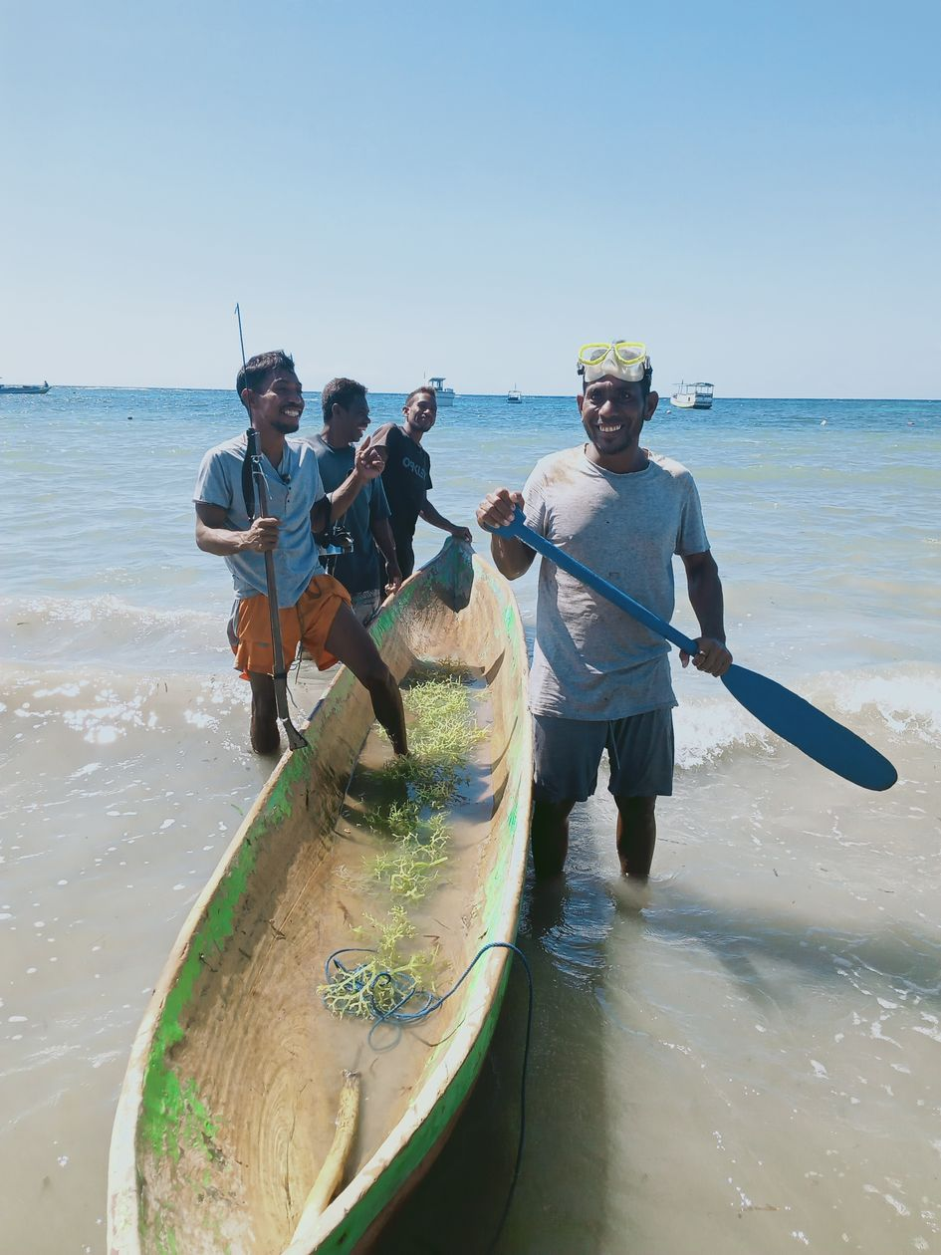 | Fig. 4C) “A group of fishermen about to go diving” by Hiana  I wanted to take this photo because I live nearby this group, so it makes it easy for me to collect data as part of the fisheries monitoring group. These fishermen are preparing to go diving with a canoe and spearguns. These fishers usually catch big fish and I want to improve this, for example, by introducing Tara Bandu.

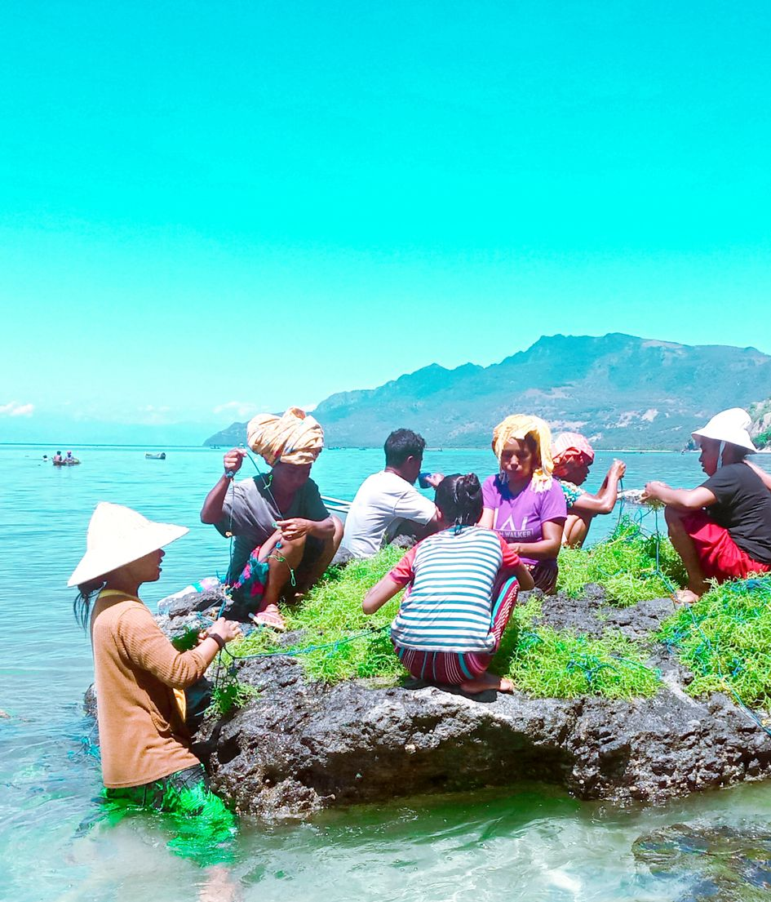 | Fig. 4D) “Me and my family tying the seaweed” by Alianca  I wanted to take this picture because I like tying the seaweed with family. You can see my family members tying the seaweed on top of a big rock. Once we collect the seaweed. we always tie it there because the spot is nearby and it keeps the seaweed clean. I feel it makes it easier for me because when I am doing the fisheries monitoring activities my family help me tie the seaweed. I want to get a spot with a nice shade so that me and my family can sit there to tie the seaweed.

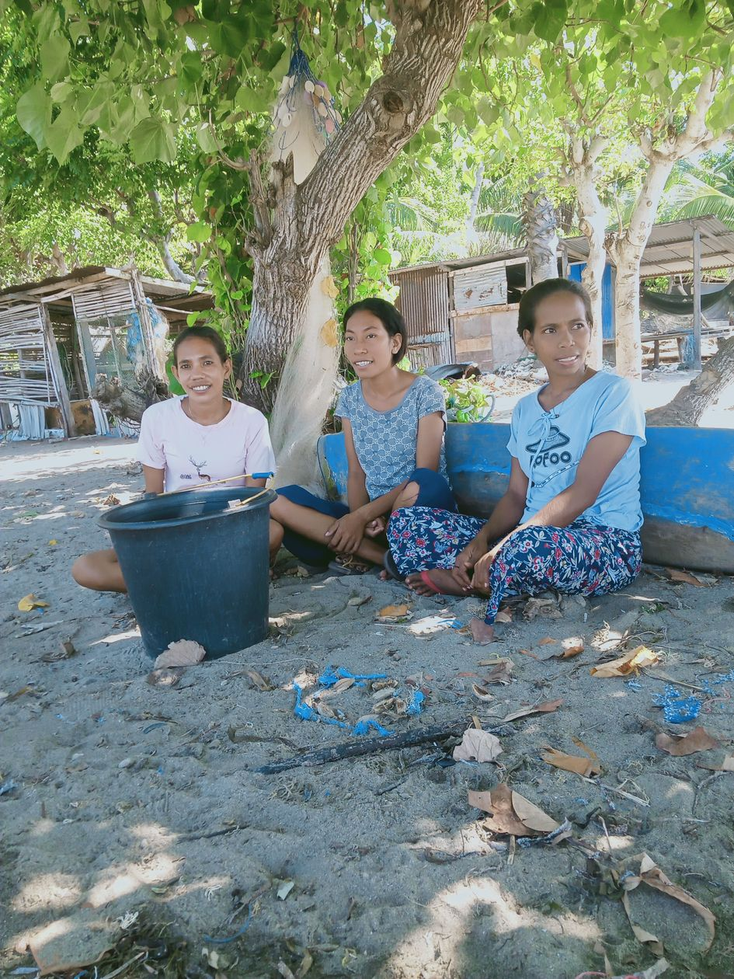 | Fig. 4E) “A photo with the fisheries monitoring group” by Hiana  I chose this photo because we are always together, which makes it easy for us to collect data, but it’s difficult sometimes because we wait for the fishermen for a long time. Overall, this way works, but I would like to change the way we have being doing it so that we wait for the fishers to return before going out to collect the data.

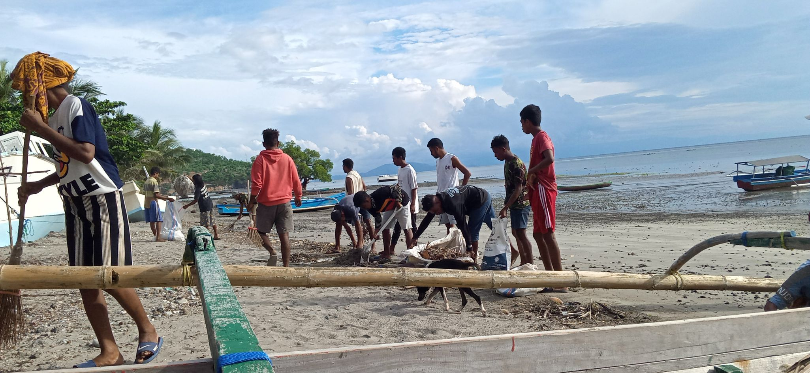
Fig. 4F Supplementary) “On Friday afternoons lots of people collect rubbish and put it in bags” by Alfansina
In this picture the community is cleaning the beach, they do this to prevent the damage it can do to the fish and to prevent mosquitoes. Every Friday, the community cleans the beach and takes the rubbish to the dump, as the xefe aldeia [aldeia chief] directed. It is good because it reduces illness, protects the fish in the sea and is good for the environment. I would like to publish/share this on Facebook to show that Ilik-namu aldeia has interest in cleaning the beach, because it makes the beach more beautiful and can attract tourists. This relates to our fisheries monitoring activities because we need to clean the beach as part of conserving the fish in the sea; if not, there won’t be anything for the fishers. Through Blue Ventures sharing films about how rubbish can damage the fish, it raises awareness about the impact this can cause.

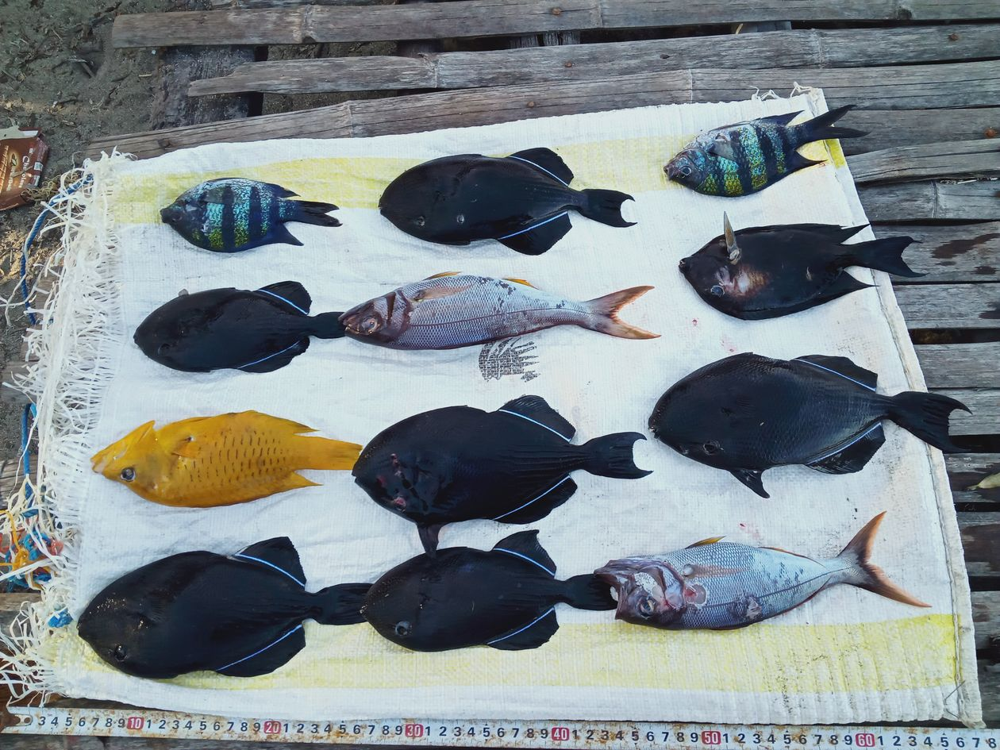
Fig. 4G Supplementary) “Fish placed on top of a sack” by Elmanda
In this photo the fish are placed on the sack, measured with a tape measure and photographed. It’s easy because I know the names of the fish. I took this photo because this will be entered into ODK for fisheries monitoring. Through photos like this, I want fishers to just catch large fish, rather than small ones, if they go fishing in the future. In terms of the fisheries monitoring programme, being close with the fishers makes it easy to collect the data.
  - Fig. 5
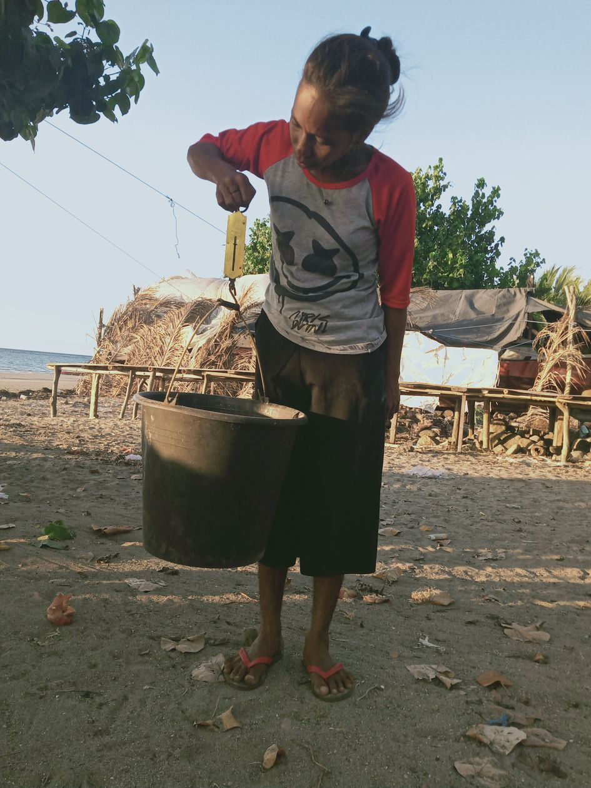 | Fig. 5A) “Weighing fish in a bucket” by Meret  In the morning I go down to the beach to meet the fishers so I can collect data. I bring a scale and put the fish in the bucket to weigh them, so I can know more about the fish. It’s hard because I don’t know all the fishers, and I must ask to weigh their fish. I want to go to the beach early so that I can wait for the fishers in order to collect data.

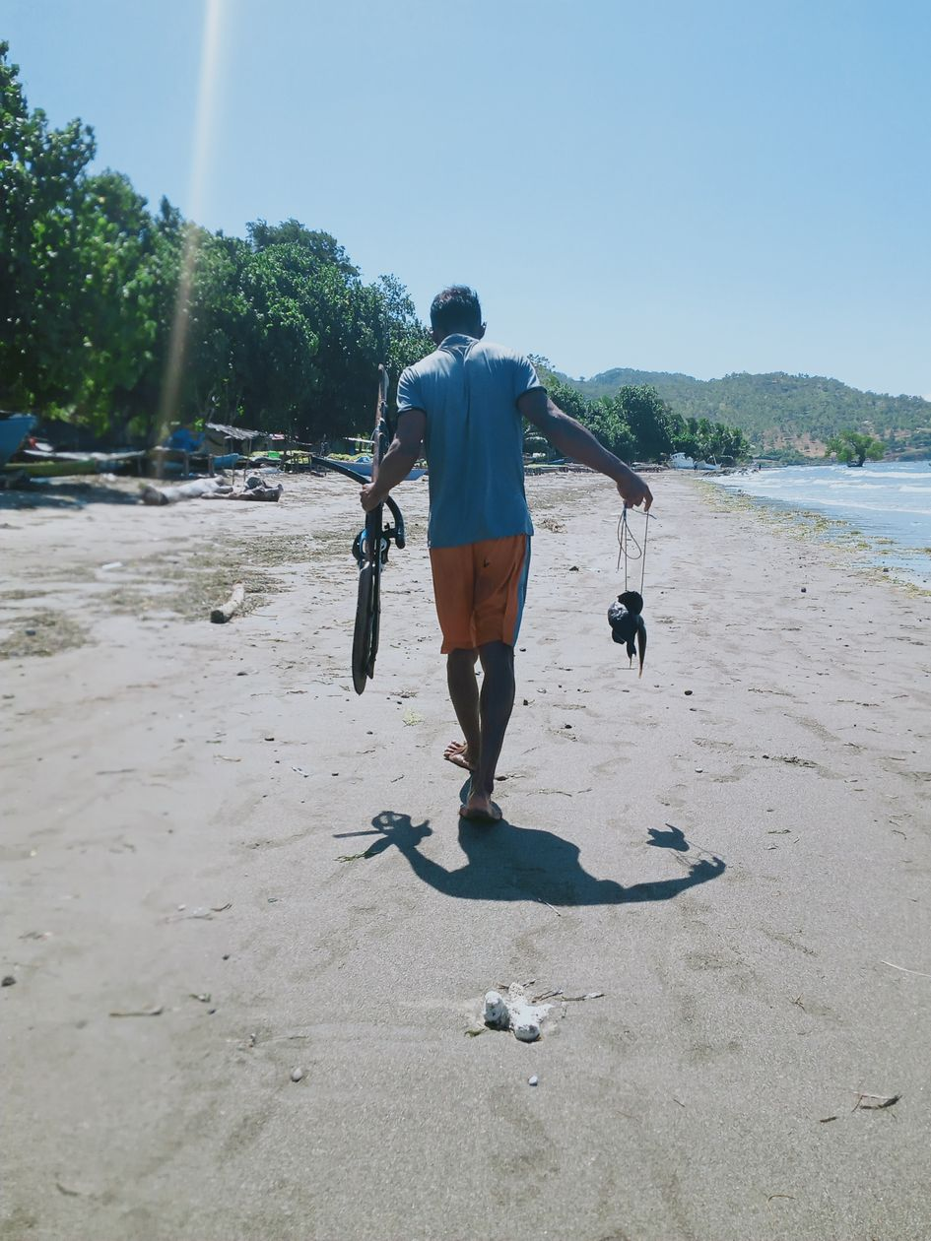 | Fig. 5B) “This fisherman did not give his fish for data collection” by Alfansina  This photo shows that sometimes this fisherman does not want to allow his catch to be used for fisheries monitoring. He is carrying his speargun and fish back home. I don’t feel good about it because then it is difficult to collect data, since he did not give us access to his fish. I want to approach the fisherman to humbly request access to his fish for data collection.

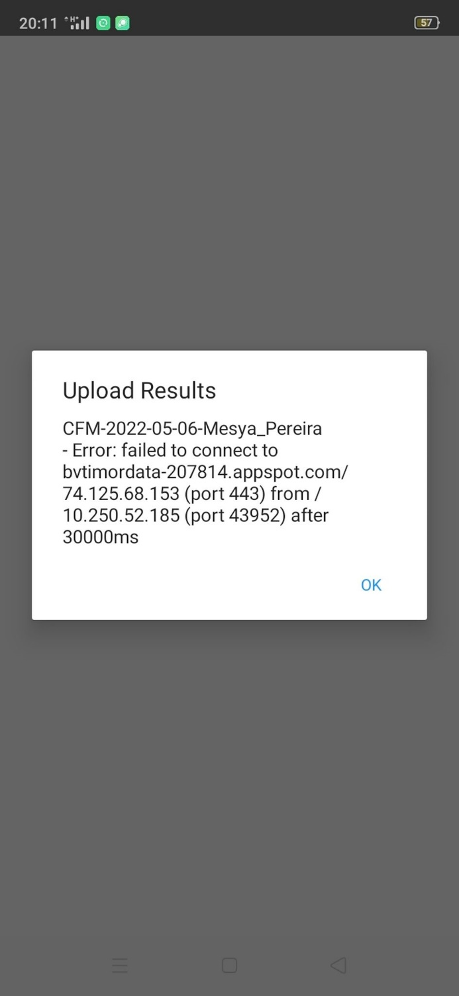 | Fig. 5C) “ODK error message due to poor internet” by Samsi  This photo shows how poor internet connectivity impacts our activities. Sometimes, once we have collected the data and try to upload it to, the internet loads too slowly and we get error messages. I need to check my phone credit and the internet connection before sending data. These issues can make it difficult to send the data, and when we get error messages like this we have to wait for [the Blue Ventures staff] to come and get the data, but this only happens sometimes.

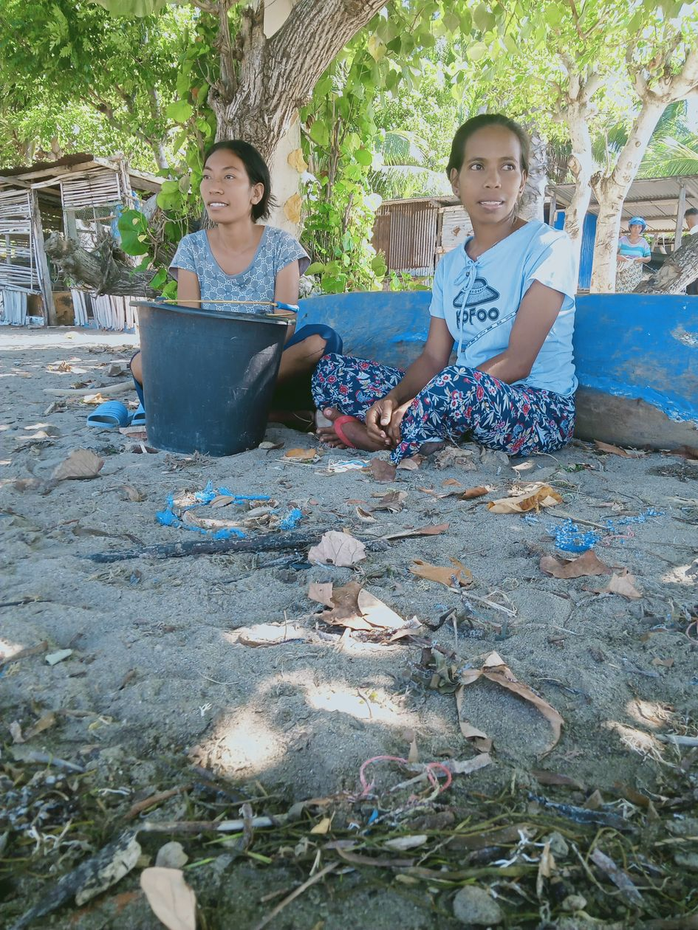 | Fig. 5D) “The monitoring group just sitting there” by Alfansina  The challenge is we have to wait for the fishers on the beach for up to one or two hours just to collect the data. [They] brought fisheries monitoring equipment to the beach and are waiting for the fishers. I think it’s not good because waiting for the fishers can take a long time, so I’d like to develop a schedule for collecting the data. Usually, we wait for the fishers at 8 am or 1 pm.

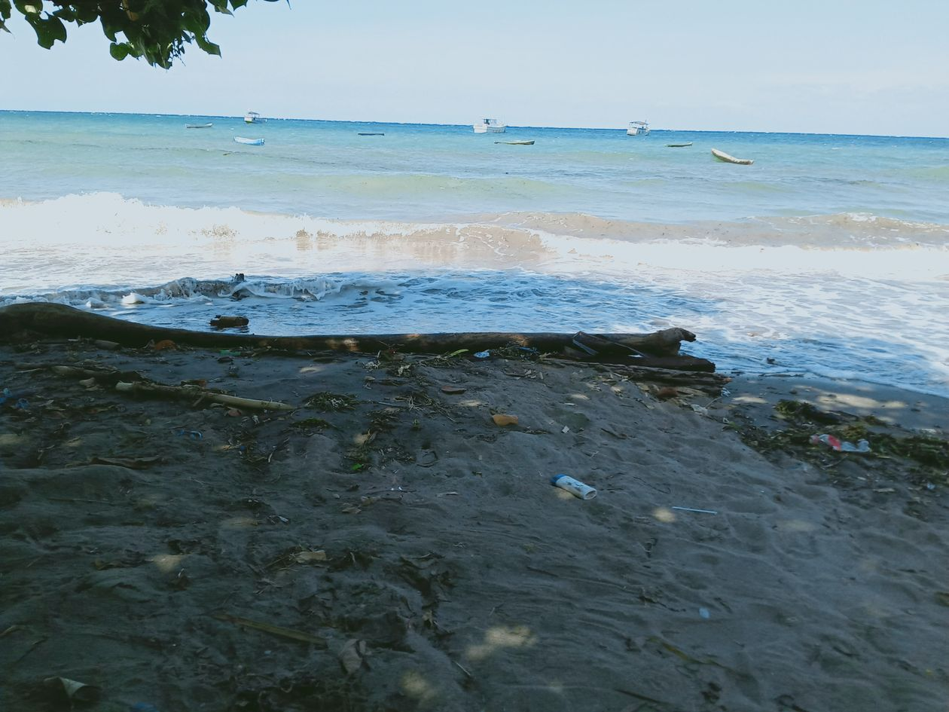 | Fig. 5E) “Fishers don’t go fishing due to rough seas” by Meret  In the season with rough seas the fishers can’t go fishing, because of the strong wind and rough conditions. As a result, the fishers can’t go to sea and they don’t have any fish for us to collect data on. Also, we need to clean the beach so that the rubbish doesn’t impact the fish in the ocean.
  - Fig. 6
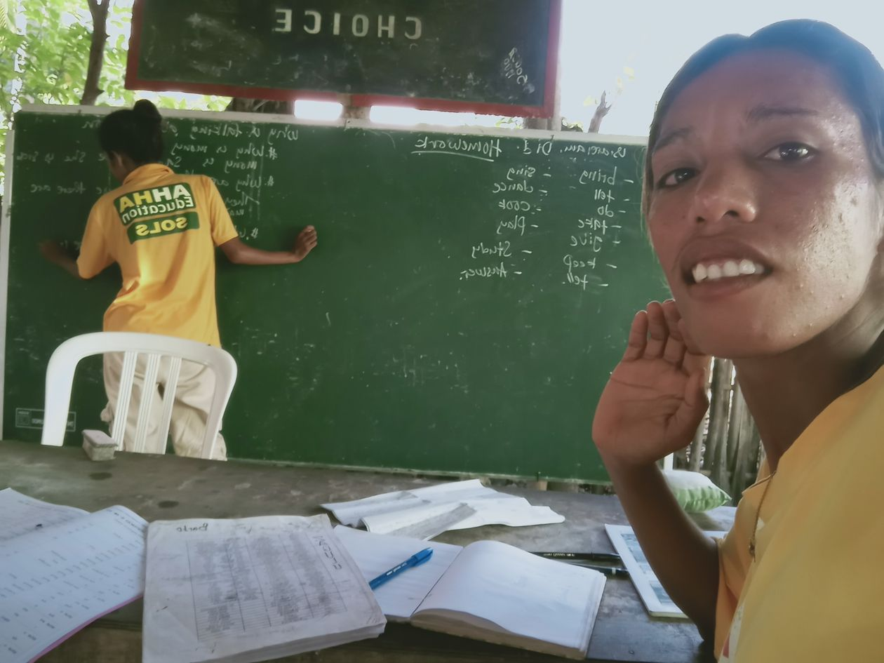 | Fig. 6A) “I learn English at SOLS [Science of Life Systems]” by Ermelita  I am learning English at SOLS so everyday I walk to Beloi for class. By learning English, I wanted to speak with foreigners and communicate with JH in English as part of the fisheries monitoring programme.

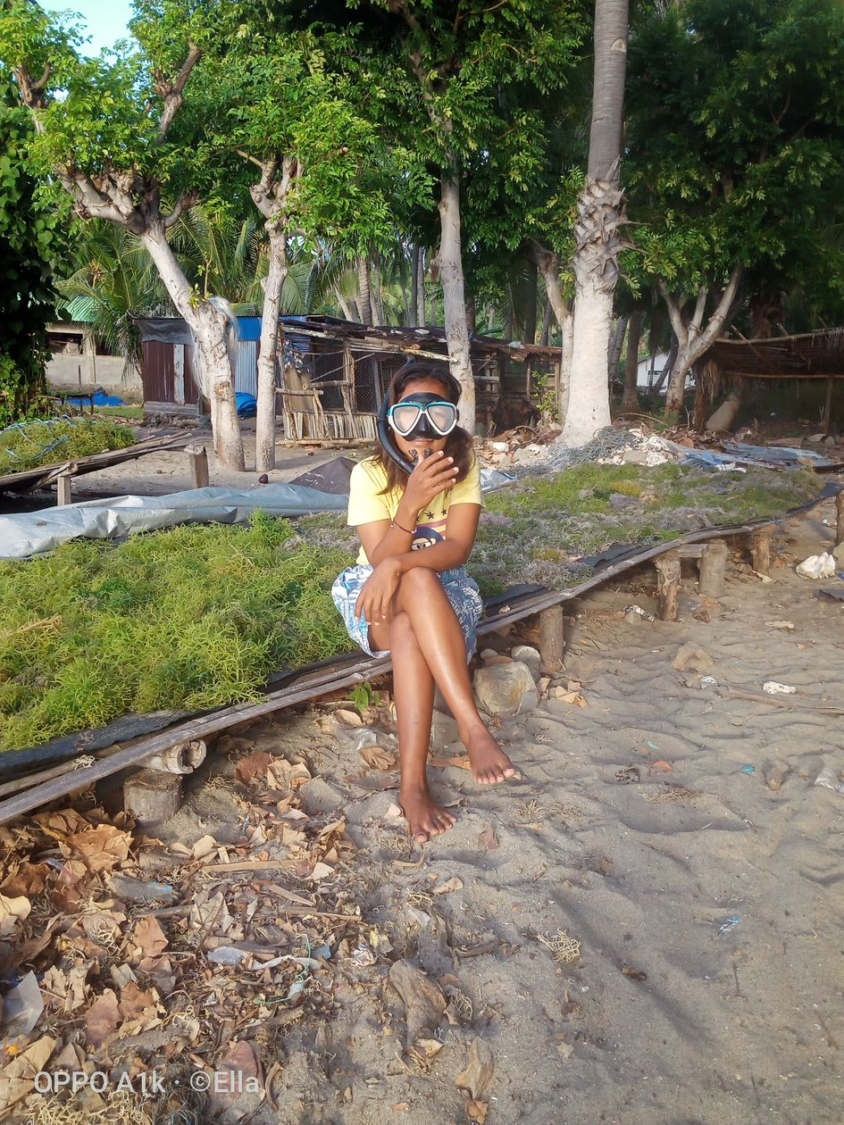 | Fig. 6B) “I want to learn snorkelling” by Samsi  I took this photo because one of my dreams is to learn how to snorkel. I am sitting on top of a bench, and behind me is the dried seaweed and the fresh seaweed which is air drying. At the time, the sea was rough so I couldn’t take the photo in the sea. Throughout the programme, the fisheries monitoring activities have been on dry land, so because of this I want to see things in the sea as well. I’ve been working with the fisheries monitoring for a long time so now I want to learn snorkelling too.

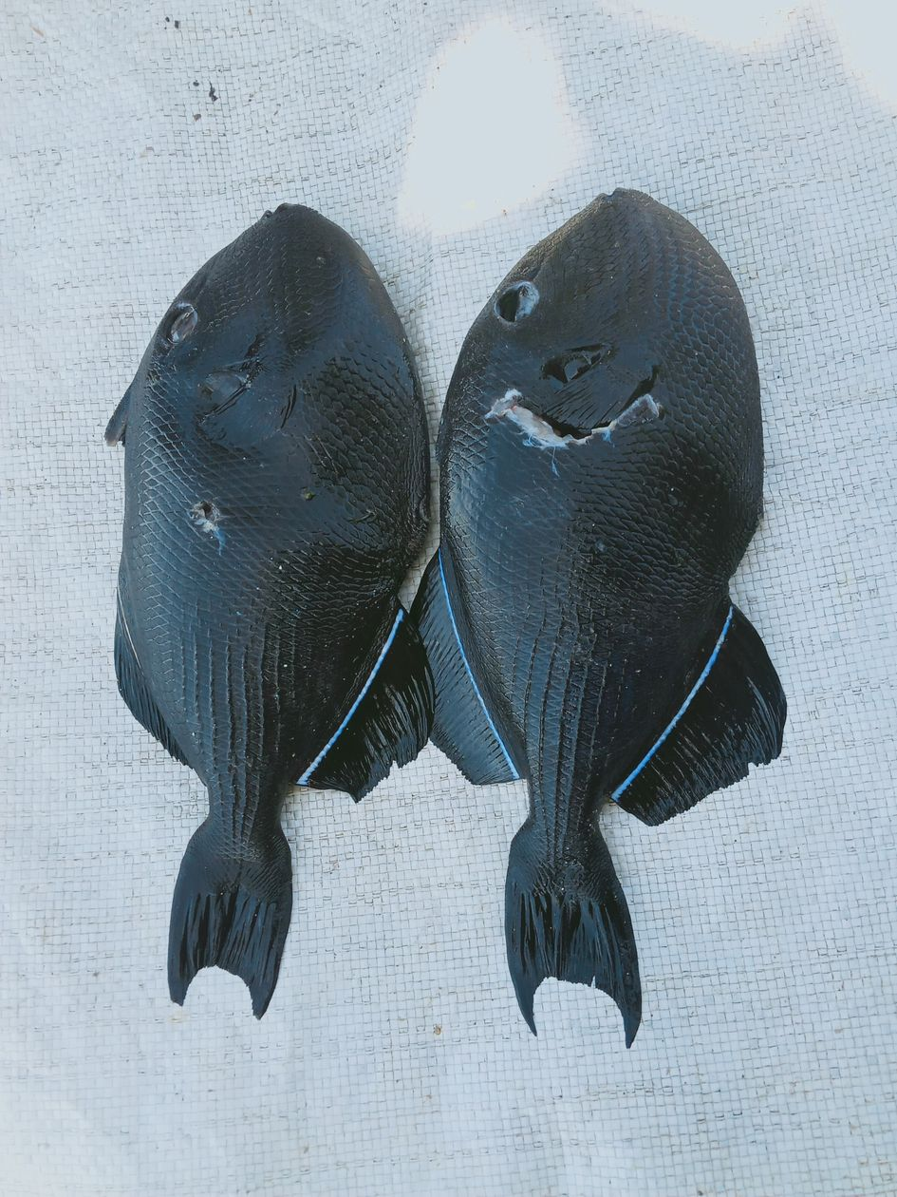 | Fig. 6C) “This fish should be added to the survey list” by Alfansina  I want this fish to be included in the survey, as it’s not on the list yet. I took a picture of this fish when I came across it during data collection because the fishers are starting to catch a lot. It’s good because this fish is easy for the fishers to catch, so I think we can add this fish to the list of ODK.

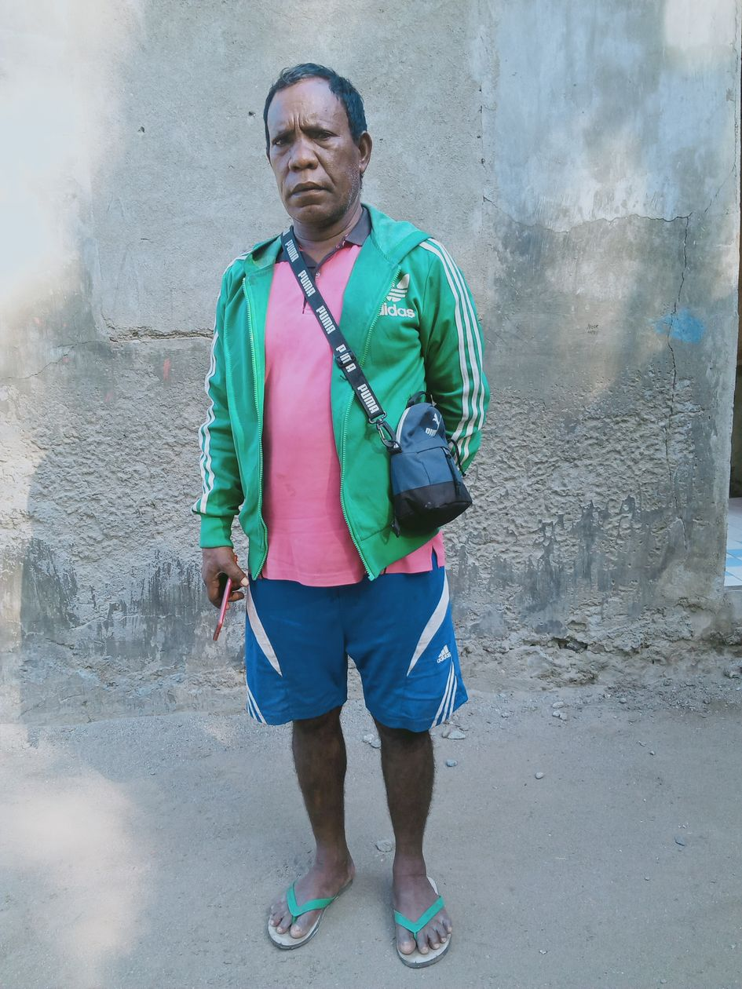 | Fig. 6D) “A fisherman knows how to catch big and small fish” by Alfansina  I took this photo of my father because it relates to the impact of marine monitoring on the community and my father is interested in implementing Tara Bandu. When I took this picture, he was working on fixing his outboard motor. My father is interested in implementing Tara Bandu because it can increase the fish and if we don’t do it, but continue fishing often, then we won’t find fish in the future. I think this change would bring something good for the future, because through Tara Bandu we could find lots of fish in the future and, if not, we won’t; and by collecting the data we can see that some fish increase and some decline. I want to have Tara Bandu because it’s important for the fishers.

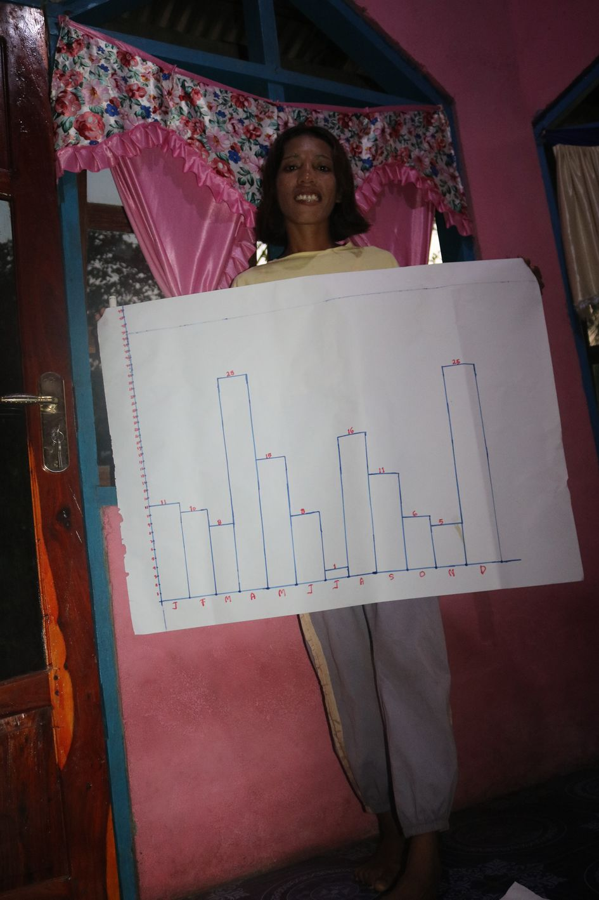 | Fig. 6E) “I show the graph that I made” by Ermelita  I want to show that fishers can see this graph, so that they can establish Tara Bandu. I wanted Tara Bandu to be established, so that this graph of the fisheries monitoring data can change.

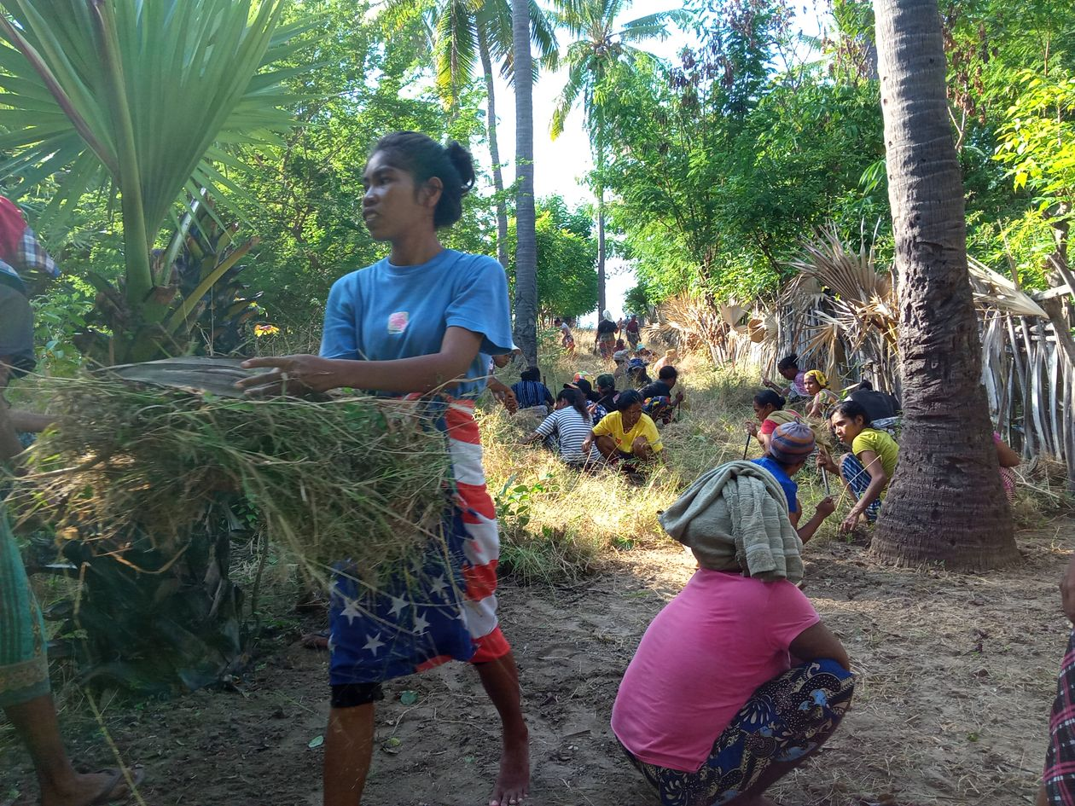
Fig. 6F) “Women cleaning up” by Ermelita
This photo shows women in the community cleaning up the road. This place is full of grass and dirt, so the community are cleaning up. It shows that the community should also clean up the beach. Men should also do the clean up. This relates to the fisheries monitoring because the community should be reminded not to litter on the beach, otherwise the trash will damage the fish.

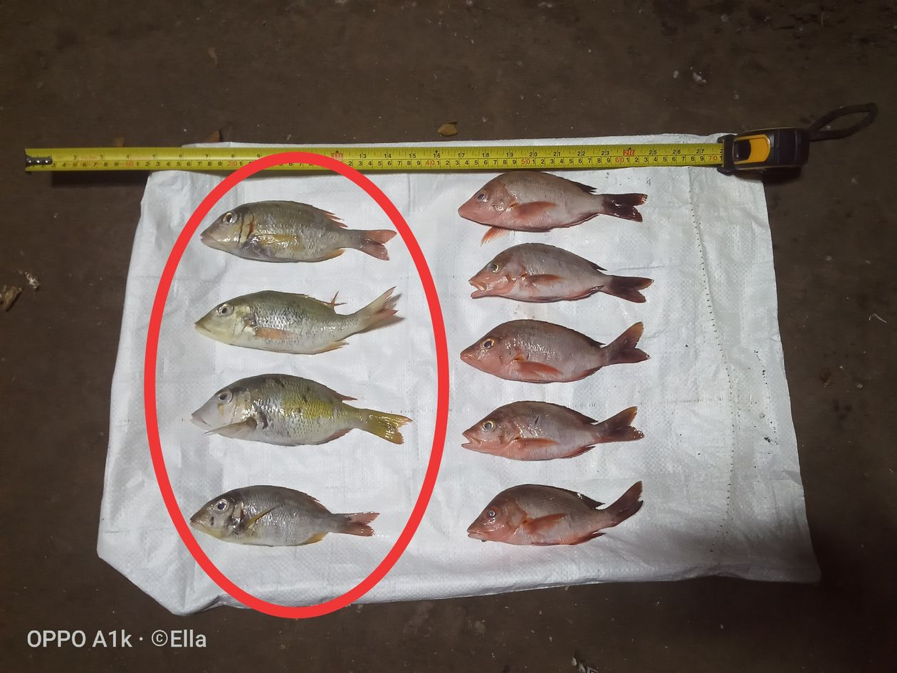
Fig. 6G Supplementary) “Some fish which need to be included in the ODK survey” by Samsi
This type of fish hasn’t been included in the ODK yet, and we now see it more often and there are a lot, so I want to include this type of fish in ODK system. This picture shows fresh yellow fish which we call Buraka in Rasua [Lethrinus sp.]. This photo is interesting because sometimes we encounter fish that are not listed on ODK, so they are categorised as ‘other’, not photographed and are weighed all together. I want to include them in the ODK so we can also upload photos with these species. Then we would be able to present the data to the community so they could know if Buraka is declinging or increasing. This photo also related to the fisheries monitoring activities because some fishers go diving at night, so I take the opportunity to collect the data as it’s easy to find the fishers to collect data in the evening.

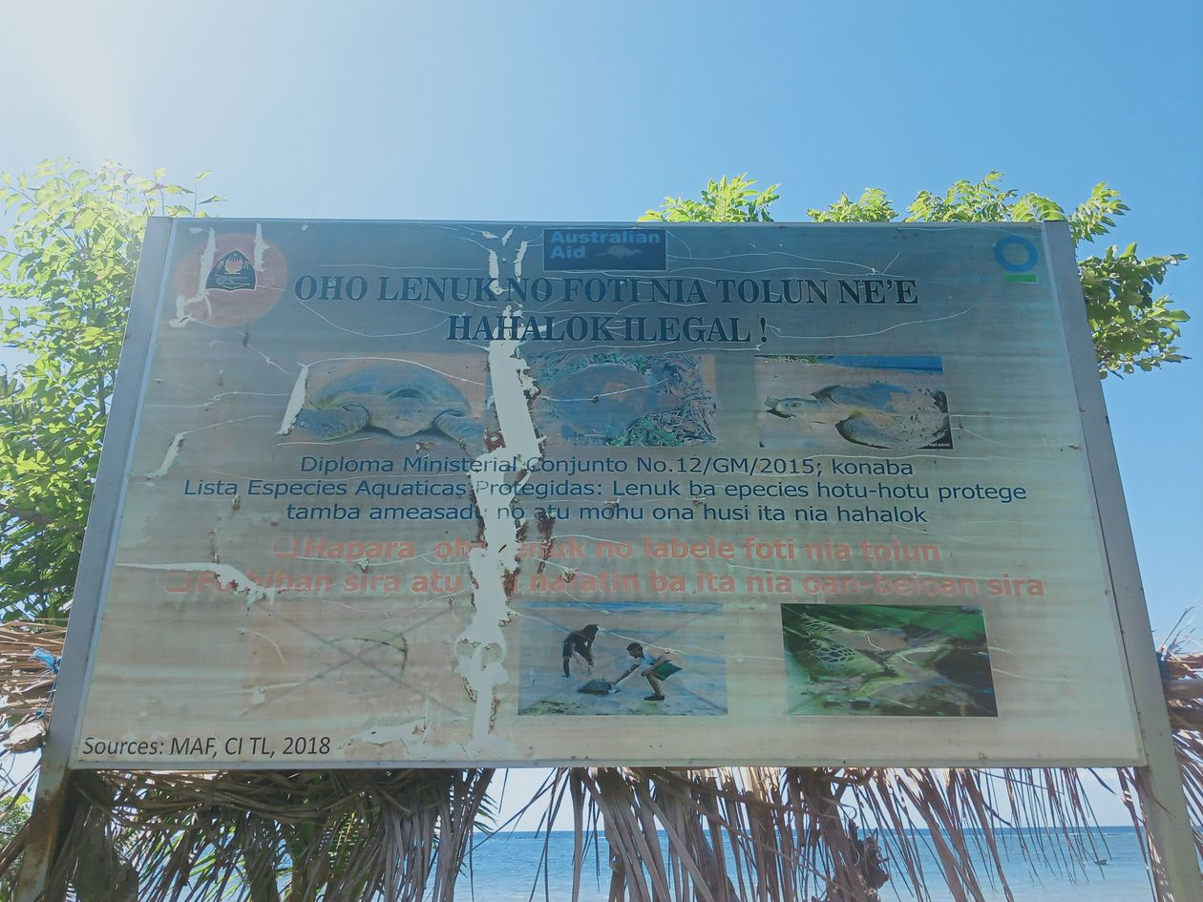
Fig. 6H Supplementary) “Notice board on the beach” by Hiana
I took this photo because it’s about sharing information with the community, so that they protect the natural resources in the sea, such as sea turtles, fish and lobsters. The community already knows how to protect marine resources. I want to share information through a notice board where they sell fish so that the community can all have access and see it. The fisheries monitoring programme is about sharing information and data with the community so they can understand these animals.

  - Fig. 7

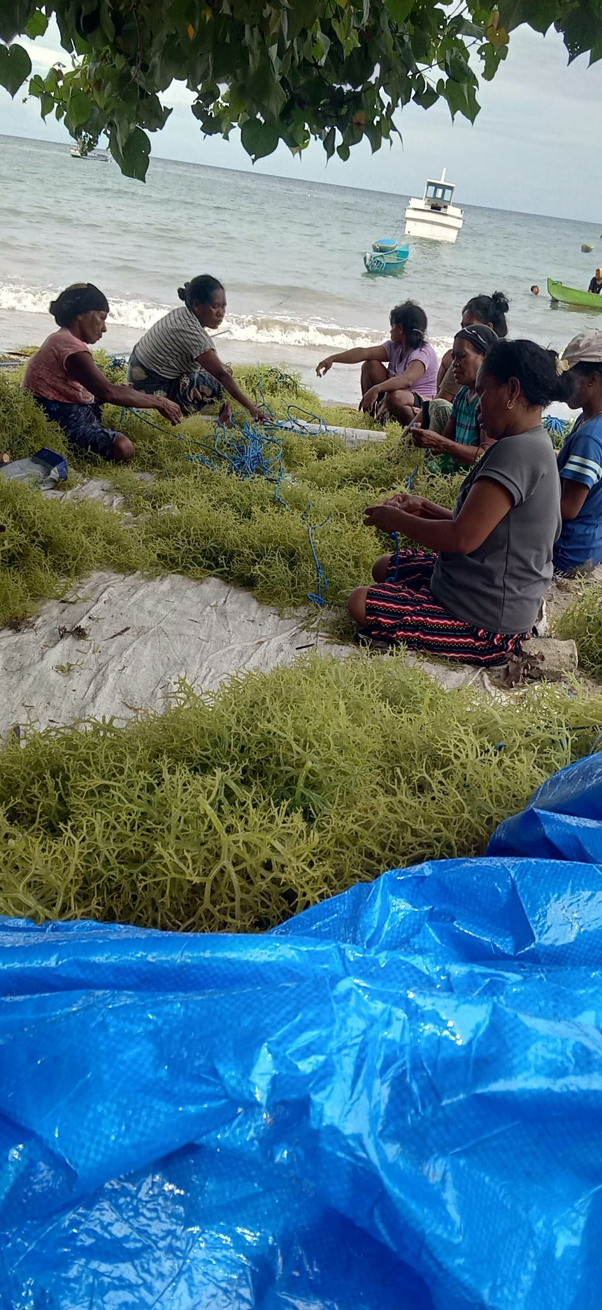 | Fig. 7A) “My sister and family tying seaweed” by Alfansina  In the future, I want the fisheries monitoring group to collect data about seaweed as well. Every day my family ties the seaweed at the beach. I feel good because, by sharing this picture on Facebook, people can see it and then they could come to buy the seaweed.

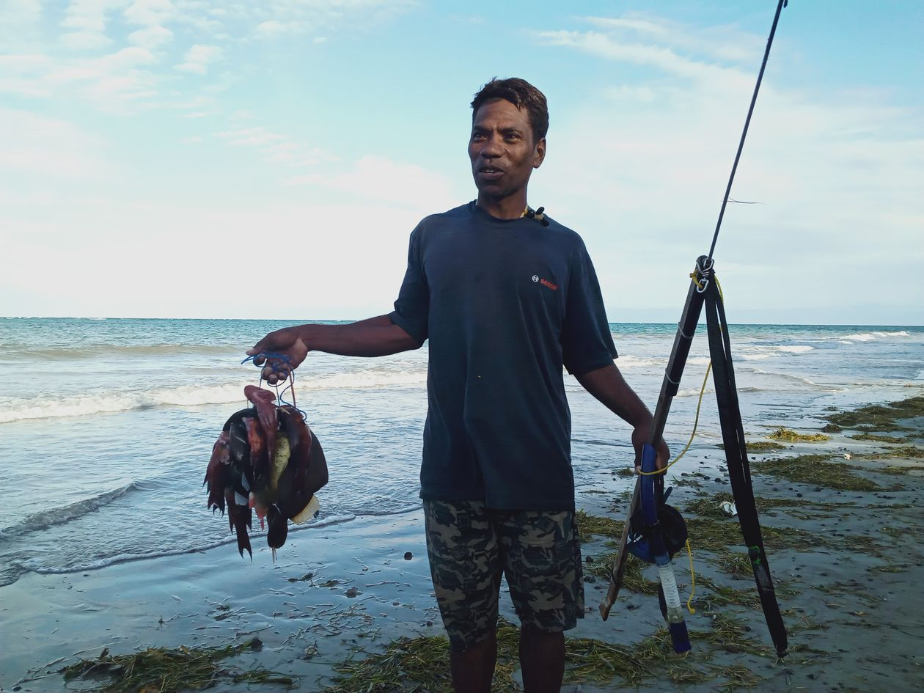 | Fig. 7B) “A fisherman who knows how to catch big fish” by Elmanda  When I met this fisherman, I asked if I could take his picture. He held up his fish, speargun and goggles, so I could photograph him. I took this picture because he gives me access to his fish to collect the data everyday. Also, the sea is rough, and the beach is dirty. Every day I collect data and I’ve already learnt how to measure the fish and identify their names.

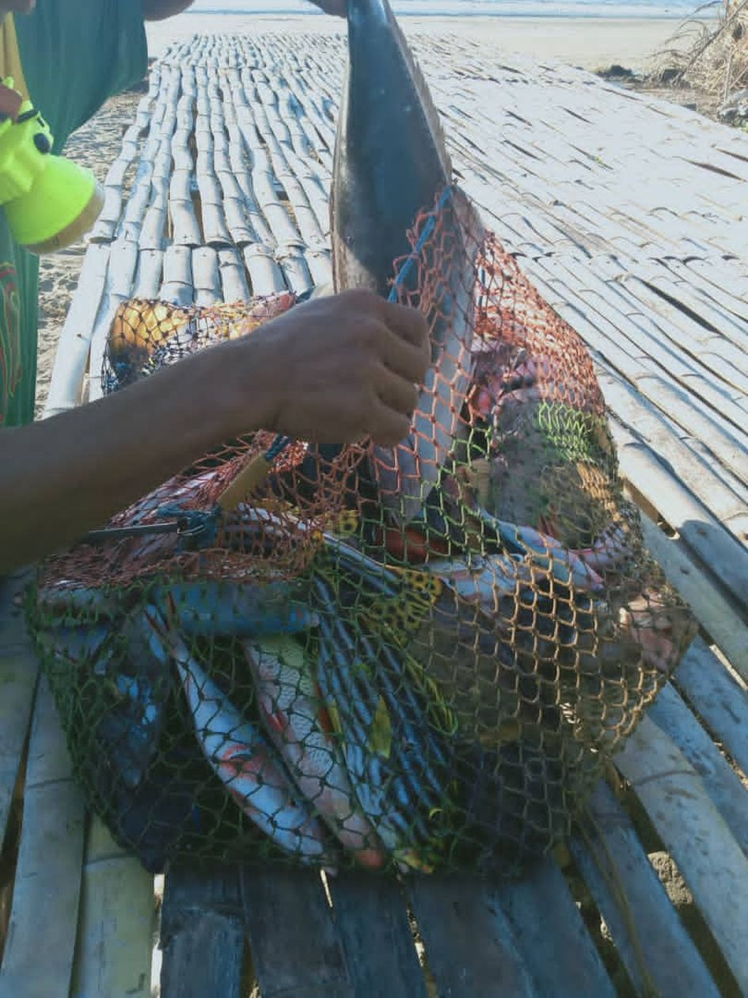 | Fig. 7C) “The fishers know to catch the big fish” by Samsi  This photo shows that the fishers already know how to catch big fish. Through our data sharing with the fishers, the fishers now understand that they should only catch the big fish, because in the past they caught both big and small fish. This fisherman takes his fish out of the net and puts them on the bench, so that buyers can buy them. He separates the good quality fish and the ones he is going to eat. This is good because the fishers go fishing, then sell their fish and make income for their livelihood. We should create a place for fishers to put their fish so that vendors can come to buy the fish. This relates to the fisheries monitoring because we shared data with the fishers so that they could also know to just catch big fish. Some of these fish will be included in the data collection.

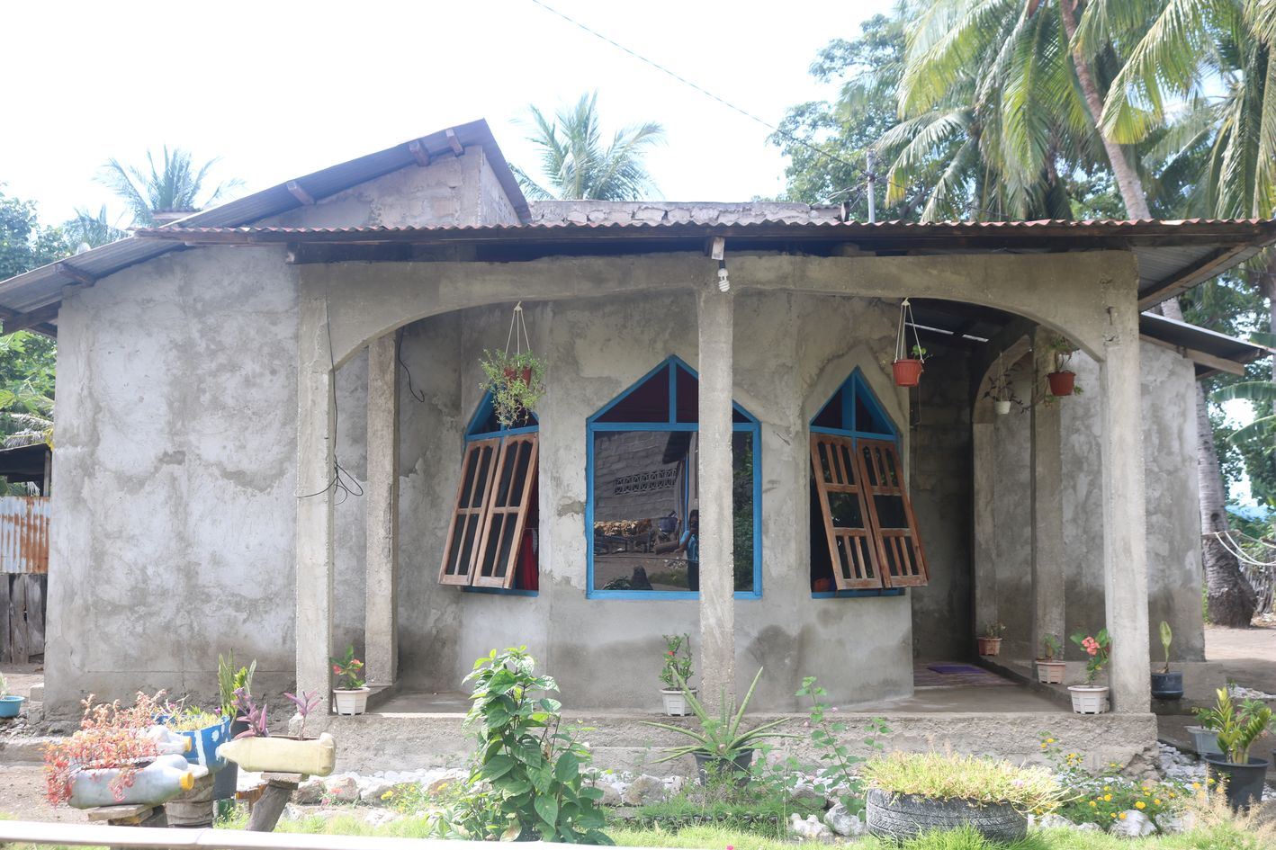
Fig. 7D) “A house to turn into a homestay” by Ermelita
I want to turn this house into a homestay, maybe visitors can stay in this homestay when they visit Biqueli. If the fishers establish Tara Bandu, visitors may come for swimming and diving and stay in our homestay. I wanted to fix up this house, so that the visitors can stay here.

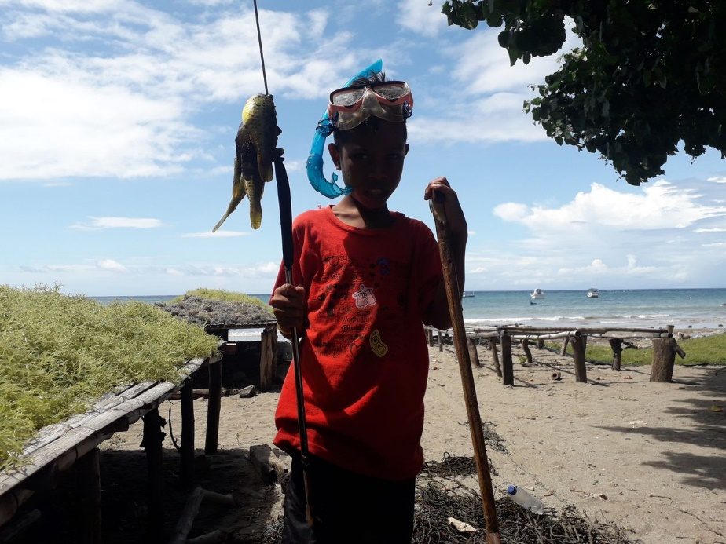 | Fig. 7E) “Younger brother standing and holding the fish” by Alianca  I wanted to take picture of this younger brother because he always goes fishing and diving every day. I feel it’s not good because he is very young, so he needs to focus on his future by going to school. I want him to focus on school, and when he goes diving, he should go with his father and/or his older friends, not alone by himself.

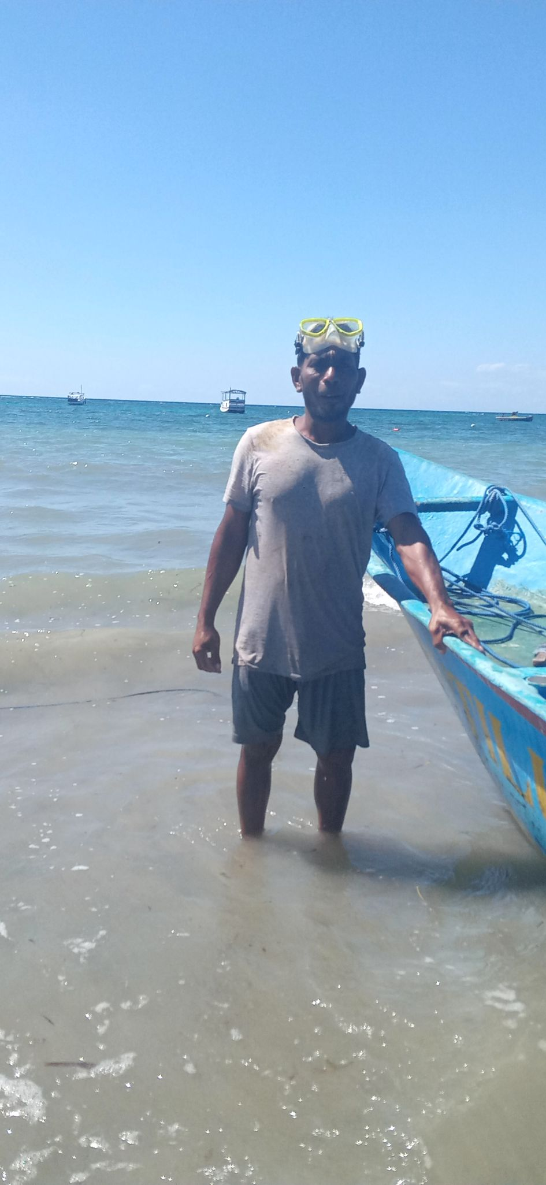 | Fig. 7F Supplementary) “Uncle… the fisherman” by Meret  This fisherman is interested in establishing Tara Bandu, as it can benefit the fishers. The fishers give their fish to us to continue collect data. Tara Bandu can provide fish with a place to breed so that fishers can continue to make their living from fishing and we can continue to collect data. Through Tara Bandu, fishers can catch a lot of fish, because now fish are declining and we don’t yet have Tara Bandu. Through our data collection, we feel that at the moment the fish population is declining, because there is no Tara Bandu within the community. So, we are advising the community that they should establish one, so the fish can continue to breed and the population will increase.

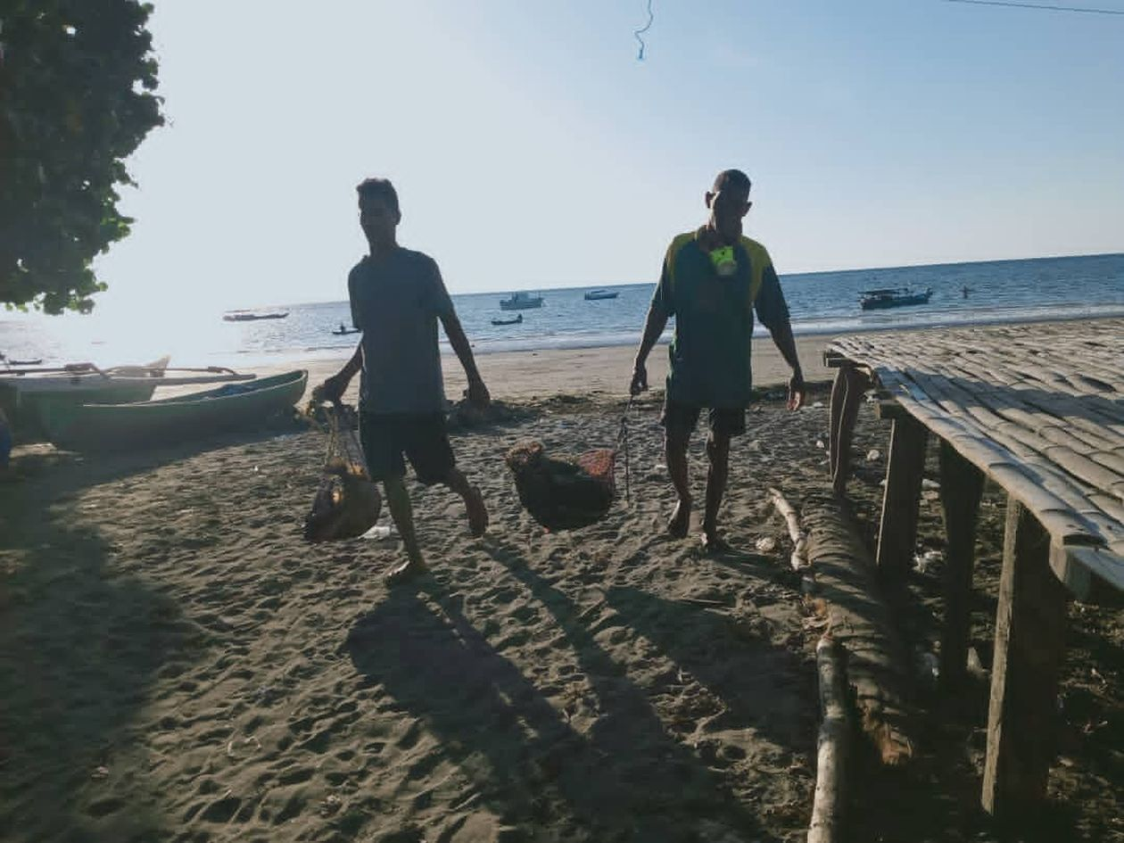
Fig. 7G Supplementary) “The fishers return from fishing” by Samsi
This photo shoes two fishers carrying their net and fish back home. These fishers go fishing at 4 am and return at 7 am, because the sea can be rough and the wind is strong in the afternoon, so they can’t go fishing then. These fishers go every day and, because the sea is rough, the others don’t go fishing. The fishers already know when it’s a good chance to go fishing, because in the season with rough seas they can’t go fishing during the afternoon. So going fishing at dawn is a good idea! I want to help the fishers with some equipment for them to put their fish and carry the catch. Every day the fishers facilitate the fisheries monitoring by providing their fish for us to collect data.

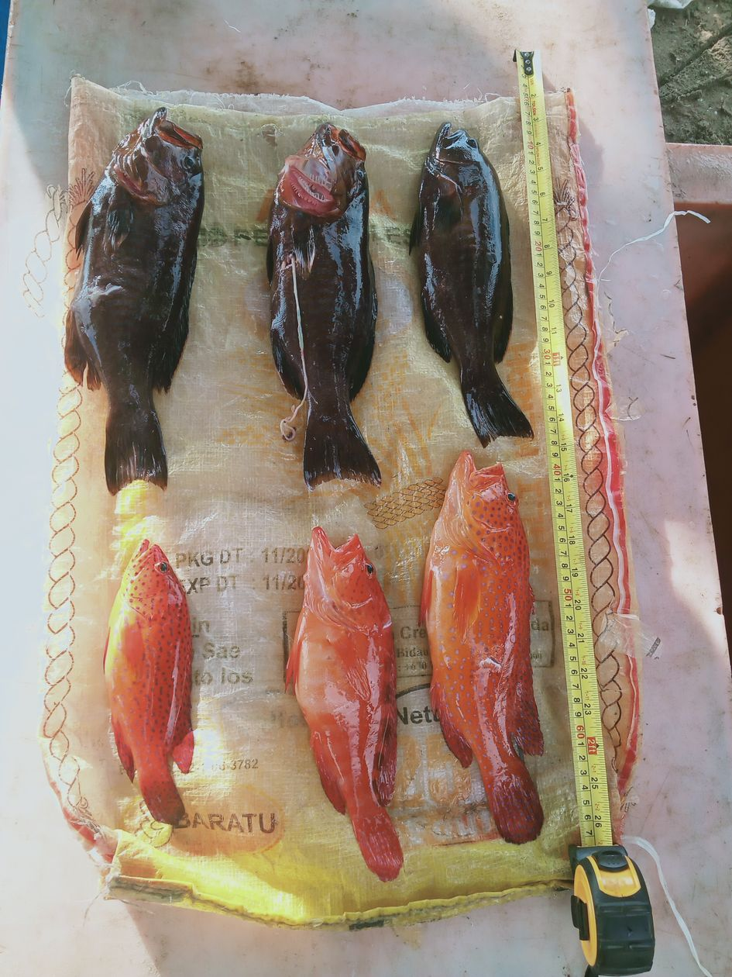 | Fig. 7H Supplementary) “Fish and a measuring tape are laid on top of a sack on the ground” by Alfansina  In this picture, the groupers are laid on top of a sack on the ground, then they are measured with a measuring tape. The fishers will put the fish in an ice box to sell. It’s good because the fishers make it easy for us to access their fish. I want to publish the picture on Facebook, so that people can see and come to buy the fish. The fisheries monitoring involves using tools such as a measuring tape to measure the fish. We lay the fish on top of a sack to photograph them. In the fisheries monitoring survey we focus on certain species, such as grouper, fusiliers, lobsters and octopus.

  - Fig. 8
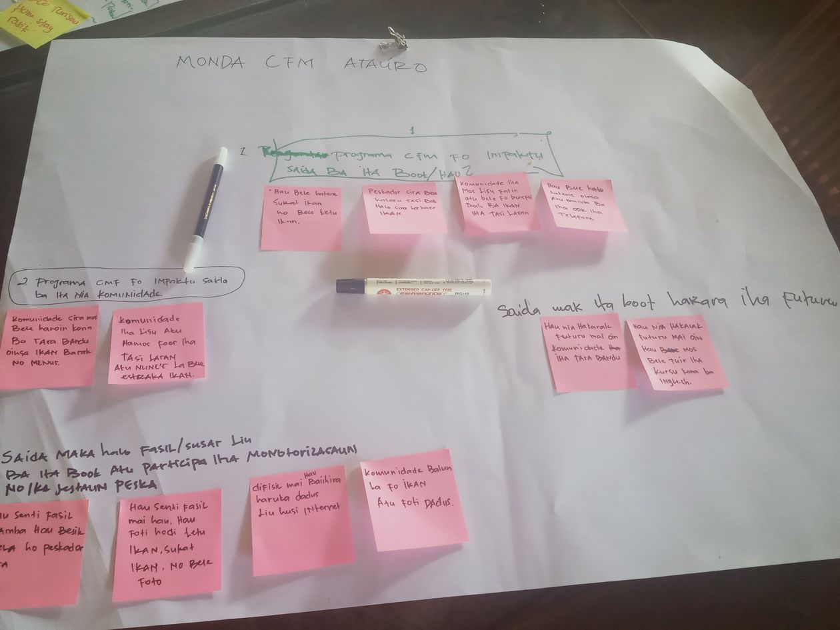 | Fig. 8A) “I want to learn more about the fisheries monitoring activities” by Elmanda  This photo shows me learning about Photovoice. I have learnt how to use the phone to collect data and take pictures. From this photo, I wanted to share that I want to learn more about the fisheries monitoring activities, because the programme benefits our lives.

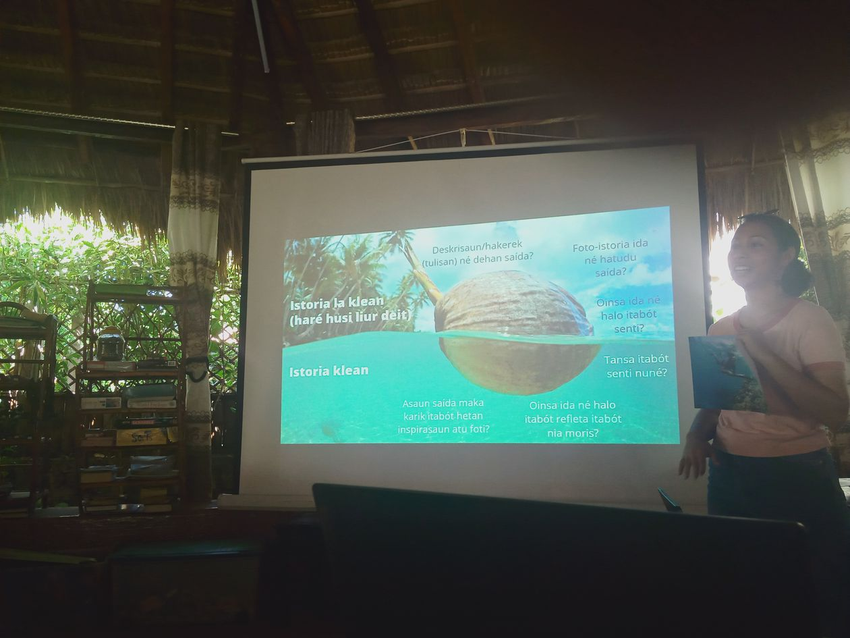 | Fig. 8B) “Learning about Photovoice” by Elmanda  This photo shows that I want to learn more about Photovoice. In the future, I want to have a good mentality and stand at the front to speak like other people.

