Continuous caloric restriction and diet replacement but not alternate-day fasting may enhance susceptibility to glucose intolerance, dyslipidemia and cell stress under renewed high-fat diet
Andrea Cristiani Beuren^{1*}, Jaíne Borges dos Santos^{1*}, Natascha Fill Izolan^{1*}, Lílian Correa Costa-Beber^{1,2*/**}, Lucas Machado Sulzbacher¹, Matias Nunes Frizzo¹, Pauline Brendler Goettems-Fiorin¹, Thiago Gomes Heck^{1,3,4}, Mirna Stela Ludwig^{1,4}

SUPPLEMENTARY MATERIAL
Extended results
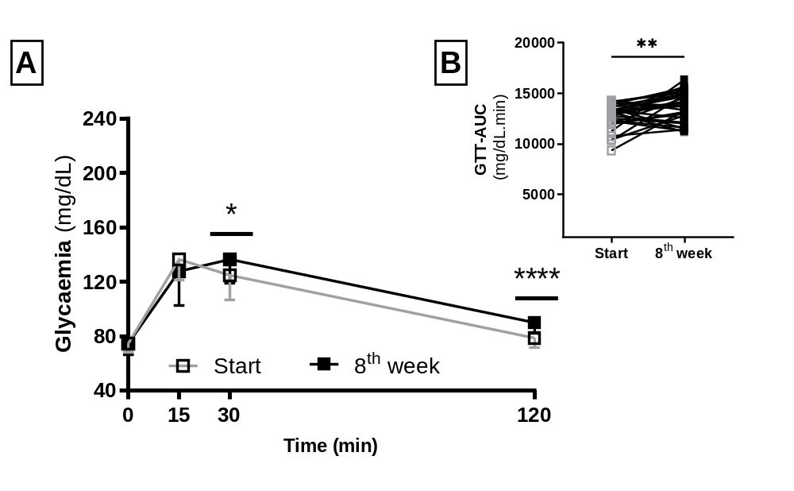
Figure S1: HFD consumption ad libitum promotes glucose intolerance. A. GTT at the baseline and at the end of the first phase (8th week). One-way ANOVA with repeated measures: Time (min): F _{2.092, 129.7} = 386.8, P < 0.0001. Start vs 8th week: F _{1, 62} = 1.913, P = 0.171. Interaction between factors: F _{2.092, 129.7} = 10.53, P < 0.0001. B. First vs final GTT-AUC. Paired T-test: **P = 0.002 vs Start. Data expressed as mean ± SEM.

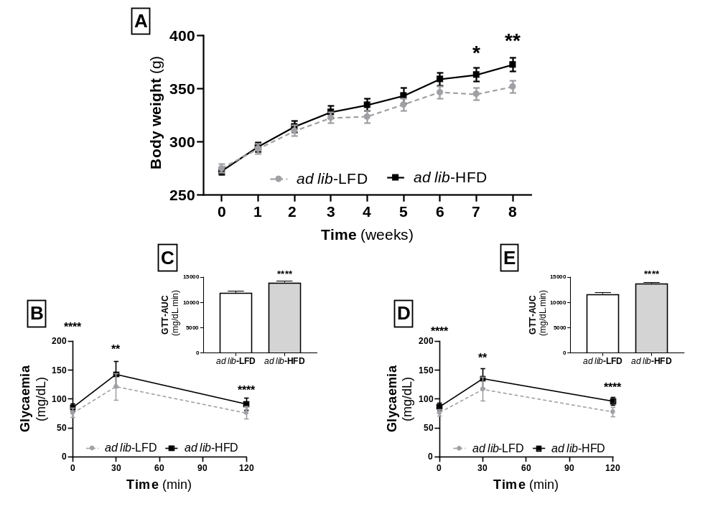
Figure S2: HFD consumption induces obesity and glucose intolerance. Male 12 weeks-old Wistar rats were divided into two groups, ad lib-LFD (n = 24) or ad lib-HFD (n = 26) receiving standard or HFD, uninterruptedly, for eight weeks (CEUA 001/2015). A. Body weight during the experiment. RM Two-way ANOVA: Time: F _{12, 507} = 72.41, P < 0.0001. Diet: F _{1, 507} = 44.12, P < 0.0001. Time vs Diet: F _{12, 507} = 2.013, P = 0.021. B. GTT curve on the 4th week. RM Two-way ANOVA: Time: F _{1.279, 61.37} = 250.0, P < 0.0001. Diet: F _{1, 48} = 25.40, P < 0.0001. Time vs Diet: F _{1.279, 61.37} = 2.441, P = 0.115. C. GTT-AUC on the 4th week. T-test: P < 0.0001. D. GTT curve on the 8th week. RM Two-way ANOVA: Time: F _{1.213, 58.21} = 222.5, P < 0.0001. Diet: F _{1, 48} = 49.11, P < 0.0001. Time vs Diet: F _{1.213, 58.21} = 1.970, P = 0.163. E. GTT-AUC on the 8th week. T-test: P < 0.0001. Data expressed as mean ± SEM. Differences between groups were represented as * P ˂ 0.05, **P ˂ 0.01, *** P ˂ 0.001 and **** P ˂ 0.0001 vs ad lib-LFD.

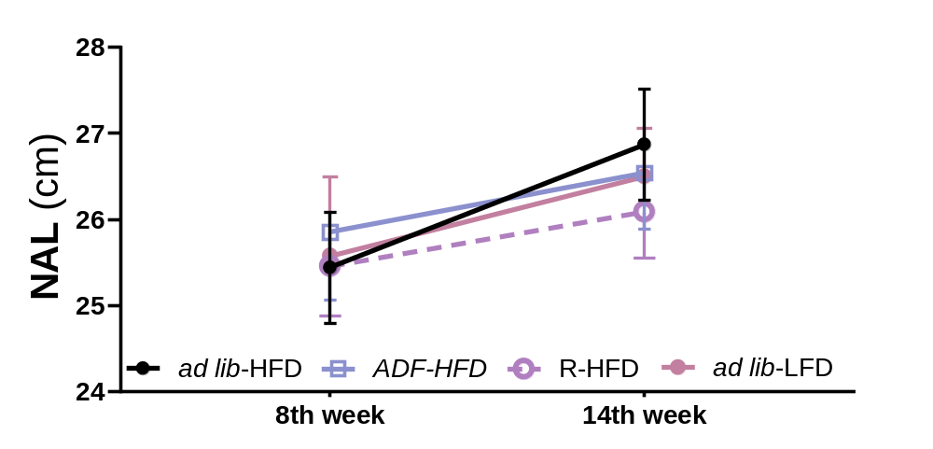
Figure S3: Only ad lib-HFD group presented an increase in animals’ length during the second phase (14th week). Data expressed in mean ± SD. RM Paired analysis identified that ad lib-HFD, ADF-HFD and ad lib-LFD enhanced their NAL along the second phase (intervention) (RM Two-way ANOVA: Time: F _{1, 28} = 50.25, P < 0.0001. Intervention: F _{3, 28} = 0.058, P = 0.980. Time vs Intervention: F _{3, 28} = 2.859, P = 0.054). No differences among groups were identified.

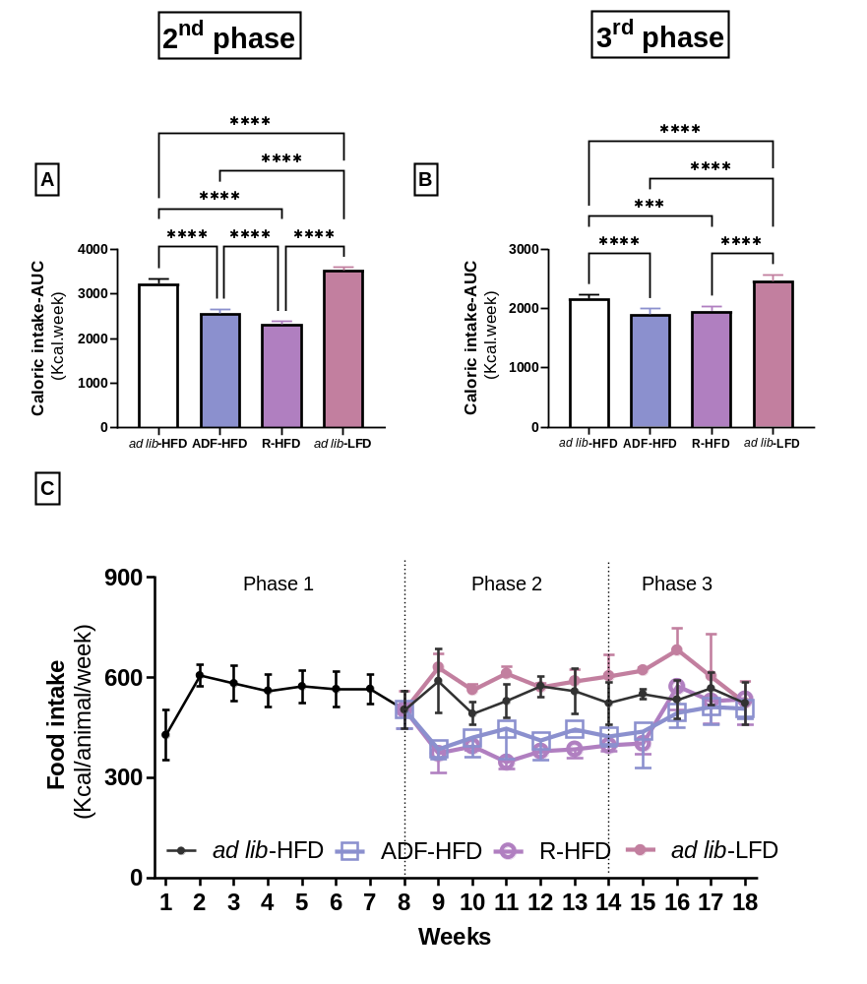
Figure S4: Effects of different dietary interventions on food consumption. A. AUC-energetic intake during the intervention (second) phase (One-way ANOVA: F _{3, 28} = 346.6, P < 0.0001). B. AUC-energetic intake during the regain/maintenance (third) phase (One-way ANOVA: F _{3, 28} = 57.45, P < 0.0001). C. Representative consumption (Kcal/animal/week) throughout the experiment. There was no obvious spillage, judged by looking, on any day. Data expressed in mean ± SD. ***P ˂ 0.001 and ****P ˂ 0.0001 represent differences between experimental groups (Tukey’s post-test).

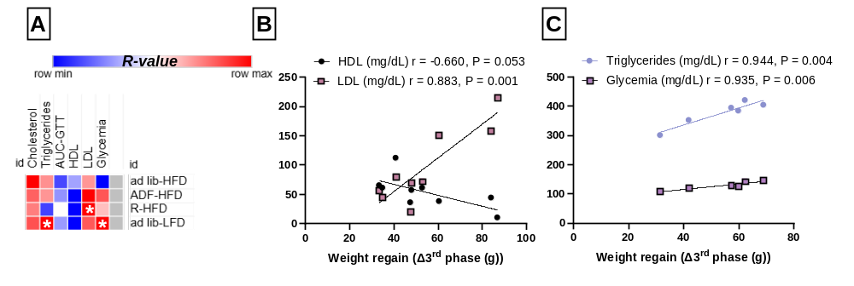
Figure S5: Weight regain in the third phase correlates with final metabolic impairment in R-HFD and ad lib-LFD groups. A. Pearson’s correlations matrix between weight regain (g) and metabolic parameters. B. Pearson’s correlations between weight regain (g), final HDL (mg/dL) and LDL (mg/dL) in the R-HFD group. C. Pearson’s correlations between weight regain, final triglycerides and glycemia in the ad lib-LFD group.

Table S1: Studies used in sample size calculation.

Reference | Number of animals per experimental group | Dietary intervention | Period of application
(Higashida et al., 2013) | 12 | ADF | 6
(Manzanero et al., 2014) | 10 | TRF | 12
(Seimon et al., 2016) | 10 | MFR | 12
(Gotthardt et al., 2016) | 8 | ADF | 8
(Gotthardt & Bello, 2017) | 7 | ADF | 4
(Delahaye et al., 2018) | 10 | TRF | 8
(Wilson et al., 2018) | 8 to 10 | MFR | 12
Notes: ADF = Alternate Day Fasting; MFR = Modified Fasting Regimens; TRF = Time-Restricted Feeding.

Table S2: Dietary regimes do not affect gastrocnemius oxidative and inflammatory response after weight rebound (third phase).
Parameter | ad lib-HFD | ADF-HFD | R-HFD | ad lib-LFD | One-way ANOVA
Protein concentration  (mg/mL) | 17.09 ± 3.251 | 19.01 ± 7.282 | 19.11 ± 3.307 | 20.11 ± 3.205 | F_{3, 28} = 0.511, P = 0.677
SOD activity  (USOD/mg prot) | 1.559 ± 0.692 | 1.517 ± 0.796 | 1.175 ± 0.458 | 1.114 ± 0.492 | F_{3, 28} = 0.994, P = 0.409
CAT activity (UCAT/mg prot) | 6.273 ± 1.868 | 6.660 ± 1.708 | 6.238 ± 1.308 | 5.880 ± 1.302 | F_{3, 28} = 0.302, P = 0.823
Lipoperoxidation (µMol MDA/g tissue) | 10.26 ± 2.776 | 9.696 ± 2.000 | 8.032 ±1.485 | 9.263 ± 1.728 | F_{3, 28} = 1.821, P = 0.166
iHSP70  (ng/g tissue) | 0.906 ± 0.451 | 0.746 ± 0.483 | 1.018 ±0.371 | 0.971 ± 0.272 | F_{3, 28} = 0.717, P = 0.549
Data expressed as mean ± SD.

REFERENCES
Delahaye, L. B., Bloomer, R. J., Butawan, M. B., Wyman, J. M., Hill, J. L., Lee, H. W., Liu, A. C., McAllan, L., Han, J. C., & van der Merwe, M. (2018). Time-restricted feeding of a high-fat diet in male C57BL/6 mice reduces adiposity but does not protect against increased systemic inflammation. Applied Physiology, Nutrition, and Metabolism, 43(10), 1033–1042. https://doi.org/10.1139/apnm-2017-0706
Gotthardt, J. D., & Bello, N. T. (2017). Meal pattern alterations associated with intermittent fasting for weight loss are normalized after high-fat diet re-feeding. Physiology & Behavior, 174, 49–56. https://doi.org/10.1016/j.physbeh.2017.02.046
Gotthardt, J. D., Verpeut, J. L., Yeomans, B. L., Yang, J. A., Yasrebi, A., Roepke, T. A., & Bello, N. T. (2016). Intermittent Fasting Promotes Fat Loss With Lean Mass Retention, Increased Hypothalamic Norepinephrine Content, and Increased Neuropeptide Y Gene Expression in Diet-Induced Obese Male Mice. Endocrinology, 157(2), 679–691. https://doi.org/10.1210/en.2015-1622
Higashida, K., Fujimoto, E., Higuchi, M., & Terada, S. (2013). Effects of alternate-day fasting on high-fat diet-induced insulin resistance in rat skeletal muscle. Life Sciences, 93(5–6), 208–213. https://doi.org/10.1016/j.lfs.2013.06.007
Manzanero, S., Erion, J. R., Santro, T., Steyn, F. J., Chen, C., Arumugam, T. V, & Stranahan, A. M. (2014). Intermittent Fasting Attenuates Increases in Neurogenesis after Ischemia and Reperfusion and Improves Recovery. Journal of Cerebral Blood Flow & Metabolism, 34(5), 897–905. https://doi.org/10.1038/jcbfm.2014.36
Seimon, R. V., Shi, Y.-C., Slack, K., Lee, K., Fernando, H. A., Nguyen, A. D., Zhang, L., Lin, S., Enriquez, R. F., Lau, J., Herzog, H., & Sainsbury, A. (2016). Intermittent Moderate Energy Restriction Improves Weight Loss Efficiency in Diet-Induced Obese Mice. PLOS ONE, 11(1), e0145157. https://doi.org/10.1371/journal.pone.0145157
Wilson, R., Deasy, W., Stathis, C., Hayes, A., & Cooke, M. (2018). Intermittent Fasting with or without Exercise Prevents Weight Gain and Improves Lipids in Diet-Induced Obese Mice. Nutrients, 10(3), 346. https://doi.org/10.3390/nu10030346

