Supplemental Figures
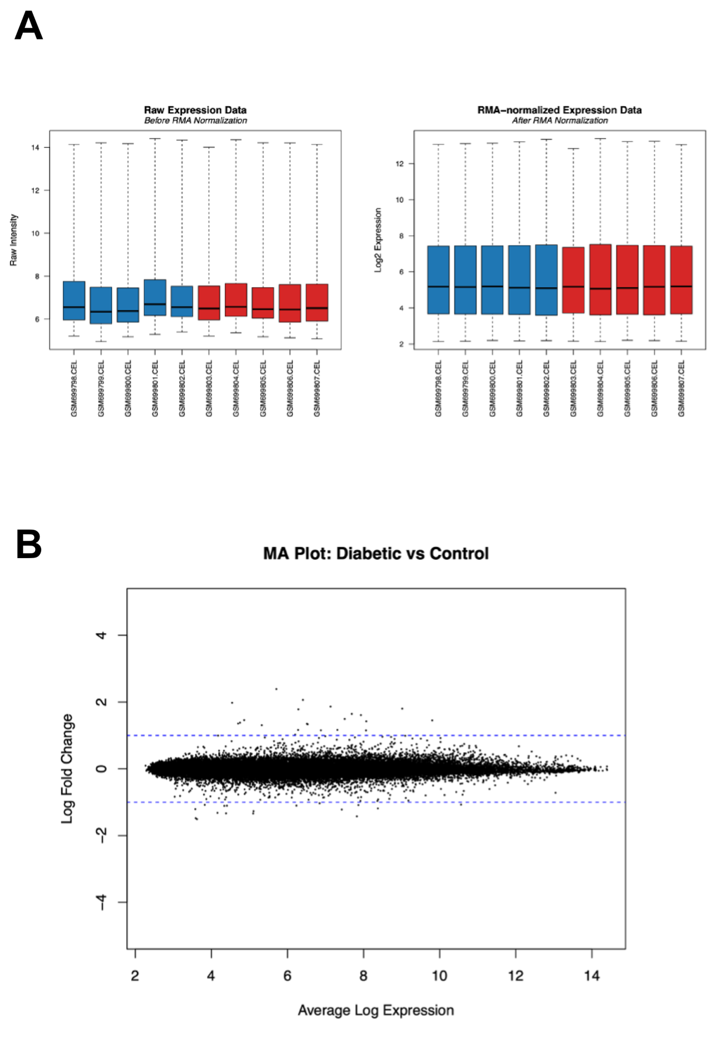
Figure S1. (A) Boxplots of gene expression values for placental/decidua samples before and after RMA normalization. Raw expression intensities (left) and log₂-transformed, normalized values (right) are shown across samples; control samples are in blue and diabetic samples are in red. (B) MA plot of differential gene expression in placental/decidua tissue (diabetic vs. control). The x-axis shows average log2 expression (A value) and the y-axis shows log₂ fold change (M value); each point represents a probe.

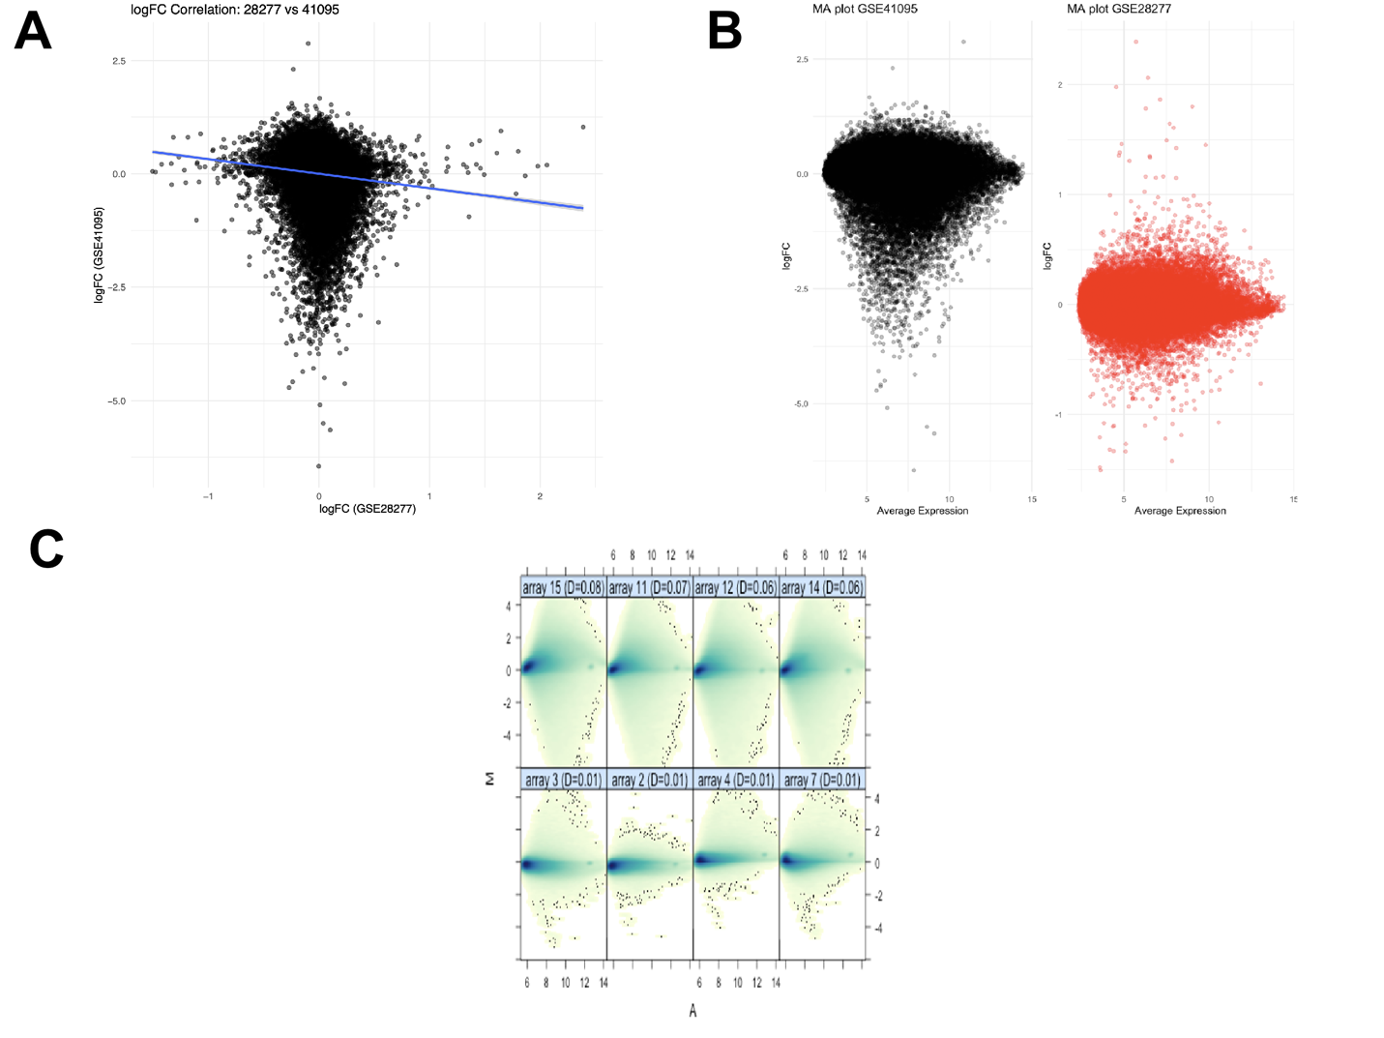
Figure S2. Cross-dataset comparison and quality assessment of differential expression. (A) Scatter plot of gene-level log₂ fold changes with a fitted regression line. (B) The x-axis shows average log₂ expression and the y-axis shows log₂ fold change; each point represents a probe. (C) MA plots for selected arrays showing M (log-ratio) versus A (mean intensity). Each panel represents an array, with the x-axis showing average log intensity and the y-axis showing log-ratio.
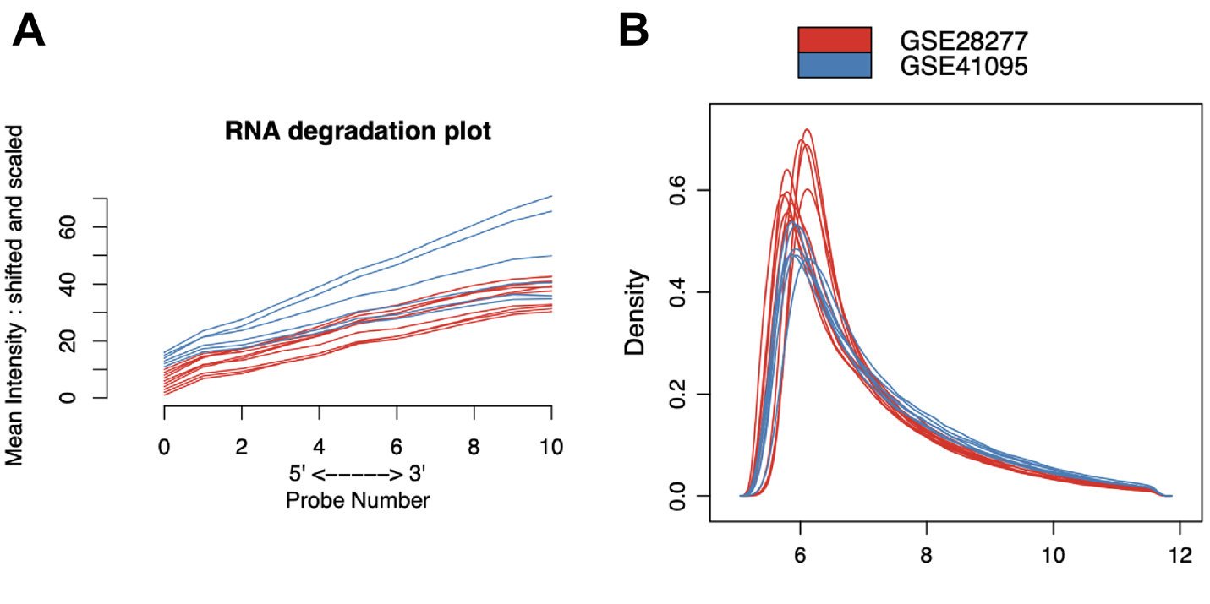
Figure S3. Quality control assessment of placental/decidua and fetal microarray datasets. (A) RNA degradation plot showing probe intensity from 5’ to 3’ across samples. The x-axis represents probe position and the y-axis represents mean intensity; each line corresponds to a sample, with placental/decidua in red and fetal tissue in blue. (B) Density distributions of RMA-normalized gene expression values for placental/decidua and fetal tissues. Each curve represents a sample, with placental/decidua in red and fetal tissue in blue.

