Supporting information
Stretchable current collectors based on carbon-embedded in a poly (acrylamide)/poly (N,N-methylenebisacrylamide) hydrogel modified with Nafion 117®.
M. Radtke, A. Ignaszak*
University of New Brunswick, Chemistry Department, Fredericton, Canada.
* Corresponding author. Email: Anna.Ignaszak@unb.ca

Fig. S1. Mechanism of crosslinking of the hydrogel.

.
Fig. S2. Raman spectrum of pristine graphene
Fig. S3. FTIR spectrum of dry hydrogels.
Fig. S4. Raman spectrum (785 nm) of pristine hydrogel without carbons.

Fig. S5. Raman spectrum: deconvolution of 2D peak for the hydrogel containing graphene at 514 nm.
Figure S6. The field Emission Secondary Electron Microscope (FESEM) image of the dry hydrogel (A) and the cross-section image at higher magnification (B).

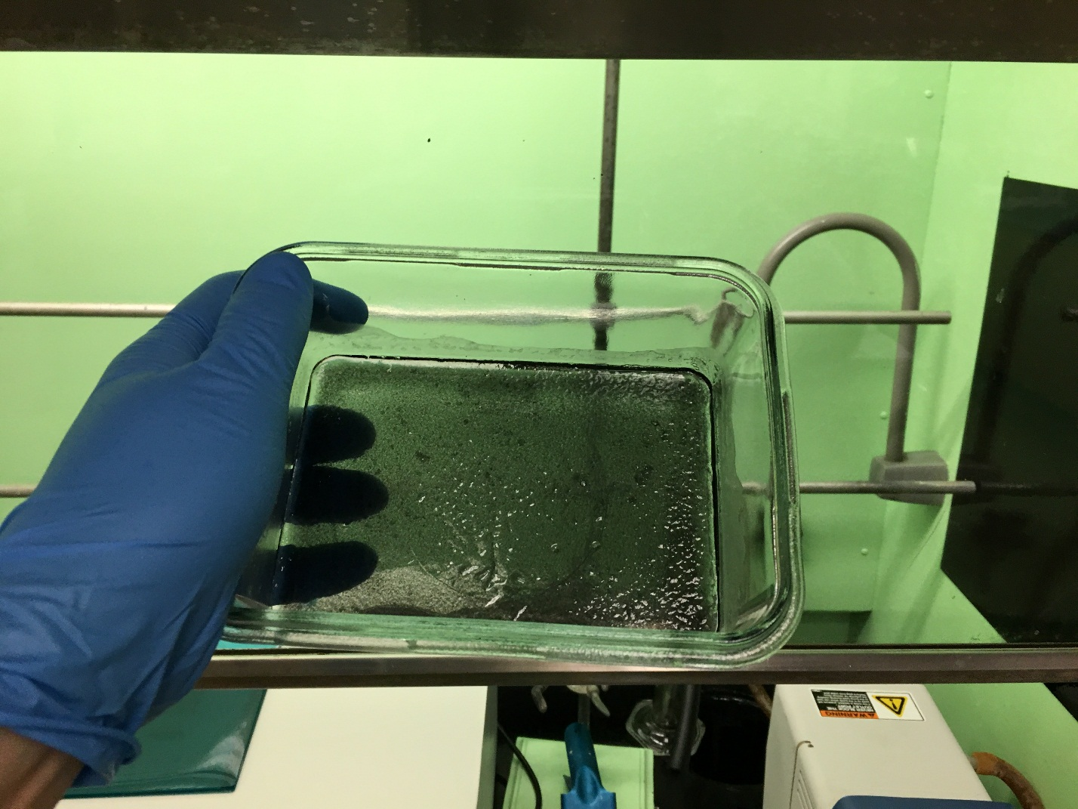
Fig. S7. Up-scaled product.
Fig. S8. Admittance spectrum of graphene-containing hydrogel in its dried state (drying at 65 °C overnight).

Fig. S9. Experimental setup for measuring of the ξ-potential by rotating disc ring electrode method. Ag/AgCl (0.222 V) was used as the reference electrode, Pt wire as the counter electrode and 0.5 cm in diameter glassy carbon rotating ring disc electrode as the working electrode. The OCP measurement was conducted at 23 °C with the constant distance between the reference and working electrode (5.7 cm). The OCP signal was read at 400 s.
Fig. S10. Admittance spectra of bare MWCNT, pure hydrogel, and MWCNT-embedded hydrogel.

