Performance evaluation of solar panels under different dust accumulation conditions using thermography: Focusing on PV temperature variation

Gomaa Galal Abd El-wahhabª, Taha Abdelfattah Mohammed Abdelwahab^{a *}, Yasser Kamal Osman Taha Osmanª, Mohamed Fawzi Abdelshafie Abuhusseinª, Ahmed Elsayed Mahmoud Fodah ª*, Khaled Abdeen Mousa Aliª

ª College of Agricultural Engineering, Al-Azhar University, Cairo, Egypt
*Corresponding authors.
E-mail address: tahaabdelfattah@Azhar.edu.eg; ahmedfodah@azhar.edu.eg

Supporting Information

S1

Fig. S1. Outdoor conditions during the experiments.

S2
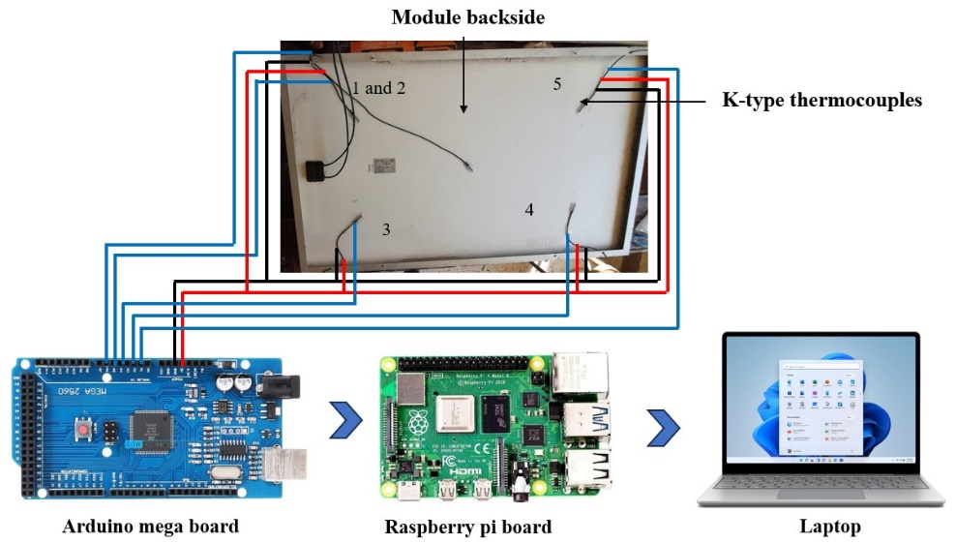
Fig. S2. Module backside equipped with five thermocouples.

S3
  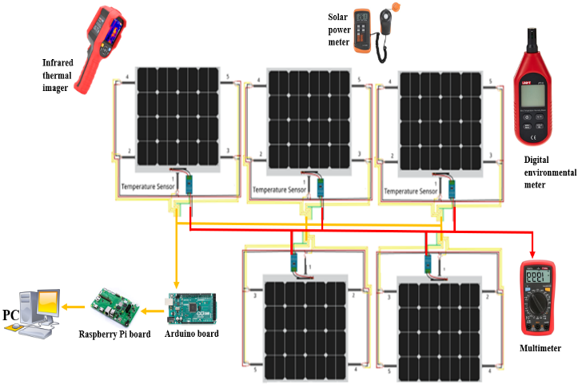 |   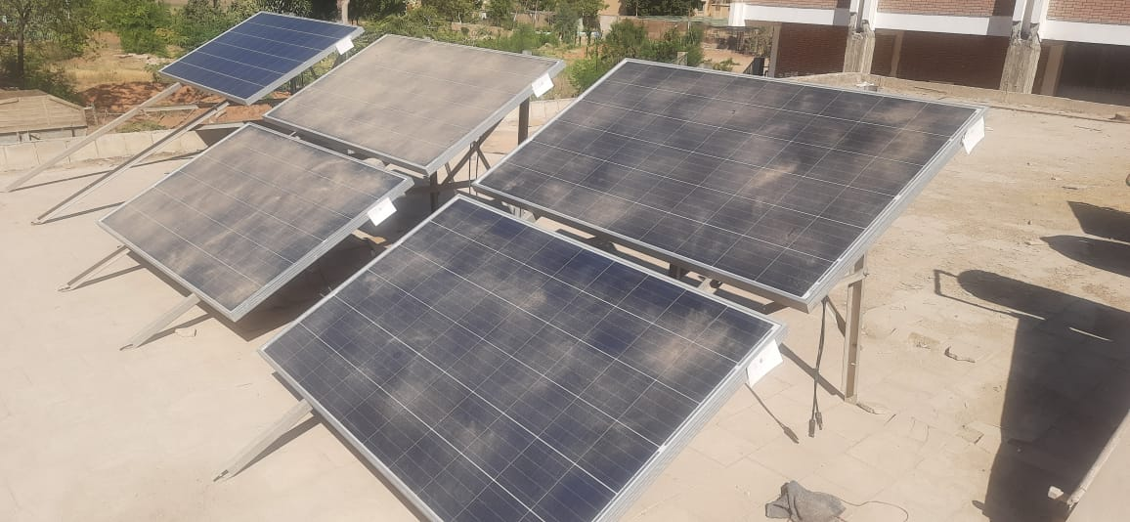
Fig. S3. Schematic diagram (a) and a complete set up of the experiments (b).

S4
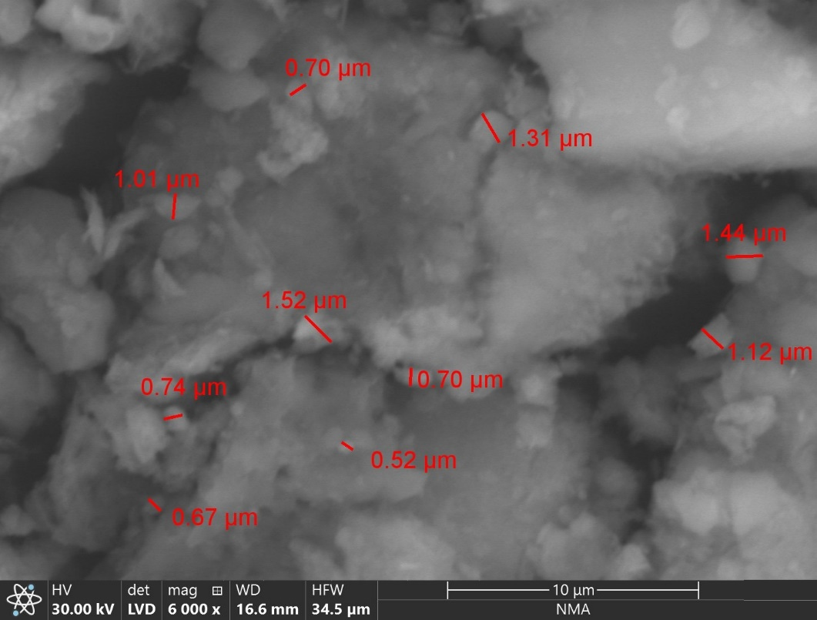
Fig. S4. Scanning electron microscope of a dust sample.

S5

Fig. S5. Dust accumulation during the testing period measured daily.

S6
Time | Dust density (g/m²)
Time | 6 g/m² (top)  12 g/m² (bottom) | 18 g/m² (top)  24 g/m² (bottom) | Clean Module
10 | 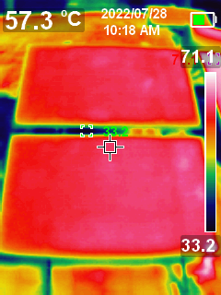 | 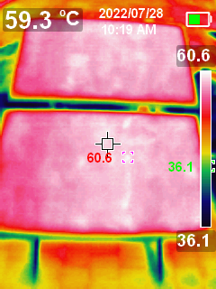 | 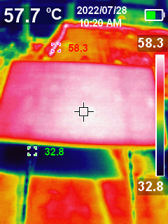
11 | 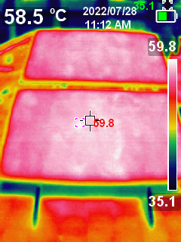 | 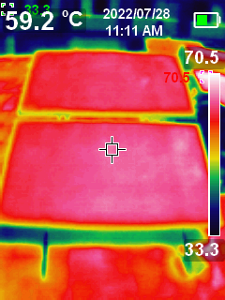 | 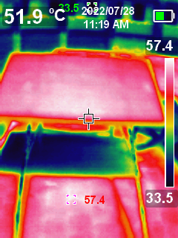
13 | 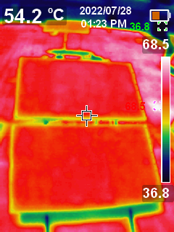 | 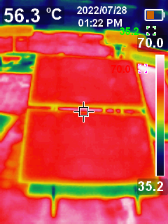 | 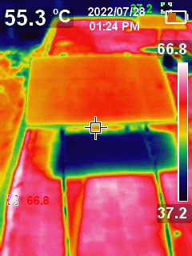
14 | 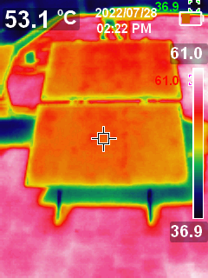 | 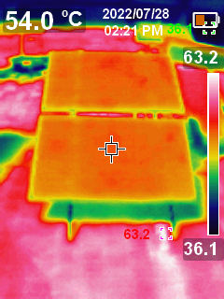 | 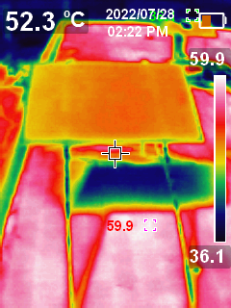
15 | 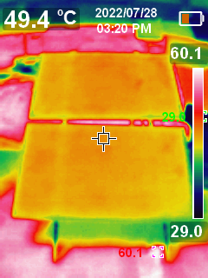 | 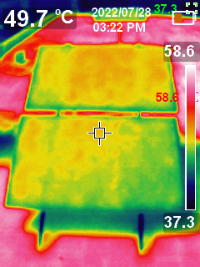 | 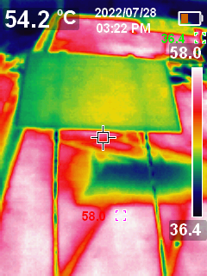
Fig. S6. Thermal images of solar photovoltaic modules under different dust densities over daytime.

