Supplementary information

Influence of 3D architecture and surface roughness of SiOC anodes on bioelectrochemical system performance: A comparative study of freeze-cast, 3D-printed, and tape-cast materials with uniform composition

Table S1: X-ray micro-computed tomography scanning parameters and specifications
Scanning parameter | Specification
Radiographic field of vision / mm | 30 × 50
Detector pixel size / μm | 30
Acquisition time / min | 130
Exposure time / s | 1
Energy of X-ray / kV | 70
Number of projections per revolution | 3200
The angular step / ° | 0.4

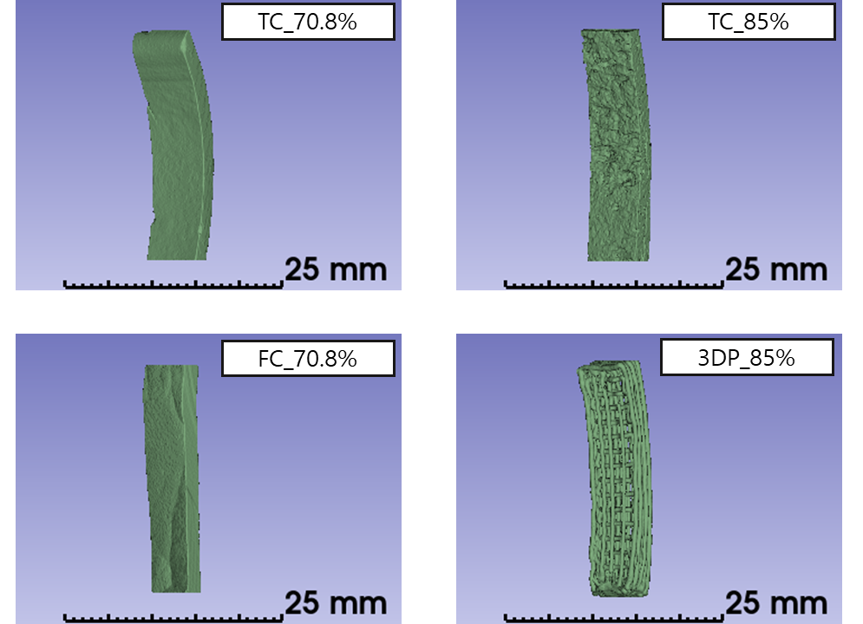
Figure S1: Reconstructed spatial representation of anode materials.

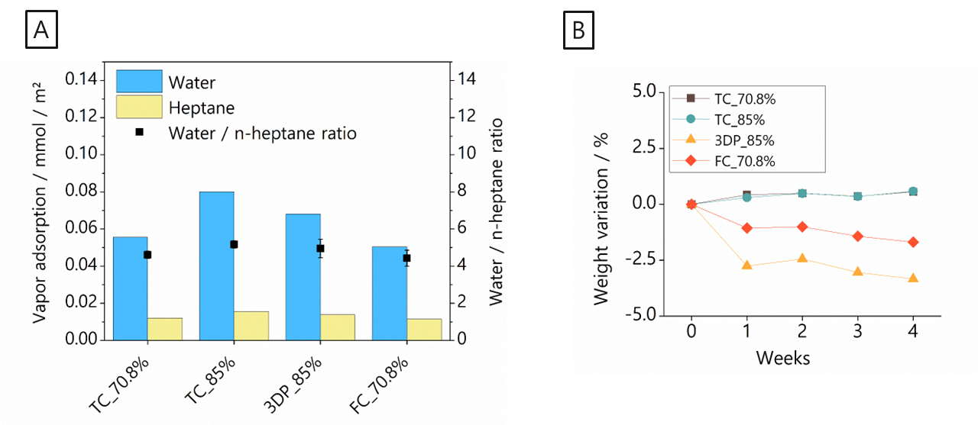

Figure S2 A) Water and n-heptane adsorption, and B) chemical stability of anode materials

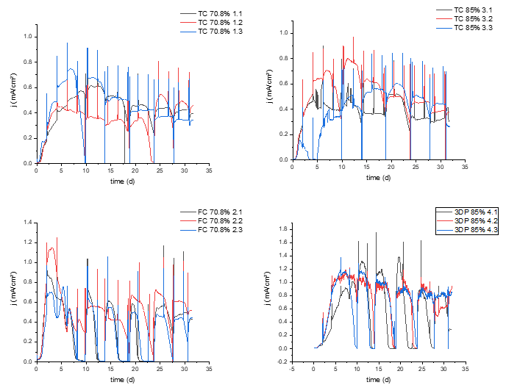
Figure S3 Chronoamperometric measurements of the bioelectrocatalytic activity of a Geobacter spp. biofilm on SiOC-based working electrodes on triplicates.

Table S2: Chemical composition of the solid fraction (all chemicals excluding the solvent p-xylene).
Chemical | Mass fraction / wt.%
Poly (methyl silsesquioxane) | 20
Poly (methyl phenyl silsesquioxane) | 20
Graphite | 29.2
Carbon black | 5
Molybdenum disilicide | 8
Azodicarbonamide | 17
Imidazole | 0.8

