Table. S1 Electrolytic bath and experimental conditions of Sn electrodeposition.
Parameter | Value
Bath chemical composition | 4.6 g SnCl₂∙2H₂O, 30 g K₄P₂O₇, 0.8 g glycine, 0.8 g potassium sodium tartrate per 100 ml pure water.
Cathode | Ni Scaffold
Anode | Pure Sn (99.8%)
Current density, mA/cm² | 75 mA/cm²
Electrodes area | Anode: 0.56 cm² , Cathode: 3 cm²
Temperature, Cº | 25
Stirring speed (rpm) | 250

Table. S2 Electrolytic bath and experimental conditions of carbon electrodeposition
Parameter | Value
Bath chemical composition | pure ethanol (99.8% Honeywell)
Cathode | Sn plated Ni Scaffold
Anode | Graphite
Voltage | 100 V
Temperature, Cº | 25
Time, min | 180

Table. S3 EDS analysis of electrodeposited Sn layer (Pulsed electrodeposition, 15% duty cycle, 2 min electrodeposition with effective time, t_{on}/_{off} = 3/17 sec.
Element | Weight % |  | Atomic % | Net Int. | Error %
SnL | 81.25 | 68.19 |  | 54.6 | 6.49
NiK | 18.75 | 31.8 |  | 9.28 | 18.34

Table. S4 EDS analysis of C/Sn/Ni nanocomposite
Element | Weight % | Atomic % | Net Int. | Error %
C K | 9.82 | 34.54 | 5.2 | 19.28
O K | 7.39 | 19.51 | 8.78 | 17.74
SnL | 37.51 | 13.35 | 58.78 | 7.24
NiK | 45.29 | 32.59 | 51.51 | 6.1

Table. S5 Electrochemical parameters for Sn layers compared with Ni scaffold obtained from linear polarization tests.
Specimen |  | Corrosion rate (mm/year) | E_{corr}(V) | J _{corr} (A/cm²) | Βc (V/dec) | Βa (V/dec)
Ni | Ni foam | 0.035 | 0.085 | 3.2615E-6 | 0.272 | 0.175
Sn/Ni | Direct 3 min | 0.7003 | -0.241 | 5.191E-5 | 0.239 | 0.217
Sn/Ni | Pulse, 50% duty cycle,  t_{on}/_{off} : 3/3, 3 min | 0.579 | -0.27 | 4.292E-5 | 0.203 | 0.218
Sn/Ni | Pulse, 15% duty cycle,  t_{on}/_{off}: 3/17, 2 min | 0.222 | -0.294 | 2.09E-5 | 0.175 | 0.127
Sn/Ni | Pulse, 15% duty cycle,  t_{on}/_{off}: 3/17, 3 min | 0.155 | -0.139 | 1.28E-5 | 0.162 | 0.179
Sn/Ni | Pulse, 15% duty cycle,  t_{on}/_{off}: 2/11.333, 3 min | 0.113 | -0.145 | 2.86E-6 | 0.139 | 0.184
Sn/Ni | Pulse, 15% duty cycle,  t_{on}/_{off}: 1/5.667, 2 min | 0.073 | -0.083 | 6.066E-6 | 0.151 | 0.189
Sn/Ni | Pulse, 15% duty cycle,  t_{on}/_{off}: 0.1/0.567, 2 min | 0.017 | -0.113 | 0.00018 | 0.175 | 0.230
C/Sn/Ni | Sn layer: Pulse, 15% duty cycle t_{on}/_{off}: 3/17, 2 min | 0.2703 | -0.269 | 2.24E-5 | 0.202 | 0.105
C/Sn/Ni | Sn layer: Pulse, 15% duty cycle, t_{on}/_{off}: 3/17, 3 min | 0.2011 | -0.296 | 1.499E-5 | 0.193 | 0.143

Table. S6 Parameters obtained by fitting EIS experimental spectra recorded in 1M LiPF₆ solution.
Samples |  | Rp(Ω) | Rs(Ω) | CPE.Y0(F) | CPE.N
Ni | Ni without any deposition | 12677 | 69 | 1.2 E-4 | 0.885
Sn/Ni | Direct, 3 min | 127 | 60 | 2.4E-4 | 0.505
Sn/Ni | Pulse, 50% duty cycle, t_{on}/_{off} : 3/3, 3 min | 182 | 58.5 | 7.3E-4 | 0.382
Sn/Ni | Pulse, 15% duty cycle, t_{on}/_{off} : 3/17, 2 min | 168 | 61.6 | 4.3E-4 | 0.572
Sn/Ni | Pulse, 15% duty cycle, t_{on}/_{off} : 3/17, 3 min | 703 | 77.5 | 1E-3 | 0.687
Sn/Ni | Pulse, 15% duty cycle, t_{on}/_{off} : 2/11.333, 3 min | 654 | 83.7 | 4.5E-4 | 0.669
Sn/Ni | Pulse, 15% duty cycle, t_{on}/_{off} : 1/5.667, 2 min | 1300 | 65.3 | 3.5E-4 | 0.606
Sn/Ni | Pulse, 15% duty cycle, t_{on}/_{off} : 0.1/0.567, 2 min | 9510 | -217 | 1.67E-4 | 0.402
C/Sn/Ni | Sn layer: Pulse, 15% duty cycle, t_{on}/_{off} : 3/17, 2 min | 94 | 57 | 2.2E-4 | 0.574
C/Sn/Ni | Sn layer: Pulse, 15% duty cycle, t_{on}/_{off} : 3/17 sec, 3 min | 415.88 | 94.7 | 9.34E-5 | 0.643

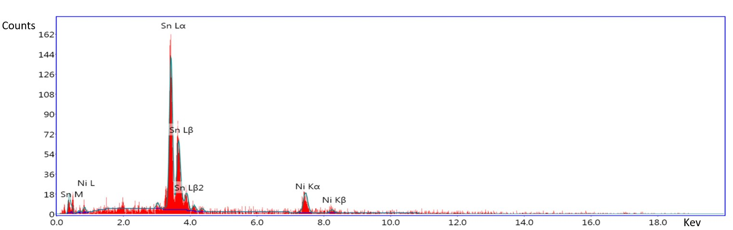
Fig. S1 EDS analysis of electrodeposited Sn on Ni foam substrate (Pulsed electrodeposition, 15% duty cycle, 2 min electrodeposition effective time, t on/off = 3/17 sec.

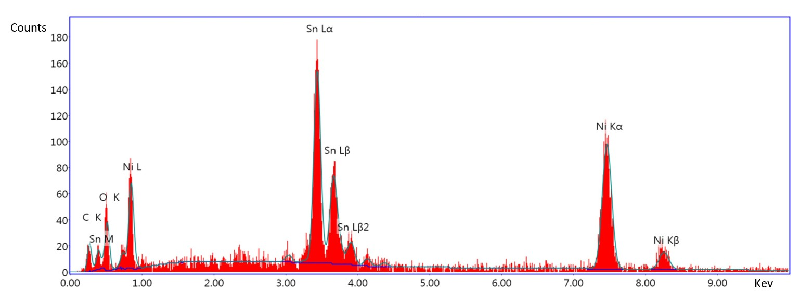

Fig. S2 EDS analysis of electrodeposited C/ Sn layers on Ni foam substrate.

