A Structural and Compositional Analysis of the Customization of Ti₃C₂ MXenes for Enhanced Power Storage

W. A. Hussein^{1*}, P. Ragupathy², Raghupandiyan Naresh², V. Varshini², Ghalia A. Gaber^{1*}
¹ Department of Chemistry, Faculty of Science (Girls), Al-Azhar University, P.O. Box: 11754, Yousef Abbas Str., Nasr City, Cairo, Egypt
² CSIR-Central Electrochemical Research Institute, Karaikudi-630003, India

*Correspondence:
W. A. Hussein Email: wallaahmed@azhar.edu.eg
Ghalia A. Gaber Email: ghaliaasaid@azhar.edu.eg

Table S1. XRD crystallite size (D), inter-planar spacing (d-Spacing), and lattice parameters of all electrodes.
Parameters  Electrodes | D (nm) | d-Spacing Å | C lattice Å
c-Ti₃C₂ | 2.8 | 8.8 | 17.7
d-Ti₃C₂ | 2.3 | 9.8 | 19.6
c-Ti₃C₂/Si | 1.9 | 9.3 | 18.7
d-Ti₃C₂/Si | 1.0 | 10.1 | 20.2

Table S2. Statistical fitting parameters obtained from FT-IR deconvolution analysis of all electrodes.
Parameters  Electrodes | Reduced Chi-Sqr | R-Square (COD) | Adj. R-Square
c-Ti₃C₂ | 4.31798E-5 | 0.94543 | 0.94481
d-Ti₃C₂ | 8.63468E-4 | 0.92121 | 0.91992
c-Ti₃C₂/Si | 2.09922E-4 | 0.98168 | 0.98135
d-Ti₃C₂/Si | 3.97427E-5 | 0.96889 | 0.96853

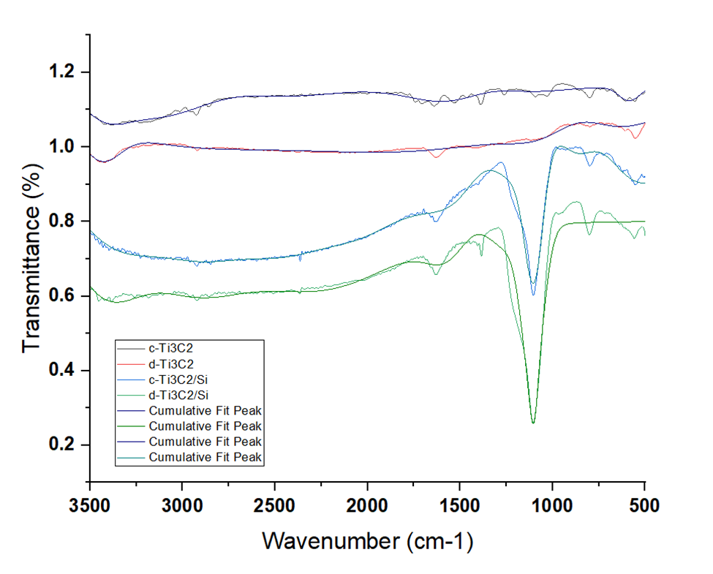
Fig. S1. FTIR spectral deconvolution for all electrodes (c-Ti₃C₂, d-Ti₃C₂, c-Ti₃C₂/Si, and d-Ti₃C₂/Si) showing the measured signal and cumulative fit peaks.

Table S3. Fraction of Ti, C, O, and F atoms of synthesized MXene
Element (atom %) | MAX-Ti₃AlC₂ | c-Ti₃C₂ | d-Ti₃C₂ | c-Ti₃C₂/Si | d-Ti₃C₂/Si
C | 45.71 | 14.91 | 23.33 | 42.89 | 15.71
O | 13.74 | 10.25 | 17.00 | 45.72 | 33.68
F |  | 14.67 | 23.72
Al | 16.82 | 2.33 | 1.15 | 1.46 | 1.10
Ti | 23.73 | 57.84 | 34.81 | 62.74 | 48.47
Si |  |  |  | 3.51 | 1.04

