Supplementary Materials
American Journal of Cardiovascular Drugs
Efficacy of PCSK9 Inhibitors on Clinical Outcomes in Patients with Established
Atherosclerotic Cardiovascular Disease: A Network Meta-Analysis
Luca Raone, MD, ^{a,b}; Valeria Gritti, MD ª, Alessandro Mandurino-Mirizzi, MD ^{c;d}; Francesco Maria Sparasci, MD ^{a,b}; Valeria Scotti ^{e}; Alessia Currao, PharmD ^{a,f}; Giuseppe Colonna, MD ^{c}; Marco Ferlini, MD ª; Leonardo De Luca, MD, PhD ª

Affiliations:
- Division of Cardiology, Fondazione IRCCS Policlinico San Matteo, Pavia, Italy
- Department of Molecular Medicine, University of Pavia, Pavia, Italy
- Division of Cardiology, Vito Fazzi Hospital, Lecce, Italy
- Department of Experimental Medicine (DiMeS), University of Salento, Lecce, Italy
- Centre for Scientific Documentation, Fondazione IRCCS Policlinico San Matteo, Pavia, Italy
- Department of Internal Medicine and Medical Therapy, University of Pavia, Italy

Address for correspondence
Luca Raone, MD
Department of Molecular Medicine, University of Pavia, Pavia, Italy
Division of Cardiology, Fondazione IRCCS Policlinico San Matteo, Pavia, Italy
Viale Golgi 19, 27100 Pavia
Email: raone.luca@gmail.com

Table of Contents
Supplementary Methods 1. Research Protocol and search strategy…………………………………3
Supplementary Methods 2. Risk of Bias assessment…………………………………….…………7
Supplementary Figure 1. PRISMA flowchart……………...…………………………….…………8
Supplementary Figure 2. Forest and Ranking Plots for All-Cause Death and Cardiovascular Death.9

Supplementary Methods 1. Research Protocol and search strategy
Aim
The aim of this network meta-analysis is to evaluate and compare the efficacy of different PCSK9 inhibitor regimens on major cardiovascular outcomes in patients with established ASCVD.

Population
Patients with ACSVD treated with one of the following PCSK9 inhibitors at approved dosages.

Intervention
Evolocumab 420 mg monthly/ Evolocumab 140 mg every 2 weeks
Alirocumab 75 mg every 2 weeks
Alirocumab 150 mg every 2 weeks
Inclisiran 284 mg

Comparison
The comparisons in this network meta-analysis are based on randomized controlled trials evaluating PCSK9 inhibitor regimens versus placebo or standard statin therapy, in the context of optimized background lipid-lowering treatment.

Outcome
The primary endpoint was the occurrence of MACE. For the purposes of this study, MACE was defined as a composite outcome comprising the aggregate of the individual endpoints of cardiovascular death, myocardial infarction, stroke, and coronary revascularization, as reported in each included trial.
The secondary endpoints included all-cause mortality, as well as the individual components of the MACE composite - namely, myocardial infarction, stroke, cardiovascular death, and revascularization.

Search strategy
Databases searched: Medline, EMBASE and the Cochrane Central Register of Controlled Trials.
The following search strategies were used:

Medline
'coronary artery disease'/exp AND (('pcsk9 inhibitor'/exp OR 'pcsk9 inhibitors' OR 'pcsk9 inhibitor' OR pcsk9 OR 'inclisiran'/exp OR 'aln 60212' OR 'aln pcssc' OR 'aln60212' OR 'inclisiran sodium' OR 'kjx 839' OR 'kjx839' OR 'leqvio' OR 'inclisiran') AND 'small interfering rna'/exp OR 'rna, small interfering' OR 'short interfering rna' OR 'sirna' OR 'sirnas' OR 'small interfering ribonucleic acid' OR 'small interfering rna' OR 'proprotein convertase 9 inhibitor'/exp)

Embase
'coronary artery disease'/exp AND (('pcsk9 inhibitor'/exp OR 'pcsk9 inhibitors' OR 'pcsk9 inhibitor' OR pcsk9 OR 'inclisiran'/exp OR 'aln 60212' OR 'aln pcssc' OR 'aln60212' OR 'inclisiran sodium' OR 'kjx 839' OR 'kjx839' OR 'leqvio' OR 'inclisiran') AND ro AND 'small interfering rna'/exp OR 'rna, small interfering' OR 'short interfering rna' OR 'sirna' OR 'sirnas' OR 'small interfering ribonucleic acid' OR 'small interfering rna' OR 'proprotein convertase 9 inhibitor'/exp)

Cochrane
'"Coronary Artery Disease" AND ("PCSK9 Inhibitors" OR Inclisiran OR OR 'siRNA' OR 'siRNAs')
The reference list of eligible studies, systematic reviews and meta-analyses was searched for additional studies (backward snowballing). The initial search was carried out by two authors (L.R. and F.M.S.) and all references were reported on an Excel table.
After removal duplicates, titles and abstracts of the search results were screened by the same two authors (L.R. and F.M.S.) independently. Non-relevant studies were decided at the reviewers’ discretion. At this stage reviewers were overly inclusive to reduce chance of omitting relevant articles.
The full text of the remaining results was independently assessed in duplicates by the 2 authors
(L.R. and F.M.S.) for inclusion, based on predetermined inclusion and exclusion criteria. Any
disagreement at this stage was resolved by consensus and by the mediation of a third author (V.G.). The final list of included studies was decided upon discussion between authors with full agreement required prior to inclusion.

Study inclusion criteria
1) Randomized controlled trials.
2) The study included patients with established atherosclerotic cardiovascular disease treated with one of the following PCSK9 inhibitors at approved dosage: Evolocumab 420 mg monthly/Evolocumab 140 mg every 2 weeks; Alirocumab 75 mg every 2 weeks; Alirocumab 150 mg every 2 weeks; Inclisiran 284 mg
3) The study provided information on any of the primary or additional endpoints of the meta-analysis.
5) English language.

Study exclusion criteria
1) Observational studies.
2) Studies that do not report clinical outcomes.

No restrictions on follow-up period or sample size were applied.
Data extraction
Two authors (L.R. and F.M.S.) extracted data in parallel and independently onto a dedicated
electronic database. The database was prepared on Microsoft Excel and contained columns for all
required extracted data. The database was then compared between the two investigators and was reviewed by a third author (V.G.) to ensure validity and accuracy of data extraction.
Data extracted from each study concerned:
- first author, study name, study design, year and journal of publication;
- sample size, baseline population characteristics, clinical presentation, baseline and follow-up lipid profile, length of follow-up;
- inclusion and exclusion criteria;
- data of primary and additional endpoints: number of events in patients treated with statin therapy and the PCSK9 inhibitor, statin therapy only or statin therapy plus placebo, relative risk or hazard ratio where reported, upper and lower 95% confidence intervals where reported, P value where reported.

Supplementary Methods 2. Risk of Bias assessment
The version 2 of the Cochrane risk-of-bias tool for randomized trials (RoB 2) was used.
Study | Experimental | Comparator | Randomization process | Deviations from  int interventionsª | Missing  outcome data | Measurement of the outcome | Selection of the reported result | Overall
ODISSEY OUTCOMES | Alirocumab | Placebo | + | + | + | + | + | +
FOURIER | Evolocumab | Placebo | + | + | + | + | + | +
ORION -10 | Inclisiran | Placebo | + | + | + | + | + | +
HUYGENS | Evolocumab | Placebo | + | + | + | + | + | +
PACMAN-AMI | Alirocumab | Placebo | + | + | + | + | + | +
Gao et al. | Alirocumab | Standard of care | ? | + | + | + | + | ?
GLAGOV | Evolocumab | Placebo | + | + | + | + | + | +
EVOPACS | Evolocumab | Placebo | + | + | + | + | + | +

+ = Low risk
- = High risk
? = some concerns
ª Deviations from intended interventions

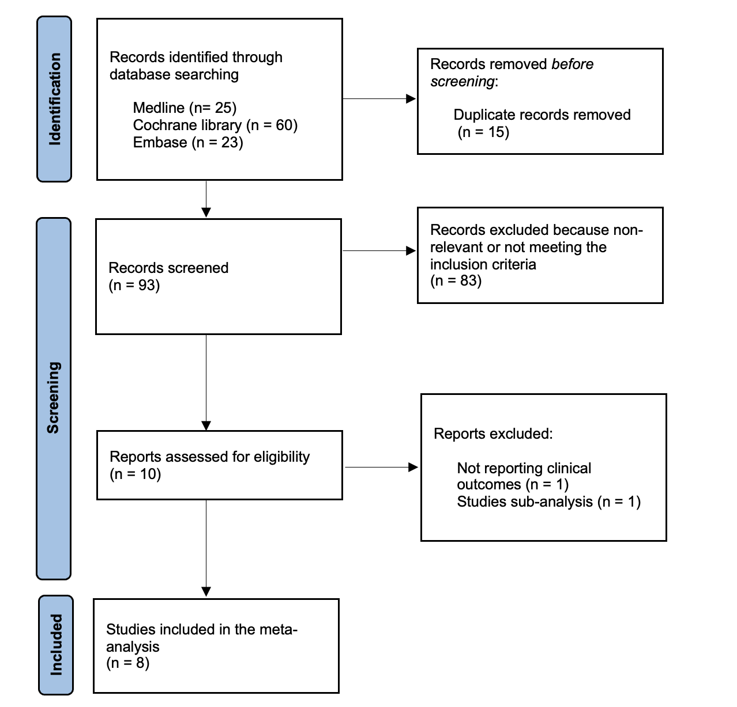
Supplementary Figure 1. PRISMA flowchart
Supplementary Figure 2. Forest and Ranking Plots for All-Cause Death and Cardiovascular Death.
