Supplementary Information

Chlormethine gel versus chlormethine ointment for treatment of patients with mycosis fungoides: a post-hoc analysis of clinical trial data
Authors: Christiane Querfeld¹, Julia J. Scarisbrick², Chalid Assaf^{3,4}, Youn H. Kim⁵, Joan Guitart⁶, Pietro Quaglino⁷, Emmilia Hodak^{8,9}
Affiliations: ¹City of Hope Cancer Center and Beckman Research Institute, Duarte, CA, USA; ²University of Birmingham, Birmingham, UK; ³Department of Dermatology and Venerology, Helios Klinikum Krefeld, Krefeld, Germany; ⁴Academic Teaching Hospital of the University of Aachen, Aachen, Germany; ⁵Department of Dermatology, Stanford Cancer Center, Stanford, CA, USA; ⁶Northwestern University Feinberg School of Medicine, Chicago, IL, USA; ⁷Department of Medical Sciences, Dermatology Clinic, University of Turin, Turin, Italy; ⁸Division of Dermatology, Rabin Medical Center, Beilinson Hospital, Petah Tikvah, Israel; ⁹Sackler Faculty of Medicine, Tel Aviv University, Tel Aviv, Israel.

Fig. S1 Association between the frequency of chlormethine gel application and the occurrence of skin-related adverse events. Data from patients included in the safety population of the study 201 chlormethine gel arm (n=128) and from all patients in study 202 were included. CI, confidence interval; HR, hazard ratio
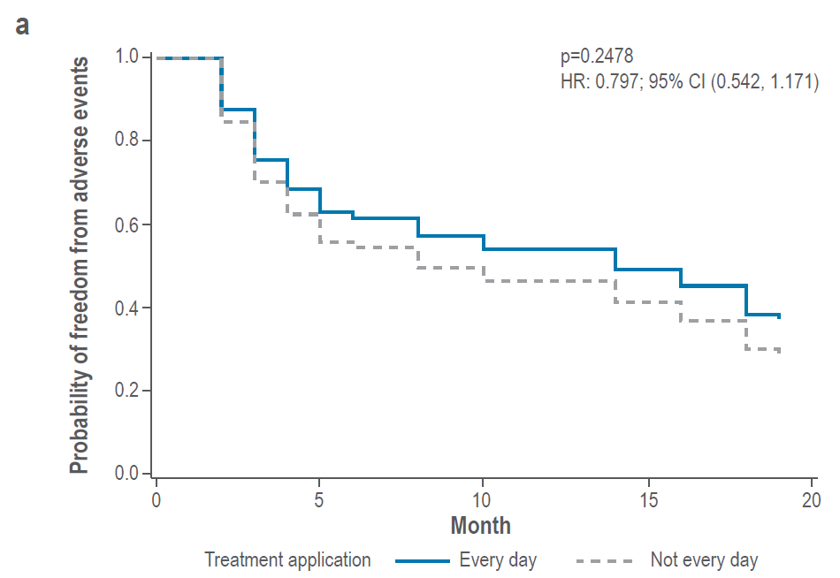

Fig. S2 Association between the frequency of chlormethine gel application and improved skin response per Composite Assessment of Index Lesion Severity (CAILS). Data were included from patients in the safety population of the study 201 chlormethine gel arm (n=128) and from all patients in study 202. CI, confidence interval; HR, hazard ratio
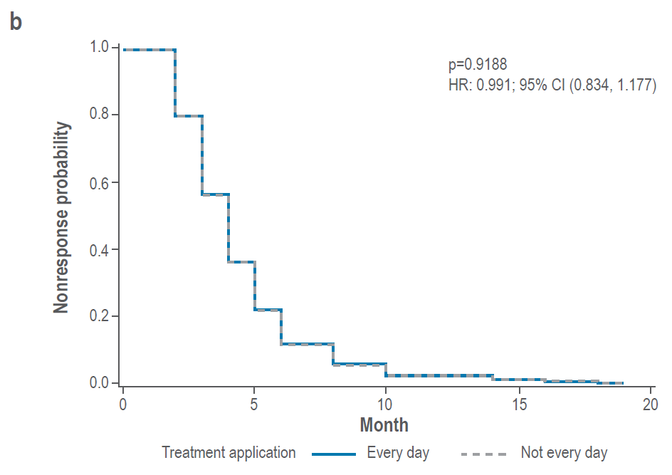

Fig. S3 Repeated measures analysis for patients treated with chlormethine gel during both study 201 and 202 and patients treated with chlormethine ointment during study 201 and chlormethine gel during study 202 with a) complete response (CR), and b) at least very good partial response (VGPR). SE, standard error


