Supplementary Information

Patient-Reported Hair Loss and Its Impacts as Measured by the Alopecia Areata Patient Priority Outcomes Instrument in Patients Treated With Ritlecitinib: The ALLEGRO Phase 2b/3 Randomized Clinical Trial

American Journal of Clinical Dermatology

Rodney Sinclair,¹ Natasha Mesinkovska,² Debanjali Mitra,³ Dalia Wajsbrot,³ Ernest H. Law,³ Robert Wolk,⁴ Brett King⁵

¹Sinclair Dermatology, Melbourne, Victoria, Australia; ²UC Irvine School of Medicine, Irvine, CA, USA; ³Pfizer Inc, New York, NY, USA; ⁴Pfizer Inc, Groton, CT, USA; ⁵Yale School of Medicine, New Haven, CT, USA.

Corresponding author: Ernest Law, ernest.law@pfizer.com

Supplementary Fig. 1. Forest plot of mean change (95% ci) from baseline in AAPPO (A) emotional symptoms and (b) activity limitations by SALT score of ≤20 response category
Supplementary Table 1. Baseline demographics and clinical characteristics
Supplementary Table 2. Participants by SALT score of ≤20 response

Supplementary Fig. 1 Forest plot of mean change (95% CI) from baseline in AAPPO (a) emotional symptoms and (b) activity limitations by SALT score of ≤20 response category
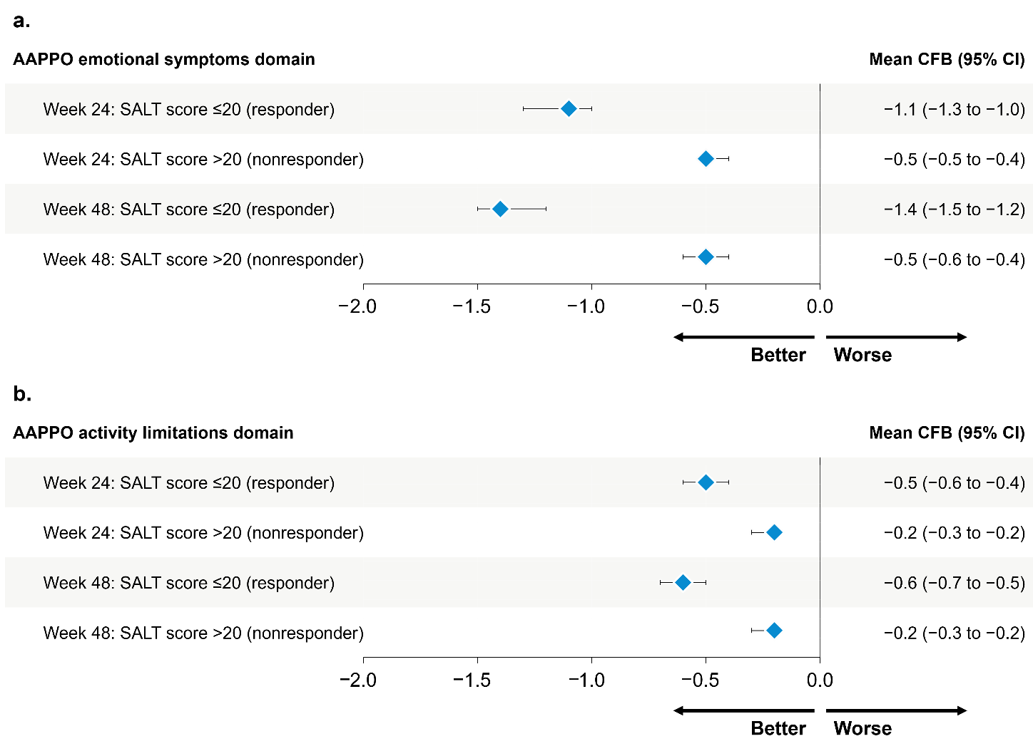
AAPPO, Alopecia Areata Patient Priority Outcomes; CFB, change from baseline; SALT, Severity of Alopecia Tool.

Supplementary Table 1 Baseline demographics and clinical characteristics [1]
 | Placeboª (n=131) | Ritlecitinib QD
 |  | 10 mg (n=63) | 30 mg (n=132) | 50 mg (n=130) | 200/30 mg (n=130) | 200/50 mg (n=132)
Age, mean (SD), y | 34.0 (15.0) | 34.3 (13.9) | 33.7 (14.8) | 32.4 (13.4) | 33.7 (13.8) | 34.5 (15.0)
Age category, n (%)
12-17 y | 19 (14.5) | 9 (14.3) | 20 (15.2) | 18 (13.8) | 19 (14.6) | 20 (15.2)
≥18 y | 112 (85.5) | 54 (85.7) | 112 (84.8) | 112 (86.2) | 111 (85.4) | 112 (84.8)
Female, n (%) | 86 (65.6) | 43 (68.3) | 80 (60.6) | 71 (54.6) | 85 (65.4) | 81 (61.4)
Male, n (%) | 45 (34.4) | 20 (31.7) | 52 (39.4) | 59 (45.4) | 45 (34.6) | 51 (38.6)
Race, n (%)
African American or Black | 4 (3.1) | 2 (3.2) | 3 (2.3) | 5 (3.8) | 7 (5.4) | 6 (4.5)
American Indian or Alaska Native | 0 | 0 | 2 (1.5) | 0 | 1 (0.8) | 0
Asian | 31 (23.7) | 17 (27.0) | 34 (25.8) | 43 (33.1) | 28 (21.5) | 33 (25.0)
Multiracial | 2 (1.5) | 0 | 2 (1.5) | 1 (0.8) | 3 (2.3) | 0
Native Hawaiian or Other Pacific Islander | 0 | 1 (1.6) | 0 | 0 | 0 | 0
White | 94 (71.8) | 42 (66.7) | 91 (68.9) | 79 (60.8) | 90 (69.2) | 92 (69.7)
Not reported | 0 | 1 (1.6) | 0 | 2 (1.5) | 1 (0.8) | 1 (0.8)
Severity of AA, n (%)
AT/AU^{b} | 60 (45.8) | 29 (46.0) | 61 (46.2) | 60 (46.2) | 60 (46.2) | 60 (45.5)
Baseline SALT score, mean (SD)
Non-AT/AU^{b} | 87.0 (12.9) | 78.3 (17.6) | 81.5 (16.3) | 82.0 (15.9) | 82.4 (15.4) | 82.2 (16.5)
Disease duration since diagnosis, mean (SD), y | 11.0 (11.8) | 10.8 (10.7) | 8.8 (8.9) | 8.7 (8.7) | 11.6 (11.7) | 9.9 (10.8)
Duration of current AA episode, mean (SD), y | 3.2 (2.7) | 3.3 (2.7) | 3.6 (2.8) | 3.2 (2.7) | 3.4 (2.9) | 3.4 (2.9)

AA, alopecia areata; AT, alopecia totalis; AU, alopecia universalis; QD, once daily; SALT, Severity of Alopecia Tool.
ªPatients received placebo until week 24 and then were switched to active ritlecitinib treatment.
^{b}Patients in the AT/AU category had a SALT score of 100% at baseline, as assessed by the investigator (regardless of the category in the AA history case report form).

Supplementary Table 2 Patients by SALT score of ≤20 response
 |  | Overall | Placeboª | Ritlecitinib treatment^{b}
Week 24 | Responder  (SALT score ≤20) | 114 | 2 | 112
Week 24 | Nonresponder (SALT score >20) | 536 | 123 | 413
Week 48 | Responder  (SALT score ≤20) | 225 | 34 | 191
Week 48 | Nonresponder (SALT score>20) | 396 | 85 | 311

SALT, Severity of Alopecia Tool.
ªPatients received placebo until week 24 and then were switched to active ritlecitinib treatment.
^{b}The ritlecitinib treatment category includes all participants randomized to receive any dose of active ritlecitinib treatment.

REFERENCES
1. King B, Zhang X, Harcha WG, Szepietowski JC, Shapiro J, Lynde C, et al. Efficacy and safety of ritlecitinib in adults and adolescents with alopecia areata: a randomised, double-blind, multicentre, phase 2b-3 trial. Lancet. 2023;401(10387):1518–1529. doi:10.1016/S0140-6736(23)00222-2

