Title: Efficacy and Safety of Oral Janus Kinase Inhibitors in Adults and Adolescents with Alopecia Areata: A Systematic Review and Meta-Analysis of Randomised Controlled Trials
Samuel Morriss¹, Chuan Hui Foo^{2,3}, Emily Lin^{4,5}, Flavia Rodrigues-Dias⁶, Daniella Kushnir-Grinbaum^{6,7}, Holly FitzGerald⁶, Shalem Leemaqz⁸, Sharon Lee³, Bevin Bhoyrul⁶
¹ Department of Dermatology, The Royal Melbourne Hospital, Parkville, Victoria, Australia
² Department of Mathematics, Faculty of Science and Mathematics, Sultan Idris Education University, 35900 Tanjong Malim, Malaysia
³ School of Mathematics and Physics, The University of Queensland, 4067, St Lucia, Australia
⁴ Department of Medicine, Monash University, Clayton, VIC, Australia
⁵ Department of Rheumatology, Monash Health, Clayton, VIC, Australia
⁶ Sinclair Dermatology, East Melbourne, Victoria, Australia
⁷ Department of Dermatology, Emek Medical Centre, Afula, Israel, affiliated with the Ruth and Bruce Rappaport Faculty of Medicine of the Technion Institute of Technology, Haifa, Israel
⁸ Flinders University, Adelaide, Australia

Journal: Americal Journal of Clinical Dermatology

Corresponding author:
Samuel Morriss
samuel.h.morriss@gmail.com

Supplementary Figure 4. Severe adverse effects of Janus kinase inhibitors versus placebo or active comparator.
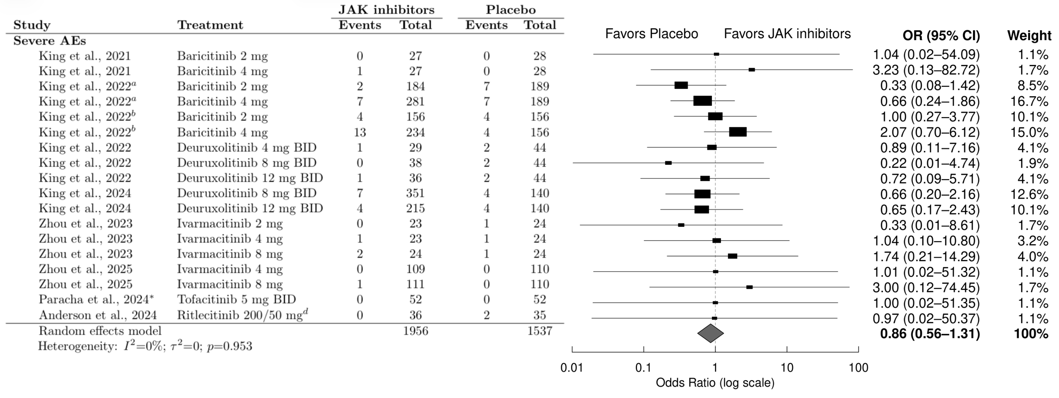

Abbreviations:
AEs, adverse events; BID, twice daily; CI, confidence interval; JAK, Janus kinase; OR, odds ratio.
ª Refers to the BRAVE-AA1 trial in King et al., 2022.
^{b} Refers to the BRAVE-AA2 trial in King et al., 2022.
^{d} Ritlecitinib 200/50 mg refers to the regimen of 200 mg once daily for 4 weeks, followed by 50 mg once daily for 20 weeks.
* This study compared tofacitinib with azathioprine (2 mg/kg once daily) rather than placebo.

Study references: Anderson et al., 2024 [31]; King et al., 2021 [29]; King et al., 2022a & 2022b [18]; King et al., 2022 [30]; King et al., 2024 [17]; Paracha et al., 2024 [27]; Zhou et al., 2023 [19]; Zhou et al., 2025 [20].

Supplementary Figure 5. Serious adverse effects of Janus kinase inhibitors versus placebo or active comparator.
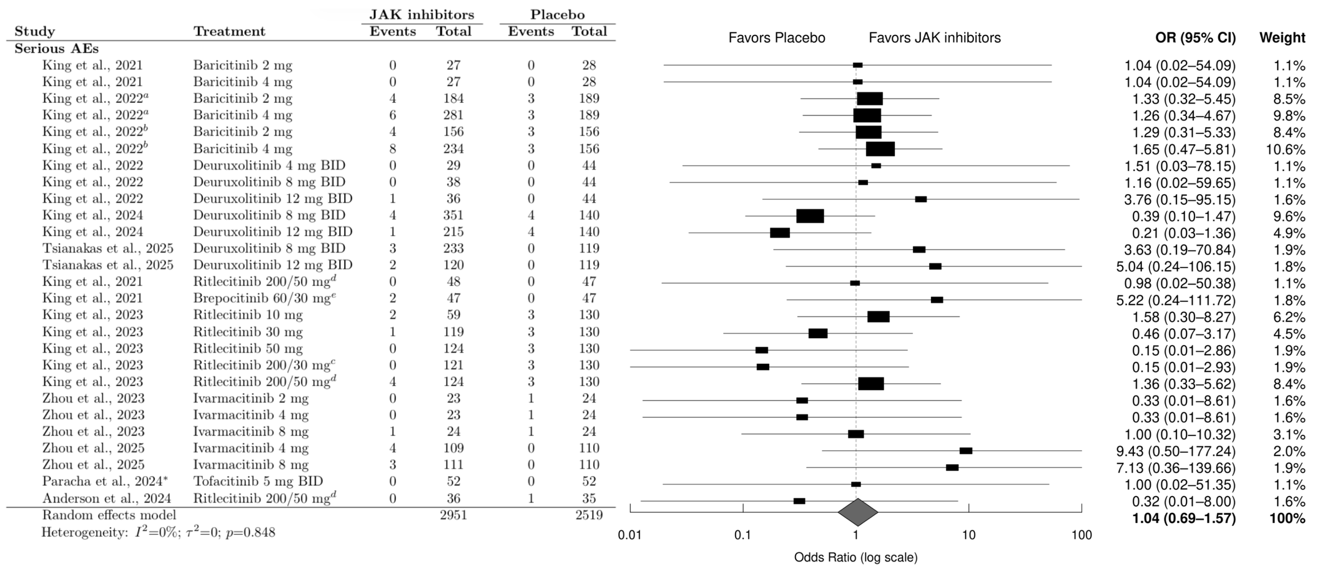

Abbreviations:
AEs, adverse events; BID, twice daily; CI, confidence interval; JAK, Janus kinase; OR, odds ratio.
ª Refers to the BRAVE-AA1 trial in King et al., 2022.
^{b} Refers to the BRAVE-AA2 trial in King et al., 2022.
^{c} Ritlecitinib 200/30 mg refers to the regimen of 200 mg once daily for 4 weeks, followed by 30 mg once daily for 20 weeks.
^{d} Ritlecitinib 200/50 mg refers to the regimen of 200 mg once daily for 4 weeks, followed by 50 mg once daily for 20 weeks.
^{e} Brepocitinib 60/30 mg refers to the regimen of 60 mg once daily for 4 weeks, followed by 30 mg once daily for 20 weeks.
* This study compared tofacitinib with azathioprine (2 mg/kg once daily) rather than placebo.

Study references: Anderson et al., 2024 [31]; King et al., 2021 (baricitinib) [29]; King et al., 2021 (ritlecitinib and brepocitinib) [15]; King et al., 2022a & 2022b [18]; King et al., 2022 [30]; King et al., 2023 [16]; King et al., 2024 [17]; Paracha et al., 2024 [27]; Tsianakas et al., 2025 [28]; Zhou et al., 2023 [19]; Zhou et al., 2025 [20].

Supplementary Figure 6. Discontinuation due to adverse events of Janus kinase inhibitors versus placebo or active comparator.
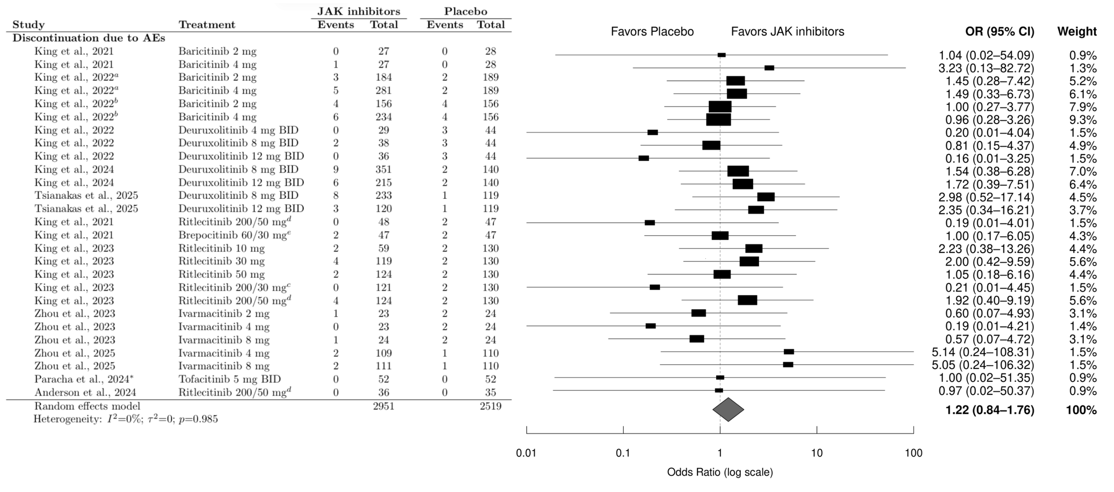

Abbreviations:
AEs, adverse events; BID, twice daily; CI, confidence interval; JAK, Janus kinase; OR, odds ratio.
ª Refers to the BRAVE-AA1 trial in King et al., 2022.
^{b} Refers to the BRAVE-AA2 trial in King et al., 2022.
^{c} Ritlecitinib 200/30 mg refers to the regimen of 200 mg once daily for 4 weeks, followed by 30 mg once daily for 20 weeks.
^{d} Ritlecitinib 200/50 mg refers to the regimen of 200 mg once daily for 4 weeks, followed by 50 mg once daily for 20 weeks.
^{e} Brepocitinib 60/30 mg refers to the regimen of 60 mg once daily for 4 weeks, followed by 30 mg once daily for 20 weeks.
* This study compared tofacitinib with azathioprine (2 mg/kg once daily) rather than placebo.

Study references: Anderson et al., 2024 [31]; King et al., 2021 (baricitinib) [29]; King et al., 2021 (ritlecitinib and brepocitinib) [15]; King et al., 2022a & 2022b [18]; King et al., 2022 [30]; King et al., 2023 [16]; King et al., 2024 [17]; Paracha et al., 2024 [27]; Tsianakas et al., 2025 [28]; Zhou et al., 2023 [19]; Zhou et al., 2025 [20].

