Online Resource / Electronic SUPPLEMENTary Material

Multinomial Logistic Regression for Selection of Intervention to Be Used
For all but the first simulated quit attempt, the intervention used in quit attempts is predicted via a multinomial logistic regression:
$p_{i}^{k}=\frac{e^{(β_{0}^{k}+\sum_{j=1}{β_{j}^{k}x_{j,i}})}}{1+{\sum_{k}{e}}^{(β_{0}^{k}+\sum_{j=1}{β_{j}^{k}x_{j,i}})}}$,
where $β^{k}$ is the vector of the regression coefficients associated with the k^{th} modality, i.e., $β_{j}^{k}$is the regression coefficients associated with the j^{th} predictor variable and the k^{th} modality, and x_{i} is the vector of individual characteristics. Parameter estimates for β derived from the web-based survey [1] are provided in Table S1.
Table S1 Parameter Estimates for Multinomial Logistic Regression for Selection of Intervention to Be Used
Parameter | Varenicline vs.  Unassisted | BMT vs.  Unassisted | NRT vs.  Unassisted
 | β¹ | β² | β³
Intercept (β₀) | 3.494 | 4.929 | 2.875
Use of varenicline in 5 most recent quit attempts | −3.815 | −2.907 | 2.341
Use of NRT or BMT in 5 most recent quit attempts | −1.754 | −2.634 | −3.660
Unassisted in 5 most recent quit attempts | 0.327 | 0.828 | 0.334
Number of previous quit attempts | 0.134 | 0.043 | 0.023
Log likelihood | −214.8, N=1990 | −70.67, N=1952 | −410.5, N=2063
Abbreviations: BMT, behavioural modification therapy; NRT, nicotine replacement therapy.

Time to Next Quit Attempt
Time to next quit attempt was calculated as $S_{t}= e^{-λt},$where $λ={β_{0}+β}_{j}x_{j,i}$, β is the vector of regression coefficients and x_{j,i} is the associated is the vector of patient characteristics. Parameter estimates for β derived from the web based survey responses (N=1135) [1] are provided in Table S2.
Table S2 Parameter Estimates for Determining Time to Next Quit Attempt
Parameter | Estimate β
Intercept(β₀) | −8.4783
Number of previous quit attempts | 0.2508
Female | 0.2304
N =771, Log likelihood: −3919.4

Calculation of Quit Attempt Outcomes
Table S3 Parameter Estimates for Logistic Regression Predicting Abstinence at 12 Weeks Following Quit Attempt Initiation†
Parameter | Estimate | 95% CI
Intercept | −1.007 | (−1.549,−0.466)
NRT | 0.921 | (0.556, 1.286)
Varenicline | 1.520 | (1.305, 1.734)
Bupropion | 0.891 | (0.643, 1.139)
Age (years) | 0.033 | (0.019, 0.048)
Race
Asian | −0.210 | (−0.649, 0.229)
Black | −0.588 | (−0.916, −0.261)
Other | −0.107 | (−0.394, 0.179)
Female | −0.121 | (−0.269, 0.027)
Number of years smoked | −0.014 | (−0.028, −0.000)
Cigarettes per day in past month | −0.017 | (−0.026, −0.007)
Frequent contact with another smoker (Yes/No) | −0.151 | (−0.304, 0.003)
Prior quit attempt (Yes/No) | −0.399 | (−0.633, −0.166)
Prior medical* quit attempt (Yes/No) | −0.170 | (−0.326, −0.013)
FTND score | −0.104 | (−0.147, −0.061)
Number of lifetime quit attempts in excess of 4 | −0.008 | (−0.017, 0.001)
COPD (Yes/No) | −1.498 | (−2.218, −0.779)
COPD (Yes/No) x FTND score | 0.159 | (0.059, 0.258)
COPD x Active treatment* (Yes/No) | 0.237 | (−0.243, 0.718)
Double Blind Study (Yes/No) | −0.575 | (−0.823,−0.328)
† Note that this equation was used to directly estimate the probability of success with brief counselling (i.e., placebo with brief counselling in the clinical trials), varenicline, and NRT. As no data from the 5 trials analysed were available for unassisted quit attempts and BMT (Behaviour Modification Therapy), odd ratios from the literature were used to modify the prediction from the logistic regression
* Varenicline, bupropion, or NRT
Abbreviations: COPD, Chronic Obstructive Pulmonary Disease; FTND, Fagerström Test for Nicotine Dependence; NRT, Nicotine Replacement Therapy.

Calculation of Relapse Risk in the First Year
For those individuals who make a successful quit attempt (i.e., remain abstinent after 12 weeks), the individualized risk of relapse within the first year is estimated using data from the 5 varenicline trials. Parametric distributions failed to capture the observed distributions of abstinence duration. Thus, a series of interconnecting segments of Kaplan-Meier (KM) curves were fitted, with distinct segments specified for weeks 0–13 and weeks 14 or later. The following equation for the underlying risk of relapse was fitted:
$$\ln\left(S_{t}\right)= β_{1}t_{1}+ β_{2}t_{2}$$
where the time variables and coefficients were defined as follows:
t₁ = min (time, 13)
t₂ = max (0, time – 13)
β₁ = -0.03507, β₂ = -0.00984,
where t represents time after a successful quit attempt. The average probability of relapse for weeks 0–13 and weeks 14 or later, is 36.6% and 23.3%, respectively.
A Cox proportional hazards model was then fit to factor in the predictors of risk of relapse Significant predictors included age, measures of smoking history (e.g., number of years smoked), frequent contact with smokers, and a history of COPD (Table S4 below). Older individuals were at lower risk of relapse, although individuals who started smoking at an older age were more likely to relapse, as were those who had smoked longer and at a higher frequency. However, subjects with COPD were more likely to relapse in these trials. Treatment was not a significant predictor for the risk of relapse. The annual probability of relapse following the first year of abstinence was derived from a published study.
Table S4 Parameter Estimates for the Cox Proportional Hazards Model for Relapse
Parameter | Estimate | Standard Error
Age (years) | −0.055 | 0.016
Age started smoking (years) | 0.039 | 0.018
Number of years smoked | 0.044 | 0.016
Cigarettes per day since start of smoking | 0.010 | 0.005
Longest number of days of abstinence in the past year | 0.003 | 0.001
Frequent contact with another smoker(Yes/No) | 0.220 | 0.084
Number of quit attempts* | 0.111 | 0.053
COPD(Yes/No) | 0.208 | 0.121

* Logarithm of the number of quit attempts Winsorized to 20
Abbreviations: COPD, Chronic Obstructive Pulmonary Disease

Calculation of Relative Risk for a Former Smoker for Each Smoking-related Disease
The risk of developing smoking-related diseases in former smokers declines the longer an individual is abstinent in the simulation. This decline is modelled using equations developed and published by Hoogenveen et al [2], γ₀ and η regression coefficients are specified for each of the smoking-related diseases in the simulation (MI, stroke, COPD, lung cancer, stomach cancer, and liver cancer). Coefficients for these diseases developed by Hoogenveen et al. are provided in Table S5 below.
Table S5 Coefficients for Calculating Relative Risk for Former Smokers Developing Smoking-related Diseases [2]
Smoking-Related Diseases | γ₀ | η
MI | 0.24228 | 0.05822
Stroke | 0.31947 | 0.01648
COPD | 0.20333 | 0.03087
Lung cancer | 0.15637 | 0.02065
Stomach cancer | 0.0264112 | 0
Abbreviations: COPD, Chronic Obstructive Pulmonary Disease; MI, myocardial infarction.

The relative risks for current vs. non-smokers were derived for each of the smoking-related diseases, and also the hazards for Japanese non-smokers (never smokers) from published sources (MI [3], stroke [3], COPD [4], lung cancer [5-7], stomach cancer [5, 7], and hepatic cancer [7]).

Table S6 Annual Probability of Disease in Non-smokers
Sex & Age Band | COPD | MI | Stroke | Lung cancer | Stomach cancer | Hepatic cancer
Males
18−19 | 0.0014391 | 0.0003365 | 0.0004549 | 0.0000028 | 0.0000088 | 0.0000004
20−29 | 0.0014391 | 0.0003365 | 0.0004549 | 0.0000028 | 0.0000088 | 0.0000004
30−39 | 0.0013631 | 0.0003365 | 0.0004549 | 0.0000175 | 0.0000483 | 0.0000096
40−49 | 0.0013631 | 0.0006791 | 0.0010399 | 0.0000531 | 0.0002376 | 0.0000707
50−59 | 0.0022999 | 0.0013674 | 0.0023834 | 0.0002591 | 0.0009450 | 0.0003622
60−69 | 0.0068325 | 0.0027641 | 0.0054781 | 0.0007918 | 0.0024668 | 0.0008531
70−79 | 0.0126097 | 0.0046230 | 0.0100725 | 0.0026002 | 0.0049615 | 0.0019483
80+ | 0.0126097 | 0.0046230 | 0.0100725 | 0.0035586 | 0.0063318 | 0.0019699
Females
18−19 | 0.0008412 | 0.0001181 | 0.0003004 | 0.0000042 | 0.0000102 | 0.0000014
20−29 | 0.0008412 | 0.0001181 | 0.0003004 | 0.0000042 | 0.0000102 | 0.0000014
30−39 | 0.0008424 | 0.0001181 | 0.0003004 | 0.0000152 | 0.0000663 | 0.0000087
40−49 | 0.0008400 | 0.0002373 | 0.0006871 | 0.0000592 | 0.0001892 | 0.0000183
50−59 | 0.0013976 | 0.0004780 | 0.0015741 | 0.0002449 | 0.0004185 | 0.0000869
60−69 | 0.0030385 | 0.0009632 | 0.0036111 | 0.0001972 | 0.0007530 | 0.0002282
70−79 | 0.0060641 | 0.0016056 | 0.0066134 | 0.0012134 | 0.0016430 | 0.0009078
80+ | 0.0060641 | 0.0016056 | 0.0066134 | 0.0017288 | 0.0026780 | 0.0011110
Abbreviations: COPD, Chronic Obstructive Pulmonary Disease; MI, myocardial infarction.

Table S7. Relative Risk of Each Smoking-Related Disease (Smokers vs. Never-smokers)
Sex & Age Range | COPD | MI | Stroke | Lung cancer | Stomach cancer | Hepatic cancer
Males
18−19 | 2.59 | 1.42 | 1.51 | 3.12 | 1.51 | 1.81
20−29 | 2.59 | 1.42 | 1.51 | 3.12 | 1.51 | 1.81
30−39 | 2.59 | 1.42 | 1.51 | 3.12 | 1.51 | 1.81
40−49 | 2.59 | 1.42 | 1.51 | 5.22 | 1.51 | 1.81
50−59 | 2.59 | 1.42 | 1.51 | 5.22 | 1.51 | 1.81
60−69 | 2.59 | 1.41 | 1.50 | 5.56 | 1.51 | 1.81
70−79 | 2.59 | 1.41 | 1.49 | 5.56 | 1.51 | 1.81
80+ | 2.59 | 1.41 | 1.49 | 7.40 | 1.51 | 1.81
Females
18−19 | 1.38 | 1.42 | 1.51 | 2.53 | 1.22 | 1.73
20−29 | 1.38 | 1.42 | 1.51 | 2.53 | 1.22 | 1.73
30−39 | 1.38 | 1.42 | 1.51 | 2.53 | 1.22 | 1.73
40−49 | 1.38 | 1.42 | 1.51 | 4.23 | 1.22 | 1.73
50−59 | 1.38 | 1.42 | 1.51 | 4.23 | 1.22 | 1.73
60−69 | 1.38 | 1.42 | 1.50 | 4.50 | 1.22 | 1.73
70−79 | 1.38 | 1.42 | 1.50 | 4.50 | 1.22 | 1.73
80+ | 1.38 | 1.42 | 1.50 | 6.00 | 1.22 | 1.73
Abbreviations: COPD, Chronic Obstructive Pulmonary Disease; MI, myocardial infarction.

Survival Following Smoking-related Diseases
Survival Function $S_{t}= e^{-λt}$
Parameter estimates derived from published sources are provided in Table S8.
Table S8 Parameter Estimates for Survival Following Smoking-related Diseases
Smoking-related Diseases | λ
MI [8] | −0.0924
Stroke [8] | −0.0988
COPD [9] | −0.0713
Lung cancer [10] | −0.1735
Stomach cancer [10] | −0.0671
Hepatic cancer [10] | −0.2193
Note: An initial acute case fatality rate (9.4%) is also applied for MI [11].
Abbreviations: COPD, Chronic Obstructive Pulmonary Disease; MI, Myocardial Infarction.

Gompertz Survival Function for Background Mortality
Gompertz functions taking the form of $S_{t}= e^{\frac{-(e^{γt}-1)e^{λ}}{γ}}$ were used to assign time of death to individuals in the absence of developing smoking-related diseases. Coefficients for the functions developed from life tables are provided below (Table S9) [12].
Table S9 Gompertz Function Parameters for Background Mortality by Age and Gender
Gender | Parameter | Age ≤ 35 | Age > 35
Male | λ | −7.946 | −7.378
Male | γ | 0.026 | 0.100
Female | λ | −9.352 | −8.116
Female | γ | 0.045 | 0.102

Calculation of Age-dependent Health Utility Values
Age-dependent health utility values were assigned using the following equation based on reported European Quality of Life – 5 Dimensions (EQ-5D) index scores of a nationally representative sample of US adults participating in the 2000–2002 Medical Expenditure Panel Survey [13].
The equation used in the simulation was:

Probabilistic Sensitivity Analysis Assumptions
Table S10 provides a summary of the parameters and their distributions included in the probabalistic sensitivity analysis (PSA). Only those parameters around which there is analytical or quantifiable uncertainty were included in the PSA. Distributions were selected and fitted according to the statistical properties of those parameters included.
Table S10 Probabilistic Sensitivity Analysis Assumptions
Parameter | Distribution | Mean | Standard Error | Standard Error Source
Logistic regression parameter for predicting response via the pivotal trials | LogNormal | 1 | 0.15 | Assumed 15% of Mean
Cox proportional hazards model for relapse (multiple parameters) | LogNormal | 1 | 0.15 | Assumed 15% of Mean
Exponential survival analysis: time to next quit attempt (No. of previous QA) | LogNormal | 0.2508 | 0.0159 | Calculated from the analyses
Exponential survival analysis: time to next quit attempt (gender) | LogNormal | 0.2304 | 0.1005 | Calculated from the analyses
Exponential survival analysis: time to next quit attempt (constant) | Normal | −8.4783 | 0.0676 | Calculated from the analyses
Comorbidity costs | Gamma | Base case value |  | Assumed 10% of Mean
Utilities for COPD | Beta | 0.785 | 0.182 | Derived from Fukuchi et al.[4]
Utilities for Lung, Gastric, & Hepatic cancer | Uniform | 0.7821 (min) | 0.8712 (max) | Derived from Kang et al.[14]
Utilities for MI | Uniform | 0.7986 (min) | 0.8835 (max) | Derived from Kang et al.[14]
Utilities for Stroke | Uniform | 0.092 (min) | 0.89  (max) | Derived from Hattori et al.[15]
Abbreviations: COPD, Chronic obstructive pulmonary disease; MI, Myocardial infarction; QA, Quit attempt.

Figure S1 Cost-effectiveness Plane for Varenicline versus Unassisted
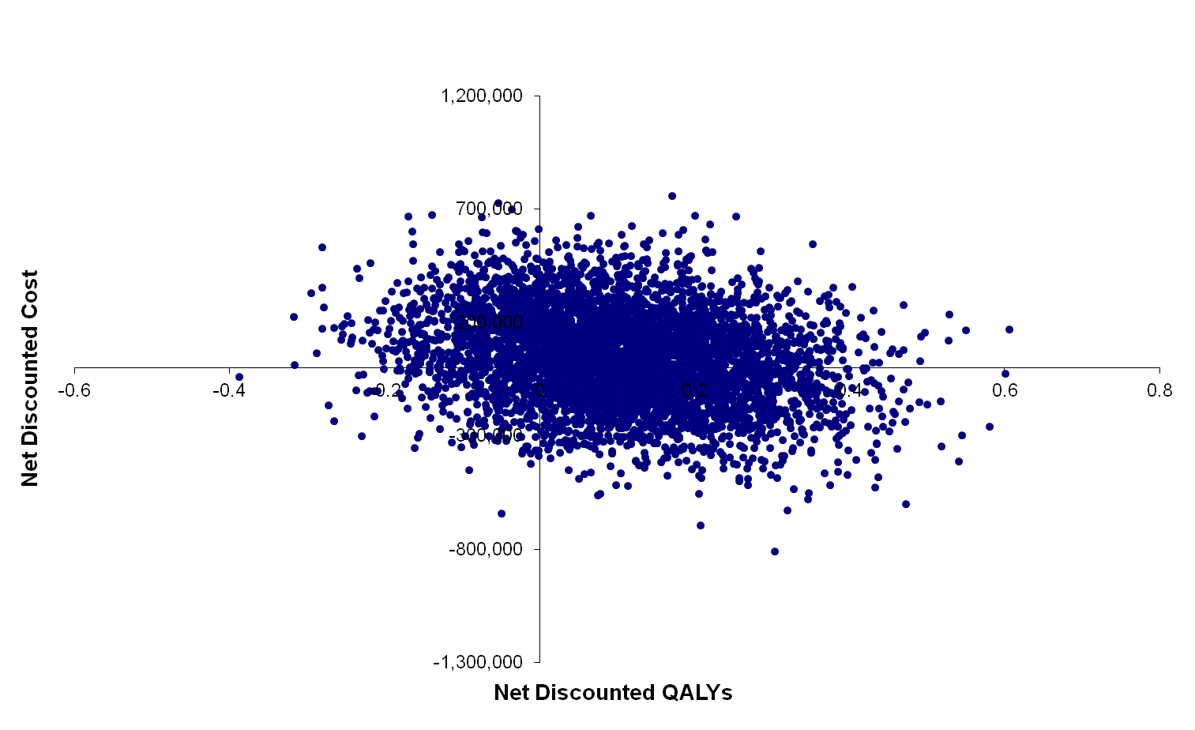
Abbreviation: QALY, Quality-adjusted life-year.

The cost-effective acceptability curve shows the probability of cost-effectiveness (according to QALYs) against different payer thresholds. Fig. S2 shows that the probability of varenicline providing a cost-effective alternative to unassisted is:
- 35% at a threshold of ¥0 (due to dominating in 35% of the replications)
- 67% at a threshold of ¥2,500,000
- 73% at a threshold of ¥5,000,000.

Figure S2 Cost-effectiveness Acceptability Curve for Varenicline versus Unassisted
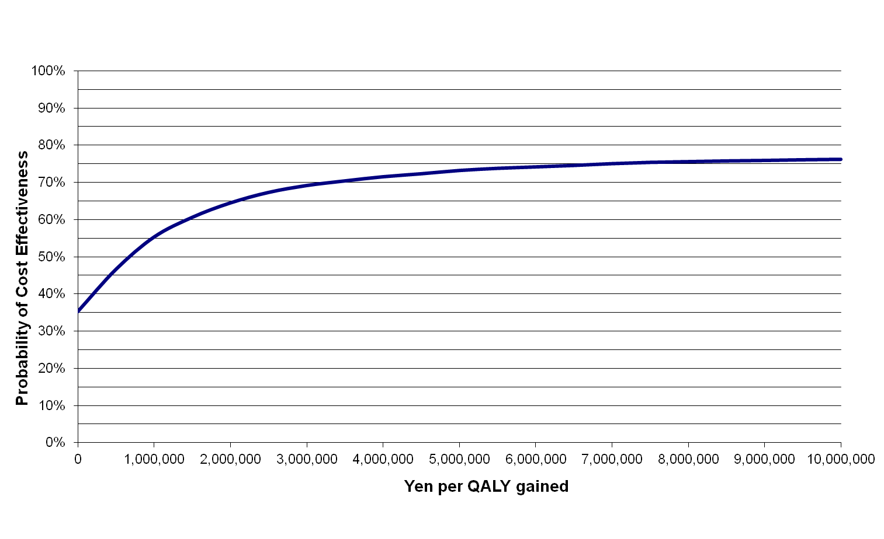
Abbreviations: CER, Cost-effectiveness ratio; QALY, Quality-adjusted life-year.

REFERENCES
1. Igarashi A, Negishi S, Goto R, et al. Web-based survey on smoking cessation behaviors of current and former smokers in Japan. Curr Med Res Opin. 2014 Oct;30:1911-21.
2. Hoogenveen RT, van Baal PH, Boshuizen HC, et al. Dynamic effects of smoking cessation on disease incidence, mortality and quality of life: The role of time since cessation. Cost Eff Resour Alloc. 2008;6:1.
3. Ministry of Health, Labour and Welfare. Patient Survey 2011: Statistics Table 13: Total number of patients by sex, year and classification of diseases [in Japanese]. Tokyo: Ministry of Health Labour, and Welfare，Health Statistics Office, Vital, Health and Social Statistics Division; 2011. http://www.mhlw.go.jp/toukei/saikin/hw/kanja/11/. Accessed 20 Oct 2015.
4. Fukuchi Y, Nishimura M, Ichinose M, et al. COPD in Japan: the Nippon COPD Epidemiology study. Respirology. 2004 Nov;9:458-65.
5. Matsuda A, Matsuda T, Shibata A, et al. Cancer incidence and incidence rates in Japan in 2008: a study of 25 population-based cancer registries for the Monitoring of Cancer Incidence in Japan (MCIJ) project. Jpn J Clin Oncol. 2014 Apr;44:388-96.
6. National Cancer Center. Cancer Statistics in Japan, 2008: Smoking and Cancer (in Japanese). Tokyo: National Cancer Center, Foundation for Promotion of Cancer Research (FPCR) 2008. http://ganjoho.jp/professional/statistics/backnumber/2008_jp.html. Accessed 28 October 2014.
7. Sobue T. The epidemiological study of the relationship between smoking and disease via pooled analysis of large scale cohort studies, Research Grant of MHLW in Japan. General research project against life-style diseases. Research for reviewing scientific evidences around tobacco (PI: Sobue T). Saitama, Japan: National Institute of Public Health. Report available at http://mhlw-grants.niph.go.jp/niph/search/NIDD00.do?resrchNum=200624022A. 2006.
8. Kubo M, Kiyohara Y, Kato I, et al. Trends in the incidence, mortality, and survival rate of cardiovascular disease in a Japanese community: the Hisayama study. Stroke. 2003 Oct;34:2349-54.
9. Soler-Cataluna JJ, Martinez-Garcia MA, Roman Sanchez P, et al. Severe acute exacerbations and mortality in patients with chronic obstructive pulmonary disease. Thorax. 2005 Nov;60:925-31.
10. National Cancer Center. Cancer Statistics in Japan, 2013: Survival Rate in the Member Hospitals of the Association of Clinical Cancer Centers (in Japanese). Tokyo: National Cancer Center, Foundation for Promotion of Cancer Research (FPCR). 2013. http://ganjoho.jp/data/professional/statistics/backnumber/2013/cancer_statistics_2013.pdf. Accessed 28 October 2014.
11. Okura N, Ogawa H, Katoh J, et al. Long-term prognosis of patients with acute myocardial infarction in the era of acute revascularization (from the Heart Institute of Japan Acute Myocardial Infarction [HIJAMI] registry). Int J Cardiol. 2012 Sep 6;159:205-10.
12. Ministry of Health Labour and Welfare. Abridged Life Table 2012 (in Japanese). Tokyo: Ministry of Health, Labour, and Welfare. 2013. http://www.mhlw.go.jp/toukei/saikin/hw/life/life12/dl/life12-11.xls. Accessed 9 November 2014.
13. Sullivan PW, Ghushchyan V. Mapping the EQ-5D index from the SF-12: US general population preferences in a nationally representative sample. Med Decis Making. 2006 Jul-Aug;26:401-9.
14. Kang EJ, Ko SK. A catalogue of EQ-5D utility weights for chronic diseases among noninstitutionalized community residents in Korea. Value Health. 2009 Nov-Dec;12 Suppl 3:S114-7.
15. Hattori N, Hirayama T, Katayama Y. Medical care for chronic-phase stroke in Japan. Neurol Med Chir (Tokyo). 2012;52:175-80.

