Cost-effectiveness of insulin degludec and liraglutide (IDegLira) in a fixed combination for uncontrolled type 2 diabetes in Sweden

Authors: Åsa Ericsson¹, Adam Lundqvist²
Affliations:
¹Novo Nordisk Scandinavia AB, Sweden
²IHE, The Swedish Institute for Health Economics, Sweden

Corresponding author:
Åsa Ericsson, Novo Nordisk, Box 505, 87 Vattenverksvägen 47
SE-202 15 Malmö, Sweden
Email: asae@novonordisk.com

Supplementary material

Supplement 1: Indirect treatment comparison methodology
The indirect treatment comparison (ITC) included individual patient-level data from studies that were similar to DUAL™ II (as DUAL™ V was ongoing at the time of this cost-effectiveness analysis), and which fulfilled the following criteria: completed studies, multinational, randomized clinical trials (phase III or phase IV), involved T2D patients uncontrolled on basal insulin therapy and used titration targets similar to those used in DUAL™ II (i.e. fasting plasma glucose [FPG] of 4¬–5 mmol/L). Data used from the ITC include comparisons between patients treated with IDegLira and insulin glargine, either alone or in combination with another drug (i.e. insulin aspart or liraglutide). All extension studies were excluded. The ITC used standard multivariate analysis of individual patient level data allowing for adjustments for potential heterogeneity in baseline characteristics between the treatment arms. More detailed methodology of the ITC can be found in the publication by Freemantle et al. 2015.(1)

Table S1: Annual cost of complications (converted to SEK 2013)(2)
Complication | Description and cost | Reference
Non-proliferative retinopathy | Visit to ophthalmology clinic SEK 712  Screening photography SEK 427  Total costs: SEK 1139 | Södra regionvårdsnämnden 2014(3)
Proliferative retinopathy | 3 visits to ophthalmology clinic SEK 2136  Three visits for laser treatment including fluorescein angiography 3*(SEK 1,993 + SEK 6,241) = SEK 24,702  Clinic visit and screening photography in subsequent years.  Total costs, first year: SEK 26,838  Total costs, subsequent years: SEK 1139 | Södra regionvårdsnämnden 2014(3)
Macular oedema | First year: 3 injections of ranibizumab 3*SEK 12,842 = SEK 38,526  Following year: 1 injection of ranibizumab SEK 12,842 | Södra regionvårdsnämnden 2014(3)
Severe visual impairment | First year: SEK 9184  Subsequent years: SEK 3920 | Persson 2010(4)
Symptomatic neuropathy | Gabapentin analgesia 3*800 mg/day SEK 11,746  Medical treatment of erectile dysfunction (men only) 50 mg/week SEK 4936  First year, men: SEK 8341^{a)}  First year, women: SEK 5873^{a)}  Subsequent years, men: SEK 16,684  Subsequent years, women: SEK 11,746 | Apoteket, Produkter (Products). 2013; TLV 2013
Peripheral vascular disease | The Eurodiale study: Healed wounds SEK 73,581  Risk of recurring wounds (assumed 10%) SEK 7358  First year: SEK 73,581  Subsequent years: SEK 7358 | Prompers 2008(5)
Amputation | The Eurodiale study: Major amputation SEK 252,648  Risk of recurring wounds (assumed 10%) SEK 7358  First year: SEK 252,648  Subsequent years: SEK 7358 | Prompers 2008(5)
Microalbuminuria | Treatment with angiotensin receptor blocker (50mg losartan/8mg candesartan) SEK 677 + calcium antagonist (5 mg) SEK 618  First year: SEK 648  Subsequent years: SEK 1295 | TLV 2013
Macroalbuminuria (Clinical nephropathy) | Treatment with:  - angiotensin receptor blocker (50mg losartan/8mg candesartan) SEK 677 + calcium antagonist (5 mg) SEK 618  - Vitamin D (2*500mg/day) SEK 1312  3 physician visits (first year) 3*SEK 1386 = SEK 4158  First year: SEK 6765  Subsequent years: SEK 2607 | Södra regionvårdsnämnden 2014(3); TLV 2013
Nephropathy, uraemia stage | KPP database  E32 Dialysis SEK 124,584  317O Dialysis (primary care) SEK 4085 (3.5/week=> annual cost: SEK 743,470)  First year: SEK 124,584 + 0.5*SEK 743,470^{a)} = SEK 496,319  Subsequent years: SEK 743,470 | Sveriges kommuner och landsting, KPP-databasen. Sveriges kommuner och landsting, KPP-databasen, 2011(6)
Ischaemic heart disease | Symptomatic ischaemic heart disease:  First year: SEK 94,251  Subsequent years: SEK 3394 | Gerdtham 2009(7)
Myocardial infarction | Non-fatal myocardial infarction:  First year: SEK 100,763  Subsequent years: SEK 2243 | Gerdtham 2009(7)
Stroke | First year: SEK 179,836  Subsequent years: SEK 161,788 | Ghatnekar 2002(8)
Heart failure | First year: SEK 70,952  Subsequent years: SEK 7090 | Gerdtham 2009(7)
mg: milligrams; SEK, Swedish Krona.
^{a)}Patients may commence treatment at any time of the year. On average the first year of treatment will therefore be 6 months.

Table S2: Sensitivity analyses performed and rationale for testing
Variable | Rationale for analysis
Patient characteristics
Gender - women | Difference in risk equations between men and women, meant that the model can only be used for the sexes separately. In the main analysis we used men, and in a sensitivity analysis we tested for women
Smoking status - smoker | Differences in risk equations between smokers and non-smokers meant that the model can only test for each status separately. In the main analysis we used non-smokers and in a sensitivity analysis we tested smokers
Baseline HbA1c - 9% | In order to investigate the effect of disease progression on the results, sensitivity analyses were undertaken with a higher baseline HbA1c value of 9%:
Baseline BMI - 25 and 35 | Two different baseline BMIs were tested in sensitivity analyses; 25 and 35, respectively.
Clinical endpoints
HbA1c drift for GLP-1 - 0.08% | The upward drift of 0.15% used in the main model is an assumption based on the UK prospective diabetes study.(9, 10) Long term data on exenatide suggests a slower upward trend in HbA1c when using GLP1, however and we used 0.08% in one sensitivity analysis.(11)
No difference in HbA1c | To test for the importance of HbA1c decline, we removed the difference and used the IdegLira decline for both groups.
No difference in HbA1c but different complexity of regimen | We tested the impact of this variable in cases where IdegLira is not a cost-effective treatment (i.e. when the difference in HbA1c is ignored). Vs basal insulin + Liraglutide only.
Half the difference in HbA1c | To test for the importance of HbA1c decline, we removed half of the difference and used the IdegLira decline as a reference value.
No difference in BMI | To test for the importance for BMI change, we removed the difference and used the IdegLira value for both groups.
No difference in hypoglycaemia insulin glargine/NPH insulin | The clinical trials were undertaken with the insulin analogues levemir and insulin degludec, but in the main analysis human insulin was used as the comparator (by applying a lower price and a higher number of hypos). In this sensitivity analyses, we assumed that there was no difference so that we could investigate the effects of differences in hypoglycaemia rates between insulin analogues and human insulin on the results vs neutral protamine hagedorn insulin only
Lower efficacy for Liraglutide 1.2 mg | The clinical trials compared IdegLira with Liraglutide 1.8 mg. However, in clinical practice in Sweden the lower dose 1.2 mg is more commonly used, so we used the price for the lower dose but the efficacy for the higher dose in the analyses (conservative). One Liraglutide study that included both doses, showed a difference in efficacy, where HbA1c was 75% and weight loss 84% for the low dose as compared to the high dose. In order to analyse the result vs Liraglutide 1.2 given this difference, we undertook this sensitivity analysis. HbA1c reduction (75%) and weight loss (84%). vs Liraglutide only
Costs
Healthcare perspective | Just direct costs.
Price of higher dose of Liraglutide | Instead of decreasing efficacy of the lower Liraglutide dose, we undertook a sensitivity analysis with the correct price for the higher dose used in the clinical trials (1.8 mg daily).
Patient utility
Different impact of BMI – 0.021 | We used the utility value from the new TTO study(12) of -0.021 instead of the more conservative of 0.006 used in the main analysis.
No impact of complexity vs basal-bolus | We undertook a sensitivity analysis that ignored the utility difference due to regimen complexity versus basal-bolus from the TTO study.(12)
BMI: body mass index; GLP-1: glucagon-like peptide-1; HbA1c: glycated haemoglobin; mg: milligrams; NPH: neutral protamine hagedorn; TTO: Time trade-off.
Table S3: Input variables assessed in probabilistic sensitivity analyses*
Variable | Source/assumption
Cost of micro- and macrovascular complications | SE = 10%
QALYs of micro- and macrovascular complications | Neuropathy and nephropathy: Bagust 2004(13)  Other complications: SE = 10%
Costs of hypoglycaemia | SE = 20%
QALYs of hypoglycaemia | Evans 2013(14)
Drug prices | SE = 0%
Treatment effects (e.g. HbA1c, BMI etc.) | Buse 2014(15)
Treatment related patient utility | SE = 50%
QALY: quality-adjusted life year; SE: standard error.
*Sources were provided for each variable where available. Otherwise, the standard deviation assumption is directly stated.

Table S4: ICER in different HbA1c-related sensitivity analyses (SEK)*
Comparator | Base case analysis | HbA1c baseline 9% | HbA1c drift 0.08% | No difference | Halved difference
Insulin glargine | 28,000 | 27,000 | Dominant | 332,000 | 92,000
NPH insulin | 70,000 | 69,000 | 39,000 | 484,000 | 156,000
Insulin aspart added to insulin glargine | Dominant | Dominant | Dominant | Dominant | Dominant
Insulin aspart added to NPH insulin | Dominant | Dominant | Dominant | Dominant | Dominant
Liraglutide 1.2 mg added to insulin glargine† | Dominant | Dominant | Dominant | liraglutide added to insulin glargine lower cost | 30,000
Liraglutide 1.2 mg added to NPH insulin† | 60,000 | 57,000 | 77,000 | liraglutide added to NPH insulin lower cost | 149,000
EUR: euro; GBP: great British pound; HbA1c: glycated haemoglobin; ICER: incremental cost-effectiveness ratio; mg: milligrams, NPH: neutral protamine hagedorn; SEK: Swedish krona.
*At the time of manuscript submission, the SEK to GBP and SEK to EUR exchange rate was 0.086918 and 0.102420, respectively. For instance, 1,000 SEK is equivalent to 86.91 GBP or 1,024.20 EUR.(16)
†Given that the clinical trials included in the indirect treatment compared IDegLira to liraglutide 1.8 mg, data for this dose was applied to liraglutide 1.2 mg (more commonly used dose in Sweden). Thus, in the base case analysis we conservatively assumed the two doses have equivalent efficacy, but only used the price of the lower dose in the base case analysis. However, in the sensitivity analyses liraglutide 1.2 mg was assumed to result in a HBA1c reduction of 75% and a weight loss of 84% of that observed with liraglutide 1.8 mg.

Fig. S1 Schematic overview of model

Fig. S2 Cost-effectiveness acceptability curve of IdegLira versus NPH insulin (3% discount)
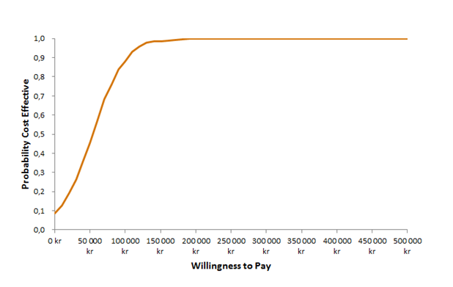
KR: Swedish Krona; NPH: neutral protamine hagedorn.
Fig. S3 Cost-effectiveness acceptability curve of IdegLira versus insulin glargine (3% discount)
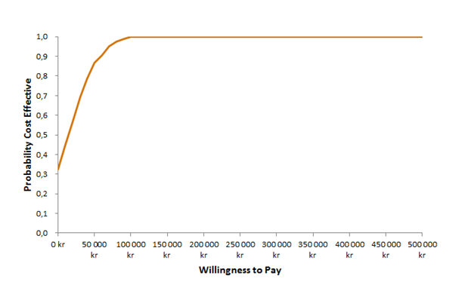
KR: Swedish Krona.
Fig. S4 Cost-effectiveness acceptability curve of IdegLira versus insulin aspart added to NPH insulin (3% discount)
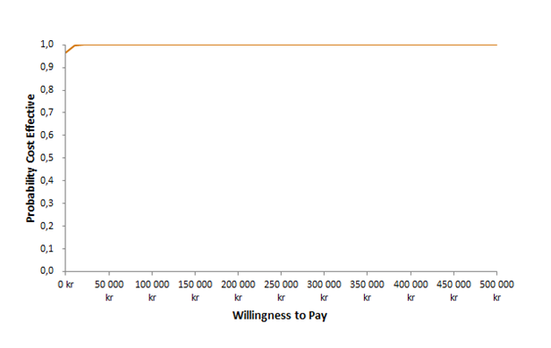KR: Swedish Krona; NPH: neutral protamine hagedorn.
Fig. S5 Cost-effectiveness acceptability curve of IdegLira versus insulin aspart added to insulin glargine (3% discount)
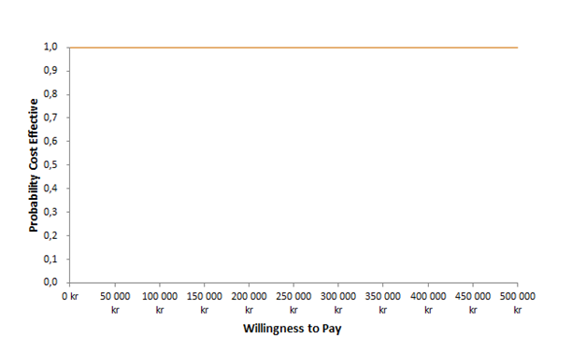
KR: Swedish Krona.
Fig. S6 Cost-effectiveness acceptability curve of IdegLira versus liraglutide added to NPH insulin (3% discount)
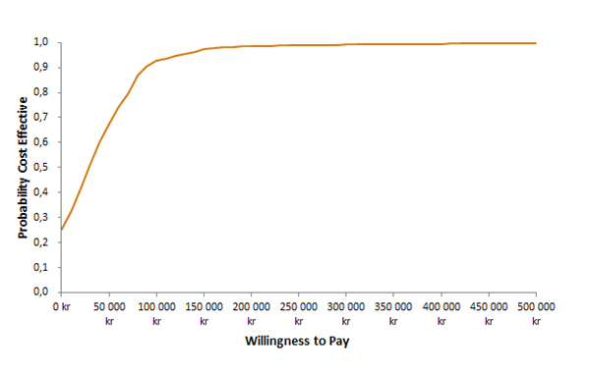KR: Swedish Krona; NPH: neutral protamine hagedorn.
Fig. S7 Cost-effectiveness acceptability curve of IdegLira versus liraglutide added to insulin glargine (3% discount)
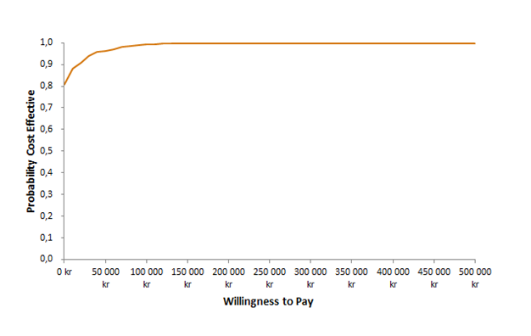 KR: Swedish Krona.

References
1. Freemantle N, Mamdani M, Vilsboll T, Kongso JH, Kvist K, Bain SC. IDegLira Versus Alternative Intensification Strategies in Patients with Type 2 Diabetes Inadequately Controlled on Basal Insulin Therapy. Diabetes therapy : research, treatment and education of diabetes and related disorders. 2015;6(4):573-91.
2. Steen Carlsson K, Persson U. Cost-effectiveness of add-on treatments to metformin in a Swedish setting: liraglutide vs sulphonylurea or sitagplitin. J Med Econ. 2014;17(9):658-69.
3. Södra regionvårdsnämnden. Regionala priser och ersättningar för södra regionvårdsnämnden 2014. Available from: https://www.skane.se/Upload/Webbplatser/Sodra%20regionvardsnamnden/prislista/2014/helaprislistan2014.pdf.
4. Persson U, Willis M, Odegaard K. A case study of ex ante, value-based price and reimbursement decision-making: TLV and rimonabant in Sweden. Eur J Health Econ. 2010;11(2):195-203.
5. Prompers L, Huijberts M, Schaper N, Apelqvist J, Bakker K, Edmonds M, et al. Resource utilisation and costs associated with the treatment of diabetic foot ulcers. Prospective data from the Eurodiale Study. Diabetologia. 2008;51(10):1826-34.
6. Sveriges Kommuner och Landsting. KPP-databasen 2011. Available from: http://skl.se/ekonomijuridikstatistik/statistiknyckeltaljamforelser/kostnadperpatientkpp.1076.html.
7. Gerdtham UG, Clarke P, Hayes A, Gudbjornsdottir S. Estimating the cost of diabetes mellitus-related events from inpatient admissions in Sweden using administrative hospitalization data. PharmacoEconomics. 2009;27(1):81-90.
8. Ghatnekar O, Willis M, Persson U. Cost-effectiveness of treating deep diabetic foot ulcers with Promogran in four European countries. J Wound Care. 2002;11(2):70-4.
9. Turner R, Cull C, Holman R. United Kingdom Prospective Diabetes Study 17: a 9-year update of a randomized, controlled trial on the effect of improved metabolic control on complications in non-insulin-dependent diabetes mellitus. Annals of internal medicine. 1996;124(1 Pt 2):136-45.
10. Ward AJ, Salas M, Caro JJ, Owens D. Health and economic impact of combining metformin with nateglinide to achieve glycemic control: Comparison of the lifetime costs of complications in the U.K. Cost effectiveness and resource allocation : C/E. 2004;2(1):2.
11. Henry, R.R., et al., DURATION-1 extension: Efficacy and tolerability of exenatide once weekly (qw) over 6 years in patients with T2DM. Poster presentation 964-P. Presented at the American Diabetes Association 74nd Annual Scientific Sessions, San Francisco 13-17 June 2014: http://ada.scientificposters.com/epsAbstractADA.cfm?id=8, 2014.
12. Novo Nordisk, data on file 2014 – TTO analysis.
13. Bagust A, Beale S. Modelling EuroQol health-related utility values for diabetic complications from CODE-2 data. Health Econ. 2005;14(3):217-30.
14. Evans M, Khunti K, Mamdani M, Galbo-Jorgensen CB, Gundgaard J, Bogelund M, et al. Health-related quality of life associated with daytime and nocturnal hypoglycaemic events: a time trade-off survey in five countries. Health Qual Life Outcomes. 2013;11:90.
15. Buse JB, Vilsboll T, Thurman J, Blevins TC, Langbakke IH, Bottcher SG, et al. Contribution of liraglutide in the fixed-ratio combination of insulin degludec and liraglutide (IDegLira). Diabetes care. 2014;37(11):2926-33.
16. X-Rates. Swedish krona historic exchange rates look-up 2016 [cited 2016 November]. Available from: http://www.x-rates.com/historical/?from=SEK&amount=1&date=2016-11-24.

