Supplementary Material

Public health impact and cost-effectiveness of non-live adjuvanted recombinant zoster vaccine in Canadian adults

Ashleigh McGirr, Desiree Van Oorschot, Robyn Widenmaier, Michael Stokes, Michael Ganz, Hyosung Jung, Lijoy Varghese, Desmond Curran

Applied Health Economics and Health Policy

Input parameters

Demographic data
Data on the total Canadian population ≥ 50 years of age (approximately 12 million) and the age distribution in the Canadian population are based on the Canadian 2011 census program (1); age-specific mortality was obtained from Statistics Canada, last updated in 2009 (2) (SI, Table 1).
SI Table 1: Demographic parameters specific to the Canadian population
Age groups (years) | Number | All-cause Mortality Rate (%) | Range, All-cause Mortality Rate (%)
50-54 | 4,999,600 | 0.34 | 0.32, 0.36
55-59 | 4,999,600 | 0.50 | 0.48, 0.59
60-64 | 2,052,670 | 0.78 | 0.74, 0.93
65-69 | 1,521,715 | 1.25 | 1.19, 1.57
70-74 | 2,075,765 | 1.99 | 1.96, 2.63
75-79 | 2,075,765 | 3.32 | 3.22, 4.32
80-84 | 1,347,585 | 5.66 | 5.65, 7.45
85-89 | 1,347,585 | 9.61 | 9.37, 12.3
≥ 90 | 1,347,585 | 18.75 | 18.34, 21.36

Epidemiologic data
Input parameters for HZ and PHN incidence data, stratified by age-group, are provided in SI Table 2.
The incidence rate for HZ was obtained from Marra et al. (3), who analyzed population-based data from British Columbia between 2009 and 2012. Results were stratified by age and gender. The probability of developing PHN following HZ infection was derived from Drolet et al. (4), who conducted a prospective, observational study in patients with HZ, recruited across Canada. The definition of PHN was similar to that used in the Shingles Prevention Study (SPS), and the Zoster Efficacy Study in Adults 50 and 70 Years of Age or Older studies (ZOE-50 and ZOE-70, respectively), i.e., a score of worst pain ≥ 3 on the Zoster Brief Pain Inventory scale and pain persisting or appearing ≥ 90 days after rash onset (5-7).
SI Table 2: Base values, ranges and standard deviations for incidence rates of herpes zoster and postherpetic neuralgia used in base base-case scenario and sensitivity analyses
Age Group (years) | Base Value | Range | Standard Deviation | Reference
Annual probability of initial or recurrent HZ incidence*
50‒59 | 0.005982 | 0.00459, 0.00603 | 0.00037 | Marra et al, 2016 (3)
60‒64 | 0.008662 | 0.00698, 0.00990 | 0.00074 | Marra et al, 2016 (3)
65‒69 | 0.008662 | 0.00698, 0.01156 | 0.00117 | Marra et al, 2016 (3)
70‒79 | 0.010841 | 0.00846, 0.01131 | 0.00073 | Marra et al, 2016 (3)
≥ 80 | 0.011039 | 0.00846, 0.01244 | 0.00102 | Marra et al, 2016 (3)
Percentage of PHN three months after initial or recurrent HZ (%) †
50‒59 | 14.60 | 11.90, 18.25 | 0.01862 | Drolet et al, 2010 (4)  Najazfadeh et al. 2009 (8)  Brisson et al. 2008 (9)
60‒64 | 20.50 | 6.90, 25.63 | 0.06939
65‒69 | 20.50 | 6.90, 25.63 | 0.06939
70‒79 | 33.80 | 18.50, 42.25 | 0.07806
≥ 80 | 33.80 | 18.50, 42.25 | 0.07806
Case fatality rate for HZ cases (%) ‡
50-59 | 0.00 | 0.00, 0.00 | 0.00001 | Brisson et al, 2008 (9)  Brisson et al. 2008 (10) Najafzadeh 2009 (8) Edgar et al. 2007 (11)
60-64 | 0.00 | 0.00, 0.00 | 0.00001
65-69 | 0.012 | 0.0027, 0.0830 | 0.0036
70‒74 | 0.012 | 0.0035, 0.0830 | 0.00036
75-79 | 0.012 | 0.0078, 0.0830 | 0.00035
80-84 | 0.076 | 0.0078, 0.0830 | 0.00035
≥ 85 | 0.076 | 0.0078, 0.2016 | 0.00064
HZ: herpes zoster; PHN: postherpetic neuralgia;
Incidence rates from the literature were converted to annual probabilities.
* Standard errors were calculated using range rules, where SE = (upper bound – lower bound)/3.92;
† Upper bound: base incidence estimate + 20%
‡The mean and standard error values were used to generate parameters for the beta distribution that was used to vary these input values for the probabilistic sensitivity analyses.

HZ mortality data were obtained from a study investigating the cost-effectiveness of vaccination against HZ and PHN in Canada (9). Complications data were taken from Yawn et al. (12), and included ocular, neurological, cutaneous and other non-pain related complications (SI, Table 3).
SI Table 3: Base values and ranges for complication rates associated with herpes zoster
Age group, years | Base Value (%) | Range (%)
Ocular
50-59 | 2.87 | 2.01, 3.73
60-64  65-69 | 3.82 | 2.67, 4.97
70-79 | 4.14 | 2.90, 5.38
≥ 80 | 5.41 | 3.79, 7.03
Neurological
50-59 | 2.46 | 1.72, 3.20
60-64  65-69 | 3.17 | 2.22, 4.12
70-79 | 5.99 | 4.19, 7.79
≥ 80 | 4.23 | 2.96, 5.50
Cutaneous
50-59 | 1.74 | 1.22, 2.26
60-64  65-69 | 1.05 | 0.74, 1.37
70-79 | 2.09 | 1.46, 2.71
≥ 80 | 2.44 | 1.71, 3.17
Other non-pain
50-59 | 2.03 | 1.42, 2.64
60-64  65-69 | 1.63 | 1.14, 2.12
70-79 | 2.44 | 1.71, 3.17
≥ 80 | 2.85 | 2.00, 3.71

Vaccine efficacy and adverse events
VE against HZ (VE_{HZ}) for RZV was derived from two international clinical phase III trials, i.e. the ZOE-50 (n=16,116) and ZOE-70 (n=14,816) trials (6, 7). Subjects ≥ 70 years of age from ZOE-50 and ZOE-70 were pooled for analysis. In the clinical trials, VE_{HZ} was similar across age groups in the ZOE-50 trial and the HZ efficacy remained consistent across age groups in the ZOE-70+ pooled analysis. VE over time was analyzed by a linear approximation to the yearly VE estimates based on mean follow-up data of 3.2 and 3.7 years in the ZOE-50 and ZOE-70 trials. Decline of VE over time, i.e., waning, was estimated at 1% (range: 0%, 2.6%) during the first 4 years following vaccination and at 2.3% (range: 0.7%, 4.6%) for the following years. In subjects ≥ 70 years of age waning was estimated to be constant at 3.6% per year (range: 1.4%, 6.6%). The VE_{HZ} estimate at time 0 was 98.4% in ZOE-50 and 97.8% in ZOE-70. Since in a real-world scenario, not every individual would receive the second dose of RZV, VE and waning rate for single dose RZV were also modeled. It should be noted that single dose VE_{HZ} was not a pre-specified endpoint in the ZOE studies and compliance with the second dose of RZV was high in the clinical trial setting. Furthermore, follow-up in individuals not receiving the second dose of RZV was only 76 days for ZOE-50 and 85 days for ZOE-70, leading to a small number of observed events and precluding a robust estimate of single single-dose efficacy. Similarly, due to the very high VE_{HZ} across the ZOE studies, the number of breakthrough cases was small. Among breakthrough cases, only four subjects developed PHN and the VE_{PHN} was therefore similar to VE_{HZ}.
VE_{HZ} and VE_{PHN} efficacy for ZVL were obtained from the SPS (n=38,546) and Zostavax Efficacy and Safety Trial (ZEST; n=22,439) studies (5, 13). VE_{HZ} for individuals 60-69 years of age was 63.89% and 40.85% in individuals 70-79 years of age. Waning was determined based on long-term follow-up of these two studies and estimated at 5.4% (range: 4.5%, 6.4%) during the first 4 years and 5.1% (range: 4.1%, 6.0%) thereafter (14). ZVL vaccination showed additional protection against PHN by lowering the probability of developing PHN in vaccinated subjects with break-through HZ as compared to subjects with HZ in the placebo group.
Safety and adverse events (AEs) were divided into four categories: local/general AEs, AEs leading to general practitioner (GP) visit, emergency room (ER) visit and hospitalization. For RZV, rates were taken from clinical trial data; for ZVL, rates for local/general AEs were taken from clinical trials, while it was conservatively assumed that rates for the other categories corresponded to those observed in the placebo arm of the ZOE studies (SI Table 4).
SI Table 4: Adverse events base input values and ranges used for sensitivity analyses
Age groups (years of age) | AE local/general ; ZVL (%) |  | AE local/general; RZV (%)
 | Base Value | Range | Base Value | Range
50-59 | 49.5 | 24.75, 74.25 | 85.30 | 42.65, 127.95
60-64  65-69 | 31.7 | 15.85, 47.55 | 79.80 | 39.90, 119.70
70-79 | 31.7 | 15.85, 47.55 | 68.80 | 34.40, 103.20
≥ 80 | 31.7 | 15.85, 47.55 | 68.80 | 34.40, 103.20
 | GP visit ; ZVL (%) |  | GP visit ; RZV (%)
 | Base Value | Range | Base Value | Range
50-59 | 0.72 | 0.36, 1.08 | 1.72 | 0.86, 2,58
60-64 | 0.72 | 0.36, 1.08 | 1.38 | 0.69, 2.07
65-69 | 0.72 | 0.36, 1.08 | 1.27 | 0.64, 1.91
70-79 | 0.72 | 0.36, 1.08 | 1.42 | 0.71, 2.13
≥ 80 | 0.72 | 0.36, 1.08 | 1.42 | 0.71, 2.13
 | ER visit ; ZVL (%) |  | ER visit ; RZV (%)
 | Base Value | Range | Base Value | Range
50-59 | 0.02 | 0.01, 0.03 | 0.04 | 0.02, 0.06
60-64  65-69 | 0.02 | 0.01, 0.03 | 0.18 | 0.09, 0.27
70-79 | 0.02 | 0.01, 0.03 | 0.10 | 0.05, 0.15
≥ 80 | 0.02 | 0.01, 0.03 | 0.10 | 0.05, 0.15
 | Hospitalization ; ZVL (%) |  | Hospitalization ; RZV (%)
 | Base Value | Range | Base Value | Range
50-59 | 0.03 | 0.02, 0.05 | 0.04 | 0.02, 0.06
60-64  65-69 | 0.03 | 0.02, 0.05 | 0.04 | 0.02, 0.06
70-79 | 0.03 | 0.02, 0.05 | 0.04 | 0.02, 0.06
≥ 80 | 0.03 | 0.02, 0.05 | 0.04 | 0.02, 0.06
AE = adverse event; ER = emergency room; GP = general practitioner; RZV: recombinant zoster vaccine; ZVL: zoster vaccine life.

Utilities
Age-specific utility parameters for the general population were derived from a prospective national survey using the Health Utilities Index-Mark III measure (15). Data for patients with ‘No condition’ were used as an estimate of the ‘No HZ’ health state. Utility parameters for the ‘HZ’ and ‘PHN’ health states were derived from a prospective, national study in persons with HZ ≥ 50 years of age who were recruited during routine clinical practice, which used the EuroQoL EQ-5D assessment tool with the UK scoring system (16). QALY loss associated with HZ and PHN was calculated by subtracting HZ and PHN utility values from age-specific utilities for ‘No HZ’ health state. QALYs accrued over each annual cycle were calculated accounting for the average duration of HZ and PHN. Utility decrements due to AEs are based on values reported by Le & Rothberg (17). AEs were treated according to four distinct categories including local/general AEs, AEs leading to a GP visit, an ER visit or hospitalization (SI Table 4). Disutilities were applied on a per-dose basis depending on the incidence rate of the four types of AEs (Table 2).

Costs
For the vaccination strategies, vaccine acquisition cost, administration cost and costs related to the treatment of vaccine induced AEs were included. Resource use profiles were constructed from previously published Canadian studies and unit health care costs were applied to these profiles to obtain estimates for the costs of HZ/PHN disease management (8, 18). Unit costs related to outpatient physician visits and prescription drugs were obtained from the fee schedules of the Ontario Ministry of Health and Long-Term Care and Ontario Drug Benefit Formulary, respectively [MOHLTC 2016; MOHLTC 2017]. Unit costs for hospitalizations were taken from the Ontario Case Costing Initiative [OCCI 2015/2016].
We used the 95% CI percent range around HZ only and HZ/PHN costs reported in Friesen et al. (18) to derive standard errors for sensitivity analyses, as several of the key resource resource-use parameters were obtained directly from that article.
Only costs related to AEs requiring a medically attended visits were included. Direct health care costs due to local/general reactions were not included since it was assumed that the cost of an OTC analgesic would not be covered by the Ministry. The mean cost per GP visit due to an allergic reaction ($77.20) was estimated from the Ontario Ministry of Health and Long-Term Care schedule of benefits [MOHLTC 2016]. The cost of an ER visit resulting from a reaction to vaccination ($254.50) was obtained using ambulatory care data from the Ontario Case Costing Initiative (OCCI) for cases with an International Classification of Diseases diagnosis code associated with complications, e.g., infection and serum reactions, after infusion, transfusion or therapeutic injection. The length of stay for a serious AE requiring hospitalization was assumed to be three days. The per diem cost of a HZ-related hospitalization ($1,212.73), estimated using OCCI data, was then applied to calculate the cost of serious (hospitalization) reactions.

Results

Probabilistic Sensitivity Analysis in Adults ≥ 60 years of age
SI Figure 1: Probabilistic sensitivity analyses for RZV vs. ZVL in adults ≥ 60 years of age. A): cost-effectiveness plane, solid line represents a WTP threshold of 50,000 CAD per QALY; B) cost-effectiveness acceptability curve.
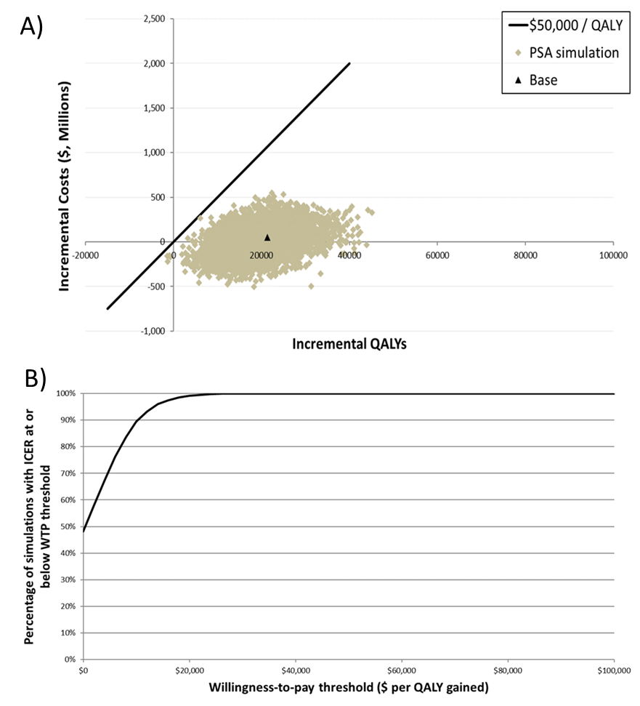
ICER: incremental cost-effectiveness ratio; CAD: Canadian dollar; PSA: probabilistic sensitivity analyses; QALY: quality-adjusted life life-year; WTP: willingness to pay.

Cost-effectiveness in adults 50 years of age and older
SI Table 5: HZ and PHN outcomes in adults 50 years of age and older
Outcomes | RZV | No vaccination | ZVL | # Cases Avoided  (RZV vs. no vaccination) | # Cases Avoided  (RZV vs. ZVL)
HZ cases | 1,684,454 | 2,709,225 | 2,425,569 | 1,024,771 | 741,116
PHN cases | 511,400 | 776,005 | 688,431 | 264,605 | 177,031
Complication cases | 228,709 | 351,901 | 321,472 | 123,192 | 92,763
Ocular | 76,609 | 117,413 | 107,284 | 40,805 | 30,675
Neurological | 76,598 | 119,028 | 108,887 | 42,430 | 32,289
Cutaneous | 34,278 | 52,095 | 47,602 | 17,818 | 13,325
Other non-pain | 41,224 | 63,364 | 57,700 | 22,140 | 16,475
HZ-related deaths | 824 | 1,083 | 1,057 | 260 | 234
HZ: herpes zoster, RZV: herpes zoster subunit; ZVL: zoster vaccine live; PHN: postherpetic neuralgia.
SI Table 6: Incremental cost-effectiveness ratios in adults 50 years of age and older
Outcomes | RZV | No vaccination | ZVL | Incremental  (RZV vs. no vaccination) | Incremental  (RZV vs. ZVL)
Life-years/QALYs (discounted at 1.5%)
Life-years | 235,647,926 | 235,645,857 | 235,646,147 | 2,069 | 1,778
QALYs | 213,064,283 | 213,008,922 | 213,026,623 | 55,361 | 37,660
Costs Associated with Vaccine Program, ($)
Vaccination costs | 2,206,384,092 | 0 | 1,756,104,574 | 2,206,384,092 | 450,279,518
Direct costs due to HZ and complications | 855,528,604 | 1,378,814,691 | 1,211,181,988 | -523,286,087 | -355,653,384
Total direct costs | 3,061,912,696 | 1,378,814,691 | 2,967,286,562 | 1,683,098,005 | 94,626,134
Cost-effectiveness, ($ per QALY gained)
Base case: Incremental cost per QALY (1.5%) |  |  |  | 30,402 | 2,513
Incremental cost per QALY (0%) |  |  |  | 24,893 | 527
Incremental cost per QALY (3%) |  |  |  | 36,127 | 4,685
Incremental cost per QALY (5%) |  |  |  | 43,995 | 7,842
HZ: herpes zoster, RZV: adjuvanted Recombinant Zoster vaccine; ZVL: zoster vaccine live; QALY: quality-adjusted life-year.
$ in Canadian Dollars.

SI Figure 2: One-way sensitivity analysis results for ICER of RZV vs. no vaccination for adults 50 years of age and older
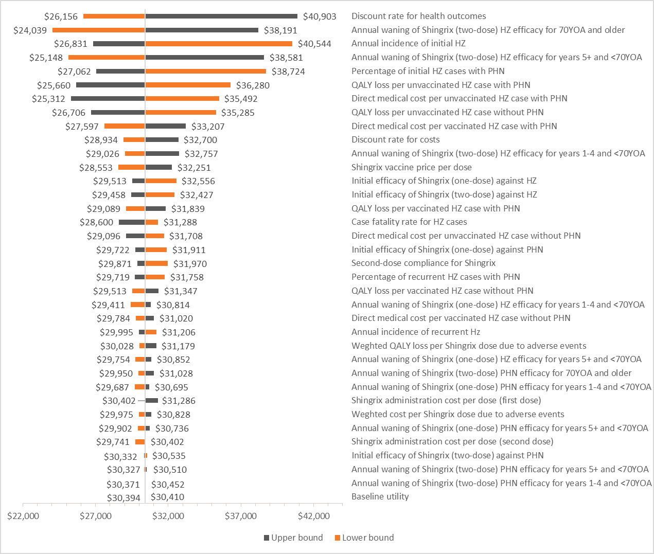
QALY: quality-adjusted life years; RZV: adjuvanted Recombinant Zoster vaccine; YOA: years of age; ICER: incremental cost-effectiveness ratio

SI Figure 3: Probabilistic sensitivity analyses for RZV vs. no vaccination in adults 50 years of age and older. A): cost-effectiveness plane, solid line represents a WTP of 50,000 CAD per QALY; B) cost-effectiveness acceptability curve.
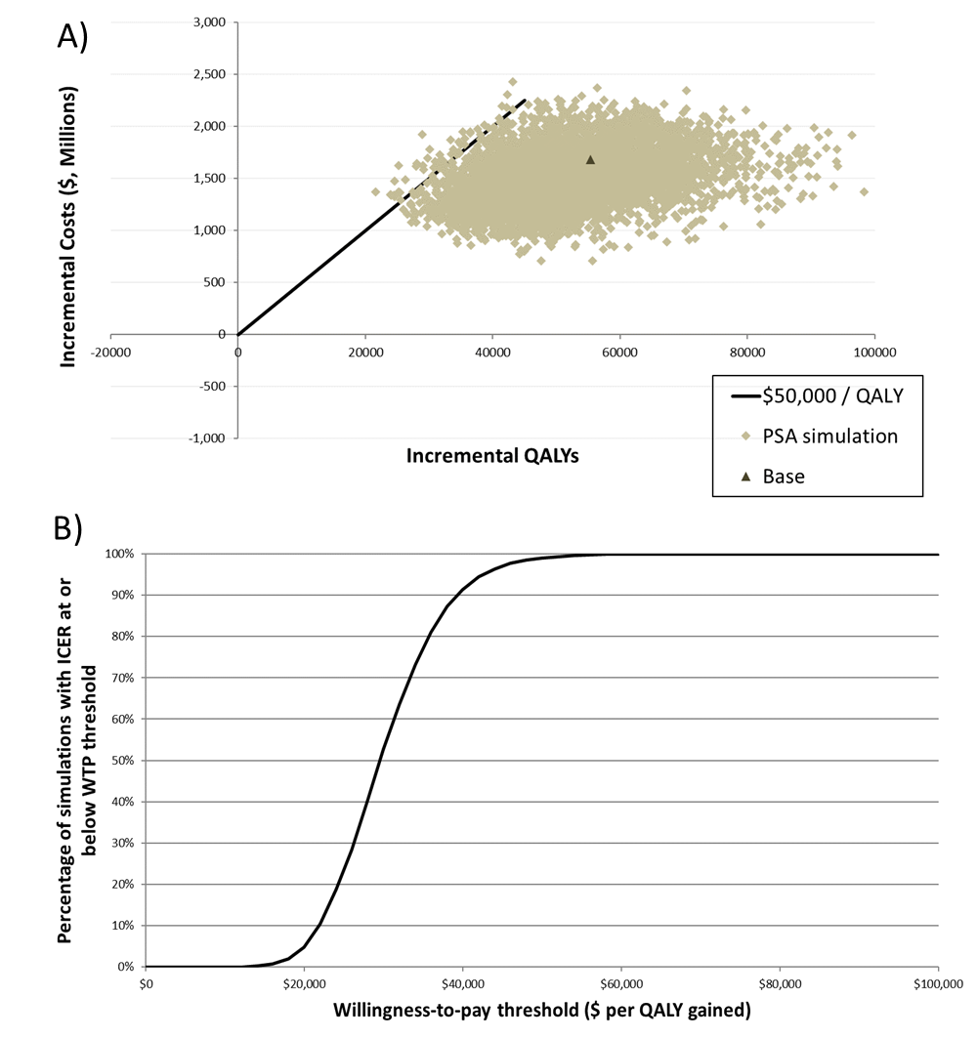
ICER: incremental cost-effectiveness ratio; PSA: probabilistic sensitivity analyses; QALY: quality-adjusted life-year; WTP: willingness to pay. RZV: adjuvanted Recombinant Zoster vaccine; CAD: Canadian dollar

SI Figure 4: One-way sensitivity analysis results for ICER of RZV vs. ZVL for adults 50 years of age and older
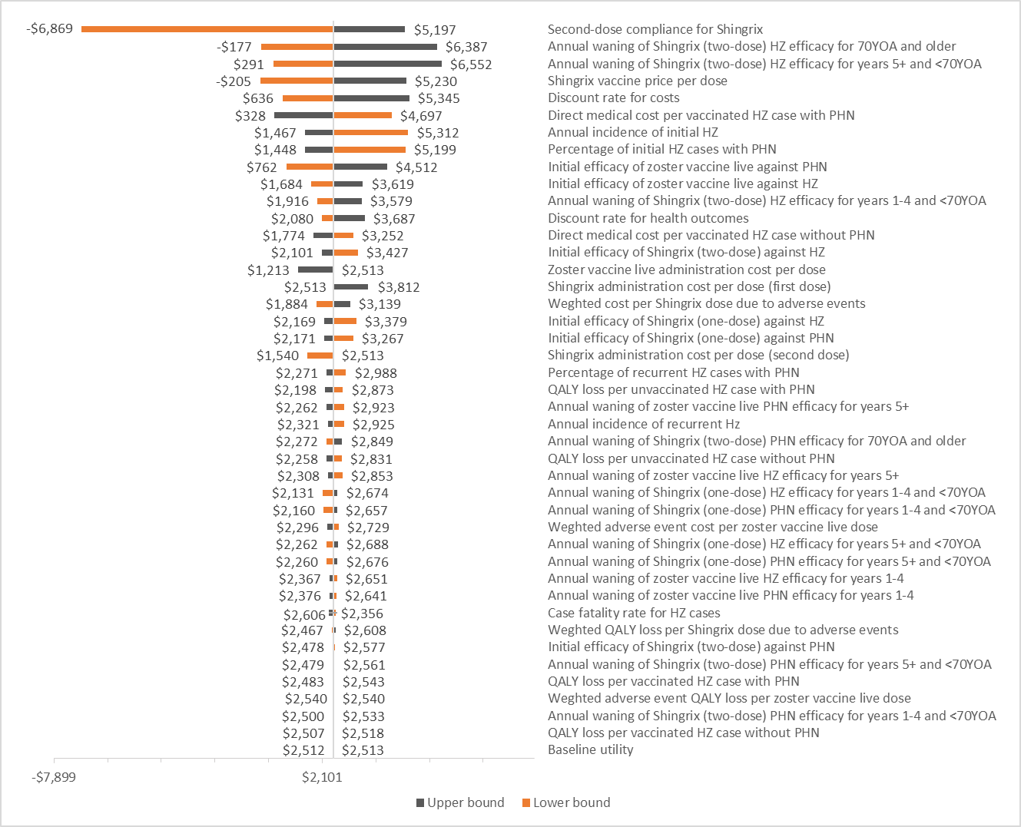
QALY: quality-adjusted life years; RZV: adjuvanted Recombinant Zoster vaccine; YOA: years of age; ICER: incremental cost-effectiveness ratio
SI Figure 5: Probabilistic sensitivity analyses for RZV vs. no ZVL in adults 50 years of age and older. A): cost-effectiveness plane, solid line represents a WTP of 50,000 CAD per QALY; B) cost-effectiveness acceptability curve.
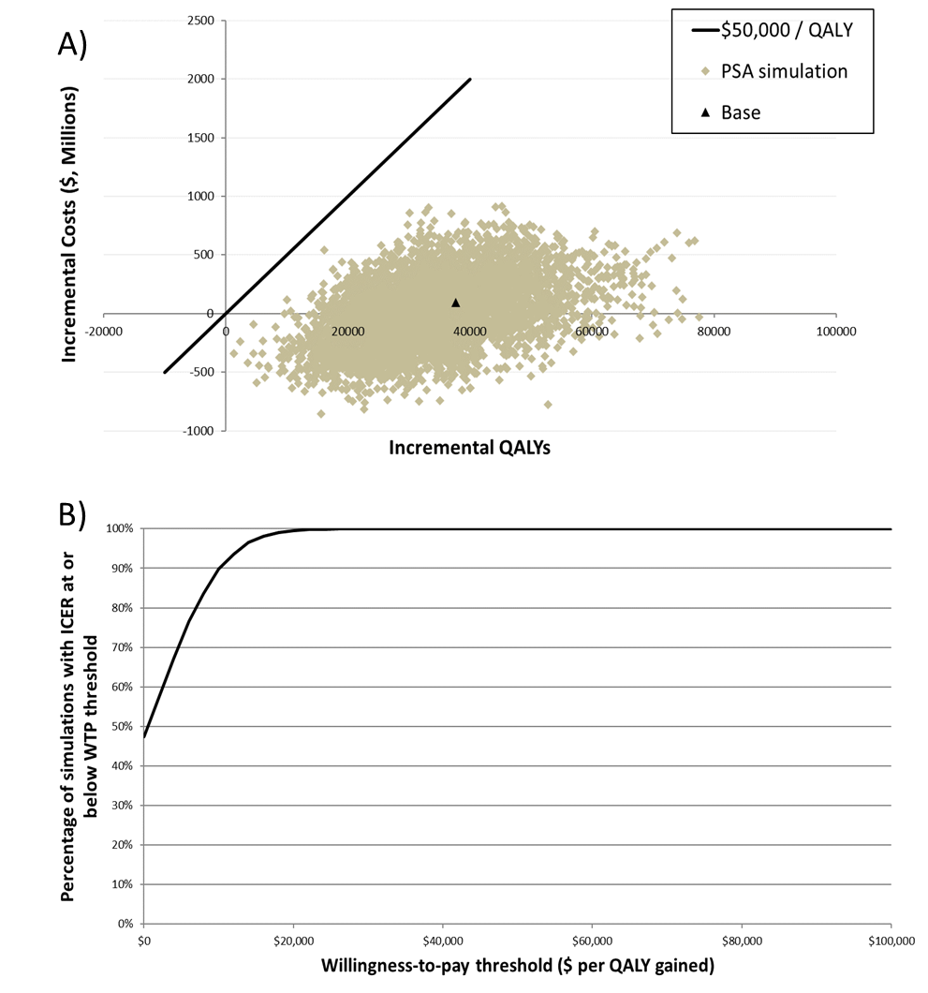
ICER: incremental cost-effectiveness ratio; PSA: probabilistic sensitivity analyses; QALY: quality-adjusted life-year; WTP: willingness to pay. CAD: Canadian dollar; RZV: adjuvanted Recombinant Zoster vaccine; ZVL: Zoster Vaccine Live

References

1. Statistics Canada. 2011 Census Profile. 2011. Available from: http://www12.statcan.gc.ca/census-recensement/2011/dp-pd/prof/details/page.cfm?Lang=E&Geo1=PR&Code1=01&Geo2=PR&Code2=01&Data=Count&SearchText=Canada&SearchType=Begins&SearchPR=01&B1=All&Custom=&TABID=1. [accessed June 13, 2018].
2. Statistics Canada. Deaths by age group and geography — Both sexes. 2009. Available from: http://www.statcan.gc.ca/pub/84f0211x/2009000/t003-eng.htm [accessed June 13, 2018].
3. Marra F, Chong M, Najafzadeh M. Increasing incidence associated with herpes zoster infection in British Columbia, Canada. BMC Infect Dis. 2016;16(1):589.
4. Drolet M, Brisson M, Schmader K, Levin M, Johnson R, Oxman M, et al. Predictors of postherpetic neuralgia among patients with herpes zoster: A prospective study. J Pain. 2010;11(11):1211-21.
5. Oxman MN, Levin MJ, Johnson GR, Schmader KE, Straus SE, Gelb LD, et al. A Vaccine to Prevent Herpes Zoster and Postherpetic Neuralgia in Older Adults. N Engl J Med. 2005;352(22):2271-84.
6. Cunningham AL, Lal H, Kovac M, Chlibek R, Hwang S-J, Díez-Domingo J, et al. Efficacy of the Herpes Zoster Subunit Vaccine in Adults 70 Years of Age or Older. N Engl J Med. 2016;375(11):1019-32.
7. Lal H, Cunningham AL, Godeaux O, Chlibek R, Diez-Domingo J, Hwang S-J, et al. Efficacy of an Adjuvanted Herpes Zoster Subunit Vaccine in Older Adults. N Engl J Med. 2015;372(22):2087-96.
8. Najafzadeh M, Marra CA, Galanis E, Patrick DM. Cost effectiveness of herpes zoster vaccine in Canada. Pharmacoeconomics. 2009;27(12):991-1004.
9. Brisson M, Pellissier JM, Camden S, Quach C, De Wals P. The potential cost-effectiveness of vaccination against herpes zoster and post-herpetic neuralgia. Human vaccines. 2008;4(3):238-45.
10. Brisson M. Estimating the number needed to vaccinate to prevent herpes zoster-related disease, health care resource use and mortality. Can J Public Health. 2008;99:383-6.
11. Edgar BL, Galanis E, Kay C, Skowronski D, Naus M, Patrick D. The burden of varicella and zoster in British Columbia 1994-2003: baseline assessment prior to universal vaccination. Canada communicable disease report = Releve des maladies transmissibles au Canada. 2007;33(11):1-15.
12. Yawn BP, Saddier P, Wollan PC, St Sauver JL, Kurland MJ, Sy LS. A population-based study of the incidence and complication rates of herpes zoster before zoster vaccine introduction. Mayo Clin Proc. 2007;82(11):1341-9.
13. Schmader KE, Levin MJ, Gnann JW, McNeil SA, Vesikari T, Betts RF, et al. Efficacy, safety, and tolerability of herpes zoster vaccine in persons aged 50-59 years. Clin Infect Dis. 2012;54(7):922-8.
14. Morrison VA, for the Shingles Prevention Study G, Johnson GR, for the Shingles Prevention Study G, Schmader KE, for the Shingles Prevention Study G, et al. Long-term Persistence of Zoster Vaccine Efficacy. Clin Infect Dis. 2015;60(6):900-9.
15. Mittmann N, Trakas K, Risebrough N, Liu BA. Utility scores for chronic conditions in a community-dwelling population. Pharmacoeconomics. 1999;15(4):369-76.
16. Drolet M, Brisson M, Schmader KE, Levin MJ, Johnson R, Oxman MN, et al. The impact of herpes zoster and postherpetic neuralgia on health-related quality of life: A prospective study. CMAJ. 2010;182(16):1731-6.
17. Le P, Rothberg MB. Cost-Effectiveness of Herpes Zoster Vaccine for Persons Aged 50 Years. Ann Intern Med. 2015;163(7):489-.
18. Friesen KJ, Chateau D, Falk J, Alessi-Severini S, Bugden S. Cost of shingles: Population based burden of disease analysis of herpes zoster and postherpetic neuralgia. BMC Infect Dis. 2017;17(1):69.
19. Statistics Canada. Consumer Price Index, by province (monthly). 2017. Available from: http://www.statcan.gc.ca/tables-tableaux/sum-som/l01/cst01/cpis01a-eng.htm [accessed June 13, 2018].

