Supplemental materials
Cost-effectiveness analysis of a HMGA2 prognostic test for acute myeloid leukemia in a Canadian setting.
Applied Health Economics and Health Policy
Tremblay G., et al.

Figures

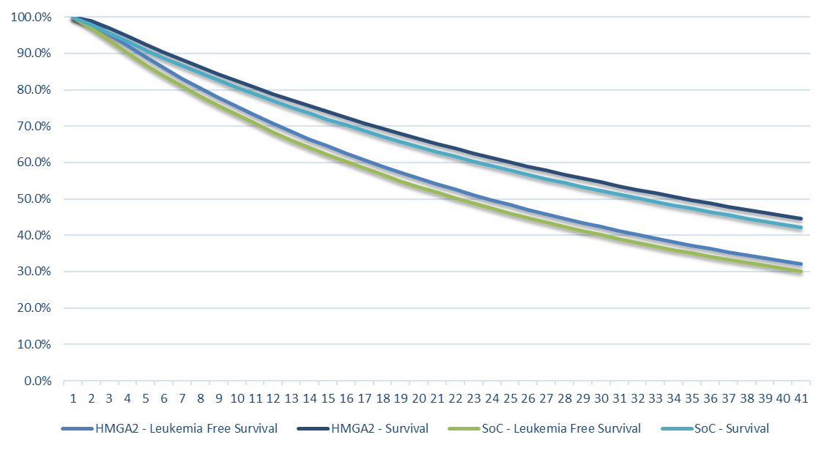
Figure S1 – Estimated leukemia-free survival and overall survival for the standard of care and the HMGA2 prognostic test. SOC, standard of care.

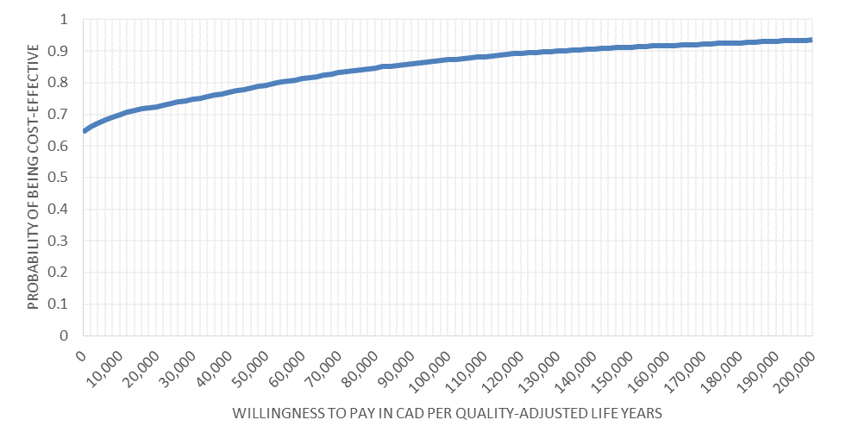
Figure S2 – Cost-effectiveness acceptability curve of the HMGA2 prognostic test compared with the standard of care. CAD, Canadian dollar.

Tables

Table S1. Probabilities of experiencing an event over the course of the disease by risk and age group.
Risk group | Adverse |  | Intermediate |  | Favorable |  | Time horizonª
Age group | <59 | ≥60 | <59 | ≥60 | <59 | ≥60
Relapse[1] | 70.00% | 60.00% | 47.89% | 73.01% | 23.68% | 66.66% | 5
Early HSCT[1] | 34.88% | 12.00% | 30.41% | 3.57% | 4.88% | 0.00% | 3
Late HSCT^{b}[1] | 13.95% | 12.00% | 42.57% | 4.76% | 19.51% | 0.00% | 3
GVHD[1] | 53.20% | 59.32% | 58.60% | 65.34% | 46.10% | 51.40% | 3
Infections[2] | 49.13% | 49.13% | 49.13% | 49.13% | 49.13% | 49.13% | 3
False negative[3] | 0.20% | 0.20% | 0.20% | 0.20% | 0.20% | 0.20% | 1
False positive[3] | 31.45% | 31.45% | 31.45% | 31.45% | 31.45% | 31.45% | 1
Experimental therapy^{c} | 5.60% | 5.60% | 5.60% | 5.60% | 5.60% | 5.60% | 5
GHVD, graft versus host disease; HSCT, hematopoietic stem cell transplantation.
ªTime horizon measured in years. ^{b}Defined as HSCT in second complete remission or after relapse. ^{c}Source for data: physician survey (please see Table S4 and Table S5 for more details about the survey).

Table S2. Chemotherapy dosages and drug costs (CAD).
Drug | Vial dose (mg) | Cost | Cost per mg
Daunorubicin | 20[4] | $91ª | $4.55
Cytarabine | 5000^{b} | $989^{b} | $0.20
Idarubicin | 10^{b} | $122^{b} | $12.20
Etoposide | 50[5] | $32.82^{c} | $0.66
Mitoxantrone | 50^{b} | $51^{b} | $1.02
Decitabine | 10^{b} | $91^{b} | $9.10
Azacitidine | 50^{b} | $98^{b} | $1.96
Mercaptopurine | 50[6] | $2.86^{c} | $0.06
Fludarabine | 10[7] | $38.33^{c} | $3.83
CAD, Canadian dollar.
ªSource: Ontario Drug Benefit formulary. ^{b}Source: Selleck Chemicals. ^{c}Source: Régie de l’assurance maladie du Québec database.

Table S3. Chemotherapy drugs utilization and costs (CAD).
Drugs | Market share (comparator mix) - unbalanced |  |  |  | Market share (comparator mix) - balanced |  |  |  | Number of months (proxy for cycle)
Drugs | I | C1 | R | C2/R2 | I | C1 | R | C2/R2 | I | C1 | R | C2/R2
7 + 3 (cytarabine, daunorubicin) | 31.2% |  |  |  | 35.7% | 0.0% | 0.0% | 0.0% | 2.7
7 + 3 (cytarabine, idarubicin) | 11.1% |  |  |  | 12.7% | 0.0% | 0.0% | 0.0% | 3.2
7 + 3 + 7 (cytarabine, daunorubicin, etoposide) | 8.9% |  |  |  | 10.2% | 0.0% | 0.0% | 0.0% | 3.4
5 + 2 (cytarabine, daunorubicin) | 8.7% |  | 3.8% | 3.3% | 10.0% | 0.0% | 20.0% | 13.6% | 3.3 |  | 3.9 | 3.5
5 + 2 (cytarabine, idarubicin) | 6.2% |  |  |  | 7.1% | 0.0% | 0.0% | 0.0% | 4.1
5 + 2 (cytarabine, mitoxantrone) | 5.0% |  | 3.5% | 2.2% | 5.7% | 0.0% | 18.4% | 9.1% | 4.3 |  | 4.9 | 3.6
Decitabine | 4.6% | 11.7% | 3.8% | 6.5% | 5.3% | 14.7% | 20.0% | 26.9% | 6.5 | 8.5 | 5.5 | 4.6
Azacitidine | 4.0% |  |  |  | 4.6% | 0.0% | 0.0% | 0.0% | 8.0
7 + 3 (cytarabine, mitoxantrone) | 3.9% |  | 1.4% | 2.9% | 4.5% | 0.0% | 7.4% | 12.0% | 3.2 |  | 2.9 | 5.0
FLAG-Ida | 3.7% |  |  |  | 4.2% | 0.0% | 0.0% | 0.0% | 2.0
HiDAC (high-dose cytarabine) |  | 45.0% |  |  | 0.0% | 56.6% | 0.0% | 0.0% |  | 6.2
LoDAC (low-dose cytarabine) |  | 15.5% | 3.6% | 6.0% | 0.0% | 19.5% | 18.9% | 24.8.1% |  | 9.3 | 4.3 | 4.6
Mercaptopurine |  | 7.3% |  |  | 0.0% | 9.2% | 0.0% | 0.0% |  | 9.4
Cytarabine, fludarabine |  |  | 2.9% | 3.3% | 0.0% | 0.0% | 15.3% | 13.6% |  |  | 3.1 | 3.6
Total | 87.3% | 79.5% | 19.0% | 24.2% | 100.0% | 100.0% | 100.0% | 100.0%
Average duration |  |  |  |  |  |  |  |  | 3.52 | 7.44 | 4.28 | 4.27
Average cost per month |  |  |  |  |  |  |  |  | $1,777 | $3,945 | $1,299 | $1,293
CAD, Canadian dollar; C1, consolidation 1; C2, consolidation 2; I, induction; R, relapse; R2, second relapse

Table S4. Medical resource utilization form. Physicians were requested to provide approximations of monthly resources for AML patients during the health states highlighted in the form below (disease-related utilization; Table S4). Physicians were free to provide units ranging from 0 to ∞ and were requested to consider a monthly horizon (one month in the health state).
Health state | Generalist visits | Specialist (oncologist / hematologist) visits | Emergency visits | Hospitalization days | Nurse home visits
Induction
Consolidation
Relapse (with treatment)
Progressive disease (no treatment)
Remission or maintenance
HSCT without complications
HSCT with complications
Palliative care
Other resource use (optional):

HSCT, hematopoietic stem cell transplantation.

Table S5. Drug utilization form. Drug utilization in induction, consolidation 1, progression/relapse and consolidation 2. Physicians and clinicians were requested to approximate the proportion of prescriptions for the treatments outlined in the form below (Table S5) at induction, consolidation 1, progression/relapse and consolidation 2 stages. An example from a European physician survey was provided; however, other agents could also be added if they were used. The same form was filled in by physicians and clinicians for each stage of treatment.
Drugs used | Example from EU physician survey | Proportion of your total prescribing (what you are using, %)
7 + 3 (cytarabine, daunorubicin) | 0.0%
7 + 3 (cytarabine, idarubicin) | 0.0%
7 + 3 + 7 (cytarabine, daunorubicin, etoposide) | 0.0%
5 + 2 (cytarabine, daunorubicin) | 11.6%
5 + 2 (cytarabine, idarubicin) | 0.0%
5 + 2 (cytarabine, mitoxantrone) | 7.7%
Dacogen | 22.8%
Vidaza | 0.0%
7 + 3 (cytarabine, mitoxantrone) | 10.2%
FLAG-Ida | 0.0%
HiDAC (high-dose cytarabine) | 0.0%
LoDAC (low-dose cytarabine) | 21.1%
ATRA (all-trans-retinoic acid) | 15.1%
Mercaptopurine | 0.0%
Cytarabine, fludarabine | 11.6%
Total | 100%
EU, European Union.

Table S6. Healthcare resource utilization and costs (CAD).
Health state costs | Hospital stay |  | Physician visit |  | Oncologist - hematologist visit |  | Nurse visits | Emergency visit |  | Total costs
Unit costs | $820.09 |  | $81.21 |  | $165.11 |  | $42.93 | $184.09
Utilization per month
Stable disease | 0.13 |  | 0.18 |  | 0.63 |  | 0.08 | 0.10
Post-relapse | 0.74 |  | 0.17 |  | 1.05 |  | 0.31 | 0.59
Total costs
Stable disease | $107 |  | $14 |  | $104 |  | $3 | $19 |  | $249
Post-relapse | $605 |  | $14 |  | $173 |  | $13 | $109 |  | $914
Source
Utilization | Reed et al. 2004[8] |  | Reed et al. 2004[8] |  | Reed et al. 2004[8] |  | Reed et al. 2004[8] | Dawson et al. 2009[9]
Costs | CIHI |  | OHiP |  | OHiP |  | PayScale | CIHIª
CAD, Canadian dollar; CIHI, Canadian Institute for Health Information; OHiP, Ontario Health Insurance Plan.
ªIt was assumed that 80% of patients were admitted into hospital via the emergency department (based on KOL opinion).

Table S7. Health utility levels used in the model.
Event | Utility level | Duration (months) | Source | Elicitation method | Country
LFS | 0.66 | 1 | Leunis 2015[10] | EQ-5D index | Netherland
Post-relapse | 0.53 | 1 | Leunis 2015[10] | EQ-5D index | Netherland
On treatment | 0.09 | 1 | Leunis 2015[10] | EQ-5D index | Netherland
Relapse | -0.05 | 6 | Leunis 2015[10] | EQ-5D index | Netherland
Early HSCT | 0.08 | 9 | Teng et al. 2005[11] | EQ-5D index | Netherland
Late HSCTª | 0.08 | 9 | Teng et al. 2005[11] | EQ-5D index | Netherland
GVHD | -0.26 | 6 | Swinburn et al. 2015[12] | Vignette study | Mexico
Infections | -0.31 | 1 | Leunis 2015[10] | EQ-5D index | Netherland
False negative | -0.02 | 1 | Stout et al. 2006[13] | EQ-5D index | United States
False Positive | -0.01 | 1 | Stout et al. 2006[13] | EQ-5D index | United States
GVHD, graft versus host disease; HSCT, hematopoietic stem cell transplantation; LFS, leukemia-free survival.
ªDefined as HSCT in second complete remission or after relapse.

Table S8. Total costs (CAD) – discounted.
 | Standard of care |  |  |  | HMGA2 prognostic test
 | 2 years | 5 years | 10 years | Lifetime | 2 years | 5 years | 10 years | Lifetime
Drug costs | 26,167 | 28,649 | 28,883 | 28,883 | 20,926 | 22,726 | 22,893 | 22,893
Induction | 4,849 | 4,849 | 4,849 | 4,849 | 3,890 | 3,890 | 3,890 | 3,890
Consolidation 1 | 18,413 | 18,413 | 18,413 | 18,413 | 14,958 | 14,958 | 14,958 | 14,958
Relapse | 1,599 | 2,760 | 2,826 | 2,826 | 1,258 | 2,204 | 2,259 | 2,259
Consolidation 2 or second relapse | 1,307 | 2,627 | 2,795 | 2,795 | 820 | 1,674 | 1,786 | 1,786
Diagnostic costs | 4,732 | 4,732 | 4,732 | 4,732 | 5,132 | 5,132 | 5,132 | 5,132
Diagnostic and testing | 4,732 | 4,732 | 4,732 | 4,732 | 5,132 | 5,132 | 5,132 | 5,132
Routine medical costs | 5,751 | 11,982 | 17,502 | 22,490 | 5,802 | 12,262 | 18,216 | 24,061
Standard follow-up | 4,039 | 6,584 | 8,022 | 8,751 | 4,102 | 6,781 | 8,364 | 9,229
Post-relapse routine care | 1,712 | 5,399 | 9,480 | 13,739 | 1,700 | 5,481 | 9,852 | 14,832
Event costs | 19,816 | 27,667 | 27,788 | 27,788 | 19,703 | 27,660 | 27,787 | 27,787
Relapse | 11,446 | 18,659 | 18,780 | 18,780 | 11,281 | 18,651 | 18,777 | 18,777
Infections | 6,638 | 7,269 | 7,269 | 7,269 | 6,689 | 7,269 | 7,269 | 7,269
False negative | 11 | 11 | 11 | 11 | 11 | 11 | 11 | 11
False positive | 1,709 | 1,709 | 1,709 | 1,709 | 1,710 | 1,710 | 1,710 | 1,710
Experimental therapy | 11 | 19 | 19 | 19 | 11 | 19 | 19 | 19
GVHD-related costs | 22,847 | 35,171 | 35,171 | 35,171 | 19,363 | 30,030 | 30,030 | 30,030
Early HSCT | 8,847 | 11,492 | 11,492 | 11,492 | 7,032 | 9,189 | 9,189 | 9,189
Late HSCTª | 7,841 | 14,198 | 14,198 | 14,198 | 6,215 | 11,356 | 11,356 | 11,356
GVHD | 6,159 | 9,481 | 9,481 | 9,481 | 6,115 | 9,485 | 9,485 | 9,485
End of life costs | 12,317 | 20,452 | 25,270 | 28,023 | 11,835 | 19,895 | 24,860 | 27,913
Mortality | 4,699 | 7,838 | 9,691 | 10,746 | 4,513 | 7,621 | 9,529 | 10,700
Palliative care | 7,618 | 12,614 | 15,579 | 17,276 | 7,322 | 12,274 | 15,330 | 17,214
Total costs | 91,630 | 128,652 | 139,345 | 147,086 | 82,760 | 117,705 | 128,917 | 137,816
Indirect costs | 6,441 | 11,067 | 13,411 | 14,272 | 6,179 | 10,745 | 13,152 | 14,092
Total costs (including indirect costs) | 98,072 | 139,719 | 152,756 | 161,358 | 88,938 | 128,450 | 142,069 | 151,908
CAD, Canadian dollar; GVHD, graft versus host disease; HSCT, hematopoietic stem cell transplantation.
ªDefined as HSCT in second complete remission or after relapse.
Note: Data have been rounded without decimals for presentation.

Table S9. Quality-adjusted life years (QALY) per source.
 | Standard of care |  |  |  | HMGA2 prognostic test
 | 2 years | 5 years | 10 years | Lifetime | 2 years | 5 years | 10 years | Lifetime
QALYs | 0.99 | 1.77 | 2.34 | 2.82 | 1.00 | 1.82 | 2.44 | 3.00
LFS | 0.91 | 1.50 | 1.85 | 2.06 | 0.92 | 1.55 | 1.94 | 2.18
Post-relapse | 0.08 | 0.27 | 0.49 | 0.76 | 0.08 | 0.27 | 0.51 | 0.82
Disutility | 0.06 | 0.06 | 0.07 | 0.07 | 0.04 | 0.04 | 0.05 | 0.05
On treatment | 0.08 | 0.09 | 0.09 | 0.09 | 0.06 | 0.07 | 0.07 | 0.07
Relapse | -0.01 | -0.01 | -0.01 | -0.01 | -0.01 | -0.01 | -0.01 | -0.01
Early HSCT | 0.01 | 0.01 | 0.01 | 0.01 | 0.01 | 0.01 | 0.01 | 0.01
Late HSCTª | 0.01 | 0.01 | 0.01 | 0.01 | 0.01 | 0.01 | 0.01 | 0.01
GVHD | -0.02 | -0.03 | -0.03 | -0.03 | -0.02 | -0.03 | -0.03 | -0.03
Infections | -0.01 | -0.01 | -0.01 | -0.01 | -0.01 | -0.01 | -0.01 | -0.01
False negative | 0.00 | 0.00 | 0.00 | 0.00 | 0.00 | 0.00 | 0.00 | 0.00
False positive | 0.00 | 0.00 | 0.00 | 0.00 | 0.00 | 0.00 | 0.00 | 0.00
QALYs (undiscounted) | 1.05 | 1.83 | 2.41 | 2.88 | 1.04 | 1.86 | 2.49 | 3.05
QALYs (discounted) | 1.03 | 1.78 | 2.30 | 2.66 | 1.03 | 1.81 | 2.37 | 2.80
Utility per patient per year (discounted) | 0.684 | 0.661 | 0.647 | 0.637 | 0.674 | 0.653 | 0.641 | 0.631
GVHD, graft versus host disease; HSCT, hematopoietic stem cell transplantation; QALY, quality-adjusted life-year.
ªDefined as HSCT in second complete remission or after relapse.
Note: Data have been rounded at the second decimals (QALYs) for presentation.

Table S10. Incremental costs difference between the HMGA2 prognostic test and the standard of care (CAD).
 | Incremental (lifetime horizon) |  |  | ICER
 | LYs | QALYs | Costs | Cost per LY | Cost per QALY
Public healthcare perspective | 0.260 | 0.138 | -$9,270 | Dominant  (-$35,689) | Dominant  (-$67,138)
Societal perspective | 0.260 | 0.138 | -$9,451 | Dominant  (-$36,384) | Dominant  (-$68,445)
CAD, Canadian dollar; ICER, incremental cost-effectiveness ratio; LY, life-year; QALY, quality-adjusted life-year.

Reference
1. Leucegene. Data on file. 2016.
2. Fernandez HF, Sun Z, Yao X, et al. Anthracycline dose intensification in acute myeloid leukemia. The New England journal of medicine. 2009; 361: 1249-59.
3. Croswell JM, Kramer BS, Kreimer AR, et al. Cumulative incidence of false-positive results in repeated, multimodal cancer screening. Annals of family medicine. 2009; 7: 212-22.
4. British Columbia Cancer Agency. Cancer Drug Manual: CERUBIDINE (daunorubicin) monograph. 2017. http://www.bccancer.bc.ca/drug-database-site/Drug%20Index/Daunorubicin_monograph_1Feb2017.pdf. Accessed June, 2017.
5. British Columbia Cancer Agency. Cancer Drug Manual: VEPESID/ETOPOPHOS (etoposide) monograph. 2017. http://www.bccancer.bc.ca/drug-database-site/Drug%20Index/Etoposide_monograph_1Mar2017.pdf. Accessed June, 2017.
6. British Columbia Cancer Agency. Cancer Drug Manual: PURINETHOL (mercaptopurine) monograph. 2007. http://www.bccancer.bc.ca/drug-database-site/Drug%20Index/Mercaptopurine_monograph.pdf Accessed Nov, 2018.
7. British Columbia Cancer Agency. Cancer Drug Manual: FLUDARA (fludarabine) monograph. 2013. http://www.bccancer.bc.ca/drug-database-site/Drug%20Index/Fludarabine_monograph_1Sept2013_formatted.pdf. Accessed June, 2017.
8. Reed SD, Anstrom KJ, Ludmer JA, et al. Cost-effectiveness of imatinib versus interferon-alpha plus low-dose cytarabine for patients with newly diagnosed chronic-phase chronic myeloid leukemia. Cancer. 2004; 101: 2574-83.
9. Dawson H, Zinck G. CIHI Survey: ED spending in Canada: a focus on the cost of patients waiting for access to an in-patient bed in Ontario. Healthcare quarterly. 2009; 12: 25-8.
10. Leunis A. The cost-effectiveness of personalized medicine strategies in acute myeloid leukemia. 2015. https://repub.eur.nl/pMontreal canadaub/78280/a.leunis.pdf. Accessed June, 2018.
11. Teng YK, Verburg RJ, Sont JK, et al. Long-term followup of health status in patients with severe rheumatoid arthritis after high-dose chemotherapy followed by autologous hematopoietic stem cell transplantation. Arthritis and rheumatism. 2005; 52: 2272-6.
12. Swinburn P, Shingler S, Acaster S, et al. Health utilities in relation to treatment response and adverse events in relapsed/refractory Hodgkin lymphoma and systemic anaplastic large cell lymphoma. Leukemia & lymphoma. 2015; 56: 1839-45.
13. Stout NK, Rosenberg MA, Trentham-Dietz A, et al. Retrospective cost-effectiveness analysis of screening mammography. Journal of the National Cancer Institute. 2006; 98: 774-82.

