Applied Health Economics and Health Policy
EQ-5D-5L health state values for the Mexican population

Cristina Gutierrez-Delgado.(*). PhD. Rosa-María Galindo-Suárez. MEconomics. Cesar Cruz-Santiago. PhD. Koonal Shah. PhD. Manny Papadimitropoulos. PhD. Yan Feng. PhD. Bernarda Zamora. PhD.Nancy Devlin. PhD.
Cristina Gutierrez-Delgado.(*). PhD. Faculty of Sciences. National Autonomous University of Mexico and Economic Analysis Unit, Secretariat of Health. Mexico. crisgutdel@gmail.com

Funding. This study received unrestricted financial support of the Asociación Mexicana de la Industria de Investigación Farmacética (AMIIF) AC and in-kind support from the EuroQol Group for initial training on the EQ-5D-5L protocol of CG, RG, CC and access to the EQ-VT tool for the study.
Conflict of interests: ND, KS and YF are members of the EuroQol Group. CG started the project as member of the Economic Analysis Unit. However, she left her position in 2019. RG started the project as member of General Health Council. However, she left her position in November 2018. MP and RG are currently employees of the pharmaceutical industry.
APPENDIX

Section 1. Sampling design
Based on the diagnosis, the aim is to identify the current Quality of Life situation, taking as a segmentation variable the socioeconomic levels that particularize the population in Mexico.
The methodology used to make this diagnosis is face-to-face interviews with people living in the dwellings belonging to the selected Basic Geostatistics Area (AGEB's), in a random sample taken from the INEGI Population and Housing Census 2010 database.
Information will be collected according to the different Socioeconomic Levels (SEL) established by the Mexican Association of Market Intelligence and Opinion Agencies (AMAI) in Mexico.
The sample design is defined to meet the requirements set in the project objectives, based on the main particularity of the classification of socioeconomic levels and being distributed proportionally in sex and age ranges.
For the calculation of parameters, design and selection of a sample of a thousand interviews with national representativeness, the country was stratified in seven socioeconomic regions, from which the states that represent them are selected, proportionally to the size of the population they possess, from which the municipalities are selected and the Basic Geostatistics Area (AGEB) level defined by INEGI is reached. From them, a quota survey is carried out that allows us to have, at the national level, proportions of the sex variables, age ranges and socioeconomic level.
INEGI defines the socioeconomic regions of Mexico, which is useful for market research and research support. The main indicators that were used to develop this regionalization are:
a) Housing infrastructure (piped water, electricity, drainage)
b) Housing quality (non-ground floor, material of walls and ceilings)
c) Overcrowding (How many inhabitants are there for each room of the house)
d) Housing equipment (bathrooms, gas heaters, refrigerator, television, telephone, vehicles)
e) Health (Surviving children of women aged 20 to 34, percentage of beneficiaries of health services, percentage of people over 65 with access to health services, percentage of people under 18 years entitled to health services and percentage of women head of household entitled to health services).
f) Education (Percentage of literacy, attendance at different school levels, schooling average, and percentage of households where the head has a full middle school or more).
g) Employment (percentage of economically active population, employed women, salary levels, people benefiting from wages)
The regions are conformed as follows:
Region 1: Chiapas, Guerrero y Oaxaca
Region 2: Campeche, Hidalgo, Puebla, San Luis Potosí, Tabasco y Veracruz.
Region 3: Durango, Guanajuato, Michoacán de Ocampo, Tlaxcala y Zacatecas.
Region 4: Colima, Estado de México, Morelos, Nayarit, Querétaro, Quintana Roo, Sinaloa y Yucatán.
Region 5: Baja California, Baja California Sur, Chihuahua, Sonora y Tamaulipas
Region 6: Aguascalientes, Coahuila de Zaragoza, Jalisco y Nuevo León
Region 7: Ciudad de México
According to The Mexican Association of Marketing Research and Public Opinion Agencies (AMAI), the description of each socioeconomic level is as follows:
A / B: The socioeconomic level A / B is made up mostly (82%) of households in which the head of the family have professional studies. 98% of these houses have Internet access. It is the level that invests the most in education (13% of its expenditure) and also the one that spends the least amount on food (25%).
C +: 89% of households in this level have one or more transport vehicles and 91% have internet access in their home. A little less than a third (31%) of its expenditure goes to food, and what goes (5%) to footwear and clothing is very homogeneous with other levels.
C: 81% of households in this level have a head of household with higher education than middle school and 73% have an Internet connection in their home. Of the total expenses of this level, 35% are allocated to food and 9% to education.
D +: In 62% of households at this level, the head of household has middle school education. Only 19% have internet connection in their home. 41% of its expenditure goes to food and 7% to education.
E: The vast majority of households at this level (95%) have a head of household with no higher education than middle school. The possession of internet in housing is minimal (0.1%) It is the level at which most of its expenditure is allocated to food (52%) and the group in which the lowest proportion dedicated to education is observed (5 %)
With the above, there is total control from the sample design and selection of AGEB’s, in the proportionality and representativeness.
Target population
Population who are 18 years or older, randomly selected and resident in the homes of the selected AGEB's.
Sampling frame
2010 Population and Housing Census with proportional adjustment to the 2010 AMAI socioeconomic levels at the national level.
Sampling units
Primary Sampling Unit (UPM): Entity
Secondary Sampling Unit (USM): Municipality
Tertiary Sampling Unit (UTM): AGEB’s
Quaternary Sampling Unit (UCM): Target population
Sampling
The sample design is probabilistic (PPT), stratified and multi-stage where the sampling units are selected with a probability method proportional to the population size and a random selection of the target population within the selected AGEB’s:
- Probabilistic. Because all sampling units have a known and non-zero probability of being selected.
- PPT. The method in which the sampling units were selected, this is by assigning the selection probabilities proportionally to the size of the unit.
- Stratified. Because sampling units with similar geographical characteristics are grouped together to form strata or cluster.
  - Socioeconomic Regions
- Multistage, there are several stages of selection.
  - Entity
  - Municipality
  - AGEB
- SRS. Simple Random Sampling, is the sampling technique in which all the elements that make up the universe and that are therefore described in the sampling frame, have the same probability of being selected.
Sample size
The sample size is randomly stratified of 1,000 (thousand) interviews nationwide, with a maximum expected error of estimation of 3.8%, with a 15% non-response rate and a design effect of 1.2 with 95% confidence. Because there is no previous record, the proportion was set at 50%. The following expression was used to determine the sample size:

Where

n = Sample size | D =Value of confidence at 95%
Ni= Population per stratum | B = Estimation error
p = Proportion of successes in the estimator | DEFF = Sample design effect
q =1 – p | TNR = Expected non-response rate

Sample sizes:
Regions | Entities | Municipalities | AGEB’s | Population 18 years and older | Interviews | % Population | % Interviews
1 | 3 | 769 | 6,207 | 7,931,675 | 100 | 10.1% | 10.0%
2 | 6 | 599 | 8,951 | 15,093,816 | 192 | 19.2% | 19.2%
3 | 5 | 316 | 9,425 | 9,682,184 | 126 | 12.3% | 12.6%
4 | 8 | 339 | 10,605 | 18,697,285 | 237 | 23.8% | 23.7%
5 | 5 | 192 | 9,726 | 9,124,117 | 118 | 11.6% | 11.8%
6 | 4 | 225 | 8,847 | 11,178,743 | 145 | 14.3% | 14.5%
7 | 1 | 16 | 2,432 | 6,715,516 | 82 | 8.6% | 8.2%
Total | 32 | 2,456 | 56,193 | 78,423,336 | 1,000 | 100% | 100%

Selection
For both, the selection of entities and municipalities, as well as for the selection of AGEB’s, a random sampling was carried out proportional to the population size and sequential (PPT) within each stratum or socioeconomic region. For the selection of the population under study, a Simple Random Sampling (SRS) is performed within each selected AGEB. In order to distribute the number of entities, municipalities and AGEB´s between the different stages, an affixation was used proportional to the eligible population within each stage. The stages are described below:
- In the first stage, 10 states are distributed proportionally, maintaining a balance according to the sample size of each region (stratum) and taking into account their dispersion.
- In the second stage, 33 municipalities are distributed proportionally, in the selected states, maintaining a balance according to the sample size of each region and taking into account their dispersion.
- In the third stage, 90 AGEB’s are distributed proportionally, in the selected municipalities, maintaining a balance according to the sample size of each region and taking into account their dispersion.
- Finally, in the fourth stage the target population is selected, randomly within the selected AGEB's, with an approximate of 11 interviews, for a total of 1,000.
These stages are presented in the following distribution chart:
Regions | Entities | Municipalities | AGEB’s
1 | 1 | 4 | 9
2 | 2 | 6 | 18
3 | 1 | 4 | 11
4 | 2 | 8 | 22
5 | 1 | 3 | 10
6 | 2 | 5 | 14
7 | 1 | 3 | 6

Expansion factor
For the achievement of obtaining statistical representation at the national level of socioeconomic levels, gender and age ranges; it is necessary to assign a minimum sample size in each of the regions, generating a sample size that meets the requirements, as well as a proportional and correct distribution of the selected levels.
The expansion factor is used when it is of your desire to know the value in the population of a result obtained in the effective sample.
To expand, aggregate sampling units are constructed, which for this case were considered three proportion variables for each of the 7 regions, which are Socioeconomic Levels (7 levels), Gender (2 categories) and Age Ranges (4 ranges) In total, the intersection of the variables cause an aggregate sampling unit, for each unit a coefficient is obtained.
The following tables show the distribution of the questionnaires that satisfy the proportionality in each of the aggregates:
Distribution of surveys in the 7 regions and by socioeconomic levels
 | AMAI
 | A/B | C+ | C | C- | D+ | D | E
 | 6.0% | 11.0% | 13.0% | 14.0% | 15.0% | 30.0% | 11.0%

REGIONS | Surveys distribution
REGIONS | A/B | C+ | C | C- | D+ | D | E | Total
1 | 5 | 10 | 13 | 14 | 15 | 31 | 12 | 100
2 | 11 | 21 | 23 | 27 | 29 | 59 | 22 | 192
3 | 7 | 14 | 16 | 17 | 19 | 38 | 15 | 126
4 | 14 | 25 | 31 | 33 | 35 | 72 | 27 | 237
5 | 7 | 13 | 15 | 16 | 17 | 36 | 14 | 118
6 | 9 | 16 | 19 | 20 | 20 | 44 | 17 | 145
7 | 8 | 12 | 14 | 15 | 16 | 17 | 0 | 82
TOTAL | 61 | 111 | 131 | 142 | 151 | 297 | 107 | 1,000

Distribution of surveys in the 7 regions and by gender
 |  |  |  |  |  |  | INEGI
 |  |  |  |  |  |  | Men | Women
 |  |  |  |  |  |  | 49% | 51%
REGIONS | A/B |  | C+ |  | C |  | C-
REGIONS | Men | Women | Men | Women | Men | Women | Men | Women
1 | 2 | 3 | 5 | 5 | 6 | 7 | 7 | 7
2 | 5 | 6 | 10 | 11 | 11 | 12 | 13 | 14
3 | 3 | 4 | 7 | 7 | 8 | 8 | 8 | 9
4 | 7 | 7 | 12 | 13 | 15 | 16 | 16 | 17
5 | 3 | 4 | 6 | 7 | 7 | 8 | 8 | 8
6 | 4 | 5 | 8 | 8 | 9 | 10 | 10 | 10
7 | 4 | 4 | 6 | 6 | 7 | 7 | 7 | 8
Sub Total | 28 | 33 | 54 | 57 | 63 | 68 | 69 | 73
TOTAL | 61 |  | 111 |  | 131 |  | 142
REGIONS | D+ |  | D |  | E |  | Total |  | TOTAL
REGIONS | Men | Women | Men | Women | Men | Women | Men | Women | TOTAL
1 | 7 | 8 | 15 | 16 | 6 | 6 | 48 | 52 | 100
2 | 14 | 15 | 29 | 30 | 11 | 11 | 93 | 99 | 192
3 | 9 | 10 | 19 | 19 | 7 | 8 | 61 | 65 | 126
4 | 17 | 18 | 36 | 36 | 13 | 14 | 116 | 121 | 237
5 | 8 | 9 | 18 | 18 | 7 | 7 | 57 | 61 | 118
6 | 10 | 10 | 22 | 22 | 8 | 9 | 71 | 74 | 145
7 | 8 | 8 | 8 | 9 | 0 | 0 | 40 | 42 | 82
Sub Total | 73 | 78 | 147 | 150 | 52 | 55 | 486 | 514 | 1,000
TOTAL | 151 |  | 297 |  | 107 |  | 1,000

Distribution of surveys in the 7 regions and by age range
 |  |  |  |  | Age ranges INEGI
 |  |  |  |  | 19 - 29 years | 30 - 44 years | 45 - 59 years | 60 years +
 |  |  |  |  | 38% | 30% | 19% | 13%
REGIONS | A/B |  |  |  | C+
REGIONS | 19 - 29 years | 30 - 44 years | 45 - 59 years | 60 years + | 19 - 29 years | 30 - 44 years | 45 - 59 years | 60 years +
1 | 2 | 1 | 1 | 1 | 4 | 3 | 2 | 1
2 | 4 | 3 | 2 | 2 | 8 | 6 | 4 | 3
3 | 3 | 2 | 1 | 1 | 5 | 4 | 3 | 2
4 | 5 | 4 | 3 | 2 | 9 | 8 | 5 | 3
5 | 3 | 2 | 1 | 1 | 5 | 4 | 2 | 2
6 | 3 | 3 | 2 | 1 | 6 | 5 | 3 | 2
7 | 3 | 2 | 2 | 1 | 4 | 4 | 2 | 2
Sub Total | 23 | 17 | 12 | 9 | 41 | 34 | 21 | 15
TOTAL | 61 |  |  |  | 111
REGIONS | C |  |  |  | C-
REGIONS | 19 a 29 years | 30 a 44 years | 45 a 59 years | 60 years & older | 19 a 29 years | 30 a 44 years | 45 a 59 years | 60 years & older
1 | 5 | 4 | 2 | 2 | 5 | 4 | 3 | 2
2 | 9 | 7 | 4 | 3 | 10 | 8 | 5 | 4
3 | 6 | 5 | 3 | 2 | 7 | 5 | 3 | 2
4 | 12 | 9 | 6 | 4 | 13 | 10 | 6 | 4
5 | 6 | 4 | 3 | 2 | 6 | 5 | 3 | 2
6 | 7 | 6 | 4 | 2 | 8 | 6 | 4 | 2
7 | 5 | 4 | 3 | 2 | 6 | 4 | 3 | 2
Sub Total | 50 | 39 | 25 | 17 | 55 | 42 | 27 | 18
TOTAL | 131 |  |  |  | 142

Once the afore mentioned sample was obtained with its proper proportional distribution of the sample size, the weights were constructed. Like the sample selection, it was developed in stages:
- In the first stage, the inverse of the probability of the person being selected (object of study) within the selected AGEB, is used to calculate the Expansion Factor.
Using the following formula:
Where:
= The inverse of the probability, if the person is selected
= The number of surveys of the target population within the AGEB (sample size)
= The sum of the population in the AGEB
- In the second stage, the inverse of the probability of being selected the AGEB in the selected Municipality is used to calculate the Expansion Factor.

Using the following formula:
Where:
= The inverse of the probability, if the AGEB is selected
= The population of the selected AGEB
= The number of AGEB´s selected in the Municipality (sample size)
= The sum of the AGEBS population in the selected Municipality

• The third stage, for the calculation of the Expansion Factor, it is used the inverse of the probability of selecting the Municipality in the selected Federal Entity.
Using the following formula:
Where:
= The inverse of the probability, if the Municipality is selected
= The population of the selected Municipality
= The number of municipalities selected in the Federal Entity (sample size)

= The sum of the population of all Municipalities within the Federative Entity

• The fourth stage, for the calculation of the Expansion Factor, uses the inverse of the probability of being selected by the Federative Entity in the Region.
Using the following formula:
Where:
= The inverse of the probability, if the Federal Entity is selected
= The population of the selected Entity
= The number of Federative Entity selected in the Region (sample size)
= The sum of the population of all Federal Entities in the Region

- The fifth stage is a calculation of adjustment to the population within each of the Regions towards the total target population of the study.

Using the following formula:
Where:
= Adjustment factor by region
= The population of the Region
= The total target population of the study

Finally, the five expansion factors of each of the stages are multiplied, to result in an approximate expansion in the total population of 78, 423,381 people.
The expander value is interpreted as the number of elements of the population that is represented by each element of the effective sample.
Section 2. Discrete Choice Experiment (DCE) Analysis

Design, analysis and model results from DCE valuation of EQ-5D-5L in Mexico
The study followed the EQ-VT protocol and therefore included collection of both cTTO and DCE data. A prior decision was made to based the value set on cTTO data only (as opposed to a hybrid model) as explained in our paper. However, we did perform analysis and modelling of the DCE data. The DCE methods, data and results are provided here, including some discussion of the reasons why there appear to be differences between the cTTO and DCE results.

DCE design.
The DCE design included 196 paired comparisons divided into 28 blocks of seven pairs (identified using a Bayesian design,). The blocks were well-balanced in terms of the severity of the health states. No pairs were included in which one health state logically dominated the other (i.e. at least as good on all five dimensions). The software randomly assigned participants to both cTTO and DCE blocks. Further details about the experimental design are reported by Oppe and van Hout.

Methods
For DCE, descriptive analysis focused on calculating the proportion of respondents choosing one health state or the other for each unit of difference in LSS between the two health states.
No criteria were agreed in advance for the exclusion of DCE data, though in sensitivity analyses we explored the impact of excluding respondents who always chose the same alternative, or systematically alternated between the two alternatives, in each task.
The DCE data were modelled using conditional logit and mixed logit. As with the cTTO models, 20-parameter models were estimated. Conditional logit models are widely used in analysing discrete choice data. Mixed logit modelling extends the conditional logit model by allowing parameters to vary from one respondent to another.
Results
In the DCE, the health state labelled ‘A’ was selected 52.0% of the time. A small minority (0.3%) of respondents made the same choice in all DCE tasks. No DCE data were excluded from the dataset for analysis. As the difference in severity between the two health states increased (as judged by their LSS), respondents were more likely to choose the health state with lower LSS (see Figure 2 of section 3 of this Appendix).
Table 1 in this section shows the DCE results based on the conditional logit and mixed logit models. All of the coefficients are logically ordered and statistically significant (p<0.05), and the estimated parameters from the two models are very close to each other. In contrast to the cTTO model, the largest utility decrement is for MO5; the smallest is for AD2. Considerably greater weight is placed on mobility problems in the DCE data compared to the cTTO data. The sensitivity analysis with two DCE models (with exclusion rule applied) are reported in Table 4 of section 3 of this Appendix.
Table 1: DCE model results: conditional logit and mixed logit
 | Conditional logit |  | Mixed logit
 | Coefficient | P value | Coefficient | P value
Mobility 2 | -0.2905 | 0.0000 | -0.3709 | 0.0000
Mobility 3 | -0.3336 | 0.0000 | -0.3997 | 0.0000
Mobility 4 | -1.0332 | 0.0000 | -1.3170 | 0.0000
Mobility 5 | -1.7229 | 0.0000 | -2.1728 | 0.0000
Self-Care 2 | -0.3295 | 0.0000 | -0.4418 | 0.0000
Self-Care 3 | -0.4934 | 0.0000 | -0.6461 | 0.0000
Self-Care 4 | -0.9169 | 0.0000 | -1.1667 | 0.0000
Self-Care 5 | -1.2870 | 0.0000 | -1.6228 | 0.0000
Usual Activities 2 | -0.3384 | 0.0000 | -0.4048 | 0.0000
Usual Activities 3 | -0.4062 | 0.0000 | -0.4885 | 0.0000
Usual Activities 4 | -0.9583 | 0.0000 | -1.1790 | 0.0000
Usual Activities 5 | -1.3160 | 0.0000 | -1.6381 | 0.0000
Pain/Discomfort 2 | -0.3254 | 0.0000 | -0.3919 | 0.0000
Pain/Discomfort 3 | -0.4051 | 0.0000 | -0.5021 | 0.0000
Pain/Discomfort 4 | -1.0216 | 0.0000 | -1.2596 | 0.0000
Pain/Discomfort 5 | -1.6193 | 0.0000 | -2.0949 | 0.0000
Anxiety/Depression 2 | -0.2141 | 0.0010 | -0.2668 | 0.0000
Anxiety/Depression 3 | -0.3816 | 0.0000 | -0.4670 | 0.0000
Anxiety/Depression 4 | -0.6760 | 0.0000 | -0.8603 | 0.0000
Anxiety/Depression 5 | -1.2746 | 0.0000 | -1.6130 | 0.0000
No. observations | 7,000 |  | 7,000
Model performance | AIC = 7475.8  BIC = 7626.7 |  | AIC = 7436.4  BIC = 7738.3

Comparing the predicted values from DCE models with the cTTO models reported in our paper
The predicted values from our preferred cTTO model and mixed logit DCE model for the 86 health states in the valuation study show that for the majority of the health states, the predicted TTO values are higher than those derived from the DCE model. The mean absolute difference of parameter estimates from the two models is calculated. The minimum parameter difference is for AD3 (cTTO=-0.0824; DCE=-0.0815; difference= 0.0009). The maximum parameter difference is for MO5 (cTTO=-0.2697; DCE=-0.3793; difference= 0.1096). The mean absolute deviation from the two sets of estimated parameters is 0.0304. Graphical comparisons between the cTTO model and the mixed logit and conditional logit DCE models are presented in the appendix (Figures 4 and 5).

What might explain the difference between cTTO and DCE models?
The marked differences between the preferences elicited using cTTO and DCE methods raises interesting questions about the nature of the two tasks and whether they are measuring the same underlying construct or capturing complementary information about preferences. There may be specific cultural or other factors that led Mexican respondents to respond very differently to them. Most obviously, cTTO tasks involve trading off length and quality of life, compared to the DCE tasks where duration and death do not feature. Distinctive attitudes to death in Mexico – such as the celebration of Dia de los Muertos – could lead to a greater willingness to trade life years in the cTTO, although it is not clear to us why this would necessarily affect the ordering of dimensions. Another possibility is that the DCE responses were a product of a heuristic – for example, as mobility is always the first dimension in the health state descriptions, mobility problems may exert an influence on respondents’ pairwise choices between states. However, there are reasons why Mexican respondents might be sensitive to mobility issues: Mexico does not have any social care infrastructure or social security coverage to help people with a disability. Mobility problems can cause important life limitations. A similar case can be made for the importance of pain in the value set generated from cTTO data: access to treatment for pain is an ongoing issue in Mexico. The GHC has published two mandatory agreements since 2014 seeking to improve access to prescriptions for the management of chronic pain, and a further agreement is expected in 2020. Such considerations might help us to understand what may have influenced respondents – but such ex post explanations are necessarily speculative, and the characteristics of these values may be a product of more complex factors. Importantly, it remains unclear why the cTTO and DCE data diverge in terms of dimension importance. We are not aware of any research to date which has systematically explored this issue across all EQ-5D-5L value set studies, which is an important gap in this literature.

Our analysis of the DCE data collected alongside cTTO reveal some interesting differences in the effects on values of problems in each dimension. The rank order of dimensions, from most to least important (measured by the size of the level 5 coefficient) in the DCE models was mobility, pain/discomfort, usual activities, selfcare, and anxiety/depression. By comparison, in the final value set based on cTTO data, pain/discomfort has the highest utility decrement, followed by anxiety/depression, usual activities, mobility and self-care. The latter is arguably a more common ordering of dimensions observed in previous EQ-5D-5L value set studies although in the Uruguayan cTTO-based value set, we note that mobility was the most important dimension. However, the preferences reported in other countries provide a limited guide to what preferences might be expected in Mexico, given that the point of conducting such exercises is to allow for distinctive local preferences.

Section 3. Additional results
Table 1: TTO values – descriptive statistics, by health state (n=9,787)
Profile | Mean | SD | Median | LSS | N
11121 | 0.96 | 0.06 | 1.00 | 6 | 195
21111 | 0.95 | 0.08 | 1.00 | 6 | 207
11211 | 0.94 | 0.08 | 0.95 | 6 | 204
12111 | 0.94 | 0.10 | 0.95 | 6 | 191
11112 | 0.94 | 0.09 | 0.95 | 6 | 194
11221 | 0.90 | 0.09 | 0.95 | 7 | 98
11212 | 0.89 | 0.09 | 0.90 | 7 | 100
12121 | 0.89 | 0.10 | 0.90 | 7 | 95
21112 | 0.89 | 0.09 | 0.90 | 7 | 101
12112 | 0.88 | 0.10 | 0.90 | 7 | 99
11122 | 0.88 | 0.16 | 0.95 | 7 | 95
13122 | 0.78 | 0.17 | 0.80 | 9 | 107
14113 | 0.73 | 0.24 | 0.80 | 10 | 100
13313 | 0.72 | 0.19 | 0.75 | 11 | 109
11421 | 0.71 | 0.29 | 0.80 | 9 | 107
25222 | 0.70 | 0.26 | 0.75 | 13 | 91
32314 | 0.66 | 0.24 | 0.70 | 13 | 94
25122 | 0.66 | 0.30 | 0.70 | 12 | 107
12334 | 0.65 | 0.26 | 0.70 | 13 | 94
21334 | 0.63 | 0.31 | 0.70 | 13 | 94
11414 | 0.63 | 0.35 | 0.70 | 11 | 88
13224 | 0.62 | 0.35 | 0.70 | 12 | 94
12513 | 0.60 | 0.38 | 0.70 | 12 | 101
42321 | 0.60 | 0.33 | 0.70 | 12 | 91
25331 | 0.59 | 0.34 | 0.65 | 14 | 89
23242 | 0.58 | 0.34 | 0.70 | 13 | 92
35311 | 0.58 | 0.39 | 0.70 | 13 | 94
22434 | 0.58 | 0.28 | 0.60 | 15 | 106
11235 | 0.57 | 0.35 | 0.65 | 12 | 97
31514 | 0.54 | 0.35 | 0.60 | 14 | 92
53412 | 0.54 | 0.32 | 0.55 | 15 | 93
12514 | 0.52 | 0.39 | 0.60 | 13 | 97
53221 | 0.52 | 0.47 | 0.65 | 13 | 101
24342 | 0.51 | 0.32 | 0.60 | 15 | 92
21315 | 0.51 | 0.42 | 0.60 | 12 | 99
35332 | 0.50 | 0.37 | 0.60 | 16 | 105
34232 | 0.50 | 0.42 | 0.60 | 14 | 94
23514 | 0.47 | 0.46 | 0.60 | 15 | 94
12344 | 0.46 | 0.41 | 0.52 | 14 | 102
42115 | 0.46 | 0.40 | 0.52 | 13 | 108
12244 | 0.45 | 0.42 | 0.55 | 13 | 110
52431 | 0.44 | 0.39 | 0.55 | 15 | 99
11425 | 0.44 | 0.42 | 0.55 | 13 | 106
31524 | 0.44 | 0.43 | 0.55 | 15 | 99
32443 | 0.40 | 0.44 | 0.50 | 16 | 92
35143 | 0.40 | 0.43 | 0.50 | 16 | 91
45133 | 0.40 | 0.43 | 0.50 | 16 | 94
21444 | 0.39 | 0.42 | 0.50 | 15 | 90
31525 | 0.39 | 0.41 | 0.50 | 16 | 107
52215 | 0.38 | 0.47 | 0.55 | 15 | 92
23152 | 0.36 | 0.45 | 0.50 | 13 | 98
12543 | 0.35 | 0.50 | 0.50 | 15 | 92
43514 | 0.35 | 0.47 | 0.47 | 17 | 94
54231 | 0.35 | 0.49 | 0.45 | 15 | 97
21345 | 0.34 | 0.45 | 0.45 | 15 | 98
34244 | 0.33 | 0.43 | 0.40 | 17 | 99
53243 | 0.32 | 0.45 | 0.43 | 17 | 90
45233 | 0.32 | 0.48 | 0.40 | 17 | 109
15151 | 0.31 | 0.49 | 0.47 | 13 | 94
45413 | 0.29 | 0.50 | 0.45 | 17 | 101
24443 | 0.29 | 0.48 | 0.40 | 17 | 99
44125 | 0.29 | 0.43 | 0.40 | 16 | 101
43315 | 0.29 | 0.48 | 0.40 | 16 | 99
51152 | 0.28 | 0.48 | 0.43 | 14 | 106
33253 | 0.28 | 0.50 | 0.40 | 16 | 93
53244 | 0.26 | 0.48 | 0.40 | 18 | 90
55233 | 0.24 | 0.47 | 0.35 | 18 | 104
34515 | 0.20 | 0.52 | 0.30 | 18 | 93
43542 | 0.20 | 0.51 | 0.32 | 18 | 94
52335 | 0.19 | 0.50 | 0.35 | 18 | 95
54342 | 0.18 | 0.50 | 0.32 | 18 | 102
24553 | 0.18 | 0.46 | 0.25 | 19 | 104
54153 | 0.16 | 0.52 | 0.30 | 18 | 97
35245 | 0.15 | 0.51 | 0.30 | 19 | 96
45144 | 0.14 | 0.50 | 0.30 | 18 | 98
51451 | 0.10 | 0.56 | 0.25 | 16 | 93
55424 | 0.10 | 0.52 | 0.30 | 20 | 99
24445 | 0.09 | 0.52 | 0.20 | 19 | 95
55225 | 0.07 | 0.55 | 0.20 | 19 | 93
14554 | 0.03 | 0.52 | 0.15 | 19 | 102
34155 | 0.03 | 0.51 | 0.20 | 18 | 91
44345 | 0.01 | 0.51 | 0.20 | 20 | 100
44553 | -0.10 | 0.55 | 0.05 | 21 | 97
52455 | -0.11 | 0.59 | 0.00 | 21 | 109
43555 | -0.13 | 0.56 | 0.00 | 22 | 94
55555 | -0.66 | 0.42 | -0.90 | 25 | 980

Table 2: TTO values – descriptive statistics, by level sum score (n=9,787)
Level sum score | Mean | SD | Median | No. profiles | N
6 | 0.95 | 0.08 | 0.95 | 5 | 991
7 | 0.89 | 0.11 | 0.90 | 6 | 588
9 | 0.74 | 0.24 | 0.80 | 2 | 214
10 | 0.73 | 0.24 | 0.80 | 1 | 100
11 | 0.68 | 0.27 | 0.70 | 2 | 197
12 | 0.59 | 0.36 | 0.70 | 6 | 589
13 | 0.52 | 0.40 | 0.60 | 13 | 1,273
14 | 0.47 | 0.42 | 0.60 | 5 | 483
15 | 0.44 | 0.42 | 0.55 | 11 | 1,052
16 | 0.34 | 0.46 | 0.45 | 9 | 875
17 | 0.32 | 0.47 | 0.40 | 6 | 592
18 | 0.18 | 0.50 | 0.30 | 9 | 864
19 | 0.10 | 0.51 | 0.20 | 5 | 490
20 | 0.05 | 0.52 | 0.20 | 2 | 199
21 | -0.11 | 0.57 | 0.03 | 2 | 206
22 | -0.13 | 0.56 | 0.00 | 1 | 94
25 | -0.66 | 0.42 | -0.90 | 1 | 980

Table 3: Comparison of cTTO results across candidate models
 | GLS model |  | Tobit model censored at -1 |  | Heteroscedastic model with Bayesian estimation |  | Heteroscedastic censored model with Bayesian estimation
 | Coefficients | P value | Coefficients | P value | Coefficients | MCSE | Coefficients | MCSE
Mobility 2 | -0.0047 | 0.6800 | -0.0093 | 0.4280 | -0.0032 | 0.0005 | 0.0160 | 0.0003
Mobility 3 | 0.0317 | 0.0100 | 0.0225 | 0.0780 | 0.0422 | 0.0004 | 0.0473 | 0.0004
Mobility 4 | 0.1510 | 0.0000 | 0.1424 | 0.0000 | 0.1654 | 0.0005 | 0.1786 | 0.0005
Mobility 5 | 0.2684 | 0.0000 | 0.2750 | 0.0000 | 0.2596 | 0.0005 | 0.2697 | 0.0004
Self-Care 2 | 0.0282 | 0.0100 | 0.0266 | 0.0200 | 0.0231 | 0.0005 | 0.0476 | 0.0003
Self-Care 3 | 0.0757 | 0.0000 | 0.0738 | 0.0000 | 0.0806 | 0.0005 | 0.0819 | 0.0005
Self-Care 4 | 0.1492 | 0.0000 | 0.1466 | 0.0000 | 0.1513 | 0.0005 | 0.1697 | 0.0005
Self-Care 5 | 0.2894 | 0.0000 | 0.3065 | 0.0000 | 0.2567 | 0.0005 | 0.2589 | 0.0005
Usual Activities 2 | 0.0510 | 0.0000 | 0.0498 | 0.0000 | 0.0400 | 0.0006 | 0.0553 | 0.0003
Usual Activities 3 | 0.0977 | 0.0000 | 0.0977 | 0.0000 | 0.0844 | 0.0005 | 0.0952 | 0.0004
Usual Activities 4 | 0.1731 | 0.0000 | 0.1728 | 0.0000 | 0.1703 | 0.0005 | 0.1798 | 0.0004
Usual Activities 5 | 0.2870 | 0.0000 | 0.3043 | 0.0000 | 0.2605 | 0.0005 | 0.2758 | 0.0005
Pain/Discomfort 2 | 0.0444 | 0.0000 | 0.0398 | 0.0000 | 0.0367 | 0.0006 | 0.0531 | 0.0002
Pain/Discomfort 3 | 0.0894 | 0.0000 | 0.0876 | 0.0000 | 0.0901 | 0.0005 | 0.0808 | 0.0004
Pain/Discomfort 4 | 0.2457 | 0.0000 | 0.2501 | 0.0000 | 0.2406 | 0.0004 | 0.2283 | 0.0004
Pain/Discomfort 5 | 0.4312 | 0.0000 | 0.4414 | 0.0000 | 0.4299 | 0.0005 | 0.4579 | 0.0004
Anxiety/Depression 2 | 0.0413 | 0.0000 | 0.0395 | 0.0010 | 0.0350 | 0.0007 | 0.0551 | 0.0003
Anxiety/Depression 3 | 0.0687 | 0.0000 | 0.0625 | 0.0000 | 0.0672 | 0.0007 | 0.0824 | 0.0005
Anxiety/Depression 4 | 0.1597 | 0.0000 | 0.1578 | 0.0000 | 0.1577 | 0.0006 | 0.1611 | 0.0005
Anxiety/Depression 5 | 0.3278 | 0.0000 | 0.3367 | 0.0000 | 0.3161 | 0.0005 | 0.3337 | 0.0004
$$α_{0}$$ |  |  |  |  | -1.5270 | 0.0006 | -1.6435 | 0.0005
$$α_{1}$$ |  |  |  |  | 0.6481 | 0.0009 | 1.1088 | 0.0009
No. observations | 9,787 |  | 9,787 |  | 9,787 |  | 9,787
No. log inconsistency | 1 |  | 1 |  | 1 |  | 0
No. left-censored | 0 |  | 436 |  | 0 |  | 436
BIC | 8222.80 |  | 9532.49
AIC | 8064.64 |  | 9374.33
DIC |  |  |  |  | 6610.33 |  | 9121.68
Note: Bayesian information criterion (BIC); Akaike information criterion (AIC); Deviance information criterion (DIC); variance function for the two Bayesian models is $σ_{j}^{2}=exp\left(α_{0}+α_{1}μ_{j}\right)$. The two Bayesian models have sample size of 10,000 with 12,500 MCMC interactions and 2,500 times burn-in.

Table 4: DCE model results: conditional logit and mixed logit (N= 6,919)
 | Conditional logit |  | Mixed logit
 | Coefficient | P value | Coefficient | P value
Mobility 2 | -0.2938 | 0.0000 | -0.3702 | 0.0000
Mobility 3 | -0.3433 | 0.0000 | -0.4373 | 0.0000
Mobility 4 | -1.0476 | 0.0000 | -1.3634 | 0.0000
Mobility 5 | -1.7307 | 0.0000 | -2.2497 | 0.0000
Self-Care 2 | -0.3366 | 0.0000 | -0.4629 | 0.0000
Self-Care 3 | -0.4981 | 0.0000 | -0.6782 | 0.0000
Self-Care 4 | -0.9233 | 0.0000 | -1.2068 | 0.0000
Self-Care 5 | -1.2894 | 0.0000 | -1.6843 | 0.0000
Usual Activities 2 | -0.3409 | 0.0000 | -0.3993 | 0.0000
Usual Activities 3 | -0.4000 | 0.0000 | -0.4898 | 0.0000
Usual Activities 4 | -0.9600 | 0.0000 | -1.1824 | 0.0000
Usual Activities 5 | -1.3230 | 0.0000 | -1.6920 | 0.0000
Pain/Discomfort 2 | -0.3167 | 0.0000 | -0.4103 | 0.0000
Pain/Discomfort 3 | -0.3928 | 0.0000 | -0.4874 | 0.0000
Pain/Discomfort 4 | -1.0146 | 0.0000 | -1.2802 | 0.0000
Pain/Discomfort 5 | -1.6218 | 0.0000 | -2.1660 | 0.0000
Anxiety/Depression 2 | -0.2114 | 0.0010 | -0.2721 | 0.0000
Anxiety/Depression 3 | -0.3790 | 0.0000 | -0.4556 | 0.0000
Anxiety/Depression 4 | -0.6713 | 0.0000 | -0.8928 | 0.0000
Anxiety/Depression 5 | -1.2761 | 0.0000 | -1.6646 | 0.0000
No. observations | 6,916 |  | 6,916
Model performance | AIC = 7373.84  BIC = 7524.53 |  | AIC = 7314.86  BIC = 7616.25

Figure 1: Histogram of the observed TTO values

Figure 2: Respondents choosing A/B in the DCE tasks, by difference in level sum score between A and B

Figure 3: Standard deviations of residuals for each health state

Note: each cross (x) represents the standard deviation value for one of the 86 health states with observed cTTO values.

Figure 4: Plotted predicted values for 86 health states from preferred cTTO model vs. mixed logit DCE model
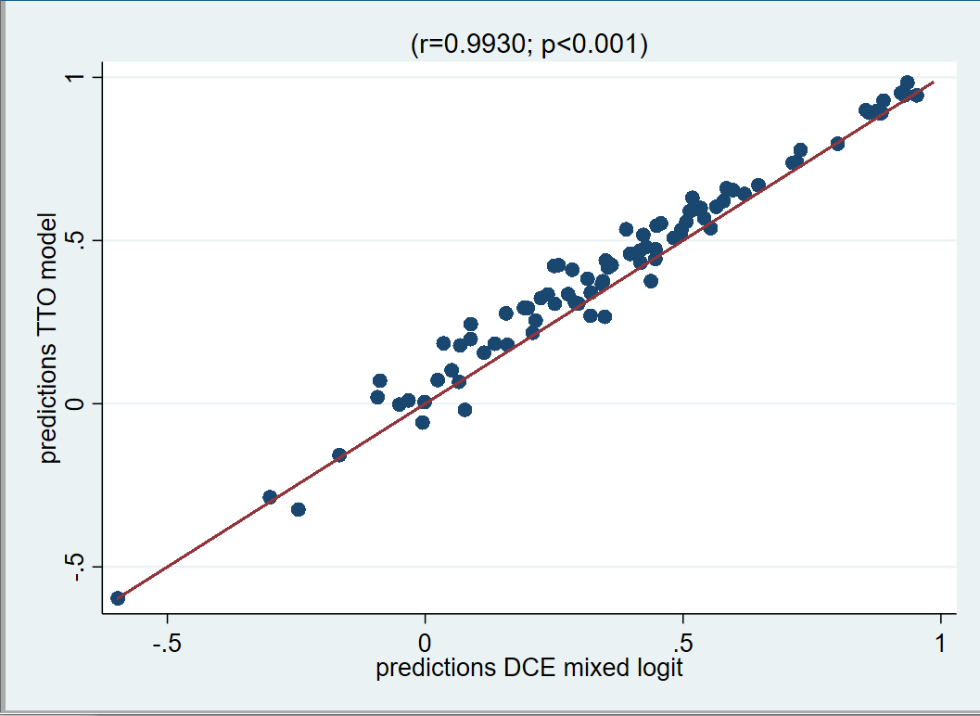

Figure 5: Plotted predicted values for 86 health states from preferred cTTO model vs. conditional logit DCE model
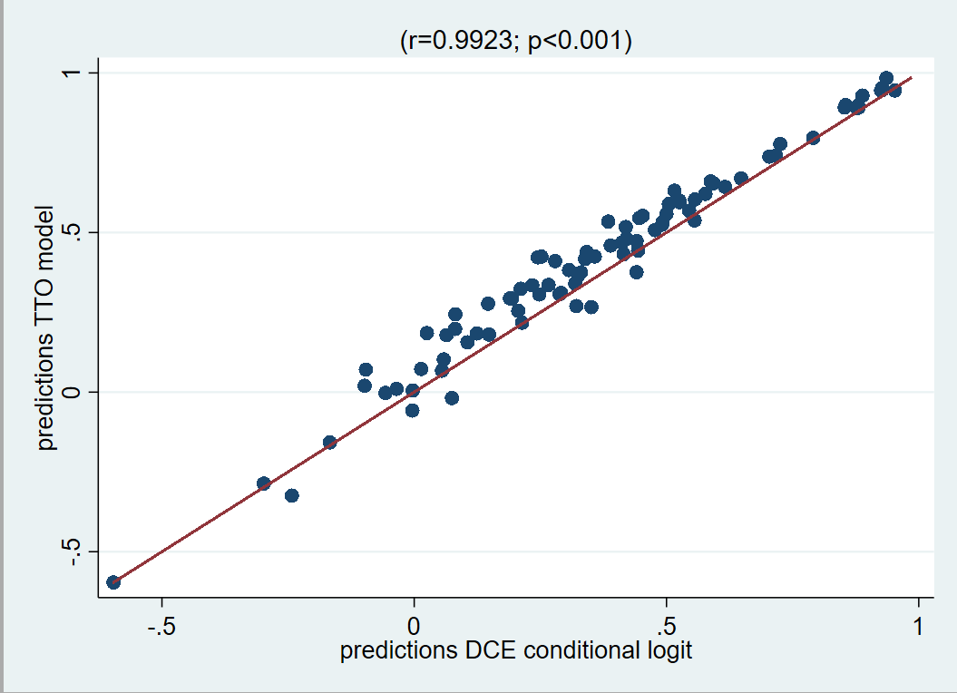

Regiones Socioeconómicas de México, INEGI, http://sc.inegi.gob.mx/niveles/datosnbi/reg_soc_mexico.pdf pp. 14-24
Niveles Socioeconómicos AMAI: http://nse.amai.org/niveles-socio-economicos/
Sandor, Z. and Wedel, M., 2001. Designing Conjoint Choice Experiments Using Managers’ Prior Beliefs. Journal of Marketing Research, 38, pp.430-444.
Bliemer, M.C.J., Rose, J.M. and Hess, S., 2008. Approximation of Bayesian efficiency in experimental choice designs. Journal of Choice Modelling, 1(1), pp.98-126.
Oppe, M. and van Hout, B. 2017. The “power” of eliciting EQ-5D-5L values: the experimental design of the EQ-VT. EuroQol Working Paper. Rotterdam: EuroQol.
McFadden, D. 1973. Conditionallogit analvsis of qualitative choice behavior. In: Zarernbka, P. (ed.), Frontiers in Econometrics. New York: Wiley.
Hauber, B., Gonzalez, J., Groothuis-Oudshoorn, C., Prior, T., Marshall, D., Cunningham, C., et al., 2016. Statistical methods for the analysis of discrete choice experiments: a report of the ISPOR conjoint analysis good research practice task force. Value in Health, 19, pp.300-315.
Roudijk, B., Donders, A.R.T., and Stalmeier, P.F.M., 2019. Cultural Values: Can They Explain Differences in Health Utilities between Countries? Medical Decision Making, Available at: https://doi.org/10.1177/0272989X19841587
Abel Olsen, J., Lamu, A.N. and Cairns, J., 2018. In search of a common currency: A comparison of seven EQ‐5D‐5L value sets. Health Economics, 27(1), pp.39-49.

