IQVIA AG, Branch Basel and SIMUL8 Corporation Ltd.
ENTIMOS infusion chair queuing model implementation in SIMUL8
The ENTIMOS implementation team
Version 2.0
4-26-2021

Contents
Project Objectives 3
Purpose of this document 3
The ENTIMOS model 4
Model structure 4
Payer approval workup period and pre-infusion activities, and arrivals 4
Intravenous Pre-treatment 7
Infusion & Monitoring 7
IRR handling 8
Recovery and monitoring and patient discharge 8
Patient retention in system 9
Model assumptions 9
Omission of pharmacists and neurologists 9
Staffing and staff pooling 10
Handling of do not attends (DNAs) / Were not brought (WAB) to appointments 12
Handling of non-MS patients 12
Pre-Treatment 12
Warm-up period 12
Programming considerations 13
Input parameters 14
Data sources 14
Treatment-specific parameters 14
Posology summary 14
IRR rates and distribution of patients across IRR handling procedures 16
Center-specific parameters 18
Resources and patient distribution 18
Scheduling 22
Activity timings 23
Cost parameters 24
Drug cost 25
Treatment adjunctive cost 27
Staff cost 30
Interventions 33
System compromise 33
System equilibrium 33
Built in corrective actions 33
Automated corrective actions 33
Outputs 34
References 37
Appendix 38
Appendix I: User interface and summary of customizable model parameters 38
Appendix II: Treatment specific settings 39
Appendix III: Site specific settings 41
Appendix IV: Catalogue of SIMUL8 sheets 43

Project Objectives

On behalf of Novartis, IQVIA is conducting a TIMIOS, a time and motion study to compare the time and resource utilization spent on administering Ocrevus (Ocrelizumab, Roche) and Ofatumumab (Novartis) with in patients with relapsing forms of multiple sclerosis (RMS).
In parallel, IQVIA and SIMUL8 are co-developing the ENTIMOS model, which allows users to simulate the time and resource utilization associated with three intravenously (IV)-administered disease modifying treatments (DMTs) for multiple sclerosis (MS): Ocrelizumab, Tysabri (Natalizumab), and Lemtrada (Alemtuzumab). ENTIMOS also permits the simulation of scenarios wherein either a proportion of the patients are shifted out of the infusion center or where the resource mix (infusion chairs or staffing) is changed. As ENTIMOS is built ahead of the TIMIOS readout, we used qualitative evaluations during the site selection phase to create the baseline process flow framework that describes how IV DMTs for MS are administered in various infusion center types in geographies of interest (US, UK and Australia). In a final phase, the data collected during the Time and Motion study will be used to refine the structure and parameters used in the ENTIMOS model.

Purpose of this document

This document describes the structure of the ENTIMOS model and the parameters included in it. It also describes assumptions made, where necessary. In addition, it contains information that familiarizes the user how the model can be used, including a catalogue of the available tables and figures for the presentation of model results.

The ENTIMOS model

The ENTIMOS model was created to capture process flow variations in different types of infusion centers that treat MS patients in the geographies of interest. In particular, data was collected from the following types of centers:
- Centers that provided infusions to MS patients only
- Centers that provided infusions to MS and other neurology patients
- Centers that provided infusions to MS and oncology patients (e.g., infusion centers in general hospitals)

Given that a degree of variation across infusion centers can be expected, we have created a model that combines common elements across the process flows in infusion centers with both conditional statements (i.e., if-else/case-type constructs), SIMUL8 labels, and user customization options

Model structure

Figure 1 summarizes the model structure, including elements of the process flow model that have an expanded component. The model includes the following main blocks of activity:

Payer approval workup period and pre-infusion activities, and arrivals

Payer approval for first-time patients
MS patients given a prescription for their first MS DMT infusion, or that are shifting to another MS DMT, would have to first get payer approval before they can proceed with appointment scheduling. Payer approval time varies across countries and across different health insurance providers and is known to be in the order of weeks. It is one of the parameters that users can specify in the model. Together with any waiting period in a given infusion center (please see Arrivals) the payer approval time defines the time from prescription to the time of first infusion.

Workup period and pre-infusion activities
The pre-infusion workup period consists of laboratory tests and vital signs checks that are conducted prior to the administration of both MS and non-MS DMTs. While the step is not explicitly modeled for time utilization, it is included as a separate step in order to account for any infusion chair utilization. In particular, users can specify whether the pre-infusion workup is performed outside the clinic, in the waiting room, or while a patient is seated in an infusion chair (see Center Settings as indicated in the Appendix). In all cases, it is assumed that workup for majority of patients is successful, with centers indicating that a failure in the workup occurs very rarely.

In addition to the lab tests and vital signs checks, other steps that may be conducted prior to check-in and infusion include patient screening and the administration of additional oral pre-treatment (Conte et al. 2019) apart from the infused pre-treatment recommended in the summary of product characteristics (SmPC). Additional oral pre-treatment allows the model to account for protocols used in selected centers to reduce the occurrence of IRRs.

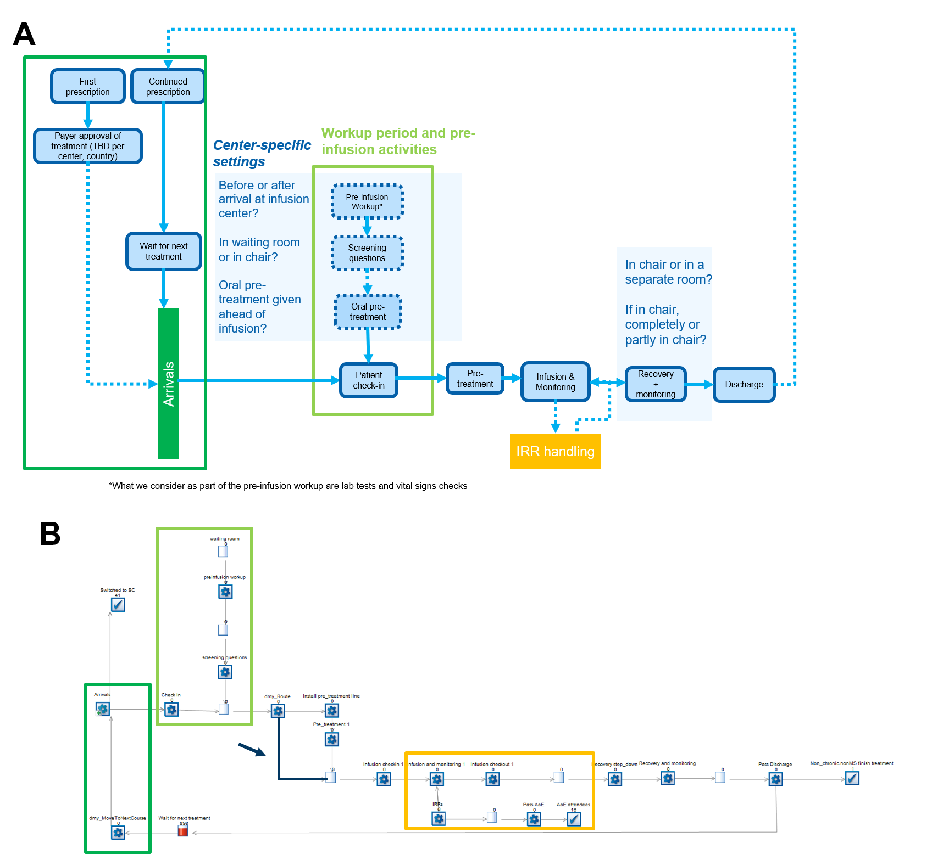
Figure 1 shows the conceptual structure of the process flow model (A), together with the actual flow used in SIMUL8 (B). Details for both arrivals, where posology is taken into account (dark green), as well as IRR handling (orange) are shown in the next sections in Figures 2 and 3. The path highlighted in blue in panel B (shown with an arrow) allows for pathways where pre-treatment is selectively required, as the case it with Alemtuzumab.

Arrivals
Once payer approval is received (for first time patients), or when a patient has concluded a round of infusion without any severe infusion related reactions handling (IRR, please see section IRRs handling), the patient’s next appointment is scheduled according to two generalized scheduling algorithms:
- Scheduling mode 1: scheduling organized to waiting time in queue / first-come, first-served

Some centers have also indicated that they frequently implement a first-come, first served scheduling policy, and we have provided this as an option in the model through scheduling mode 1. In this particular implementation, patients that have been waiting the longest for an appointment are prioritized.

- Scheduling mode 2: scheduling organized according to appointment length
Centers have reported that long infusions (6 – 8 hours, including Ocrelizumab) are automatically provided with the earliest slots available that fits the recommended posology of the DMT. This mode may result in suboptimal scheduling (i.e., chairs are not necessarily used to maximum capacity).

Whenever a patient is assigned a slot, the amount of time reserved for the patient consists of the maximum time that a patient is expected to spend on a chair. For example, if pre-treatment takes as much as 30 minutes, the infusion is expected to take maximum two hours, IRR handling takes another hour, and recovery and monitoring takes 30 minutes, then the chair is blocked for four hours even if the infusion might actually be at least an hour less if an IRR does not occur. Regardless of the scheduling mode, a patient has to wait for the first available slot in a given center, potentially adding to the waiting time from prescription to first infusion; inefficiencies in scheduling, in-center delays due to resource constraints, and unexpected events, as well as patients who do not attend (DNAs) their scheduled appointment at short notice (please see section on DNAs), will influence how much longer this waiting time will be.

On the day of arrival, the patient checks-in in the infusion center. In some cases, the patient may have completed the activities in the workup period. However, part of the workup period and pre-infusion activities may still be conducted in the center or while the patient is seated in the chair.

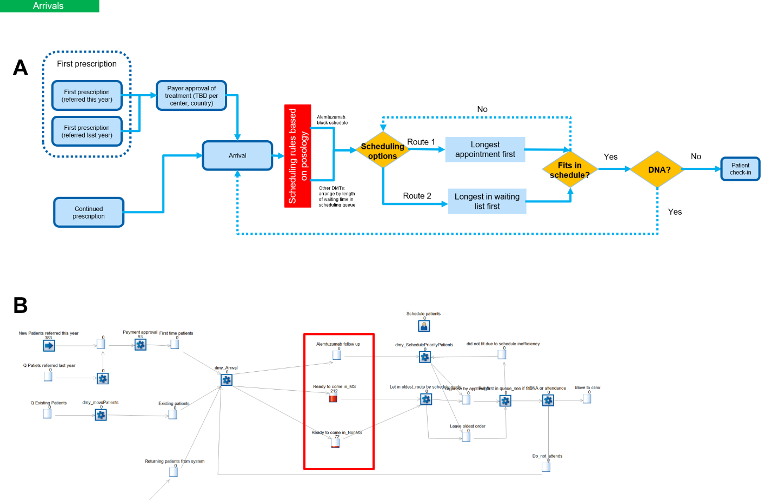
Figure 2 illustrates the organization of factors taken into consideration for programming arrivals (A), together with the actual flow used in SIMUL8 (B). Note that payer approvals for patients who have received a prescription for the first time are coded in this section, together with the two scheduling options (longest appointment first or longest in queue first), as well as the handling of DNAs, are modelled in this section.

Intravenous Pre-treatment
All MS DMTs considered in the model require the administration of pre-treatment almost universally with IV-administered anti-inflammatory drugs. According to the SmPC recommendations, these are administered on the same day as the MS DMT, with the exception of additional oral pre-treatment in more recent protocols (Conte et al. 2019). The full intravenous pre-treatment step is conducted in an infusion chair, with a setup phase that involves the attachment of the infusion line, assumed to completely occupy nurse time.

Infusion & Monitoring
Following intravenous pre-treatment and flushing of the infusion line, the MS DMTs are administered; typically, the flow rate of administration is either provided in the SmPC or in a center’s standard operating procedures (for example, the Mellen Center’s guide to Ocrevus administration).The infusion chair is occupied during the whole MS DMT administration process.

IRR handling
IRRs occur in reaction to components of the administered drug, resulting in a variety of symptoms (chills, fever, nausea, flushing, etc.). Depending on the type and severity of IRRs, recommendations are made to either stop the treatment immediately or to resolve the IRR by slowing down the infusion with or without administering additional symptomatic treatment (Figure 3). Under Route 1 of IRR handling (Figure 3A), a distinction is made between the variants (slowdown only / slowdown and administration of symptomatic medication).

Recovery and monitoring and patient discharge
Following infusion, a patient is monitored over a prescribed period that varies across DMTs. As centers may have different ways of handling recovery and monitoring, we have provided the option for a user to define whether recovery occurs while the patient is seated in the IV chair, partly in the IV chair, or in a recovery room. If recovery partly occurs in the IV chair, the user will be eventually asked to define the proportion of time that recovery is spent in the IV chair versus the time spent elsewhere.
After a patient has successfully completed the programmed treatment of the day, the patient is automatically put in the queue for scheduling their next appointment.

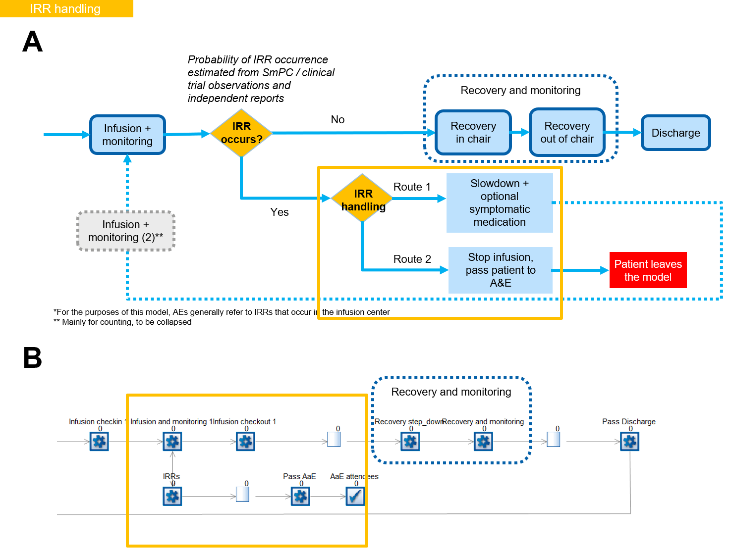
Figure 3. shows the conceptual structure of IRR handling (A), together with the actual flow used in SIMUL8 (B).

Patient retention in system
Given that the main interest is a chronic disease, all patients are assumed to remain in the system. Treatment switch across DMTs represented in the model (ocrelizumab, natalizumab and alemtuzumab) as well as mortality are not captured in the model. Only patients that experience a severe infusion related reaction (IRR), which requires DMT administration to be stopped, are removed from the system. However, the model includes scenarios with pre-defined interventions, which allow shifting a proportion of new or existing patients to non-IV MS DMTs (see section Interventions).

Model assumptions

The principal assumptions that are used to simplify model coding are defined for key topics in this section.

Omission of pharmacists and neurologists
We have omitted pharmacists and neurologists due to the limited amount of time that they spend on DMT preparation and with the patients, respectively.
MS DMT preparation involves only dilution of the drug in all three cases, which does not take more than 5 minutes per preparation. Both premedication, as well as the medication used to resolve infusion related reactions (IRRs), are either preloaded into an automated medication dispensing system or available in ready-to-use vials.
Neurologists’ involvement is limited to confirming readouts of blood test results in a step that is either conducted ahead of the infusion (i.e., a patient is scheduled for infusion if the blood tests are normal) or very early on into the infusion. Neurologists may also be involved in case there is an IRR that could not be resolved according to an infusion’s standard operating procedures; on average, it takes 5 minutes to get the response from the neurologist on IRR handling. In the UK, there are no dedicated neurologists staffed to infusion centers, and IRRs are handled using standard operating procedures (SOP) or referred to A&E when necessary.

Staffing and staff pooling
Given the omission of pharmacists and neurologists, the model only currently considers two kinds of staff: staff nurses (i.e., full-time or part-time nurses employed by the infusion center) and agency nurses / bank nurses.
There are two ways by which one can use staff resource constraints to the model:
- Option 1: Delineate individual steps where staff are required to be with the patient for the duration of the step
- Option 2: Use a pool of nurse hours from which time is used based on the number of hours that each nurse spends on average for actively managing each patient

Given that option 1 is likely to require a very complex, albeit linear model where additional steps are only necessitated to constrain staff (and not other resources), we have implemented option 2 instead. Briefly, the total pool of nurse hours (e.g. per week) is calculated based on the following user inputs are calculated:

$Total Hours={Time}_{Patient_care}*{((N}_{Fulltime}*{Contracted_Hours}_{Fulltime}$)+${(N}_{Part-time}*{Contracted_Hours}_{Part-Time}$))

These hours are depleted according to the following formula:

$$Remaining Hours=Total Hours- \sum_{i=1}^{n}{{Time, Patient}_{i}}, where$$

$$Time, {Patient}_{i}= \sum_{j=1}^{n}{{Activity}_{j}}*{Time}_{Nurse}$$

$Time$_{Patient_care} is obtained from user-entered parameter that defines the percentage of time that a nurse spends on patient case, while Time_{Nurse} is likewise a user-entered parameter that defines the percentage of an activity where the nurse must be actively involved (Figure 4). The descriptions for the quantities used in these formulas are provided in Table 1.

s. Description of parameters in nurse hour depletion formula
Label | Description
Time_{Patient_care} | Value from 0..1, representing the % of time that a nurse spends with the patient (as opposed time used for administrative tasks). This value can be assigned by the user (see Figure 4A).
N_{Fulltime,} N_{Parttime} | Number of nurses contracted on full- or part-time bases
Contracted_Hours_{Fulltime,} Contracted_Hours_{Part-time,} | Number of hours per week for which full-time or part-time staff are contracted
Time_{Nurse} | Value from 0..1, representing the % of time that a nurse spends on a given activity / task. This value can be assigned by the user (see Figure 4B).

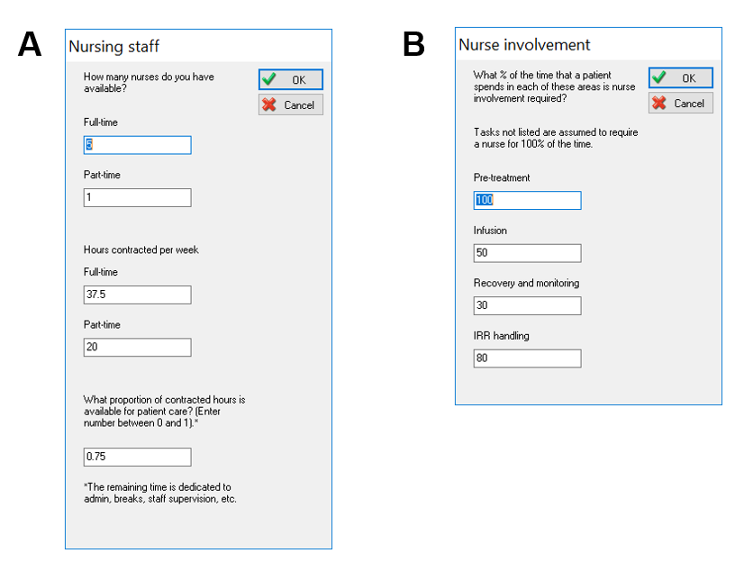
Figure 4. Dialogue boxes to obtain user input required for estimating the total available hours of nursing time which can be spent on direct patient care (A) and the expected amount of time spent by a nurse with the patient per activity (B).If an unexpected event, e.g., and IRR, occurs, then more time will be depleted from the total available hours of nursing time.

This form of staff pooling allows us to realistically simulate the scenario where the nurse checks regularly on (multiple) patients over an infusion, without having to explicitly define the different check points as discrete steps in the model.
When the number of incoming patients and their required nursing time surpasses the hours available from the staffing pool, it is currently assumed that extra hours are taken over by agency nurses, who have a higher billing rate than staff nurses. The staff pooling implementation may be revisited, should staff constraints need to be modeled more explicitly, i.e., tying activity to discrete steps in a process.

Handling of do not attends (DNAs) / Were not brought (WAB) to appointments
From the qualitative evaluations that we have conducted, DNAs / WABs may be as high as 15% of scheduled patients per week, and consequently non-negligible. In a simulation where the percentage of DNAs/WABs > 0, it is assumed that the infusion chair is blocked for the duration of the originally scheduled appointment and cannot be used. We will not consider cancellations made enough in advance under DNAs / WABs. Users can specify the rate of DNAs / WABs for their site under the Center Settings dialogue box (please see Figure 1A). We also have not added in same day add-on appointments, which may be added, should the need for it arise.

Handling of non-MS patients
Following qualitative interviews in a subset of sites, we were able to obtain the list of non-MS-specific DMTs that are typically administered in the same centers. For all these DMTs, the process flow for administration are sufficiently similar to the MS DMTs, and as such could be handled using the same pathway, but with different parameters.
Users will be encouraged to simulate different scenarios to approximate situations were centers have different predominant non-MS populations. Specifically, users can still change the MS:non-MS patient ratio, the cost range associated with the DMTs for the specific non-MS population being covered, as well as the time range that the nurse spends with the patient.

Pre-Treatment
Since most MS and non-MS treatments share the same recommended drugs for pre-treatment, the model assumes, that all MS and non-MS patients receive the same pre-treatment.

Warm-up period
Warm-up period is a period of time before time 0, when the model is running but its results are discarded. During the warm-up period patients are loaded to the model and their appointments are evenly distributed across time, building a realistic waiting time of patients at time 0. Warm-up period is running for 24 weeks, only with baseline characteristics and existing patients.
At the start of the warm-up period patients are loaded into the model as defined in the input sheet split by medication (see section Resources and patient distribution) and the type of their next due infusion (1st, 2nd or succeeding infusion). The date of next appointment is estimated by sampling a random number from a range of waiting time (where the minimum is 0 days and maximum is the time interval between subsequent infusion according to a given drug’s posology).
For non-MS patient group, appointment sampling does not follow a specific posology, because of the diversity of non-MS patient types. The next appointment is estimated by first sampling the expected number of visits per year and, assuming the time between treatments to remain constant, sampling the time between time 0 and the next treatment.
The waiting time until the next appointment described above represents the assumed time at which a patient is ready for their first treatment in the simulation. However, because of the random sampling on certain days there will be no arrivals and multiple on others. Over time, this randomness is smoothed out. If the appointment of too many patients fall to one day and none to another day, some patients are delayed by a day, meaning that their following treatments will also be delayed by that day (if posology is strictly observed), resulting in patients arriving distributed more evenly across both days.

Programming considerations

The main intended use of the model is to be able to simulate effects of changing the following assumptions on waiting times, resource utilization, and costs:
- Patient mix, principally on IV vs. switched out of the infusion centre
- Resources
  - Number of nurses
  - Number of chairs
In addition to these parameters, users can adjust other features, including, but not limited to the following:
- Patient mix
  - MS vs. non-MS
  - For MS patients, proportion of patients on Ocrelizumab, Natalizumab and Alemtuzumab
- Center-specific treatment pathway
  - Pre-infusion workup done outside clinic, in waiting room, or (partly) in infusion chair
  - Additional oral pre-treatment administered (Y/N), which would impact the IRR rate
  - Recovery and monitoring done fully or partly in infusion chair, or done fully in recovery room
- DNA rates
- Costs (fixed and variable), which are expected to vary per country
Consequently, the programming design was done to be maximally flexible to take any further customization requirements into account. The full set of customizable options are introduced in the Appendix (Figure A1).

Input parameters

Data sources

Input parameters were obtained from surveys with infusion centers, KOL interviews and published data including scientific publications and publicly available price lists or statistics on labor cost.
For the survey, an initial site screening was performed to identify the most representative sites in terms of the broadest cross-section of site types. From these sites further information on treatment pathways, hospital type and mix of patients was obtained. As indicated previously, the types of centers prioritized for the qualitative evaluation included centers that provided infusions to either MS patients only, or to MS patients and other neurology patients or to MS patients and oncology patients.
The prioritized centers were requested to complete three questionnaires per site (for site administrators, nurses and pharmacists). These questionnaires collected information on site logistics, arrivals and scheduling policy, as well as the processes conducted on the site. Of the centers invited to participate in qualitative evaluations, six US sites provided responses to the administrator, nurse and / or pharmacist questionnaire
A KOL interview (Dr. Richard Nicholas) was conducted to verify whether a similar process flow applies in the UK.
Additionally, a targeted literature review was performed to identify relevant scientific publications and information on drug posology and prices, material prices and labor cost.

Treatment-specific parameters

Posology summary
Information on the posology of each of the DMTs were obtained from their respective SmPCs (Table 2). Additionally, information on the min / max duration were calculated from the recommended administration rates and the dose that needs to be administered per patient in a day. Note that for non-MS DMTs, we used the minimum and maximum reported infusion durations reported in Table 3 to create a generalized infusion duration for the whole DMT class.

Table 2. Posology and expected duration of infusion for MS and non-MS DMTs.
DMT / Dose | Duration (per infusion, hours) |  | Total dose administered (mg/day) | Dose equivalents | # Consecutive infusion days | # pre-treatment days | Interval to next infusion (weeks)
 | Min | Max
Ocrevus
Initial Dose: Infusion 1 of 2* | 2.5 | 4 | 300 | 1 | 1 | 1 | 2
Initial Dose: Infusion 2 of 2 | 2.5 | 4 | 300 | 1 | 1 | 1 | 24
Subsequent Doses (One infusion every 6 months)* | 3.5 | 5 | 600 | 2 | 1 | 1 | 24
Natalizumab
Once every four weeks | 1 | 2 | 300 | 1 | 1 | 1 | 4
Alemtuzumab
Initial dose (five consecutive infusions)** | 4 | 8 | 12 | 1 | 5 | 3 | 52
Maintenance, Year 1 (3 consecutive infusions) | 4 | 8 | 12 | 1 | 3 | 3 | 52
Maintenance, after Year 1, if needed (3 consecutive infusions) | 4 | 8 | 12 | 1 | 3 | 3 | 52
Non-MS DMT settings***
Initial dose (also assume two infusions) | 2 | 6 | Not specified; assumed to be the same for all non-MS DMTs | 1
Succeeding doses | 2 | 6 | Not specified; assumed to be the same for all non-MS DMTs | 1
* The recent approval of a two hour administration protocol for Ocrevus will be covered as a simulation scenario, rather than coded as a default parameter
** For Alemtuzumab, the maximum was also based on the caveat that the infusion cannot take more than 8 hours
*** Covers the range for majority of the expected administration duration for non-MS DMTs indicated in Table 3, as well as those studied in other time and motion studies that include oncology patients such as in De Cock et al. 2016 and in Schwartzberg et al. 2019.
Table 3. Posology and administration details of top non-MS DMTs
DMT /Posology | Duration (per infusion, hours
 | Min | Max
Rituximab (Rituxan/Mab-Thera)
Initial dose:  2 infusions (sep. 2 weeks) | 4 | 6
Maintenance:  min 24 weeks after | 2 | 4
Infliximab (Remicade)
Initial dose:  Crohn’s:  2 IV infusions (week 1, 2-6)  RA, UC, PsA, Pso:  3 IV infusions (week 1, 2, 6) | 2 | 2
Maintenance: either at reoccurrence of disease or every 8 weeks | 2 | 2
IVIg
Maintenance: 3 – 4 weeks | 3 | 4

IRR rates and distribution of patients across IRR handling procedures
IRR rates are based on indications on the SmPC or from literature, including results of clinical trials for the DMTs, and are indicated under the source column in Table 4 and in Table 5 for non-MS DMTs. For non-MS DMTs generalized values for the entire treatment class were used as model inputs. The maximum IRR rate is assumed for the first infusion and will be less for succeeding infusions. IRR handling has been generalized to three modes: stop, slowdown infusion or slowdown with symptomatic treatment.

Table 4. IRR rates for MS DMTs
DMT | IRR rate, first infusion | IRR rate, succeeding infusions | Source
Ocrelizumab | 34.3% to 39.9% in clinical trials; 25% reported in clinics | 10% or less | Mayer et al. 2019 (OPERA and ORATORIO studies)  Cleveland Clinic Mellen Center FAQs
Natalizumab | Not reported directly, but higher incidence is known to occur at 2nd infusion; assumed < 2% | 2-4% | O’Connor et al. 2014 (STRATA study)  Cleveland Clinic Mellen Center FAQs
Alemtuzumab | 71% to 90% without pre-medication | 63 – 69% | Havrdova et al. 2015  Perry (ed) 2007.

Table 5. IRR rates for non-MS DMTs
DMT | IRR rate, first infusion | IRR rate, succeeding infusions | Source
Generalized IRR rates for non-MS DMT class | 17.2% | 14.3%
Rituximab (Rituxan/Mab-Thera) | 23% | 12% | MabThera SmPC
Infliximab  (Remicade) | 18% | 9% | Remicade SmPC
IVIg | 2.5%* | 87.5% | Guo et al. 2018.

Center-specific parameters

Resources and patient distribution
For the UK, the default center-specific settings for the number of patients and available resources are based on Charing Cross numbers (see Table 6 and Table 7 respectively). The DNA rate at Charing Cross is 2%. Payer approval time is currently assumed to be a minimum of 4 weeks to a maximum of 20 weeks.

Table 6. UK center distribution of MS and non-MS patients
Parameter Group | Parameter | Value (%) | Relevant notes or assumptions
Patient counts | Total no. of MS patients in care | 860 (83%)
 | Total no. of non-MS patients in care | 170 (17%)
Patient distribution by DMT | MS patients on Ocrelizumab | 552 (64%)
 | MS patients on Natalizumab | 308 (36%)
 | MS patients on Alemtuzumab | 0 (0%)
New patients per week | Average number of new MS patients per week | 7 | The number of new patients per week is expected to increase over time. For instance, if DMTs are approved for patients with primary progressive MS (PPMS), there can be as much as a 15% increase in demand for infusion services
 | New patients on Ocrelizumab | 6 (86%)
 | New patients on Natalizumab | 1 (14%)
 | New patients on Alemtuzumab | 0 (0%)

Table 7. UK staffing and resource-related parameters
Parameter Group | Parameter | Value | Relevant notes or assumptions
Resources
 | Total no. of beds and chairs per facility | 12
Nurse counts | Number of full-time nurses | 10
 | Number of part-time nurses | 0
Nurse shifts | Shift duration | 37.5 hours / week

For the US, default center specific inputs were based on values from the Oklahoma Medical Research Foundation (OMRF) MS Center of Excellence for patient number (see Table 8) and resources (see Table 9). OMRF is a center that handles both MS and non-MS patients. Payer approval time is currently assumed to be a minimum of 1 weeks to a maximum of 10 weeks.

Table 8. US center distribution of MS and non-MS patients
Parameter Group | Parameter | Value (%) | Relevant notes or assumptions
Patient counts | Total no. of MS patients in care | 435 (94%)
 | Total no. of non-MS patients in care | 27 (6%)
Patient distribution by DMT | MS patients on Ocrelizumab | 350 (81%)
 | MS patients on Natalizumab | 75 (17%)
 | MS patients on Alemtuzumab | 10 (2%)
New patients per week | Average number of new MS patients per week | 3
 | New patients on Ocrelizumab | 2 (66%)
 | New patients on Natalizumab | 1 (33%)
 | New patients on Alemtuzumab | 0 (0%)
DNAs | DNA rate | 2%

Table 9. US staffing and resource-related parameters
Parameter Group | Parameter | Value | Relevant notes or assumptions
Resources
 | Total no. of beds and chairs per facility | 11
Nurse counts | Number of full-time nurses | 2
 | Number of part-time nurses | 0
Nurse shifts | Shift duration | 40 hours / week
 | Time available for direct patient care | 75%

For Australia, the Gloucester House Infusion Center served as reference for the default values for patient numbers and resources (see Table 10 and Table 11). For Australia, natalizumab was treated separately in a dedicated center patient number and resource inputs are presented in Table 12 and Table 13.

Table 10. Australian center distribution of MS and non-MS patients
Parameter Group | Parameter | Value (%)
Patient counts | Total no. of MS patients in care | 155 (58%)
 | Total no. of non-MS patients in care | 110 (42%)
Patient distribution by DMT | MS patients on Ocrelizumab | 150 (97%)
 | MS patients on Natalizumab | 1 (1%)
 | MS patients on Alemtuzumab | 4 (3%)
New patients per week | Average number of new MS patients per week | 2
 | New patients on Ocrelizumab | 2 (100%)
 | New patients on Natalizumab | 0 (0%)
 | New patients on Alemtuzumab | 0 (0%)

Table 11. Australia staffing and resource-related parameters
Parameter Group | Parameter | Value | Relevant notes or assumptions
Resources
 | Total no. of beds and chairs per facility | 25
Nurse counts | Number of full-time nurses | 1
 | Number of part-time nurses | 5
Nurse shifts | Shift duration | 40 hours / week

Table 12. Australia natalizumab center distribution of MS and non-MS patients
Parameter Group | Parameter | Value (%)
Patient counts | Total no. of MS patients in care | 100 (100%)
 | Total no. of non-MS patients in care | 0 (0%)
Patient distribution by DMT | MS patients on Ocrelizumab | 0 (0%)
 | MS patients on Natalizumab | 100 (100%)
 | MS patients on Alemtuzumab | 0 (0%)
New patients per week | Average number of new MS patients per week | 1
 | New patients on Ocrelizumab | 0 (0%)
 | New patients on Natalizumab | 1 (100%)
 | New patients on Alemtuzumab | 0 (0%)

Table 13. Australia natalizumab center inputs for staffing and resource-related parameters
Parameter Group | Parameter | Value | Relevant notes or assumptions
Resources
 | Total no. of beds and chairs per facility | 5
Nurse counts | Number of full-time nurses | 1
 | Number of part-time nurses | 0
Nurse shifts | Shift duration | 40 hours / week

Treatment pathways
In the US, the settings describing the treatment pathway of an average patient are presented in Table 14.

Table 14. US Center treatment pathway settings
Pathway segment | Setting
Pre-infusion workup setting | Outside clinic
Oral pre-treatment | No
Infusion recovery setting | Fully in IV chair

Scheduling
The refence center for the UK, Charing Cross, operates 12 hours a day detailed opening times are provided in Table 15. Long infusions (e.g., ocrelizumab and alemtuzumab) are booked to start at 8:00 AM. Additionally, there is an added restriction for Natalizumab that only three slots per day may be booked per chair.
In the US, the reference center OMRF operates 7.5 hours a day, detailed opening times are provided in Table 16. Ocrelizumab patients must start their appointment before 09:00 and other patients start until 14:00.
In Australia, the general infusion center operates 8.75 hours per day and the dedicated natalizumab center 8.5 hours per day. Detailed opening time are provided in Table 17. Ocrelizumab and alemtuzumab patients start at 09:00 all other patients before 10.00. In the natalizumab center no appointments are scheduled after 14.00.

Table 15. UK Center Opening Times
Day | Opening Times
 | Open | Close
Monday to Friday | 08:00 | 20:00
Saturday to Sunday | Closed

Table 16. US Center Opening Times
Day | Opening Times
 | Open | Close
Monday to Friday | 08:30 | 16:00
Saturday to Sunday | Closed

Table 17. Australian Center Opening Times
Day | Opening Times
 | Open | Close
General Infusion Center
Monday to Friday | 08:00 | 16:45
Saturday to Sunday | Closed
Natalizumab Infusion center
Monday to Wednesday | 08:00 |  | 16:30
Thursday (every 2nd) | 08:00 |  | 16:30
Friday to Sunday | Closed

Activity timings
For each of the processes included in the model, default timings in Table 18 were used. These values are based on responses provided in the qualitative evaluation, by a KOL, or on literature, unless indicated that it is an assumed value under the notes column.

Table 18. Default activity timings used in the model
Activity | Time | unit | Time on chair? (Y/N) | Default nurse involvement (%)
Payer approval of treatment | 1-10 | weeks | N | N/A
Patient check-in | 3 | mins | N | 100%
Screening questions | 3 | mins | Y/N* | 100%
Pre-infusion Workup | 30 | mins | Y/N* | N/A
Pre-treatment |  |  | Y | 100%
- Install pre-treatment line | 8 | mins |  | 100%
- Pre-treatment |  |  |  | 100%
Ocrelizumab, natalizumab and non-MS DMTs | 30 | mins
Alemtuzumab | 45 | mins
- Uninstall pre-treatment line | 7 | mins |  | 100%
Delay between pre-treatment and infusion (ocrelizumab)
- 1st pre-treatment | 60 | mins | Y | 0%
- 2nd pre-treatment | 30 | mins | Y | 0%
Infusion and monitoring | See Table 2 |  | Y | 50%
- Start infusion | See Table 2
- Monitoring | See Table 2
- End infusion | See Table 2
IRR handling | 30-60 | mins | Y | 100%
Recovery and monitoring: |  |  | Y/N*
Ocrelizumab, natalizumab and non-MS DMTs | 60 | mins |  | 30%
Alemtuzumab | 120 | mins |  | 30%
Discharge | 10 | mins | N | 100%

Cost parameters
In the current version of the model, triangular distribution for parameters are allowed for DMT costs, IRR handling costs, and staff costs.

Drug cost
Cost estimates that are used for ENTIMOS are summarized in Table 19 for the UK, in Table 20 for the US and in Table 21 for Australia. If not provided by Novartis directly, sites from which cost estimates were obtained are indicated under the source column.
Non-MS DMT cost, specifically the most commonly used value, are based on information available from the default center or based on publicly available information on cost distributions.

Table 19. UK treatment cost estimates for MS and non-MS DMTs
DMT | Cost per dose or unit* |  |  | Source
 | Min | Most commonly used | Max
Ocrelizumab | £ 4,790.00 | £ 4,790.00 | £ 4,790.00 | BNF
Natalizumab | £ 1,130.00 | £ 1,130.00 | £ 1,130.00 | BNF
Alemtuzumab | £ 7,045.00 | £ 7,045.00 | £ 7,045.00 | BNF
Non-MS DMTs | £ 1,096.00 | £ 4,672.00 | £ 5,606.40 | Min: Rituximab assuming 1.82 m² body surface are, 375 mg/m², generic price (Sources: MabThera SmPC, BNF)  Most commonly used:  IVIg assuming 73 kg, 2g/kg, £32 per gram, Source: Patel et al. 2014)  Max: Same cost as for most commonly used adding a 20% margin  Treatments are based on most common non-MS treatments at Charing Cross: IVIg (73% of non-MS patients), Infliximab (18% of non-MS patients) and Rituximab (9% of non-MS patients).

Table 20. US treatment cost estimates for MS and non-MS DMTs
DMT | Cost per dose or unit* |  |  | Source
 | Min | Most commonly used value | Max
Ocrelizumab | $61,509.50 | $63,706.25 | $65,903.00 | Provided by NVS
Natalizumab | $6,016.46 | $6,443.58 | $6,870.69 | Provided by NVS
Alemtuzumab | $20,749.80 | $ 22,422.90 | $24,096.00 | Provided by NVS
Non-MS DMTs | $1,506.83 | $3,642.34 | $7,884.00 | Estimated costs per year:  Rituximab: $33,409  Infliximab: $40,874  Source: Schmier et al. 2017  IVIg:  Mean: $23,271  Median: $18,082  Max: $47,304  Assuming that initiation includes 3 doses, plus 3 - 9 doses for the rest of the year.  Costs per dose per unit are estimated by dividing annual costs by 6 infusions / year, which is assumed to be the most frequent number of infusions.  The top three non-MS DMTs administered at OMRF, the US reference center are abatacept, infliximab and rituximab.

Table 21. Australian treatment cost estimates for MS and non-MS DMTs
DMT | Cost per dose or unit* |  |  | Source
 | Min | Most commonly used value | Max
Ocrelizumab** | AU$ 17,533.00 | AU$ 17,556.70 | AU$ 17,580.39 | http://www.pbs.gov.au/
Natalizumab | AU$ 1,340.68 | AU$1,364.38 | AU$1,388.07 | http://www.pbs.gov.au/
Alemtuzumab | AU$ 10,824.30 | AU$ 10,829.04 | AU$ 10,833.78 | http://www.pbs.gov.au/
Non-MS DMTs | AU$ 320.71 | AU$ 331.00 | AU$ 8497.05 | http://www.pbs.gov.au/  Infliximab, currently assumed to be the most commonly used non-MS DMT  Min AU$ 320.71 / 100 mg  Mode AU$ 331.00 / 100 mg  Mode AU$ 341.28 / 100 mg  https://www.blood.gov.au/national-product-list  IVIg price per gram:  Min AU$45.00  Mode AU$45.00  Max AU$58.20  Dosing is estimated from Patel et al. 2014 (2 grams per kg; estimated for 73 kg)  The most commonly used value for Australia is subject to confirmation by the Australian Novartis affiliate
** Based on Dispensed Price for Maximum Quantity (DPMQ) values published on the site

Treatment adjunctive cost
Treatment adjunctive cost includes all cost, which can be directly tied to treatment, apart from the drug cost. A summary is provided in Table 22 for the UK, in Table 23 for US and in Table 24 for Australia.

Table 22. UK treatment adjunctive cost estimates for MS and non-MS DMTs
DMT | Cost per dose or unit |  |  | Source
 | Min | Most commonly used value | Max
Infusion costs*
Infusion cost |  | £178.00 |  | 2020/21 NHS National Tariff Payment System: AA30F for Medical Care of Patients with Multiple Sclerosis, with CC Score 0-1  HRG codes sourced from NICE resource impact report TA585 (ocrelizumab)
Other costs
Infusion set (IV set, including bags and tubes) | £9.30 | £10.50 | £11.60 | Estimated from Franken et al, 2018, in the absence of published costs for the UK
Pre-medication | £4.75 | £4.75 | £4.75 | Methylprednisolone (100mg, IV) (dosing based on ocrelizumab SmPC) most common pre-treatment for treatments included in model  Source: BNF
IRR handling costs** | £0.00 | £4.80 | £89.99 | Min: no symptomatic treatment  Most common: methylprednisolone (20-40 mg, IV)  Max: epinephrine (1:1000, 0.2-0.5 ml over 2 doses)  Sources: Dosing: Namey et al. 2010, Price: BNF
* Infusion costs are assumed to be the same for MS and non-MS DMTs
** IRRs are handled either by stopping, infusion slow down, or infusion slow down and treatment with symptomatic medication. When the infusion is handled by infusion slow down, costs will be reflected as a function of a longer infusion time. On top of this, additional costs are incurred when symptomatic medication is administered.

Table 23. US treatment adjunctive cost estimates for MS and non-MS DMTs
DMT | Cost per dose or unit |  |  | Source
 | Min | Most commonly used value | Max
Infusion costs*
Infusion cost, first hour | $62.27 | $76.88 | $103.73 | CPT 96365
Infusion costs, succeeding hours | $19.66 | $23.40 | $30.56 | CPT 96366
Other costs
Infusion set (IV set, including bags and tubes)** | $39.00 | $127.00 | $233.00 | Prices used based on both estimates for MS and non-MS DMTs (e.g. Schmier et al. 2017)
Pre-medication*** | $28.92 | $76.70 | $83.15 | Prices are given per unit from a survey of websites (drugs.com, goodrx.com)
IRR handling costs^{O} | $0.00 | $6.45 | $189.20 | Prices are given per unit from a survey of websites (drugs.com, goodrx.com)
* Infusion costs are assumed to be the same for MS and non-MS DMTs
** For price estimates, we used information on the following products: IV Bag (Intravia 250 ml Medication delivery bag, Baxter), IV administration set components from Braun
*** Concomitant medication considered are pre-treatments specified in product SmPCs or dosing and administration guides, e.g., 100 mg methylprednisolone and diphenhydramine for Ocrelizumab.
^{O} IRRs are handled either by stopping, infusion slow down, or infusion slow down and treatment with symptomatic medication. When the infusion is handled by infusion slow down, costs will be reflected as a function of a longer infusion time. On top of this, additional costs are incurred when symptomatic medication is administered such as diphenhydramine (50 mg / ml, administered by IV) and / or acetaminophen ($6.45, taken as the most frequent cost), or methylprednisolone (20 – 40 mg, IV) or epinephrine (1:1000, 0.2 – 0.5 ml over 2 doses) (Namey et al. 2010). The maximum price given for IRR handling costs is based on the cost of epinephrine auto-injectors or injection ampoules OR methylprednisolone, whichever is higher. A price of $0.00 is estimated for the case when the IRR handling protocol takes the form of a slowdown in infusion. All additional costs due to the IRR in this case will be labor and opportunity costs.

Table 24. Australian treatment adjunctive cost estimates for MS and non-MS DMTs
DMT | Cost per dose or unit |  |  | Source
 | Min | Most commonly used value |  | Min
Infusion costs*
Infusion cost, first hour | To be determined | To be determined | To be determined
Infusion costs, succeeding hours | To be determined | To be determined | To be determined
Other costs
Infusion set (IV set, including bags and tubes)** | AUS$ 11.00 | AUS$ 12.25 | AUS$ 13.50 | https://www.medshop.com.au/ and North et al. 2015, which outlines costs for New Zealand
Pre-medication*** | AU$41.64 | AU$41.64 | AU$41.64 | http://www.pbs.gov.au/
IRR handling costs^{O} | AU$ 0.00 | AU$ 21.68 | AU$ 84.26 | http://www.pbs.gov.au/
* Infusion costs are assumed to be the same for MS and non-MS DMTs
** For price estimates, we used information on the following products: IV bag (Intravia 250 ml Medication delivery bag, Baxter)
*** Concomitant medication considered are pre-treatments specified in product SmPCs or dosing and administration guides, e.g., 100 mg methylprednisolone and diphenhydramine for Ocrelizumab.
^{O} IRRs are handled either by stopping, infusion slow down, or infusion slow down and treatment with symptomatic medication. When the infusion is handled by infusion slow down, costs will be reflected as a function of a longer infusion time. On top of this, additional costs are incurred when symptomatic medication is administered.

Staff cost
Staff cost estimates used in ENTIMOS are summarized in Table 25, Table 26 and Table 27 for UK, US and Australia. If not provided by Novartis directly, sites from which cost estimates were obtained are indicated under the source column.

Table 25. UK nurse salary estimates in geographies of interest
Country | Cost per hour |  |  | Source
 | Min | Most commonly used value | Max
UK, staff nurse | £ 18.70 | £ 20.05 | £ 21.40 | Source: https://www.healthcareers.nhs.uk/working-health/working-nhs/nhs-pay-and-benefits/agenda-change-pay-rates  Min: Band 7, 1-2y experience  Max: Band 7, 8+ years experience  Assumed weekly work hours: 40h
UK, agency nurse | £ 20.00 | £ 22.00 | £ 25.00 | Assumed to be between c. 10 – 20% more than the salary of the full-time nurse
Weekend / public holiday rate |  | 1.2x |  | Assumed

Table 26. US nurse salary estimates in geographies of interest
Country | Cost per hour |  |  | Source
 | Min | Most commonly used value | Max
US, staff nurse | $80.00 | $101.43 | $120.00 | From US Bureau of Labor statistics site; validated by US NVS affiliate
US, agency nurse | $100.00 | $120.00 | $140.00 | Assumed values

Table 27. Australian nurse salary estimates in geographies of interest
Country | Cost per hour |  |  | Source
 | Min | Most commonly used value | Max
Staff nurse | AU$ 24.10 | AU$ 41.60 | AU$ 55.85 | From published state-by-state nurse salary guides in Australia  Salary bands considered include both min and max salaries for nursing assistants, enrolled nurses, nurse practitioners and nurse unit manager.
Agency nurse | AU$ 24.90 | AU$ 42.15 | AU$ 58.35 | From published state-by-state nurse salary guides in Australia  Estimated from max salaries for nursing assistants, enrolled nurses, nurse practitioners and nurse unit manager.

Interventions

System compromise

With a specific number of patients and a defined capacity of the infusion suite, the simulation will reach a point, were patients will not be able to be treated according to the schedule defined in the SmPCs. System compromise is reached, when the next due appointment for an infusion (as per approved use in the SmPC) is delayed by 30 days or more. The model allows to change this default definition of system compromise directly in the user interphase

System equilibrium

Defined in opposition to system compromise as a situation where the average waiting time for the next infusion does not exceed 30 days from the time when it is due, evaluated on a monthly basis over a time horizon of up to five years.

Built in corrective actions

System compromise can be avoided by taking corrective actions, which impact the number of patients queuing for the next infusion or the through-put of the infusion center. The model includes three built in interventions or corrective actions described in Table 28. These interventions are applied on an annual basis.

Table 28. Default corrective actions
Intervention | Change | Description
Shift out new patients | Annual reduction in % | Reduces the number of new patients entering the model each week by a defined percentage
Shift out existing patients | Annual reduction in % | Reduces the number of existing patients by a defined percentage at the beginning of each year
Add infusion chairs | Number of additional chairs per year | Adds a defined number of chairs at the beginning of each year

These corrective actions can either be applied manually or automatically. Through manually changing these intervention parameters in the user interface, new scenarios can easily be defined, allowing to assess the impact of each change on excess waiting time and system compromise. 5

Automated corrective actions

When applying the automated function, the model performs an optimization, which for each intervention type (add chairs, shift out existing patients, shift out new patients; all on annual basis) determines the marginal corrective action required to maintain system equilibrium during the simulation horizon.
To identify the minimal % of new or existing patients that need be switched per year, the model employs a binary search algorithm (https://en.wikipedia.org/wiki/Binary_search_algorithm). The algorithm works by first dividing the range 0%-100% into two equal parts by selecting their mid-point (50%) as input. If system compromise was avoided by shifting out 50% of patients, the lower half of the range (0%-50%) will be halved again, and their midpoint (25%) used as input. If system compromise was not reached, the upper half will be divided in an analogous way. This process will be continued by searching for the marginal corrective action within progressively smaller ranges spanning 50%, 25%, and 12.5% of the solution space. Once the range where the solution is located has been identified with a precision of 12.5%, the algorithm continues searching adding increments of 5%, and then 1%, eventually returning the lowest percentage of patients to be switched out annually, to achieve system equilibrium over the time horizon of the simulation.
To find the minimal number of infusion chairs to be added annually, in order to achieve system equilibrium over the time horizon of the simulations, the model increases the number of chairs by one, starting from base case plus zero, until system equilibrium is reached.

Outputs
The key outputs of the ENTIMOS model cover various metrics that reflect the efficiency of an infusion center’s operations. The different outputs and their descriptions are listed in Table 29.

Table 29. List of built-in ENTIMOS model results
Summary graphs and tables
Summary results | - Summary of parameter values  - Patient waiting times  - Patient queue size  - Cumulative IV administrations  - Total nurse hours | Cross-sections of selected detailed graphs (list below) over entire simulation time
Cost results | Cost results table | Tabular comparison of the costs per DMT per scenario, at a per center and per patient basis
Detailed graphs
Patient throughput | Number of IV administrations performed | Cumulative number of IV administrations per month in one year  Note: each patient may receive more than one IV administration per year, depending on a DMT’s posology
Patient throughput | Change in expected cumulative IV administration with respect to the baseline case | The expected increase or decrease in IV administrations that can be accommodated as a consequence of the impact of each scenario on a center’s effective capacity.  Note: The baseline is, by definition, at 0 for this graph.
Patient waiting time
For appointment scheduling | Waiting time for appointment scheduling | The amount of time between a concluded appointment and the next scheduled appointment  Example: for Ocrevus patients, there is a 6 months interval between infusions. The next appointment may be 6 months +n days, based on availability of chairs.  Note: This measure is sensitive to the scheduling algorithm used
For appointment scheduling | Cumulative waiting times for scheduling (per 10 patients) | Sum of waiting times for scheduling appointment across months, reported per 10 patients
For appointment scheduling | Average waiting time from payer approval to scheduling | Is a compound measure that consists of:  - Payer approval time in a country  - Appointment scheduling time
In-center waiting times | Average monthly within-center waiting times | The amount of time between a patient’s arrival for his / her appointment and the time that the patient starts an infusion
In-center waiting times | Cumulative within-center waiting times (per 10 patients) | The total amount of time (per 10 patients) between a patient’s arrival for his / her appointment and the time that the patient starts an infusion across the simulation time period
Patient queue size | Queue size at the end of the month for all type of patients  Subgraphs include:  - Queue size at the end of the month for MS patients  - Queue size at the end of the month for non-MS patients  - Queue size at the end of the month by MS DMT (Ocrelizumab, Natalizumab and Alemtuzumab) | Number of patients (both MS and non-MS) waiting for their appointment at the end of the month  Note: each patient may receive more than one IV administration per year, depending on a DMT’s posology, and may thus be added to a queue multiple times.
Resource utilization
Staffing | Monthly average agency nurse hours per 10 patients | The amount of additional time required (per 10 patients) from agency nurses for direct patient care, on top of the current contracted hours of regular staff nurses
Staffing | Cumulative agency nurse hours needed per 10 patients | The total additional time required (per 10 patients) from agency nurses for direct patient care over a year
Chair utilization | Actual chair utilization | The percentage of time that infusion chairs are actually used, as opposed to the percentage of time for which it is reserved.  Example: if a chair is scheduled for use 7.5 hours, and it is used for 6 hours, then its actual utilization is 80%.
Chair utilization | Scheduled chair utilization | The percentage of time for which chairs are scheduled for use.  Example: if a chair is scheduled for use 7.5 out of 8 hours of operation, then its scheduled utilization is 93.8%.
Chair utilization | Opportunity of unused chair time (no. of extra possible administrations per chair) | Calculates the number of 4-hour IV infusions that can be carried out per chair based on actual chair utilization

References

Conte WL, Arndt N, Cipriani VP, and Dellaria J. 2019. Reduction in ocrelizumab-induced infusion reactions by a modified premedication protocol. Mult Scler Related Disord. 27: 397 – 399.

De Cock E, Pivot X, Hauser N, Verma S, Kritikou P, Millar D and Knoop A. 2016. A time and motion study of subcutaneous versus intravenous trastuzumab in patients with HER2-positive early breast cancer. Cancer Med. 5: 387 – 397.

Franken MG, Kanters TA, Coenen JL, de Jong P, Koene HR, Lugtenburg PJ, Jager A, and Uyl-de Groot CA. 2018. Anticancer Drugs. 29: 791 – 801.

Guo Y, Tian X, Wang X and Xiao Z. 2018. Adverse effects of immunoglobulin therapy. Front Immunol. 9: 1299.

Havrdova E, Horakova D and Kovarova I. 2015. Alemtuzumab in the treatment of multiple sclerosis: key clinical trial results and considerations for use. Ther Adv Neurol Disord. 8: 31 – 45.

Mayer L, Kappos L, Racke MK, Rammohan K, Traboulsee A, Hauser SL, Julian L, Köndgen H, Li C, Napieralski J, Zheng H and Wolinsky JS. Ocrelizumab infusion experience in patients with relapsing and primary progressive multiple sclerosis: results from the phase 3 randomized OPERA I, OPERA II, and ORATORIO studies. 2019. Mult Scler Relat Disord. 30: 236 – 243.

Namey M, Halper J, O’leary S, Beavin J and Bishop C. 2010. Best practices in multiple sclerosis: infusion reactions versus hypersensitivity associated with biologic therapies. J Infus Nurs. 33: 98 – 111.

North RT, Harvey VJ, Cox LC and Ryan SN. 2015. Medical resource utilization for administration of trastuzumab in a New Zealand oncology outpatient setting: a time and motion study. 7: 423 – 430.

O’Connor P, Goodman A, Kappos L, Lublin F, Polman C, Rudick RA, Hauswirth K, Cristiano LM, Forrestal F and Duda P. 2014. Long-term safety and effectiveness of natalizumab redosing and treatment in the STRATA MS study. Neurology. 83: 78 – 86.

Patel N, Woodall A and Gow D. 2014. Investigating the bundle compliance of IVIG delivery in the Greater Manchester Neuroscience centre. BMJ Quality Improvement Reports. u202201.w1219: 1 – 3.

Perry MC (ed). 2007. The chemotherapy source book, 4th edition. Lippincott Williams & Wilkins.

Schmier J, Ogden K, Nickman N, Halpern MT, Cifaldi M, Ganguli A, Bao Y and Garg V. 2017. Costs of providing infusion therapy for rheumatoid arthritis in a hospital-based infusion center setting. Clinical Therapeutics. 39: 1600 – 1617.

Schwartzberg L, Chatterjee D, Knoth R, Gibbs SN, Ahmed KH, Broder MS and Yermilov I. 2019. A time-and-motion study of chemotherapy administration in metastatic breast cancer. San Antonio Breast Cancer Symposium (Poster P2-15-13).

Appendix

Appendix I: User interface and summary of customizable model parameters

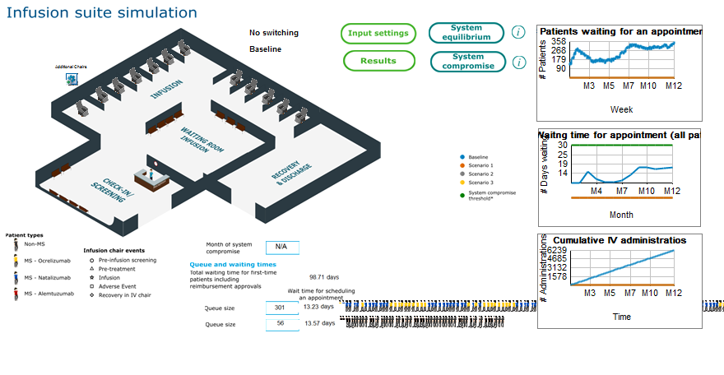
Figure A1 illustrates the current user interface and the model parameters that can be customized. Input settings is divided into center settings and treatment settings. Under center settings parameters related to patient numbers and mix, capacity and staffing can be adjusted. Under treatment settings posology, IRR and treatment cost can be modified. The system equilibrium function allows to access the corrective actions described in the Interventions section.
A detailed list of all parameters that can be modified in the model are specified under Appendices 2 and 3).

Appendix II: Treatment specific settings

Users can modify parameters under “Basic settings” to perform key hypothesis testing using the ENTIMOS model. Table 30 summarizes all variables that can be specified the user to customize the simulation settings:

Table 30. Variables that can be changed under the treatment settings user interface button and permitted input value types
Variable | Variable Group membership | Values | Notes
Cost of Ocrelizumab Infusion (by dose) | Costs / Medication and IRR | REAL
Cost of Natalizumab Infusion (by dose) | Costs / Medication and IRR | REAL
Cost of Alemtuzumab Infusion (by dose) | Costs / Medication and IRR | REAL
Cost of non-MS infusion (by dose) | Costs / Medication and IRR | REAL
Cost of infusion for first hour | Costs / Medication and IRR | REAL
Cost of infusion for succeeding hours | Costs / Medication and IRR | REAL
Cost of pre-medication | Costs / Medication and IRR | REAL
Cost of concomitant medication | Costs / Medication and IRR | REAL
Cost of medication used in IRR handling | Costs / Medication and IRR | REAL
IRR rates, Ocrelizumab (initial dose) | IRRs | REAL
IRR rates, Natalizumab (initial dose) | IRRs | REAL
IRR rates, Alemtuzumab (initial dose) | IRRs | REAL
IRR rates, Ocrelizumab (succeeding doses) | IRRs | REAL
IRR rates, Natalizumab (succeeding doses) | IRRs | REAL
IRR rates, Alemtuzumab (succeeding doses) | IRRs | REAL
IRR solutions, Ocrelizumab | IRRs / IRR solutions | Slow down infusion: REAL (%)  Slow down + medication: REAL (%)  Stop infusion: REAL (%)  Slow down infusion: REAL (%)  Slow down + medication: REAL (%)  Stop infusion: REAL (%)
IRR solutions, Natalizumab | IRRs / IRR solutions | Slow down infusion: REAL (%)  Slow down + medication: REAL (%)  Stop infusion: REAL (%)
IRR solutions, Alemtuzumab | IRRs / IRR solutions | Slow down infusion: REAL (%)  Slow down + medication: REAL (%)  Stop infusion: REAL (%)
IRR solutions, Non-MS DMTs | IRRs / IRR solutions | Slow down infusion: REAL (%)  Slow down + medication: REAL (%)  Stop infusion: REAL (%)
Ocrelizumab Posology | Posology | INTEGER (no. of weeks between infusions) | Allows users to specify changes in dosing (e.g., extended dosing) for MS DMTs
Natalizumab Posology | Posology | INTEGER (no. of weeks between infusions) | Allows users to specify changes in dosing (e.g., extended dosing) for MS DMTs
Alemtuzumab Posology | Posology | INTEGER (no. of weeks between infusions) | Allows users to specify changes in dosing (e.g., extended dosing) for MS DMTs
Payer approval time | Delay | INTEGER: 1 to n

Appendix III: Site specific settings

The parameters summarized in Table 31 are the additional inputs that allow the user to customize the settings of the model to a specific infusion center.

Table 31. Variables that can be changed under the center settings user interface button and permitted input value types
Variable | Variable Group membership | Values | Notes
Chairs and Bed Capacity | Resources | INTEGER: 1 to n
Pre-infusion workup specifications | Treatment pathway | Option 1: Outside clinic  Option 2: In waiting room  Option 3: In infusion chair | The specification on where the pre-infusion workup is performed impacts arrivals and scheduling, which in turn affects general infusion center efficiency
Administration of additional oral pre-treatment | Treatment pathway | Option 1: Yes  Option 2: No | Administration of additional oral pre-treatment (e.g., Conte et al. 2019) is expected to reduce IRR rates. IRR rate reduction through this mode of action can thus be simulated in ENTIMOS
Recovery and monitoring specifications | Treatment pathway | Option 1: Fully in chair  Option 2: Partially in chair  Option 3: Fully in recovery room | The specification on where the recovery and monitoring occurs impacts arrivals and scheduling, which in turn affects general infusion center efficiency
Total no. of MS Patients | Patient numbers | INTEGER: 1 to n | Sum of No. of Ocrelizumab, Natalizumab and Alemtuzumab patients specified must be equal to the total no. of MS patients specified
Total no. of non-MS Patients | Patient numbers | INTEGER: 1 to n
No. of Ocrelizumab patients | Patient numbers / MS Patients by Treatment | INTEGER: 1 to n | Split across 1st, 2nd and further visits must be specified. Sum of values must equal the total no. of Ocrelizumab patients specified.
No. of Natalizumab patients | Patient numbers / MS Patients by Treatment | INTEGER: 1 to n | Split across 1st, 2nd and further visits must be specified. Sum of values must equal the total no. of Natalizumab patients specified.
No. of Alemtuzumab patients | Patient numbers / MS Patients by Treatment | INTEGER: 1 to n | Split across 1st, 2nd and further visits must be specified. Sum of values must equal the total no. of Alemtuzumab patients specified.
New patients per week | Patient numbers / New arrivals | INTEGER: 1 to n
New MS patients per week | Patient numbers / New arrivals | REAL (%) | The sum of these values must equal 100%
New non-MS patients per week | Patient numbers / New arrivals | REAL (%) | The sum of these values must equal 100%
New Ocrelizumab patients per week | Patient numbers / New arrivals | REAL (%) | The sum of these values must equal 100%
New Natalizumab patients per week | Patient numbers / New arrivals | REAL (%) | The sum of these values must equal 100%
New Alemtuzumab patients | Patient numbers / New arrivals | REAL (%) | The sum of these values must equal 100%
Opening time | Center schedule | Time units: HH:MM
Closing time | Center schedule | Time units: HH:MM
Clinic opening days | Center schedule | Days of the week (Mon to Sun)
Scheduling mode | Center schedule | Option 1: First come first served  Option 2: Longest appointments first | The scheduling modes in scope for ENTIMOS are restricted to these two options, based on responses from the qualitative interviews
DNAs | DNAs | REAL (%)
No. of staff nurses, full-time | Staffing | INTEGER: 1 to n
No. of staff nurses, part-time | Staffing | INTEGER: 0 to n
Hours contracted per week, full-time staff nurses | Staffing / Time allocation | REAL
Hours contracted per week, part-time staff nurses | Staffing / Time allocation | REAL
Proportion of contracted hours available for patient care | Staffing / Time allocation | REAL (%)
Nurse involvement in patient care, pre-treatment | Staffing / Time allocation | REAL (%)
Nurse involvement in patient care, infusion | Staffing / Time allocation | REAL (%)
Nurse involvement in patient care, recovery and monitoring | Staffing / Time allocation | REAL (%)
Nurse involvement in patient care, IRR handling | Staffing / Time allocation | REAL (%)
Rate, nurse | Costs / Staff | REAL
Rate, nurse (agency) | Costs / Staff | REAL
Weekend / public holiday rate multiplier | Costs / Staff | REAL

Appendix IV: Catalogue of SIMUL8 sheets

Table 33 summarizes all the sheets that are used in ENTIMOS to store default data, data intermediates, and results. These sheets are currently categorized into six general types, which are described in Table 32.

Table 32. Variables that can be changed under the basic settings user interface button and permitted input value types
Sheet type | Description
Calculation sheet | Sheets that store calculation intermediates that are used as the basis for (formatted) results sheets
Default | Sheets that store pre-determined default values and settings, including country-specific default values. Subsets of content from these sheets are copied onto input parameters sheet for use in actual simulations.
Input parameters sheet | Sheets that contain actual values that are used for simulations. Typically, input parameters sheets are populated with content from both default spreadsheets, as well as any user-specified parameters that were entered through the ENTIMOS user interface (e.g. through the Treatment settings or Center settings customization buttons)
Misc | Sheet that contains instructions for display-related parameters, but do not contain actual data
Results | Sheets that contain simulation results; currently, there are separate spreadsheets for different result groups to facilitate ease-of-access from the ENTIMOS model interface
Tracking | Sheets that are used for cross-referencing, or tracking which parameters were altered by the user. These are mainly used for providing automated descriptions of scenarios that users test in their simulations

Table 33. ENTIMOS spreadsheet catalogue
Sheet type | Name | Description
Calculation sheet | ssAppointmentsPerDayResults | Sheet that records number of appointments (IV administrations) per day
Calculation sheet | ssCalculationStaffCost | Used for calculating the number of nurse hours used during the simulation period, as well as their associated costs. This sheet is populated in the course of a simulation.
Calculation sheet | ssCharts | Stores values for live graphics that appear in the ENTIMOS model interface
Calculation sheet | ssNewSchedulingAssistant | Sheet that is used for determining the availability of appointment slots, based on the expected appointment duration of an incoming patient and the remaining slots available for the infusion chairs in a facility.
Calculation sheet | ssNursingTimeCalculations | Sheet where the time that a nurse spends with a patient for individual steps is calculated. This is then subtracted from the nurse's contracted time and used to calculate bank hours needed to serve deficits in nurse time.
Calculation sheet | ssOpeningTimes | Sheet in which center opening times are temporarily stored and accessed for scheduling-related procedures
Calculation sheet | ssPatientPopulationDetail | Contents of ssArrivals are copied onto this sheet for use in the simulation
Calculation sheet | ssRunningCostResults | Sheet that stores the number of infusions per DMT, as well as the costs related to these infusions
Calculation sheet | ssTemp | Used in storing patient count-related parameters for handling patient arrivals and labeling
Calculation sheet | ssWeeklyStaffTimeRequired | Sheet where extra time requirements due to unexpected events (e.g., IRRs) against available nurse time
Default | ssDefaultArrivals | Sheet where all the patient distributions (MS / non-MS; and for MS patients, by MS DMT) are saved
Default | ssDefaultCosts_Staff | Sheet where default nursing costs are encoded for each of the countries. These values are loaded onto ssStaffCosts upon selection of the default country (via the Import defaults button)
Default | ssDefaultPosology | Sheet where default posology information for Ocrelizumab, Alemtuzumab, and Natalizumab, as well as a generalized posology for the top 3 non-MS DMTs per country are stored. These values are loaded onto ssPosology upon selection of the default country (via the Import defaults button)  Note: the posology information is currently the same across the countries, but it is possible that there are slight variations, e.g. extended dosing, that need to be adjusted at a country level
Default | ssDefaultsAdverseEvents | Sheet where default likelihood values for IRRs per visit (1st infusion or subsequent infusions) and per DMT are stored. For patients for whom IRRs occur, the distribution of patients according to different modes or IRR handling are also specified. These values are loaded onto ssAdverseEvents upon selection of the default country (via the Import defaults button)  Note: the IRR rates for the DMTs are based on published data. IRR handling rates are based on published information, where possible. All IRR rates for MS DMTs are constant for now. Non-MS IRR rates is expected to vary across countries and between centers, as the top non-MS DMTs may actually vary per country).
Default | ssDefaultsCosts_Medication | Sheet where default medication costs are encoded per country. These values are loaded onto ssCosts upon selection of the default country (via the Import defaults button)
Default | ssDefaultsOther | Sheet where all other country-specific features are specified. These features include the number of chairs and beds, the number of staff, the time available for patient care, do not attends (DNAs), and where activities are carried out
Default | ssDefaultsTiming | Sheet where any country-specific default timing information for various steps in the model, including payment approval time, is stored
Input parameters sheet | ssAdverseEvents | Sheet that contains the IRR rates that will be used in the simulation. Country defaults (stored in ssDefaultsAdverseEvents) are copied onto this sheet when defaults are imported (via Import defaults button). Any further user-defined changes in IRR rates (via Center settings > IRRs) are stored on this sheet.
Input parameters sheet | ssArrivals | Sheet that contains the patient numbers that will be used in the simulation. Country defaults (stored in ssDefaultArrivals) are copied onto this sheet when defaults are imported (via Import defaults button). Any further user-defined changes in patient numbers are stored on this sheet.
Input parameters sheet | ssCosts | Sheet that contains the costs associated with medication and IRR handling. Country defaults (stored in ssDefaults_CostsMedifications) are copied onto this sheet when defaults are imported (via Import defaults button). Any further user-defined changes in costs related to DMTs (via Basic settings > Medication and IRRs) are stored on this sheet.
Input parameters sheet | ssPathwayPlanner | Sheet for storing center-specific pathway settings, such as whether screening is done outside the clinic, or in the clinic; which activities are conducted in the chair, etc. Country defaults (stored in ssDefaultsOther) are copied onto this sheet when defaults are imported (via Import defaults button). Any further user-defined changes in treatment pathways (via Center settings > Treatment Pathway) are stored on this sheet.
Input parameters sheet | ssPosology | Sheet for storing posology information for Ocrelizumab, Alemtuzumab, and Natalizumab, as well as a generalized posology for the top 3 non-MS DMTs per country. Country defaults (stored in ssDefaultPosology) are copied onto this sheet when defaults are imported (via Import defaults button). Any further user-defined changes in posology (via Center settings > Change posology) are stored on this sheet.
Input parameters sheet | ssResourcesAndCapacity | Sheet for storing an infusion center's resources:  1. Infusion chairs  2. Staffing & contract  3. Amount of time that staff can spend on direct patient care  Country defaults (stored in ssDefaultsOther) are copied onto this sheet when defaults are imported (via Import defaults button). Any further user-defined changes in resources and capacity (via Basic settings > Chairs and Bed Capacity or Basic settings > Staffing) are stored on this sheet.
Input parameters sheet | ssStaffCosts | Sheet that stores hourly rates of staff. Country defaults (stored in ssDefaultCosts_Staff) are copied onto this sheet when defaults are imported (via Import defaults button). Any further user-defined changes in staff costs (via Basic settings > Costs > Staff) are stored on this sheet.
Input parameters sheet | ssSubCutaneousTransfer | Sheet that stores user-defined changes in the percentage of patients shifting from IV-administered DMTs to SC alternatives (via Basic settings > IV/SC Scenario)
Input parameters sheet | ssTimings | Sheet that stores information for the timing of both events in the model, including DMT-specific infusion timings
Misc | ssDisplay | Sheet for changing display text
Results | ss2years | Results sheet where the outcomes of runs that exceed one year are stored. These are not directly accessible from the Results interface
Results | ssMonthlyResults | Sheet where results for key graphed, derived variables are written, and which are subsequently copied onto external-facing report sheets
Results | ssNewCostResults | Results sheet that illustrate the costs per DMT per country across scenarios
Results | ssResultsPatientThrougput | Results sheet that illustrates how many IV administrations are carried out over a year
Results | ssResultsPatientWaitingTimes | Results sheet that illustrates the waiting center times per 10 patients
Results | ssResultsQueueSizes | Results sheet that illustrates the size of the queue at the end of the month, including by DMT
Results | ssResultsResourceUtilizationChair | Results sheet that illustrates the amount of time a chair was utilized (actual vs. scheduled) and the amount of extra administrations of a given length of time (e.g. 4 hours) possible
Results | ssResultsResourceUtilizationStaff | Results sheet that illustrates how many agency nurse hours are used (per 10 patients): these are essentially extra hours that are used to cover staff deficiencies due to unexpected events (e.g. IRRs) that drive inefficiency
Results | ssResultsTotal | Sheet that contains all results in a single spreadsheet.  Note: this sheet may be made redundant based on further user feedback / user preference with respect to the presentation of results. This spreadhseet is currently not accessible through the Results button.
Results | ssSummaryResults | Results sheet with graphs that illustrate impacts of all scenarios at end of simulation horizon.
Tracking | ssLookup | Sheet for tracking / cross-referencing where particular results are stored, as well as where outputs should be written
Tracking | ssResetToBaseline | Sheet used to track whether a subset of variables have been changed from the baseline run settings used. Any changes in these tracked variables are indicated in the scenario descriptions that can be found on the results sheets

In the case of Alemtuzumab, patients receive pre-treatment on 3 out of 5 treatment days, accounting for the branch in Figure 1 where pre-treatment is bypassed.
This can be accessed in the timings sheet, and user access will be programmed in the next version.
Methodist Hospitals, Memorial Healthcare System, St Vincent Healthcare Neuroscience Center, CCT Research, International Neurorehabilitation Institute, and the University of Colorado
Site contact was suspended in the UK due to COVID-19, and a KOL interview organized by NVS was conducted in its stead

