Appendix
Appendix A – Table: Study sample drugs

Appendix B – Figure: Annual treatment costs on substance level. Circular nets for (I) diabetes, (II) cardiovascular diseases, and (III) psoriasis.
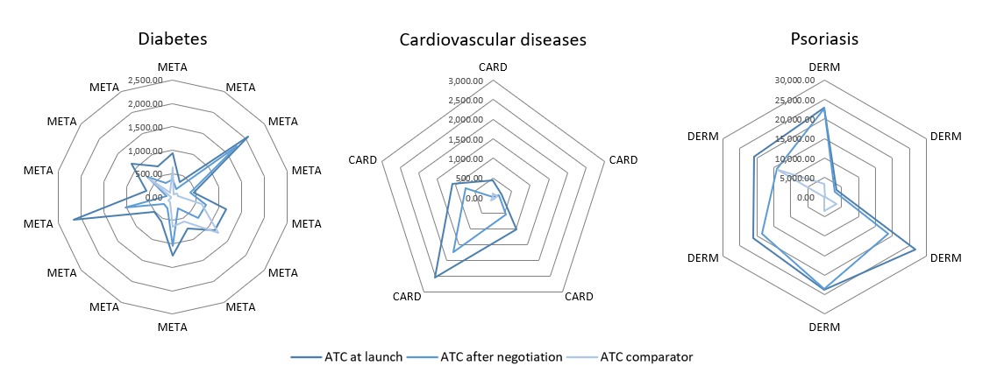

Appendix C – Figure: ICERs over time on patient group level after negotiation.
