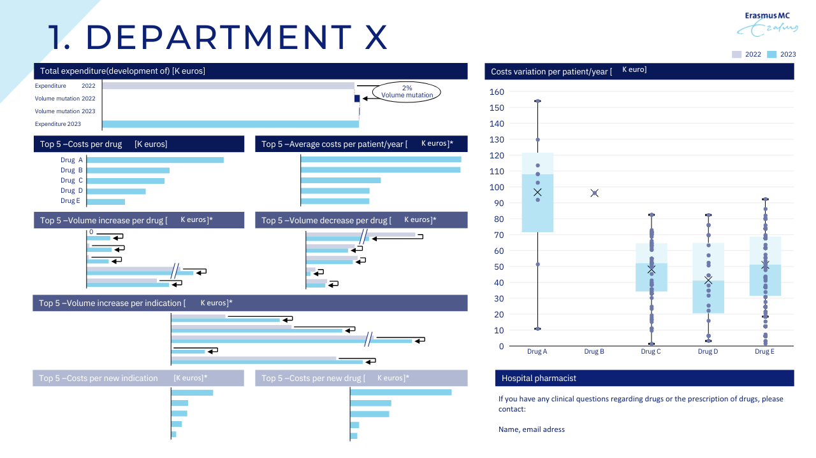
Supplementary Figure: Example factsheet showing annual drug costs, prescription patterns, costs per patient, and changes in costs by volume and price.

