Beyond the Diagnosis: Valuing Genome-Wide Sequencing for Rare Disease Diagnosis Using Contingent Valuation
Applied Health Economics and Health Policy
Michael Abbott^{1*}, Mandy Ryan¹, Rodolfo Hernández¹, Sebastian Heidenreich², Zosia Miedzybrodzka³
1: Health Economics Research Unit, University of Aberdeen, Aberdeen, UK 2: Evidera Inc., London, UK
3: Department of Medical Genetics, University of Aberdeen, Aberdeen, UK
*Corresponding author: email: michael.abbott@ed.ac.uk
Online Supplementary Material 2
Contingent Valuation Survey Template
Understanding Your Views, Values and Experience of Genome Sequencing

You have been invited to participate in this study because you participated in:
- The Scottish Genomes Partnership (SGP) study as part of the 100,000 Genomes Project, and/or
- The Deciphering Developmental Disorders (DDD) study
Researchers at the University of Aberdeen are evaluating genome sequencing for the diagnosis of rare conditions. We want to understand your views about genome sequencing and its benefits for you. This will help NHS Scotland decide which tests to provide in the future.
The questionnaire is divided into three sections, and will take approximately 20 minutes to complete.
Thank you for your participation!
Screening Question
Are you:
- An adult with a rare condition
- A parent of a child with a rare condition
- A relative/representative/caregiver of someone with a rare condition
- None of the above
SECTION 1: YOUR EXPERIENCE OF GENOME SEQUENCING
In the research study, you had a new type of genetic test called genome sequencing to try to find the cause of a rare condition. Genome sequencing is the most detailed genetic test possible. It allows us to read a person's entire DNA sequence to look for any changes which might cause the condition
In this section, we are interested in how you felt when you received your genome sequencing results. This will help us to assess the positive and negative aspects of the test you received. We are interested in how your test results made you feel, regardless of whether you received a diagnosis or not.﻿

How useful were your test results in terms of:
Please select an option from 1 (Not at all useful) to 7 (extremely useful) for each statement:

1) Simply to provide information
2) Contribution to my self-knowledge
3) Satisfy my curiosity
4) Help to better understand my health
5) Feel good about helping the medical community
6) Feel good about having information for family members
7) Help me cope with my health risks
8) Inform my decisions about having children
9) Use for testing a future pregnancy, if appropriate
10) Improve communication with my family members
11) Help me to use social programs, like resources and services
12) Help with life planning
13) Help me feel more in control of my life
14) Help me or my family mentally prepare for the future

﻿
Some people report negative experiences of genome sequencing. We would like to know whether you had any negative experiences of genome sequencing.
Thinking about your experience of genome sequencing please read each statement on the left and select an option from 1 (not at all) to 5 (a great deal) for each:
- How uncertain did you feel about what your test result means for you?
- How uncertain did you feel about what your test result means for your child(ren) and/or family's risk of disease?
- How much guilt did you feel about the test result?
- How much loss of control over your life did you feel because of the test result?
- How much regret did you feel about the decision to receive a test?

SECTION 2: VALUING GENOME SEQUENCING
We are interested in how much you value genome sequencing. There are different ways genetic testing could be provided, and we would like to know what is most important to you. There are no right or wrong answers in this section. We are interested in what you prefer.
﻿We would like you to imagine that you are at the genetics clinic for the first time, trying to diagnose a rare condition. The doctor tells you about some private genetic testing plans which are not available on the NHS. The genetic testing plans have different features, which will be described on the next few pages.

1. ﻿﻿Chance of Diagnosis
Some people might get a diagnosis from the genetic testing plan, but many will not. The chance of getting a diagnosis can vary depending on the type of condition and the type of test. For example, a 20% chance of diagnosis means that 20 out of every 100 people will receive a diagnosis, but 80 will not.

2. Number of Times You Need to Visit the Clinic
Some genetic testing plans will require more clinic visits than others. A clinic appointment might involve taking a blood sample, discussing the test you are getting, or discussing positive or negative test results. You would need to travel to and from the genetics clinic for each appointment.

﻿3. Time Spent Looking for a Diagnosis
Some genetic testing plans will give you results quicker than others. Remember there is only a chance of getting a diagnosis. Some people will receive a diagnosis by the end of the genetic testing plan, but many will not.

4. Cost to You
Imagine the testing plans are provided by a private company. They are not available on the NHS, so you would need to pay privately for each plan.
How much would you be willing to pay for the test you had in the research study?
- I would not be willing to pay for the test
- £1 - £250
- £251 - £500
- £501 - £1,000
- £1,001 - £1,500
- £1,501 - £2,000
- £2,001 - £2,500
- £2,501 - £3,000
- £3,001 - £4,000
- £3,501 - £4,000
- £4,001 - £6,000
- £6,001 - £8,000
- More than £8,000: [________]

*If the respondent selects ‘I would not be willing to pay for the test:’
Please tell us why you would not be willing to pay for the test you had in the research study:
- I can't afford it
- I don't value the test
- Someone else should pay for it (e.g. the government)
- Other:
Choosing Between Testing Plans

You will be presented with a series of fifteen choices. In each choice, we would like you to choose between Genomic Test A, Genomic Test B, or Standard Genetic Testing. The features of Genomic Test A and B will differ in each choice. The features of Standard Genetic Testing will always be the same.

Standard Genetic Testing does not involve genome sequencing. It involves a series of targeted gene tests which look at specific genes based on your symptoms.
In the example below, please compare the features of each test and choose between Genomic Test A, Genomic Test B, and Standard Genetic Testing. If you need a reminder of what any of these features mean, you can hover over the dotted line to see a description.

Example Choice Task:
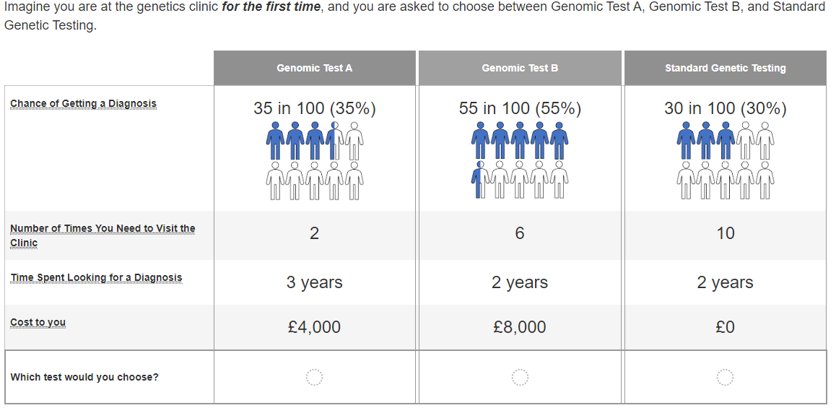

SECTION 3: ABOUT YOU
In this section, you will be asked some background questions about you. Your answers to these questions will help the researchers to better understand the results of this survey.

Did you find the cause of the rare condition from your research study results?

- Yes
- No
- Unsure/Don't Know

When you enrolled in the research study, how confident were you that the test would find the cause of the rare condition?
Please select an option from 1 (not at all confident) to 5 (extremely confident)

- 1
- 2
- 3
- 4
- 5
- Unsure/Don't Know

When you received your results from the research study, how disappointed did you feel about your genome sequencing results?
Please select an option from 1 (not at all disappointed) to 5 (extremely disappointed)

- 1
- 2
- 3
- 4
- 5
- Unsure/Don't Know

How long have you been trying to find a diagnosis for your/your child’s/your relative’s condition? If you have received a diagnosis, please enter how long you were trying to find a diagnosis
____ years and ____ months

What is your year of birth?
_____

What gender do you identify as?
- Male
- Female
- Non-binary
- Prefer not to answer

How much is your household income from all sources? (before tax; include benefits or pensions as well as income from wages etc.)
﻿Please select either weekly or annual household income
- Options for weekly/annual household income
- Prefer not to answer

Including yourself, how many people currently live in your household?
- 1
- 2
- 3
- 4
- More than 4:

How many people in your household are under the age of 18?
- 1
- 2
- 3
- More than 3:

Survey End
Thank you for participating in this survey!

Your responses are very important to us and will be used to help plan genetic testing to diagnose rare conditions in Scotland.



