Beyond the Diagnosis: Valuing Genome-Wide Sequencing for Rare Disease Diagnosis Using Contingent Valuation
Applied Health Economics and Health Policy
Michael Abbott^{1*}, Mandy Ryan¹, Rodolfo Hernández¹, Sebastian Heidenreich², Zosia Miedzybrodzka³
1: Health Economics Research Unit, University of Aberdeen, Aberdeen, UK 2: Evidera Inc., London, UK
3: Department of Medical Genetics, University of Aberdeen, Aberdeen, UK
*Corresponding author: email: michael.abbott@ed.ac.uk
Online Supplementary Material 3
Contingent Valuation Survey Analysis

Contingent Valuation Payment Card
Fig. ESM3.1 Contingent Valuation Payment Card
Imagine the test you had in the research study is not available on the NHS. Instead, it is provided by a private company. This means you would need to pay privately to receive the test. How much would you be willing to pay for the test you had in the research study?
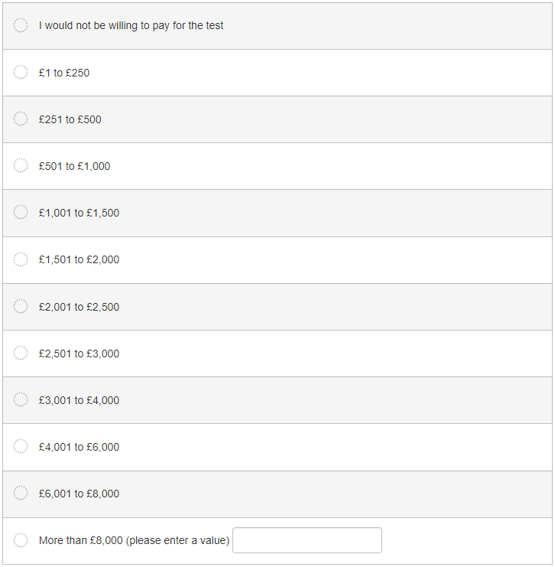

Survey Sample Characteristics
Table ESM3.1: Survey Participant Sample Characteristics
Number of respondents | 171
Adults with a rare condition | 36 (21.10%)
Parents/caregivers of a child with a rare condition | 135 (78.90%)
Diagnosed | 70 (40.94%)
Undiagnosed | 101 (59.06%)
Mean age | 42.16 (95% CI 39.62 – 44.71)
Mean pre-genome sequencing clinic visits | 4.53 (95% CI 3.66 – 5.39)
Mean diagnostic odyssey (years) – parents/caregivers | 8.85 (95% CI 7.87 – 9.83)
Mean diagnostic odyssey (years) – adults | 18.44 (95% CI 12.24 – 24.64)
Mean waiting time for SGP/DDD results (months) | 40.88 (95% CI 29.79 – 51.96)
Household income < £20,000 per annum | 45 (26.32%)
Household income £20,000 - £50,000 per annum | 66 (38.60%)
Household income > £50,000 per annum | 60 (35.08%)

Free-Text Reasons for Zero WTP:
Thirteen respondents provided free-text reasons for zero WTP values:
- “didn’t benefit me and couldn’t afford”
- “it’s not going to change anything”
- “there is not a value”
- “not guaranteed a result”
- “I never got results for the rest”
- “[Child’s] condition is not life threatening”
- “low probability of diagnosis”
- “Wouldn’t change diagnosis”
- “Government myopic attitude”
- “Didn’t get an answer”
- “It’s not my fault this happened to me”
- “Never found out what was wrong”
- “Tests results came back with a result only to be told this was an error a few days later”

