Cover Page
Manuscript Title:
Enhancing naloxone distribution for opioid users in the United States: a cost-utility analysis of academic detailing to clinicians
Running Title:
Cost-Utility Analysis of Academic Detailing on Naloxone Distribution
Journal Name:
Applied Health Economics and Health Policy
Authors and Author Affiliations:
Olivia Yip, PharmD
The Comparative Health Outcomes, Policy, and Economics (CHOICE) Institute, School of Pharmacy, University of Washington, Seattle, Washington, USA
ORCID: 0009-0009-0090-8530
Mark Bounthavong, PharmD, PhD
University of California San Diego Skaggs School of Pharmacy and Pharmaceutical Sciences, La Jolla, California
U.S. Department of Veterans Affairs (VA) Health Economics Resource Center, Menlo Park, California
ORCID: 0000-0002-7343-9458
Corresponding Author:
Mark Bounthavong, PharmD, PhD
Email: mbounthavong@health.ucsd.edu

Supplements
Supplement S1 CHEERS Statement

Topic | No. | Item | Location where item is reported
Title
Title | 1 | Identify the study as an economic evaluation and specify the interventions being compared. | Title, Page 1
Abstract
Abstract | 2 | Provide a structured summary that highlights context, key methods, results, and alternative analyses. | Abstract, Page 2
Introduction
Background and objectives | 3 | Give the context for the study, the study question, and its practical relevance for decision making in policy or practice. | Introduction
Methods
Health economic analysis plan | 4 | Indicate whether a health economic analysis plan was developed and where available. | Not Reported
Study population | 5 | Describe characteristics of the study population (such as age range, demographics, socioeconomic, or clinical characteristics). | Methods; Outcomes, Study Design
Setting and location | 6 | Provide relevant contextual information that may influence findings. | Methods;  Study Design
Comparators | 7 | Describe the interventions or strategies being compared and why chosen. | Methods; Hybrid decision tree and Markov model
Perspective | 8 | State the perspective(s) adopted by the study and why chosen. | Methods;  Study design
Time horizon | 9 | State the time horizon for the study and why appropriate. | Methods;  Survival curve fitting
Discount rate | 10 | Report the discount rate(s) and reason chosen. | Methods, Outcomes
Selection of outcomes | 11 | Describe what outcomes were used as the measure(s) of benefit(s) and harm(s). | Methods, Outcomes
Measurement of outcomes | 12 | Describe how outcomes used to capture benefit(s) and harm(s) were measured. | Methods; Outcomes
Valuation of outcomes | 13 | Describe the population and methods used to measure and value outcomes. | Methods;  Outcomes
Measurement and valuation of resources and costs | 14 | Describe how costs were valued. | Methods;  Costs
Currency, price date, and conversion | 15 | Report the dates of the estimated resource quantities and unit costs, plus the currency and year of conversion. | Methods;  Costs
Rationale and description of model | 16 | If modelling is used, describe in detail and why used. Report if the model is publicly available and where it can be accessed. | Methods;  Hybrid decision tree and Markov model
Analytics and assumptions | 17 | Describe any methods for analysing or statistically transforming data, any extrapolation methods, and approaches for validating any model used. | Methods
Characterising heterogeneity | 18 | Describe any methods used for estimating how the results of the study vary for subgroups. | Not Reported
Characterising distributional effects | 19 | Describe how impacts are distributed across different individuals or adjustments made to reflect priority populations. | Not Reported
Characterising uncertainty | 20 | Describe methods to characterise any sources of uncertainty in the analysis. | Methods;  Sensitivity Analysis
Approach to engagement with patients and others affected by the study | 21 | Describe any approaches to engage patients or service recipients, the general public, communities, or stakeholders (such as clinicians or payers) in the design of the study. | Not Reported
Results
Study parameters | 22 | Report all analytic inputs (such as values, ranges, references) including uncertainty or distributional assumptions. | Results, Table 1
Summary of main results | 23 | Report the mean values for the main categories of costs and outcomes of interest and summarise them in the most appropriate overall measure. | Results, first paragraph
Effect of uncertainty | 24 | Describe how uncertainty about analytic judgments, inputs, or projections affect findings. Report the effect of choice of discount rate and time horizon, if applicable. | Results, second to last paragraph
Effect of engagement with patients and others affected by the study | 25 | Report on any difference patient/service recipient, general public, community, or stakeholder involvement made to the approach or findings of the study | Not reported
Discussion
Study findings, limitations, generalisability, and current knowledge | 26 | Report key findings, limitations, ethical or equity considerations not captured, and how these could affect patients, policy, or practice. | Discussion
Other relevant information
Source of funding | 27 | Describe how the study was funded and any role of the funder in the identification, design, conduct, and reporting of the analysis | Title Page
Conflicts of interest | 28 | Report authors conflicts of interest according to journal or International Committee of Medical Journal Editors requirements. | Title Page

Supplement S2. Impact Inventory
Sector | Type of impact (list category within each sector with unit of measure if relevant. | Perspective: Health Care Sector
Formal Health Care Sector
Health | Health outcomes (effects)
 | Longevity effects | x
 | Health-related quality-of-life effects | x
 | Other health effects (e.g., adverse events and secondary transmission of infection)
 | Medical costs
 | Paid for by third-party payers | x
 | Paid for by patients out-of-pocket
 | Future related medical costs (payers and patients)
 | Future unrelated medical costs (payers and patients)
Informal Health Care Sector
Health | Patient-time costs | N/A
 | Unpaid caregiver time costs | N/A
 | Transportation costs | N/A
Non-Health Care Sectors (with examples of possible items)
Productivity | Labor market earnings lost | N/A
 | Costs of unpaid lost productivity due to illness | N/A
 | Cost of uncompensated household production | N/A
Consumption | Future consumption unrelated to health | N/A
Social services | Cost of social services as part of intervention | N/A
Legal of Criminal Justice | Number of crimes related to intervention | N/A
 | Cost of crimes related to intervention | N/A
Education | Impact of intervention on educational achievement of population | N/A
Housing | Cost of intervention on home improvements (e.g., removing lead paint) | N/A
Environment | Production of toxic waste pollution by intervention | N/A
Other (specify) | Other impacts | N/A
x denotes being included in the manuscript/ model

Supplement S3. Survival curve fit and extrapolation.
Data from the fitted Kaplan-Meier Curve
We used the study by Walley and colleagues [1] to digitize the Kaplan-Meier curve for individuals with opioid use disorder who experienced all-cause mortality up to 12 months. Data from the digitized Kaplan-Meier curve is provided below:
x | Curve1
0 | 1
0.5 | 1
1 | 0.999634
1.5 | 0.998972
2 | 0.998009
2.5 | 0.99788
3 | 0.99666
3.5 | 0.99666
4 | 0.995311
4.5 | 0.994803
5 | 0.994347
5.5 | 0.993062
6 | 0.993062
6.5 | 0.991777
7 | 0.991713
7.5 | 0.9903
8 | 0.990236
8.5 | 0.989336
9 | 0.988456
9.5 | 0.988437
10 | 0.986702
10.5 | 0.986702
11 | 0.985996
11.5 | 0.985932
12 | 0.985546

Generate the Individual Patient Data
This was inputted into the Excel file provided by Tierney and colleagues [2] to generate the number at risk. Then we manually inputted the number at risk into the R code supplied by Guyot and colleagues [3] to generate the individual patient data (IPD).

Survival curve fit and extrapolation
We tested several parametric survival curve functions including the Weibull, Exponential, Generalized Gamma, Log-normal, and Gompertz survival curves. The Weibull had the best fit based on Akaike Information Criterion (AIC) values.

Image of the Weibull fit to the digitized Kaplan-Meier curve.
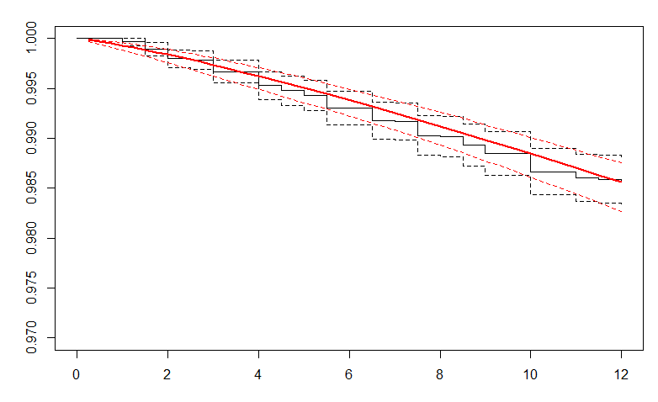

We generated the lambda and gamma parameters from the Weibull function and used those in our extrapolation beyond 12 months. We extrapolated survival for up to 65 cycles in the Markov model (equivalent to when the subjects reached 85 years old) at which point we assumed they reached the Death absorbing state.

Survival curve fittings and evaluations were performed using R (version 4.4.2; R Core Team, 2024).

Supplement S4. Scenario analyses of varying academic detailing effectiveness.
Scenario 1 - AD Effectiveness | Incremental Cost (US$) | Incremental QALY | ICER (US$ per QALY gained) | iNMB (US$)
Base-case*: AD Effectiveness = 80% | US$309 | 0.60 | US$514 | US$29,739
Scenario 1a (Best-case): AD Effectiveness = 90% | US$352 | 0.70 | US$500 | US$34,781
Scenario 1b (Worst-case): AD Effectiveness = 50% | US$185 | 0.31 | US$604 | US$15,133
Scenario 2 - Disutility | Incremental Cost (US$) | Incremental QALY | ICER (US$ per QALY gained) | iNMB (US$)
Base Case**: Disutility due to long-term effects of severe hypoxia = -0.119 | $309 | 0.60 | $514 | $29,739
Scenario 2: Disutility due to long-term effects of severe hypoxia = -0.19 | $309 | 0.59 | $523 | $29,215
US$, United Sates dollar
QALY, quality-adjusted life year
ICER, incremental cost-effectiveness ratio
iNMB, incremental net monetary benefit
AD, academic detailing
* In the base-case, we assumed that the probability of a provider prescribing naloxone would be 80% based on Behar (2017) [4].
** In the base-case, we assumed that the disutility of an opioid overdose was -0.119 based studies by Townsend (2020) [5] and Rivero-Arias (2009) [6].

References
1. Walley AY, Xuan Z, Hackman HH, Quinn E, Doe-Simkins M, Sorensen-Alawad A, et al. Opioid overdose rates and implementation of overdose education and nasal naloxone distribution in Massachusetts: interrupted time series analysis. BMJ. 2013;346:f174.
2. Tierney JF, Stewart LA, Ghersi D, Burdett S, Sydes MR. Practical methods for incorporating summary time-to-event data into meta-analysis. Trials. 2007;8:16.
3. Guyot P, Ades AE, Beasley M, Lueza B, Pignon J-P, Welton NJ. Extrapolation of Survival Curves from Cancer Trials Using External Information. Med Decis Making. 2017;37:353–66.
4. Behar E, Rowe C, Santos G-M, Coffa D, Turner C, Santos NC, et al. Acceptability of Naloxone Co-Prescription Among Primary Care Providers Treating Patients on Long-Term Opioid Therapy for Pain. J Gen Intern Med. 2017;32:291–5.
5. Townsend T, Blostein F, Doan T, Madson-Olson S, Galecki P, Hutton DW. Cost-effectiveness analysis of alternative naloxone distribution strategies: First responder and lay distribution in the United States. International Journal of Drug Policy. 2020;75:102536.
6. Rivero-Arias O, Ouellet M, Gray A, Wolstenholme J, Rothwell PM, Luengo-Fernandez R. Mapping the modified Rankin scale (mRS) measurement into the generic EuroQol (EQ-5D) health outcome. Med Decis Making. 2010;30:341–54.

