Target Journal: Clinical Drug Investigation
Article Category: Original articles
Manuscript Title
Safety, Tolerability, and Pharmacokinetics of a Novel Anti-obesity agent, S-309309, in Healthy Adults Without or With Obesity
Running Title: Phase 1 RCT of S-309309 in Obesity
Authors: Toru Ishibashi¹, Hideki Tanioka^{1,*}, Tatsuya Ikehara², Safwan Kezbor³, and Takuhiro Sonoyama⁴
Affiliations:
¹Project Management Department, Shionogi & Co., Ltd., Osaka, Japan.
²Laboratory for Drug Discovery and Disease Research, Shionogi & Co., Ltd., Osaka, Japan.
³Clinical Development, Shionogi Inc. Florham Park, NJ, USA.
⁴Medical Science Department, Shionogi & Co., Ltd., Osaka, Japan.
Corresponding author:
Hideki Tanioka
Project Management Department, Shionogi & Co., Ltd.,
9F, Nissay Yodoyabashi East, 3-13, Imabashi 3-chome, Chuo-ku, Osaka 541-0042, Japan.
Email: hideki.tanioka@shionogi.co.jp
Phone number: +81-80-2528-3602

Online Resource 1 Study Design

ªThe effect of food on the pharmacokinetics of S-309309 was assessed; ^{b}High-fat/high-calorie meal; ^{c}The effect of S-309309 on the pharmacokinetics of midazolam on day −2 and day 15
MD, multiple dose; SAD, single ascending dose
Online Resource 2 MS/MS Conditions for Determination of S-309309 Concentration
Analyte | Monitoring ion | CE | DP | CXP | Dwell time | CUR | IS
Analyte | (m/z) | (V) | (V) | (V) | (msec) |  | (V)
S-309309 | 518 > 167 | 55 | 100 | 15 | 100 | 30 | 4000
Internal standard | 524 > 167 | 55 | 100 | 15 | 50 | 30 | 4000

CE, Collision energy; CXP, Collision Cell Exit Potential; CUR, Curtain Gas; DP, Declustering potential; IS, Ionspray Voltage

Online Resource 3 Baseline Demographics of Study Participants
Parameters |  | Single Dose Administration |  |  |  |  |  |  | Multiple Dose Administration
 |  | Cohort A  1 mg S-309309  N=6 | Cohort B  3 mg S-309309  N=6 | Cohort C  10 mg S-309309  N=6 | Cohort D  30 mg S-309309  N=8 | Cohort E  100 mg S-309309  N=6 | Cohort F  300 mg S-309309  N=6 | Pooled Placebo  N=12 | Group G1  50 mg S-309309  N=12 | Placebo  N=4 | Group G2  50 mg S-309309  N=8 | Placebo  N=4
Sex | Male | 2 (33.3) | 5 (83.3) | 5 (83.3) | 7 (87.5) | 4 (66.7) | 5 (83.3) | 8 (66.7) | 8 (100) | 3 (75.0) | 6 (75.0) | 3 (75.0)
Sex | Female | 4 (66.7) | 1 (16.7) | 1 (16.7) | 1 (12.5) | 2 (33.3) | 1 (16.7) | 4 (33.3) | 0 | 1 (25.0) | 2 (25.0) | 1 (25.0)
Age (Years) | Mean (SD) | 47.0 (5.29) | 36.8 (8.18) | 37.3 (11.18) | 42.6 (8.00) | 42.2 (10.57) | 38.3 (12.82) | 43.3 (9.59) | 33.9 (10.23) | 44.8 (5.38) | 35.9 (12.09) | 31.3 (4.50)
Age (Years) | Min | 42 | 27 | 27 | 28 | 30 | 20 | 25 | 21 | 39 | 18 | 26
Age (Years) | Median | 46.5 | 37.0 | 34.5 | 43.0 | 42.5 | 43.5 | 46.5 | 34.5 | 44.0 | 39.5 | 31.0
Age (Years) | Max | 54 | 49 | 54 | 51 | 53 | 50 | 55 | 49 | 52 | 53 | 37
Height (cm) | Mean (SD) | 165.30 (7.40) | 180.03 (12.23) | 168.25 (9.26) | 173.75 (7.92) | 177.57 (7.31) | 168.97 (6.73) | 169.67 (7.39) | 177.55 (5.38) | 167.08 (4.67) | 170.43 (8.59) | 167.85 (11.12)
Height (cm) | Min | 158.1 | 161.7 | 150.9 | 158.2 | 168.3 | 156.7 | 157.5 | 170.2 | 161.5 | 154.3 | 152.5
Height (cm) | Median | 163.45 | 180.05 | 169.70 | 175.40 | 178.60 | 169.65 | 170.10 | 177.50 | 166.95 | 172.45 | 169.90
Height (cm) | Max | 176.3 | 195.9 | 177.9 | 184.3 | 184.8 | 176.4 | 180.9 | 188.7 | 172.9 | 182.1 | 179.1
Weight (kg) | Mean (SD) | 72.23 (10.50) | 86.92 (12.53) | 74.15 (12.83) | 80.56 (8.50) | 79.87 (11.74) | 74.25 (8.19) | 73.82 (9.61) | 84.59 (10.65) | 74.60 (3.58) | 94.08 (6.94) | 90.65 (11.41)
Weight (kg) | Min | 53.0 | 70.0 | 49.5 | 67.1 | 65.9 | 63.9 | 60.2 | 66.4 | 71.7 | 86.4 | 74.0
Weight (kg) | Median | 74.85 | 89.35 | 77.45 | 79.70 | 78.05 | 77.35 | 77.75 | 84.50 | 73.60 | 94.65 | 94.60
Weight (kg) | Max | 82.5 | 102.9 | 87.3 | 92.7 | 99.5 | 81.5 | 87.4 | 101.7 | 79.5 | 107.8 | 99.4
BMI (kg/m²) | Mean (SD) | 26.40 (3.29) | 26.80 (2.77) | 26.00 (2.61) | 26.66 (1.69) | 25.42 (3.95) | 25.97 (1.92) | 25.69 (3.20) | 26.83 (2.93) | 26.80 (2.31) | 32.43 (1.88) | 32.10 (0.96)
BMI (kg/m²) | Min | 21.2 | 21.7 | 21.7 | 24.1 | 19.8 | 22.2 | 18.7 | 20.7 | 24.2 | 30.0 | 31.0
BMI (kg/m²) | Median | 27.75 | 27.65 | 26.40 | 26.45 | 27.20 | 26.40 | 25.95 | 28.10 | 27.10 | 32.60 | 32.05
BMI (kg/m²) | Max | 29.5 | 29.0 | 29.0 | 29.5 | 29.2 | 27.6 | 29.2 | 29.4 | 28.8 | 36.3 | 33.3
Race,  n (%) | Black or African American | 2 (33.3) | 3 (50.0) | 0 | 2 (25.0) | 4 (66.7) | 0 | 4 (33.3) | 5 (62.5) | 0 | 3 (37.5) | 2 (50.0)
Race,  n (%) | White | 4 (66.7) | 3 (50.0) | 6 (100) | 6 (75.0) | 2 (33.3) | 6 (100) | 8 (66.7) | 3 (37.5) | 4 (100) | 5 (62.5) | 2 (50.0)
Ethnicity,  n (%) | Hispanic or Latino | 3 (50.0) | 2 (33.3) | 5 (83.3) | 6 (75.0) | 1 (16.7) | 6 (100) | 5 (41.7) | 2 (25.0) | 3 (75.0) | 3 (37.5) | 1 (25.0)
Ethnicity,  n (%) | Not Hispanic or Latino | 3 (50.0) | 4 (66.7) | 1 (16.7) | 2 (25.0) | 5 (83.3) | 0 | 6 (50.0) | 6 (75.0) | 1 (25.0) | 5 (62.5) | 3 (75.0)
Ethnicity,  n (%) | Missing | 0 | 0 | 0 | 0 | 0 | 0 | 1 (8.3) | 0 | 0 | 0 | 0
“Placebo” includes all participants given placebo in all cohorts in part 1. The last values taken before first administration were used if there were multiple results
BMI, body mass index; Max, maximum; Min, Minimum; N, number of participants; SD, standard deviation.
Online Resource 4 Trough Concentration-time Profiles of S-309309
Mean (SD) trough concentration-time profile of S-309309 following once daily multiple dose (50 mg; Cohort G) administration of S-309309 for 14 days in the fed state in healthy adults without or with obesity (groups G1 and G2), respectively
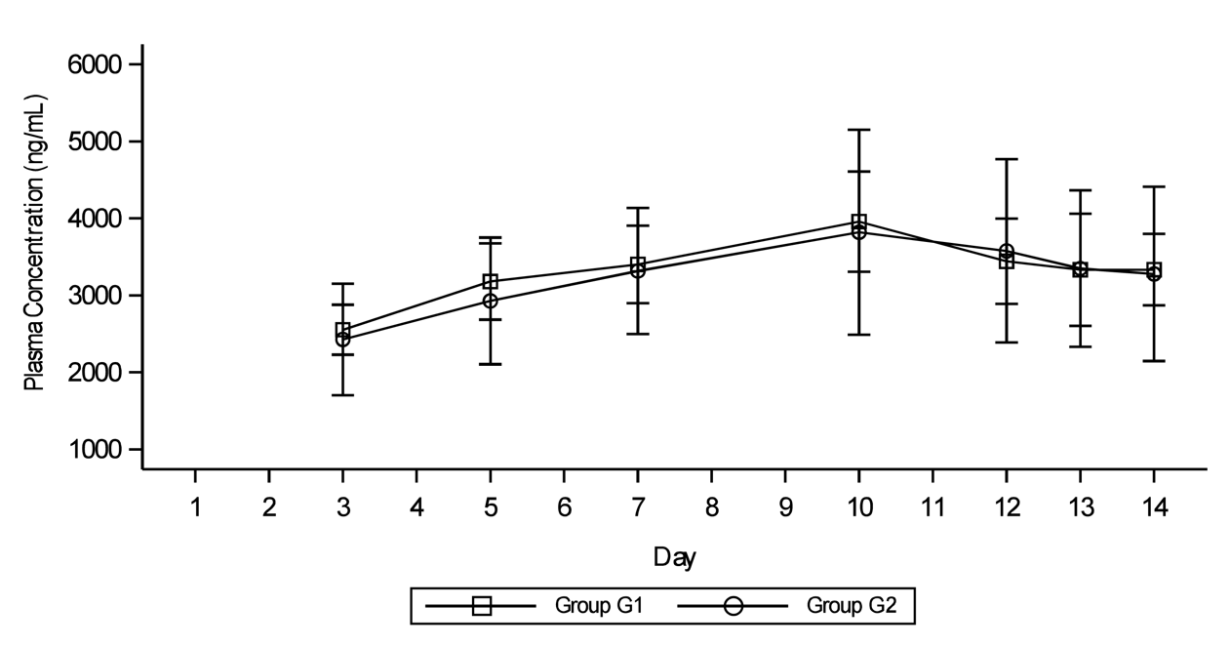
SD, standard deviation
Online Resource 5 Statistical Analysis Comparison of Pharmacokinetic Parameters of S-309309 (50 mg)ª Between Healthy Adults Without or With Obesity
Parameters | Day1 |  |  |  |  | Day 14
Parameters | Group G1 |  | Group G2 |  | Group G2/  Group G1 | Group G1 |  | Group G2 |  | Group G2/  Group G1
Parameters | N | GLS Mean | N | GLS Mean | GLS Mean Ratio  (90% CI) | N | GLS Mean | N | GLS Mean | GLS Mean Ratio  (90% CI)
C_{max} (ng/mL) | 8 | 4110 | 8 | 3640 | 0.886 (0.7540-1.041) | 8 | 7360 | 8 | 7390 | 1.00 (0.8721-1.156)
AUC_{0- τ} (ng·h/mL) | 8 | 62320 | 8 | 58220 | 0.934 (0.837-1.042) | 8 | 114200 | 8 | 112800 | 0.988 (0.8189-1.193)
ªGroup G1, once daily multiple dose administration of 50 mg S-309309 to healthy adults without obesity on days 1 to 14 in the fasted state; group G2, once daily multiple dose administration of 50 mg S-309309 to healthy adults with obesity on days 1 to 14 in the fed state
AUC_{0-τ}, area under the concentration-time curve over dosing interval τ (i.e., 24 hours); CI, confidence interval; C_{max}, maximum plasma concentration; GLS, geometric least square; N, number of participants

