Title: Assessing the Completeness of Adverse Event Reporting in Clinical Trials of Psoriasis Treatments: A Registry-Publication Comparison Study

Journal: Clinical Drug Investigation

Authors: Madeline Rowe, B.S.,¹ Madison Dinh, B.S.,¹ Ryan Sherry, B.S.,¹ Kellen Keefer, B.S.,¹ Rachel Hazlitt, B.S.,¹ Ahmed Elghzali, B.S.,¹ Daniel Archer, B.S.,¹ Alicia Ito Ford, Ph.D.,^{1,2} & Matt Vassar, Ph.D.^{1,2}

- Office of Medical Student Research, Oklahoma State University Center for Health Sciences, Tulsa, Oklahoma
- Department of Psychiatry and Behavioral Sciences, Oklahoma State University Center for Health Sciences, Tulsa, Oklahoma

Corresponding Author: Madeline Rowe, Oklahoma State University Center for Health Sciences, Address: 1111 W 17th St., Tulsa, OK 74107, United States, Email: madeline.roweresearch@gmail.com, Phone: 918-582-1972

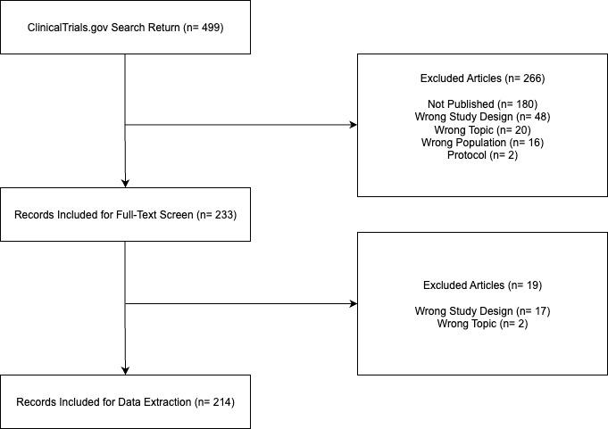

Supplemental Figure S1. PRISMA Flow Diagram of Selection Criteria

Supplemental Table S1. General Trial Characteristics
Trial Characteristic* | N of trials, % (total = 214)
Trial Phase
2 | 58 (27%)
3 | 136 (64%)
4 | 15 (7%)
Not Applicable | 5 (2%)
Masking
Single | 15 (7.0%)
Double | 55 (26%)
Triple | 25 (12%)
Quadruple | 108 (50%)
None | 11 (5.1%)
Allocation
Randomized | 214 (100%)
Intervention Model
Parallel | 210 (98%)
Crossover | 2 (0.9%)
Single Group | 2 (0.9%)
Primary Purpose
Treatment | 206 (96%)
Supportive Care | 4 (1.9%)
Prevention | 1 (0.5%)
Other | 3 (1.4%)
Type of Intervention
Drug | 174 (81%)
Biological | 31 (14%)
Device | 2 (0.9%)
Dietary Supplement | 1 (0.5%)
Procedure | 1 (0.5%)
Other | 5 (2.3%)
Funder Type
Industry | 204 (95%)
Academic | 1 (0.5%)
Institutional | 1 (0.5%)
Not Reported | 8 (3.7%)
*as reported in ClinicalTrials.gov registration

Supplemental Table S2. Regression Estimates for Adverse Event Reporting Score
Model | Term | Estimate | Standard Error | t | p-value
Unadjusted Model
Intercept | After Final Rule | 5 | 0.125 | 40.44 | <0.0001
 | Before Final Rule | -0.862 | 0.156 | -5.516 | <0.0001
Adjusted Model
Intercept | After Final Rule | 7.091 | 1.575 | 4.503 | <0.0001
 | Before Final Rule | -0.928 | 0.192 | -4.830 | <0.0001
Primary Intervention Type
 | Device | 0.724 | 0.803 | 0.901 | 0.369
 | Drug | -0.205 | 1.565 | -0.131 | 0.896
 | Procedure | -0.205 | 0.220 | -0.930 | 0.354
 | Other | 0.065 | 0.539 | 1.154 | 0.250
Funding Source
 | Industry | -0.886 | 1.102 | -0.804 | 0.423
 | Not Reported | -0.204 | 1.166 | -0.175 | 0.861
Participant Enrollment (n) |  | 0 | 0 | 1.789 | 0.076
Estimate = change in outcome for 1-unit change in predictor.
SE = standard error; t = test statistic; p = p-value.
Model = 'Unadjusted' includes only the main predictor. 'Adjusted' includes all selected covariates.

