Supplementary Materials
Real-World Treatment Patterns, Healthcare Resource Use, and Costs in Patients with Selected Indolent Hematological Malignancies

Clinical Drug Investigation
Mahek Garg¹, Ambika Satija², Yan Song², Benjamin Meade², James Signorovitch², Shravanthi Gandra¹
¹ Merck Sharp & Dohme LLC, a subsidiary of Merck & Co., Inc., Rahway, NJ, USA
² Analysis Group, Inc., Boston, MA, USA
Corresponding author:
Yan Song, PhD
Vice President, Analysis Group, Inc.
111 Huntington Avenue, 14th Floor, Boston, MA 02199
Email: Yan.Song@analysisgroup.com

Supplementary Fig. S1. FL sample selection
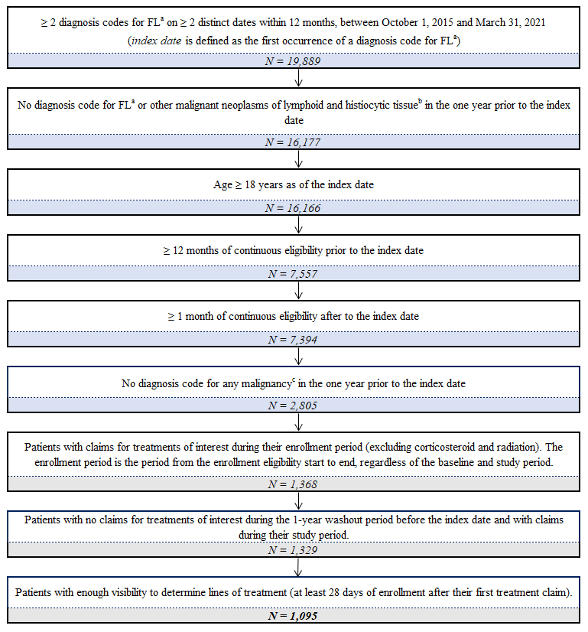
Abbreviations: FL, follicular lymphoma; ICD-9-CM, International Classification of Diseases, Ninth Revision, Clinical Modification; ICD-10-CM, International Classification of Diseases, Tenth Revision, Clinical Modification.
Notes:
[a] FL was identified based on the following ICD-10-CM code: C82.x.
[b] There was no distinct ICD-9-CM code for FL. Therefore, prior to 10/1/2015, FL was identified by 202.x (ICD-9-CM), which is labeled "other malignant neoplasm of lymphoid and histiocytic tissue."
[c] Malignancies were identified based on the ICD codes for "any malignancy, including leukemia and lymphoma" (C00.x–C26.x, C30.x–C34.x, C37.x– C41.x, C43.x, C45.x–C58.x, C60.x– C76.x, C81.x–C85.x, C88.x, C90.x–C97.x) and "metastatic solid tumor" (C77.x–C80.x) as identified in the Charlson Comorbidity Index [1]

Supplementary Fig. S2. WM sample selection
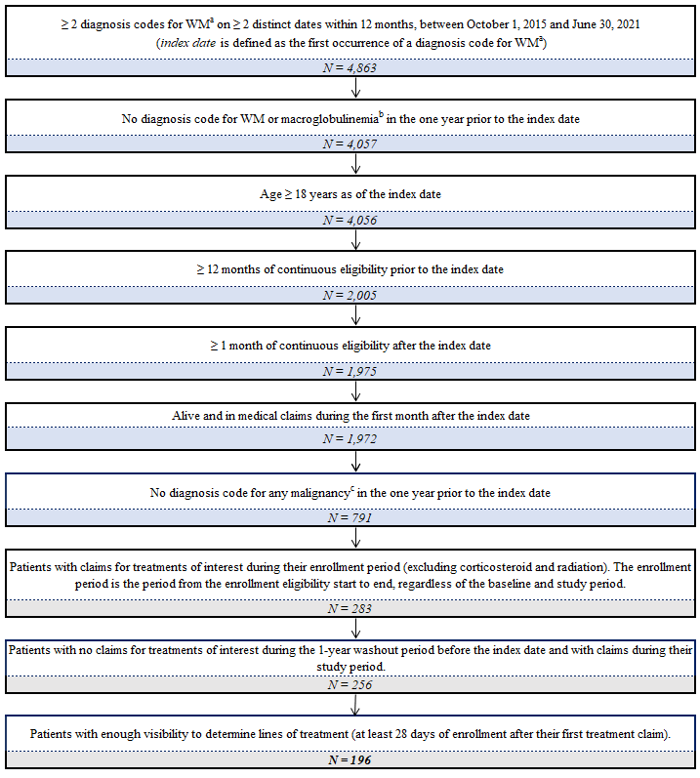
Abbreviations: ICD-9-CM, International Classification of Diseases, Ninth Revision, Clinical Modification; ICD-10-CM, International Classification of Diseases, Tenth Revision, Clinical Modification; WM, Waldenström’s macroglobulinemia.
Notes:
[a] WM was identified based on the following ICD-10-CM code: C88.0.
[b] There was no distinct ICD-9-CM code for WM. Therefore, prior to 10/1/2015, WM was identified by 273.3 (ICD-9-CM), which is labeled "Macroglobulinemia."
[c] Malignancies were identified based on the ICD codes for "any malignancy, including leukemia and lymphoma" (C00.x–C26.x, C30.x–C34.x, C37.x– C41.x, C43.x, C45.x–C58.x, C60.x– C76.x, C81.x–C85.x, C88.x, C90.x–C97.x) and "metastatic solid tumor" (C77.x–C80.x) as identified in the Charlson Comorbidity Index [1]

Supplementary Fig. S3. MZL sample selection
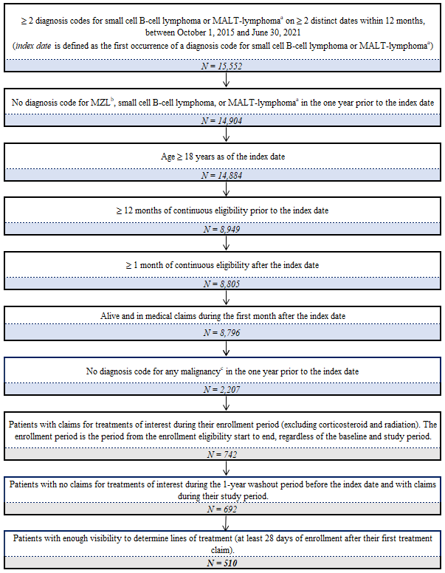
Abbreviations: ICD-9-CM, International Classification of Diseases, Ninth Revision, Clinical Modification; ICD-10-CM, International Classification of Diseases, Tenth Revision, Clinical Modification; MZL, marginal zone lymphoma.
Notes:
[a] There was no distinct ICD-10-CM code for MZL. Therefore, after 10/1/2015, MZL was identified by C83.0x (ICD-10-CM), which is labeled "Small cell B-cell lymphoma," or by C88.4 (ICD-10_CM), which is labeled "Extranodal marginal zone B-cell lymphoma of mucosa-associated lymphoid tissue [MALT-lymphoma]."
[b] Prior to 10/1/2015, MZL was identified by the following ICD-9-CM code: 200.3.
[c] Malignancies were identified based on the ICD codes for "any malignancy, including leukemia and lymphoma" (C00.x–C26.x, C30.x–C34.x, C37.x– C41.x, C43.x, C45.x–C58.x, C60.x– C76.x, C81.x–C85.x, C88.x, C90.x–C97.x) and "metastatic solid tumor" (C77.x–C80.x) as identified in the Charlson Comorbidity Index [1]

Supplementary Table S1. Treatment patterns among patients with indolent malignancies during the study period and stratified by LOT¹
- FL
Counts of Regimens by Line | Line 1 | Line 2 | Line 3
Counts of Regimens by Line | N = 1,095 | N = 236 | N = 53
Main Categories | (100.0%) | (21.6%) | (4.8%)
Bendamustine-based therapies | 449 (41.0%) | 34 (14.4%) | 7 (13.2%)
Rituximab monotherapy | 284 (25.9%) | 111 (47.0%) | 27 (50.9%)
R-CHOP or similar | 235 (21.5%) | 23 (9.7%) | —
CVP or similar | 41 (3.7%) | 14 (5.9%) | —
Other small molecule agents without rituximab | 29 (2.6%) | 19 (8.1%) | 6 (11.3%)
Other small molecule agents with rituximab | 17 (1.6%) | 6 (2.5%) | —
Lenalidomide-based therapies | 14 (1.3%) | 9 (3.8%) | —
CHOP or similar | 13 (1.2%) | — | —
Stem Cell Transplant | 7 (0.6%) | 11 (4.7%) | —
Ibrutinib-based therapies | — | — | —
GemOx or similar | — | — | —
CAR T-cell therapies | — | — | —
Bortezomib-based therapies | — | — | —

- WM
Counts of Regimens by Line | Line 1 | Line 2 | Line 3
Counts of Regimens by Line | N = 196 | N = 65 | N = 20
Main Categories | (100.0%) | (33.2%) | (10.2%)
Rituximab monotherapy | 59 (30.1%) | 22 (33.8%) | 8 (40.0%)
Bendamustine-based therapies | 55 (28.1%) | 10 (15.4%) | —
Ibrutinib-based therapies | 29 (14.8%) | 13 (20.0%) | —
Other small molecule agents without rituximab | 17 (8.7%) | — | —
Bortezomib-based therapies | 17 (8.7%) | 13 (20.0%) | —
Other small molecule agents with rituximab | 8 (4.1%) | — | —
Stem Cell Transplant | — | — | —
Lenalidomide-based therapies | — | — | —
CVP or similar | — | — | —
R-CHOP or similar | — | — | —
CHOP or similar | — | — | —
- MZL
Counts of Regimens by Line | Line 1 | Line 2 | Line 3
Counts of Regimens by Line | N = 510 | N = 116 | N = 37
Main Categories | (100.0%) | (22.7%) | (7.3%)
Rituximab monotherapy | 247 (48.4%) | 39 (33.6%) | 19 (51.4%)
Bendamustine-based therapies | 124 (24.3%) | 24 (20.7%) | 5 (13.5%)
Ibrutinib-based therapies | 47 (9.2%) | 15 (12.9%) | 6 (16.2%)
Other small molecule agents without rituximab | 31 (6.1%) | 10 (8.6%) | —
R-CHOP or similar | 28 (5.5%) | 8 (6.9%) | —
Other small molecule agents with rituximab | 10 (2.0%) | — | —
CVP or similar | 8 (1.6%) | — | —
Bortezomib-based therapies | 6 (1.2%) | — | —
Lenalidomide-based therapies | — | 7 (6.0%) | —
CHOP or similar | — | — | —
Stem cell transplant | — | — | —
Other BTK inhibitor-based therapies | — | — | —
GemOx or similar | — | — | —

“—” indicates that the results were redacted due to small sample sizes (n<5)

Abbreviations: 1L, first line; 2L, second line; 3L, third line; BTK, Bruton's tyrosine kinase; CAR T-cell therapies, chimeric antigen receptor (CAR)-T cell therapies; CHOP, cyclophosphamide-hydroxydaunorubicin hydrochloride-vincristine with or without prednisone; CVP, cyclophosphamide-vincristine with or without prednisone; GemOx, gemcitabine and oxaliplatin; LOT, line of therapy; R-CHOP, rituximab-cyclophosphamide-hydroxydaunorubicin hydrochloride-vincristine with or without prednisone; SD, standard deviation

Supplementary Table S2. All-cause and FL-related costs among patients with FL, stratified by LOT
Costs (USD), PPPM, mean ± SD [median] | Line
Costs (USD), PPPM, mean ± SD [median] | 1 | 2 | 3+
Costs (USD), PPPM, mean ± SD [median] | (N = 1,095) | (N = 236) | (N = 53)
All -cause healthcare costs
Total Overall Costs | 16,969 ± 19,285 [10,681] | 19,789 ± 25,956 [10,235] | 22,534 ± 29,070 [9,802]
Total Medical Costs | 16,447 ± 19,068 [10,068] | 19,072 ± 26,016 [9,529] | 21,449 ± 29,028 [8,427]
Hospitalization Costs | 4,754 ± 13,764 [0] | 8,971 ± 21,149 [252] | 11,763 ± 22,683 [599]
Outpatient Costs | 11,199 ± 10,906 [7,904] | 9,471 ± 11,376 [5,586] | 9,302 ± 9,622 [6,316]
ED Costs | 342 ± 1,565 [0] | 522 ± 3,040 [0] | 303 ± 565 [34]
Other Costs | 152 ± 1,210 [2] | 107 ± 405 [1] | 82 ± 179 [6]
Pharmacy Costs | 522 ± 1,889 [50] | 717 ± 2,074 [68] | 1,085 ± 2,353 [85]
Disease-related healthcare costs
Total Medical Costs | 11,089 ± 15,683 [6,034] | 10,960 ± 17,356 [4,961] | 11,806 ± 17,121 [4,117]
Hospitalization Costs | 3,014 ± 11,101 [0] | 4,802 ± 14,397 [0] | 7,344 ± 14,723 [0]
Outpatient Costs | 7,909 ± 9,312 [5,090] | 5,868 ± 7,966 [3,167] | 4,354 ± 5,824 [1,998]
ED Costs | 140 ± 1,279 [0] | 277 ± 2,807 [0] | 97 ± 386 [0]
Other Costs | 26 ± 169 [0] | 13 ± 90 [0] | 11 ± 44 [0]
Abbreviations: CI, confidence interval; ED, emergency department; FL, follicular lymphoma; LOT, line of therapy; PPPM, per-patient-per-month; SD, standard deviation; USD, United States dollar
Note:
- The most common places of service for visits classified as “Other” are independent laboratory, unspecified, other unlisted facility, skilled nursing facility, and nursing facility.

Supplementary Table S3. All-cause and WM-related costs among patients with WM, stratified by LOT
Costs (USD), PPPM, mean ± SD [median] | Line
Costs (USD), PPPM, mean ± SD [median] | 1 | 2 | 3+
Costs (USD), PPPM, mean ± SD [median] | (N = 196) | (N = 65) | (N = 20)
All -cause healthcare costs
Total Overall Costs | 15,834 ± 16,887 [9,738] | 15,639 ± 17,509 [11,033] | 13,198 ± 13,606 [6,797]
Total Medical Costs | 14,401 ± 17,197 [7,887] | 13,794 ± 17,488 [7,918] | 11,242 ± 12,350 [5,504]
Hospitalization Costs | 4,799 ± 11,443 [193] | 5,045 ± 11,516 [49] | 5,766 ± 7,408 [2,570]
Outpatient Costs | 8,957 ± 12,081 [5,003] | 8,339 ± 10,783 [5,221] | 5,114 ± 5,072 [3,647]
ED Costs | 381 ± 1,589 [0] | 327 ± 1,224 [0] | 173 ± 323 [0]
Other Costs | 264 ± 2,438 [2] | 84 ± 221 [3] | 188 ± 442 [13]
Pharmacy Costs | 1,433 ± 3,117 [80] | 1,845 ± 3,844 [138] | 1,957 ± 3,962 [55]
Disease-related healthcare costs
Total Medical Costs | 9,663 ± 14,664 [3,991] | 10,630 ± 15,990 [4,474] | 4,216 ± 6,385 [878]
Hospitalization Costs | 3,164 ± 8,916 [0] | 4,096 ± 10,017 [0] | 1,725 ± 3,820 [0]
Outpatient Costs | 6,319 ± 11,123 [2,406] | 6,335 ± 10,764 [3,158] | 2,410 ± 3,063 [878]
ED Costs | 166 ± 1,494 [0] | 170 ± 1,058 [0] | 74 ± 241 [0]
Other Costs | 15 ± 76 [0] | 28 ± 105 [0] | 7 ± 14 [0]
Abbreviations: CI, confidence interval; ED, emergency department; LOT, line of therapy; PPPM, per-patient-per-month; SD, standard deviation; USD, United States dollar; WM, Waldenström’s macroglobulinemia.
Note:
- The most common places of service for visits classified as “Other” are independent laboratory, unspecified, other unlisted facility, skilled nursing facility, and nursing facility.

Supplementary Table S4. All-cause and MZL-related costs among patients with MZL, stratified by LOT
Costs (USD), PPPM, mean ± SD [median] | Line
Costs (USD), PPPM, mean ± SD [median] | 1 | 2 | 3+
Costs (USD), PPPM, mean ± SD [median] | (N = 510) | (N = 116) | (N = 37)
All-cause healthcare costs
Total Overall Costs | 13,974 ± 22,577 [7,576] | 14,979 ± 16,536 [9,283] | 15,052 ± 19,400 [8,009]
Total Medical Costs | 12,753 ± 22,512 [6,229] | 12,499 ± 15,572 [7,675] | 12,720 ± 18,534 [4,713]
Hospitalization Costs | 4,560 ± 19,748 [0] | 4,060 ± 11,805 [0] | 7,567 ± 16,321 [0]
Outpatient Costs | 7,871 ± 9,469 [4,584] | 8,007 ± 9,334 [4,771] | 4,929 ± 4,280 [3,323]
ED Costs | 229 ± 820 [0] | 157 ± 457 [0] | 138 ± 398 [0]
Other Costs | 92 ± 495 [2] | 275 ± 1,201 [4] | 86 ± 230 [2]
Pharmacy Costs | 1,221 ± 3,298 [61] | 2,480 ± 4,775 [194] | 2,332 ± 4,303 [70]
Disease-related healthcare costs
Total Medical Costs | 5,597 ± 11,079 [1,736] | 5,228 ± 10,086 [815] | 3,699 ± 6,601 [505]
Hospitalization Costs | 1,868 ± 8,280 [0] | 1,106 ± 5,533 [0] | 1,388 ± 4,982 [0]
Outpatient Costs | 3,655 ± 6,602 [1,167] | 4,074 ± 8,762 [407] | 2,303 ± 3,428 [409]
ED Costs | 68 ± 644 [0] | 47 ± 408 [0] | 3 ± 17 [0]
Other Costs | 7 ± 61 [0] | 1 ± 3 [0] | 5 ± 26 [0]
Abbreviations: CI, confidence interval; ED, emergency department; LOT, line of therapy; MZL, marginal zone lymphoma; PPPM, per-patient-per-month; SD, standard deviation; USD, United States dollar.
Note:
The most common places of service for visits classified as “Other” are independent laboratory, unspecified, other unlisted facility, skilled nursing facility, and nursing facility.

Supplementary Table S5. Pharmacologic agents of interest
Chemotherapy agents
Bendamustine
Carboplatin
Chlorambucil
Cisplatin
Cladribine
Cyclophosphamide
Cytarabine
Doxorubicin
Etoposide
Fludarabine
Gemcitabine
Ifosfamide
Mitoxantrone
Oxaliplatin
Procarbazine
Vincristine
Vinorelbine
Novel/Targeted agents
Acalabrutinib
Bortezomib
Brentuximab Vedotin
Carfilzomib
Copanlisib
Duvelisib
Everolimus
Ibritumomab Tiuxetan
Ibrutinib
Idelalisib
Ixazomib
Lenalidomide
Loncastuximab tesirine
Obinutuzumab
Rituximab
Tazemetostat
Thalidomide
Tocilizumab
Umbralisib
Venetoclax
Zanubrutinib
Other chemotherapy-related agents
Mesna
Methotrexate
Selinexor

Supplementary Table S6. Chimeric antigen receptor T-cell agents of interest
Drug Name
Axicabtagene
Brexucabtagene autoleucel
Lisocabtagene
Tisagenlecleucel

Supplementary Table S7. Corticosteroids
Drug Name
Dexamethasone
Methylprednisolone
Prednisolone
Prednisone

Supplementary Text S1. LOT Algorithm methodology
This algorithm has been developed and adapted based on previously published algorithms to identify LOT in patients with hematological malignancies using claims data.[2, 3] A LOT could consist of a single drug or a combination of multiple drugs, which could be further combined with other therapies, including stem cell transplantation (SCT) and radiation. The definition of a LOT consisted of three steps: 1) defining individual treatments, 2) defining the LOT based on the individual treatment episodes identified for each patient, and 3) categorizing the LOT based on the individual treatments it contains.

1. Identification of individual treatments

Pharmacologic treatments: National Comprehensive Cancer Network (NCCN)-recommended systemic agents were identified. The agents were identified using General Product Identifiers (GPI), Healthcare Common Procedure Coding System (HCPCS), Current Procedural Terminology (CPT), and International Classification of Diseases, 9th (ICD-9) and 10th (ICD-10) editions (see Appendix Table 1 for list of pharmacologic agents).[4] Only the therapies that were available during the dates of the study period were considered in the algorithm.

Initiation date and discontinuation of each individual drug were identified. Discontinuation of an individual drug was defined as a treatment gap of ≥90 days.[2, 3, 5-7]

For drugs administered through intravenous (IV) infusion, the discontinuation date equaled the last administration date before the gap (≥90 day) + the treatment cycle − 1. Treatment cycles for IV drugs were defined as the 28-day combination therapy window (see section 2.A.1.a).
- Treatment cycles for IV drugs were defined as the 28-day combination therapy window (see ‘Identification of LOTs’ for definition of combination therapy window).

For oral drugs, the discontinuation date equaled the prescription fill date of the last prescription before the gap (≥90 day) + days of supply − 1.
- For prescriptions with missing days of supply, a period of 30 days was assumed as the days of supply.

SCT treatments: auto/allo-SCT was identified using ICD codes, CPT codes, and HCPCS codes.

Radiation therapy: radiation therapy was identified using ICD codes, CPT codes, and HCPCS codes.

Radiation and corticosteroid use were flagged but not used to identify LOTs.

Chimeric antigen receptor (CAR) T-cell therapy: leukapheresis was identified using CPT, HCPCS codes, revenue codes, and ICD codes. The infusion of CAR T-cell drugs was identified using GPI codes, CPT codes, HCPCS codes, and revenue codes (See Appendix Table 2 for CAR T-cell therapy agents).

2. Identification of LOTs

Washout period: the baseline period was defined as the 12-month period prior to the index date (i.e., the date of the first diagnosis code for the malignancy). Patients with a diagnosis code for any malignancy during the baseline period were excluded as part of sample selection. To increase the likelihood that the algorithm captured the first treatment initiated by patients for the disease, patients with claims for any of the treatments of interest (except radiation therapy and corticosteroids) during the baseline period were further excluded from the LOT analysis.

LOTs consisting of pharmacologic treatments

Initiation of 1L therapy

Initiation: the first line of therapy was defined by all unique agents received within the first 28 days following initiation of the first therapy. The 28-day period corresponds to the most commonly recommended duration for any NCCN-recommended treatment regimen.[8-10] NCCN resources with durations for recommended regimens were reviewed for DLBCL, FL, and WM; these resources were not available for MCL, MZL, and RS.

Initiation of ≥2L therapy

Add: a new LOT started with the initiation of a new agent added after the 28-day initiation period of the previous LOT. Each new LOT was defined as the unique agents used within the first 28-day period following the initiation of the new LOT. Corticosteroid use or radiation therapy were not used to define the starting date or ending date of a LOT (See Appendix Table 3 for corticosteroid agents).

Switch: a new LOT started when all agents from the previous LOT were discontinued, and a new agent was initiated after the discontinuation of the previous LOT. The LOT was defined as the unique agents used within the first 28-day period following the initiation of the new LOT. Corticosteroid use or radiation therapy were not used to define the starting date or ending date of a LOT.

Same drug repeated: re-initiation of the same agents from the previous LOT after a 90-day gap was considered a new LOT. Otherwise, re-initiation of the same agents from the previous LOT was considered the same LOT.

End of LOT

The end date of an LOT was defined as the earlier of a) the latest discontinuation date for a drug included in the LOT or b) the day preceding the date of initiation of a new LOT, whichever occurred first. The LOT period was the period from the LOT start date (earliest treatment initiation/switch/add date) to the LOT end date.
- Discontinuation of a LOT: discontinuation of a LOT was defined as a 90-day discontinuation of all agents, with the LOT discontinuation date defined as the discontinuation date of the last agent in the LOT.
- Partial drop: the discontinuation of a single agent or more than one agent from a combination therapy was not considered a new LOT.
- In the event of an addition, the LOT end date was the day before the start of the new LOT.

LOTs with SCT treatments

Any pharmacologic treatment started 6 months before the SCT or 10 days after (within 90 days after for rituximab treatments) were considered part of the SCT line to account for the entire SCT process (salvation, conditioning, and maintenance).

Transplantation in combination with other therapies: autologous or allogenic SCT that occurred within the same period as another treatment (LOT period plus additional 90 days) was considered to be in combination. Any pharmacologic LOT started during 6 months prior to an SCT infusion up to 10 days after the SCT infusion was considered part of the same LOT as the SCT. This ensured that the entire process (i.e., salvation, conditioning, and stem cell infusion) was considered as one LOT. Any treatment started 6 months to 10 days prior to the SCT infusion was considered salvage therapy and any treatment started within 10 days of the SCT was considered conditioning therapy.

Transplantation independent of other therapies: transplantation therapy not within the same period as any other pharmacologic LOTs was considered as a standalone SCT LOT. It was assumed that salvation and conditioning therapy data were missing.

Maintenance therapy: Rituximab monotherapy initiated within 90 days of the SCT was considered as a maintenance therapy and was part of the same LOT as the SCT.

LOTs with radiation therapy

Radiation in combination with other therapies: if radiation therapy occurred during a pharmacologic LOT, the radiation therapy was considered part of that LOT. Additionally, if radiation therapy occurred outside of a pharmacologic LOT but within 90 days of the discontinuation of a pharmacologic LOT, the radiation therapy was considered a part of that LOT.

Radiation independent of other therapies: radiation therapy not within the same period as any other anti-cancer therapies was not considered as a LOT. [11-14]

LOTs with CAR T-cell therapy

Any pharmacologic treatments started 60 days before or 14 days after the CAR T therapy were considered part of the CAR T LOT to account for lymphodepleting chemotherapy and bridging therapy.

Leukapheresis and CAR T therapy infusion were identified separately. Bridging therapy and lymphodepleting chemotherapy were defined based on the timing of leukapheresis and CAR T therapy. Together, all four were defined as one LOT. Only CAR T infusions were used to detect CAR T patients based on the HCPCS and CPT codes defined.

Multiple CAR T infusions identified within one inpatient visit were treated as one LOT. The CAR T infusion date was the first claim date for CAR T infusion during the inpatient stay.

If multiple infusions were different treatments (e.g., Kymriah vs. Yescarta), they were considered as the different lines.

If leukapheresis and CAR T infusions were both identified:

Lymphodepleting chemotherapy was identified as the chemotherapy administered after leukapheresis and within 2 weeks of CAR T infusion date.

Bridging therapy was identified as chemotherapies or immunotherapy initiated between leukapheresis and the beginning of lymphodepleting therapy.

If only CAR T infusion could be identified:

Lymphodepleting chemotherapy was identified as the chemotherapy initiated within 2 weeks of CAR T infusion date.

Bridging therapy was identified as the last chemotherapy or immunotherapy initiated between 60 days before CAR T infusion date and the initiation of lymphodepleting therapy (if any) or 14 days before CAR T infusion date (if no lymphodepleting chemotherapy).

3. Categorization of LOTs and reporting of treatment sequences

LOTs were categorized as follows. The hierarchy is in descending order, beginning with the highest level:
- SCT
- CAR T-cell therapy
- Bruton’s tyrosine kinase (BTK) inhibitors
- Ibrutinib-based therapies (with or without other treatments, including rituximab)
- Other BTK inhibitor-based therapies (with or without other treatments, including rituximab)
- A regimen of rituximab, cyclophosphamide, hydroxydaunorubicin hydrochloride, Oncovin (vincristine) and prednisone, also called R-CHOP, or similar (alone or in combination with other small molecule agents)
- A regimen of cyclophosphamide, hydroxydaunorubicin hydrochloride, Oncovin (vincristine) and prednisone, also called CHOP, or similar (alone or in combination with other small molecules)
- A regimen of cyclophosphamide, vincristine sulfate, and prednisone, also called CVP, or similar +/- rituximab (alone or in combination with other small molecule agents, with or without rituximab)
- Gemcitabine-oxaliplatin, also called GemOx, +/- rituximab (alone or in combination with other small molecule agents, with or without rituximab)
- Bendamustine-based therapies +/- rituximab (bendamustine alone or in combination with other small molecule agents, with or without rituximab)
- Lenalidomide-based therapies +/- rituximab (lenalidomide alone or in combination with other small molecule agents, with or without rituximab)
- Bortezomib-based therapies +/- rituximab (bortezomib alone or in combination with other small molecule agents, with or without rituximab)
- Rituximab monotherapy
- Other small molecule agents with rituximab
- Other small molecule agents without rituximab

REFERENCES
1. Quan H, Sundararajan V, Halfon P, Fong A, Burnand B, Luthi JC, et al. Coding algorithms for defining comorbidities in ICD-9-CM and ICD-10 administrative data. Med Care. 2005;43(11):1130–9. doi: 10.1097/01.mlr.0000182534.19832.83.
2. Yang X, Laliberte F, Germain G, Raut M, Duh MS, Sen SS, et al. Real-World Characteristics, Treatment Patterns, Health Care Resource Use, and Costs of Patients with Diffuse Large B-Cell Lymphoma in the U.S. Oncologist. 2021;26(5):e817–e26. doi: 10.1002/onco.13721.
3. Xie J, Wu A, Liao L, Nastoupil LJ, Du EX, Noman A, et al. Characteristics and treatment patterns of relapsed/refractory diffuse large B-cell lymphoma in patients receiving >/=3 therapy lines in post-CAR-T era. Curr Med Res Opin. 2021;37(10):1789–98. doi: 10.1080/03007995.2021.1957806.
4. Referenced with permission from the NCCN Clinical Practice Guidelines in Oncology (NCCN Guidelines®) for B-Cell Lymphomas V.2.2024. © National Comprehensive Cancer Network, Inc. 2024. All rights reserved. Accessed June 03, 2024. To view the most recent and complete version of the guideline, go online to NCCN.org.
5. Tsutsue S, Tobinai K, Yi J, Crawford B. Nationwide claims database analysis of treatment patterns, costs and survival of Japanese patients with diffuse large B-cell lymphoma. PLoS One. 2020;15(8):e0237509. doi: 10.1371/journal.pone.0237509.
6. Goyal RK, Nagar SP, Kabadi SM, Kaye JA, Seal B, Mato AR. Adverse events, resource use, and economic burden associated with mantle cell lymphoma: a real-world assessment of privately insured patients in the United States. Leuk Lymphoma. 2019;60(4):955–63. doi: 10.1080/10428194.2018.1509320.
7. Fowler NH, Chen G, Lim S, Manson S, Ma Q, Li FY. Treatment Patterns and Health Care Costs in Commercially Insured Patients with Follicular Lymphoma. J Health Econ Outcomes Res. 2020;7(2):148–57. doi: 10.36469/jheor.2020.16784.
8. National Comprehensive Cancer Network. (2021). B-Cell Lymphomas Treatment Regimens: Follicular Lymphoma (Grade 1-2). Retrieved from Cancer Therapy Advisor.
9. National Comprehensive Cancer Network. (2021). Waldenström Macroglobulinemia/Lymphoplasmacytic Lymphoma Treatment Regimens. Retrieved from Cancer Therapy Advisor.
10. National Comprehensive Cancer Network. (2018). Non-Hodgkin Lymphoma Treatment Regimens: Diffuse Large B-cell Lymphoma. Retrieved from Cancer Therapy Advisor. .
11. Seal BS, Sullivan SD, Ramsey S, Shermock KM, Ren J, Kreilick C, et al. Medical costs associated with use of systemic therapy in adults with colorectal cancer. J Manag Care Pharm. 2013;19(6):461–7. doi: 10.18553/jmcp.2013.19.6.461.
12. Ramsey S, Henk HJ, Smith GL, Sollano J, Chen C. First-, second-and third-line lung cancer treatment patterns and associated costs in a US healthcare claims database. Lung Cancer Management. 2015;4(3):131–43.
13. Hurvitz S, Guerin A, Brammer M, Guardino E, Zhou ZY, Latremouille Viau D, et al. Investigation of adverse-event-related costs for patients with metastatic breast cancer in a real-world setting. Oncologist. 2014;19(9):901–8. doi: 10.1634/theoncologist.2014-0059.
14. Wong W, Yim YM, Kim A, Cloutier M, Gauthier-Loiselle M, Gagnon-Sanschagrin P, et al. Assessment of costs associated with adverse events in patients with cancer. PLoS One. 2018;13(4):e0196007. doi: 10.1371/journal.pone.0196007.

