Influence of Disease and Patient Characteristics on Daratumumab Exposure and Clinical Outcomes in Relapsed or Refractory Multiple Myeloma

Supplemental Data

Supplemental Table 1. Baseline disease and patient characteristics.
 | Study MMY2002  N=123  n (%) | Study GEN501  N=100  n (%) | Combined  N=223  n (%)
Age (years)
N | 123 | 100 | 223
Median | 64 | 61 | 63
Range | (31, 84) | (38, 76) | (31, 84)
Weight (kg)
N | 123 | 100 | 223
Median | 76 | 80.5 | 78.6
Range | (38.4, 160.2) | (43, 141.8) | (38.4, 160.2)
Albumin (g/L)
N | 123 | 100 | 223
Median | 34 | 39.5 | 37
Range | (15, 47) | (20, 51) | (15, 51)
Sex
Men | 64 (52) | 68 (68) | 132 (59)
Women | 59 (48) | 32 (32) | 91 (41)
Race
White, not Hispanic or Latino | 94 (76) | 74 (74) | 168 (75)
Black, of African Heritage or African-American | 15 (12) | 2 (2) | 17 (8)
White, Hispanic or Latino | 6 (5) | 1 (1) | 7 (3)
Asian | 4 (3) | 0 | 4 (2)
Other | 4 (3) | 1 (1) | 5 (2)
Missing | 0 | 22 (22) | 22 (10)
Creatinine clearance category
≥90 mL/min | 31 (25) | 40 (40) | 71 (32)
≥60 - ≤89 mL/min | 40 (33) | 38 (38) | 78 (35)
≥30 - ≤59 mL/min | 47 (37) | 21 (21) | 68 (30)
≥15 - ≤29 mL/min | 4 (3) | 1 (1) | 5 (2)
<15 mL/min | 1 (1) | 0 | 1 (<1)
Hepatic dysfunction
Normal | 100 (81) | 88 (88) | 188 (84)
Mild dysfunction | 22 (18) | 12 (12) | 34 (15)
Missing | 1 (1) | 0 | 1 (<1)
Baseline ECOG score
0 | 36 (29) | 30 (30) | 66 (30)
1 | 77 (63) | 66 (66) | 143 (64)
2 | 10 (8) | 4 (4) | 14 (6)
Lines of prior therapy
≤3 Lines | 24 (20) | 23 (23) | 47 (21)
>3 Lines | 99 (80) | 77 (77) | 176 (80)
Type of myeloma at baseline by immunofixation
IgG | 60 (49) | 49 (49) | 109 (49)
Non-IgG | 63 (51) | 51 (51) | 114 (51)
Refractory status
None | 0 | 23 (23) | 23 (10)
PI only | 0 | 8 (8) | 8 (4)
IMiD only | 0 | 12 (12) | 12 (5)
Both PI and IMiD | 123 (100) | 57 (57) | 180 (81)
ECOG, Eastern Cooperative Oncology Group; IgG, immunoglobulin G; PI, proteasome inhibitor IMiD, immunomodulatory drug.
Note: Data are presented as percentages based on the number of patients with reported data for a particular characteristic.
Statistics were calculated before the imputation of missing values. Five patients were excluded from the population PK analyses because they did not have measurable concentrations of daratumumab: 1 patient from SIRIUS who received only one dose of 16 mg/kg daratumumab and 4 patients from GEN501 who received ≤0.1 mg/kg daratumumab.

Supplemental Fig. 1 Trough concentration versus time profiles from patients receiving 16 mg/kg daratumumab in the GEN501 and SIRIUS studies, stratified by disease and patient characteristics. The trend lines and bands represent LOESS regression lines and their associated 95% confidence intervals

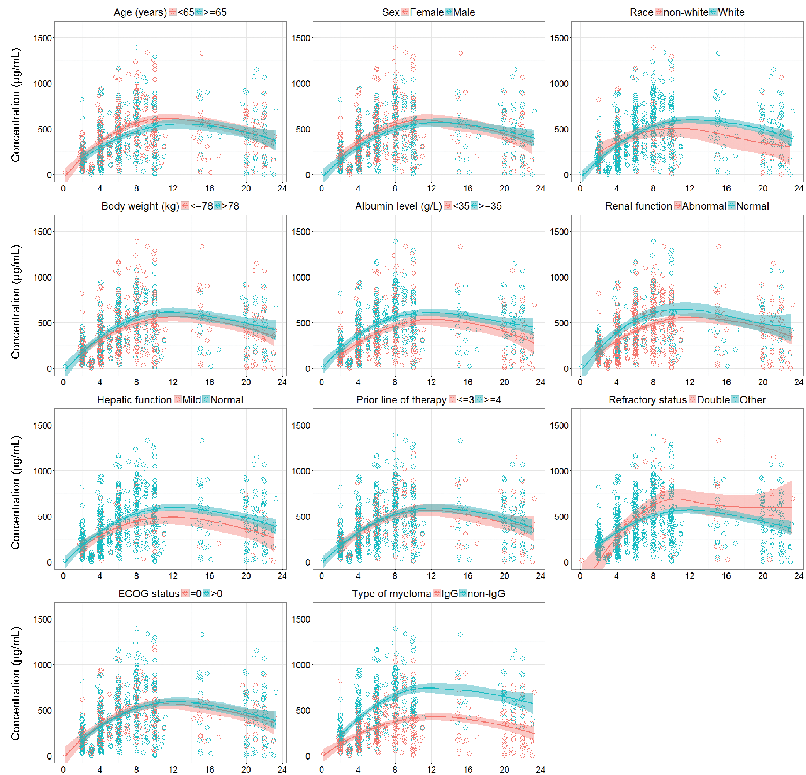
Supplemental Fig. 2 The relationship between individual linear clearance and baseline levels of IgG M-protein. Linear clearance refers to non-specific clearance of mAbs due to protein catabolism

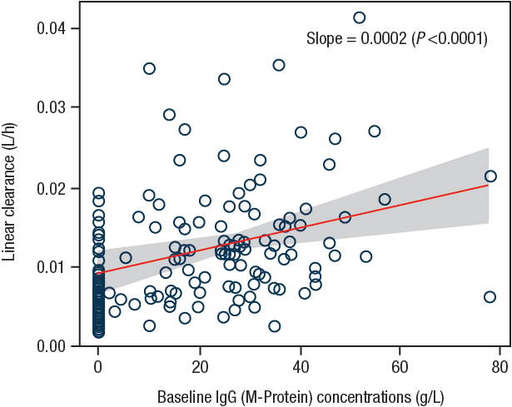

Supplemental Fig. 3 Boxplot (a) and waterfall plot (b) comparing maximum relative change in paraprotein in patients with IgG versus non-IgG MM treated with 16 mg/kg daratumumab
a.
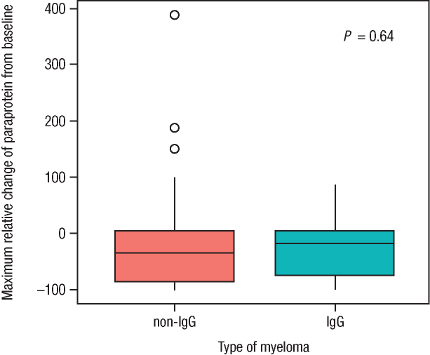
b.
