ONLINE RESOURCE

Clinical Pharmacokinetics

Clinical Pharmacokinetic and Pharmacodynamic Profile of Riociguat
Reiner Frey^{1*} • Corina Becker¹ • Soundos Saleh¹ • Sigrun Unger² • Dorina van der Mey¹ • Wolfgang Mück¹
¹ Clinical Pharmacology, Bayer AG, Wuppertal, Germany
² Global Biostatistics, Bayer AG, Wuppertal, Germany

* Corresponding author: reiner.frey@bayer.com

Table S1 Preclinical studies of riociguat in models of systemic and pulmonary hypertension (Adapted with permission of Springer from M. Humbert et al. [eds.], Pharmacotherapy of Pulmonary Hypertension, Handbook of Experimental Pharmacology. Soluble Guanylate Cyclase Stimulators in Pulmonary Hypertension 218, 2013, p279-313, Stasch J-P and Evgenov OV. Copyright © Springer-Verlag Berlin Heidelberg 2013)
Study design | Treatment | Effect of riociguat | Reference
Rat and mouse models with fully established PH (induced by monocrotaline and chronic hypoxia, respectively) | Oral riociguat administered daily | Partial reversal of PH, RV hypertrophy, and pulmonary vascular remodeling  No significant effect on systemic arterial pressure | (Schermuly, Stasch et al. 2008)
Rat model of angioproliferative PAH (induced by hypoxia and the VEGFR antagonist SU5416) | Oral riociguat administered daily | Increased open:occluded artery ratio and cardiac output  Decreased neointima:media ratio, RV systolic pressure, and total pulmonary resistance  Greater decrease in RV hypertrophy and improvement in RV function than with sildenafil | (Lang, Kojonazarov et al. 2012)
Rat model of angioproliferative PAH (induced by hypoxia and the VEGFR antagonist SU5416) | Oral riociguat administered daily | Increased Smad 1/5 phosphorylation and decreased medial thickness in vascular lesions | (Schwappacher, Kilic et al. 2013)
Mouse model of PH due to left heart disease (induced by transverse aortic constriction) | Oral riociguat administered daily | Amelioration of PH  Reduced pulmonary vascular remodeling  Improved RV function | (Pradhan, Sydykov et al. 2016)
Mouse model of COPD (induced by tobacco smoke exposure) | Oral riociguat administered daily | Prevention of PH development, RV hypertrophy, and vascular remodeling | (Weissmann, Lobo et al. 2014)
Mouse model of pulmonary fibrosis and PH (induced by bleomycin) | Oral riociguat administered daily | Attenuation of PH and RV hypertrophy to a greater extent than with sildenafil  Amelioration of pulmonary inflammation and fibrosis  Improved survival | (Evgenov, Stasch et al. 2011)
Two rat models of systemic hypertension (renin-transgenic rats with NOS inhibited by L-NAME, and rats with 5/6 nephrectomy) | Oral riociguat administered daily | Normalization of blood pressure  Reduced heart and kidney damage  Improved survival | (Sharkovska, Kalk et al. 2010)
Rat model of systemic hypertension (Dahl salt-sensitive rats fed a high-salt diet) | Oral riociguat administered daily | Attenuation of systemic hypertension, systolic dysfunction, fibrotic tissue remodeling, and degenerative changes in the myocardium and renal cortex  Improved survival | (Geschka, Kretschmer et al. 2011)
Diabetic eNOS-knockout mice | Oral riociguat and an ARB co-administered daily | Reduced blood pressure and attenuation of nephropathy | (Ott, Alter et al. 2012)
ARB angiotension II receptor blocker, COPD chronic obstructive pulmonary disease, eNOS endothelial nitric oxide synthase, L-NAME, N-nitro-l-arginine methyl ester, NOS nitric oxide synthase, PAH pulmonary arterial hypertension, PH pulmonary hypertension, RV right ventricular, VEGFR vascular endothelial growth factor receptor.

Figure S1 Riociguat individual dose-adjustment strategy (From Riociguat for the Treatment of Pulmonary Arterial Hypertension, Ghofrani HA, et al, N Engl J Med 2013;369:330-340. Copyright©2013 Massachusetts Medical Society. Reprinted with permission from Massachusetts Medical Society). Patients should receive a starting dose of riociguat of 1.0 mg TID. If the patient maintains a systolic blood pressure >95 mmHg and shows no signs or symptoms of hypotension (e.g. presyncope or dizziness), the dose should be increased by 0.5 mg TID every 2 weeks, to a maximum of 2.5 mg TID. If the patient’s systolic blood pressure decreases below 95 mmHg and the patient shows signs or symptoms of hypotension, the current dose should be decreased by 0.5 mg TID.
TID, three times daily

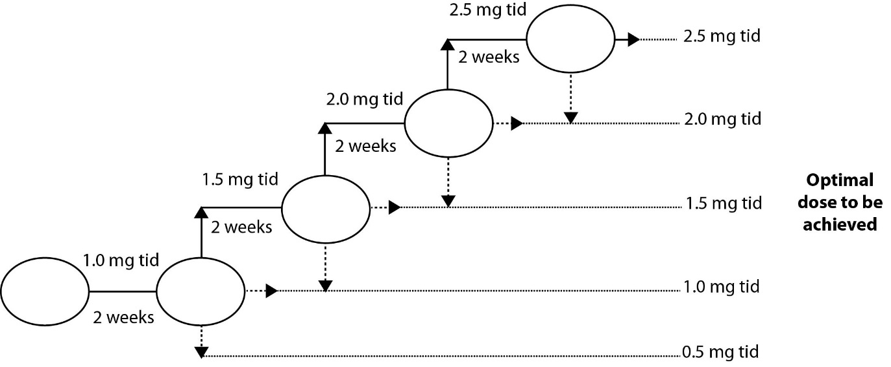

References
Evgenov, O. V., J. P. Stasch, M. Mino-Kenudson, E. J. Mark, E. S. buys, L. Zou, M. zhang, M. J. Raher, Y. Li, Y. Feng, R. C. Jones and W. Chao (2011). "Stimulator of soluble guanylate cyclase riociguat protects against bleomycin-induced pulmonary fibrosis in mice." Am J Respir Crit Care Med 183.
Geschka, S., A. Kretschmer, Y. Sharkovska, O. V. Evgenov, B. Lawrenz, A. Hucke, B. Hocher and J. P. Stasch (2011). "Soluble guanylate cyclase stimulation prevents fibrotic tissue remodeling and improves survival in salt-sensitive Dahl rats." PLoS One 6(7): 1-10.
Ghofrani, H. A., N. Galiè, F. Grimminger, E. Grunig, M. Humbert, Z. C. Jing, A. M. Keogh, D. Langleben, M. O. Kilama, A. Fritsch, D. Neuser and L. J. Rubin (2013). "Riociguat for the treatment of pulmonary arterial hypertension." N Engl J Med 369(4): 330-340.
Lang, M., B. Kojonazarov, X. Tian, A. Kalymbetov, N. Weissmann, F. Grimminger, A. Kretschmer, J. P. Stasch, W. Seeger, H. A. Ghofrani and R. T. Schermuly (2012). "The soluble guanylate cyclase stimulator riociguat ameliorates pulmonary hypertension induced by hypoxia and SU5416 in rats." PLoS One 7(8 e43433): 1-9.
Ott, I. M., M. L. Alter, W. K. von, A. Kretschmer, O. Tsuprykov, Y. Sharkovska, K. Krause-Relle, J. Raila, A. Henze, J. P. Stasch and B. Hocher (2012). "Effects of stimulation of soluble guanylate cyclase on diabetic nephropathy in diabetic eNOS knockout mice on top of angiotensin II receptor blockade." PLoS One 7(8): e42623.
Pradhan, K., A. Sydykov, X. Tian, A. Mamazhakypov, B. Neupane, H. Luitel, N. Weissmann, W. Seeger, F. Grimminger, A. Kretschmer, J. P. Stasch, H. A. Ghofrani and R. T. Schermuly (2016). "Soluble guanylate cyclase stimulator riociguat and phosphodiesterase 5 inhibitor sildenafil ameliorate pulmonary hypertension due to left heart disease in mice." Int J Cardiol 216: 85-91.
Schermuly, R. T., J. P. Stasch, S. S. Pullamsetti, R. Middendorff, D. Muller, K. D. Schluter, A. Dingendorf, S. Hackemack, E. Kolosionek, C. Kaulen, R. Dumitrascu, N. Weissmann, J. Mittendorf, W. Klepetko, W. Seeger, H. A. Ghofrani and F. Grimminger (2008). "Expression and function of soluble guanylate cyclase in pulmonary arterial hypertension." Eur Respir J 32(4): 881-891.
Schwappacher, R., A. Kilic, B. Kojonazarov, M. Lang, T. Diep, S. Zhuang, T. Gawlowski, R. T. Schermuly, A. Pfeifer, G. R. Boss and R. B. Pilz (2013). "A molecular mechanism for therapeutic effects of cGMP-elevating agents in pulmonary arterial hypertension." J Biol.Chem. 288(23): 16557-16566.
Sharkovska, Y., P. Kalk, B. Lawrenz, M. Godes, L. S. Hoffmann, K. Wellkisch, S. Geschka, K. Relle, B. Hocher and J. P. Stasch (2010). "Nitric oxide-independent stimulation of soluble guanylate cyclase reduces organ damage in experimental low-renin and high-renin models." J Hypertens 28(8): 1666-1675.
Weissmann, N., B. Lobo, A. Pichl, N. Parajuli, M. Seimetz, R. Puig-Pey, E. Ferrer, V. I. Peinado, D. Dominguez-Fandos, A. Fysikopoulos, J. P. Stasch, H. A. Ghofrani, N. Coll-Bonfill, R. Frey, R. T. Schermuly, J. Garcia-Lucio, I. Blanco, M. Bednorz, O. Tura-Ceide, E. Tadele, R. P. Brandes, J. Grimminger, W. Klepetko, P. Jaksch, R. Rodriguez-Roisin, W. Seeger, F. Grimminger and J. A. Barbera (2014). "Stimulation of soluble guanylate cyclase prevents cigarette smoke-induced pulmonary hypertension and emphysema." Am J Respir.Crit Care Med 189(11): 1359-1373.

