Electronic Supplementary Material
Clinical Pharmacokinetics
Clinical Pharmacokinetics and Pharmacodynamics of Evolocumab, a PCSK9 Inhibitor
Sreeneeranj Kasichayanula¹*; Anita Grover¹*; Maurice G. Emery¹*; Megan A. Gibbs¹*; Ransi Somaratne²; Scott M. Wasserman²; John P. Gibbs¹*
¹Clinical Pharmacology Modeling and Simulation, Amgen Inc., Thousand Oaks, CA; ²Clinical Development, Amgen Inc., Thousand Oaks, CA
(*Former Amgen employee)

Figure S1. Week 12 Unbound Evolocumab Serum Concentration Versus Total Body Weight
for 140 mg SC Q2W or 420 mg SC QM
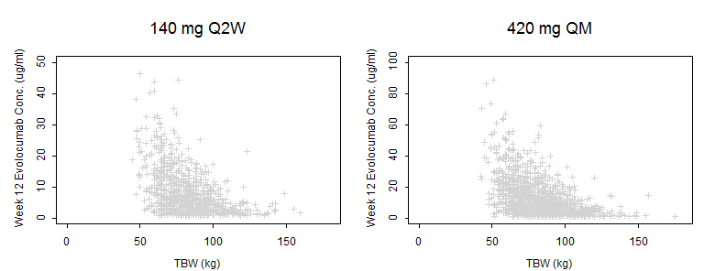
 | (N = 912) | (N = 1615)
TBW = total body weight; Q2W = once every 2 weeks; QM = once monthly (every 4 weeks).

Figure S2. Week 12 Calculated LDL-C Concentration Versus Total Body Weight
for 140 mg SC Q2W or 420 mg SC QM
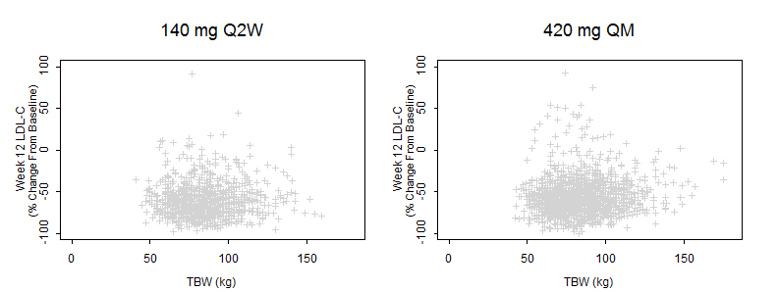
 | (N = 988) | (N = 1695)

LDL-C = low-density lipoprotein cholesterol; TBW = total body weight; Q2W = once every 2 weeks; QM = once monthly (every 4 weeks).

Figure S3. Week 12 Evolocumab Concentration Versus Race
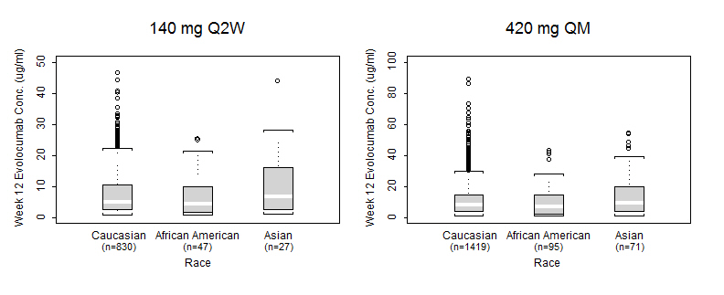
.
Q2W = once every 2 weeks; QM = once monthly (every 4 weeks).
Figure S4. Week 12 Evolocumab Concentration Versus Sex
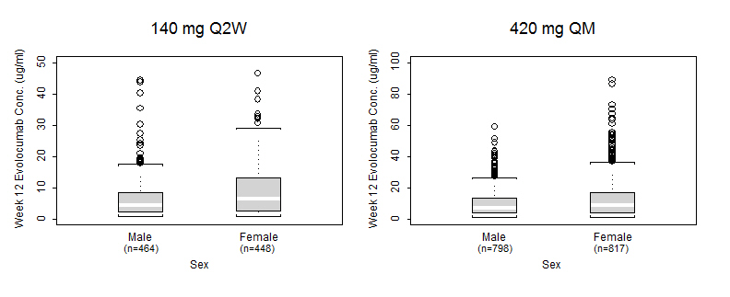
Q2W = once every 2 weeks; QM = once monthly (every 4 weeks).

Figure S5. Week 12 Unbound Evolocumab Serum Concentration Versus Age for 140 mg SC Q2W or 420 mg SC QM
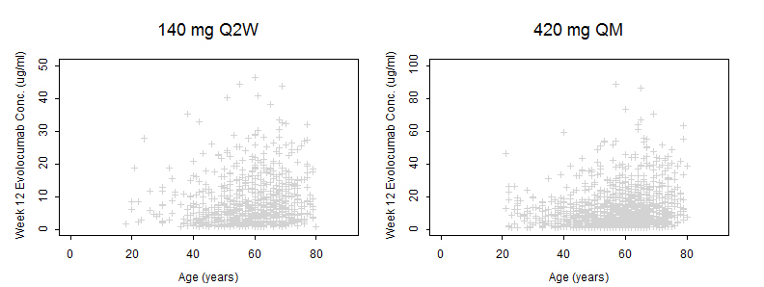
 | (N = 912) | (N = 1615)

Q2W = once every 2 weeks; QM = once monthly (every 4 weeks).

