Supplemental material

Clinical Pharmacokinetics

Pharmacokinetics and pharmacodynamics of once-weekly somapacitan in children and adults; supporting dosing rationales with a model-based analysis of three phase 1 trials
Rasmus Vestergaard Juul, Michael Højby Rasmussen, Henrik Agersø, Rune Viig Overgaard

Corresponding author: Rasmus Vestergaard Juul, Global Development, Novo Nordisk A/S, Bagsvaerd, Denmark
Email address: rvej@novonordisk.com
Phone number: +4544448888

Supplemental Methods
The number of blood samples collected for each trial is briefly summarized below for each of the phase 1 trials of once-weekly somapacitan in healthy adults [1], subjects with adult growth hormone (GH) deficiency (AGHD) [2] and children with GHD [3].
Blood samples
In healthy adults (NCT01514500), blood samples for pharmacokinetic (PK) and pharmacodynamic (PD) assessments were taken at baseline and up to 10 days (240 hours) and up to 7 days (168 hours) in the single and multiple dose parts of the trial, respectively [1]. For the multiple dosing part, samples were taken following each of the four doses and follow-up visit [1].
In adult with GHD (NCT01706783), blood samples for PK assessments were collected at baseline, 30 minutes before dosing, and 7 days after the first and fourth somapacitan dose (0, 0.25, 1, 2, 4, 6, 8, 12, 16, 20, 24, 26, 28, 30, 36, 42, 48, 50, 56, 64, 72, 96, 120, 144, and 168 hours) while PD assessments were collected at baseline, 30 minutes prior to dosing, and 7 days after the first and fourth somapacitan dose (0, 12, 24, 48, 72, 96, 120, 144, and 168 hours) [2].
In children with GHD (NCT01973244), blood samples for PK and PD assessments were performed shortly before the first treatment injection; 1, 4, 8, 12, 16, 24, 28, 36, 48, 72, 96, 168 and 240 hours post-dose; and at follow-up [3].
Assays
Analysis of serum concentrations of somapacitan and insulin-like growth factor I (IGF-I) were performed using validated assays, with similar methodology among the three phase 1 trials [1-3].
Serum concentrations of somapacitan were analyzed using a validated somapacitan-specific luminescent oxygen channeling immunoassay with no cross-activity with human GH validated in accordance with US Food and Drug Administration guidelines (US Department of Health and Human Services 2001) [for details see [2]]. Analysis of serum IGF-1 and Insulin-like growth factor-binding protein 3 (IGFBP-3) concentrations was performed using commercially available assay kits (Immuno Diagnostic Systems immunoassay ISYS assay) and Siemens Immulite 2000 immunoassay anaylzer (Siemens Healthcare Diagnostics) at the analytical central laboratory (Laboratorium für Klinische Forschung GmbH, Schwentinental, Germany). GH, IGF-1, and IGFBP-3 assay performance was in accordance with the assay information provided by the manufacturer. IGF-1 SDS values were calculated according to Bidlingmaier et al 2014 [4]. Normal reference data for the calculation of standard deviation scores were provided by the assay kit manufacturer for IGFBP-3. Reference centiles were obtained using the lambda-mu-sigma method [5].

Supplementary Results
Base PK and PK/PD models
Base PK and PK/PD models were identified using the step-wise approach described in methods, section 2.4.4.
Variability in the PK model was identified with a random effect (ETA) search initiated from a model with IIV, IOV and body weight as a covariate on 1/F (implemented as shared ETA on V_{max}/F, K₀/F and V/F). This model was considered as the simplest implementation of effects on a single parameter that did not lead to visual misspecification (Supplementary Table 1). The base PK model was defined as a model with no covariates and with shared ETA on V_{max}/F, K₀/F and V/F in addition to ETAs on K_{a} and K_{tr}.
Variability in the PK/PD model was identified with an ETA search conducted from a model with covariate GHD status on K_{in} and age group on E_{max}. This model was the simplest implementation that did not lead to visual misspecification (Supplementary Table 2). The base PK/PD model was defined as a model with no covariates and with ETAs on K_{in}, K_{out} and E_{max}.
Covariates and final model
Final PK and PK/PD models were identified using the step-wise covariate search described in methods, section 2.4.5.
A stepwise covariate search was conducted from the base PK model (Supplementary Table 1). The final PK model included a shared body weight covariate on V_{max}/F, K₀/F and V/F and a shared body weight covariate on K_{a} and K_{tr}, and both covariates were significant at p < 0.001. No further significant covariates were found.
A stepwise covariate search was conducted from the base PK/PD model (Supplementary Table 2). The final PK/PD model included covariates body weight on E_{max}, and K_{out} and GHD status on K_{in} and K_{out}, and all included covariates were significant at p < 0.001. No further significant covariates were found.
Supplementary Table 1. Stepwise search for variability and covariate analysis for base and final PK models respectively.
Random effect and covariate search parameters | ΔOFV
Random effect (ETA) search for base model from initial model*
ETA added on K_{a} | -802.4
ETA added on K_{tr} | -615.9
No further ETAs fulfilled ETA selection criteria.
Base model obtained by removing body weight covariate
Covariate search for final model
Body weight added on V_{max}/F, K₀/F and V/F | -166.9
Body weight added on K_{tr} | -41.1
Body weight added on K_{a} | -35.4
Body weight implemented as shared K_{tr} and K_{a} | 1.6
No further covariates fulfilled covariate selection criteria.
Full model obtained
ETA, random effect; F, bioavailability; K_{a}, linear absorption rate constant; K_{tr}, linear transit rate constant; K₀, zero-order rate constant; ΔOFV, difference in objective function value; PK, pharmacokinetic; V, volume of distribution; V_{max}, maximum elimination rate. *Initial model included IIV, IOV and body weight as a covariate on 1/F.
Supplementary Table 2. Stepwise search for variability and univariate covariate analysis for base and final PK/PD models respectively.
Random effect and covariate search parameters | ΔOFV
Random effect (ETA) search for base model
ETA added on K_{out} | -2819.2
ETA added on K_{in} | -71.2
ETA added on E_{max} | -85.7
No further ETAs fulfilled ETA selection criteria.
Base model obtained by removing GHD and age covariates
Covariate search for final model
Body weight added on E_{max} | -70.9
GHD status added on K_{out} | -51.4
GHD status added on K_{in} | -44.8
Body weight added on K_{out} | -13.1
No further covariates fulfilled covariate selection criteria.
Full model obtained
EC₅₀, somapacitan concentration corresponding to half-maximum stimulation of IGF-I production rate; E_{max}, maximum increase in IGF-I production rate; ETA, random effect; GHD, growth hormone deficiency; K_{in}, production rate of IGF-I; K_{out}, first order turn-over of IGF-I; PD, pharmacodynamic; PK, pharmacokinetic; ΔOFV, difference in objective function value. *Initial model included a covariate GHD status on K_{in} and age group on E_{max}.

Supplementary Table 3. Variability in population simulated PK and IGF-I levels
Modelled population | Predicted PK (Cavg) geometric mean (CV) unit | Predicted IGF-I SDS average
Modelled population | Geometric mean (CV%) | Mean (SD)
Child with GHD: 0.16 mg/kg | 153.70 (68.5) | 0.90 (1.34)
Child with GHD: 4 mg | 153.74 (90.5) | 0.90 (1.32)
Adult with GHD: 0.02 mg/kg | 2.70 (48.3) | 0.93 (1.22)
Adult with GHD: 1.6 mg | 2.68 (59.9) | 0.90 (1.17)

Population simulated PK and IGF-I levels and variability for comparable dose levels (in mg and mg/kg) in children GHD and adults with GHD. Shown is average somapacitan concentration (Cavg, geometric mean and %CV [SD/mean*100]) and average IGF-I SDS (SDSavg, mean and standard deviation [SD]). CV, coefficient of variation; GHD, growth hormone deficiency; IGF-I, insulin-like growth factor-I; PK, pharmacokinetics; SD, standard deviation; SDS, standard deviation score.

Supplemental Figure 1: Goodness-of-fit for final pharmacokinetic model
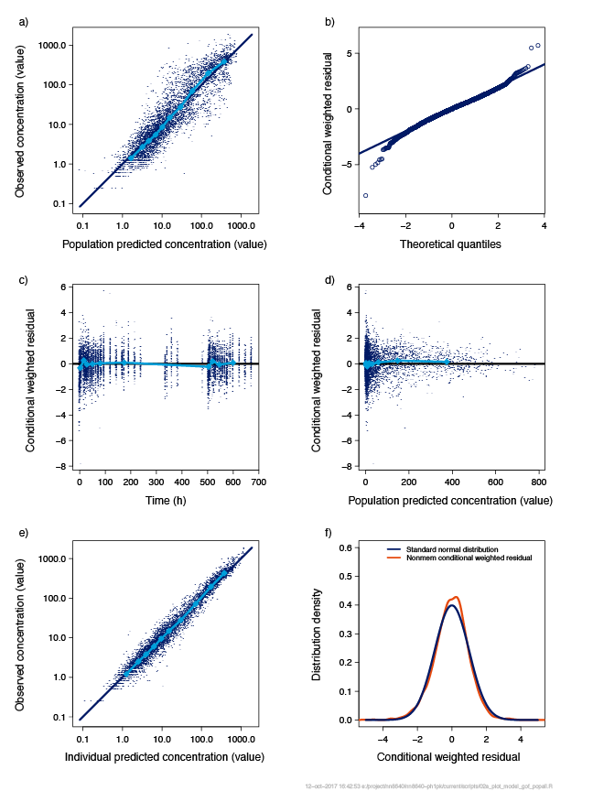
Goodness-of-fit for the final pharmacokinetic model with observed concentration plotted against the population predicted concentration (a), conditional weighted residual plotted against theoretical quantiles (b) time (c) and population predicted concentration (d), observed concentration plotted against individual predicted concentration (e) and distribution density plotted against conditional weighted residual (f). Blue circles represent the observed data with darker colouration indicating multiple/overlapping observations. Turquoise lines display the trend of the data, while dark blue/black lines indicate the expected results
Supplemental Figure 2: Goodness-of-fit for the pharmacodynamic model
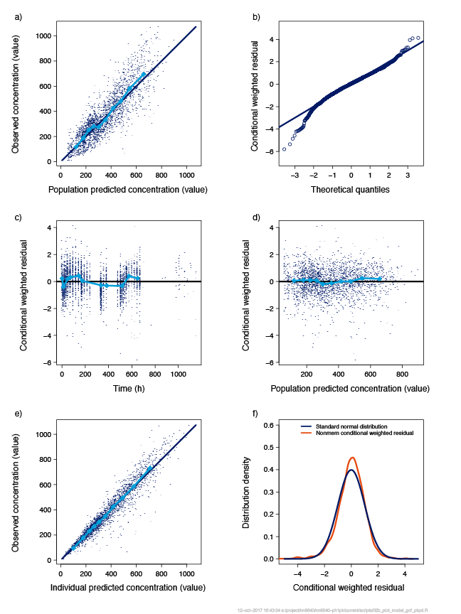
Goodness-of-fit for the final pharmacodynamic model with observed concentration plotted against the population predicted concentration (a), conditional weighted residual plotted against theoretical quantiles (b) time (c) and population predicted concentration (d), observed concentration plotted against individual predicted concentration (e) and distribution density plotted against conditional weighted residual (f). Blue circles represent the observed data with darker colouration indicating multiple/overlapping observations. Turquoise lines display the trend of the data, while dark blue/black lines indicate the expected results.

References
1. Rasmussen MH, Braendholt Olsen MW, Alifrangis L, Klim S, Suntum M. A reversible albumin-binding growth hormone derivative is well-tolerated and possesses a potential once-weekly treatment profile. J Clin Endocrinol Metab. 2014;99(11):E1819-29.
2. Rasmussen MH, Janukonyte J, Klose M, Marina D, Tanvig M, Nielsen LF et al. Reversible albumin-binding GH possesses a potential once-weekly treatment profile in adult growth hormone deficiency. J Clin Endocrinol Metab. 2016;101(3):988–98.
3. Battelino T, Rasmussen MH, De Schepper J, Zuckerman-Levin N, Gucev Z, Savendahl L. Somapacitan, a once-weekly reversible albumin-binding GH derivative, in children with GH deficiency: A randomized dose-escalation trial. Clin Endocrinol (Oxf). 2017;87(4):350–8.
4. Bidlingmaier M, Friedrich N, Emeny RT, Spranger J, Wolthers OD, Roswall J et al. Reference intervals for insulin-like growth factor-1 (igf-i) from birth to senescence: results from a multicenter study using a new automated chemiluminescence IGF-I immunoassay conforming to recent international recommendations. J Clin Endocrinol Metab. 2014;99(5):1712–21.
5. Cole TJ, Bellizzi MC, Flegal KM, Dietz WH. Establishing a standard definition for child overweight and obesity worldwide: international survey. BMJ. 2000;320(7244):1240–3.

