Electronic supplementary File 1
Main electronic supplementary file containing methodology, control streams, dose regimens, overview of the internal and external evaluation of the Zhao model and the supplementary figure.
Chloroquine for SARS-CoV-2: implications of its unique pharmacokinetic and safety properties
Authors
Cornelis Smit (1,2), Mariska Y.M. Peeters (3), John N. van den Anker (1,4), Catherijne A.J. Knibbe (2,3)
1. Pediatric Pharmacology and Pharmacometrics Research Center, University of Basel Children’s Hospital, Basel, Switzerland
2. Department of Systems Biomedicine and Pharmacology, Leiden Academic Centre for Drug Research, Leiden University, Leiden, The Netherlands
3. Department of Clinical Pharmacy, St. Antonius Hospital, Nieuwegein, The Netherlands
4. Division of Clinical Pharmacology, Children’s National Hospital, Washington, DC, USA

Corresponding author:
Prof. Dr. Catherijne A.J. Knibbe, Pharm D, PhD, FCP
Department of Clinical Pharmacy, St. Antonius Hospital,
Koekoekslaan 1, 3435 CM Nieuwegein, The Netherlands
E-mail address: c.knibbe@antoniusziekenhuis.nl
Telephone: +3188 320 7200
Fax: +3188 320 7249

Contents

1. Software used for simulations 3
2. Details of the adapted chloroquine Zhao 2014 PK model used for the figures in this report 3
2.1 Nonmem control stream for the adapted model 3
3 Dose regimens used in figures 4
4 Internal and External evaluation of the chloroquine model by Zhao et al 5
4.1 Details regarding the Zhao PK model 5
4.2 Nonmem control stream for Zhao PK model: 6
4.3 Overview of studies used for evaluation 7
4.4 Internal model evaluation 8
4.5 External model evaluation 10
5 Supplemental figure 20
6 References 21

Software used for simulations

All simulations were performed using NONMEM 7.4 [1], Pirana 2.9.9 [2] and Perl-Speaks-Nonmem version 4.9.0 [3] using control streams provided in this supplementary file. Datasets and plots were generated using R 3.6.1 [4], Rstudio 1.2.1335 [5]. Codes for the dataset-generation are provided in a separate supplementary file.

Details of the adapted chloroquine Zhao 2014 PK model used for the figures in this report
We based our NONMEM model on the model published by Zhao et al [6].
The following adaptions (based on the findings described under 4. Internal and External evaluation of the chloroquine model by Zhao et al) were applied:
- For patients > 80 kg: for Cl body-weight based 0.75 allometric increases were assumed. For the volumes of distribution and intercompartmental clearance, values were capped at values for a 80 kg individual
- For children aged 1-5 yrs: reduction in CL to 75% (on top of allometric scaling in the model of Zhao et al) based on comparison to data from Walker [7]
- For children aged < 1 yr: reduction in CL < 1 year to 50% (on top of allometric scaling in the model of Zhao et al) based on comparison to data from Adelusi [8] and Obua [9]

NONMEM control stream for the adapted model

$PROBLEM PK chloroquine COVID-19
$INPUT ID TIME AMT RATE DV MDV EVID AGE WT MF
; WT = body weight in kg
; MF = multiplication factor for CL (=0.75 when renal impaired)
$DATA SIM_zhao_typical.prn
IGNORE=@
$SUBROUTINES ADVAN4 TRANS4
PK
KA = THETA(1)
TVCL = THETA(2) * ((WT/70)**0.75) * MF
IF(AGE.LE.5) TVCL = THETA(2) * ((WT/70)**0.75) * MF * 0.75
IF(AGE.LE.1) TVCL = THETA(2) * ((WT/70)**0.75) * MF * 0.5
TVV2=THETA(3)*(80/70) ; above 80 kg V2 = TV for 80 kg
IF(WT.LE.80) TVV2 = THETA(3) * (WT/70)
TVQ = THETA(4)*((80/70)**0.75) ; above 80 kg Q = TV for 80 kg
IF(WT.LE.80) TVQ = THETA(4)* ((WT/70)**0.75)
TVV3 = THETA(5)*(80/70) ; above 80 kg V3 = TV for 80 kg
IF(WT.LE.80) TVV3 = THETA(5) * (WT/70)
ALAG1=THETA(6)
CL = TVCL * EXP(ETA(1))
V2 = TVV2 * EXP(ETA(2))
Q = TVQ
V3 = TVV3
S2 = V2
$ERROR
Y=F*(1+ERR(1))
IPRED=F
$THETA
6.12 ; KA (1/h)
(59.1) ;CL (L/h)
(2870) ;V2 (L)
(61.4) ;Q (L/h)
(1890) ;V3 (L)
0.387 ;ALAG (h)
$OMEGA
0 FIX ; CL ETA 1
0 FIX ; V2 ETA 2
$SIGMA
0 FIX ;Proportional error PK

Dose regimens used in figures

ADULTS:
 | Source | Unit | Day 1 |  |  |  | Day 2 |  | Day 3 |  | Day 4 |  | Day 5 |  | Total for 70 kg adult
 |  |  | 0 | 6 | 12 | 18 | 24 | 36 | 48 | 60 | 72 | 84 | 96 | 108 | mg | mg/kg
1 | SWAB [10] | mg | 600 |  | 300 |  | 300 | 300 | 300 | 300 | 300 | 300 | 300 | 300 | 3300 | 47
2 | Pussard [11] | mg/kg | 10* | 5* | 5* |  | 5* | 5* |  |  |  |  |  |  | 2100 | 30

* Dose was capped to 80 kg individual when TBW > 80 kg.
CHILDREN:
 | Source | Unit | Day 1 |  |  |  | Day 2 |  | Day 3 |  | Day 4 |  | Day 5 |  | Total for 10 kg child
 |  |  | 0 | 6 | 12 | 18 | 24 | 36 | 48 | 60 | 72 | 84 | 96 | 108 | mg | mg/kg
1 | SWAB [10] | mg/kg | 10 |  | 5 |  | 5 | 5 | 5 | 5 | 5 | 5 | 5 | 5 | 550 | 55
2 | Ursing [12] | mg/kg | 10 |  | 10 |  | 10 | 10 | 5 | 5 | 5 | 5 | 5 | 5 | 700 | 70

Internal and External evaluation of the chloroquine model by Zhao et al

Details regarding the Zhao PK model

Source of the used PK model:
Zhao Q, Tensfeldt TG, Chandra R, Mould DR. Population pharmacokinetics of azithromycin and chloroquine in healthy adults and paediatric malaria subjects following oral administration of fixed-dose azithromycin and chloroquine combination tablets. Malar J. 2014;13:36. Published 2014 Jan 29. doi:10.1186/1475-2875-13-36
Patient and dose characteristics in this study:
0 – 12y: 10 mg/kg 1dd during 3 days
> 18y: Single dose 310 mg or 300 mg randomized. 310 mg (2 x 155 mg) was bioequivalent to 300 mg CQ.
No patient characteristics were published in the manuscript.
PK parameters:
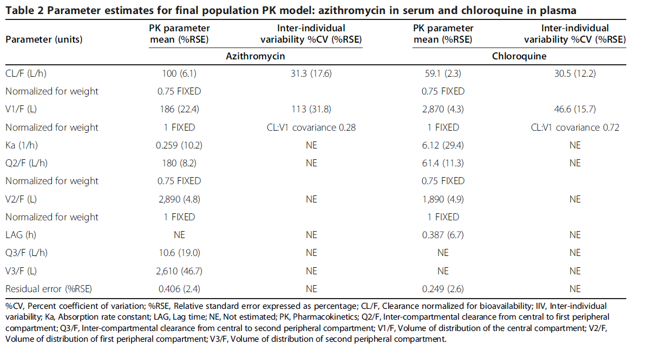

NONMEM control stream for Zhao PK model:

$PROBLEM PK chloroquine COVID-19
$INPUT ID TIME AMT RATE DV MDV EVID AGE WT MF
; WT = body weight in kg
; MF = multiplication factor for CL
$DATA SIM_zhao_typical.prn
IGNORE=@
$SUBROUTINES ADVAN4 TRANS4
$PK
KA = THETA(1)
TVCL = THETA(2) * ((WT/70)**0.75) * MF ; MF can be used to reduce CL manually (default MF = 1)
TVV2 = THETA(3) * (WT/70)
TVQ = THETA(4)* ((WT/70)**0.75)
TVV3 = THETA(5) * (WT/70)
ALAG1=THETA(6)
CL = TVCL * EXP(ETA(1))
V2 = TVV2 * EXP(ETA(2))
Q = TVQ
V3 = TVV3
S2 = V2
$ERROR
Y=F*(1+ERR(1))
IPRED=F
$THETA
6.12 ; KA (1/h)
(59.1) ;CL (L/h)
(2870) ;V2 (L)
(61.4) ;Q (L/h)
(1890) ;V3 (L)
0.387 ;ALAG (h)

$OMEGA
0 FIX ; CL ETA 1
0 FIX ; V2 ETA 2
$SIGMA
- FIX ;Proportional error PK

Overview of studies used for evaluation

Author | Population | Dose schedule | Matrix | Ref
STUDIES IN PLASMA
Zhao 2014 | Children 0 – 12 y malaria patients in sub-Saharan Africa | 10 mg/kg 1dd 3 days | Plasma | [6]
Zhao 2014 | Adult healthy volunteers in USA | Single dose 300 mg | Plasma | [6]
Edward 1983 | Adult malaria patients (Thailand) | Single IV dose 15 mg/kg | Plasma | [13]
Höglund 2014 | Adult malaria patient Thailand/Myanmar | 25 mg/kg over 3 days: 10 mg/kg at t=0, 5 mg/kg at t= 12, 24, 48h. | Plasma | [14]
Walker 1983 | Children 12m – 6y malaria patients in Africa | 10 mg/kg, day 2: 10 mg/kg, day 3: 5 mg/kg (total 25 mg/kg) | Plasma | [7]
Salako 1984 | Adult volunteers with renal insufficiency | 600 mg day single dose | Plasma | [15]
Adelusi 1982 | Children 6m – 6y with malaria (Nigeria). | 10 mg/kg on the first and second days and 5 mg/kg on the third day.  Patient characteristics: Children 6 m – 6years with malaria (Nigeria). Mean weight or age not reported. Therefore we simulate 2 children: 6 kg and 12 kg. | Plasma | [8]
STUDIES IN OTHER MATRICES
Daher 2019 | Adult malaria patients in Brazil | 600 mg day 1, 450 mg days 2 and 3. | Whole blood | [16]
Ursing 2020 | Children 5 -8 y malaria patients sub-Saharan Africa | 70 mg/kg over 5 days: Day 0 : 10 mg/kg + 10 mg/kg, day 1: 10 mg/kg + 10 mg/kg, day 2,3,4: 5 mg/kg 2dd | Dried blood spot (unpublished method) | [12]
Pussard 1991 | Young adults 14 – 24y malaria patients in Madagaskar | Group 1: 25 mg/kg over 48h: 10 mg/kg t = 0 h, 10 mg/kg t = 24h, 5 mg/kg at t = 48h.  Group 2: 30 mg/kg over 36h: 10 mg/kg t = 0, 5 mg/kg t = 6, 5 mg/kg t = 12, 5 mg/kg t = 24, 5 mg/kg t = 36h | Whole blood | [11]
Obua 2007 | Children 6m – 60m with malaria (Uganda) | 6m – 24m: 75 mg 1dd for 3 days  25m – 60 m: 150 mg 1dd for 3 days | Dried blood spot | [9]

Internal model evaluation

Zhao et al 2014 [6]
Dose and patient characteristics:
Dose regimen used in the study:
6m – 12y: 10 mg/kg 1dd 3 days
> 18y: Single dose 310 mg or 300 mg randomized. 310 mg (2 x 155 mg) was bioequivalent to 300 mg CQ. Therefore we simulated 300 mg.
No patient characteristics were published in the manuscript. Raw data was shown for 3 separate groups: >18 y, 5 – 12 y, < 5y.
Matrix: plasma
We have therefore simulated 3 typical individuals:
- 1 adult TBW 70 kg, receiving single dose 305 mg
- 1 infant 7 year old, TBW 24 kg. 10 mg/kg 1dd for 3 days
- 1 infant 2 year old, TBW 12 kg 10 mg/kg 1dd for 3 days
Results:
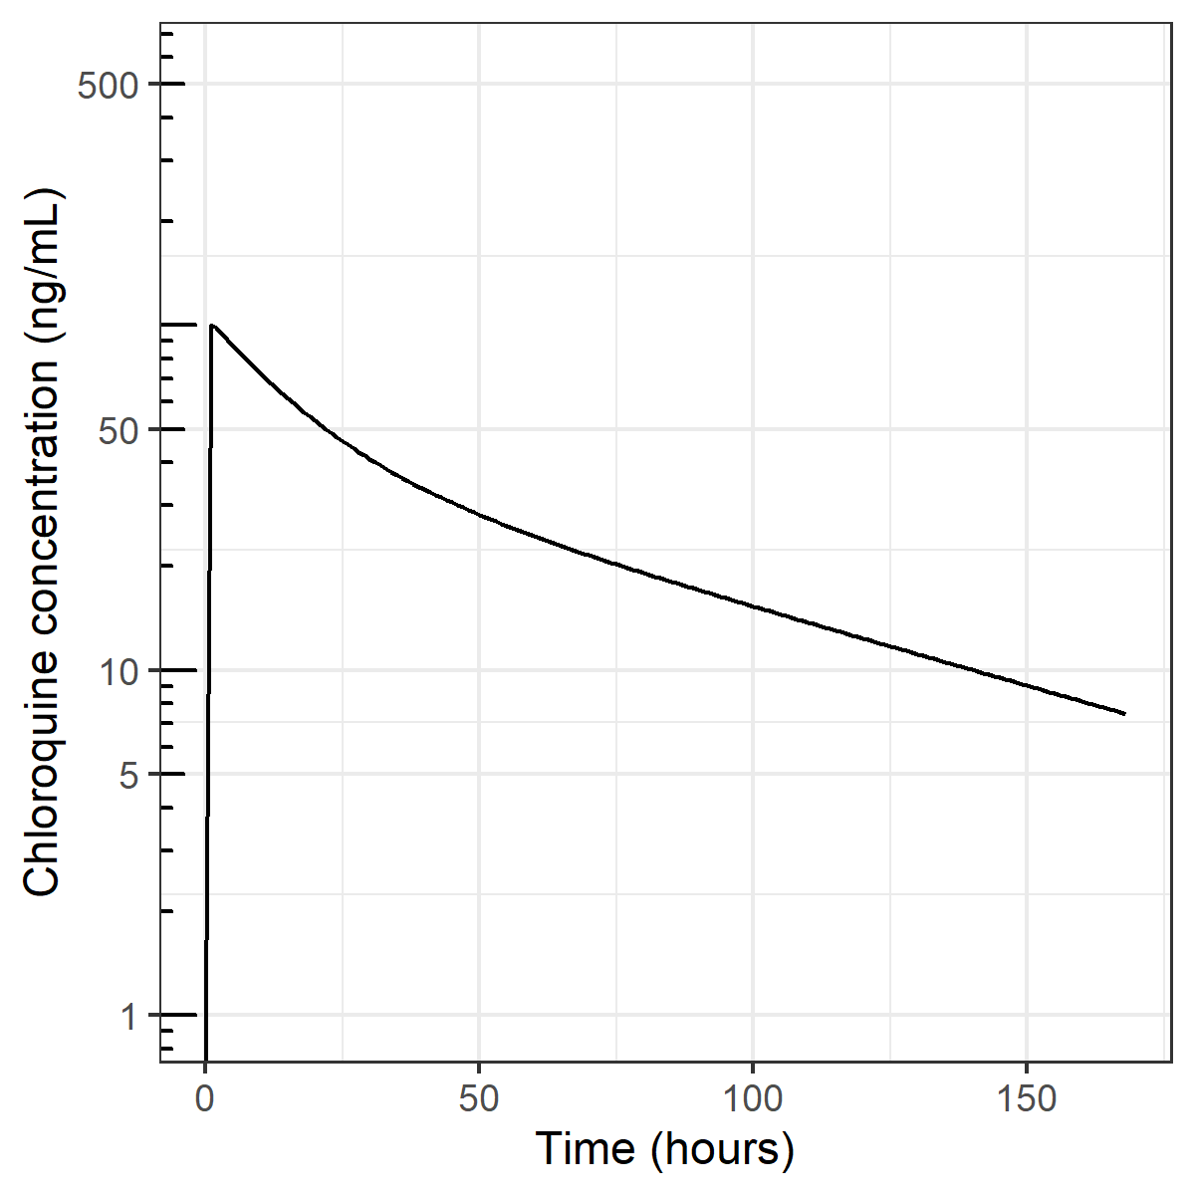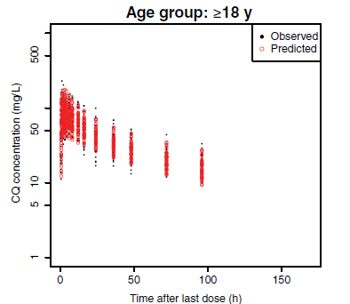
Conclusion: The entire profile including median peak and trough (around 96h) concentrations seems well predicted.
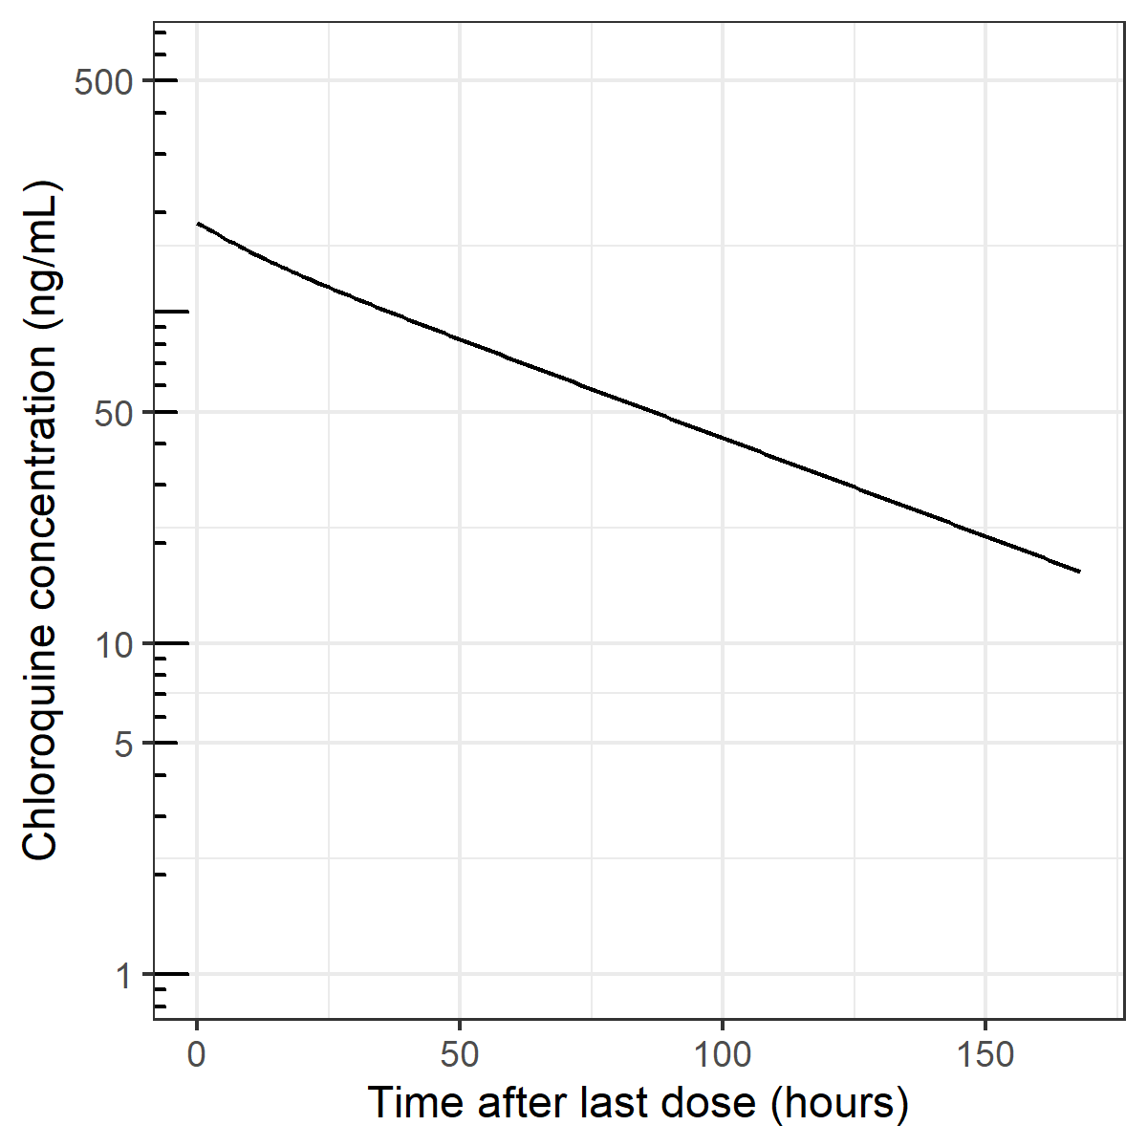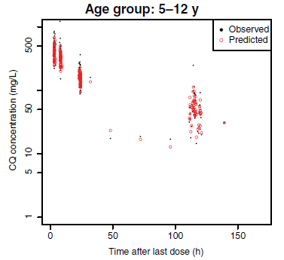
Conclusion: Overall, data is slightly underpredicted. May be caused by differences in body weight (we assumed median child to weigh 24 kg) or due to differences in rounding of doses (we simulated exactly 10 mg/kg, whereas Zhao et al report to have given rounded dosages to the nearest 50- or 100-fold).
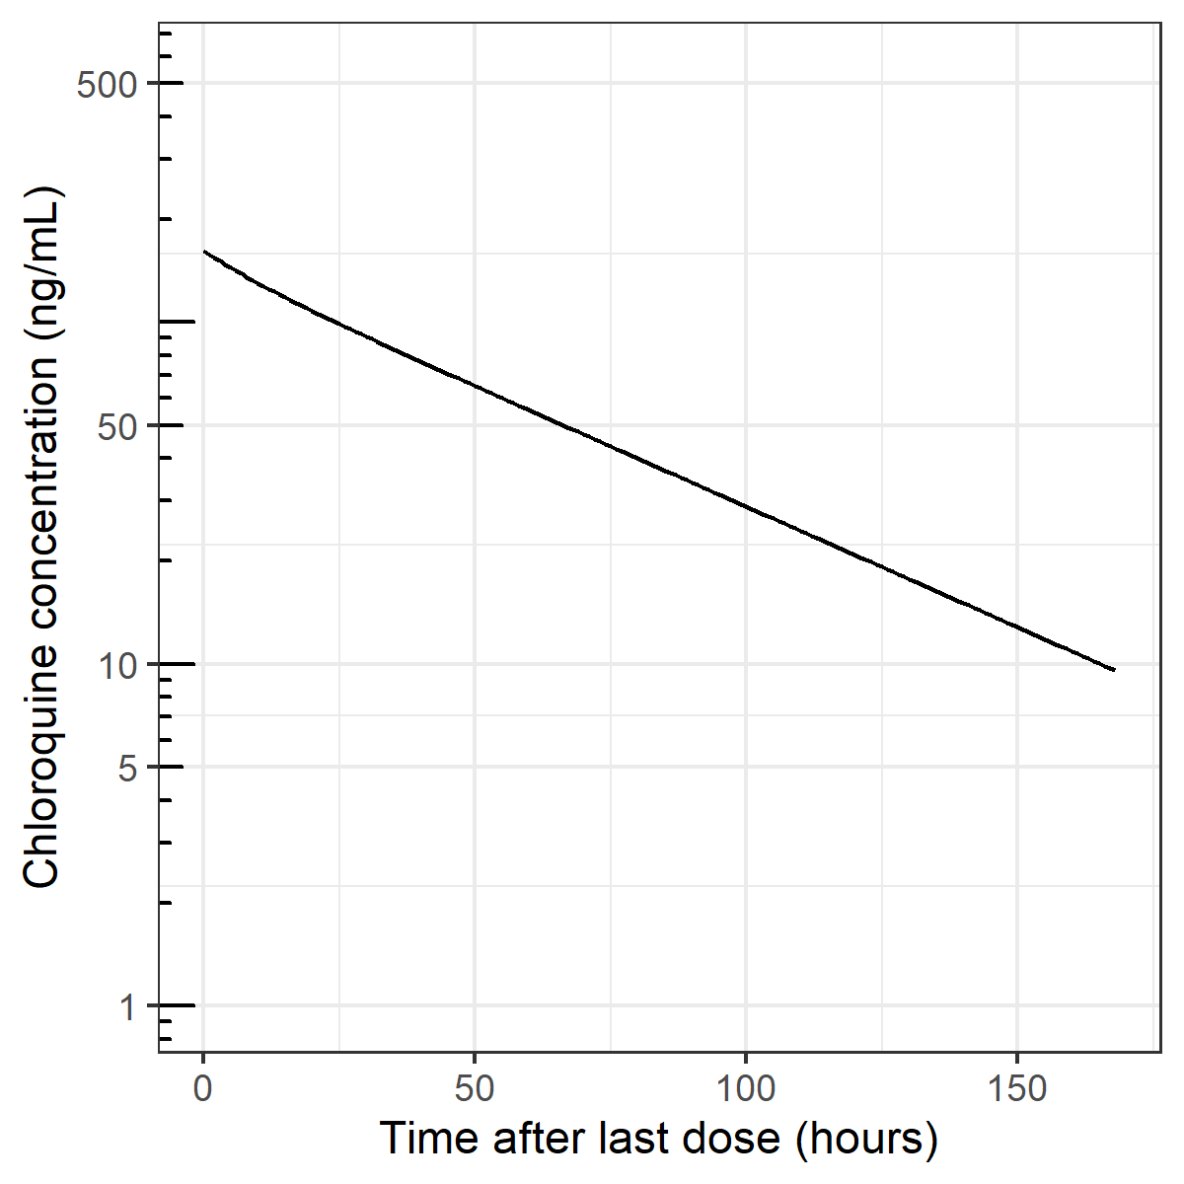
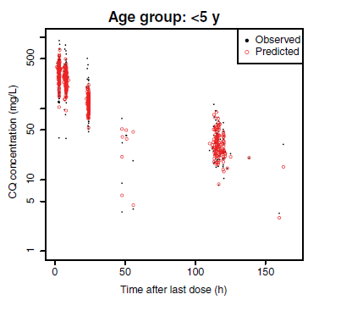
Conclusion: Data is well predicted. Differences may be caused by differences in body weight (we assumed median child to weigh 12 kg) or due to differences in rounding of doses (we simulated exactly 10 mg/kg, whereas Zhao et al report to have given rounded dosages to the nearest 50- or 100-fold).
NB: in the paper y-axis is presented as mg/L. This cannot be correct. The authors refer to an earlier study where CQ is measured in ng/mL. This is wat we have simulated as well.
Overall conclusion: The observations reported by Zhao et al seem well predicted by the model that was built based on the PK parameters published in the paper. Small differences may be due to differences in simulated patient characteristics, since this data was not reported in the original study.

External model evaluation

Remarks regarding matrices: Over the years chloroquine has been measured in several matrices, mostly whole blood, plasma and more recently also dried blood spots. Since chloroquine accumulates in red blood cells and has a very long elimination half-life, marked differences between concentrations in these different matrices can be expected. In general, whole blood concentrations are higher compared to plasma or serum concentrations, due to accumulation of chloroquine in the erythrocytes. To translate between plasma and whole blood concentrations, several multiplication factors have been found, ranging from 2.5 [17] to 3.7 – 8 [18,19]. Since the PK model from Zhao et al was developed using plasma concentrations, this uncertainty should be take into account with regard to the model evaluation in other matrices, especially whole blood concentrations.
We first present evaluation in studies that measured chloroquine in plasma, thereafter studies measuring in other matrices (which have a lower strength of evidence due to more uncertainty in translating between plasma and whole blood concentrations).

EDWARDS ET AL 1988 [13]
Edwards G, Looareesuwan S, Davies AJ, Wattanagoon Y, Phillips RE, Warrell DA. Pharmacokinetics of chloroquine in Thais: plasma and red-cell concentrations following an intravenous infusion to healthy subjects and patients with Plasmodium vivax malaria. Br J Clin Pharmacol. 1988;25(4):477–485. doi:10.1111/j.1365-2125.1988.tb03332.x
Dose and patient characteristics:
Dose regimen used in the study:
15 mg/kg single infusion
Patient characteristics: Adult malaria patients. Mean TBW 53 kg.
Matrix: plasma
Results:
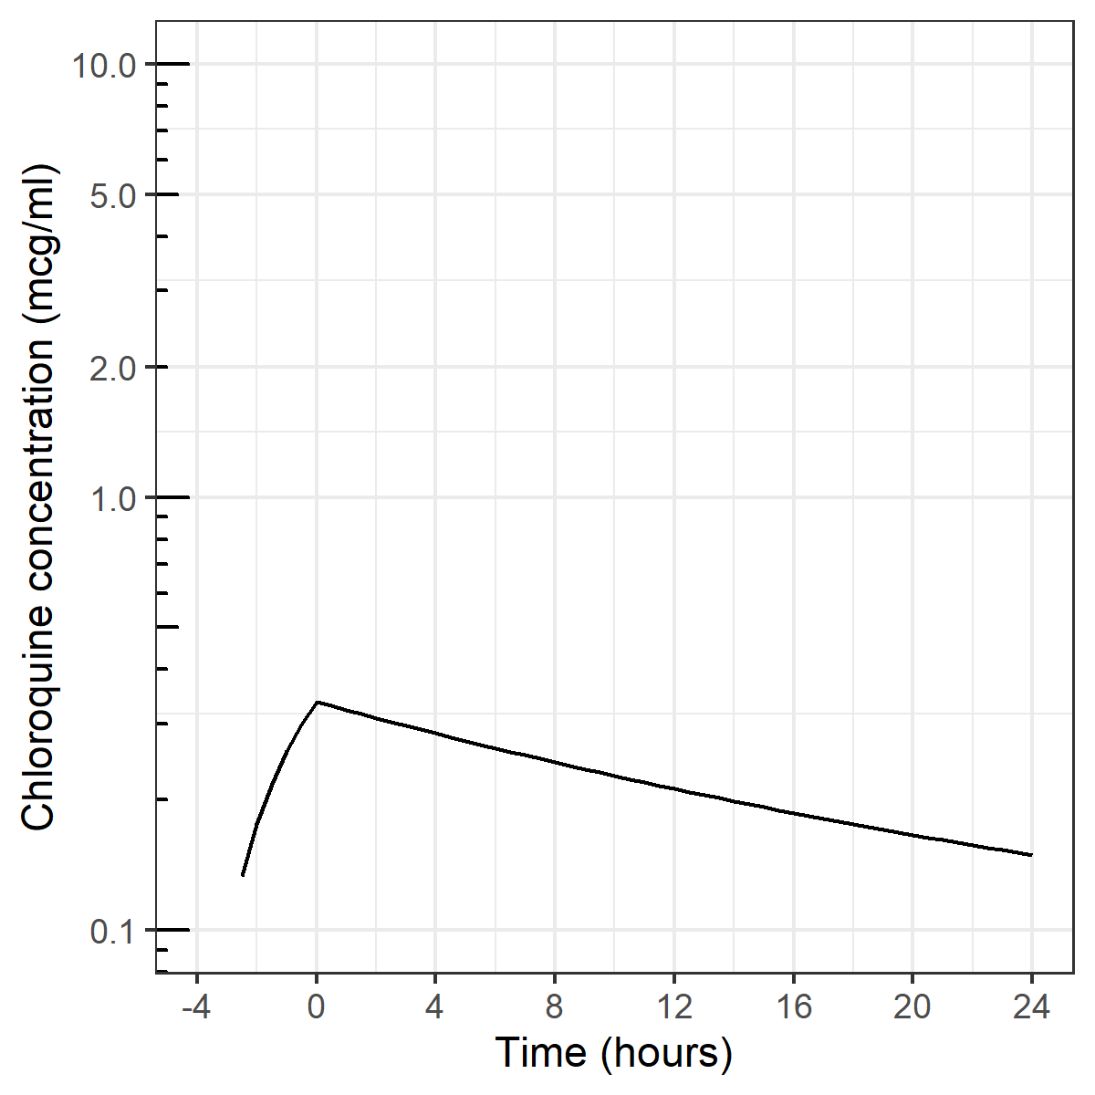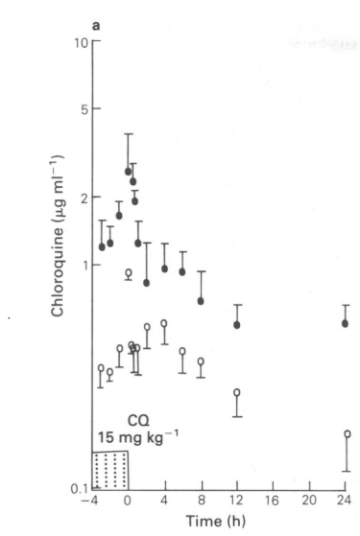
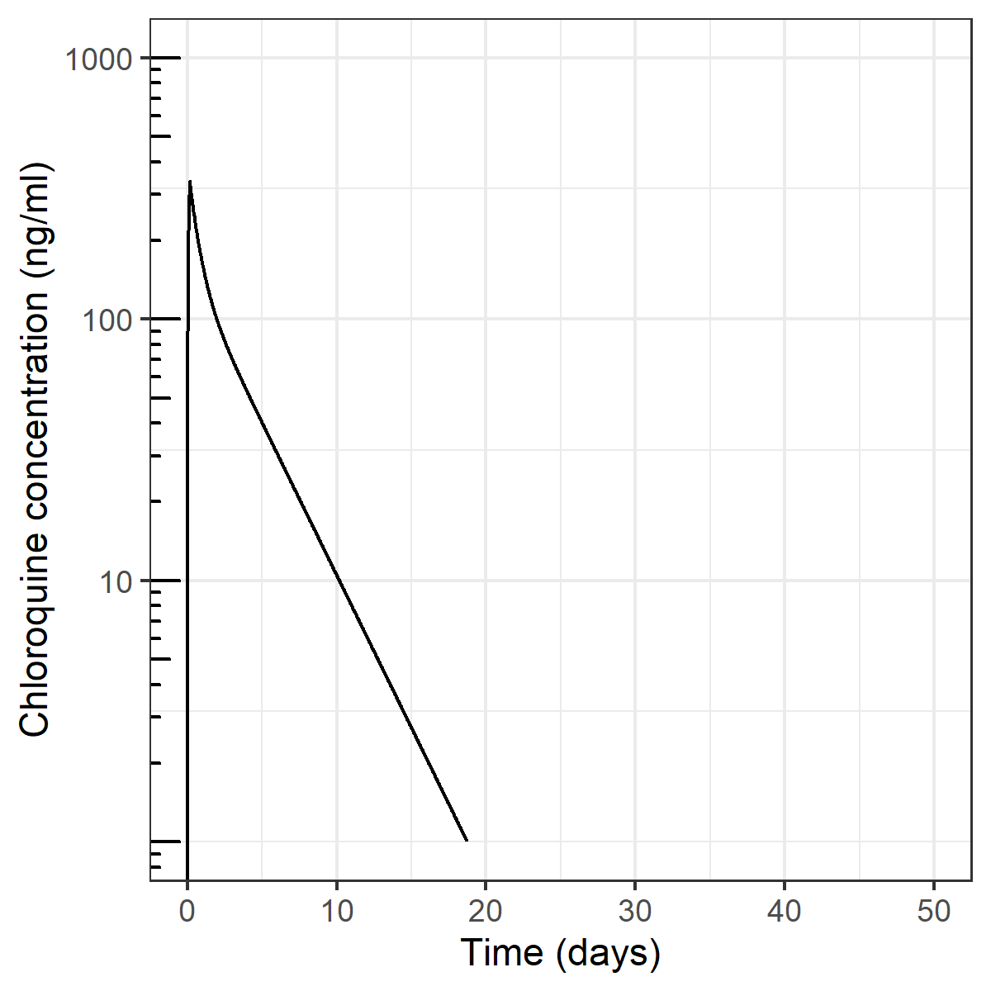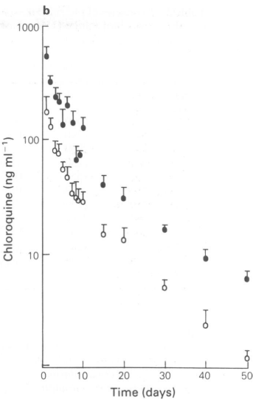
Conclusion: Plasma concentrations depicted by white circles in original article. Plasma concentrations are well predicted in first 10 days, including peak level. Half-life seems to be shorter than observed, which is likely to be due to the limited sampling time in the Zhao study (up to 5-6 days).
HOGLUND ET AL 2016 [14]
Höglund R, Moussavi Y, Ruengweerayut R, Cheomung A, Äbelö A, Na-Bangchang K. Population pharmacokinetics of a three-day chloroquine treatment in patients with Plasmodium vivax infection on the Thai-Myanmar border. Malar J. 2016;15:129. Published 2016 Feb 29. doi:10.1186/s12936-016-1181-1
Dose and patient characteristics:
Population: Adult malaria patients from the Thai-Myanmar border. Mean weight not reported, but inclusion criterium was > 40 kg TBW. In a study from Pussard et al (PMID 2039190), who studied malaria patients (from Madagaskar), mean body weight was 40 kg. Therefore, we did simulations with an assumed median patient with TBW 45 kg.
Dose: Total dose of 25 mg/kg over 3 days: 10 mg/kg at t=0, 5 mg/kg at t= 12, 24, 48h.
Matrix: plasma

Results:
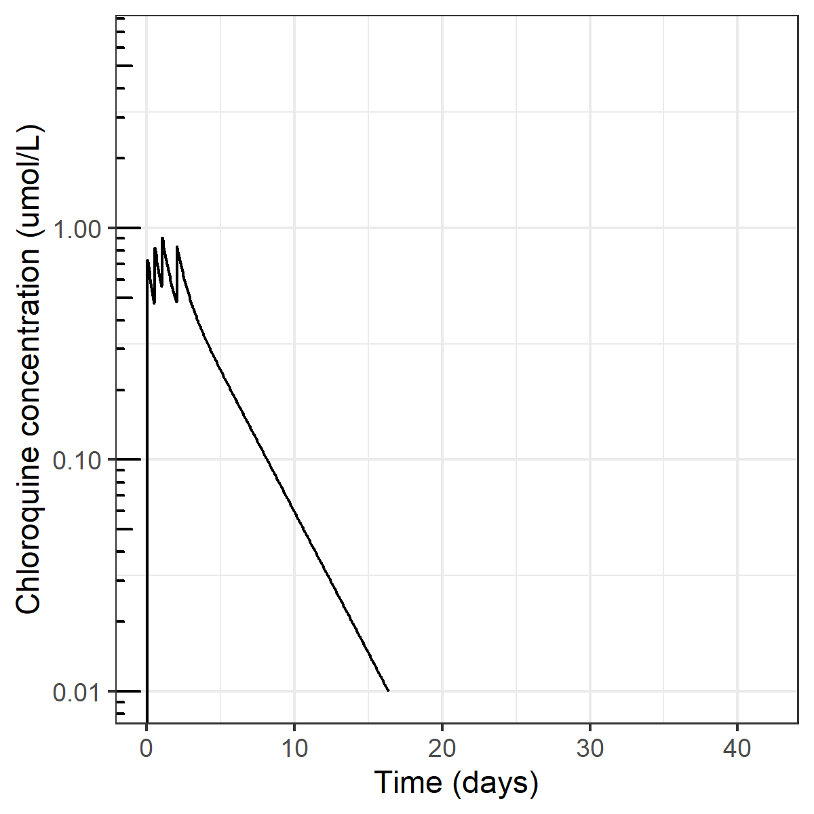
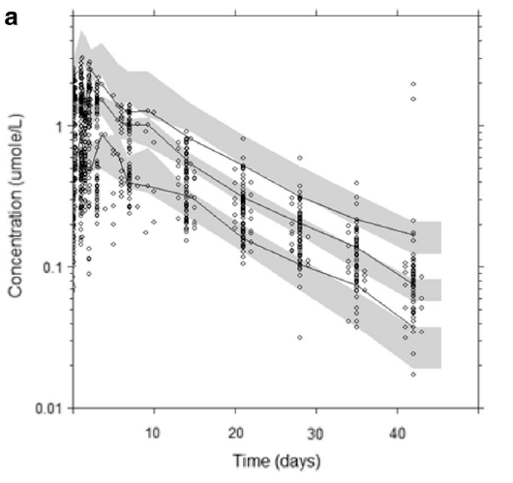
Conclusion: Median concentrations up to 5 days are well predicted. The terminal elimination of chloroquine in the population is however slower in the observed data compared to our simulations. It is unclear why the model by Zhao et al is unable to capture the samples in the terminal elimination phase in the Hoglund study (who also included the metabolite) as clearance values (6.13*100/18= 34 L/h is almost equal to 59.1 scaled to 45 kg) and volumes seem similar. In conclusion, we can state that concentrations in the first days are well predicted (during the period in which Zhao also sampled), but observations that are measured long after dose (>5-10 days) are less well predicted in this study by the model of Zhao et al.
WALKER ET AL 1983 [7]
Walker O, Dawodu AH, Adeyokunnu AA, Salako LA, Alvan G. Plasma chloroquine and desethylchloroquine concentrations in children during and after chloroquine treatment for malaria. Br J Clin Pharmacol. 1983;16(6):701–705. doi:10.1111/j.1365-2125.1983.tb02244.x
Dose and patient characteristics:
Population: Children 12 months – 6 year (African) treated for malaria. 7 children had no chloroquine in pre-treatment plasma. Weight or age characteristics not reported. Therefore, we simulated 2 children: 8 and 12 kg.
Dose: 10 mg/kg, day 2: 10 mg/kg, day 3: 5 mg/kg (total 25 mg/kg)
Matrix: plasma
Results:
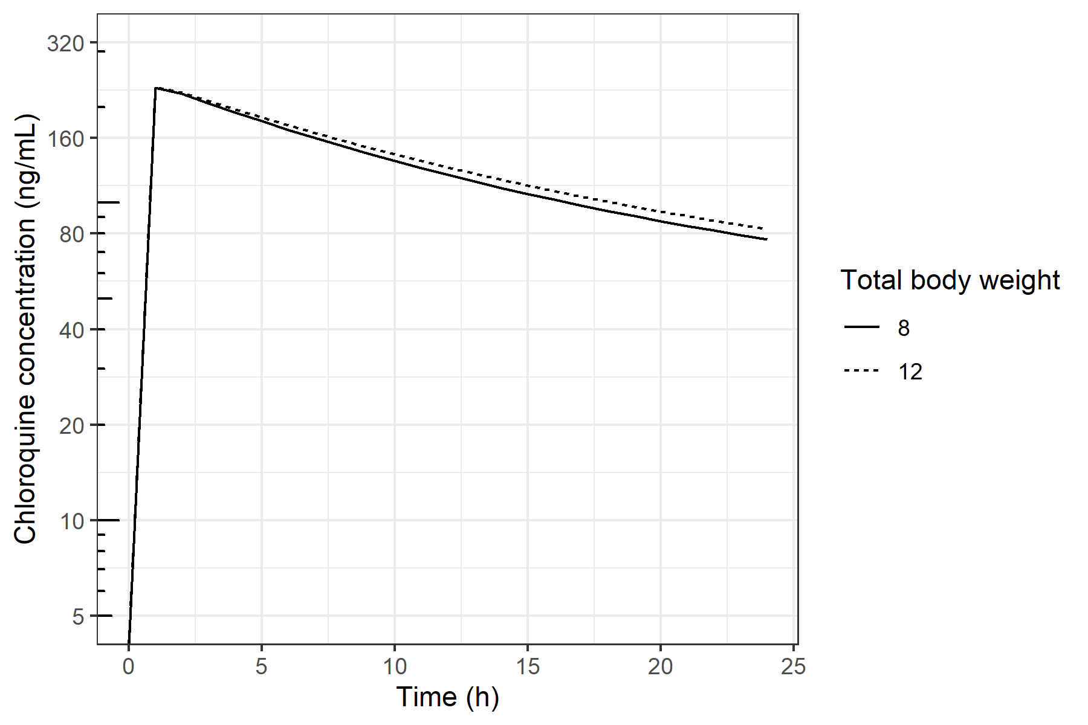
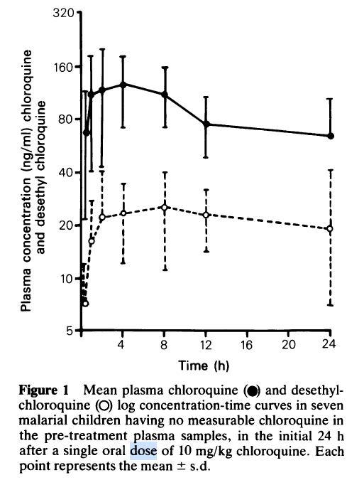
Conclusion: Observations (until 24 h after dosing) seem to be nicely predicted by the Zhao model (simulations are to be compared with black dots in observations (= chloroquine)).
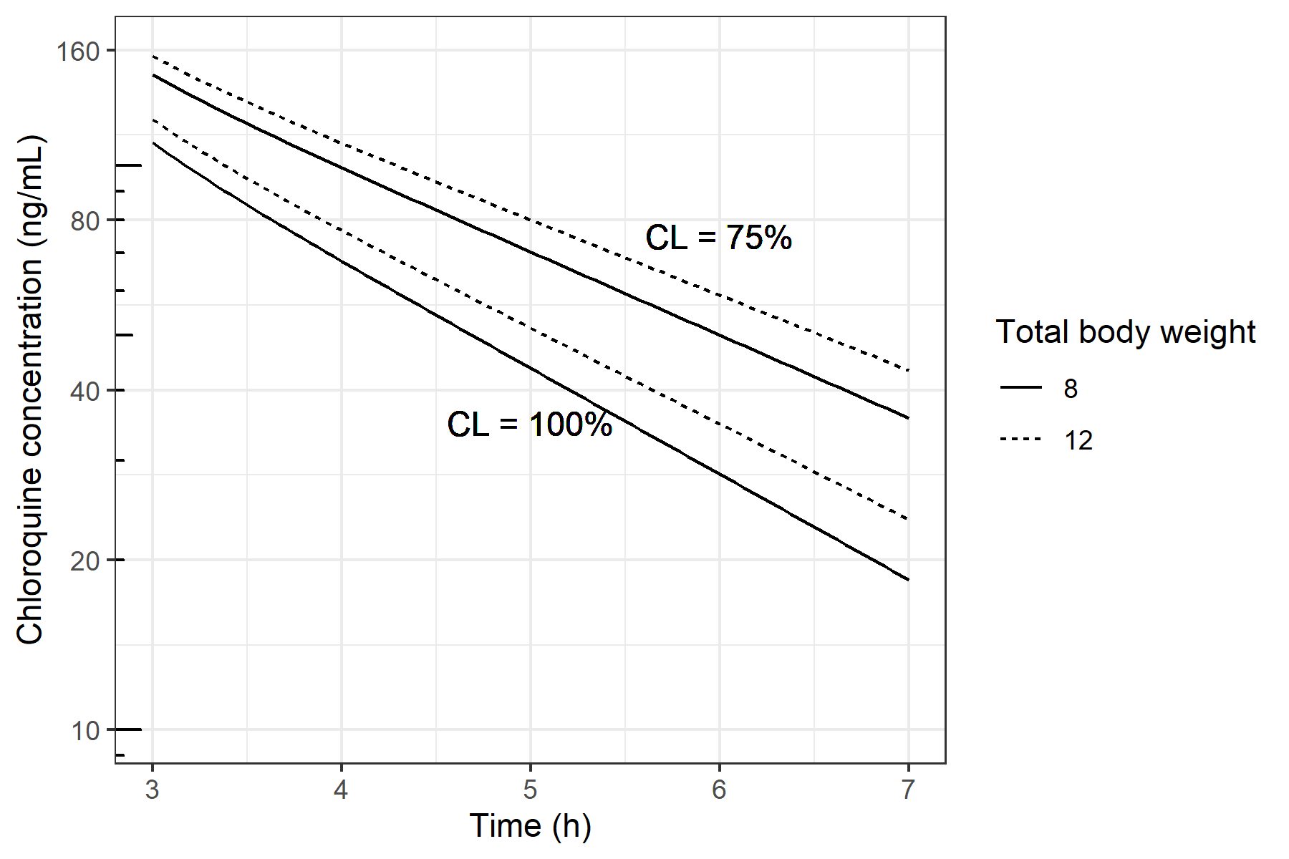
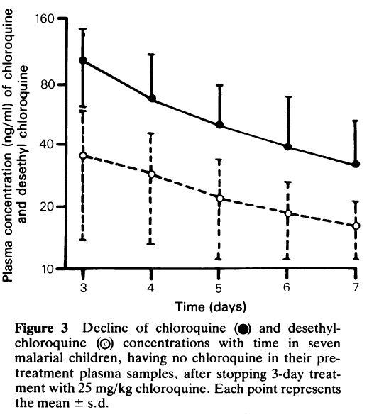

Conclusion: the model seems to predict the concentrations in these children over 7 days after dosing reasonably well. However, the decline according to the model seems to go faster than observed data. With CL reduced to 75%, the simulated concentration at day 7 is around 40 ng/mL, exactly as observed. Hence, it seems that the population under 5 year has a slightly slower CL than expected by the allometric function in Zhao et al. This may be expected with extrapolations for children under age 5 (this phenomenon has for example been demonstrated by Calvier et al [20]).
Salako ET AL 1984 [15]
Salako LA, Walker O, Iyun AO. Pharmacokinetics of chloroquine in renal insufficiency. Afr J Med Med Sci. 1984;13(3-4):177–182.
Dose and patient characteristics:
Dose regimen used in the study:
600 mg day single dose
Matrix: plasma
Patient characteristics: Adult patient volunteers with renal insufficiency. Mean TBW 59 kg. eGFR not reported, but plasma creatinine, age and gender is reported. Assuming all are African-american, the CKD-EPI would be as follows:

No | Gender | Age | Plasma creatinine (mg/dL) | CKD-EPI (ml/min/1.73 m2)
1 | Male | 30 | 4.0 | 21.8
2 | Male | 32 | 12.7 | 5.3
3 | Male | 18 | 2.0 | 54.8
4 | Male | 25 | 1.6 | 68.4
5 | Male | 45 | 3.4 | 23.9
6 | Male | 46 | 5.2 | 14.2

Average CKD-EPI is 31.4 ml/min/1.73 m².
Results:
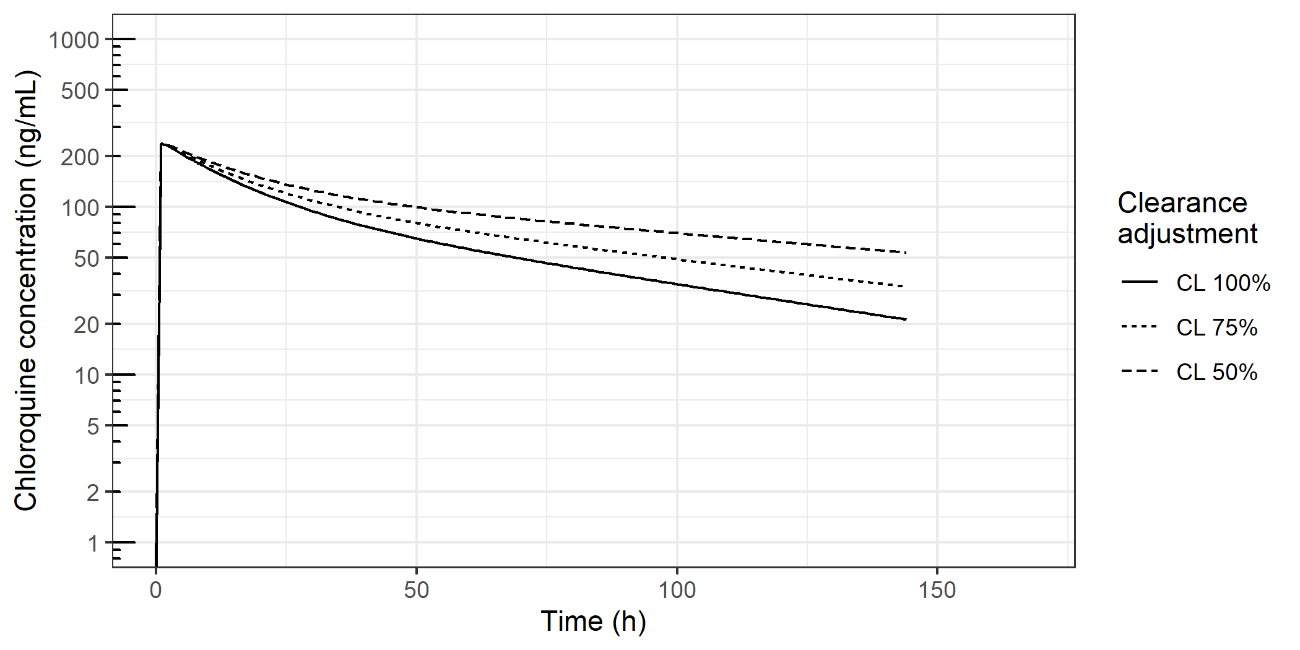
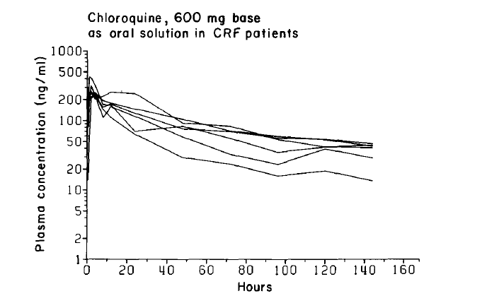
Observed median peak is well predicted. Elimination phase seems to best correlate with 50%-75% CL group. Two ‘outliers’ probably correspond to the two patients with CKD-EPI of 54 and 68 ml/min/1.73m2 (although not reported), which resembles the 100% line. The other patients had severe renal impairment (5.3 - 23.9 ml/min/1.73 m²).
Conclusion: We conclude that CL for patients with a chronic renal insufficiency is well predicted by the model by Zhao et al when we vary clearance between 100-50%. Except for one patient (presumably the patient with a CKD-EPI of 5.4 ml/min), it seems that the profile is best predicted by the -25% clearance (CL = 75%) profile. This result seems in line with the reported renal elimination of 33 – 50% of total CQ clearance [21,22] and a 38% excretion of unchanged chloroquine in urine [22]. Therefore, a CL reduction of 25% (CL = 75%) for patients with renal functions between 10 and 50 ml/min/1.73 m² seems reasonable.
Adelusi et al 1982 [8]
Adelusi SA, Dawodu AH, Salako LA. Kinetics of the uptake and elimination of chloroquine in children with malaria. Br J Clin Pharmacol. 1982;14(4):483–487. doi:10.1111/j.1365-2125.1982.tb02016.x
Dose and patient characteristics:
Dose regimen used in the study:
Each child received a total of 25 mg/kg chloroquine base over 3 days according to the following
Schedule: 10 mg/kg on the first and second days and 5 mg/kg on the third day.
Patient characteristics: Children 6 m – 6years with malaria (Nigeria). Mean weight or age not reported. Therefore we simulate 2 children: 6 kg and 12 kg.
Matrix: plasma

Results:
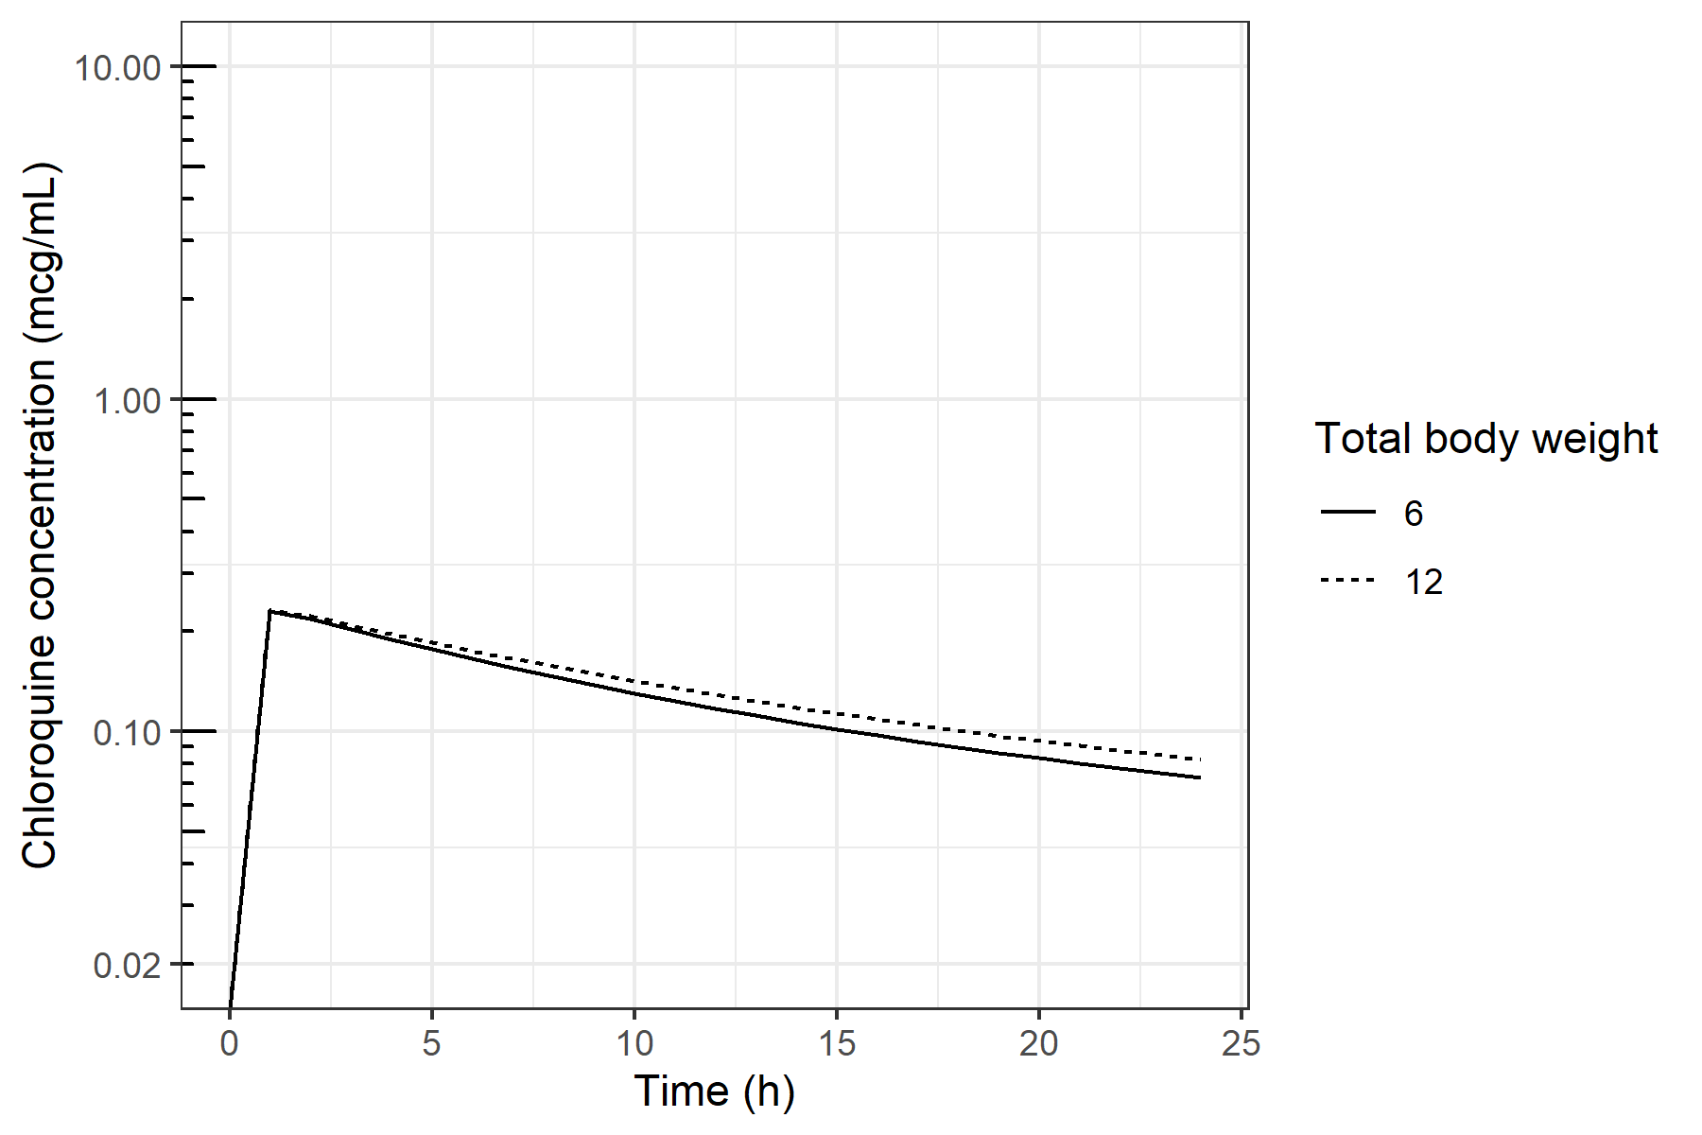
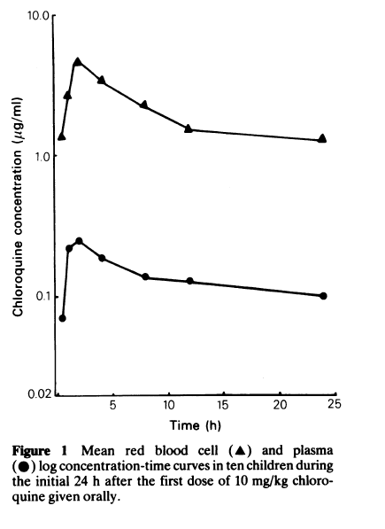
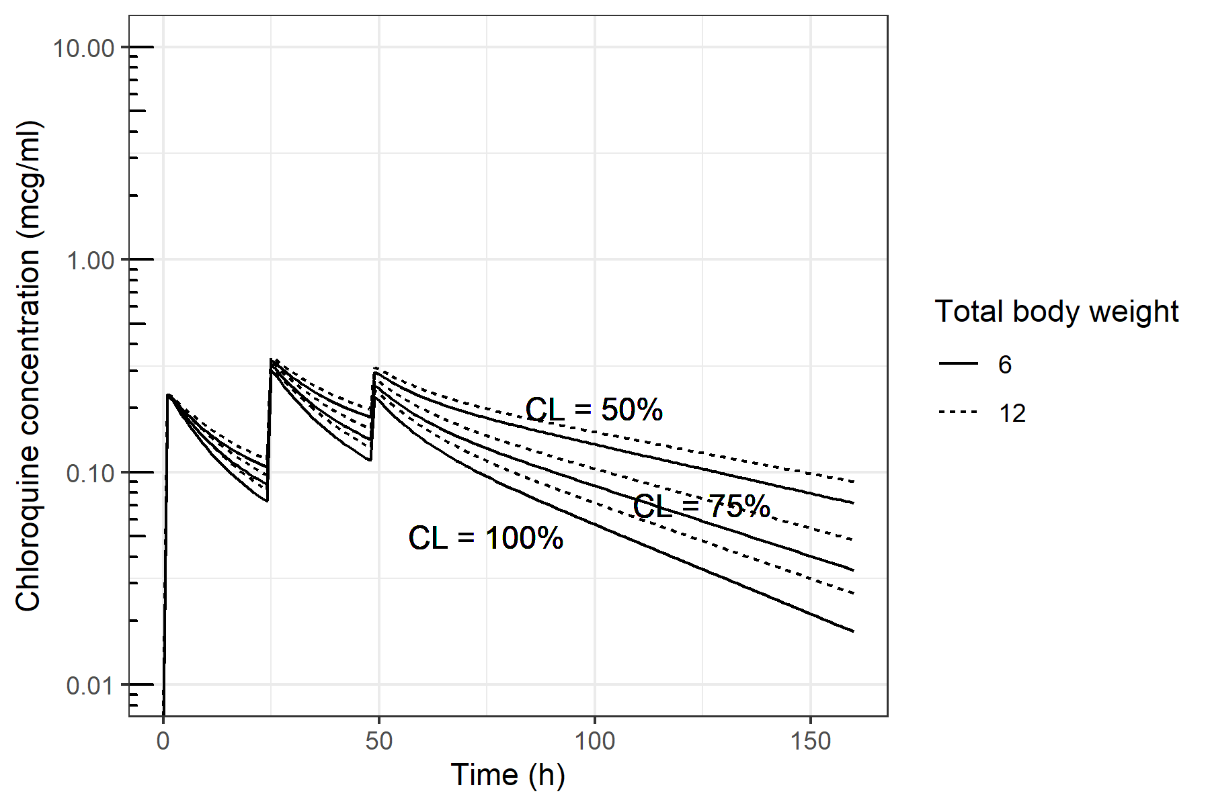
Observed median peak and elimination phase are well predicted (reference is line with black circles).
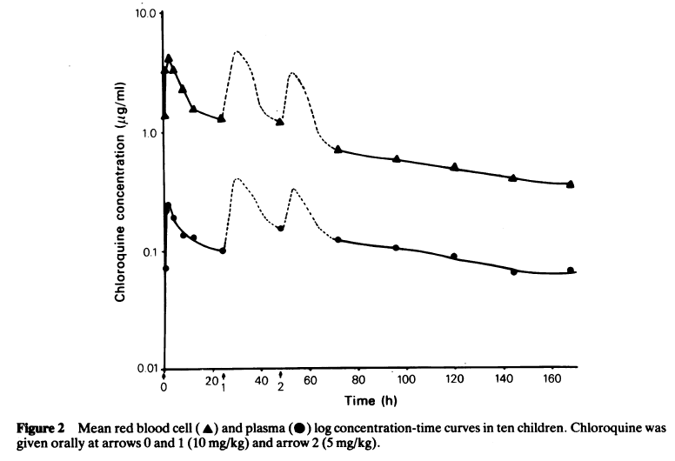
Peaks and trough concentrations for the different doses are well predicted. Elimination phase seems to fit best with CL set to 50% (upper dashed and solid line). Differences may be caused by differences in assumed body weight between the observed population and simulated individuals.
Conclusion: The Zhao et al model estimates observed concentrations in this population reasonably well. However, the predicted decline seems to go faster than what is observed. With CL reduced to 50%, the simulated concentration fits better, while for the study of Walker et al [7] (children between 1 and 5 year) 75% CL led to a reasonable fit. As in the study by Adalusei et al children below 1 year of age were included, we conclude that for the population under 1 year Cl may be better predicted with CL set to 50% instead of 75% on top of the weight-based allometric scaling that is implemented in Zhao et al [6].

DAHER ET AL 2019 [16]
Daher A, Aljayyoussi G, Pereira D, et al. Pharmacokinetics/pharmacodynamics of chloroquine and artemisinin-based combination therapy with primaquine. Malar J. 2019;18(1):325. Published 2019 Sep 23. doi:10.1186/s12936-019-2950-4
Dose and patient characteristics:
Dose regimen used in the study:
600 mg day 1, 450 mg days 2 and 3.
Patient characteristics: Adult malaria patients. Mean TBW 73 kg.
Matrix: whole blood
Results:

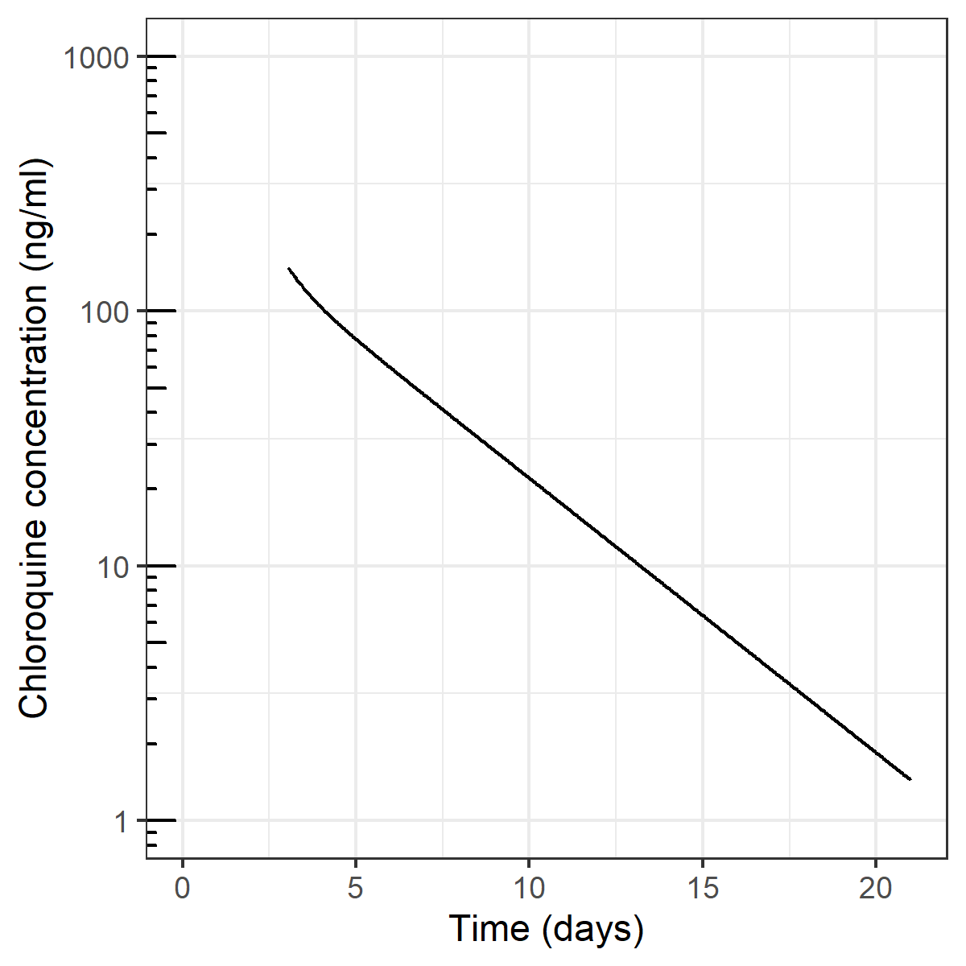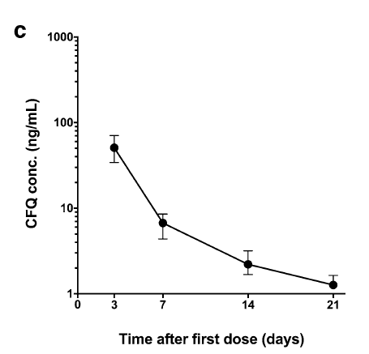
Conclusion: Reasonable agreement with observations. ‘Peak’ at day 3 is somewhat higher in simulation, which could be due to the fact that it is unknown at what timepoint on day 3 (after the last dose) the sample was taken. Trough concentrations around day 21 are well predicted, despite the fact that Zhao et al sampled up to ~5 days after the last dose only. It is emphasized that even though the model seems to predict the concentrations well, predictions are in plasma and observations in whole blood. It is known that whole blood concentrations can be 2.5 – 8 times higher compared to plasma [17][18,19]), however it may be expected that this factor may vary with time after dose. Perhaps this might explain the similar concentrations predicted by Zhao (in plasma) and measured by Daher (in whole blood). See also ‘remarks regarding matrices’.
URSING ET AL 2020 [12]
Ursing J, Rombo L, Eksborg S, et al. High-Dose Chloroquine for Uncomplicated Plasmodium falciparum Malaria Is Well Tolerated and Causes Similar QT Interval Prolongation as Standard-Dose Chloroquine in Children. Antimicrob Agents Chemother. 2020;64(3):e01846-19. Published 2020 Feb 21. doi:10.1128/AAC.01846-19

Dose and patient characteristics:
Population: Children 5 – 8 years old with malaria, mean body weight 17 kg
Dose: Day 0 : 10 mg/kg + 10 mg/kg, day 1: 10 mg/kg + 10 mg/kg, day 2,3,4: 5 mg/kg 2dd (70 mg/kg in total).
Matrix: Dried blood spot (unpublished method), possibly as whole blood sampes, although the exact methodology is not presented. Zhao et al measured in plasma. To translate between plasma and whole blood concentrations, several multiplication factors have been found, ranging from 2.5 [17] to 3.7 – 8 [18,19]. Therefore, simulated concentrations were multiplied by 2.5 to represent whole blood concentrations.

Results:
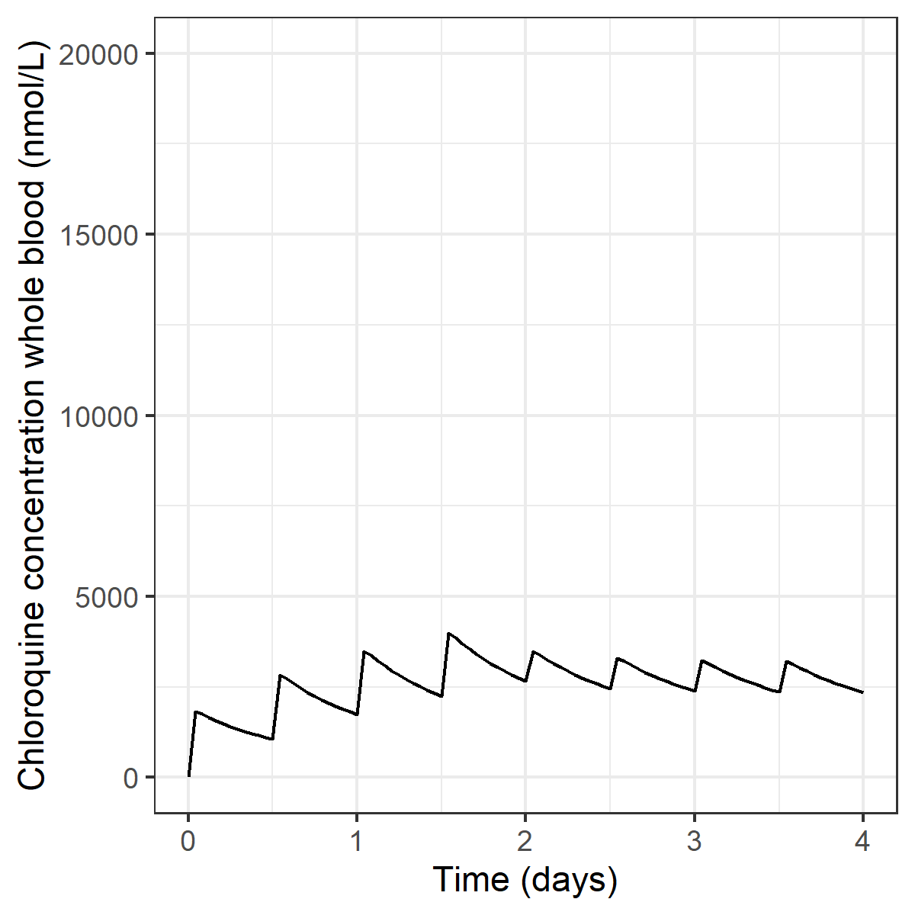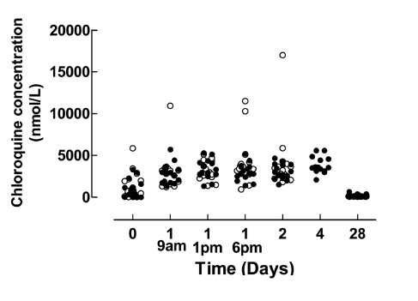
Observations from the 70 mg/kg group are shown in black dots while open dots represent 50 mg/kg dosing over 3 days.
Conclusion:
The Zhao model seems to be able to predict concentrations in children aged 5 – 12 reasonably well. Deviations probably occur due to the uncertainty of calculating whole blood concentrations from plasma concentrations.

PUSSARD ET AL 1991 [11]
Pussard E, Lepers JP, Clavier F, et al. Efficacy of a loading dose of oral chloroquine in a 36-hour treatment schedule for uncomplicated plasmodium falciparum malaria. Antimicrob Agents Chemother. 1991;35(3):406–409. doi:10.1128/aac.35.3.406
Dose and patient characteristics:
Patient characteristics: Young adults (mean age 14 – 24 year) treated for malaria in Madagaskar. Two dose groups:
Group 1: 40.3 kg mean body weight. Mean age 24.4y.
Group 2: 31.4 kg mean body weight. Mean age 14.8y.
Dose:
Group 1: 25 mg/kg over 48h: 10 mg/kg t = 0 h, 10 mg/kg t = 24h, 5 mg/kg at t = 48h.
Group 2: 30 mg/kg over 36h: 10 mg/kg t = 0, 5 mg/kg t = 6, 5 mg/kg t = 12, 5 mg/kg t = 24, 5 mg/kg t = 36h
Matrix: whole blood. Zhao et al measured in plasma. To translate between plasma and whole blood concentrations, several multiplication factors have been found, ranging from 2.5 [17] to 3.7 – 8 [18,19]. Therefore, simulated concentrations were multiplied by 2.5 to represent whole blood concentrations.
Results
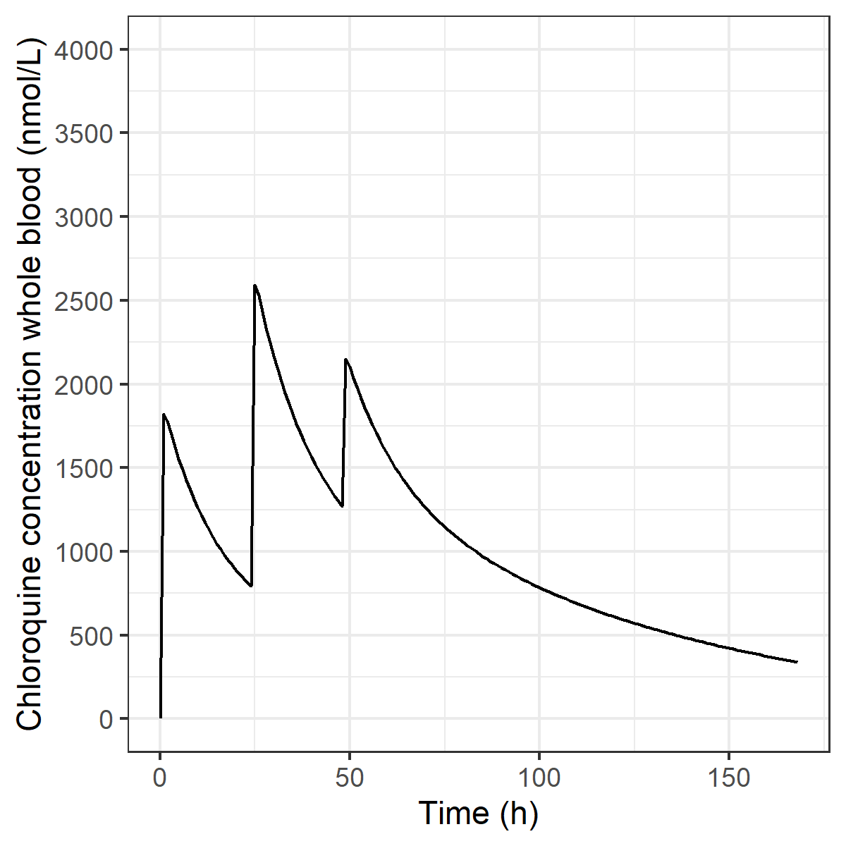
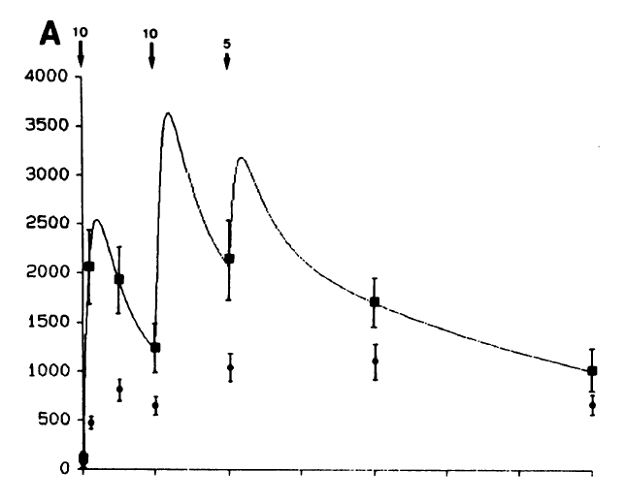

Chloroquine concentrations in Group 1 (low dose group, black squares are CQ concentrations in whole blood) are slightly lower than observed. This might be caused by the uncertain multiplication factor for calculating whole blood concentrations from plasma (we chose 2.5 according to Yao et [17], while others reported factors like 3.7 up to 8 [18,19]). This explanation is supported by the observation that the half life seems to be similar.
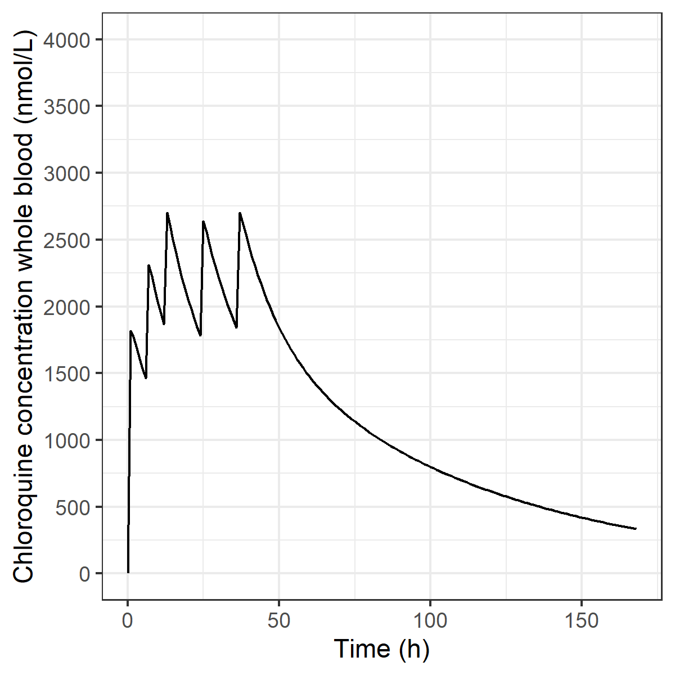
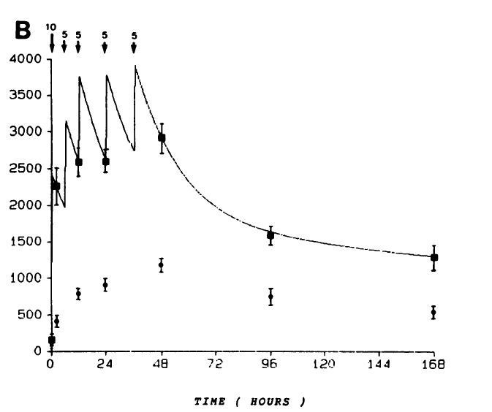
Chloroquine concentrations in Group 2 (high dose group, black squares are CQ concentrations in whole blood) are slightly lower than observed. This might be caused by the uncertain multiplication factor for calculating whole blood concentrations from plasma (we chose 2.5 according to Yao et [17], while others reported factors like 3.7 up to 8 [18,19]). This explanation is supported by the observation that the half life seems to be similar.
Conclusion: PK in these young adults seems to be reasonable well predicted, however, caution should be beared in transposing simulated plasma concentrations to whole blood concentrations.

Obua ET AL 2007 [9]
Obua C, Hellgren U, Ntale M, et al. Population pharmacokinetics of chloroquine and sulfadoxine and treatment response in children with malaria: suggestions for an improved dose regimen. Br J Clin Pharmacol. 2008;65(4):493–501. doi:10.1111/j.1365-2125.2007.03050.x
Dose and patient characteristics:
Dose regimen used in the study:
6m – 24m: 75 mg 1dd for 3 days
25m – 60 m: 150 mg 1dd for 3 days
Patient characteristics: Children 6 m – 60m with malaria (Uganda). Median weight 11.9kg (range 7-17 kg). Age median 30 months.
Matrix: Dried blood spot (based on methodology as plasma/serum)
Since 2 dose regimens were used dependent on age, we simulated 2 patients: 6 months = 7 kg (75 mg/day) and 25 months, 12 kg (150 mg/day).
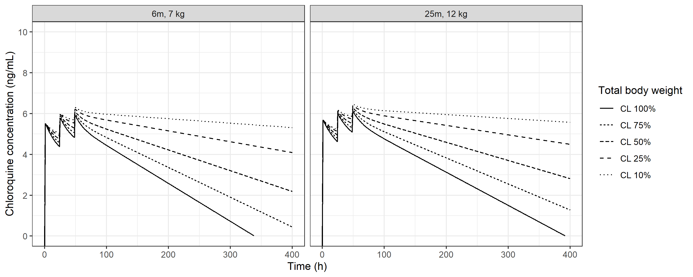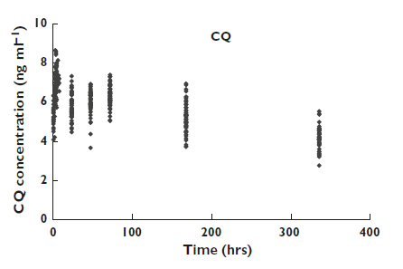
Conclusion: Median peaks of the observations are well predicted with the model. Elimination phase is best predicted when CL is set to 25-50%. This supports the findings of the evaluation of the model in Adelusi, where we found that for children < 5year or < 1 year, CL may be better predicted with CL set to 75% or 50%, respectively, on top of the weight-based allometric scaling that is implemented in Zhao et al [6].

Supplemental figure

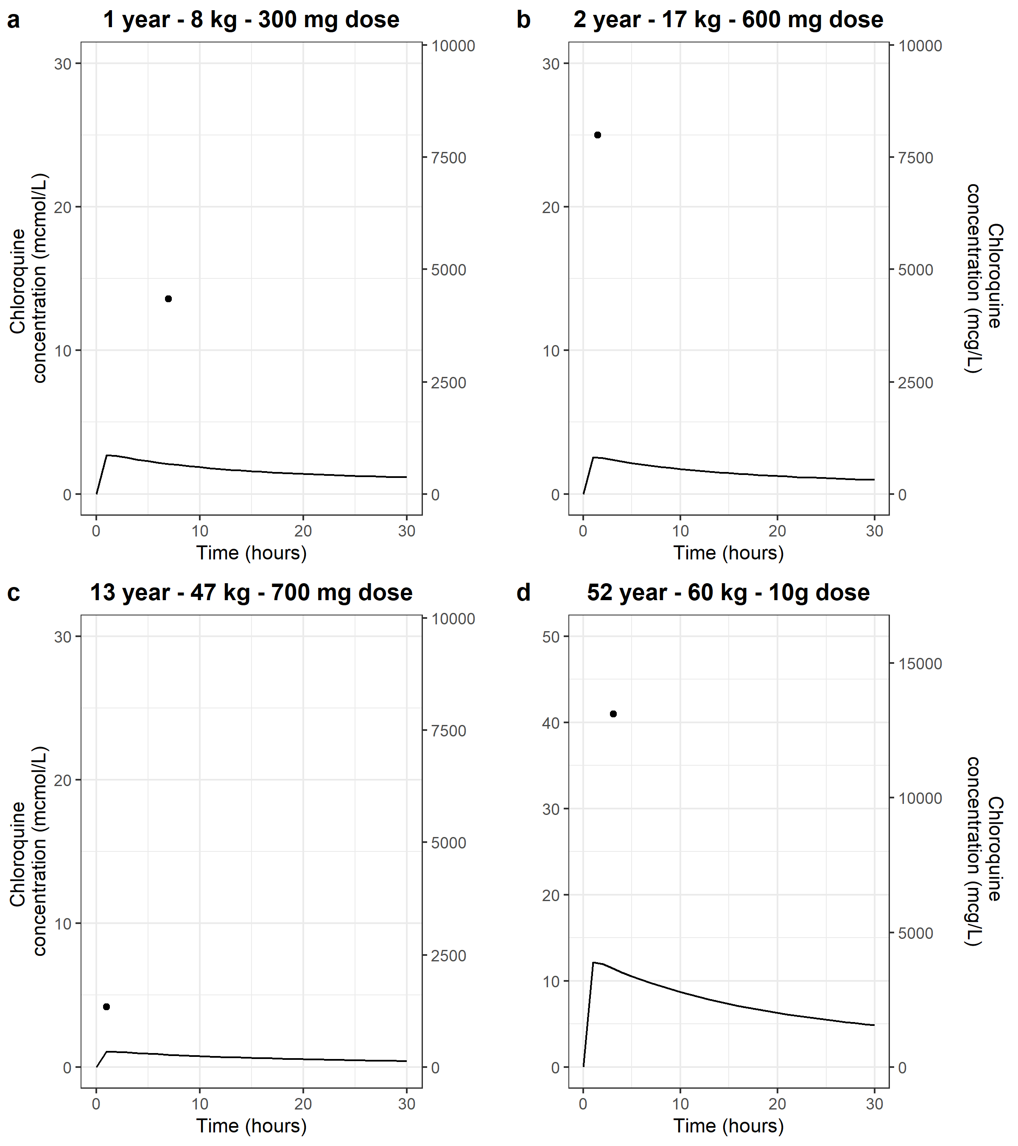
Figure 3. Plasma concentration-time profile in three cases of a chloroquine intoxication with A. a child of 1 year old who died after ingestion of around 300 mg [23], B. a child of 2 year old who died after ingestion of 600 mg [24] C. a child of 13 year old who had ventricular fibrillation after ingestion of around 700 mg [25] and D. an adult woman of 52 year old who ingested 10g [26]. Simulations are depicted by the solid lines, based on the pharmacokinetic model from Zhao et al [6] which was adapted for children below 5 and 1 years to be in agreement with observations in children in other reports [8,9,12] (i.e. a reduction in Cl to 75% and 50% on top of allometric scaling (that was already in the model) for children below 5 and 1 year of age, respectively, see under 4. for details). Dots represent reported observations as reported in the original publications, where chloroquine was measured in A. serum, B. serum, C. plasma and D. plasma. Chloroquine concentrations are shown in mcmol/l (left axis) and mcg/l (right axis).

References

1. Beal SL, Sheiner LB, Boeckmann A. NONMEM user’s guide. University of California, San Francisco, California. 1999.
2. Keizer RJ, Karlsson MO, Hooker A. Modeling and Simulation Workbench for NONMEM: Tutorial on Pirana, PsN, and Xpose. CPT Pharmacometrics Syst Pharmacol. 2013;2:e50.
3. Lindbom L, Pihlgren P, Jonsson EN, Jonsson N. PsN-Toolkit--a collection of computer intensive statistical methods for non-linear mixed effect modeling using NONMEM. Comput Methods Programs Biomed. 2005;79:241–57.
4. R Core Team. R: A language and environment for statistical computing. 2019.
5. RStudio Team. RStudio: Integrated Development for R. 2015.
6. Zhao Q, Tensfeldt TG, Chandra R, Mould DR. Population pharmacokinetics of azithromycin and chloroquine in healthy adults and paediatric malaria subjects following oral administration of fixed-dose azithromycin and chloroquine combination tablets. Malar J. 2014;13:1–8.
7. Walker O, Dawodu A, Adeyokunnu A, Salako L, Alvan G. Plasma chloroquine and desethylchloroquine concentrations in children during and after chloroquine treatment for malaria. Br J Clin Pharmacol. 1983;16:701–5.
8. Adelusi S, Dawodu A, Salako L. Kinetics of the uptake and elimination of chloroquine in children with malaria. Br J Clin Pharmacol. 1982;14:483–7.
9. Obua C, Hellgren U, Ntale M, Gustafsson LL, Ogwal-Okeng JW, Gordi T, et al. Population pharmacokinetics of chloroquine and sulfadoxine and treatment response in children with malaria: Suggestions for an improved dose regimen. Br J Clin Pharmacol. 2008;65:493–501.
10. Stichting Werkgroep Antibiotica Beleid (SWAB). Medicamenteuze behandelopties bij patiënten met COVID-19 (infecties met SARS-CoV-2) [Internet]. [cited 2020 Mar 24]. Available from: https://swab.nl/nl/covid-19
11. Pussard E, Lepers JP, Clavier F, Raharimalala L, Le Bras J, Frisk-Holmberg M, et al. Efficacy of a loading dose of oral chloroquine in a 36-hour treatment schedule for uncomplicated Plasmodium falciparum malaria. Antimicrob Agents Chemother. 1991;35:406–9.
12. Ursing J, Rombo L, Eksborg S, Larson L, Bruvoll A, Tarning J, et al. High-dose chloroquine for uncomplicated plasmodium falciparum malaria is well tolerated and causes similar QT interval prolongation as standard-dose chloroquine in children. Antimicrob Agents Chemother. 2020;64:1–12.
13. Edwards G, Looareesuwan S, Davies AJ, Wattanagoon Y, Phillips RE, Warrell DA. Pharmacokinetics of chloroquine in Thais: plasma and red-cell concentrations following an intravenous infusion to healthy subjects and patients with Plasmodium vivax malaria. Br J Clin Pharmacol. 1988;25:477–85.
14. Höglund R, Moussavi Y, Ruengweerayut R, Cheomung A, Äbelö A, Na-Bangchang K. Population pharmacokinetics of a three-day chloroquine treatment in patients with Plasmodium vivax infection on the Thai-Myanmar border. Malar J. BioMed Central; 2016;15:1–9.
15. Salako LA, Walker O, Iyun AO. Pharmacokinetics of chloroquine in renal insufficiency. Afr J Med Med Sci. 2005;13:177–82.
16. Daher A, Aljayyoussi G, Pereira D, Lacerda MVG, Alexandre MAA, Nascimento CT, et al. Pharmacokinetics/pharmacodynamics of chloroquine and artemisinin-based combination therapy with primaquine. Malar J. 2019;18:1–9.
17. Yao X, Ye F, Zhang M, Cui C, Huang B, Niu P, et al. In vitro antiviral activity and projection of optimized dosing design of h hydroxychloroquine for the treatment of severe Acute Respiratory Syndrome Coronavirus 2 (SARS-CoV-2). Clin Infect Dis. 2020;
18. Berliner RW, Earle DP, Taggart J V, Zubrod CG, Welch WJ, Conan NJ, et al. Studies on the chemotherapy of the human malarias. VI. The physiological disposition, antimalarial activity, and toxicity of several derivatives of 4-aminoquinoline. J Clin Invest. 1948;27:98–107.
19. Gustafsson LL, Bergqvist Y, Ericsson O, Larsson M, Rombo L. Pitfalls in the measurement of chloroquine concentration. Lancet (London, England). 1983;1:126.
20. Calvier EAM, Krekels EHJ, Välitalo PAJ, Rostami-Hodjegan A, Tibboel D, Danhof M, et al. Allometric scaling of clearance in paediatric patients: When does the magic of 0.75 fade? Clin Pharmacokinet. 2017;56:273–85.
21. Gustafsson LL, Walker O, Alván G, Beermann B, Estevez F, Gleisner L, et al. Disposition of chloroquine in man after single intravenous and oral doses. Br J Clin Pharmacol. 1983;15:471–9.
22. Frisk-Holmberg M, Bergqvist Y, Domeij-Nyberg B. Steady state disposition of chloroquine in patients with rheumatoid disease. Eur J Clin Pharmacol. 1983;24:837–9.
23. Kelly JC, Wasserman GS, Bernard WD, Schultz C, Knapp J. Chloroquine poisoning in a child. Ann Emerg Med. 1990;19:47–50.
24. McCann WP, Permisohn R, Palmisano PA. Fatal chloroquine poisoning in a child: Experience with peritoneal dialysis. Pediatrics. 1975;55:536–8.
25. Collee GG, Samra GS, Hanson GC. Chloroquine poisoning: ventricular fibrillation following ‘trivial’ overdose in a child. Intensive Care Med. 1992;18:170–1.
26. Boereboom FTJ, Ververs FFT, Meulenbelt J, Van Dijk A. Hemoperfusion is ineffectual in severe chloroquine poisoning. Crit Care Med. 2000;28:3346–50.

